SCHOOL OF COMPUTER SCIENCE AND ARTIFICIAL INTELLIGENCE |  |  |  |  | DEPARTMENT OF COMPUTER SCIENCE ENGINEERING
ProgramName:B. Tech |  |  |  | Assignment Type: Lab |  |  | AcademicYear:2025-2026
CourseCoordinatorName |  |  |  | Venkataramana Veeramsetty
Instructor(s)Name |  |  |  | Dr. V. Venkataramana (Co-ordinator)  Dr. T. Sampath Kumar  Dr. Pramoda Patro  Dr. Brij Kishor Tiwari  Dr.J.Ravichander  Dr. Mohammand Ali Shaik  Dr. Anirodh Kumar  Mr. S.Naresh Kumar  Dr. RAJESH VELPULA  Mr. Kundhan Kumar  Ms. Ch.Rajitha  Mr. M Prakash  Mr. B.Raju  Intern 1 (Dharma teja)  Intern 2 (Sai Prasad)  Intern 3 (Sowmya)  NS_2 ( Mounika)
CourseCode |  |  | 24CS002PC215 | CourseTitle |  | AI Assisted Coding
Year/Sem |  |  | II/I | Regulation |  | R24
Date and Day  of Assignment |  |  | Week4 - Tuesday | Time(s)
Duration |  |  | 2 Hours | Applicableto  Batches
AssignmentNumber:7.2(Present assignment number)/24(Total number of assignments)
 | Q.No. | Question |  |  |  |  |  | ExpectedTime  to complete
 | 1 | Lab 7: Error Debugging with AI: Systematic approaches to finding and fixing bugs  Lab Objectives:  - To identify and correct syntax, logic, and runtime errors in Python programs using AI tools.  - To understand common programming bugs and AI-assisted debugging suggestions.  - To evaluate how AI explains, detects, and fixes different types of coding errors.  - To build confidence in using AI to perform structured debugging practices.  Lab Outcomes (LOs):  After completing this lab, students will be able to:  - Use AI tools to detect and correct syntax, logic, and runtime errors.  - Interpret AI-suggested bug fixes and explanations.  - Apply systematic debugging strategies supported by AI-generated insights.  - Refactor buggy code using responsible and reliable programming patterns.  Task Description#1  - Task #1 – Syntax Error in Conditionals  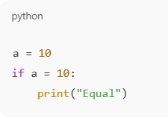  Expected Output#1  - Corrected function with syntax fix  Task Description#2 (Loops)  - Task #2 – Loop Off-By-One Error.  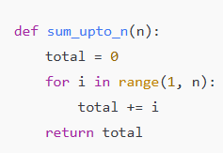  Expected Output#2  - AI fixes increment/decrement error  Task Description#3  - Error: AttributeError  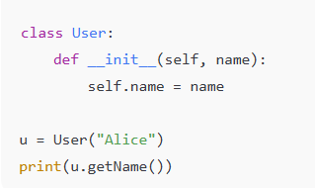  Expected Output#3  - Identify the missing method and correct the code.  Task Description#4  - Incorrect Class Attribute Initialization  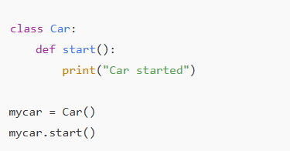  Expected Output#4  - Detect missing self and initialize attributes properly.  Task Description#5  - Conditional Logic Error in Grading System  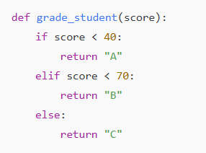  Expected Output#5  - Detect illogical grading and correct the grade levels.  Note: Report should be submitted a word document for all tasks in a single document with prompts, comments & code explanation, and output and if required, screenshots  Evaluation Criteria:  Criteria Max Marks  Task #1 0.5  Task #2 0.5  Task #3 0.5  Task #4 0.5  Task #5 0.5  Total 2.5 Marks |  |  |  |  |  | Week4 - Wednesday

TASK 1:
Syntax Error:
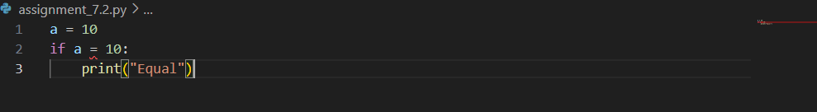
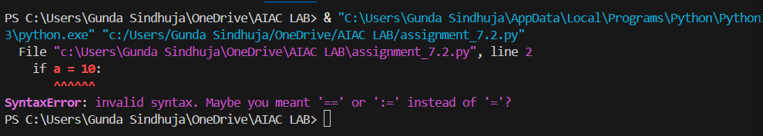

Corrected Function with Syntax Fix:
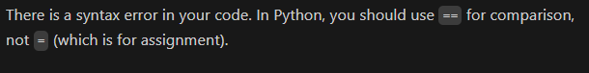

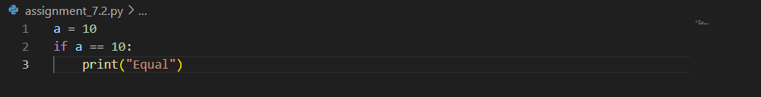
Output:
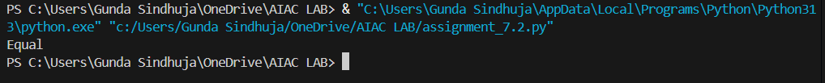

TASK 2:
Logical Error:
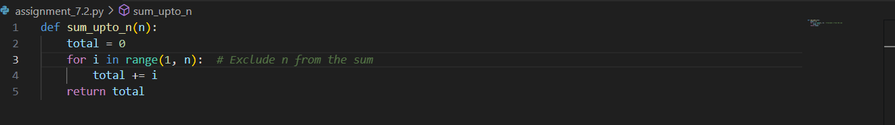

Fixing the Error:
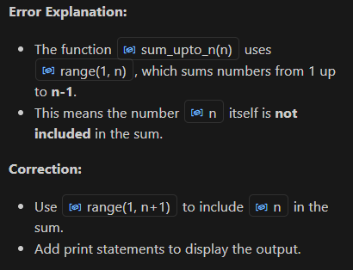
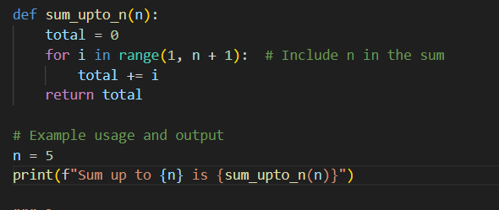
Output:
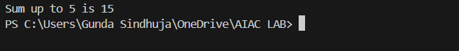

TASK 3:
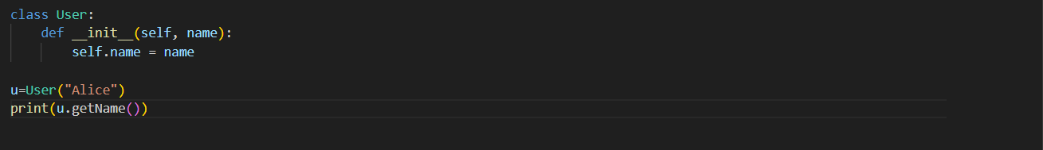
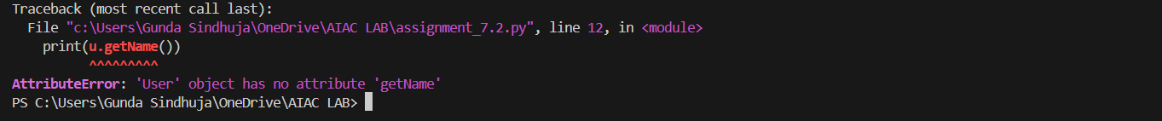

Fixing the Error:

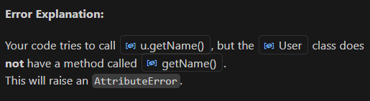
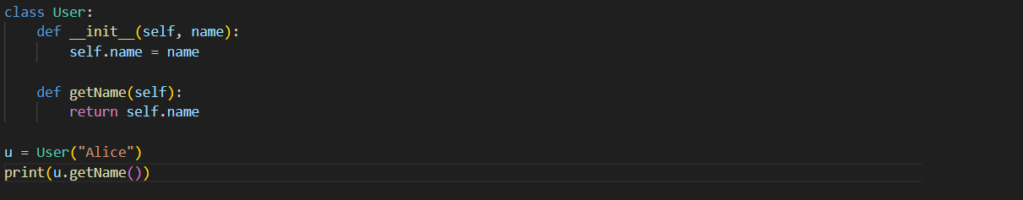
Output:

TASK 4:
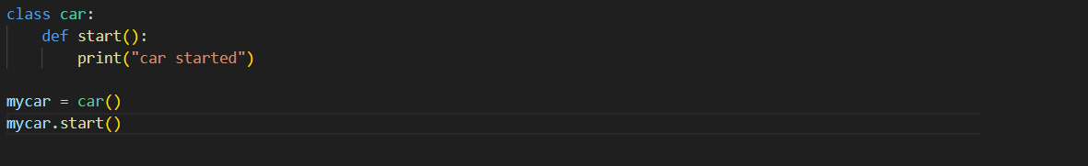
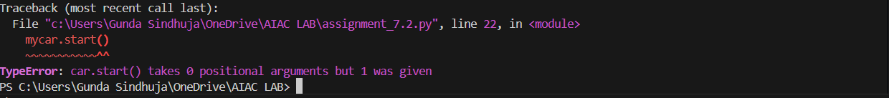

Fixing the Error:
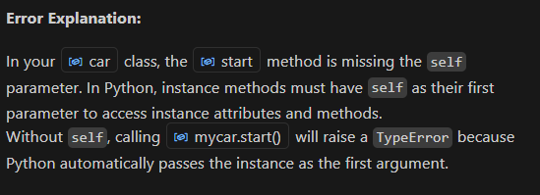
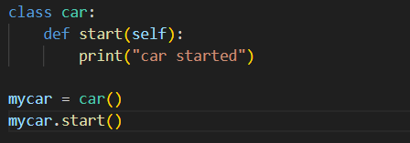
Output:
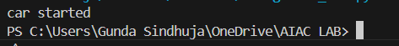

TASK 5 :

Fixing the Error:
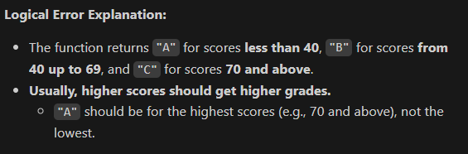

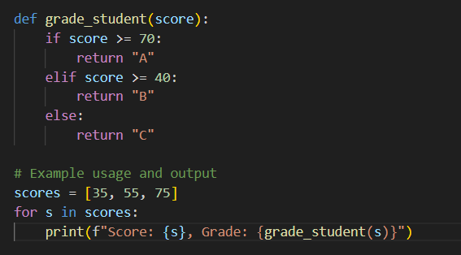
Output:
