SCHOOL OF COMPUTER SCIENCE AND ARTIFICIAL INTELLIGENCE |  |  |  |  | DEPARTMENT OF COMPUTER SCIENCE ENGINEERING
ProgramName:B. Tech |  |  |  | Assignment Type: Lab |  |  | AcademicYear:2025-2026
CourseCoordinatorName |  |  |  | Venkataramana Veeramsetty
Instructor(s)Name |  |  |  | Dr. V. Venkataramana (Co-ordinator)  Dr. T. Sampath Kumar  Dr. Pramoda Patro  Dr. Brij Kishor Tiwari  Dr.J.Ravichander  Dr. Mohammand Ali Shaik  Dr. Anirodh Kumar  Mr. S.Naresh Kumar  Dr. RAJESH VELPULA  Mr. Kundhan Kumar  Ms. Ch.Rajitha  Mr. M Prakash  Mr. B.Raju  Intern 1 (Dharma teja)  Intern 2 (Sai Prasad)  Intern 3 (Sowmya)  NS_2 ( Mounika)
CourseCode |  |  | 24CS002PC215 | CourseTitle |  | AI Assisted Coding
Year/Sem |  |  | II/I | Regulation |  | R24
Date and Day  of Assignment |  |  | Week3 - Thursday | Time(s)
Duration |  |  | 2 Hours | Applicableto  Batches
AssignmentNumber:6.4(Present assignment number)/24(Total number of assignments)
 | Q.No. | Question |  |  |  |  |  | ExpectedTime  to complete
 | 1 | Lab 6: AI-Based Code Completion – Classes, Loops, and Conditionals  Lab Objectives:  - To explore AI-powered auto-completion features for core Python constructs.  - To analyze how AI suggests logic for class definitions, loops, and conditionals.  - To evaluate the completeness and correctness of code generated by AI assistants.  Lab Outcomes (LOs):  After completing this lab, students will be able to:  - Use AI tools to generate and complete class definitions and methods.  - Understand and assess AI-suggested loops for iterative tasks.  - Generate conditional statements through prompt-driven suggestions.  - Critically evaluate AI-assisted code for correctness and clarity.  Task Description #1:  • Start a Python class named Student with attributes name, roll_number, and marks. Prompt GitHub Copilot to complete methods for displaying details and checking if marks are above average.  Expected Outcome #1:  • Completed class with Copilot-generated methods like display_details() and is_passed(), demonstrating use of if-else conditions.  Task Description #2:  • Write the first two lines of a for loop to iterate through a list of numbers. Use a comment prompt to let Copilot suggest how to calculate and print the square of even numbers only.  Expected Outcome #2:  • A complete loop generated by Copilot with conditional logic (if number % 2 == 0) and appropriate output.  Task Description #3:  • Create a class called BankAccount with attributes account_holder and balance. Use Copilot to complete methods for deposit(), withdraw(), and check for insufficient balance.  Expected Outcome #3:  • Functional class with complete method definitions using if conditions and self attributes. Code should prevent overdrawing.  Task Description #4:  • Define a list of student dictionaries with keys name and score. Ask Copilot to write a while loop to print the names of students who scored more than 75.  Expected Outcome #4:  • A complete while loop generated by Copilot with proper condition checks and formatted output.  Task Description #5:  • Begin writing a class ShoppingCart with an empty items list. Prompt Copilot to generate methods to add_item, remove_item, and use a loop to calculate the total bill using conditional discounts.  Expected Outcome #5:  • A fully implemented ShoppingCart class with Copilot-generated loops and if-else statements handling item management and discount logic.  Note: Report should be submitted a word document for all tasks in a single document with prompts, comments & code explanation, and output and if required, screenshots  Evaluation Criteria:  Criteria Max Marks  Class 1  Loop 1  condition 0.5  Total 2.5 Marks |  |  |  |  |  | Week3 - Thursday

TASK 1:
PROMPT:
- Write a Python class named Student with attributes name, roll_number, and marks.
- Modify the code to complete methods for displaying details and checking if marks are above average and whether the student is passed or not.

CODE:
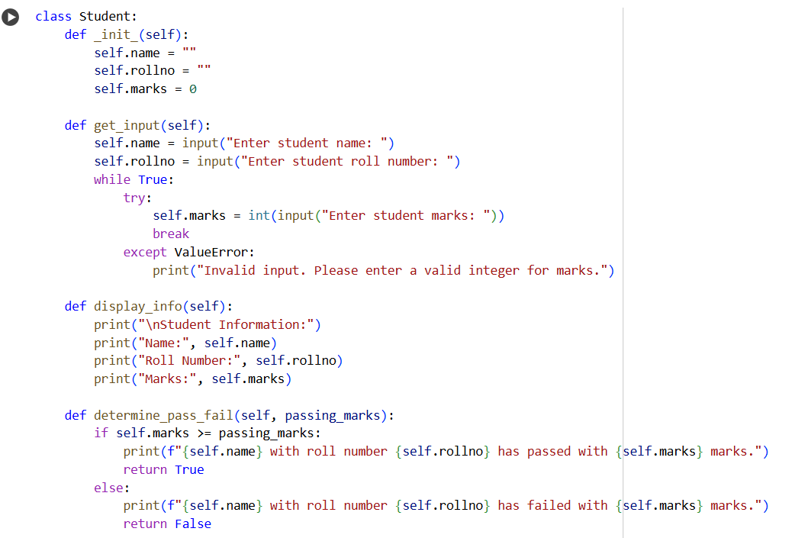
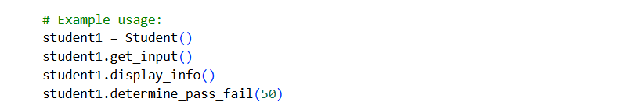
OUTPUT:
,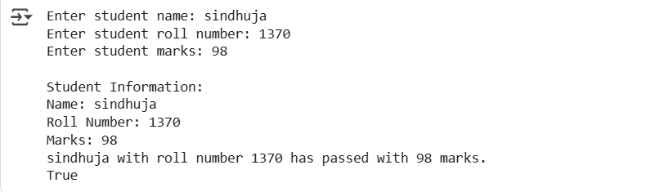

EXPLANATION:
This Python code defines a Student class with methods to get student details (name, roll number, marks) from the user, display that information, and check if the student has passed based on a given passing mark. The example usage at the end creates a Student object, gets input, displays the info, and determines the pass/fail status with a passing mark of 50. The code includes basic input validation for the marks.

TASK 2:
PROMPT:
numbers=[1,2,3,4,5,6,7,8,9,10]
for num in numbers:
#now complete the code to print the sqare of only even numbers from the list given
CODE:
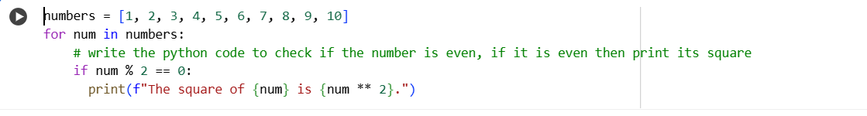
OUTPUT:
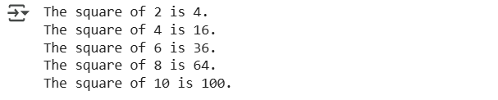
EXPLANATION:
This code initializes a list of numbers from 1 to 10. It then loops through each number in the list. Inside the loop, it checks if the current number is even using the modulo operator (%). If the number is even (remainder is 0 when divided by 2), it proceeds to the next step. It calculates the square of the even (num ** 2). Finally, it prints a formatted sentence that includes the original even number and its calculated square. This process repeats for all numbers in the list, but output is only generated for the even ones.

TASK 3:
PROMPT:
- Write a Python program to Create a class called BankAccount with attributes account_holder and balance.
- Modify the code to complete methods for deposit(), withdraw(), and check for insufficient balance based on User Inputs.
CODE:
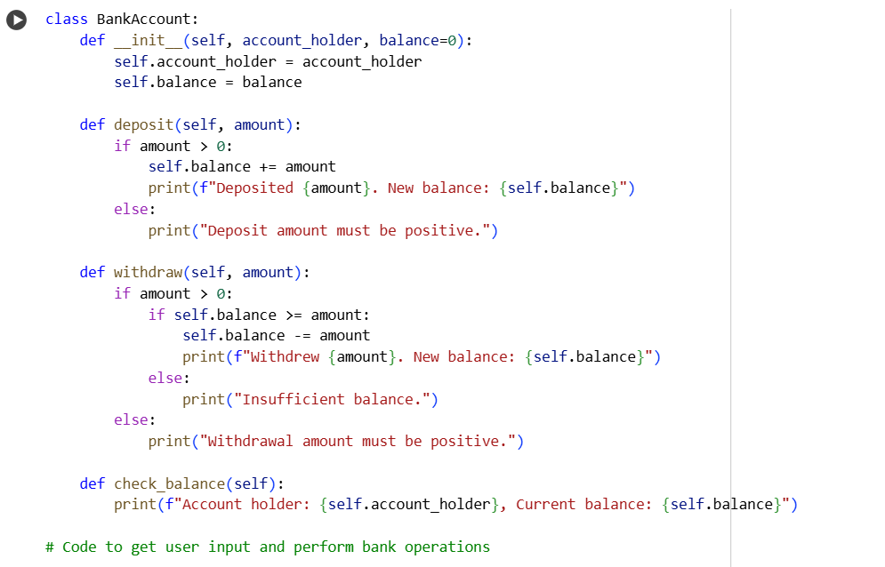
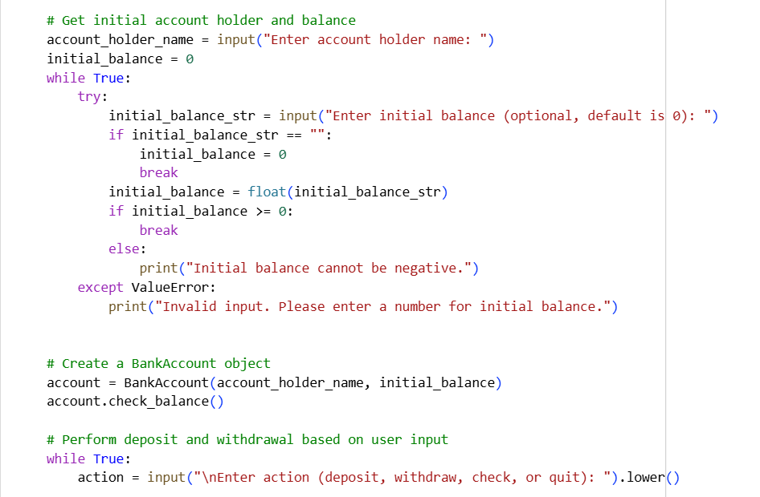
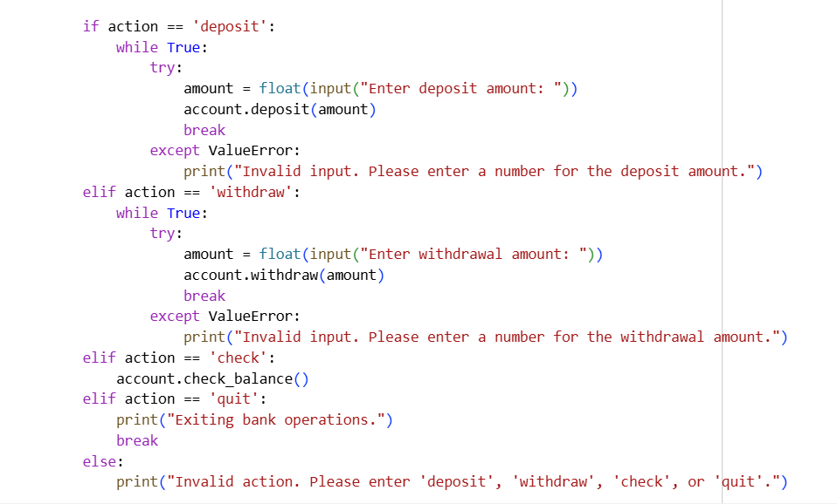

OUTPUT:
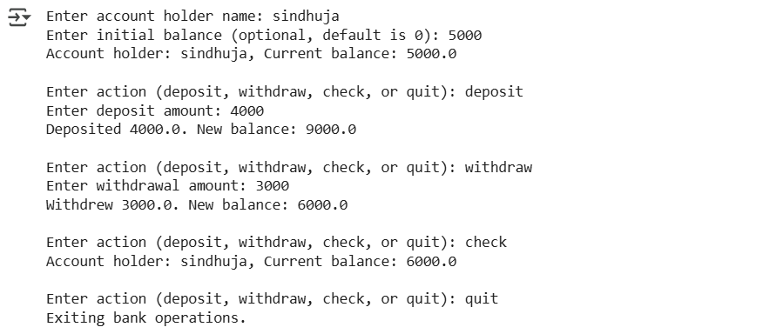
EXPLANATION:
This code defines a BankAccount class with methods for depositing and withdrawing money, and checking the balance. The init method initializes the account with a holder's name and an optional initial balance. The deposit method adds a positive amount to the balance. The withdraw method subtracts a positive amount if there's sufficient balance. The check_balance method displays the account holder and current balance. The code then takes user input to create a BankAccount object and allows the user to repeatedly perform deposit, withdraw, or check balance actions until they choose to quit. Input validation is included for amounts and initial balance.

TASK 4:
PROMPT:
- Define a list of student dictionaries with keys name and score
- Modify the code to write a while loop to print the names of students who scored more than 75.
CODE:
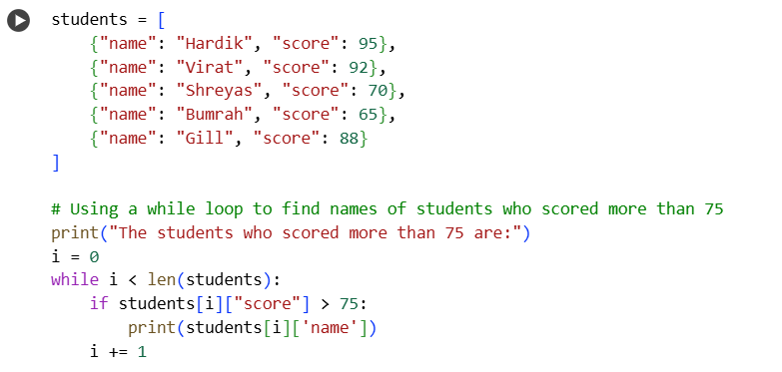
OUTPUT:
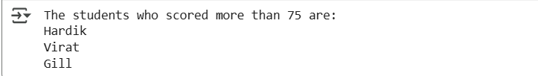
EXPLANATION:
This code initializes a list of dictionaries, where each dictionary represents a student with a name and score. It then prints an introductory sentence. A while loop is used to iterate through each student in the list. Inside the loop, it checks if the current student's score is greater than 75. If the score is above 75, the student's name is printed on a new line. The loop continues until all students in the list have been checked. This effectively lists the names of students who scored more than 75

TASK 5:
PROMPT:

1.Write a python code containing a class ShoppingCart with an empty items list.
2. Modify the code to generate methods to add_item, remove_item, and use a loop to calculate the total bill using conditional discounts. The code should take all the inputs from the user and print the output

CODE:
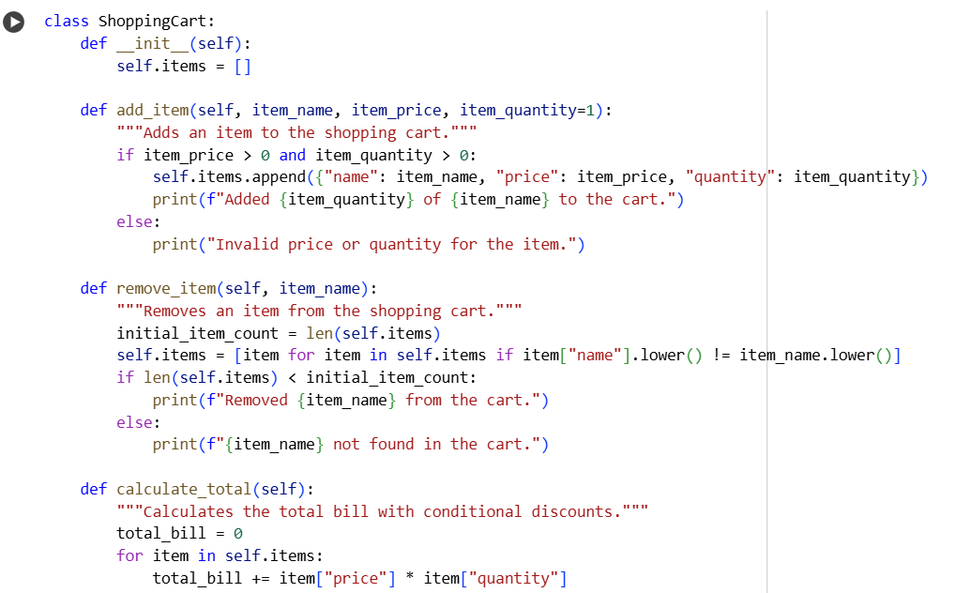
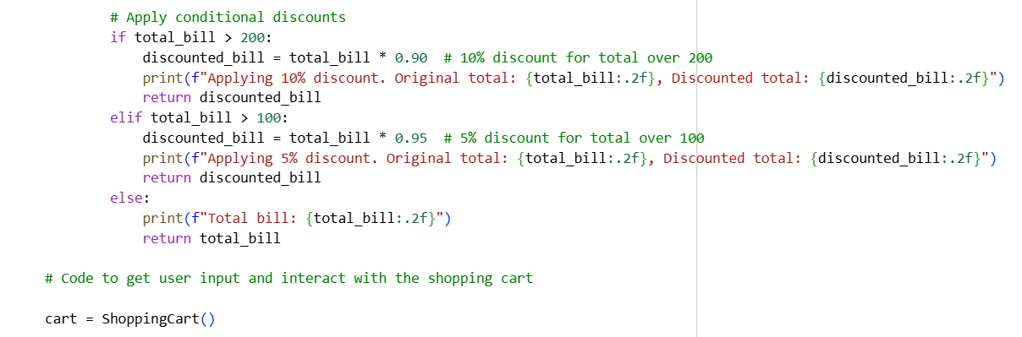
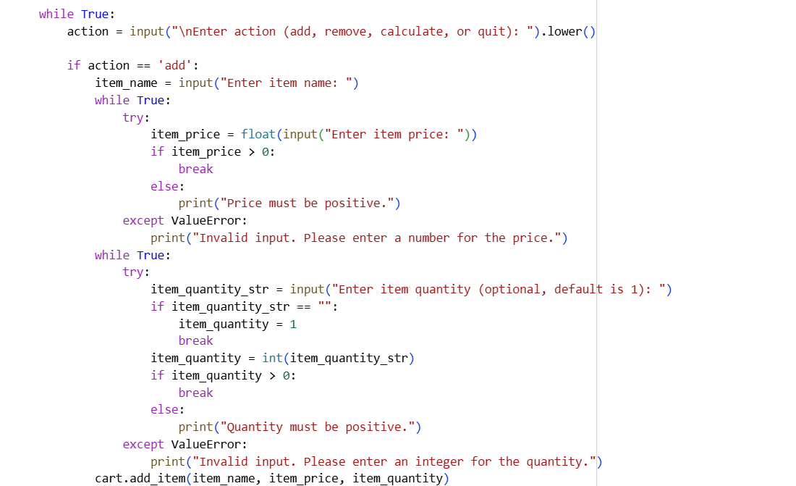
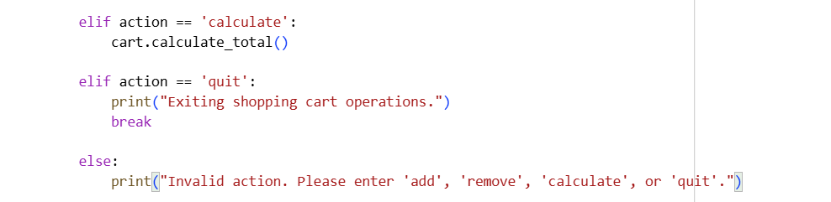

OUTPUT:
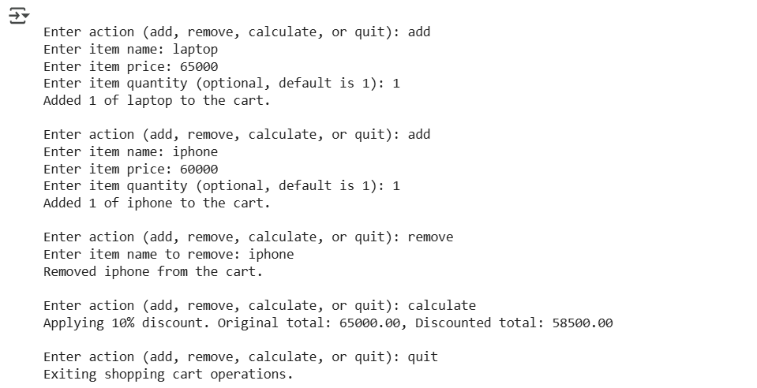
EXPLANATION:
This Python code defines a ShoppingCart class to manage items. The add_item method adds items with their price and quantity. The remove_item method removes items by name. The calculate_total method sums the cost of all items and applies a 10% discount if the total is over 200, or a 5% discount if the total is over 100. The code then interacts with the user, allowing them to add, remove, or calculate the total until they quit. Input validation is included for price and quantity.

