**NAME: KAVYA GUNDALA**

**DATE: 16-12-2023**

* **Lambda Functions in Python**

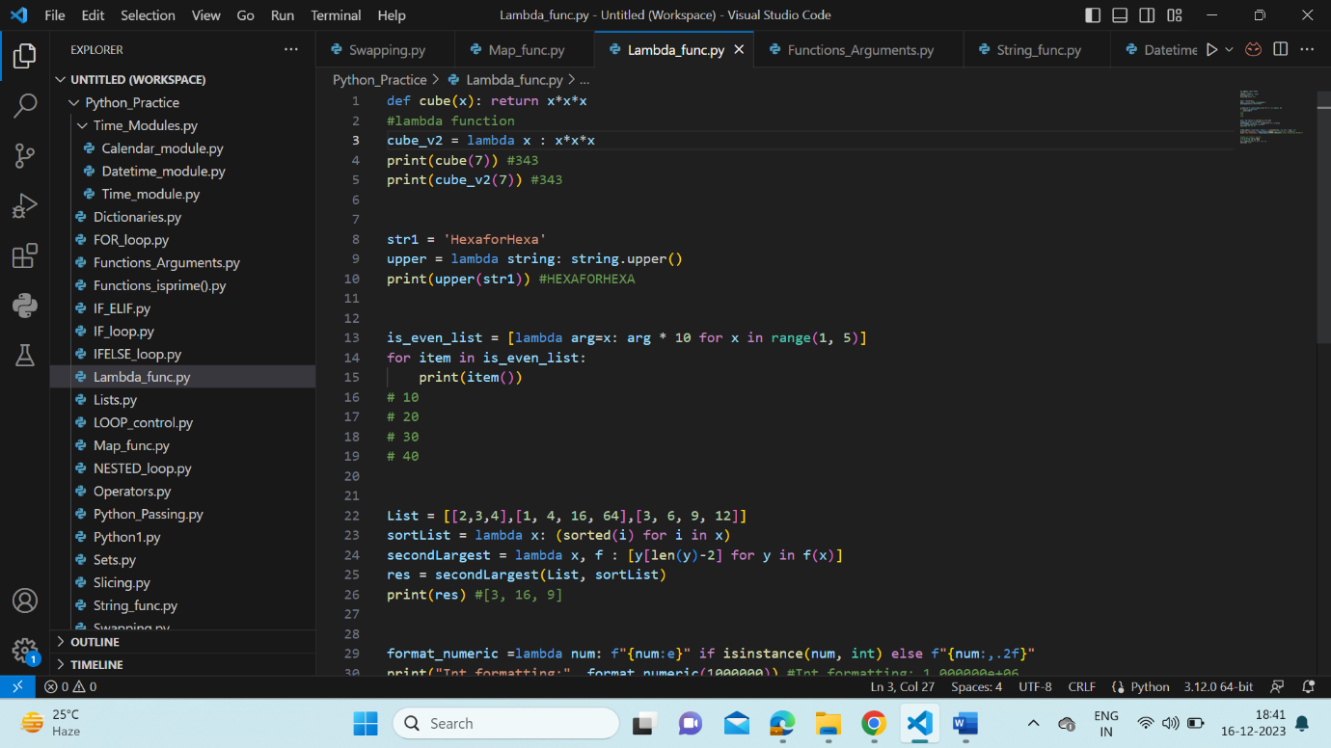

* **Python Passing – Pass by value, Pass by reference**

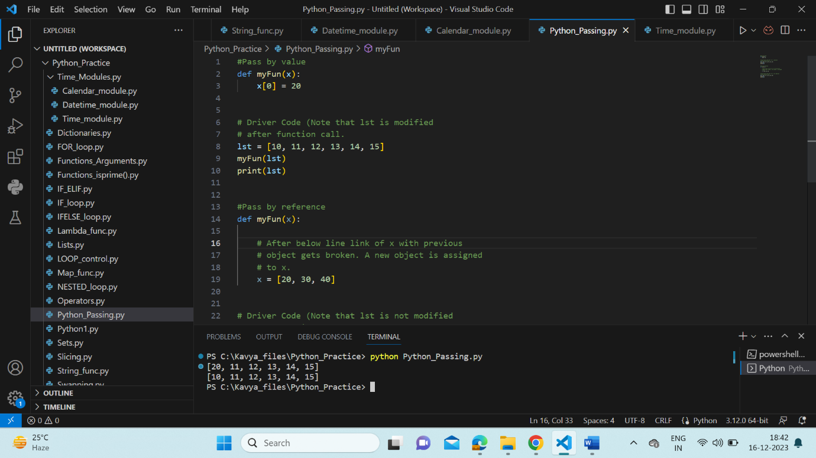

* **Map Function**

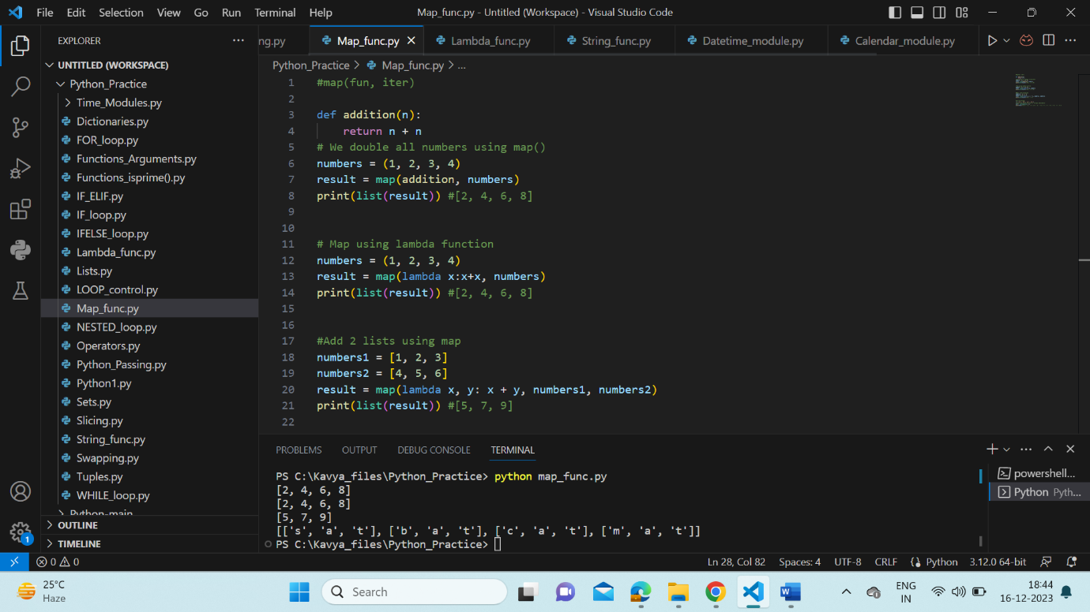

* **String functions in Python**

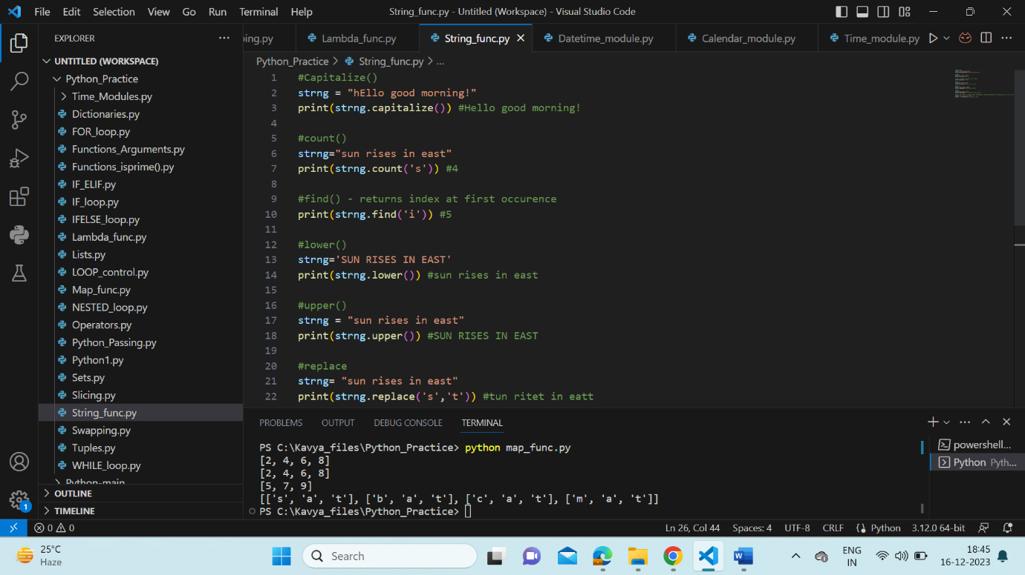

* **Swapping of 2 numbers**

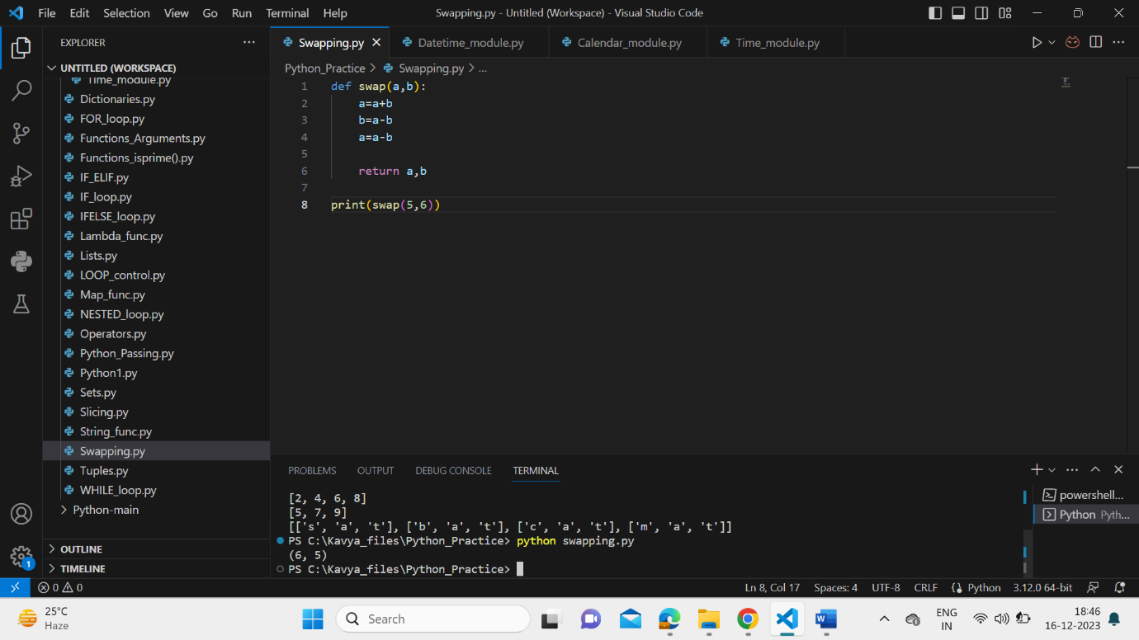

* **Datetime module**

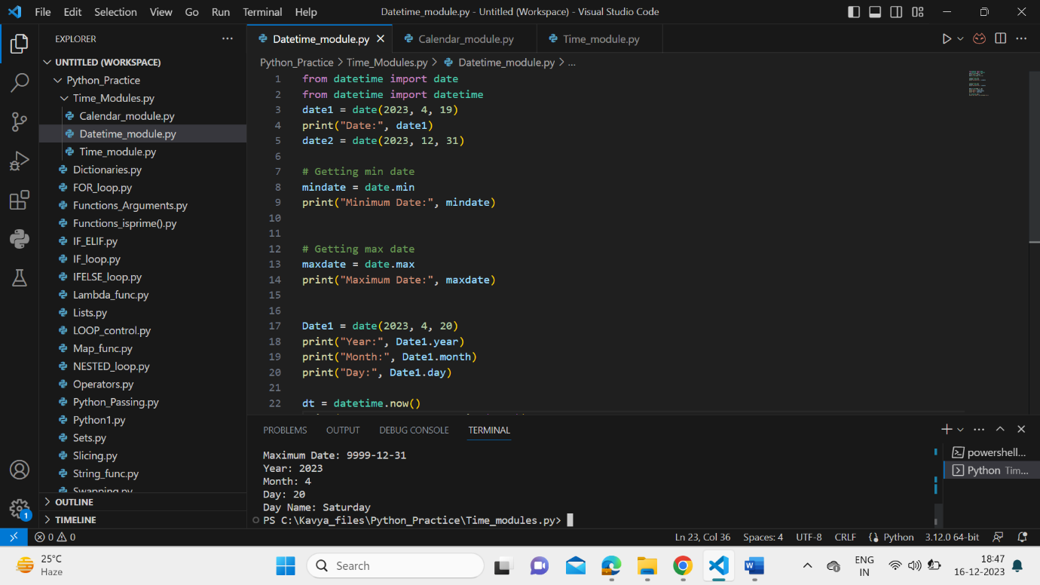

* **Time module**

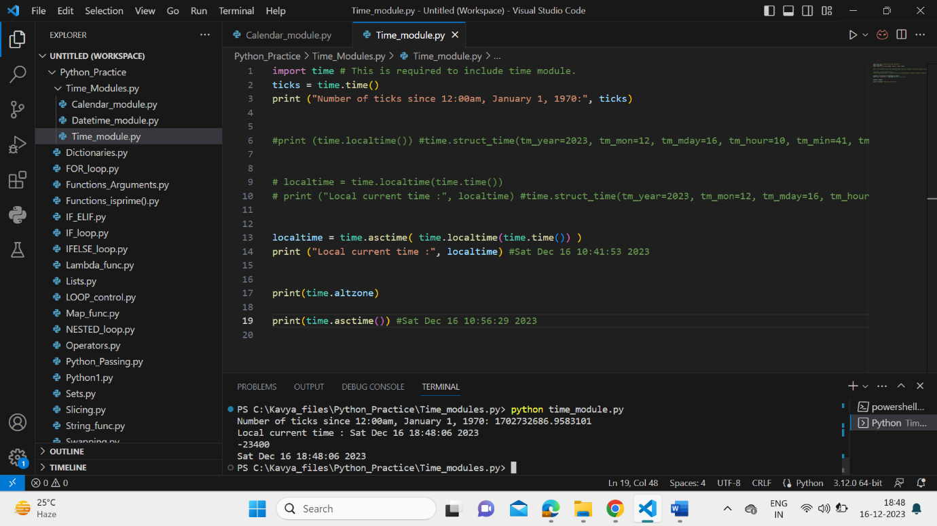

* **Calendar module**

