**Name: Kavya Gundala**

* Creating a database

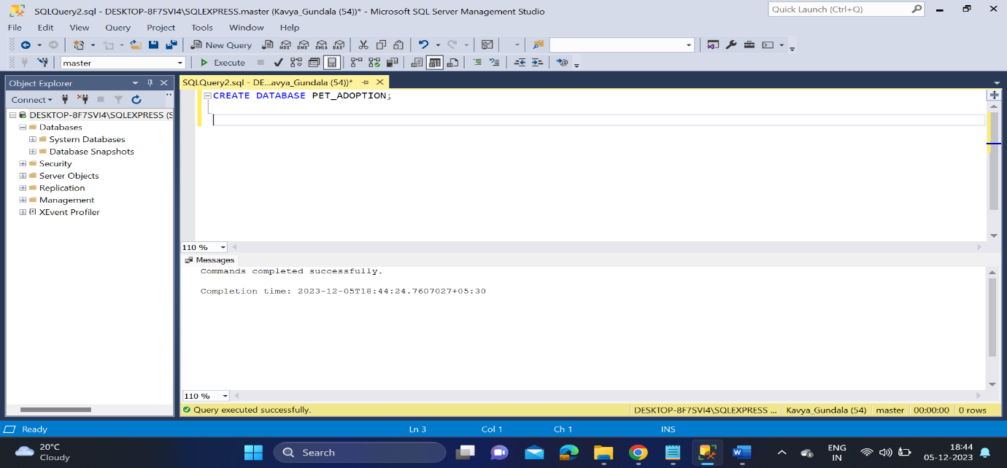

* Creating a table – Animals
* Inserting values into animals table

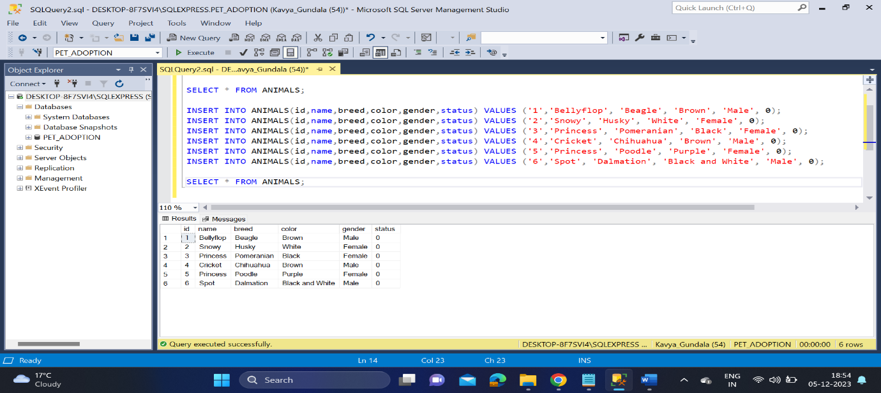

* Updating the values and deleting a row
* Used DML commands- SELECT, INSERT, UPDATE, DELETE

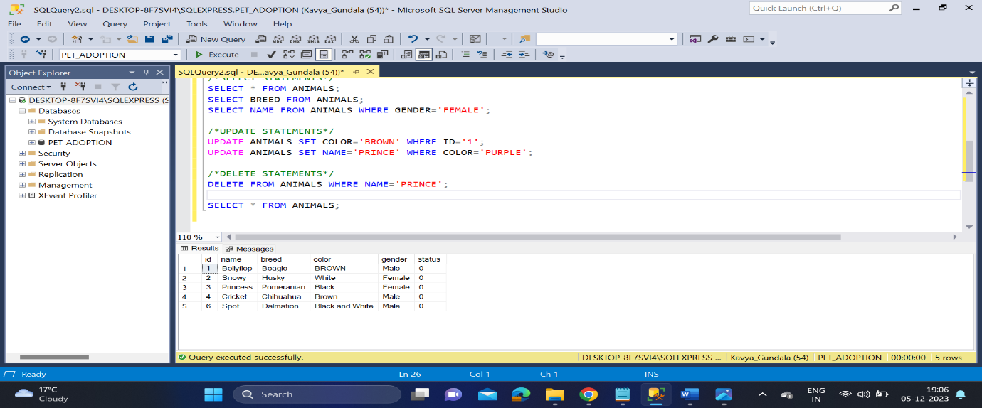

* Creating a table -Adoption and inserting values to it

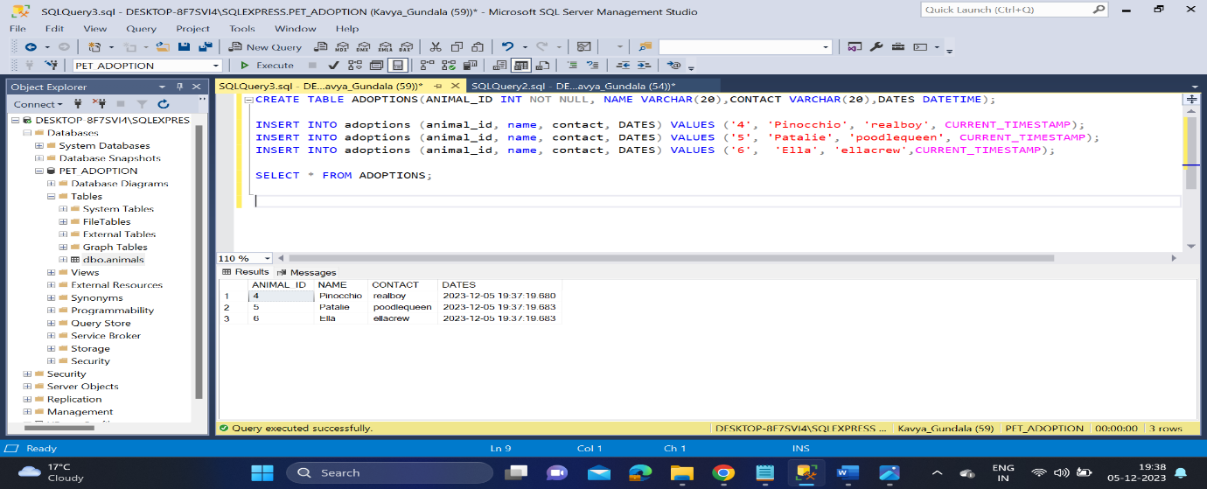

* Using ORDERBY clause on dates

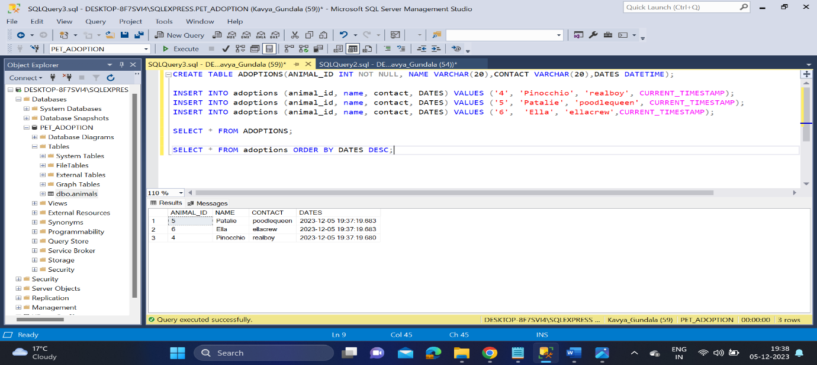

* Using DDL commands- CREATE, ALTER

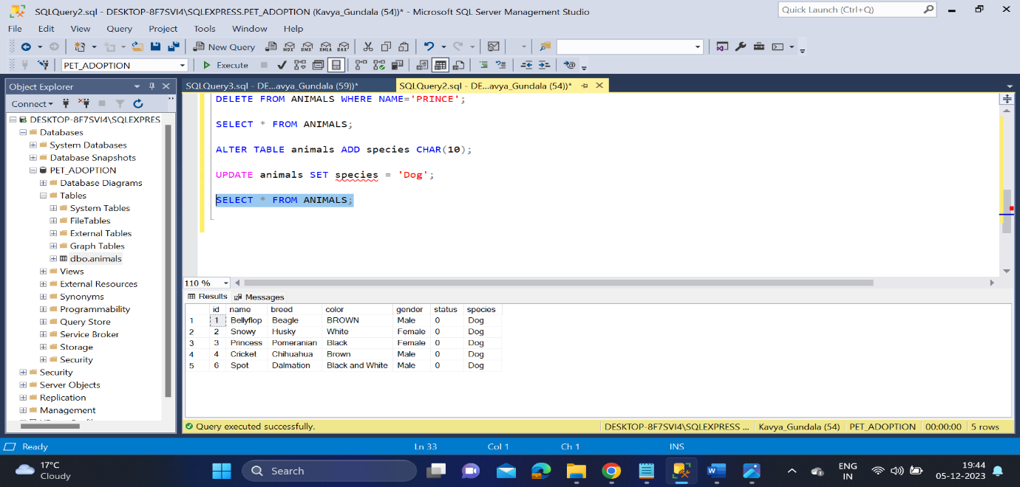

* After adding cats to the database

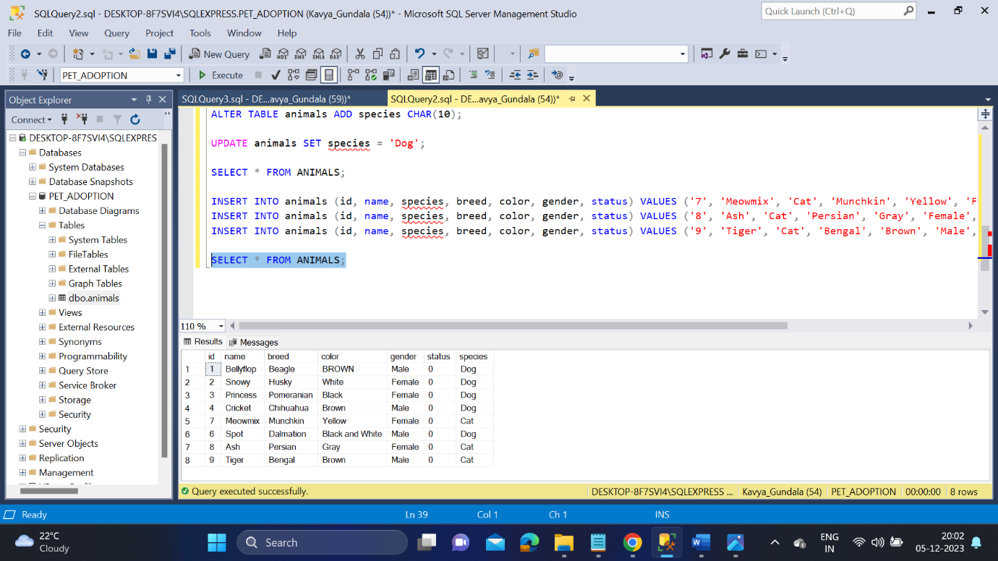

* Creating a table Shelter and adding values to it.

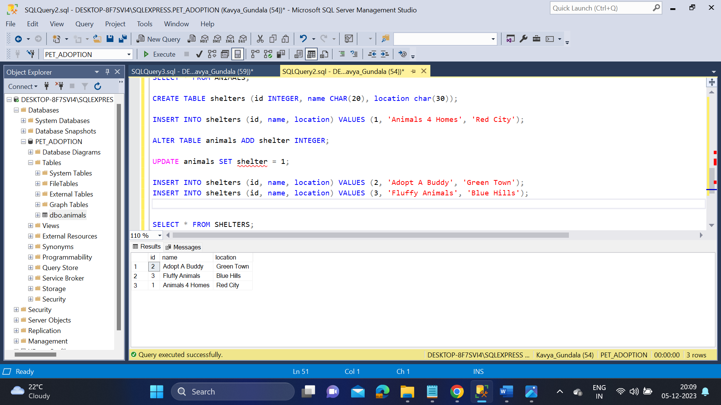

* Creating index on animals.shelter

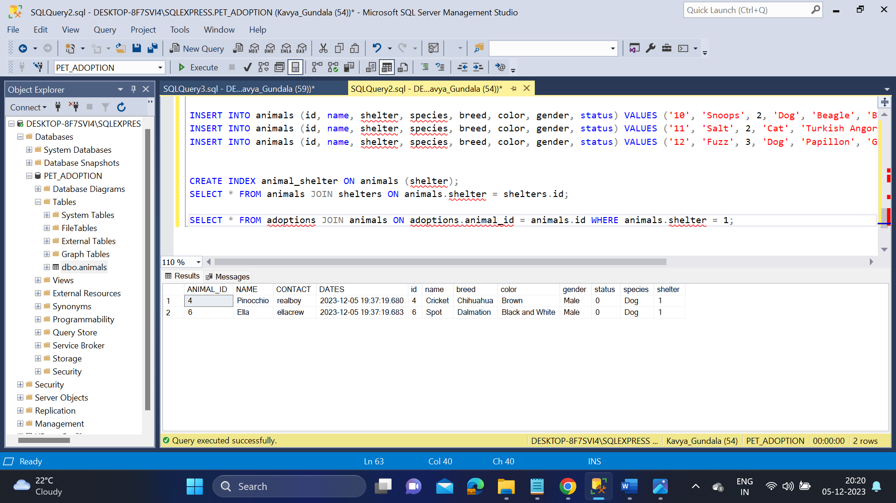

* Creating a table employee and insert values
* Now use logical operators to the table

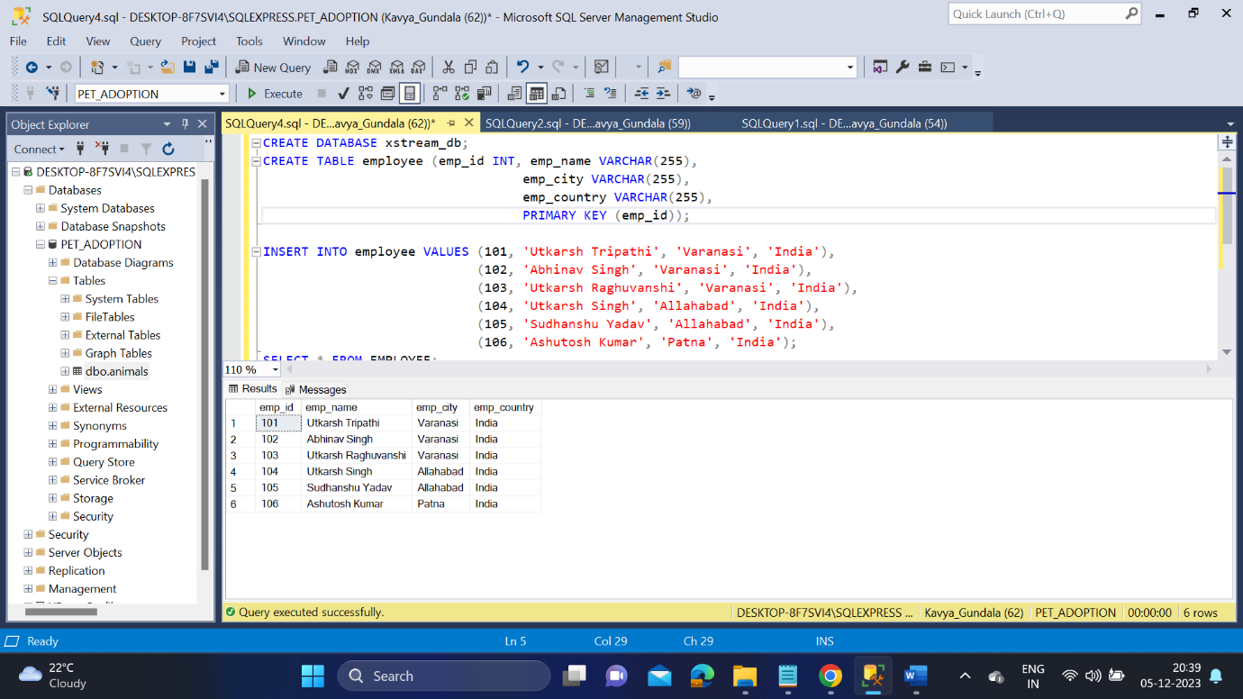

* AND operator

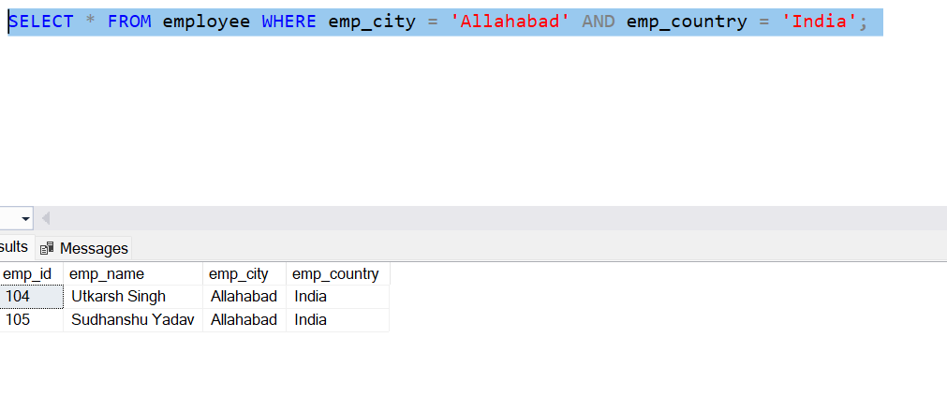

* IN operator

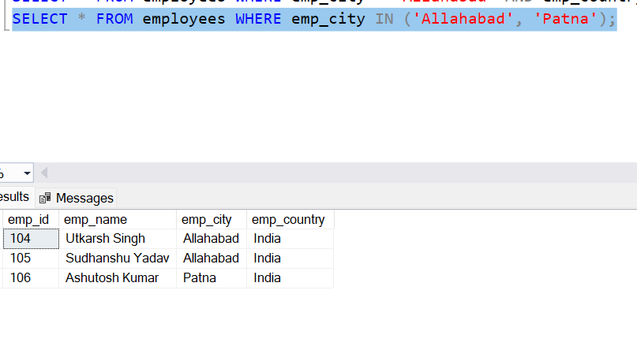

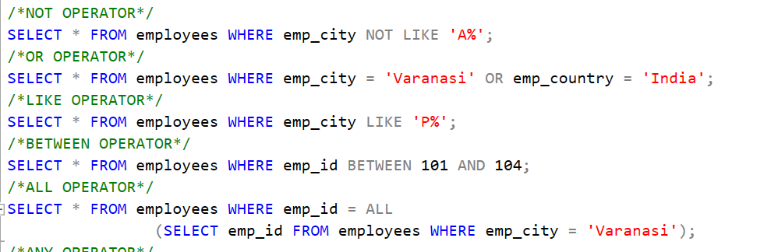

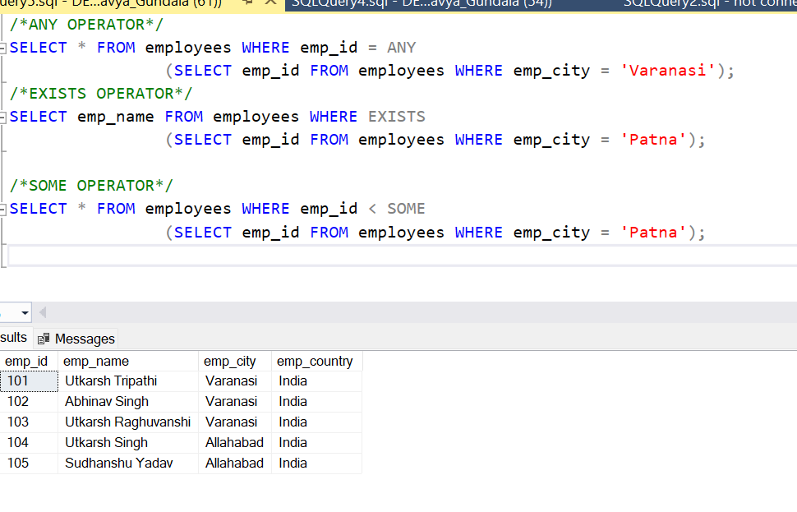

* DISTINCT operation

