Kavya Gundala

02-01-2024

Visualizations in Azure DataBricks:

* Create a ADB resource workspace and launch it.
* It opens the Azure Databricks portal.
* Now go to Compute -> Create a cluster.

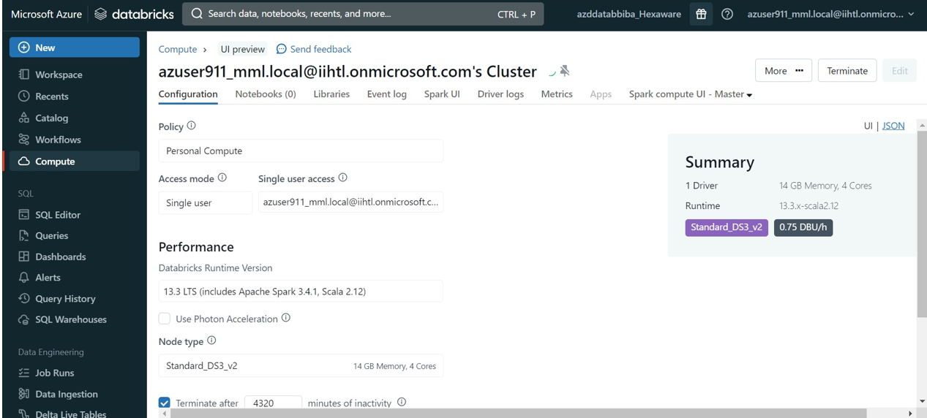

* After creation of cluster, Go to New -> Create Notebook
* Visualization of csv file in Notebook. Run the commands.

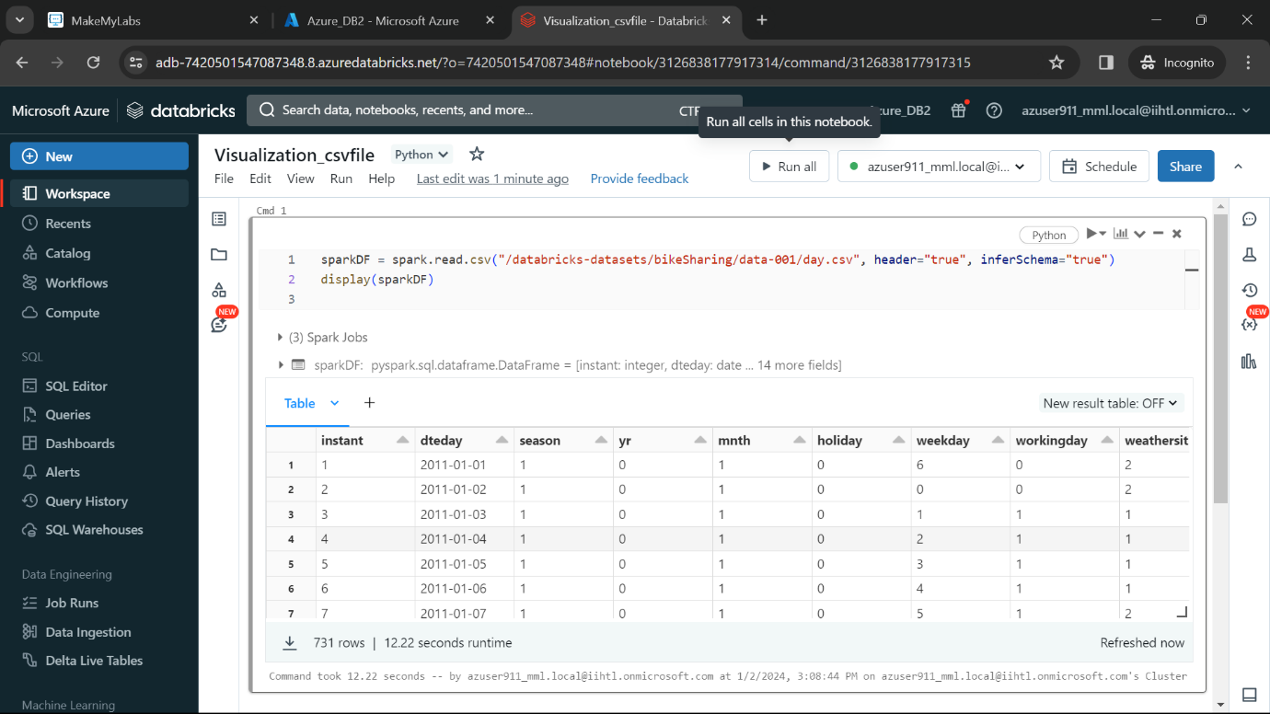

* To create Visualizations in notebook, click on ‘+’ . Click on Visualization.
* Select scatter as Visualization Type,
* Select ‘atemp’ as x column
* Select ‘Casual’ as y column
* Select ‘working day’ as groupBy

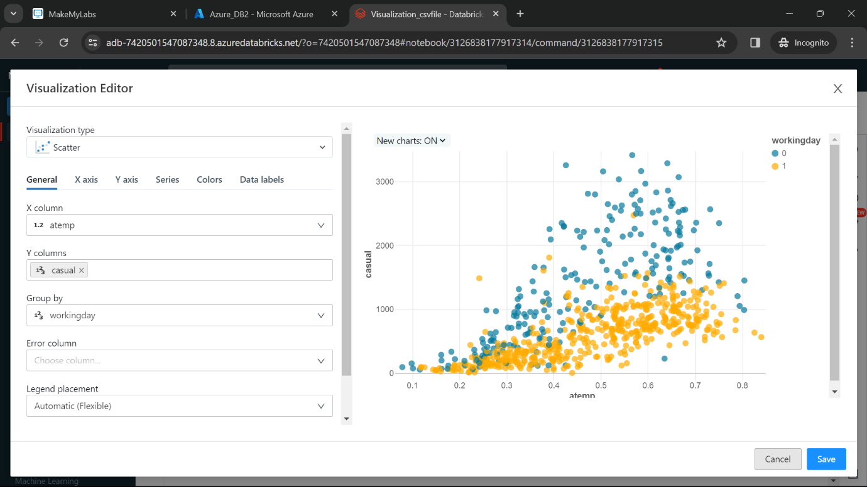

* Now click on Save.
* We can able to see the Visualization in Notebook.

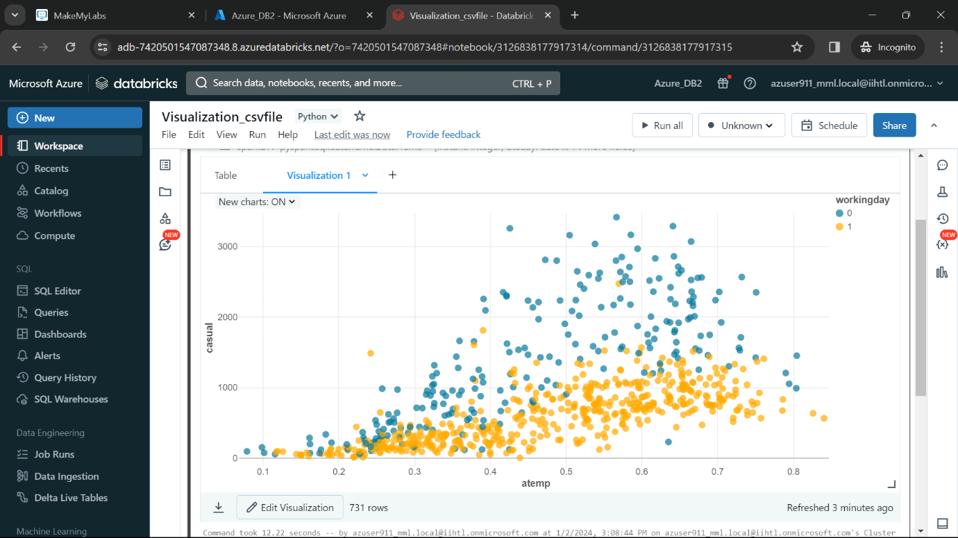

* Now to add Data Profile to our notebook, click on ‘+’ it will show:

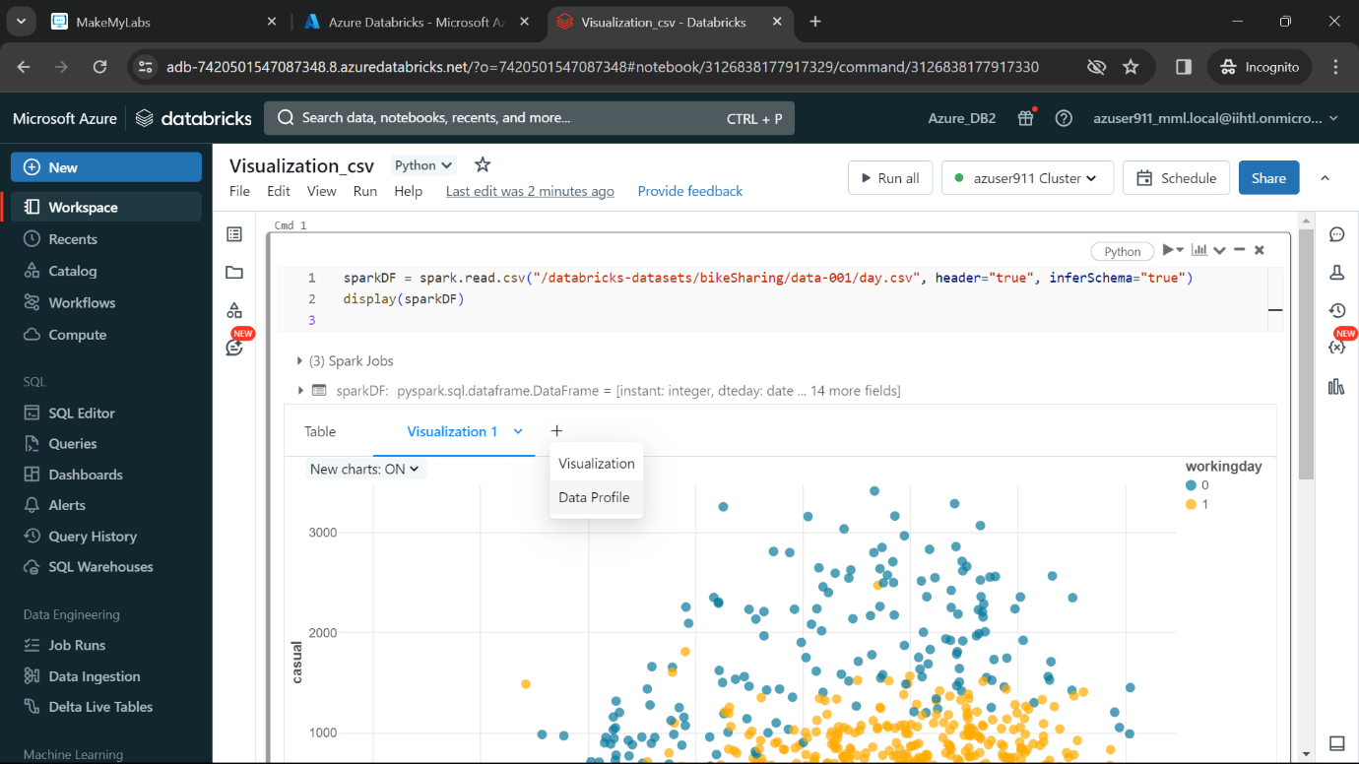

* Click on Data Profile.

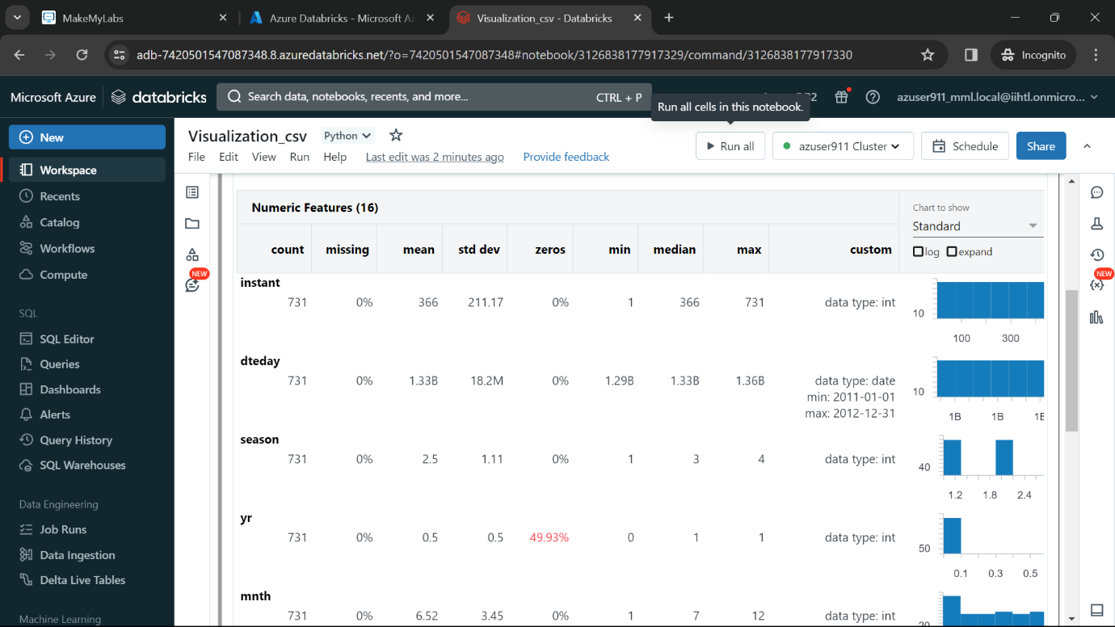

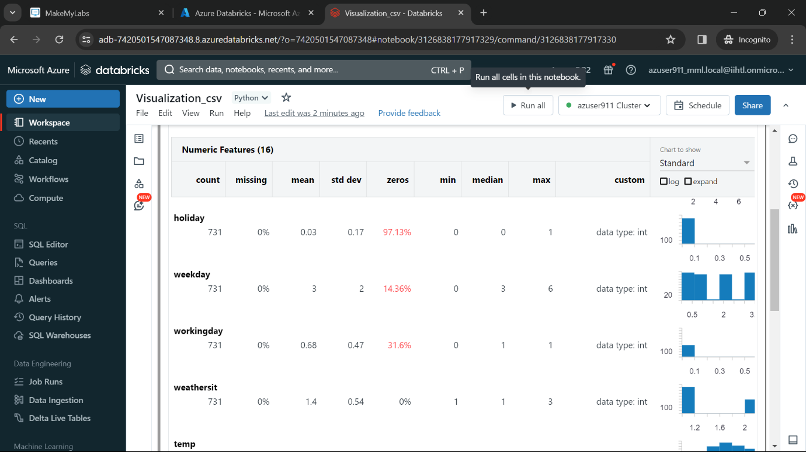

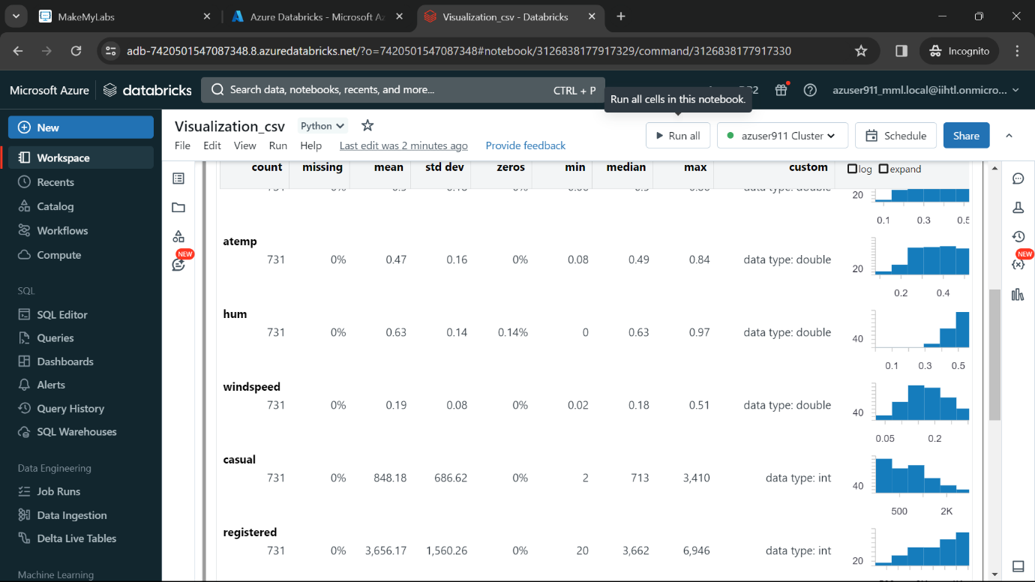

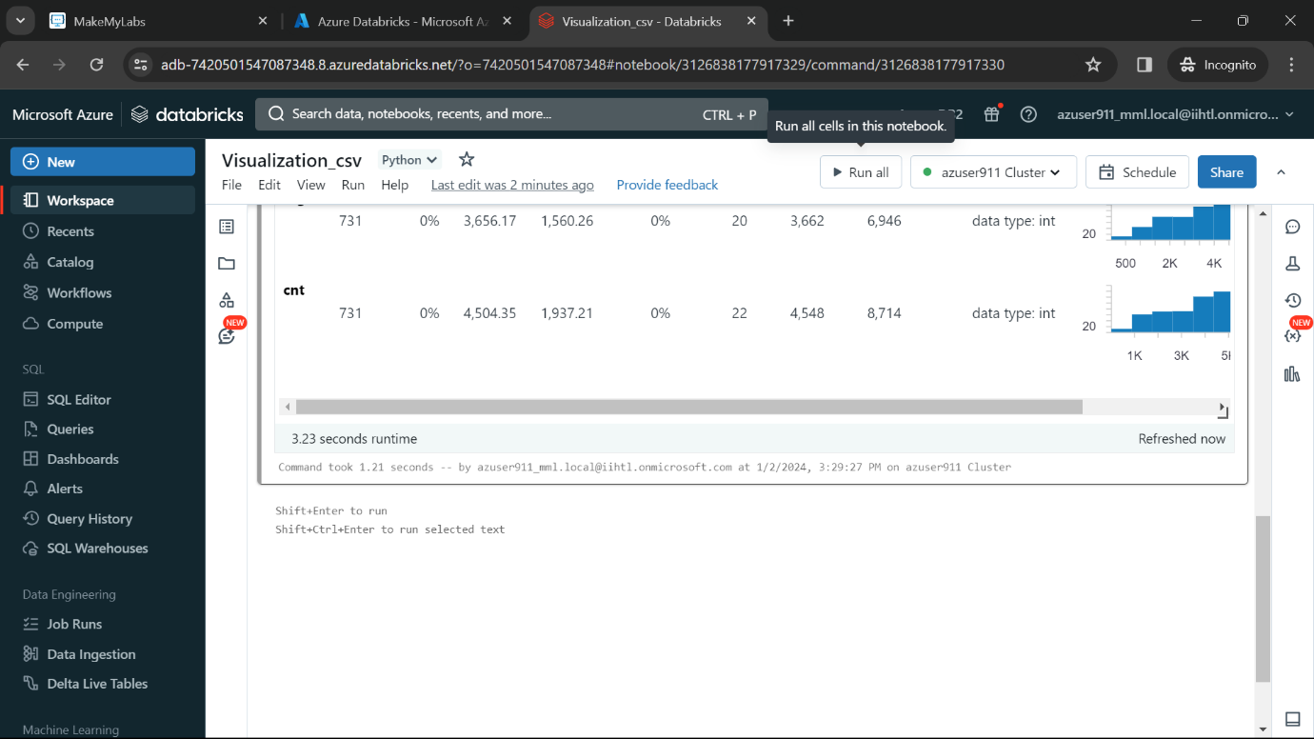

* To download the Visualization, click on Download option.

