Kavya Gundala

08-01-2024

**DevOps:**

* DevOps is a set of practices, tools, and a cultural philosophy that automate and integrate the processes between software development and IT teams continuously.
* A DevOps team includes developers and IT operations working collaboratively throughout the product lifecycle, in order to increase the speed and quality of software deployment.

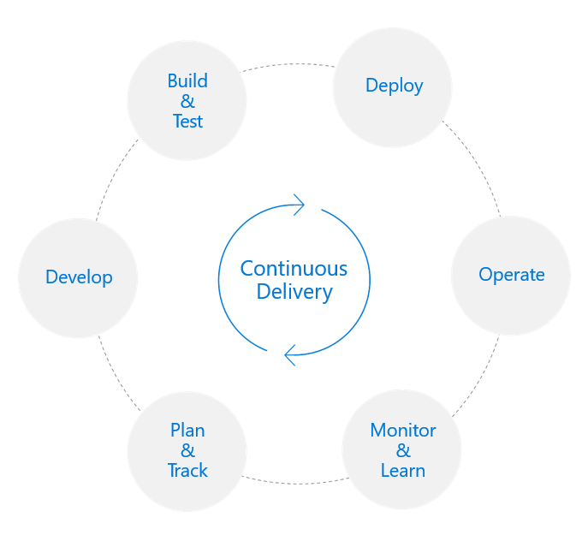

High Performance DevOps achieve:

* 46x Deployment Frequency
* Faster time to market
* 7x lower failure rate
* 2,555x Faster Lead Time for Changes
* Increased Revenue
* 2,604x Faster Mean Time to Recover

**Microsoft Azure DevOps:**

* Microsoft Azure is a powerful and flexible foundation for past, present, and future apps – easily build, manage, and deploy any application and any stack on a massive, global network using your favourite tools and frameworks.
* DevOps brings together people, processes, and technology, automating software delivery to provide continuous value to your users. Using Azure DevOps, you can deliver software faster and more reliably - no matter how big our IT department or what tools we’re using.

**Features of DevOps:**

* **Flexible** - A MS Azure user can choose among IaaS, PaaS, public cloud or hybrid.

Mirror or modernize app infrastructure with (Virtual Machines)VMs, containers, microservices or serverless. Supports all stages of the app modernization journey – from lift-and- shift to Cloud-Native.

* **Powerful** - Instantly improve the performance, scalability and resiliency of your apps by moving them to the cloud. Increase business agility with Cloud- Native capabilities and built-in DevOps for continuous innovation.
* **Open** - Azure bring a cloud that runs any app, on any platform, and any language. Build applications using the language and tools of your choice - Azure supports what we already use and love so you can get up and running fast – just bring code.

**DevOps Process:**

* **Continuous Integration(CI) -** When we use Azure Pipelines or Jenkins to build apps in the cloud and deploy to Azure, each time we commit code, it’s automatically built and tested and bugs are detected faster. It improves software development quality and speed.
* **Continuous Deployment(CD) -** By combining continuous integration and infrastructure as code (IaC), we’ll achieve identical deployments and the confidence to deploy to production at any time. With continuous deployment, you can automate the entire process from code commit to production if your CI/CD tests are successful.
* **Continuous Learning & Monitoring -** With Azure Application Insights we can identify how our applications are performing and test if the recent deployment made things better or worse. Using CI/CD practices, paired with monitoring tools, we’ll be able to safely deliver features to our customers as soon as they’re ready.

**Azure DevOps Components:**

There are five Azure components:

* Boards
* Repos
* Pipelines
* Test plans
* Artifacts

**Azure Boards:** It helps software developers track and monitor their work essentials such as stories, issues, threats, bugs, and other vulnerabilities.

* Azure boards also find a quick fix for all the problems associated with work items and essentials. It helps various teams and departments work on a single project or task by enhancing communication skills. Therefore, it is an excellent medium for tracking project performance as it progresses.
  + Connected from idea to release
  + Scrum ready
  + Project insights

**Azure Repos:** Azure Repos comprises different version control systems. These control systems make code management possible and convenient.

* These version controls enable developers to manage security and other relevant app development services single-handedly.
* It also monitors the app development process and tracks down bug fixes. This feature then presents you with the suggested changes it makes to the review process.
* There are two types of versions of controls:
  + GIT or Scattered Control Version
  + TFVC(Team Foundation Version Control) or Central Version Control

**Azure CI/CD Pipelines:** It is a CI/CD tool that supports automated building, testing, and deployment. Azure pipelines are flexible enough to work with diverse languages and projects.

* Moreover, these pipelines test and deploy your code through a combination of CI and CD for any number of targets.
* There are generally two approaches for using the Azure pipelines:
  + Approach 1 involves defining the pipelines with YAML syntax
  + Approach 2 involves defining through a classic interface

**Azure Test Plans:** DevOps provides these special services for commercial use and users only. Azure DevOps tools are rich, flexible, robust, and essential for the development team. Not only does it help to maintain the coding standard and quality, but it also enables collaboration throughout the app development phase. Additionally, it works and supports the following functions:

* Manually testing
* Automated testing
* Traceability function
* Reporting and analyzing

**Azure Artifacts:** Azure Artifacts is the last component of Azure DevOps services. It includes a library service that has shareability features. Therefore, developers can share and use packages from available feeds and public registries. Azure artifacts are pre-installed services on a system.

* These could either be on the cloud or on-premises Azure DevOps. Moreover, users pay as they consume the benefits, but the best thing is it offers free service for 2GB of storage. It also handles different package types: npm, Maven, Python, and universal packages.

**Benefits of Azure DevOps:**

1. **Planning:** with the help of Azure DevOps, DevOps teams can better plan and manage their work. It also offers them complete visibility across all spectrums for ongoing products and projects. Azure DevOps helps developers to have transparent and on-schedule working without delays and downtime. Also, it allows them to plan, define, monitor, and layout work protocols for custom dashboards, Kanban boards, etc.

2.**Developing:** enables developers to improve synchronization by sharing code manuals and collaborating on different codes. Moreover, with the help of Azure, DevOps users have the freedom to create automatic workflows. Also, these workflows help with automated testing and integration in the cloud through Azure pipelines.

3. **Delivery:** Azure DevOps services offer complete control to the developers to deploy applications to any Azure platform automatically. Therefore, with full control, users can define or spin up different cloud infrastructures with the Azure resource manager. Thus, the entire process forms a continuous delivery pipeline into these platforms with various tools and components.

4. **Operations:** Azure Monitoring Services also allow users to implement full stack tracking and monitoring on the major operations. Meanwhile, users get actionable insights and alerts from different logs and telemetry through monitoring services.