**Name: Kavya Gundala**

* **GROUP BY, HAVING, ORDER BY CLAUSE**

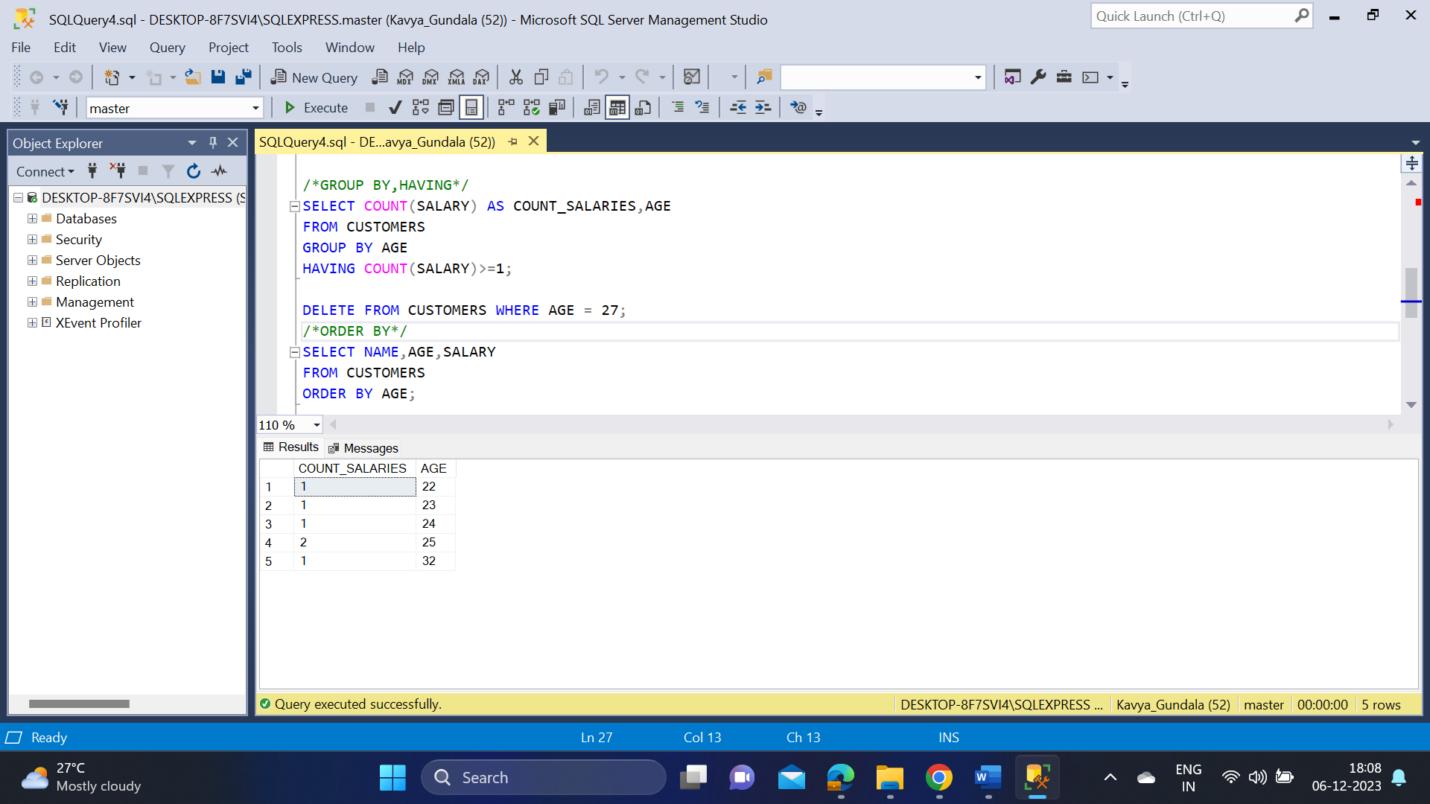

* **TCL COMMANDS- COMMIT, ROLLBACK, SAVE TRANSACTION**

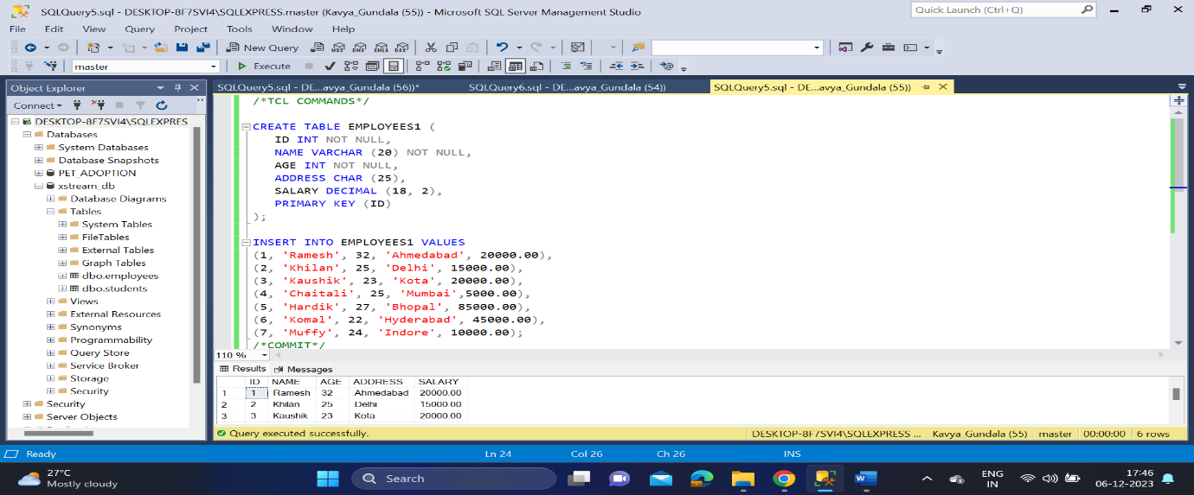

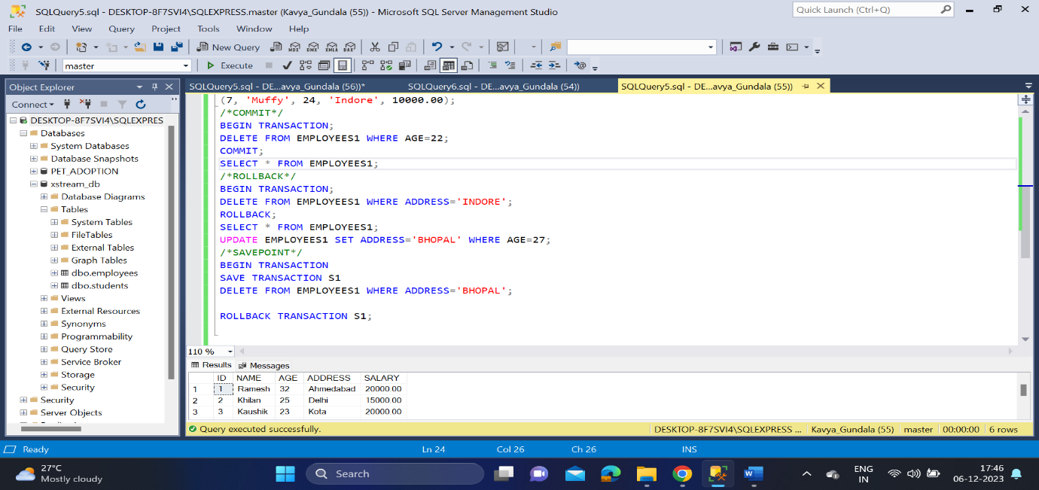

* **SET OPERATORS-UNION, UNION ALL, INTERSECT**

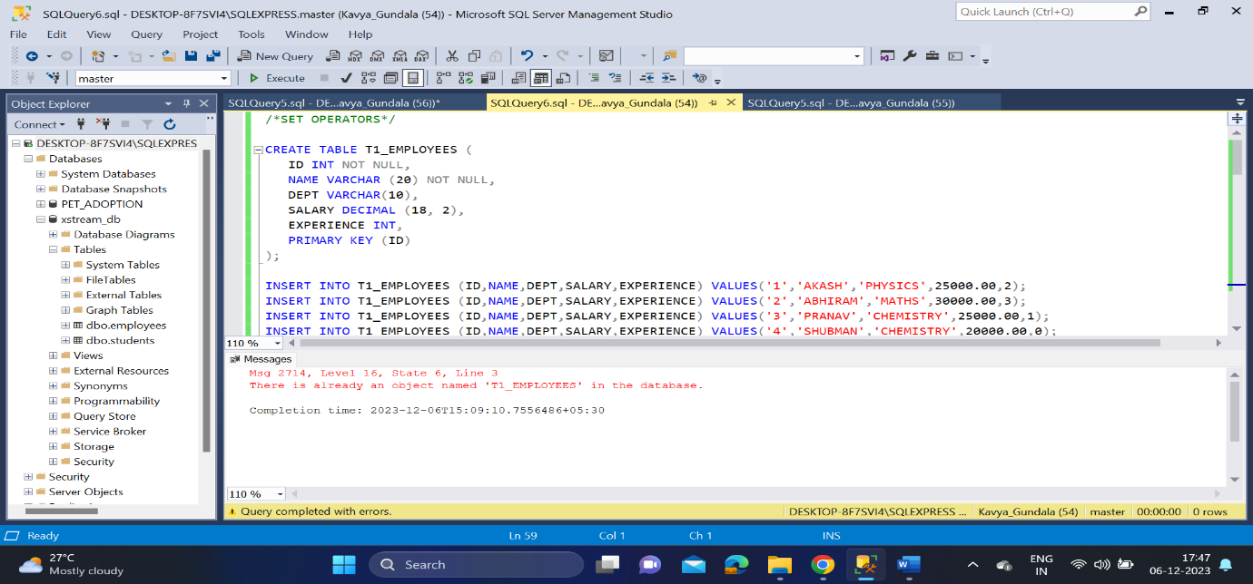

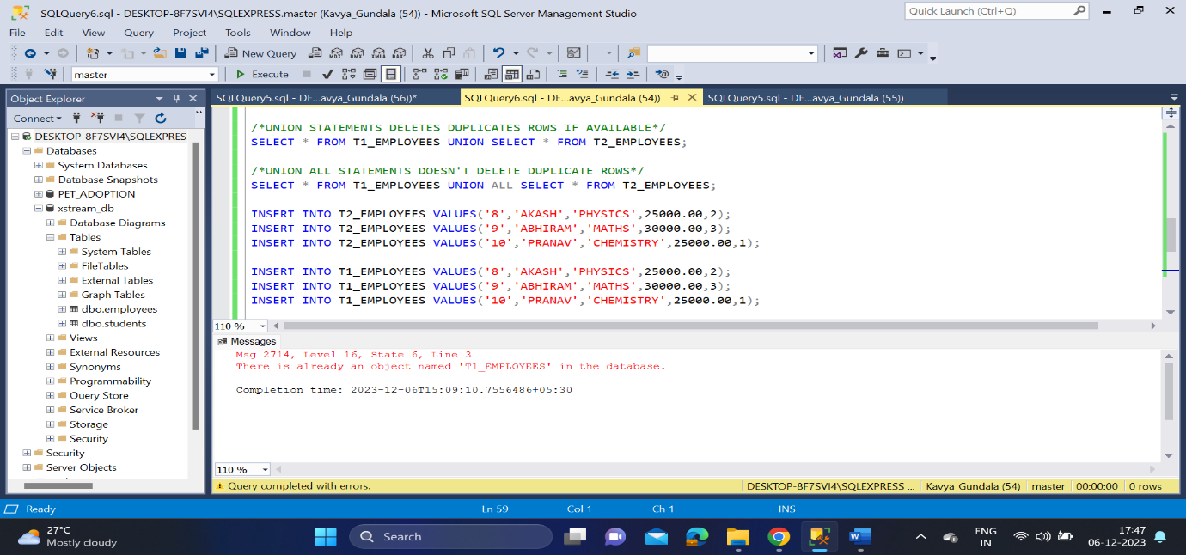

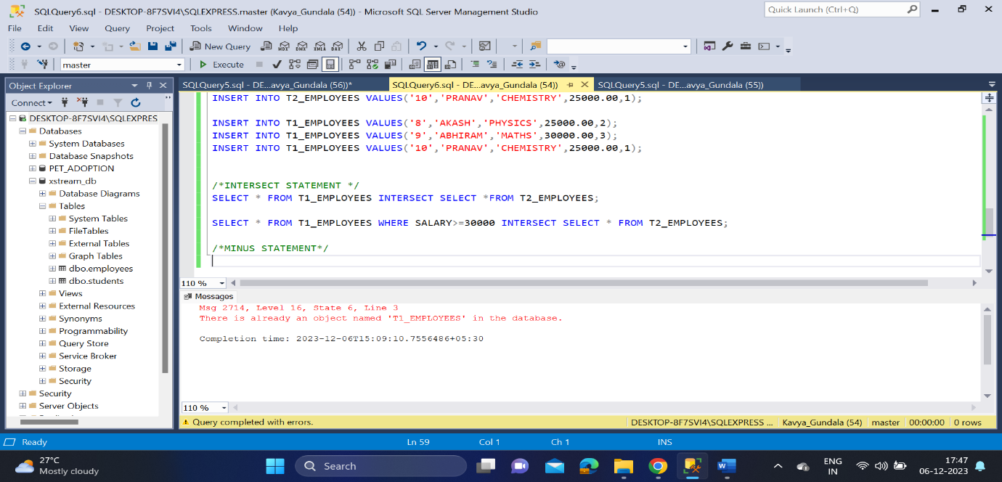

* **AGGREGATE FUNCTIONS-COUNT(),AVG(),DISTINCT(),MAX(),MIN()**

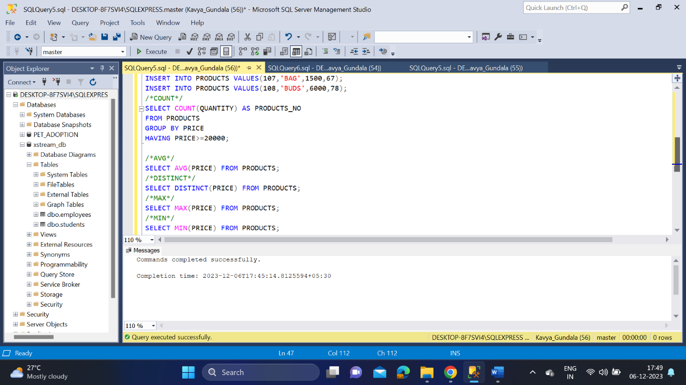

* **KEY COSTRAINTS-PRIMARY KEY,NOT NULL, UNIQUE, FOREIGN KEY, CHECK, DEFAULT**

