**NAME: KAVYA GUNDALA**

**DATE: 08-12-2023**

* **JOINS- EQUI JOIN, NON-EQUI JOIN, SUB QUERY**

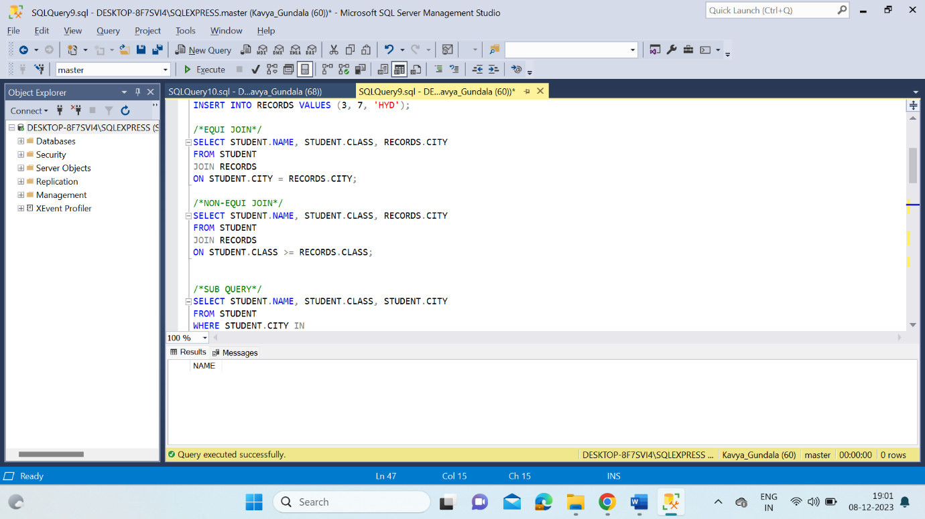

* **EXISTS, NON-EXISTS**

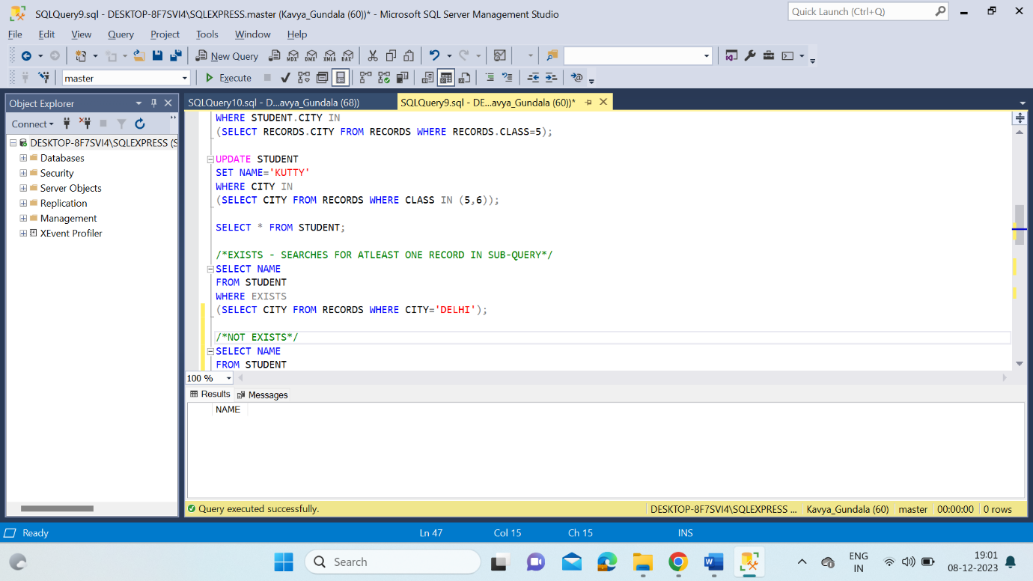

* **ANY, ALL, SOME**

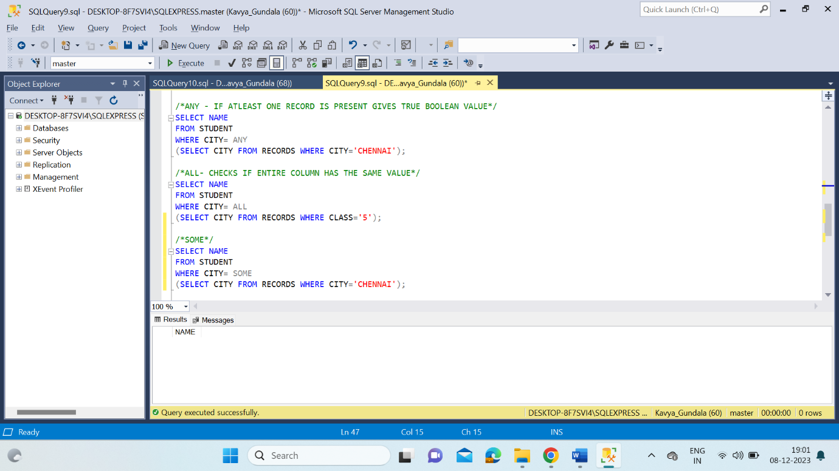

* **IN, NOT IN**

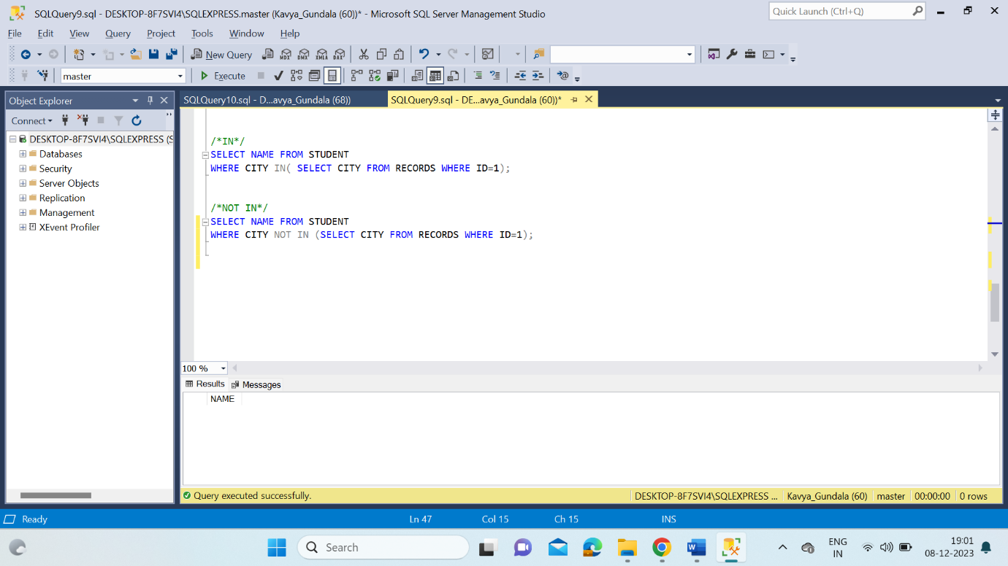

* **UNION, UNION ALL, INTERSECT, EXCEPT**

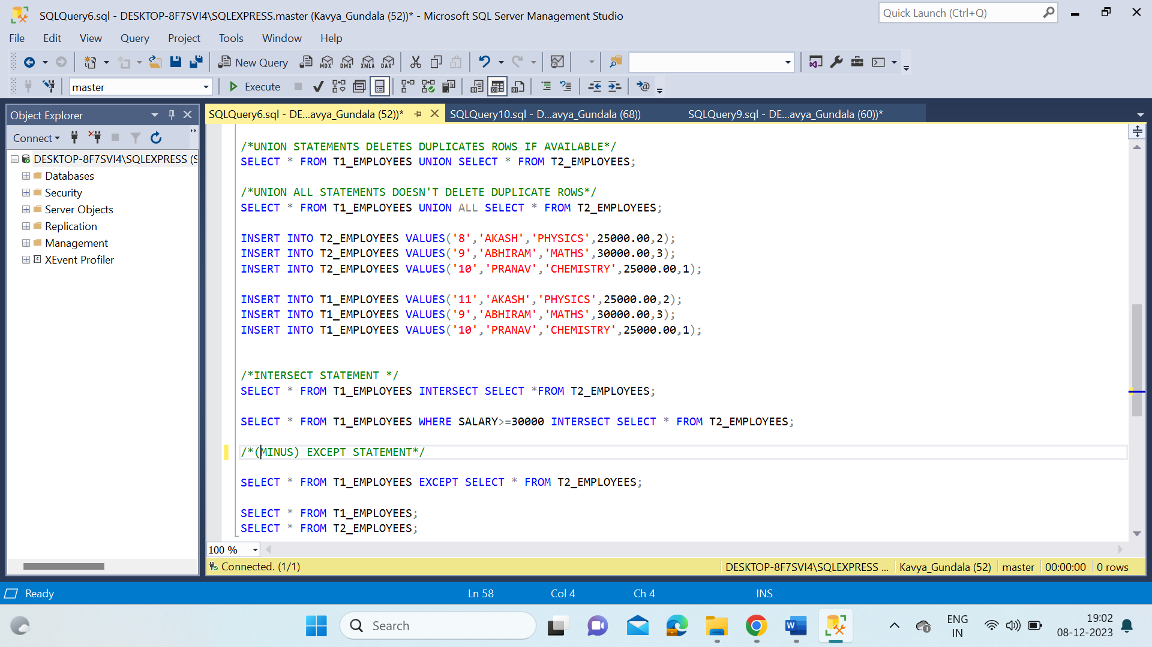

* **NESTED SUB_QUERY**

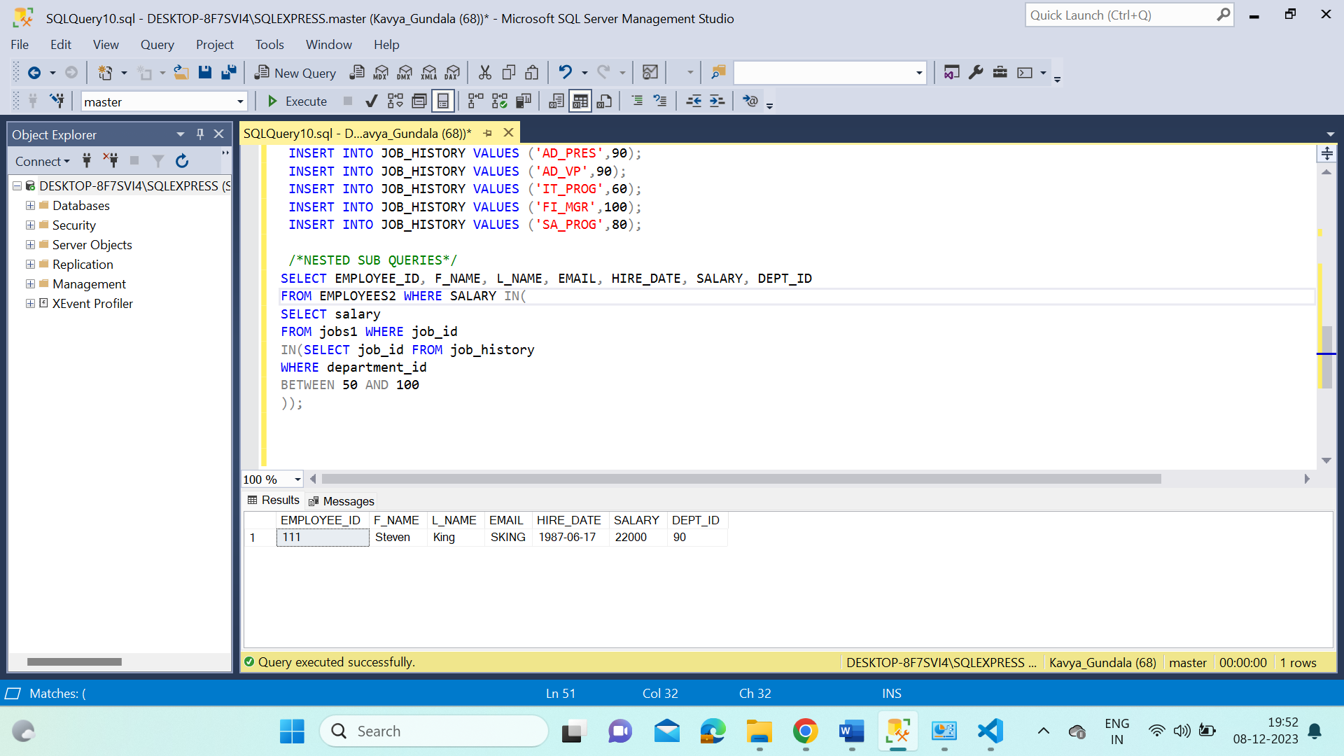

* **CORRELATED SUBQUERY**

