**NAME: KAVYA GUNDALA**

**DATE: 09-12-2023**

**Database:**

* A database is a place to store information. It can store the simplest data, such as a list of people as well as the most complex data.

**Database Schema:**

* **A database schema is a structure that represents the logical storage of the data in a database.**
* A database schema contains schema objects that may include **tables, fields, packages, views, relationships, primary key, foreign key.**
* A database schema object includes the following:
  + Consistent formatting for all data entries.
  + Database objects and unique keys for all data entries.
  + Tables with multiple columns, and each column contains its name and datatype.

**Types of Database Schema:**

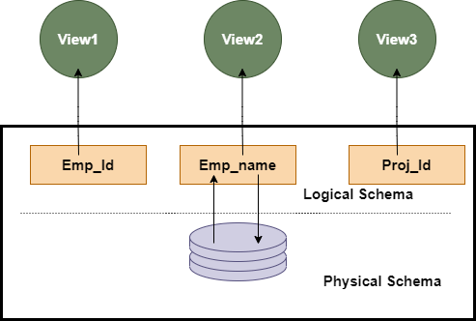

* **Physical Database Schema:** Designing a database at the physical level is called a physical schema. A physical database schema specifies how the data is stored physically on a storage system or disk storage in the form of Files and Indices.
* **Logical Database Schema:** The Logical database schema specifies all the logical constraints that need to be applied to the stored data. It defines the views, integrity constraints, and table. Here the term **integrity constraints** define the set of rules that are used by DBMS (Database Management System) to maintain the quality for insertion & update the data.
* The Logical database schema specifies all the logical constraints that need to be applied to the stored data. It defines the views, integrity constraints, and table. Here the term **integrity constraints** define the set of rules that are used by DBMS (Database Management System) to maintain the quality for insertion & update the data.
* **View Schema:** The view level design of a database is known as **view schema**. This schema generally describes the end-user interaction with the database systems.
* **SUB-TOTALS – ROLL UP, GROUPING, ROLL_NUMBER**

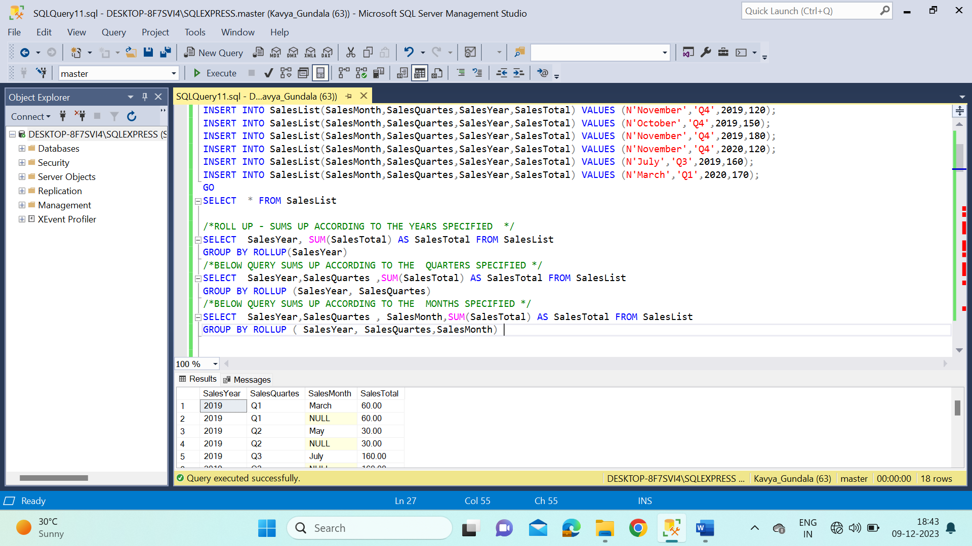

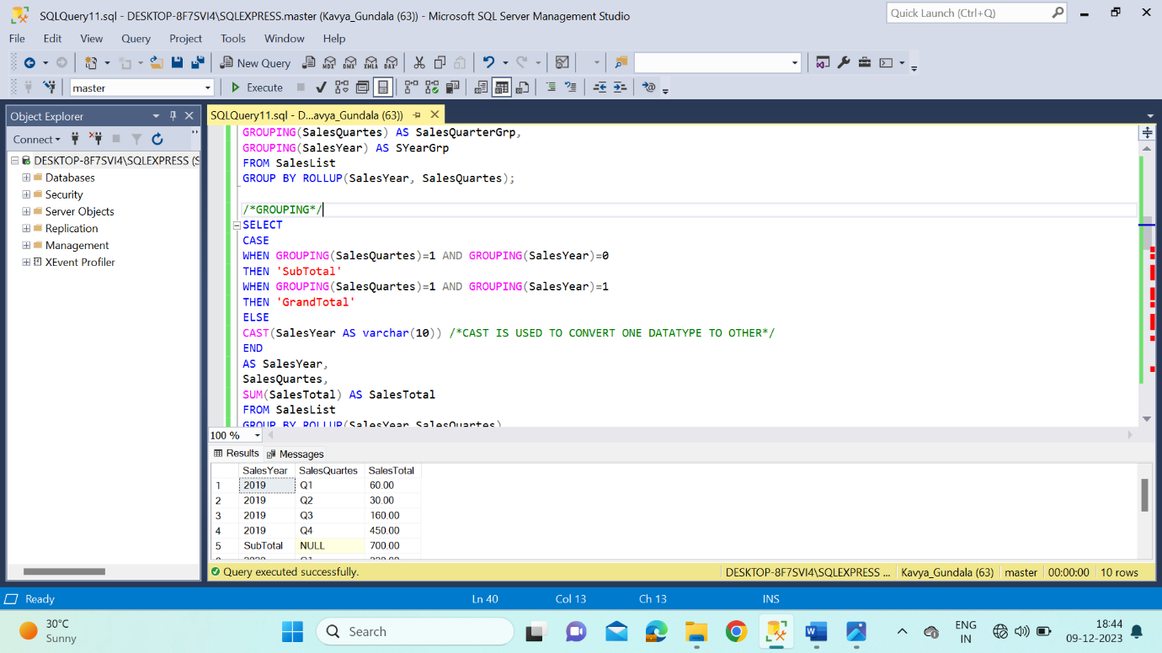

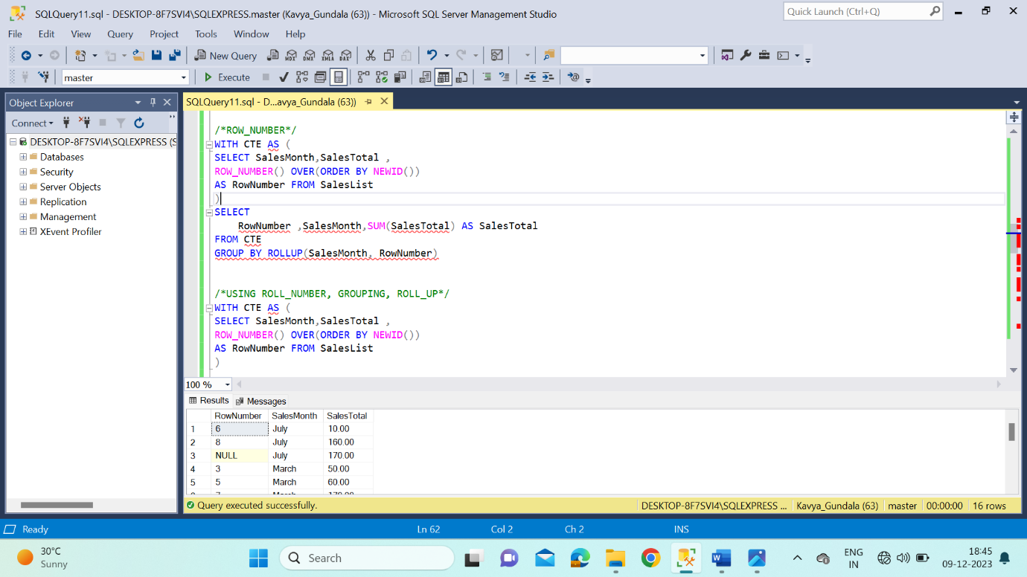

* **STORED PROCEDURES**

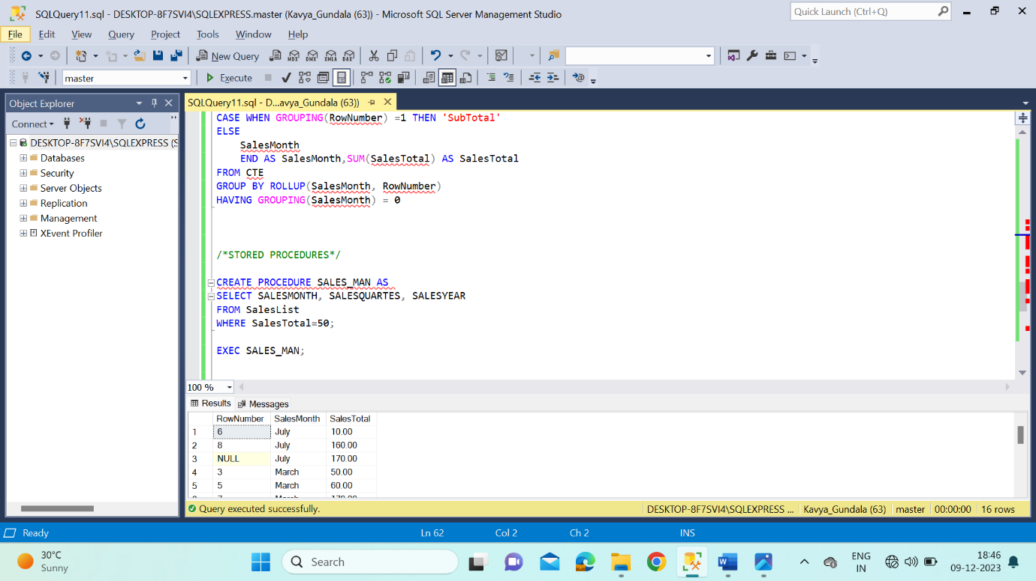

* **STORED PROCEDURES WITH MULTIPLE PARAMETERS**

