**NAME: KAVYA GUNDALA**

**DATE: 11-12-2023**

* **DATA CLEANSING STEPS: DELETING DUPLICATE ROWS**

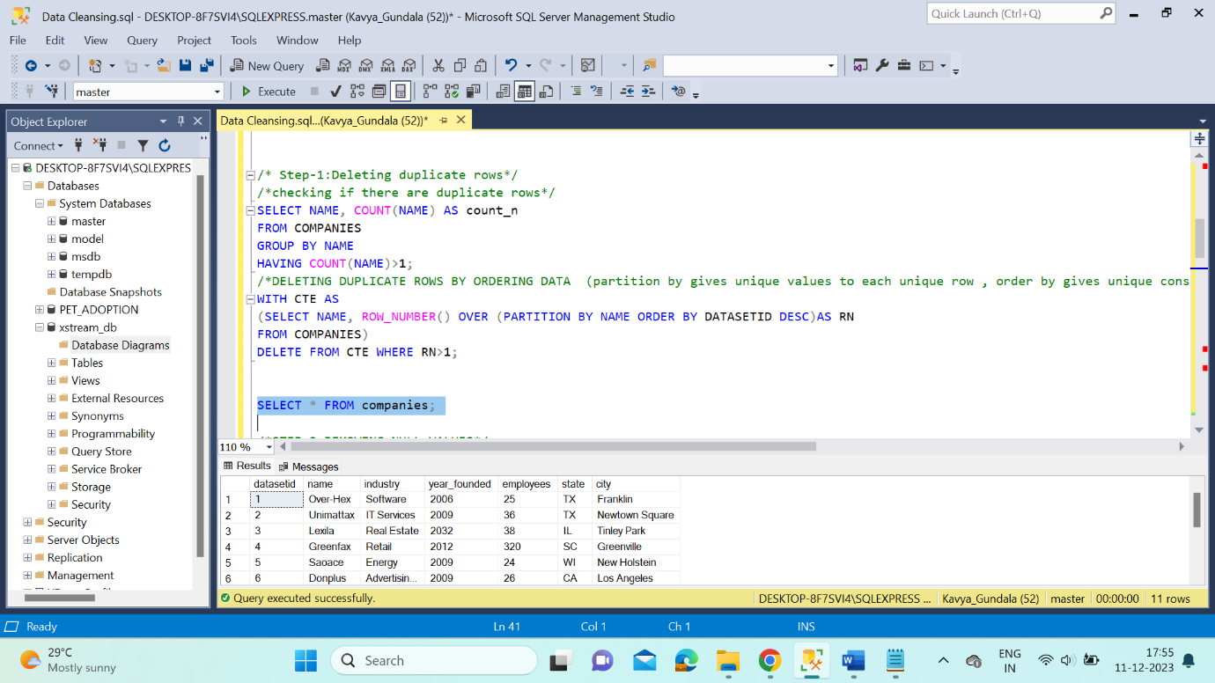

* **REMOVING NULL VALUES**

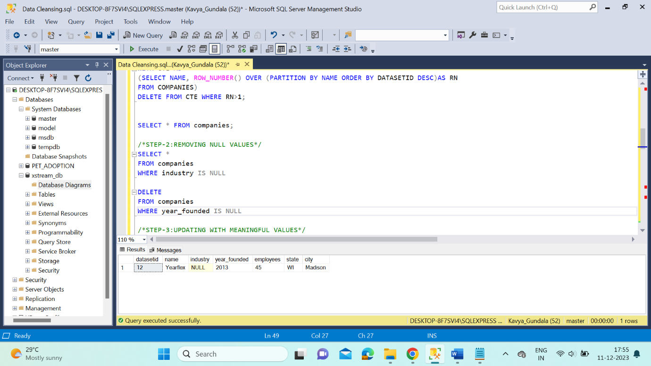

* **UPDATING WITH MEANINGFUL VALUES**

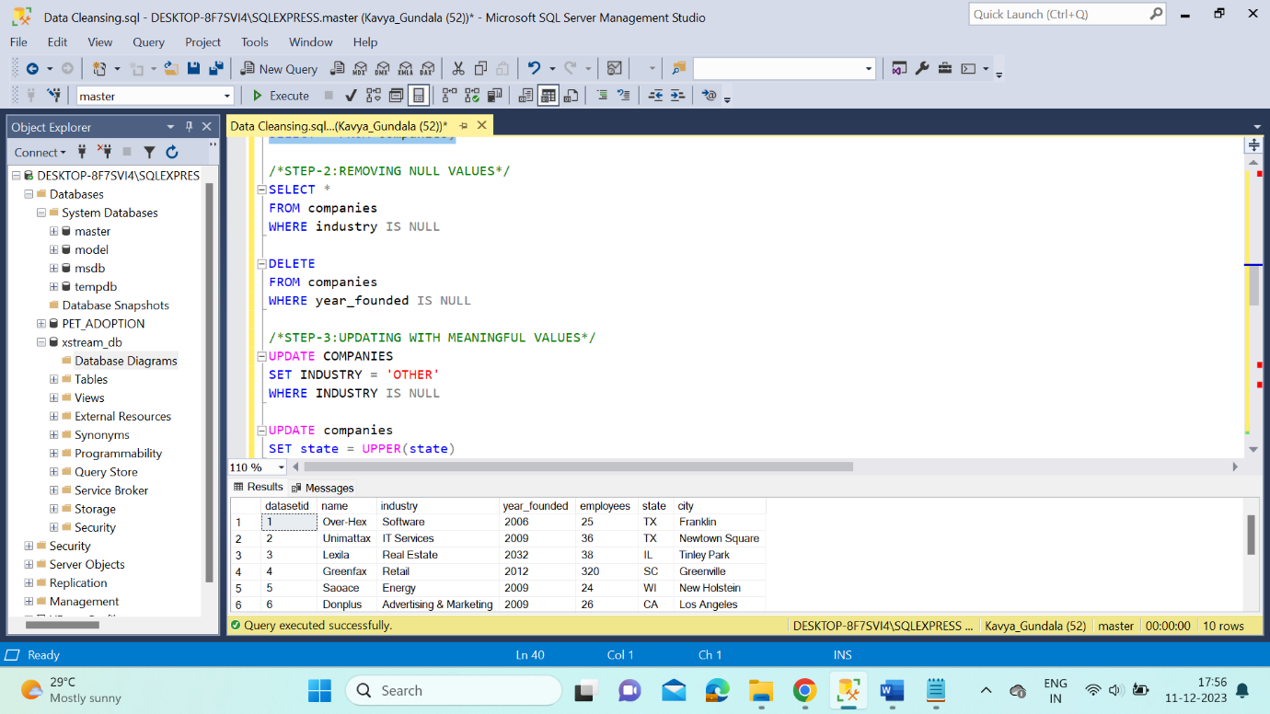

* **CORRECTING LOGICAL ERRORS**

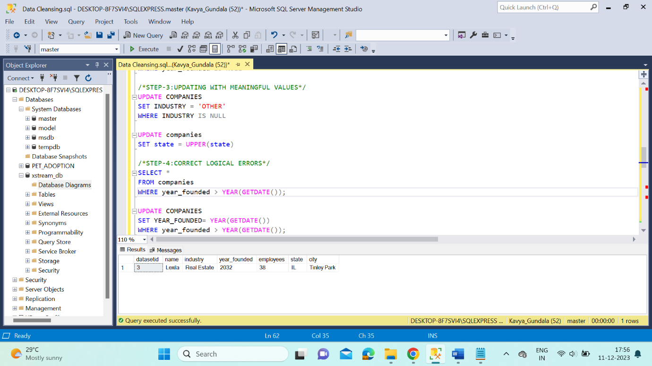

* **OVER, PARTITION BY CLAUSE**

