**NAME: KAVYA GUNDALA**

**DATE: 13-12-2023**

* **IF loops:**

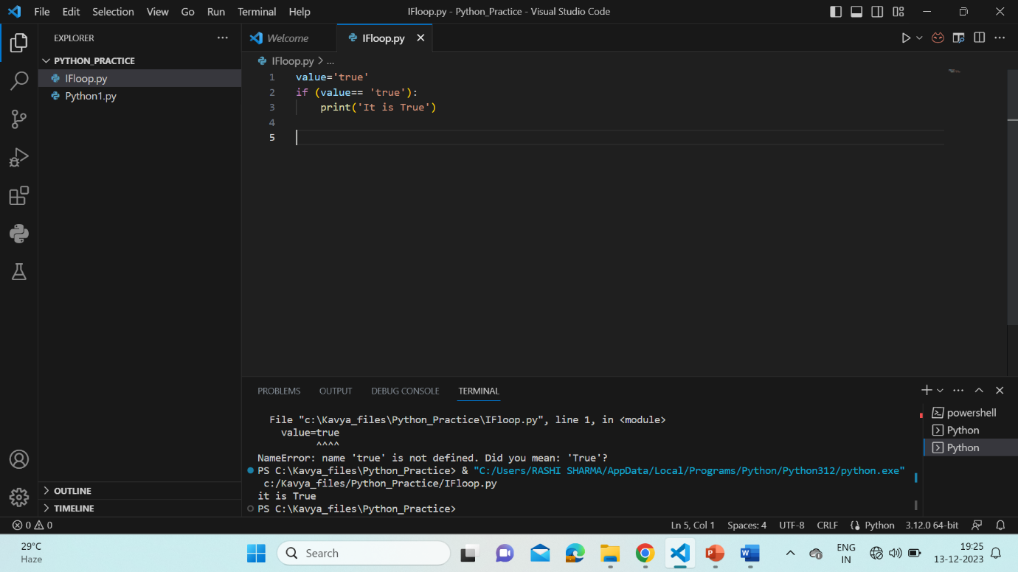

* **IF-ELSE loops:**

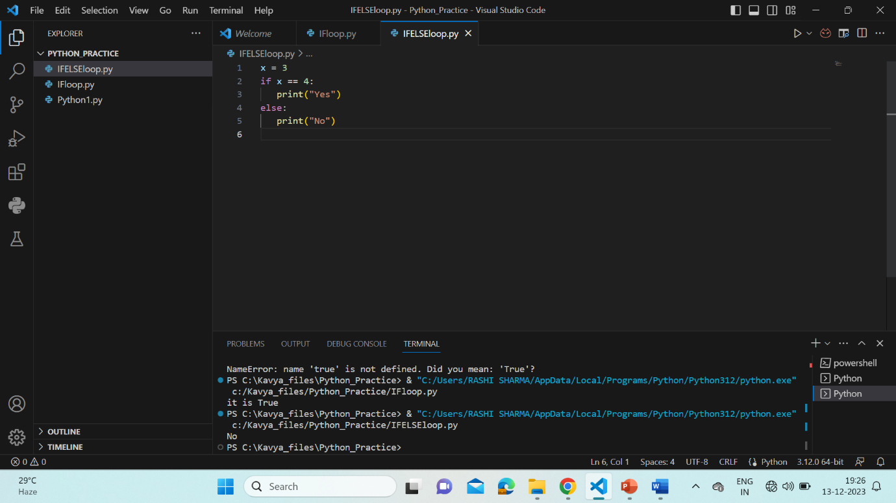

* **NESTED-IF loops:**

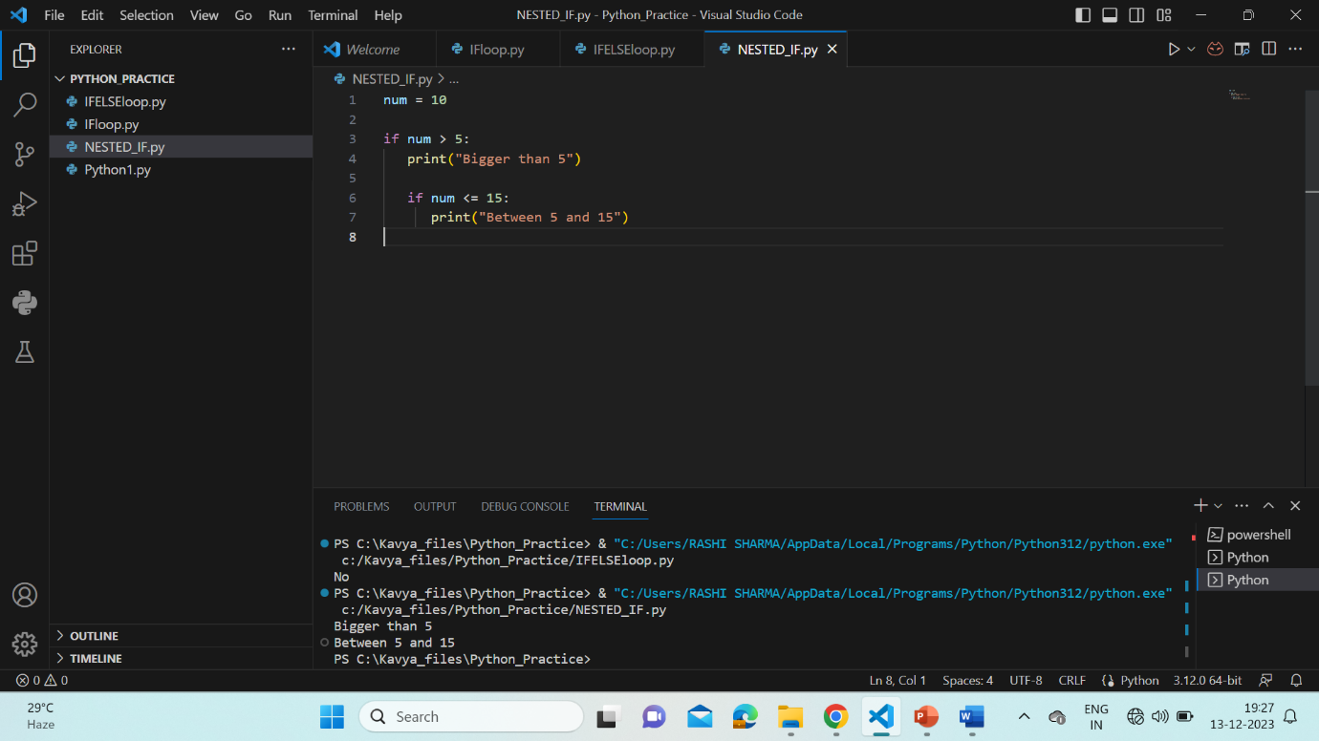

* **IF-ELIF loops:**

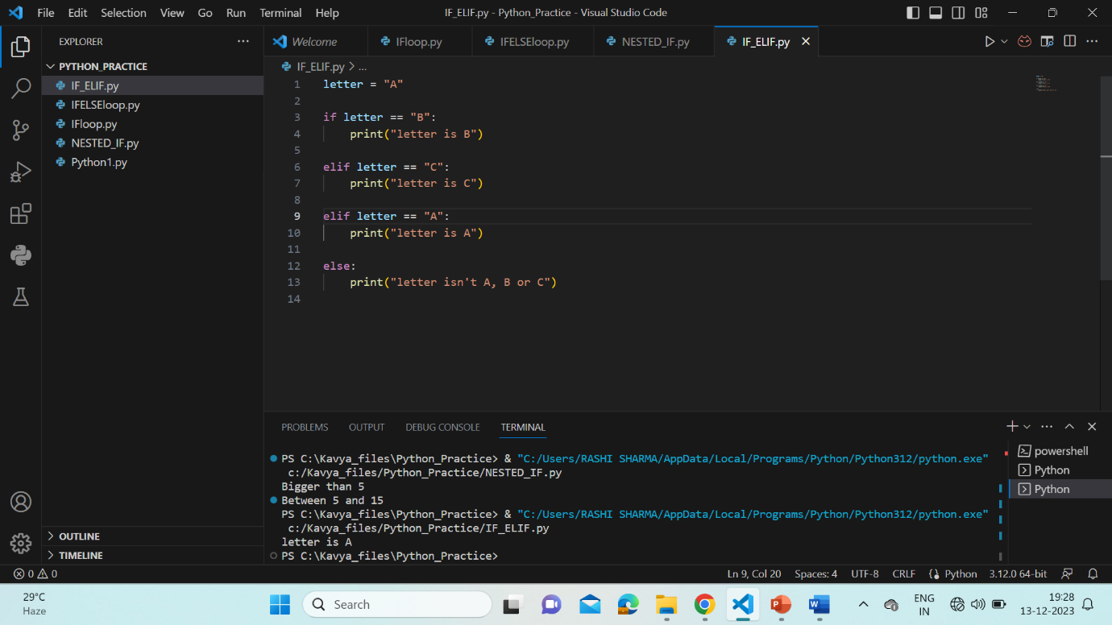

* **WHILE loops:**

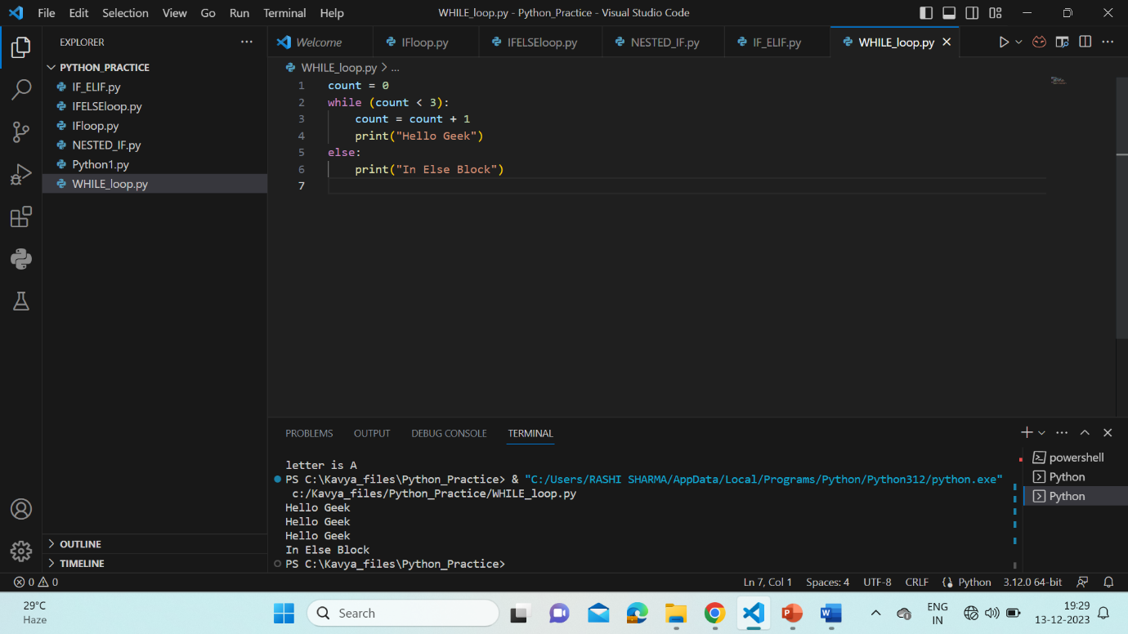

* **FOR loops with iterators:**

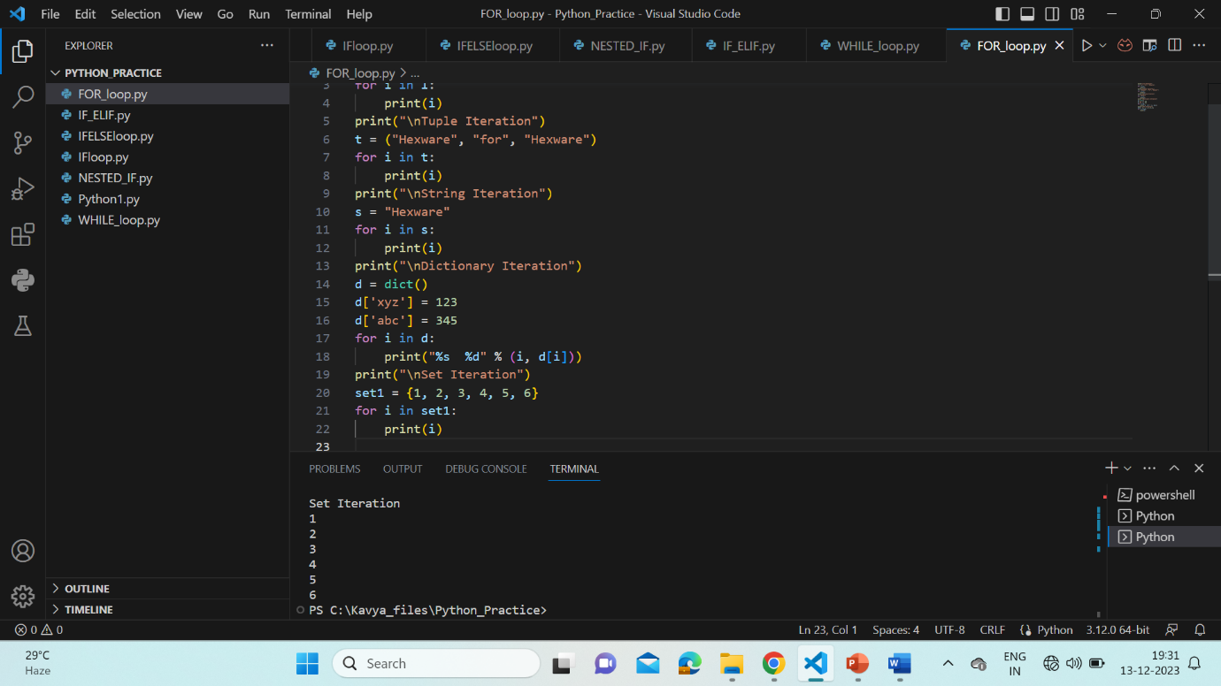

* **LOOP CONTROL statements: BREAK, CONTINUE, PASS**

