**Kavya Gundala**

**20-12-2023**

1. **Explain Python modules with examples**

* **Module: A Python module is a file containing Python definitions and statements. A module can define functions, classes, and variables.**
* **Some Pre-defined modules in python:**
* **a. renaming a pre defined module**

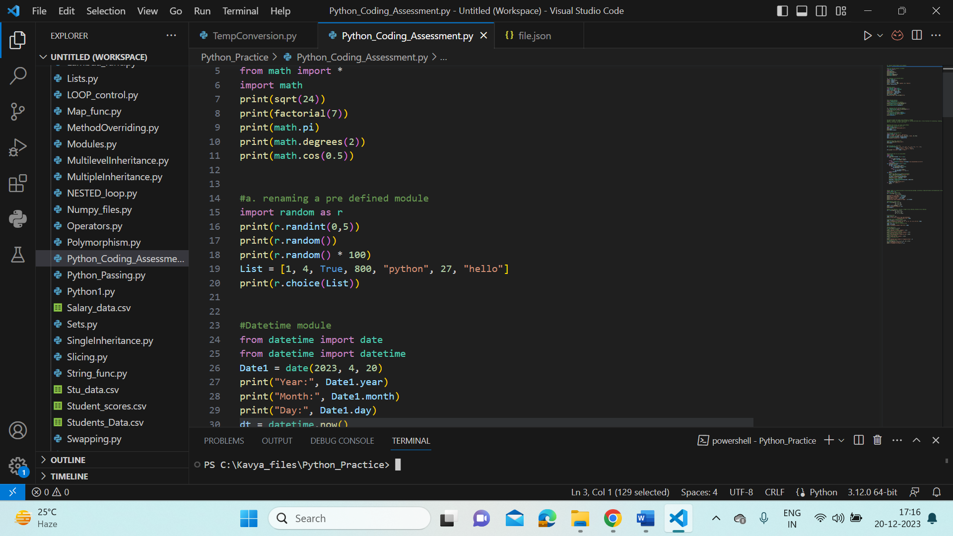

* **Output:**

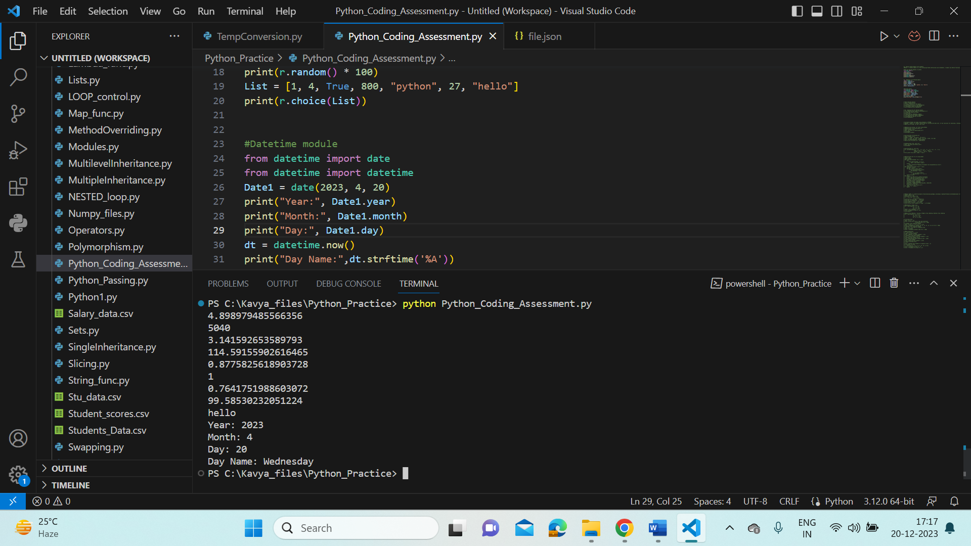

* **User-defined modules in Python:**
* **a. renaming a user- defined module:**

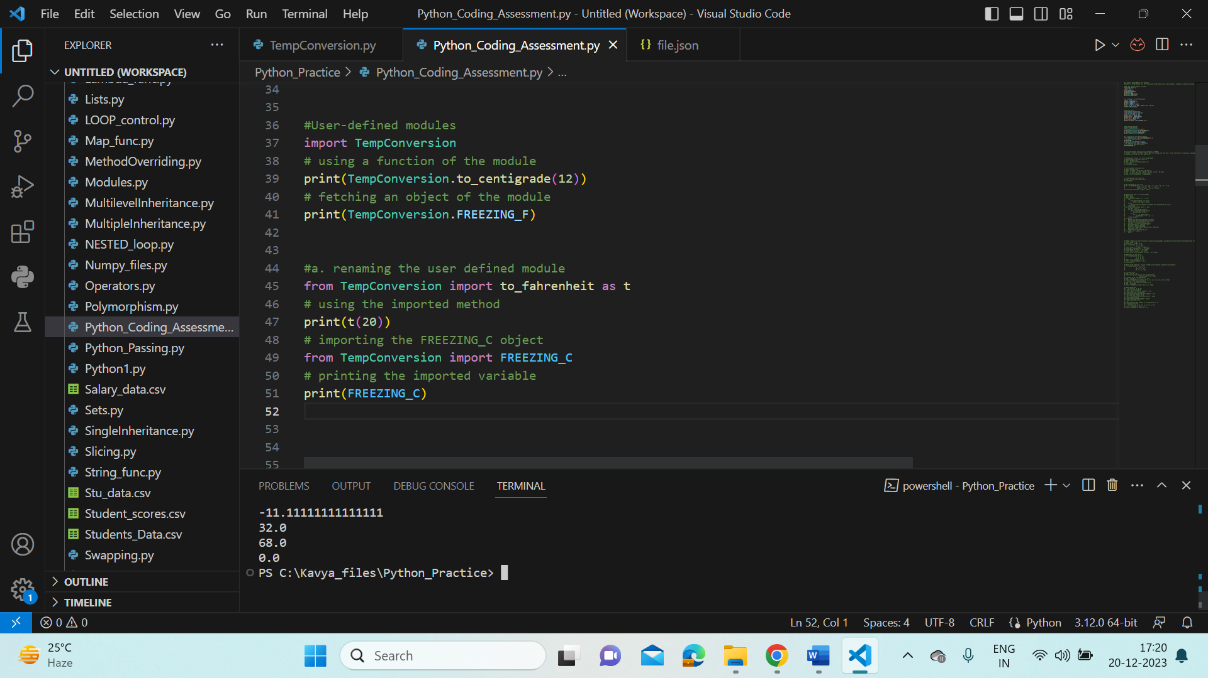

* **TempConversion.py module:**

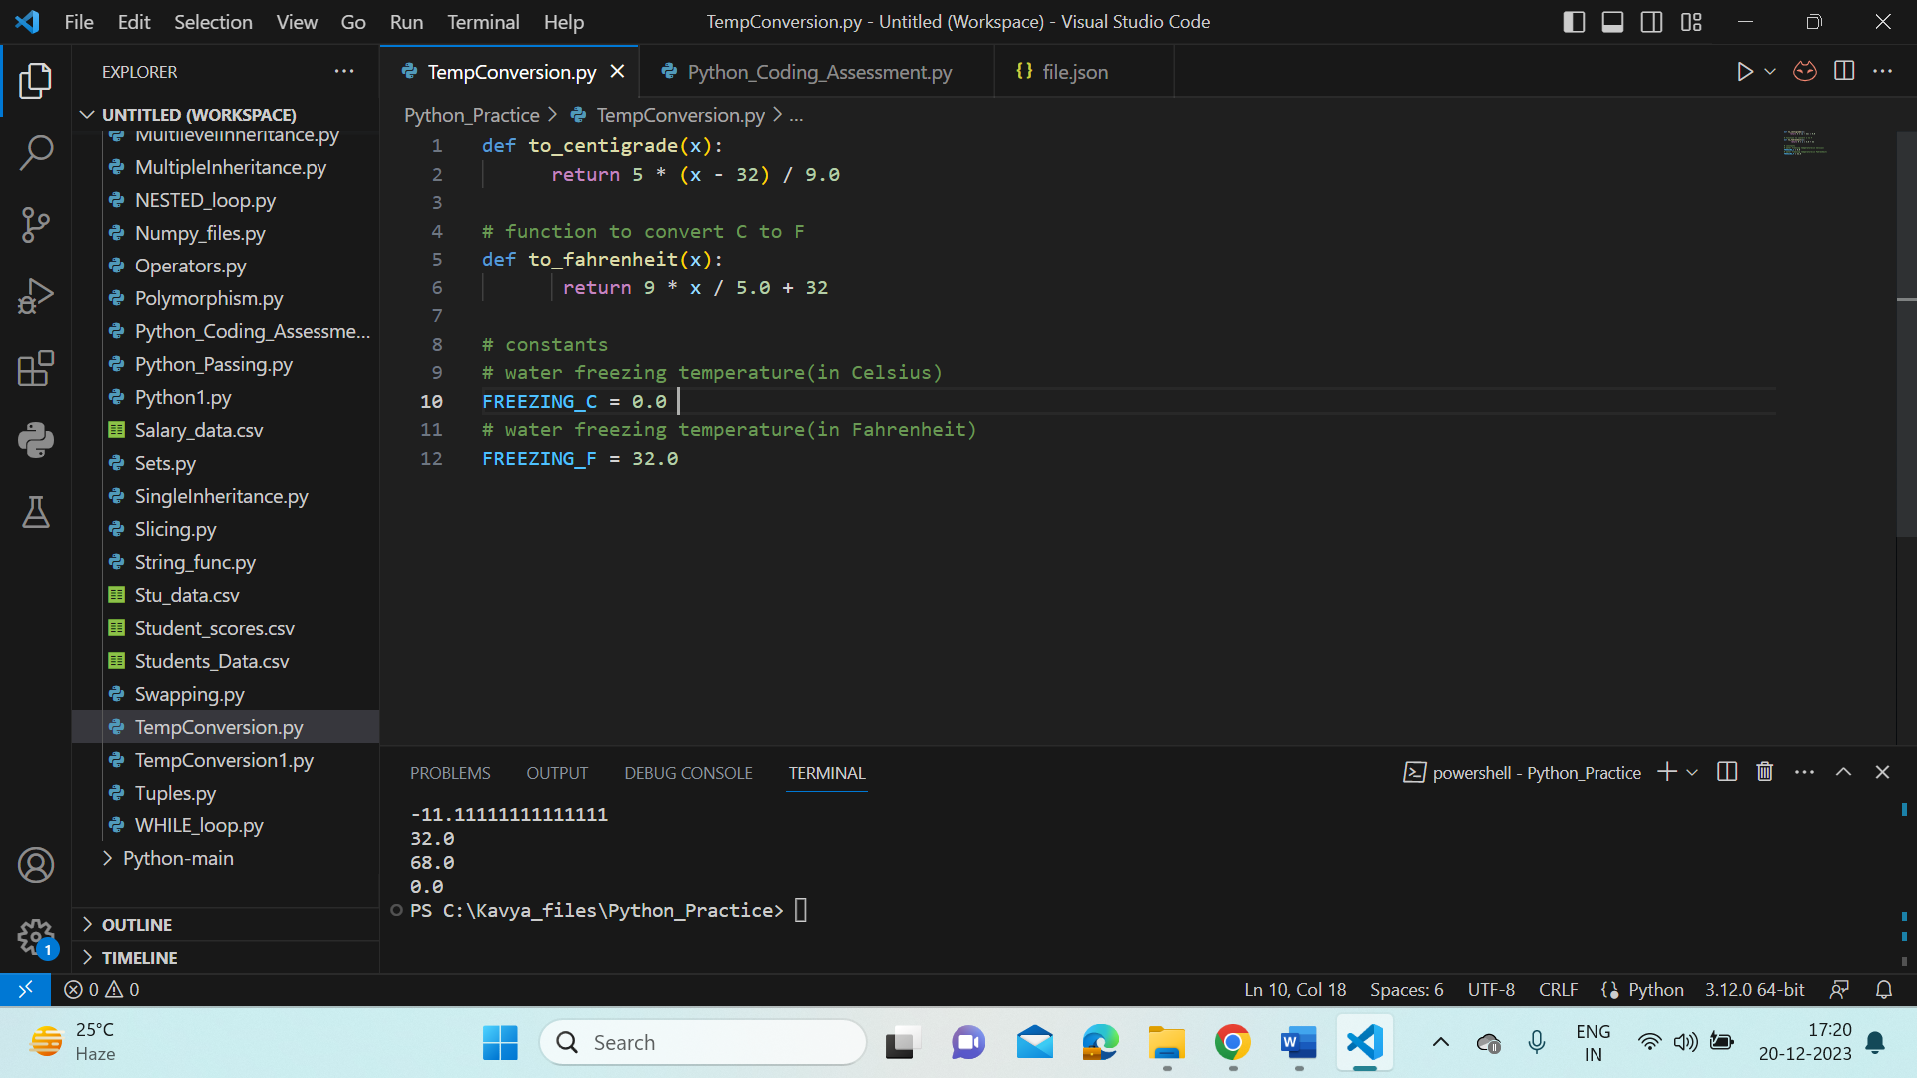

1. **Explain Pandas and numpy using Examples in PYTHON**

* **Pandas: Pandas is a Python library used for working with data sets. It has functions for analyzing, cleaning, exploring, and manipulating data.**
* **Here we are using .csv and .json files**
* **Reading & Writing data from .csv files ,Reading & Writing data from .json files using Pandas**

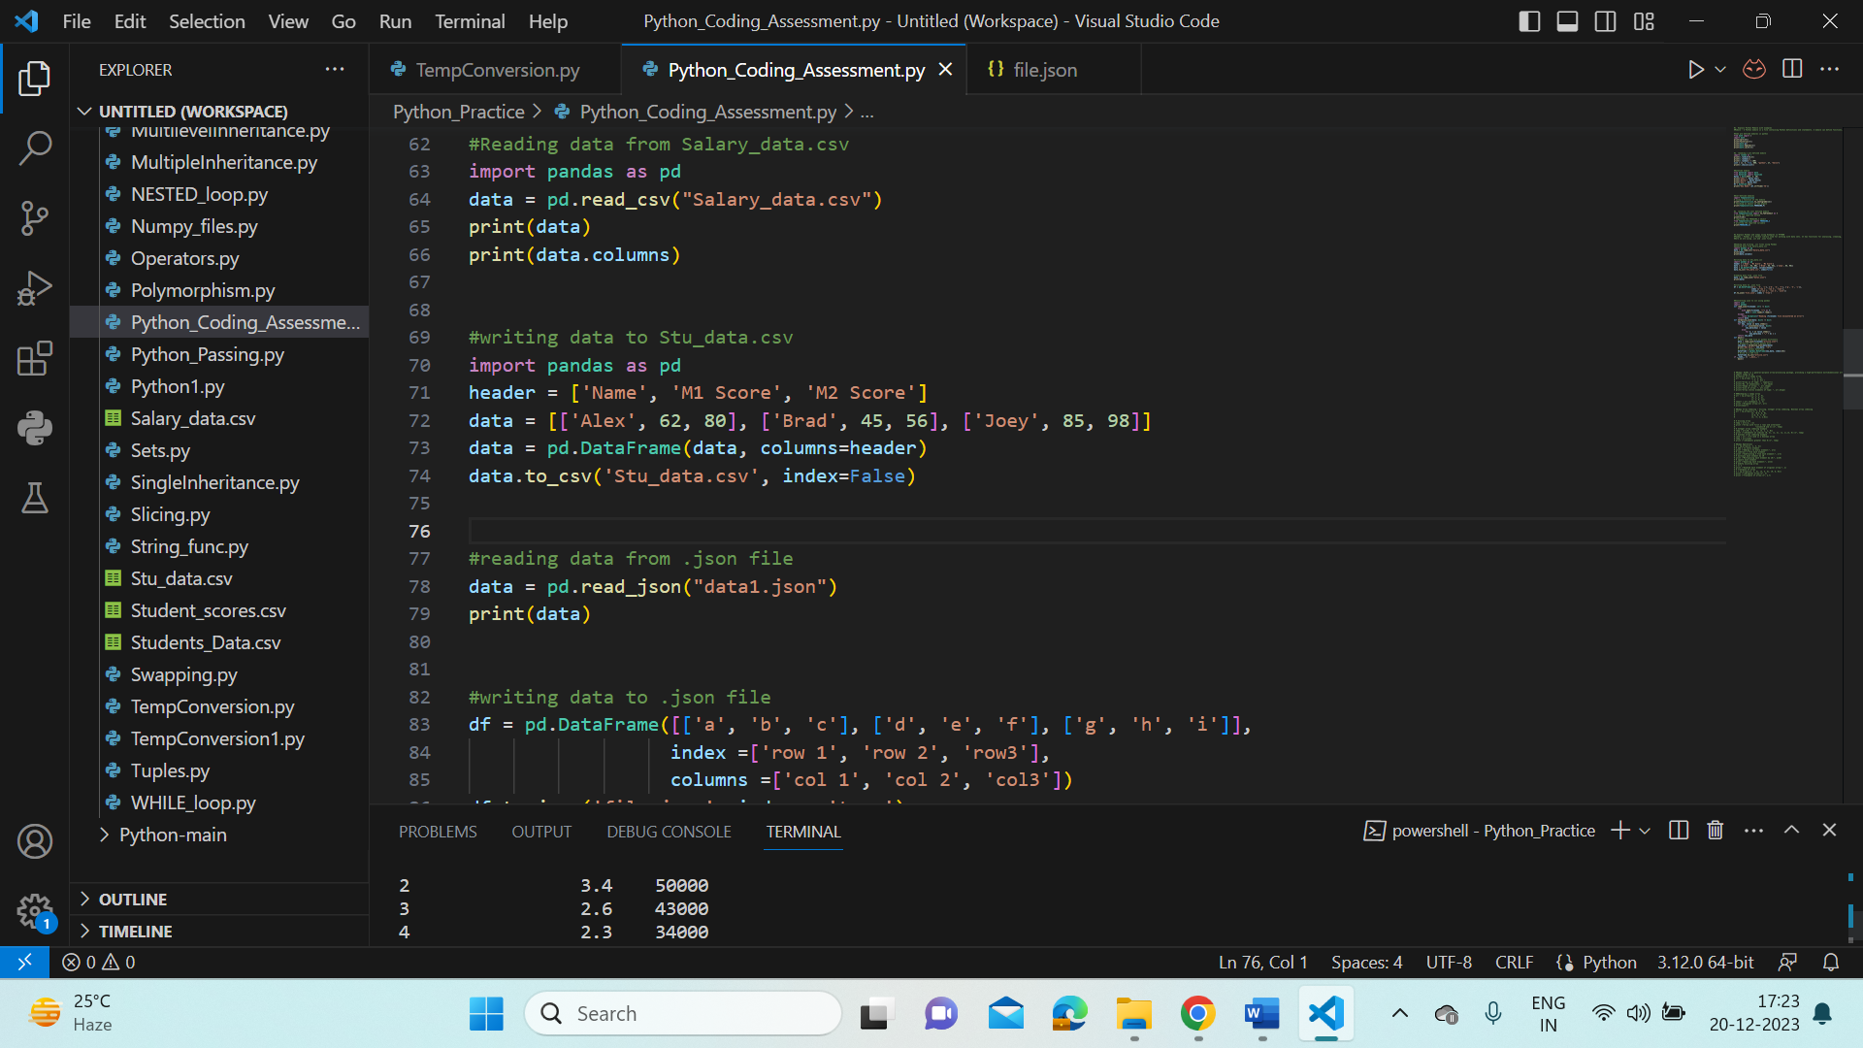

* **Output:**

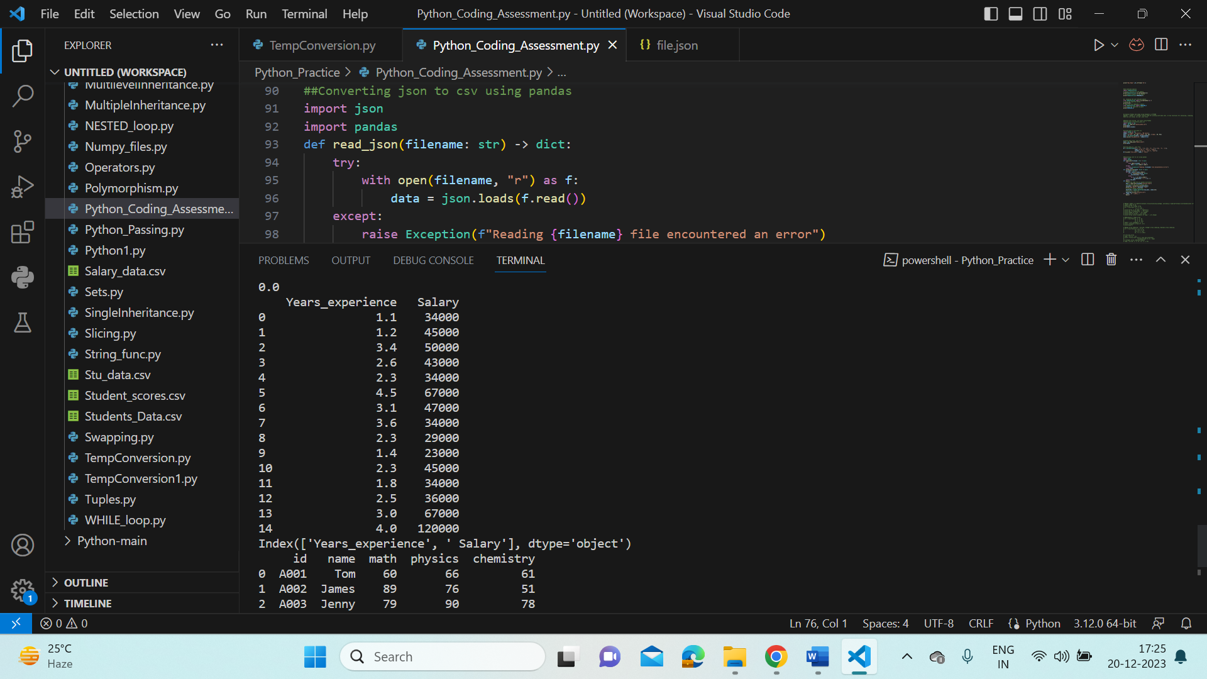

* **Converting .json to .csv files using Pandas:**

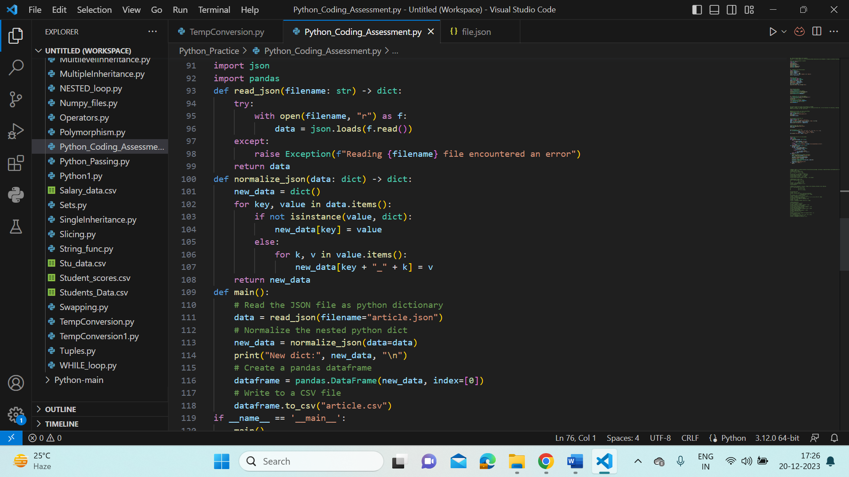

* **Output:**

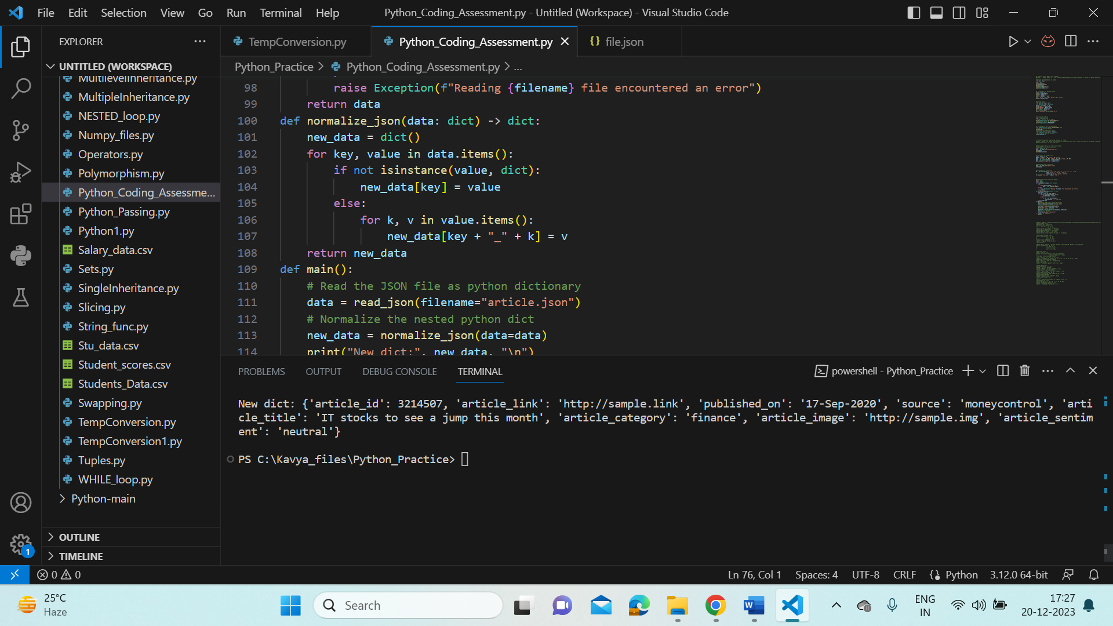

* **Numpy- NumPy is a general-purpose array-processing package, providing a high-performance multidimensional array object and tools for working with these arrays.**
* **Numpy examples:**

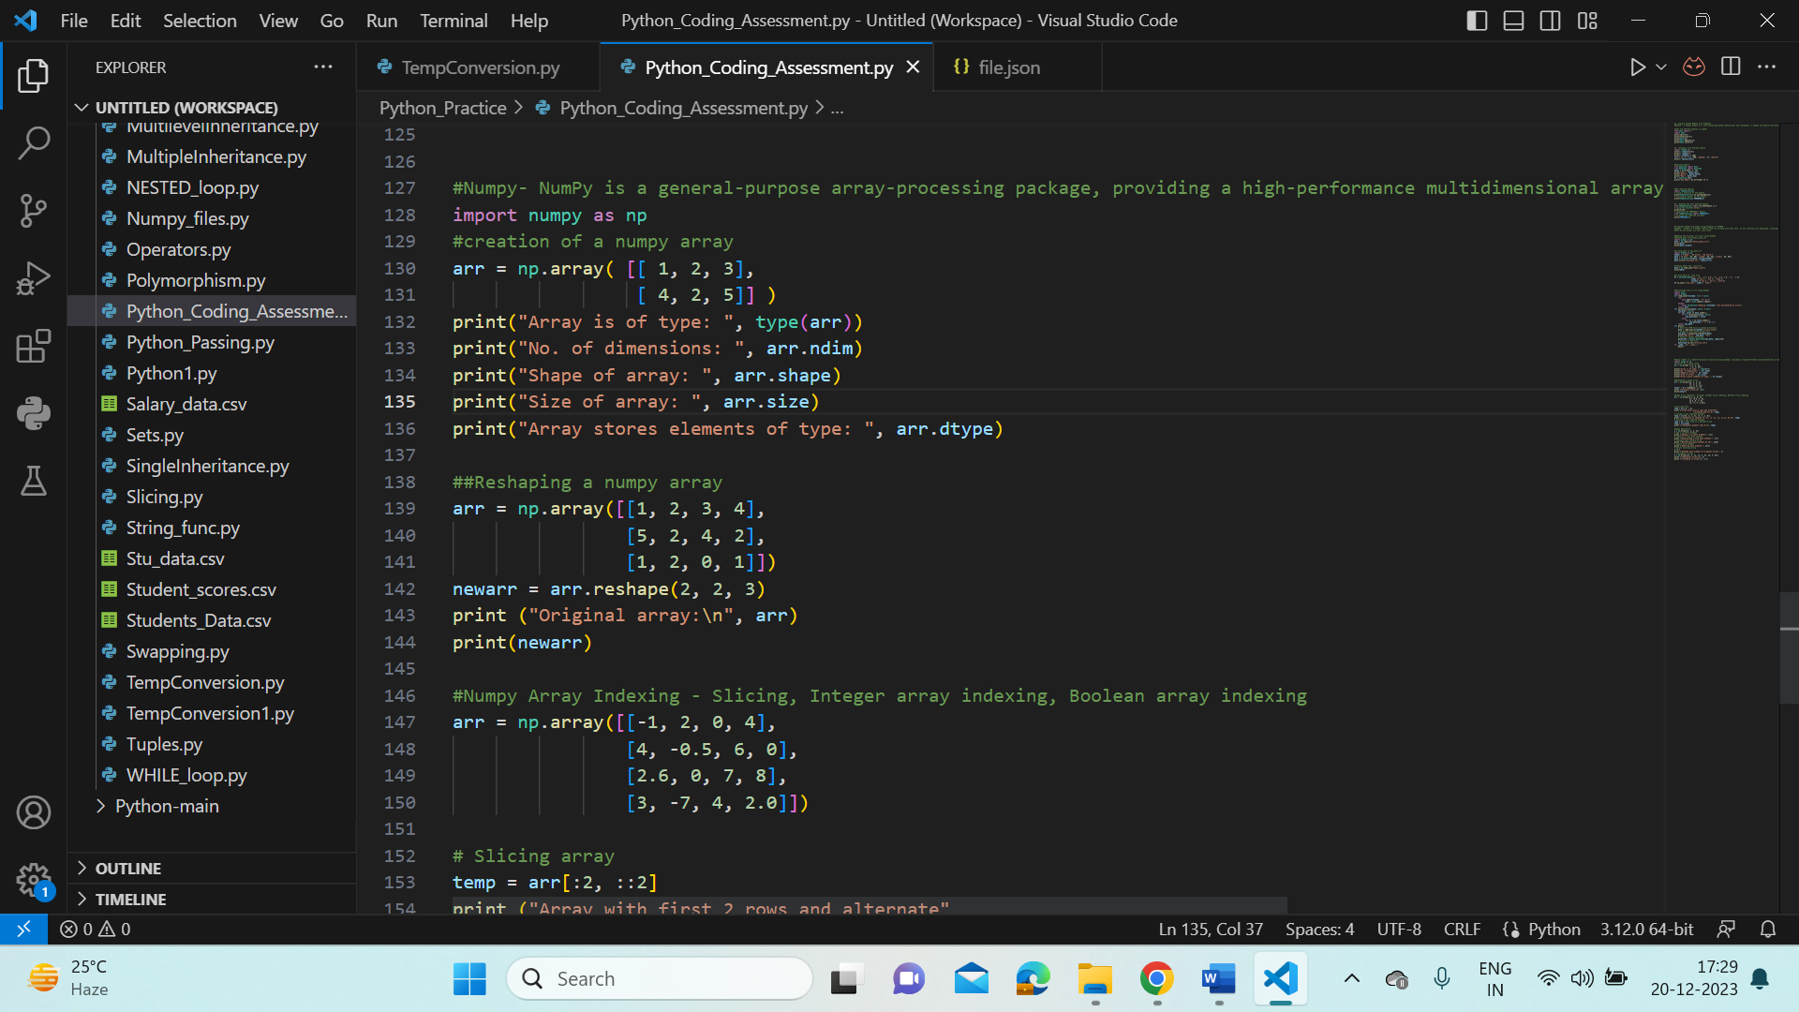

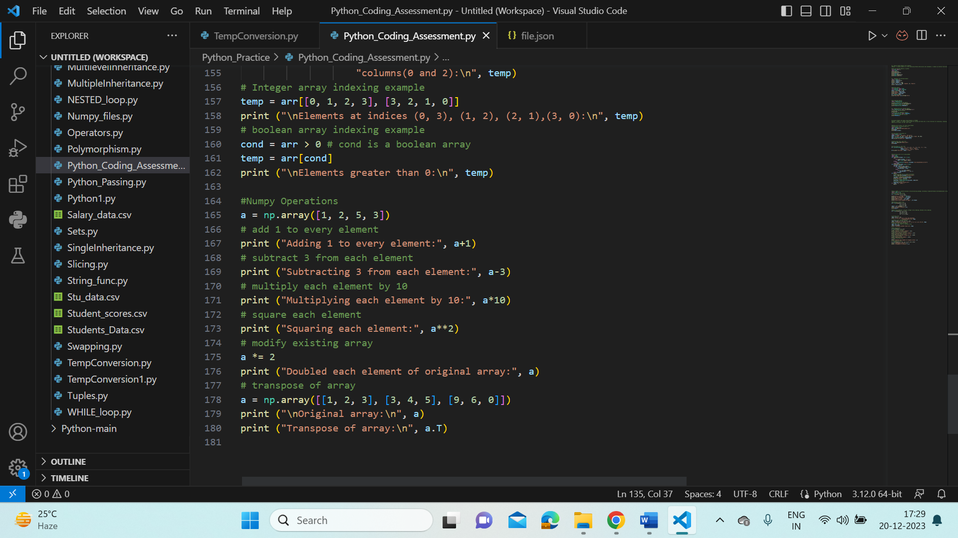

* **Output:**

