**NAME: KAVYA GUNDALA**

**DATE: 13-12-2023**

**SQL CODING ASSESSMENT**

* Created two tables orders and customers that together has customer_id column.
* Inner-join operation

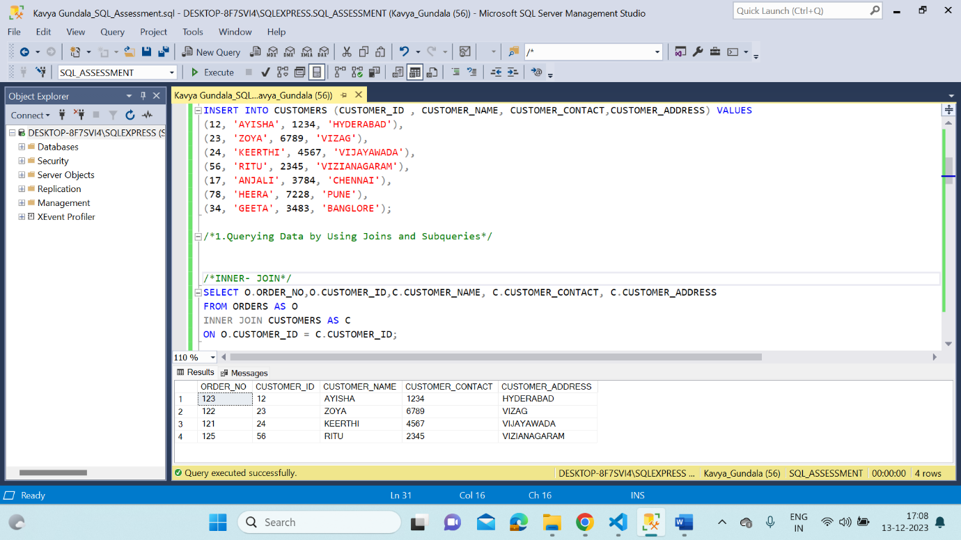

* Left join operation

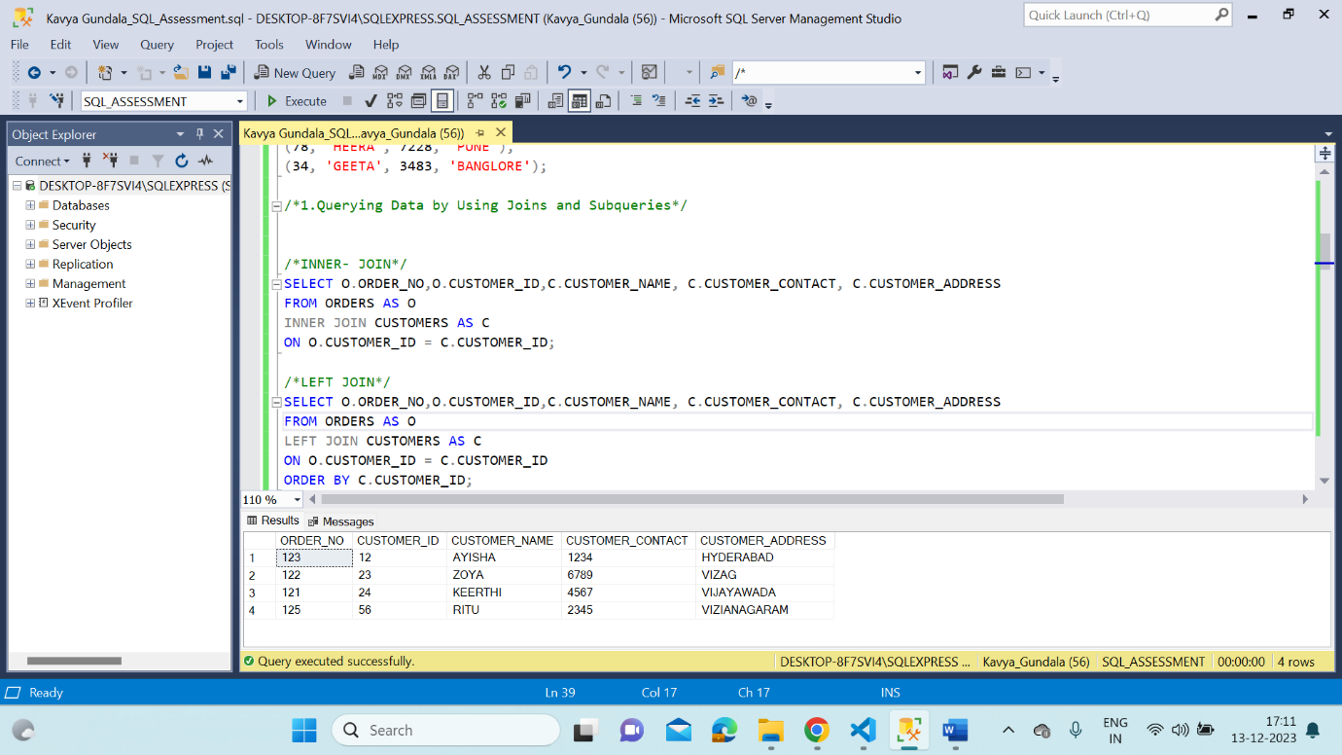

* Right Join operation

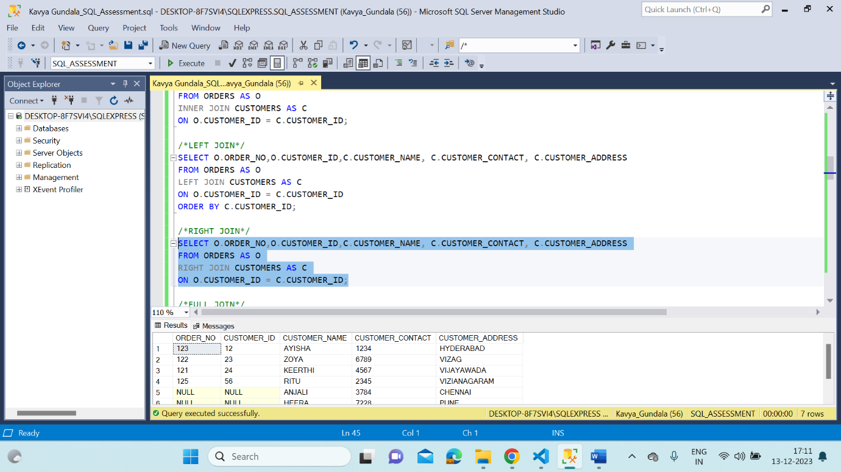

* Full Join operation

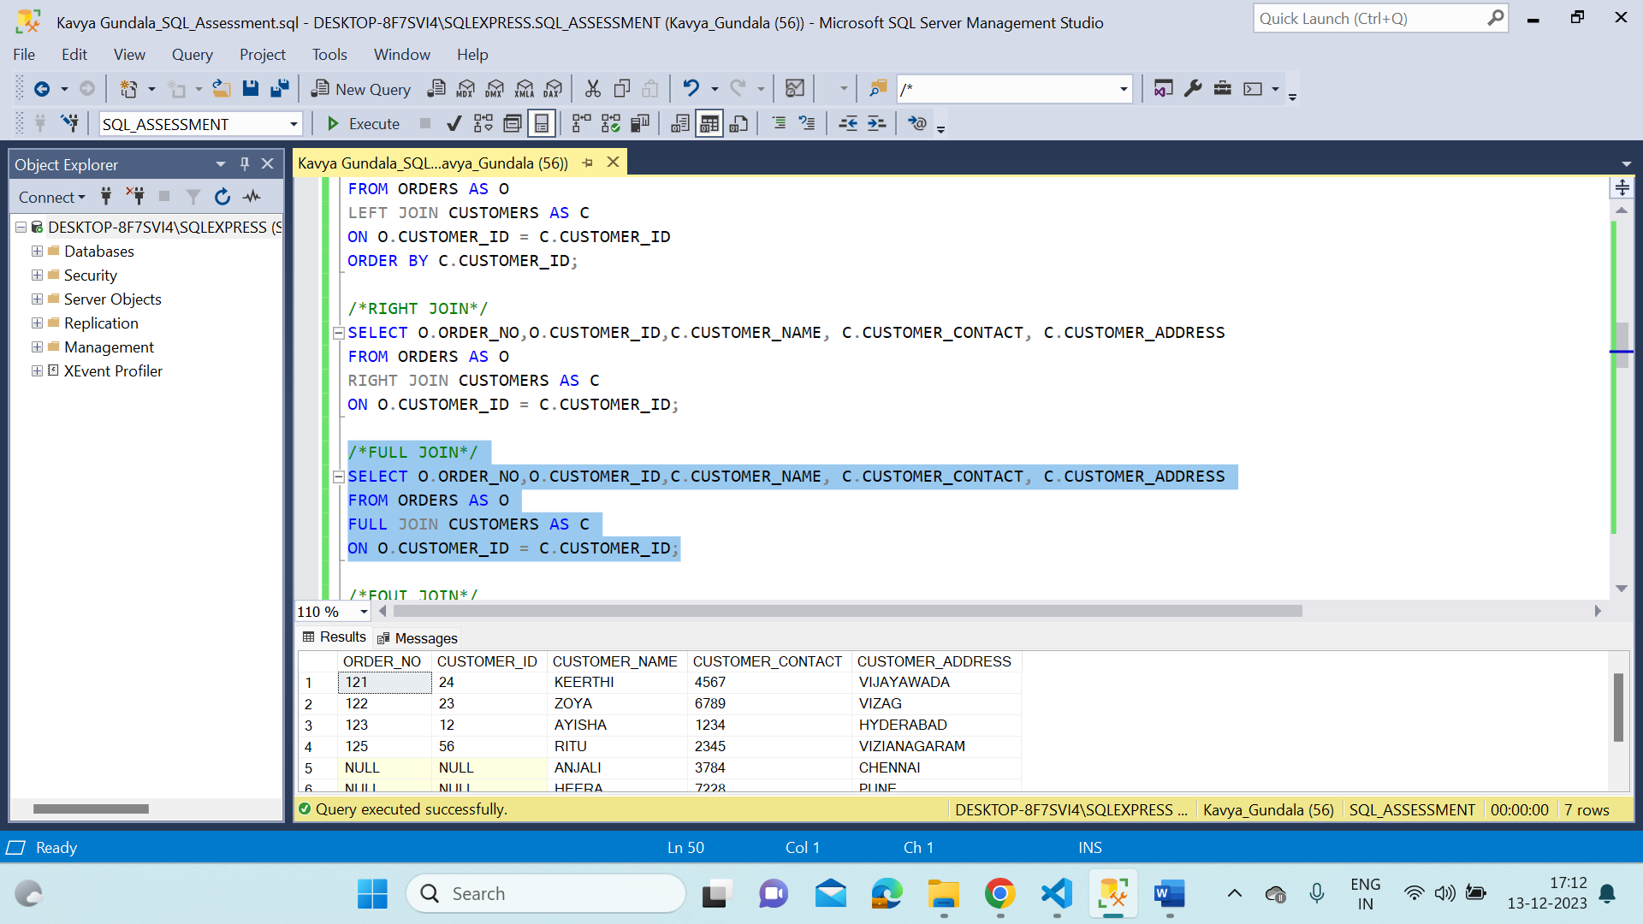

* Equi Join operation

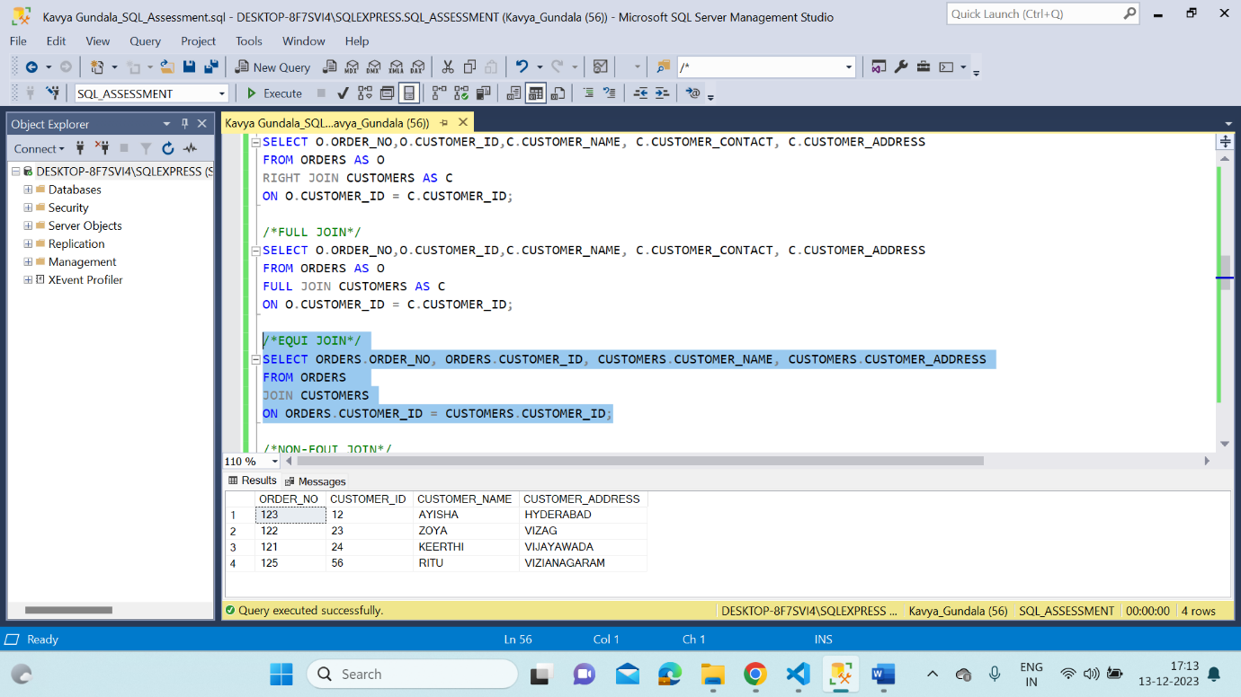

* Non- Equi Join operation

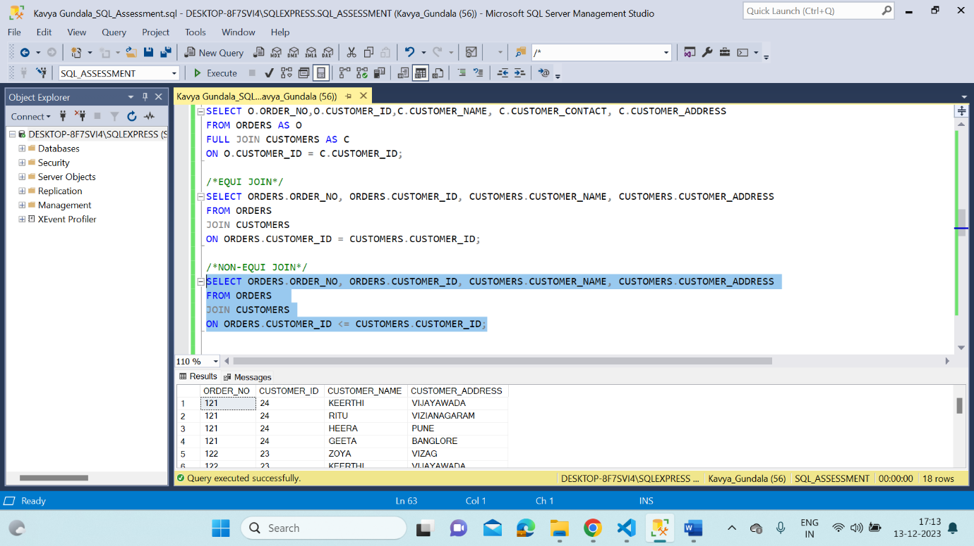

* Sub Queries

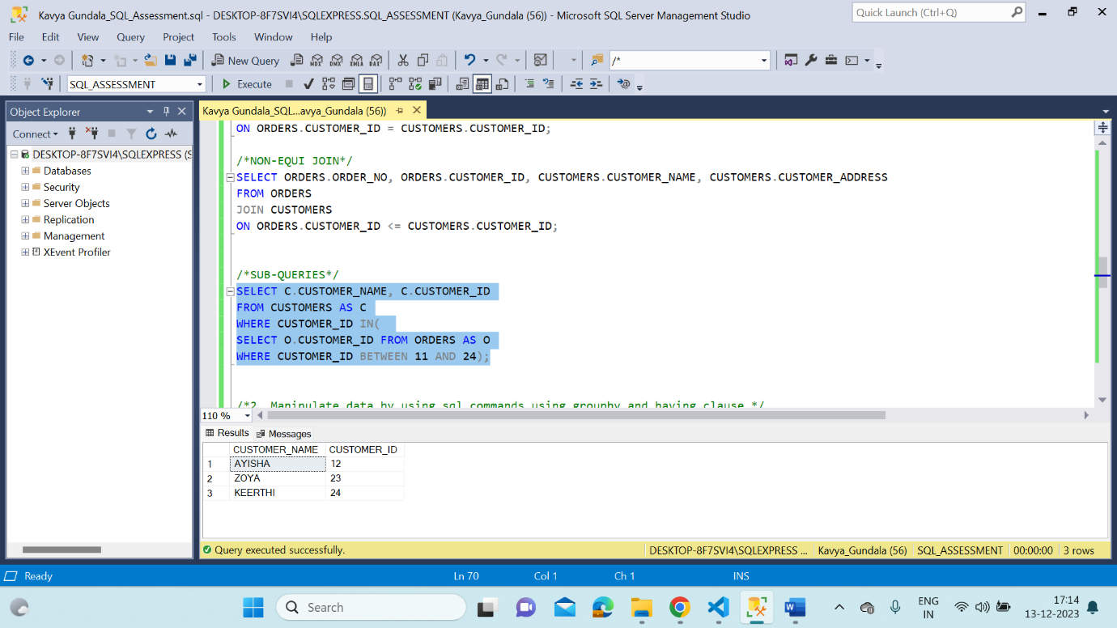

* Created a table names Students and performing DML commands

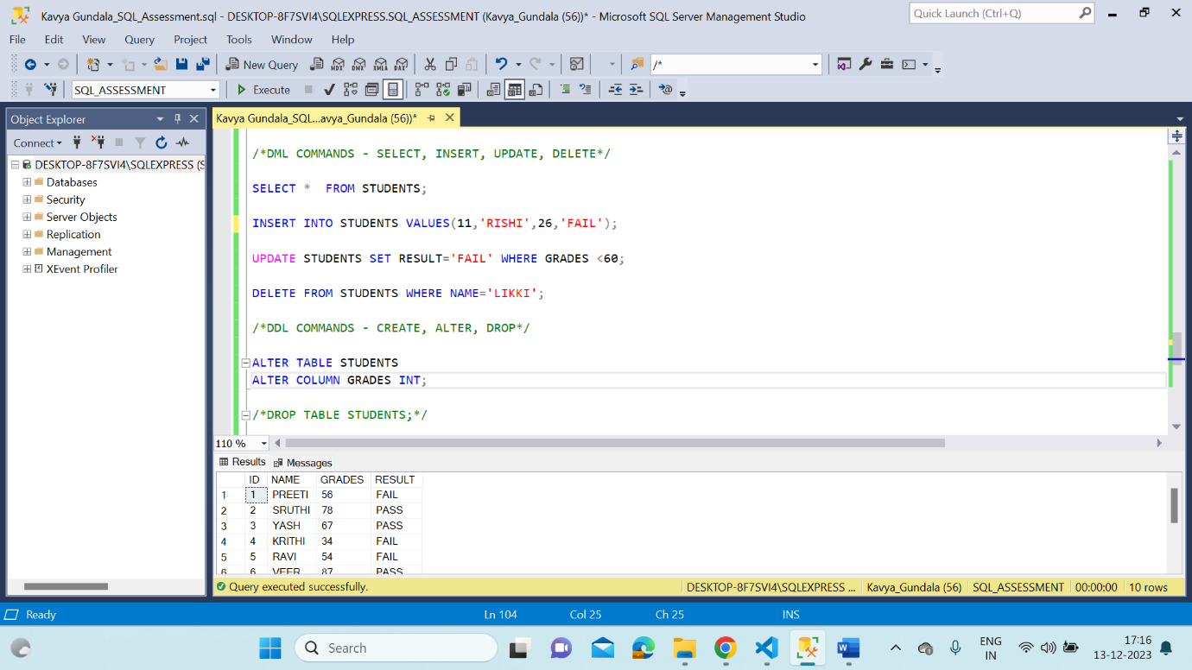

* Group by, Having, Order by clause

