Game Design Document

Fill up the following document

1. Write the title of your project.

1000 KMS To Equestria

1. What is the goal of the game?

To make a score of 1000 i.e PC reaches his family.

1. Write a brief story of your game.

Quentil is a wolf who stayed in the magical town of Kirrin Land. An attack by fire dragons

Destroyed the Kirrin Land. Help Quentil reach his family which keeps the scacred scrolls that can vanish the dragons. His family lives in a small town Equestria 1000 kms from Kirrin Land. Help Quentil reach that place safely.

1. Which are the playing characters of this game?

* Playing characters are the ones who respond to the user based on the input from the user.
* Cars, monkeys, dinos, wizards, etc., are the playing characters in the game.

|  |  |  |
| --- | --- | --- |
| Number | Character Name | What can this character do? |
| 1 | Quentil (wolf) | Jump to avoid arrows and dragons. |
| 2 |  |  |
| 3 |  |  |
| 4 |  |  |
| 5 |  |  |
| 6 |  |  |
| 7 |  |  |
| 8 |  |  |

1. Which are the Non-Playing Characters of this game?

* Non-Playing characters are the ones that don't have an action or behavior when the user interacts with the game.
* Hurdles, stones, bananas, coins, etc., are non-playing characters in the game.

|  |  |  |
| --- | --- | --- |
| Number | Character Name | What can this character do? |
| 1 | Dragons | Can Kill |
| 2 | Fire Arrow | The Pc |
| 3 |  |  |
| 4 | Background | Visual |
| 5 | Birds | Effects |
| 6 | Fire balls | Visual |
| 7 |  | Effects |
| 8 |  |  |

Draw your imagination of this game. What does this game look like?

* Draw the game either on your computer or on paper.
* Add images of the game scenes to show each of the playing and non-playing characters at least once.

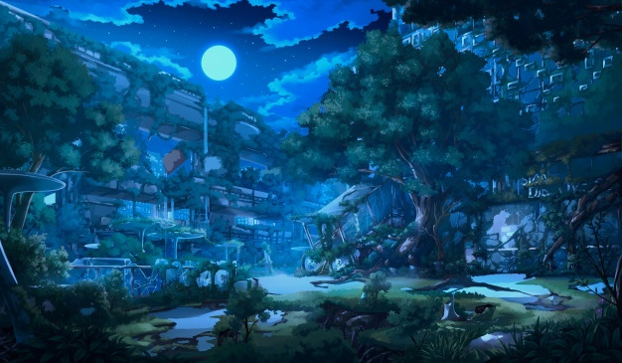 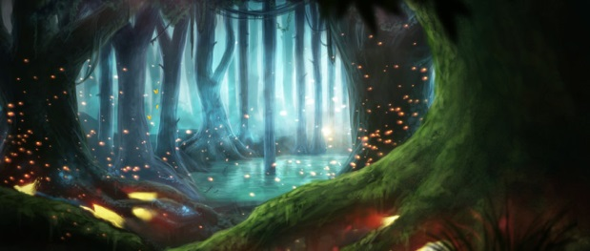

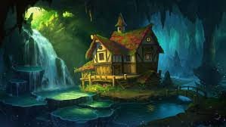 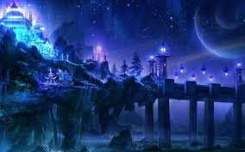

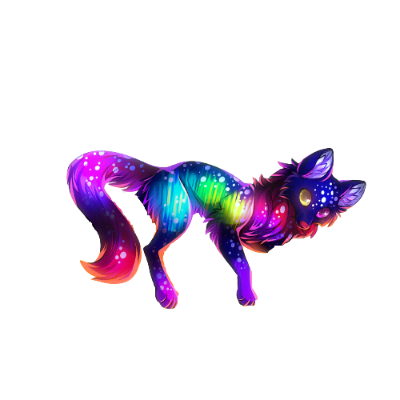

These are pcs and non pcs of the game.The game will have different backgrounds which change with score.

How do you plan to make your game engaging?

Game becomes hard as score increases. Obstacles, visual effects and audio will makre game more engaging.