**Outputs of Phase2 Project**

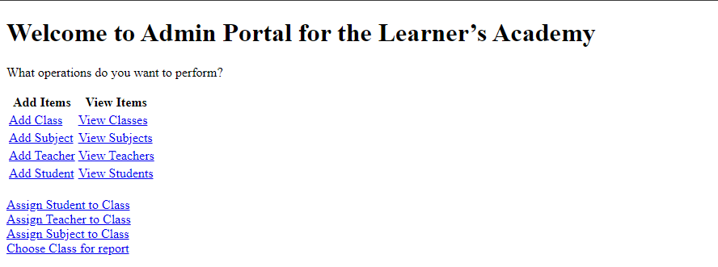

**Welcome Page**

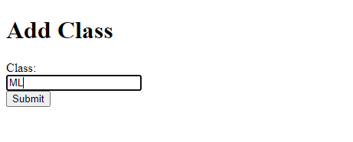

**Adding Subject ML to class**

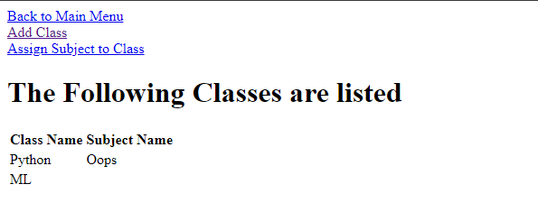

**Class List**

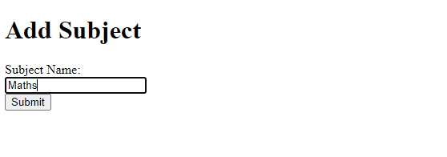

**Adding subject Maths**

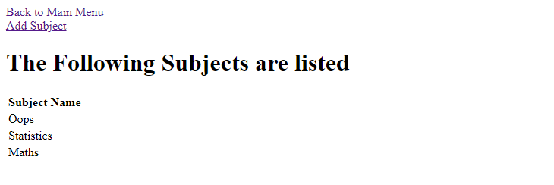

**Subject List**

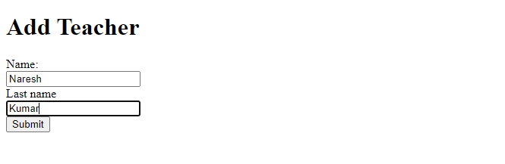

**Adding Teacher**

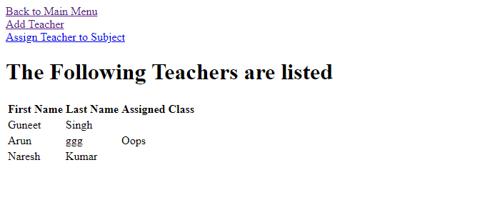

**Teacher List**

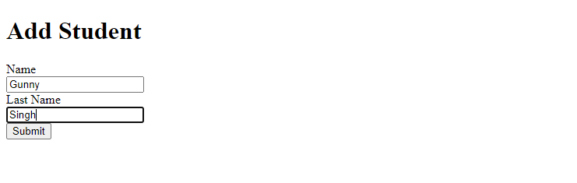

**Adding Student ‘Gunny Singh’**

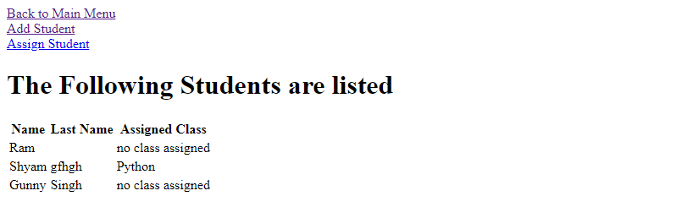

**Student List**

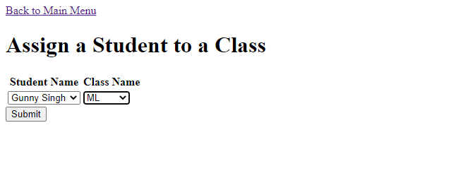

**Assiging Student to Class**

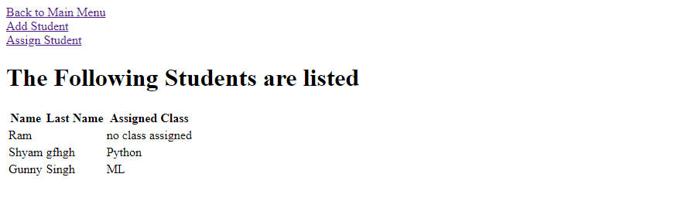

**Class ML is assigned to student named Gunny Singh**

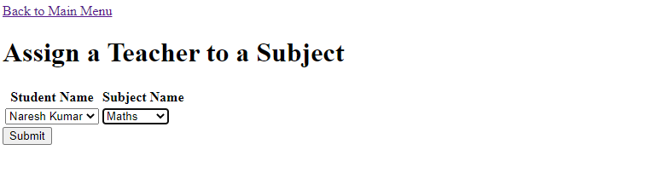

**Assigning Teacher Naresh Kumar to Maths Subject**

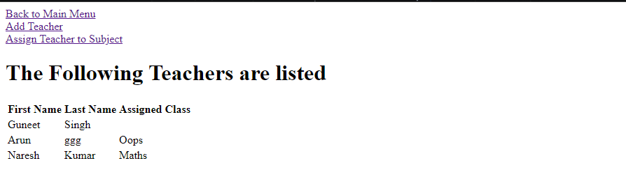

**Teacher Naresh Kumar is Assigned to Maths Class**

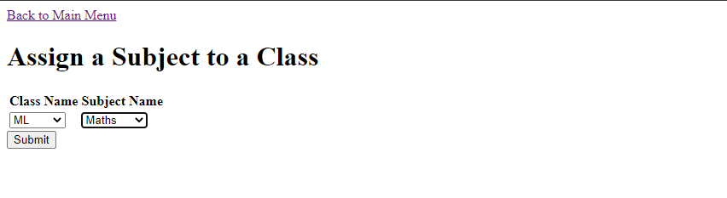

**Assigning Class ML to Maths Subject**

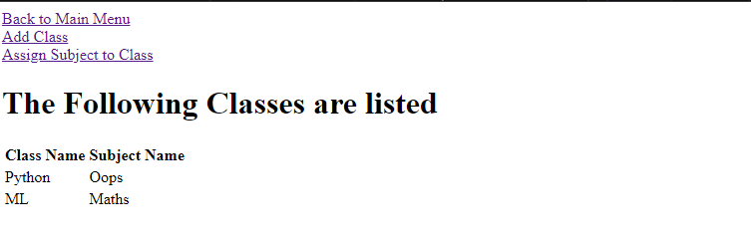

**Class ML is assigned to Maths Subject**

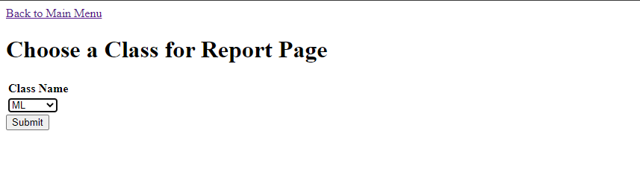

**Select Class ML for Class Report**

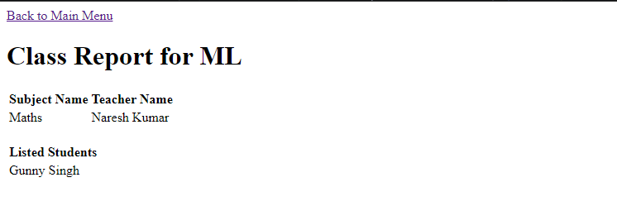

**Class Report for Class ML having details such as Subject Name, Teacher Name ,Listed Students.**

**Database Tables:**

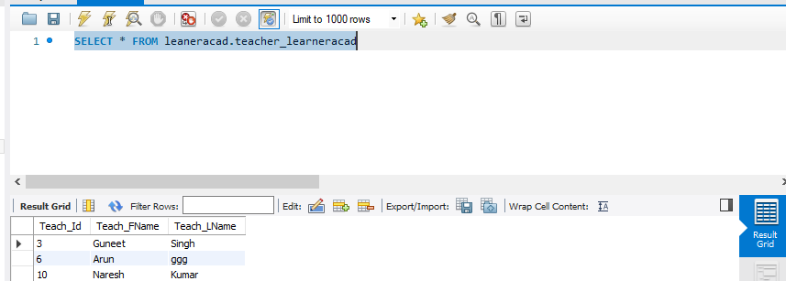

**Teacher Table**

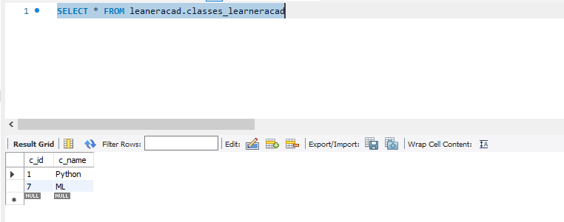

**Class Table**

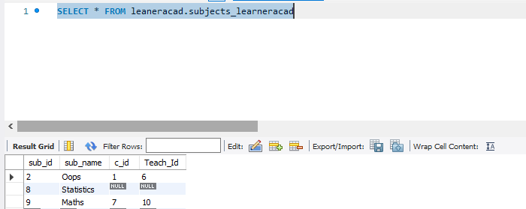

**Subjects Table**

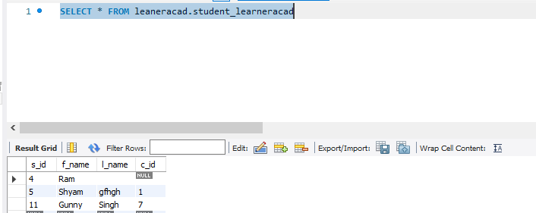

**Student Table**