Class Work Queries I tried and other modification:

1. What if both the customerID got same by any chance in the columns:

:- Below in Table Donna and Denial are having same customer ID. SO by this customerID cannot be primary key as it is not unique.

So to make it unique first I have to remove redundancy by assigning unique value to Donna.

ERROR:

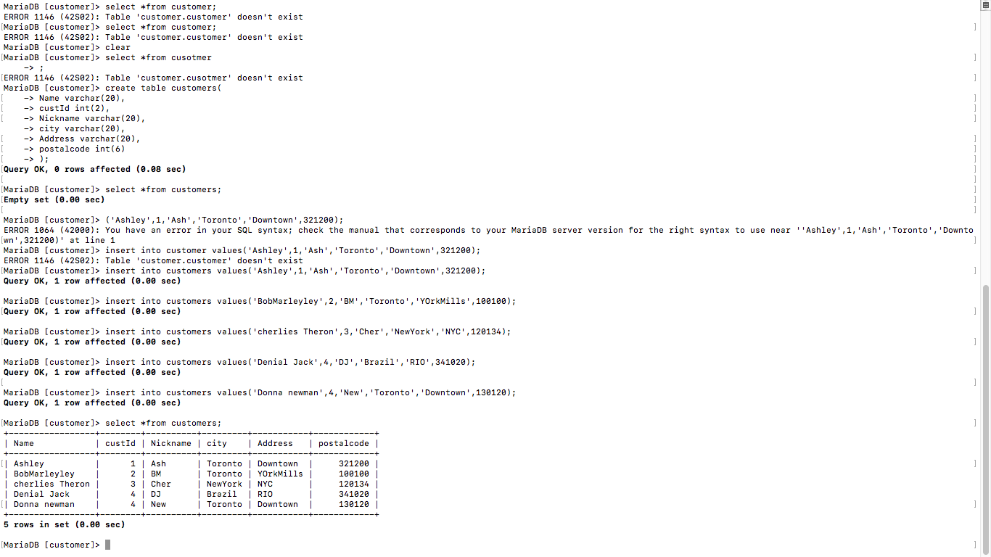

**SOLUTION : perform the query :**

**MariaDB [customer]> update customers**

**-> set custID = 5 where name = 'Donna newman';**

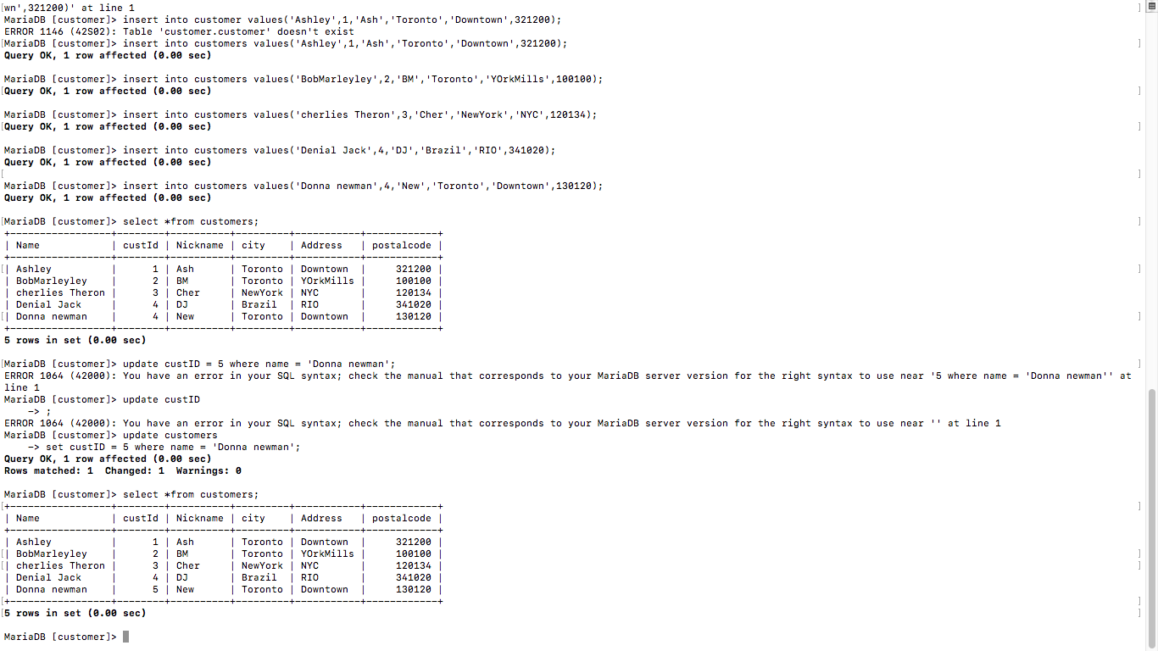

**Adding new value into table at the end:**

**So I added billy as new value at the end of the table with query :**

**insert into customers values('Billy',6,'Bill','Ottawa','ShepperdAv',140300);**

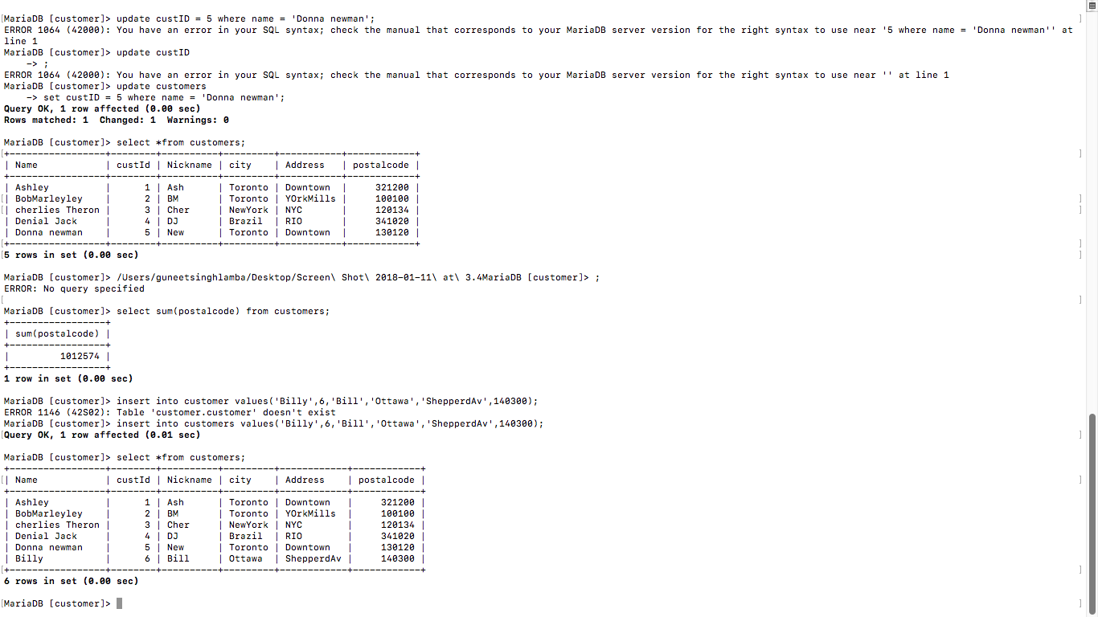

**Updating an address in a column according to name:**

**The query is used is :**

**set Address = 'GormanStreet'**

**where Name = 'Ashley'' at line 1**

**MariaDB [customer]> update customers**

**-> set Address = 'GormanStreet' where name = 'Ashley';**

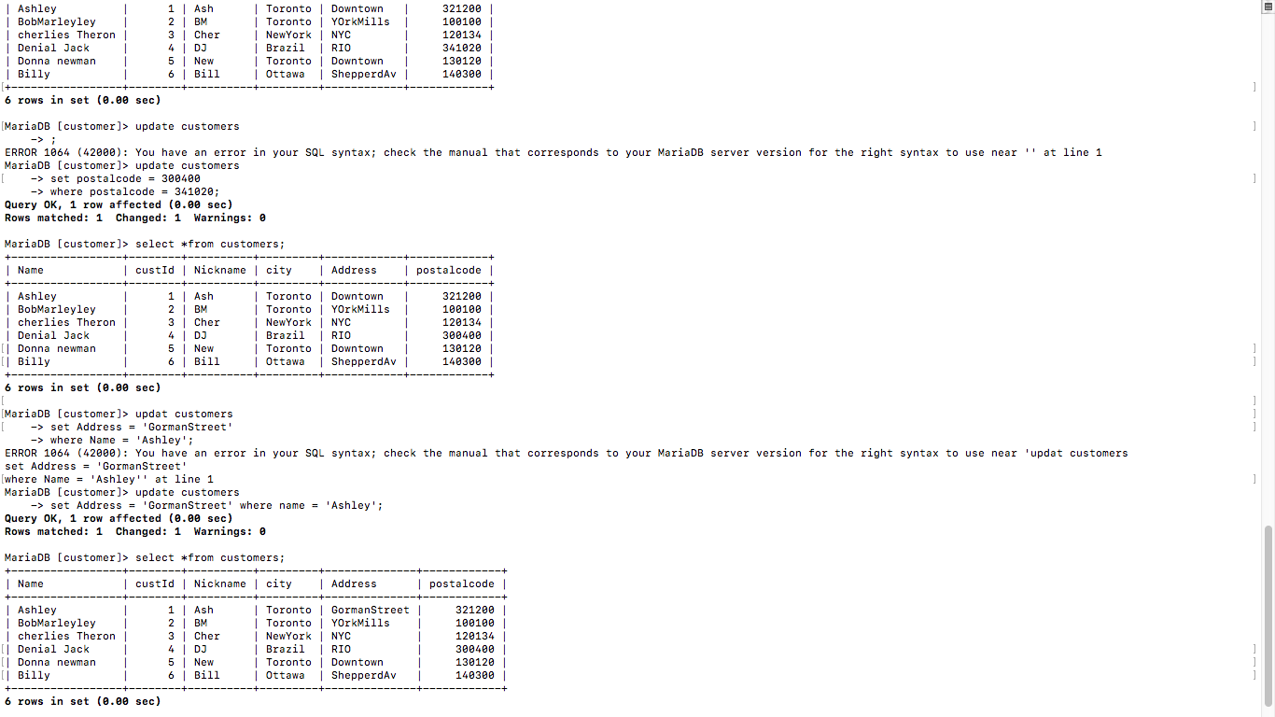

**Adding new column in table and updating values into it:**

**I first made a new column which had null values and then I updated the values in that column.**

**The query I used is:**

**For making new column:**

**Alter table customers**

**-> Add Online varchar(3);**

**For Updating values into that column:**

**update customers**

**-> set Online = 'Yes'**

**-> where custID between 1 and 6;**

