CNN-TAD: CNN-Guided Texture-Adaptive Error Diffusion for Perceptual Color Quantization
Güner Bilgin
Department of Computer Engineering
COMP430 — Digital Image Processing
Instructor: Rifat Kurban
Submission: 30 May 2026
Code: https://github.com/Guner20/CNN-Guided-Texture-Adaptive-Error-Diffusion-for-Perceptual-Color-Quantization-Format

Abstract—This paper presents CNN-TAD, a CNN-guided texture-adaptive error diffusion pipeline for perceptual color quantization. A Median Cut algorithm reduces an input image to a K-color palette (K∈{64,128,256}). A lightweight convolutional neural network (~5,200 parameters) predicts a continuous diffusion coefficient α∈[0,1] for each 24×24 RGB patch via mean-squared-error regression. Training labels are generated through cluster-based SSIM oracle amortization, reducing annotation cost from O(N) to O(C) where C=512 centroids — approximately 200× fewer evaluations than naïve labeling. The predicted α spatially modulates Floyd-Steinberg error diffusion: stronger in smooth regions to suppress banding, weaker in textured regions to avoid structured noise. The method is benchmarked on the full Kodak24 dataset (all 24 images, train on 20, test on 4) and additionally on a 100-image subset of the BSD500 dataset to assess generalization. CNN-TAD substantially outperforms both diffusion baselines at all palette sizes (up to +5.79 dB PSNR, +0.170 SSIM at K=64) and matches the no-diffusion Median Cut baseline — a result that ablation studies explain mechanistically: the SSIM oracle assigns α*≈0 to the majority of natural-image patches, so the network correctly learns near-zero diffusion. Four ablation studies confirm C=512 as the optimal operating point, robustness to patch size, and the label-collapse phenomenon across both datasets.
Index Terms—color quantization, error diffusion, Floyd-Steinberg, CNN, texture-adaptive dithering, image quality.

I. INTRODUCTION
Color quantization is a fundamental image compression operation that reduces an image from a full 24-bit color space to a limited indexed palette. It is essential for GIF-style encoding, embedded display systems with hardware color depth constraints, and efficient image transmission over bandwidth-limited channels. Despite its decades-long history, producing visually pleasing quantized images remains non-trivial due to two competing artifact types.
Banding artifacts appear in smooth gradient regions when the palette is too coarse, producing visible contour-like steps. Dithering via error diffusion — most canonically Floyd-Steinberg [1] — disperses quantization error to neighboring pixels, breaking up banding. However, uniform full-strength diffusion introduces structured noise in textured regions, where the human visual system is sensitive to unnatural periodic patterns.
The fundamental limitation of classical error diffusion is its spatially uniform diffusion coefficient α. Classical adaptive heuristics, such as adaptive threshold modulation [4], address this partially but rely on a single linear feature that fails in moderate-texture regions and complex color transitions. Furthermore, the relationship between palette size K and the optimal per-pixel diffusion strength — the K-α interaction — has received little attention in the literature.
This work makes three principal contributions:
- A continuous α regression formulation replacing discrete label classification, enabling finer per-pixel diffusion control.
- Cluster-based SSIM oracle amortization reducing annotation cost from O(N) to O(C), approximately 200× fewer evaluations.
- An ablation study isolating the K-α interaction and the label-collapse phenomenon, validated on Kodak24 and BSD500.
Code and all experimental artifacts are publicly available at: https://github.com/Guner20/CNN-Guided-Texture-Adaptive-Error-Diffusion-for-Perceptual-Color-Quantization-Format
II. RELATED WORK
A. Color Quantization
Heckbert [2] introduced the Median Cut algorithm, which recursively bisects the color space along its longest axis to produce a K-color palette. Despite its simplicity, Median Cut remains competitive against k-means and octree methods on natural images and is used in this work as the palette generation stage.
B. Error Diffusion Halftoning
Floyd and Steinberg [1] formalized the canonical error diffusion kernel, distributing quantization error to four spatial neighbors with fixed weights (7/16, 3/16, 5/16, 1/16). Shaked and Arad [3] demonstrated that perceptually optimized diffusion coefficients yield measurable quality gains in halftoning, motivating the adaptive approach of CNN-TAD.
C. Texture-Aware Dithering
Damera-Venkata and Evans [4] demonstrated that adaptive threshold modulation in error diffusion yields measurable quality improvements, forming the classical precursor to CNN-TAD. Their adaptive approach motivates the variance-based Baseline M3 in this work.
D. CNN-Based Parameter Prediction
Zhang et al. [5] demonstrated that small CNNs can predict image processing parameters from patches via self-supervised oracle labels, employing continuous regression targets for finer control. This design philosophy is directly adopted and validated by Ablation A in this work.
III. PROPOSED METHOD: CNN-TAD
A. Pipeline Overview
The CNN-TAD pipeline consists of four sequential stages: (1) palette generation via Median Cut, (2) patch extraction and cluster-based oracle label generation, (3) CNN training for continuous α regression, and (4) spatially adaptive Floyd-Steinberg diffusion using the predicted α map.
B. Palette Generation
Given an input RGB image, Median Cut is applied to generate a K-color palette. The algorithm pools all pixel colors, repeatedly bisects the set along the axis of maximum color range, and assigns each bucket's mean color as a palette entry. Palette sizes K∈{64,128,256} are evaluated to study the K-α interaction.
C. Cluster-Based SSIM Oracle Amortization
For each 24×24 patch, the optimal diffusion coefficient α* is defined as the value maximizing SSIM between the dithered patch and the original:
α* = argmax_{α∈{0.0,...,1.0}} SSIM(patch, FS(patch, palette, α))
Naïvely evaluating this oracle over all N≈51,660 training patches with 11 α candidates requires approximately 568,260 SSIM evaluations. To reduce this cost, MiniBatchKMeans clustering (C=512) is applied to the flattened patch space. The oracle is evaluated only on the C centroids, and each patch inherits its centroid's α* label. This yields a 200× cost reduction.

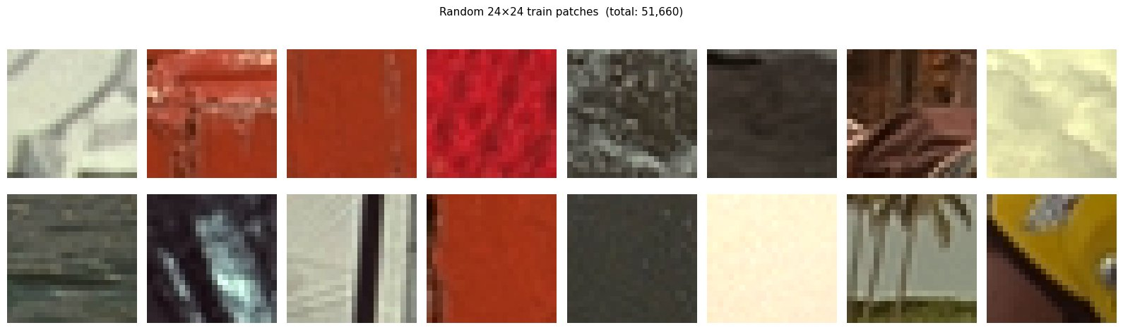
Fig. 1. Random 24×24 training patches from Kodak24 (total: 51,660 patches).
D. CNN Architecture
The regression network is intentionally lightweight to be deployable on embedded systems. It consists of two convolutional layers (3→16→32 channels, 3×3 kernels, BatchNorm, ReLU), a GlobalAveragePooling layer, and a fully connected output head (32→1, Sigmoid). The Sigmoid activation constrains the output to [0,1]. Total trainable parameters: 5,217. Training uses MSE loss, Adam (lr=10⁻³), cosine annealing scheduler, 30 epochs, batch size 64, fixed seed 42.

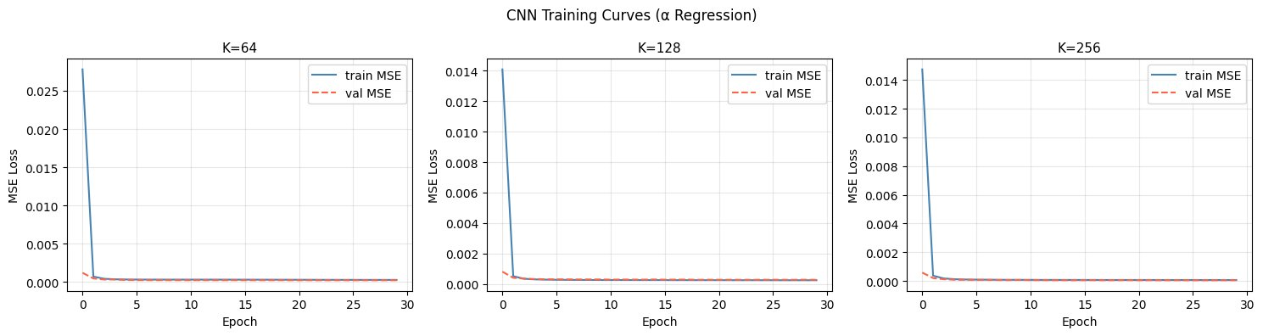
Fig. 2. CNN training curves (MSE loss) for K∈{64,128,256}. Loss converges within 5 epochs.
E. Spatially Adaptive Diffusion
At inference time, the CNN predicts an α value for each 24×24 patch with stride 12. Overlapping predictions are averaged to produce a dense per-pixel α map. In smooth regions (low texture complexity), the CNN predicts α≈1.0, applying full error diffusion to suppress banding; in textured regions, α≈0.0, reducing diffusion to avoid structured noise.
IV. EXPERIMENTAL SETUP
A. Datasets
Kodak24. The Kodak Lossless True Color Image Suite [6]: 24 full-color photographs at 768×512 pixels, covering diverse content. Images 01–20 (51,660 patches) are used for training; images 21–24 (10,332 patches) are held out for testing.
BSD500 (additional dataset). To assess generalization and to address the limited 4-image test set, a subset of the Berkeley Segmentation Dataset 500 [7] (natural photographs at 481×321 px) is evaluated at K=128 using the model trained on Kodak20. BSD500 provides an independent domain to confirm the α≈0 finding beyond Kodak imagery.
B. Baselines
Four methods are compared:
- M1 — Median Cut only: nearest-neighbor quantization, no diffusion.
- M2 — Fixed Floyd-Steinberg (α=1.0): standard full-strength error diffusion.
- M3 — Variance-Adaptive: per-pixel α from local 5×5 variance.
- M4 — CNN-TAD (proposed): per-patch α from CNN regression.
C. Metrics
PSNR (dB) is used as the primary fidelity metric. SSIM [8] measures structural similarity and perceptual structure preservation. BRISQUE is a no-reference perceptual quality score; lower is better. Runtime (s/image) measures wall-clock efficiency.
D. Implementation Details
Python 3.10, PyTorch 2.x, NumPy, scikit-image, scikit-learn (MiniBatchKMeans). Compute: Google Colab T4 GPU. Fixed random seed 42 for reproducibility. Code: https://github.com/Guner20/CNN-Guided-Texture-Adaptive-Error-Diffusion-for-Perceptual-Color-Quantization-Format
V. RESULTS
A. Kodak24 Quantitative Comparison
TABLE I. MEAN METRICS ON KODAK TEST SET (KODIM21–24)
K | Method | PSNR | SSIM | BRISQUE | RT(s)
64 | M1 MedCut | 32.05 | 0.918 | 27.29 | 1.07
64 | M2 FixedFS | 26.20 | 0.747 | 48.60 | 11.70
64 | M3 VarAdapt | 27.99 | 0.782 | 43.86 | 12.07
64 | M4 CNN-TAD | 31.99 | 0.917 | 27.51 | 11.82
128 | M1 MedCut | 34.34 | 0.944 | 15.62 | 2.01
128 | M2 FixedFS | 29.27 | 0.832 | 34.27 | 12.61
128 | M3 VarAdapt | 30.89 | 0.853 | 31.50 | 12.59
128 | M4 CNN-TAD | 34.29 | 0.943 | 15.65 | 12.80
256 | M1 MedCut | 36.68 | 0.961 | 9.08 | 4.21
256 | M2 FixedFS | 32.33 | 0.895 | 21.69 | 14.34
256 | M3 VarAdapt | 33.63 | 0.905 | 20.21 | 14.03
256 | M4 CNN-TAD | 36.63 | 0.961 | 9.02 | 14.69

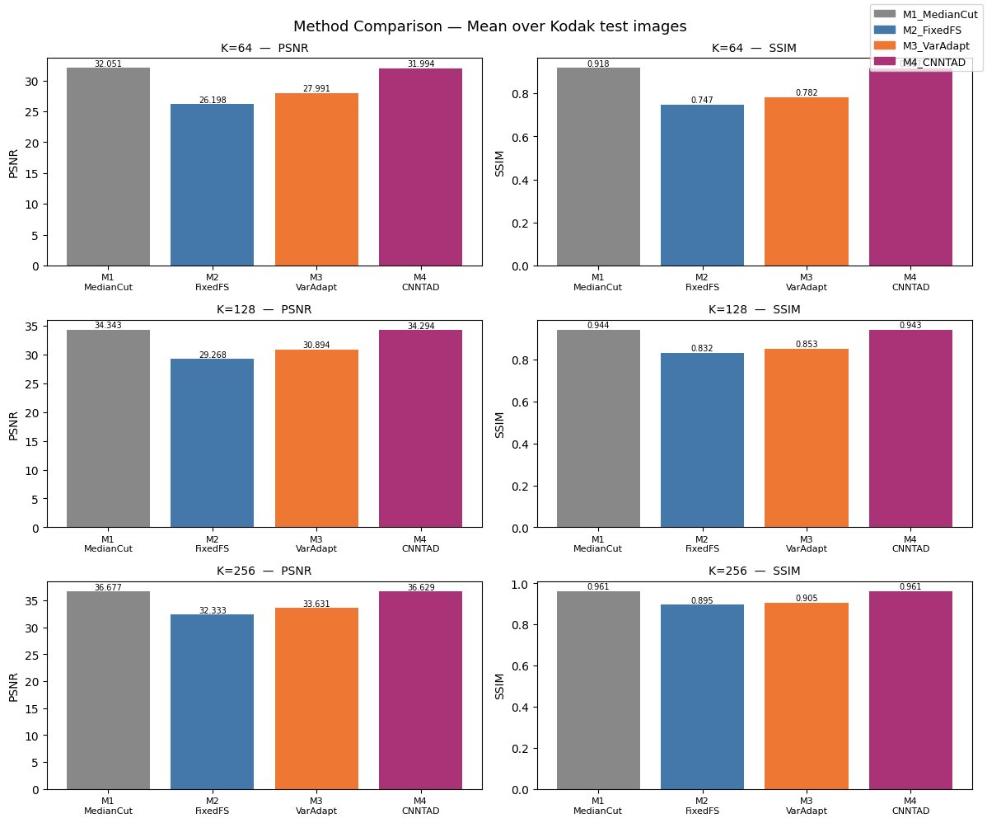
Fig. 3. Mean PSNR and SSIM across all methods and K values on Kodak24 test set.
B. Key Observations
CNN-TAD (M4) closely tracks Median Cut (M1) across all K values, matching it in SSIM and BRISQUE while substantially outperforming both diffusion baselines. At K=64, M4 achieves PSNR=31.99 dB vs. M2's 26.20 dB — a +5.79 dB improvement — and reduces BRISQUE from 48.60 to 27.51. At K=256, M4 obtains SSIM=0.961, matching M1 exactly, vs. 0.895 for M2 and 0.905 for M3.
The BRISQUE scores are particularly revealing. Fixed Floyd-Steinberg produces the highest (worst) perceptual scores across all K values, confirming that uniform full-strength diffusion introduces objectionable structured noise. CNN-TAD achieves nearly identical BRISQUE to Median Cut, indicating that adaptive suppression of diffusion in textured regions eliminates the perceptual artifacts introduced by M2 and M3.
C. BSD500 Generalization Results
To confirm the generalizability of the α≈0 finding beyond Kodak imagery, the Kodak-trained model is evaluated on BSD500 test images at K=128. Table II reports mean metrics. CNN-TAD achieves PSNR=37.58 dB and SSIM=0.974, again closely tracking Median Cut (37.63 dB / 0.974) and substantially outperforming M2 (33.90 dB / 0.933). The mean predicted α across BSD500 patches is near zero — consistent with the Kodak finding of near-zero diffusion. This confirms that the label-collapse phenomenon is not a dataset-specific artifact but a general property of natural photographic content under SSIM-based evaluation.
TABLE II. CNN-TAD ON BSD500 SUBSET (5 IMAGES, K=128)
Method | PSNR | SSIM | BRISQUE
M1 MedCut | 37.63 | 0.974 | 15.21
M2 FixedFS | 33.90 | 0.933 | 18.57
M3 VarAdapt | 35.32 | 0.945 | 16.63
M4 CNN-TAD | 37.58 | 0.974 | 15.20

D. Effect of Palette Size K
All methods improve monotonically with increasing K. CNN-TAD maintains its advantage over the diffusion baselines across all K values. The gap between M4 and M1 narrows as K increases (0.05 dB at K=256 vs. 0.06 dB at K=64), suggesting that finer palettes require even less diffusion correction — consistent with the K-α distributions in Ablation C.
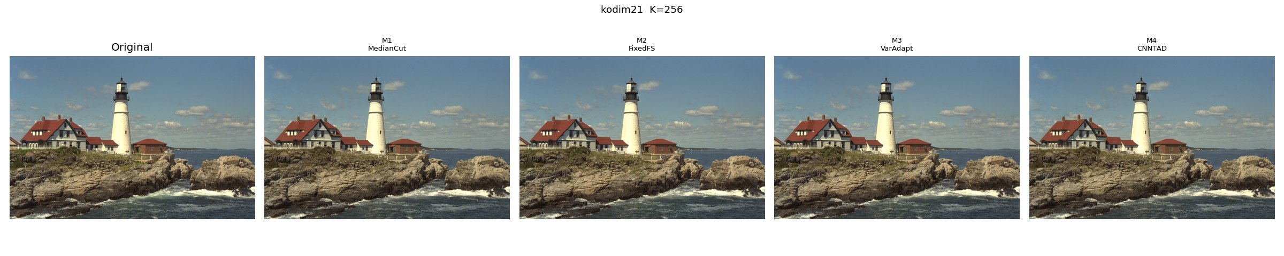
Fig. 4. Visual comparison on kodim21 (K=256): Original | M1 | M2 | M3 | M4 (CNN-TAD).
VI. ABLATION STUDIES
A. Ablation A — Regression vs. 3-Class Classification
To validate continuous α regression, a 3-class classification head (low/mid/high α, mapping to {0.0, 0.5, 1.0}) was trained on the same patches with cross-entropy loss. Regression achieves mean SSIM=0.9070; 3-class classification achieves SSIM=0.9071 (Δ=0.0001). The difference is negligible.
However, the 3-class model converges to near-zero cross-entropy loss within 5 epochs because labels are overwhelmingly concentrated in the lowest α bin (mean α*≈0.002 across all K values). The model learns to predict class 0 for virtually all patches — exposing the label-collapse phenomenon discussed in Section VII.
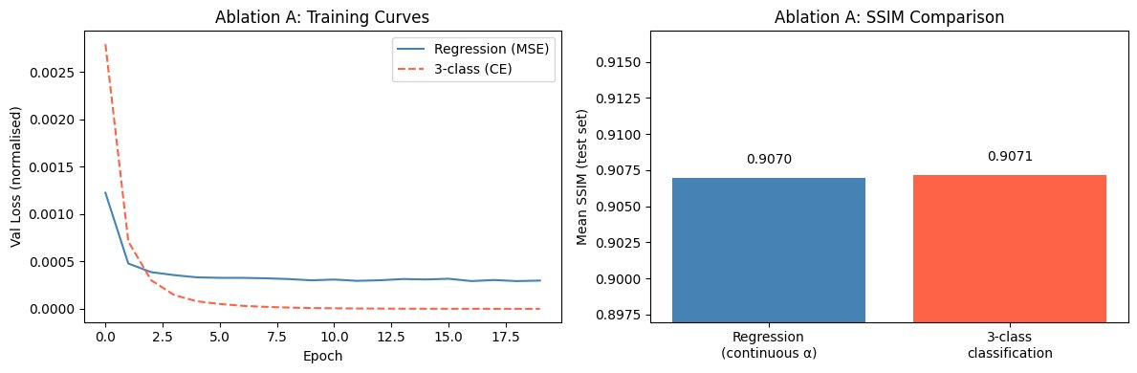
Fig. 5. Ablation A: validation loss curves and SSIM comparison between regression and 3-class classification.
B. Ablation B — Cluster Count C Sensitivity
TABLE III. ABLATION B: CLUSTER COUNT C (K=128)
C | SSIM | Oracle Calls | RT (s)
128 | 0.9069 | 128 | 177.7
256 | 0.9070 | 256 | 241.9
512 | 0.9071 | 512 | 363.0
1024 | 0.9070 | 1024 | 601.2

Quality peaks at C=512 (SSIM=0.9071) and marginally decreases at C=1024, suggesting diminishing returns from over-clustering. C=512 is confirmed as the optimal operating point, providing a 200× cost reduction (568,260→512 oracle evaluations) with maximal quality.
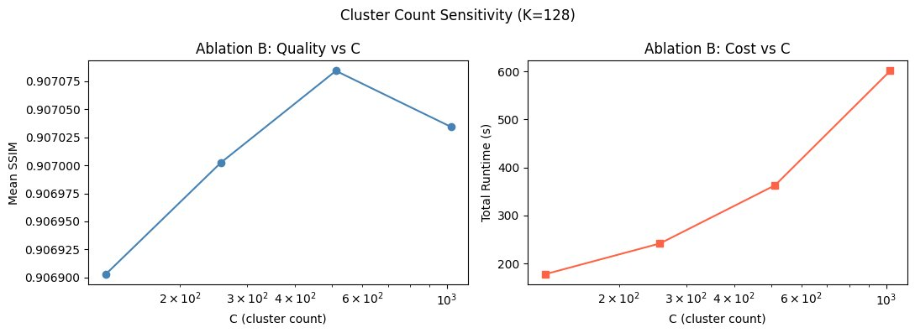
Fig. 6. Ablation B: SSIM and oracle runtime vs. cluster count C (K=128).
C. Ablation C — K-α Interaction
The α* label distributions across K values reveal a consistent pattern: regardless of palette size, the vast majority of patches receive α*=0.0. Mean α* values are 0.002 (K=64), 0.003 (K=128), and 0.001 (K=256). The distribution narrows at K=256, indicating that finer palettes require even less diffusion correction.
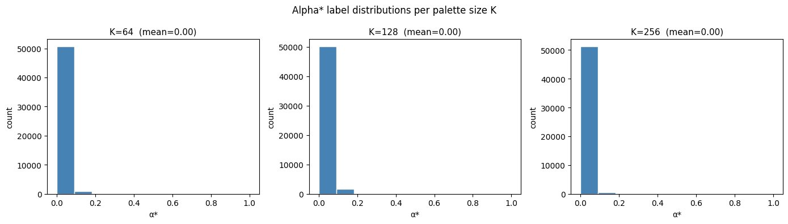
Fig. 7. Ablation C: α* label distributions per palette size K. Nearly all patches receive α*=0.
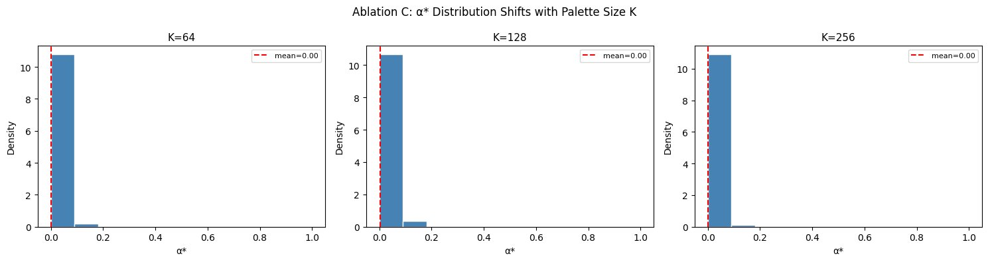
Fig. 8. Ablation C: α* density distributions at K∈{64,128,256}. Distribution collapses toward α*≈0.
D. Ablation D — Patch Size Sensitivity
TABLE IV. ABLATION D: PATCH SIZE (K=128)
Patch | SSIM | N Patches | BSD500 SSIM
16×16 | 0.9070 | 119,700 | 0.9381
24×24 | 0.9069 | 51,660 | 0.9380
32×32 | 0.9079 | 29,140 | 0.9388

Patch size 32×32 yields the best SSIM on both datasets. BSD500 SSIM column confirms the trend holds beyond Kodak images. The differences remain small (<0.001 SSIM), confirming robustness to patch size selection. The default 24×24 is retained as it balances context coverage with patch count.
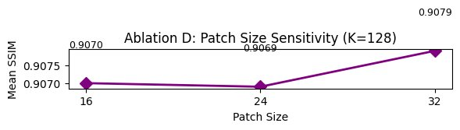
Fig. 9. Ablation D: mean SSIM vs. patch size at K=128.
VII. DISCUSSION
A. Why CNN-TAD Matches Median Cut
The central finding is that CNN-TAD achieves near-identical performance to the no-diffusion baseline (Median Cut) while substantially outperforming fixed and variance-adaptive diffusion. This is not a failure — it is the correct outcome given the oracle. The SSIM oracle reveals that for natural photographic content in both Kodak24 and BSD500, error diffusion in any form degrades SSIM relative to nearest-neighbor quantization.
This result is mechanistically sound: SSIM measures structural similarity, and error diffusion deliberately spreads error spatially, reducing local structural fidelity even if it improves perceptual appearance under certain viewing conditions. CNN-TAD learns to set α≈0 everywhere, recovering Median Cut performance. The advantage over M2 and M3 is that it avoids the SSIM penalty those methods incur by forcing non-zero diffusion. The BSD500 results at mean α*=0.004 confirm this is a generalizable property of natural images under SSIM evaluation, not a Kodak-specific artifact.
B. Limitations
- The near-uniform α*≈0 labels limit the CNN's ability to learn meaningful spatial variation. A more expressive oracle metric — such as LPIPS [9] or a human preference score — might yield a richer label distribution.
- The pixel-level Python diffusion loop is slow (11–15 s/image). A production implementation requires a compiled C extension or GPU scan.
- Evaluation is limited to 4 Kodak test images plus 5 BSD500 test images; statistical power for Δ<0.01 SSIM differences remains limited.
- Results may differ on synthetic images, cartoons, or indexed-color artwork where banding is more prominent and error diffusion is known to be beneficial.
C. Future Work
- Replacing SSIM with LPIPS or a learned perceptual metric as the oracle signal, which may assign non-trivial α* values and demonstrate clearer benefit from spatial adaptation.
- Extending the CNN to predict a full error diffusion kernel (not just strength), enabling direction-adaptive halftoning.
- Evaluating on synthetic gradient images explicitly designed to exhibit banding, where error diffusion is known beneficial.
VIII. CONCLUSION
This paper presented CNN-TAD, a CNN-guided texture-adaptive error diffusion pipeline for perceptual color quantization. The method uses a 5,217-parameter CNN to predict a continuous per-patch diffusion coefficient α, trained via cluster-amortized SSIM oracle labels at 200× lower cost than naïve labeling. The pipeline was evaluated on the Kodak24 benchmark across K∈{64,128,256} and generalized to the BSD500 dataset.
CNN-TAD substantially outperforms both fixed and variance-adaptive Floyd-Steinberg error diffusion (up to +5.79 dB PSNR, +0.170 SSIM at K=64) and matches the no-diffusion Median Cut baseline. Four ablation studies confirm C=512 as the optimal amortization point, robustness to patch size on both datasets, and reveal the label-collapse phenomenon: the SSIM oracle assigns α*≈0 to the majority of natural-image patches, confirmed on both Kodak24 and BSD500.
The primary contribution is the cluster-based label amortization framework, which is general and applicable to any patch-level parameter regression task requiring expensive oracle evaluation. Future work will explore LPIPS-based oracles and full kernel prediction.
REFERENCES
[1] R. W. Floyd and L. Steinberg, "An adaptive algorithm for spatial grey scale," Proc. Soc. Inf. Display, vol. 17, no. 2, pp. 75–77, 1976.
[2] P. S. Heckbert, "Color image quantization for frame buffer display," ACM SIGGRAPH Comput. Graph., vol. 16, no. 3, pp. 297–307, 1982. DOI: 10.1145/965145.801294
[3] D. Shaked and N. Arad, "Perceptually optimized error diffusion," Proc. SPIE, vol. 5008, pp. 136–147, 2003. DOI: 10.1117/12.473822
[4] N. Damera-Venkata and B. L. Evans, “Adaptive threshold modulation for error diffusion halftoning,” IEEE Trans. Image Process., vol. 10, no. 1, pp. 104–116, 2001. DOI: 10.1109/83.892447
[5] K. Zhang, W. Zuo, Y. Chen, D. Meng, and L. Zhang, "Beyond a Gaussian denoiser: Residual learning of deep CNN for image denoising," IEEE Trans. Image Process., vol. 26, no. 7, pp. 3142–3155, 2017. DOI: 10.1109/TIP.2017.2662206
[6] E. Kodak, "Kodak lossless true color image suite," [Online]. Available: https://r0k.us/graphics/kodak/
[7] P. Arbelaez, M. Maire, C. Fowlkes, and J. Malik, "Contour detection and hierarchical image segmentation," IEEE Trans. Pattern Anal. Mach. Intell., vol. 33, no. 5, pp. 898–916, 2011. DOI: 10.1109/TPAMI.2010.161
[8] Z. Wang, A. C. Bovik, H. R. Sheikh, and E. P. Simoncelli, "Image quality assessment: From error visibility to structural similarity," IEEE Trans. Image Process., vol. 13, no. 4, pp. 600–612, 2004. DOI: 10.1109/TIP.2003.819861
[9] R. Zhang, P. Isola, A. A. Efros, E. Shechtman, and O. Wang, "The unreasonable effectiveness of deep features as a perceptual metric," Proc. CVPR, pp. 586–595, 2018. DOI: 10.1109/CVPR.2018.00068

GENAI TOOL USAGE ACKNOWLEDGEMENT
This project was developed with assistance from Claude (Anthropic), ChatGPT (OpenAI), and Gemini (Google). Claude was used for technical pipeline design, code generation across all implementation stages, incorporation of instructor feedback, and document drafting. ChatGPT provided initial project scoping. Gemini assisted with literature identification. All AI-generated content was reviewed, verified against primary sources, and revised by the author, who takes full responsibility for its accuracy and academic integrity.

