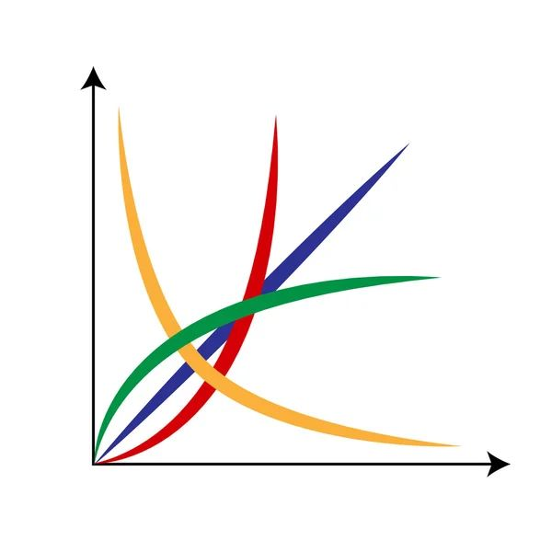



Task 1: Crosswalk Recognition

|  |  |
| --- | --- |
| **Observation** | **Result** |
| Crosswalk Detected | [ ] Yes [ ] No |
| Audio Warning | [ ] Correct [ ] Incorrect |

Task 2: User in the Center of Crosswalk

|  |  |
| --- | --- |
| **Observation** | **Result** |
| User in Center | [ ] Yes [ ] No |
| Audio Warning | [ ] Correct [ ] Incorrect |

Task 3: Traffic Light Recognition (Red)

|  |  |
| --- | --- |
| **Observation** | **Result** |
| Red Light Detected | [ ] Yes [ ] No |
| Audio Warning | [ ] Correct [ ] Incorrect |

Task 4: Traffic Light Recognition (Green)

|  |  |
| --- | --- |
| **Observation** | **Result** |
| Green Light Detected | [ ] Yes [ ] No |
| Audio Warning | [ ] Correct [ ] Incorrect |

Task 5: Obstacle Detection

Obstacle 1:

|  |  |
| --- | --- |
| **Observation** | **Result** |
| Obstacle Detected | [ ] Yes [ ] No |
| Audio Warning | [ ] Correct [ ] Incorrect |
| User Direction | [ ] Correct [ ] Incorrect |
| Distance Warning | [ ] Yes, different [ ] No, same |

Obstacle 2:

|  |  |
| --- | --- |
| **Observation** | **Result** |
| Obstacle Detected | [ ] Yes [ ] No |
| Audio Warning | [ ] Correct [ ] Incorrect |
| User Direction | [ ] Correct [ ] Incorrect |
| Distance Warning | [ ] Yes, different [ ] No, same |

Task 6: Ending of Crossing

|  |  |
| --- | --- |
| **Observation** | **Result** |
| End of Crossing | [ ] Yes [ ] No |
| Audio Warning | [ ] Correct [ ] Incorrect |

Task 7: Additional Comments (Optional)