Bilkent University

**Monopoly Project Group 2J**

*Bilopoly: Monopoly’s Bilkent version*

Final Report

Asım Güneş Üstünalp, Mohammed S. Yaseen,  Turan Mert Duran, Radman Lotfiazar, Mohammad Elham Amin

**Instructor:** Eray Tüzün

**Teaching Assistants:** Barış Ardıç, Emre Sülün, and Elgun Jabrayilzade

Contents

1. Introduction: 3

2. Lessons Learnt: 4

3. User’s Guide (Manual): 5

3.1. New Game 6

3.2. Load Game 6

3.3. Setting 7

3.4. How to play 8

3.5. Credits 9

3.6. Quit 9

3.7. Map 9

3.8. Chance Card 11

3.9. Properties 11

3.10. Vending Machine 11

3.11. Starbucks 12

3.12. Roll Dice 13

3.13. Trade Offer 14

4. Build Instruction: 16

4.1. How to Install 16

4.2. System requirements 16

# Introduction:

Bilopoly is a virtual version of Monopoly with some interesting variations in the rules and design. Its design is inspired from Bilkent University and most of the attributes are named based on that. We implement the whole game. Features including rules, propertes and concepts from the original version of Monopoly which we have decided to use in Bilopoly are implemented successfully and they are observable in the game. Furthermore, new features stated in the README text also implemented and you are able to play Bilopoly with those features. Moreover, user interface which we indicate in the Analyze report is implemented and Bilopoly is played based on those UI. However, for missing part we can mention BankAccount class which most of the attributes related to bank including mortgage, investing money and taxes are not implemented due to lack of time. Furthermore, all methods for saving game are implemented and working correctly while, we do not use them in Bilopoly. There reason for this is LoadGame class which we are facing with a problem and we cannot solve it due to lack of time and energy.

# Lessons Learnt:

Since for writing analyze and design reports of Bilopoly Game we have to use different UML diagrams including, use-case, sequence, state, activity and class object diagrams, we as a group learn that how we should design these diagrams for a project and how we should connect these diagrams to each other in order to have a consistent system. Moreover, for solving issues related to software and communication between designers being more efficient we learn different design pattern including singleton and strategy design patterns. Furthermore, requirement engineering is another topic, which during designing and implementing this project, we understand how much it is crucial and try to learning it. For instance, in this project we should understand what instructor wants, what wishes might be asked through designing the project and what technical environment we need for this project. However, reverse engineering is one of the most important knowledge which have been learnt throughout this project. For having an object oriented program, we need to break down the project. Therefore, learning reverse engineering helps us to figure out how each part of the project should be designed and built.

# User’s Guide (Manual):

In the first page of the game you are provided with six different menu options as you can see in figure 3.1-1.

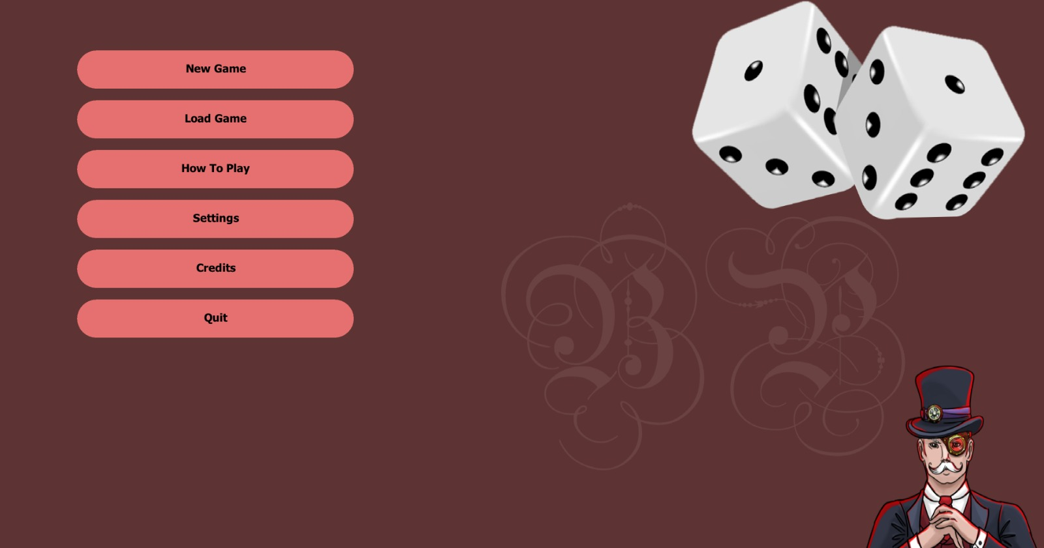

Figure ‎3.1‑1

1. New Game allow you start the new game.
2. Load Game allow you to open the saved games
3. Setting allow you to make change in music and other option
4. How to play is a brief explanation about the changes in the original version of monopoly
5. Credit is a brief information about group members
6. Quit allow you exit the game.

## New Game

After pressing New Game you can chose name, token, color for each player. As a default there is only two player in this screen but you can add or delete player as much as you want up to 8 players.

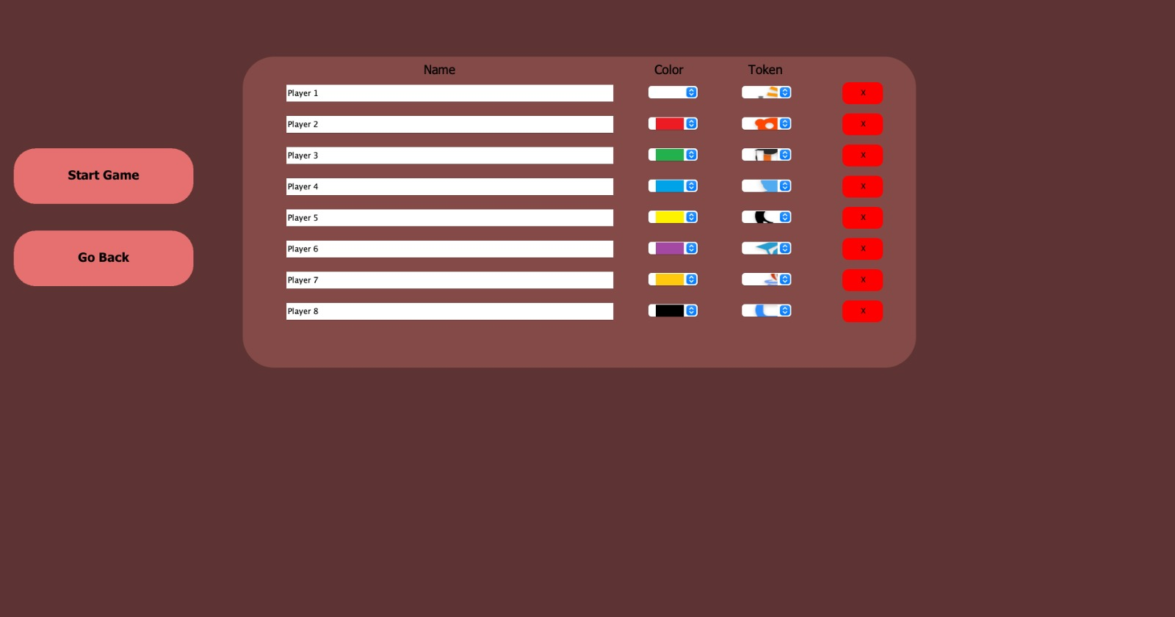

Figure ‎3.1‑1

## Load Game

After pressing load Game you are will see the below page which there are saved games. Each saved game has the name which is asked when you want to saved it and date of your last saved. Furthermore, in this game you can load the game or delete it as you can see in figure 3.2-1.

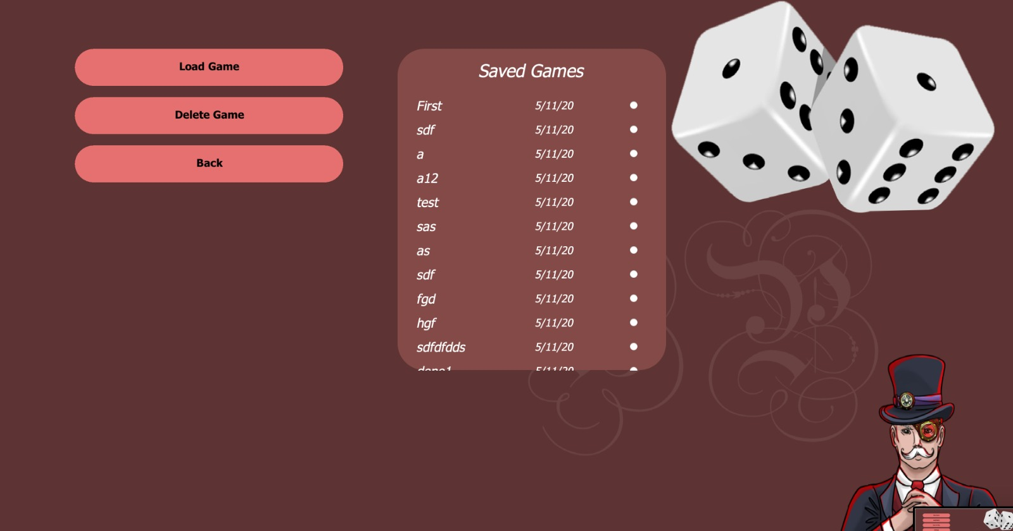

Figure ‎3.2‑1

## Setting

In this menu you are able to make change in the volume of the music and sound effect for different actions including rolling dice and moving. As default they are moderate but you are able to increase or decrease them.

Figure ‎3.3‑1

Figure ‎3.3‑1

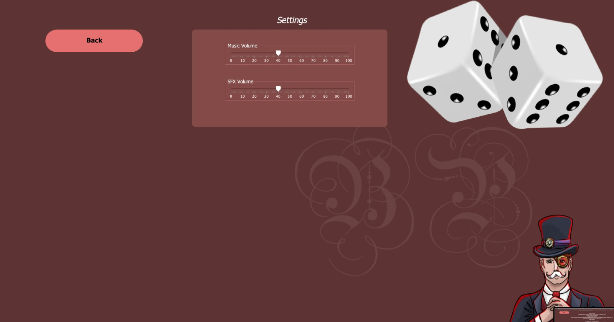

## How to play

In this part we only mention to the changes which we considered for this version of monopoly and explained which are these changes. Changes are including design or rules one which both of them explained completely for players to understand what are these changes.

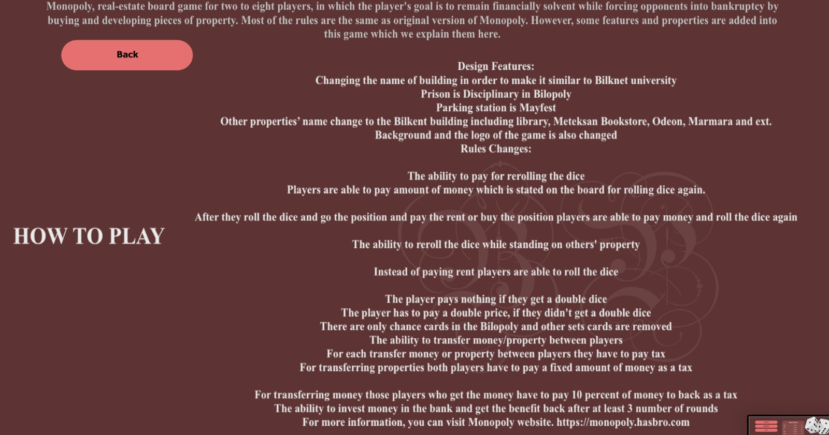

Figure ‎3.4‑1

## Credits

In this option we give very brief information about who design and implement this version of Monopoly and what is the purpose. Furthermore, there is our Github project which will be public soon and people for more information can visit our Github.

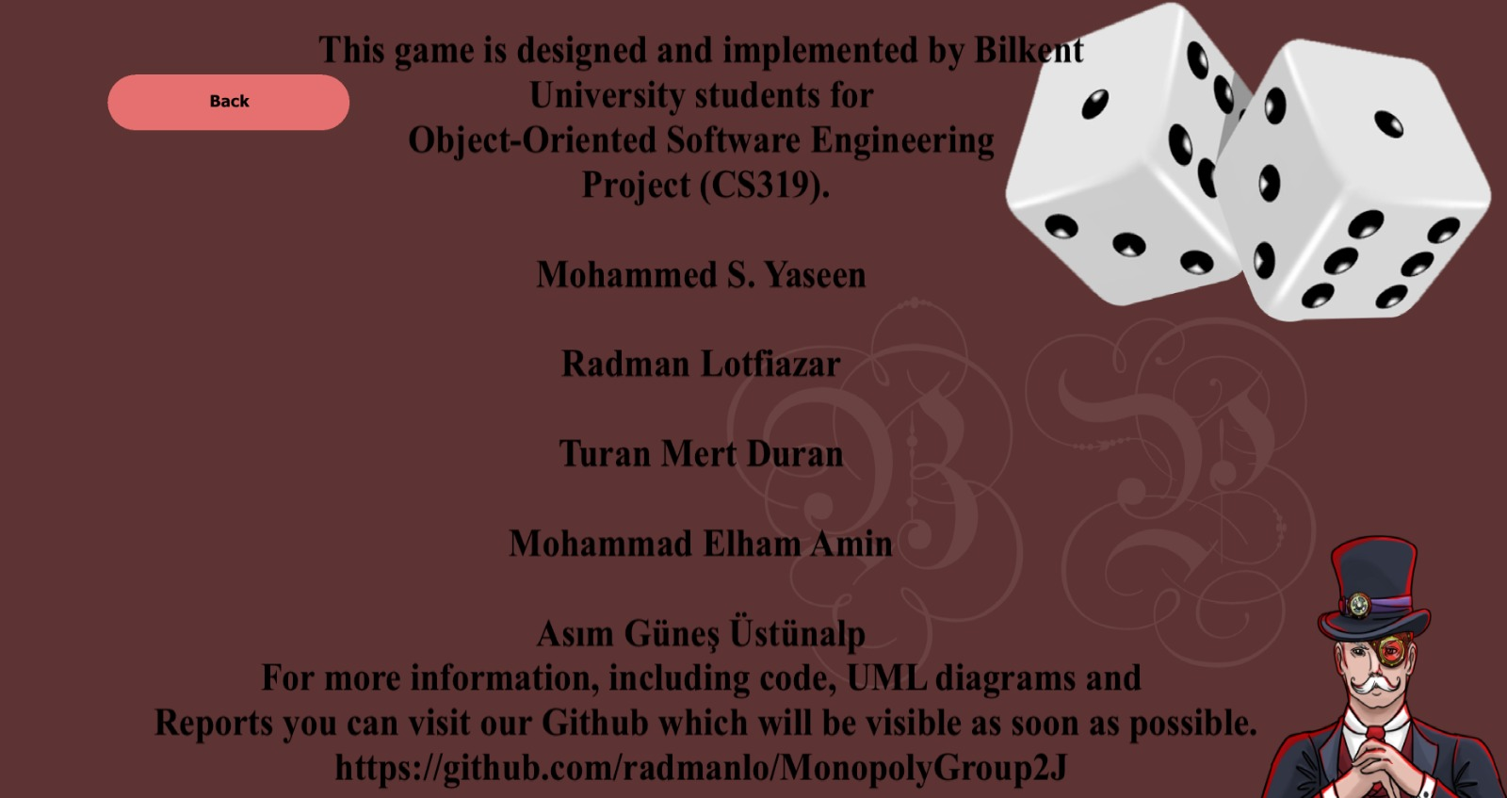

## Quit

By pressing this option, you can exit the game. However, before getting you are face with a message as you can see in the below picture which by pressing Yes you will exit the game.

Figure ‎3.6‑1

## Map

We change the Monoply map. Most of the names of locations on the board are changed. New names are inspired by Bilkent university. As you can see in the below picture instead of prison, parking, electtical companies there are Disciplinary, Mayfest and SMD Line respectively on the board. However, concept is the same as original version of monopoly and player can buy them and if they are not owner have to pay rent.

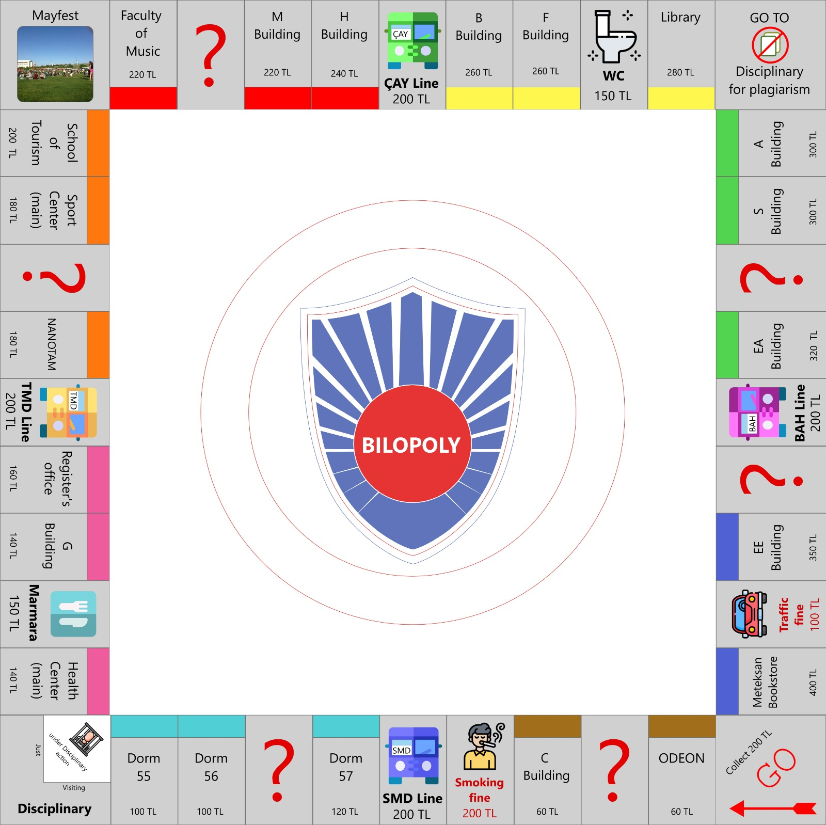

Figure ‎3.7‑1

## Chance Card

In the figure 3.7-1 where players are able to draw the chance are indicated by the question mark. Therefore, when players come to those locations they are provided by a chance card.

## Properties

In the figure 3.7-1 you can see that each group of properties has different colors. If players have all of those color their rent will be increased. Also by having all color players are able to add vending machine and after four of them they can add Starbucks.

## Vending Machine

Instead of the houses which is used in the original game for Bilopoly we used vending matching. After all properties in that specific group has 4 vending machine players are able to add Starbucks. Figure 8 indicates that how we show vending machine each place.

Figure ‎3.10‑1

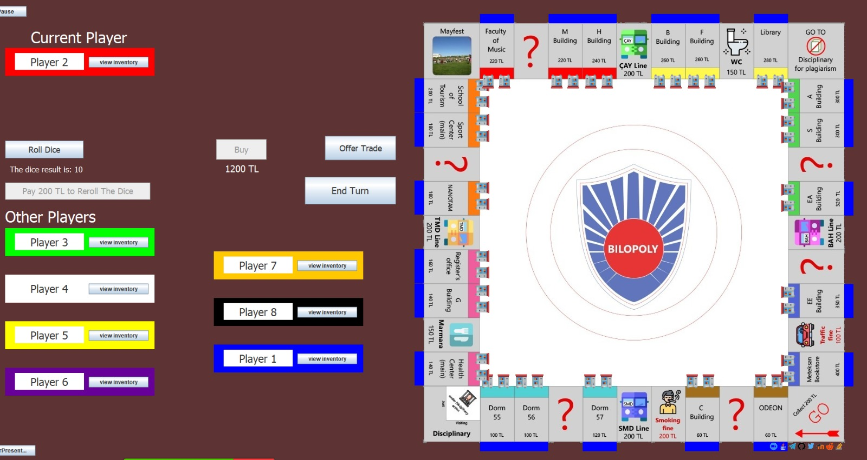

Figure ‎3.10‑2

## Starbucks

Instead of the hotel which is used in the original game we have Starbucks for making it similar to Bilkent university. In Bilkent university buildings have Starbucks are the most popular. Therefore, players should try harder to have one of them. Figure 3.11-1 indicates that how we show Starbucks on the board.

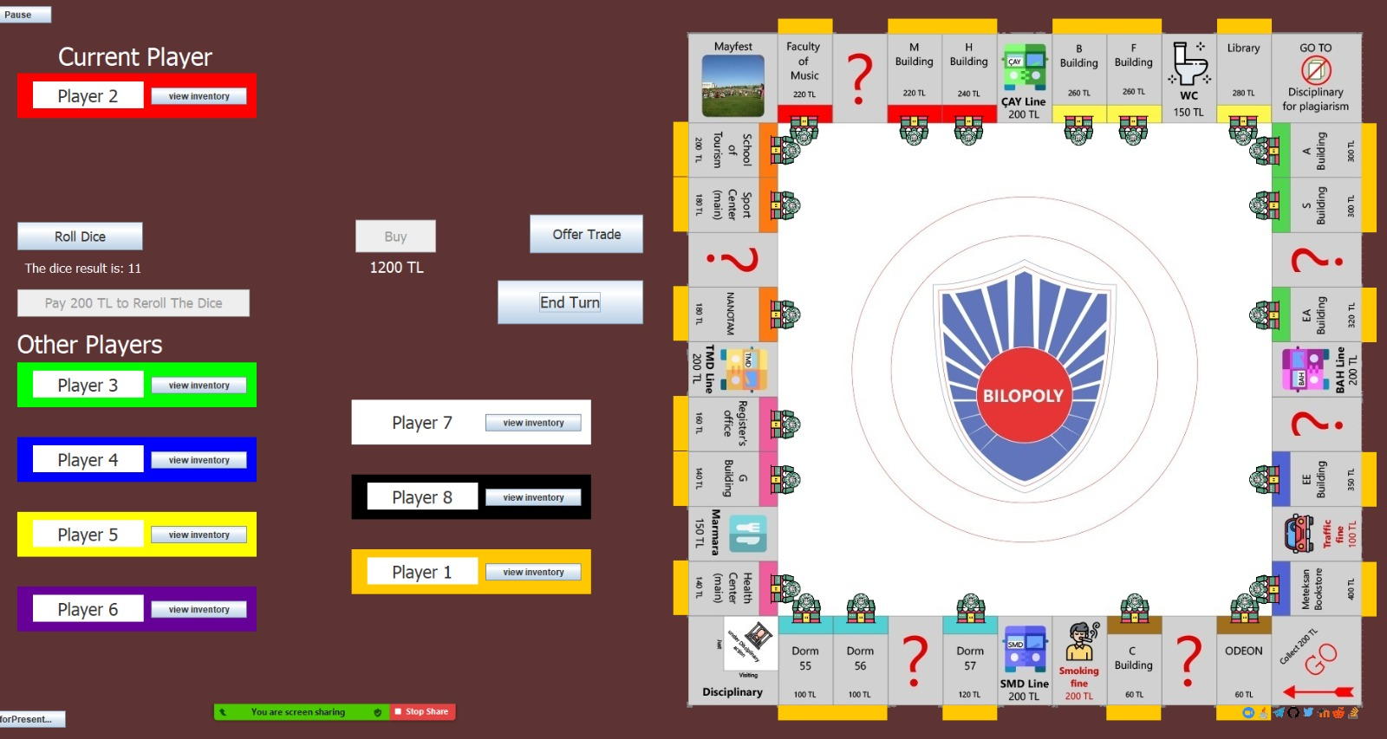

Figure ‎3.11‑1

## Roll Dice

Each player for moving have to roll the dice. In the figure 3.12-1 you can see that by pressing the roll dice, dice results will show on the board and token start to moving.

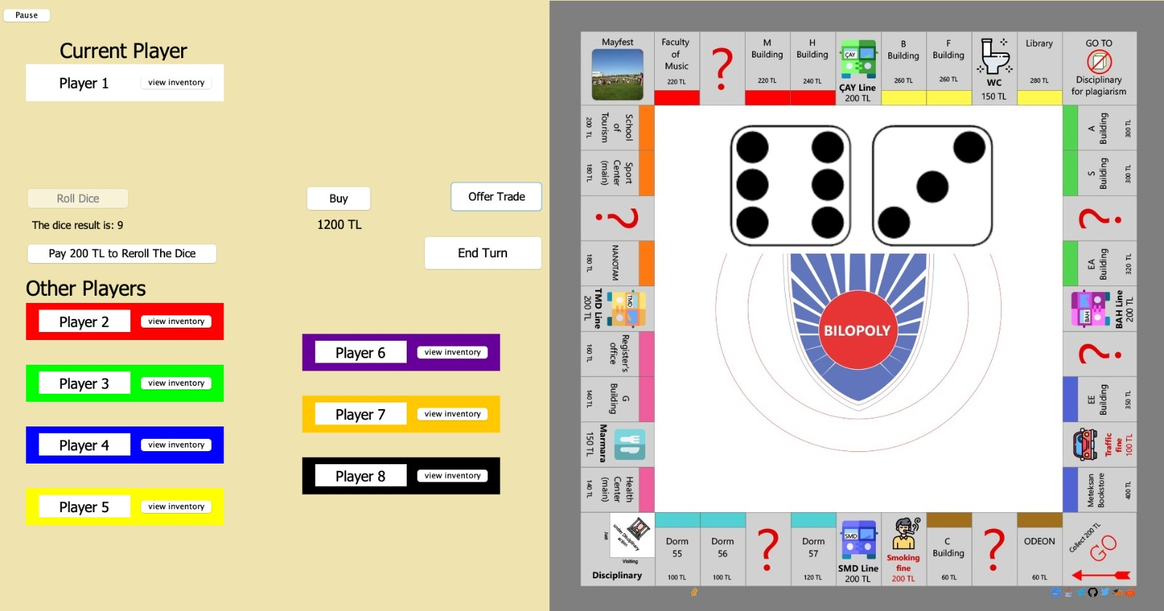

Figure ‎3.12‑1

After moving to that location player might have to pay rent. In that situation player will faced with a message the same as figure 3.12-2.

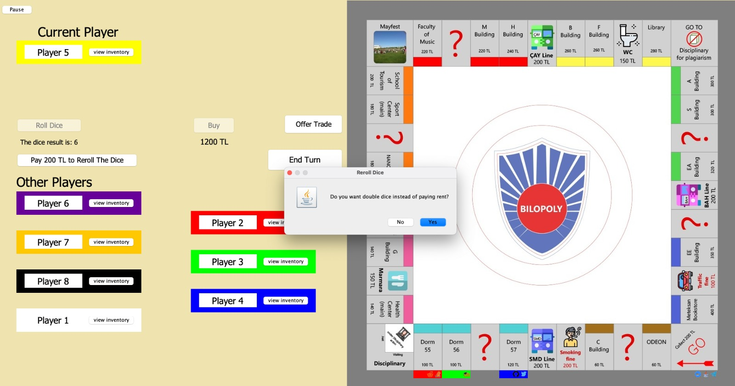

Figure ‎3.12‑2

After that if you accept it dice will be rolled and if it was double you do not have to pay rent otherwise you have to pay double of rent. Furthermore, after paying rent players are able pay 200TL and reroll the dice by pressing the that button and this procedure will repeat again.

## Trade Offer

Current player can press the Offer Trade Button and ask for trade. After pressing that button player is face with figure 3.13-1. Player has to select that offer is provided to whom and what items want and give. Furthermore, instead of the items player also ask and give money for those item.

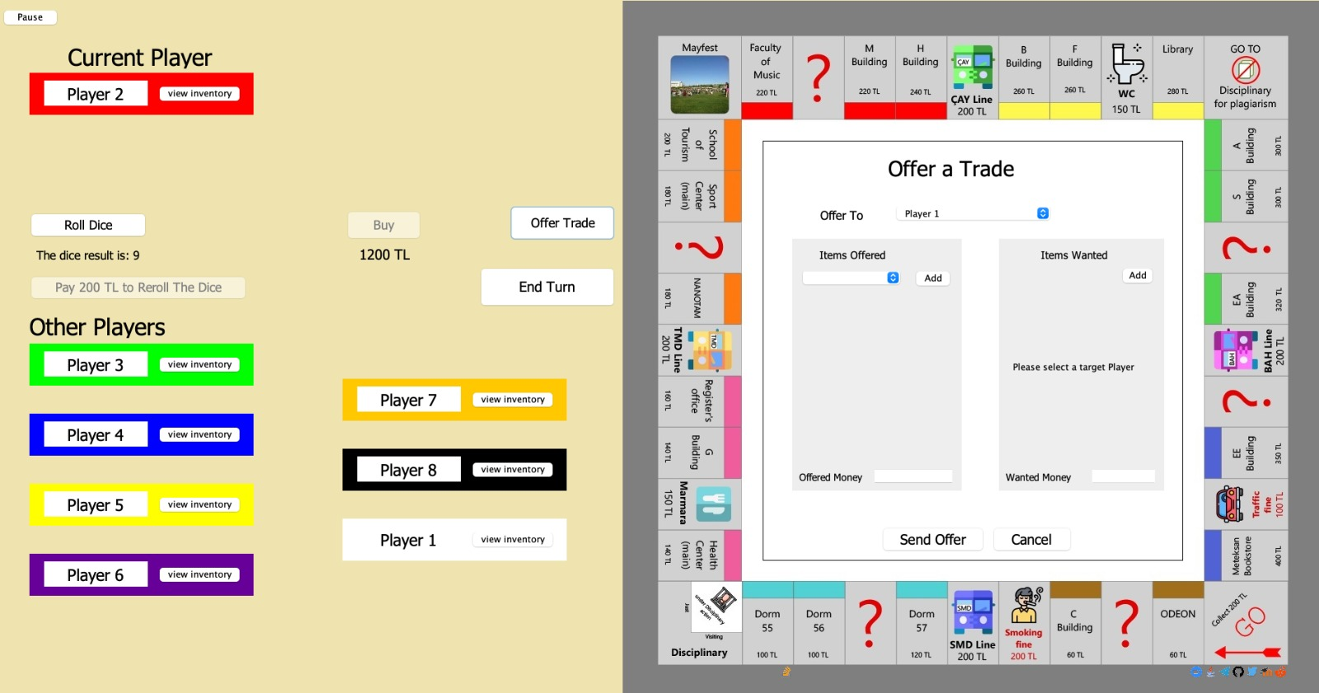

Figure ‎3.13‑1

Player provided by the offer will be faced with the figure 3.13-2. Player is able to make change to that offer or accept that.

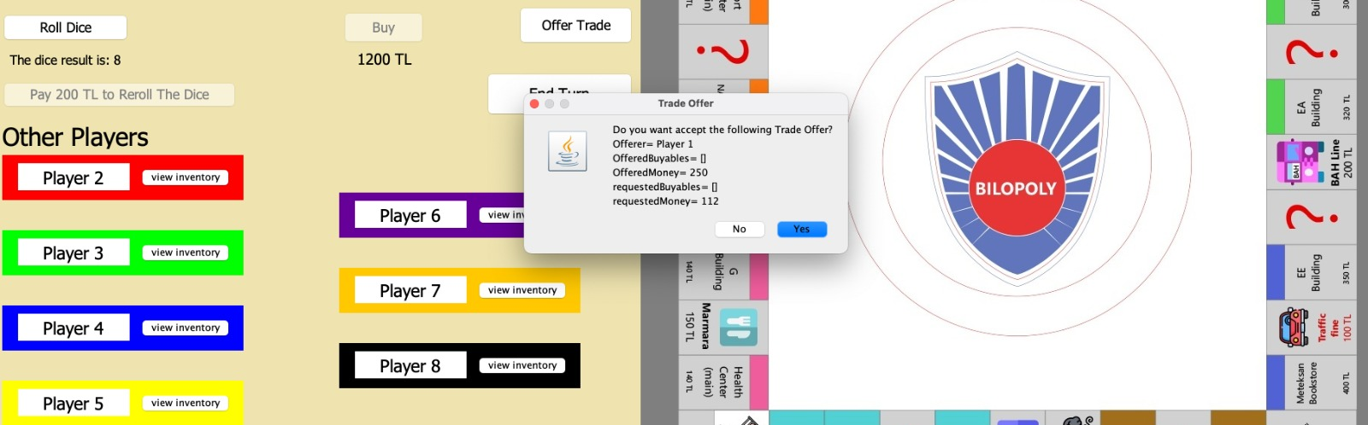

Figure ‎3.13‑2

# Build Instruction:

## How to Install

* Go to this Github address for finding our report and source code
  + <https://github.com/radmanlo/MonopolyGroup2J>
* You can clone our project via command or bash
  + You can also download our project in a zip file
* In the ProjectCode file there is our source code
* You can run it by any java compiler

## System requirements

There is not any special requirement for this game. Any computer which is able to run the java code and has an updated version of java (1.8 version) is able to run. However, for this game you have to set your resolution as 1920x1080 and zoom percentage 100%.