SIMPLE LEARN
TRAINEE MANAGEMENT SYSTEM
System Documentation & Feature Guide

A web-based application for managing organizational records
and coordinating training and trainee-related activities.
Frontend: Angular | Backend: Django REST Framework | Database: MySQL

1. Executive Summary
Simple Learn – Trainee Management System is a web application designed to support administrative and training-related workflows through a centralized browser interface. The supplied screens show an administration area for branches and locations, course and subject management, batches, trainer and trainee records, and a profile page.
The project uses Angular for the frontend, Django with Django REST Framework for backend APIs, and MySQL for data storage. The frontend communicates with the backend through HTTP requests, while Django handles request processing and database access.

2. Technology Stack
Frontend | Angular
Backend | Python, Django, Django REST Framework
Database | MySQL
API style | REST APIs
Development / API testing | Visual Studio Code and Postman

3. Core Capabilities & Features

Administration and Organization
- Branch Management: add and view branch records.
- Location Management: add location information through the administration interface.
- Profile Access: view account/profile information and access the available navigation options.

Training and Learning Management
- Course Management: view courses and access add/update workflows.
- Subject Management: view subjects and access subject/topic management dialogs.
- Batch Management: view batches and access add/update workflows.
- Trainer Management: view trainer records and open trainer detail/edit forms.
- Trainee Management: view trainee records and open trainee detail/edit forms.
The feature descriptions above are based on the supplied screenshots. Any functionality not clearly represented in those screens is not assumed in this guide.

4. Application Screens and Workflow
The screenshots below have been arranged by workflow: account access, administration setup, course and subject management, batch management, trainer and trainee management, and profile access. Figure numbers correspond to the screenshots in the supplied document.

4.1 Account Access
Users begin at the sign-in page. A separate registration screen is also included in the supplied screenshots.
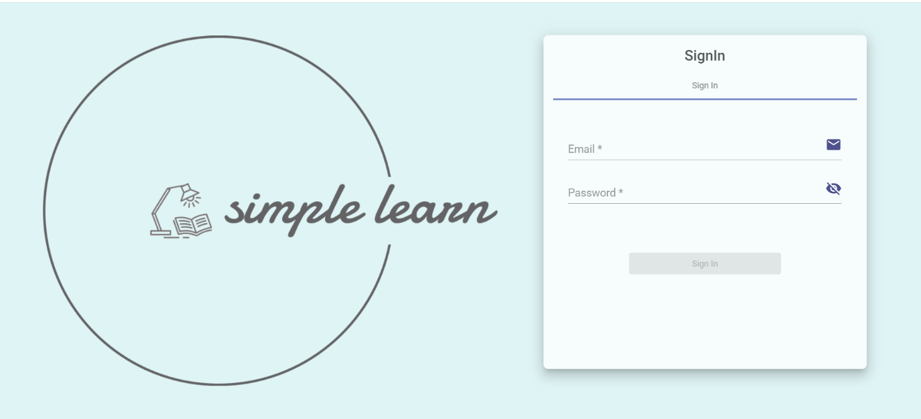
Figure 1. Sign-in Page
Application entry screen with the Simple Learn branding and sign-in form.
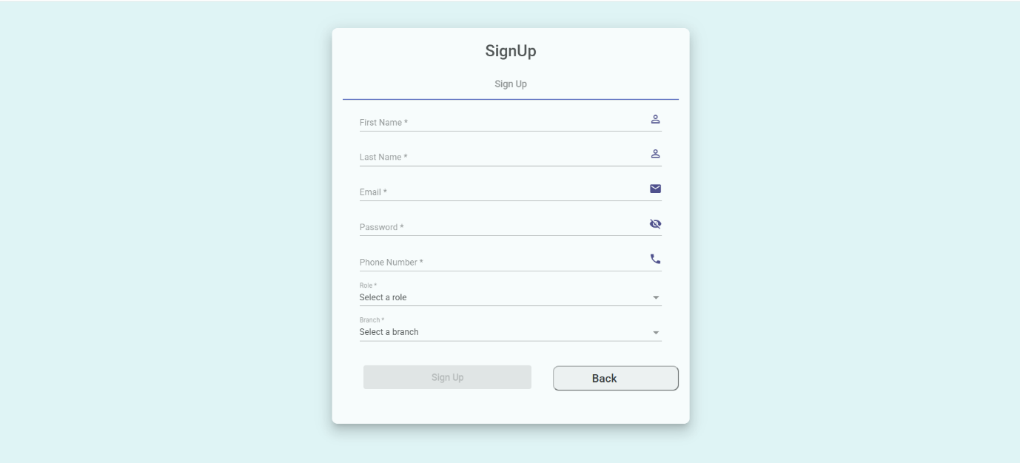
Figure 8. Registration Page
Account registration form.

4.2 Administration Dashboard and Organization Setup
The administration dashboard provides navigation to organization-related modules.
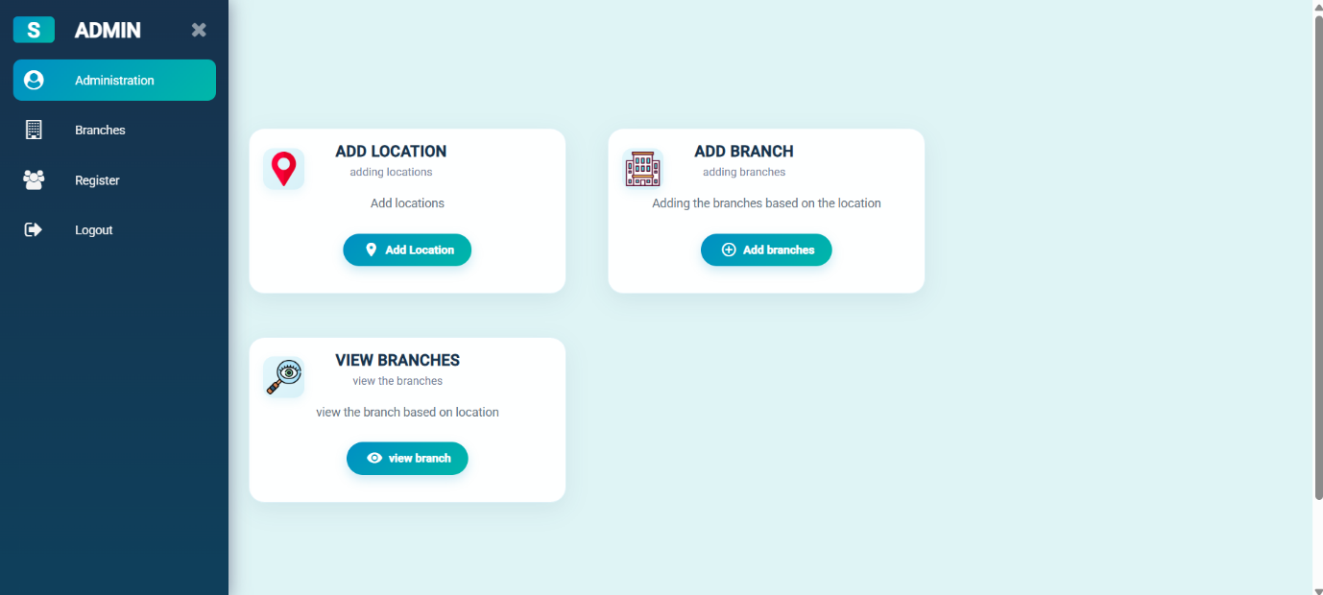
Figure 2. Administration Dashboard
Main administration page with links to branch and location workflows.
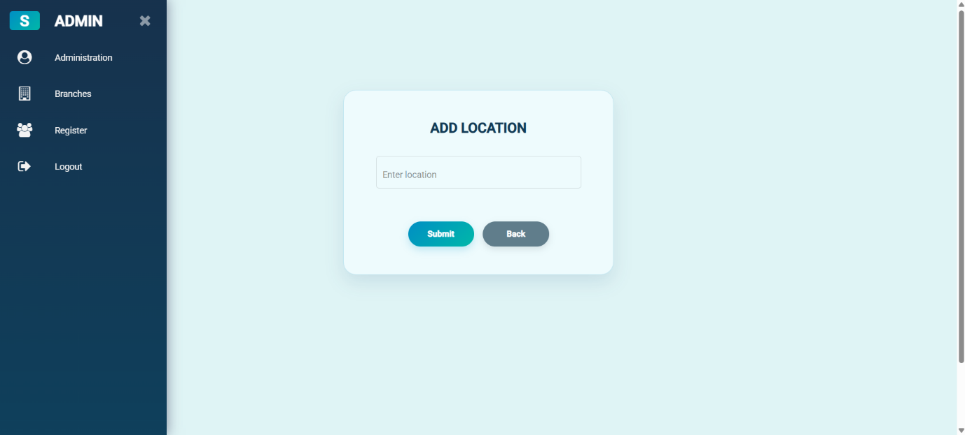
Figure 3. Add Location – Initial Form
Location form in its initial state.
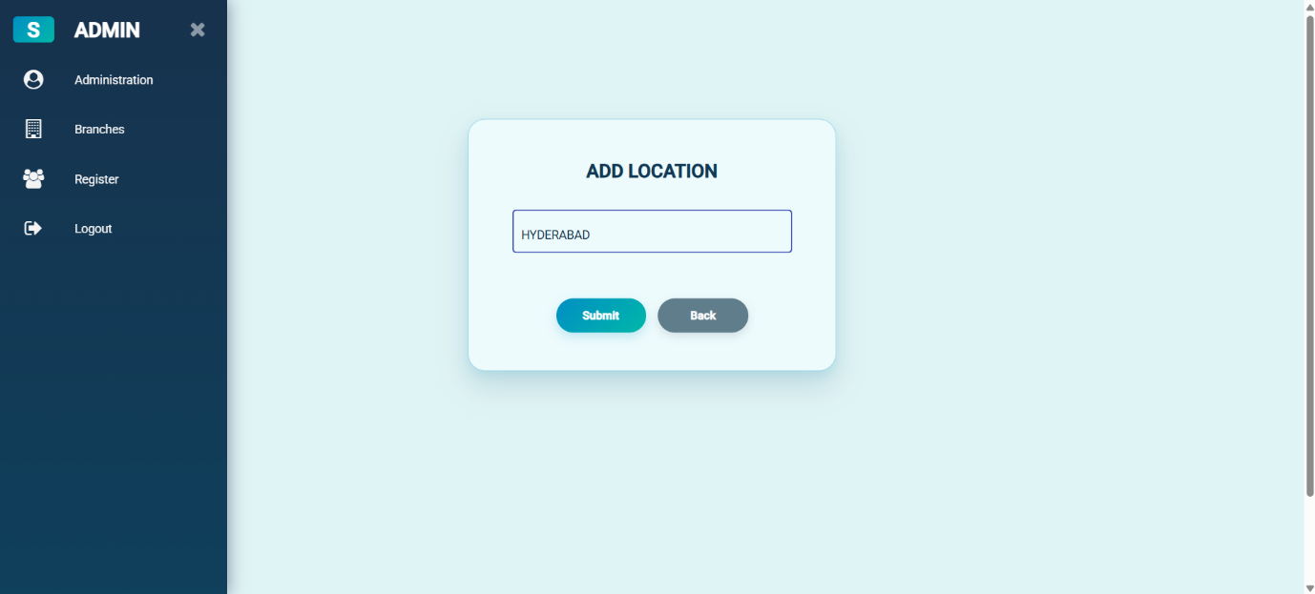
Figure 4. Add Location – Entry Form
Location form with the location field displayed.
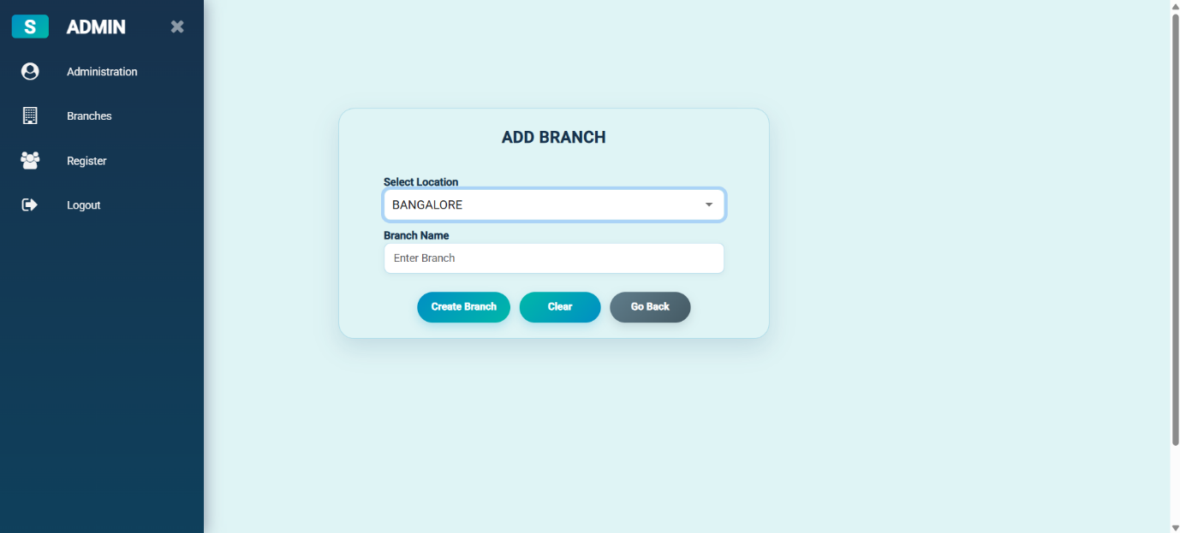
Figure 5. Add Branch – Initial Form
Branch form in its initial state.
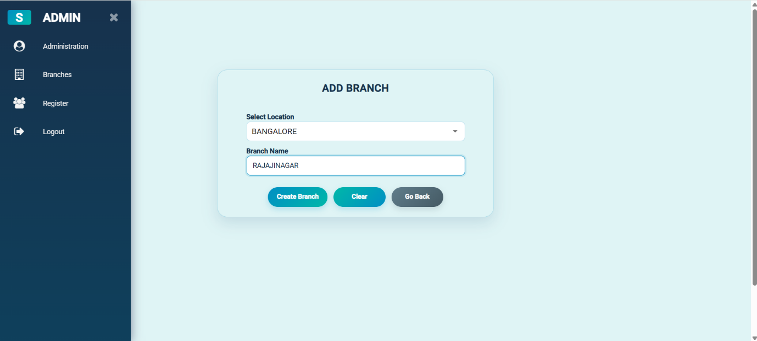
Figure 6. Add Branch – Completed Form
Branch form with entered values.
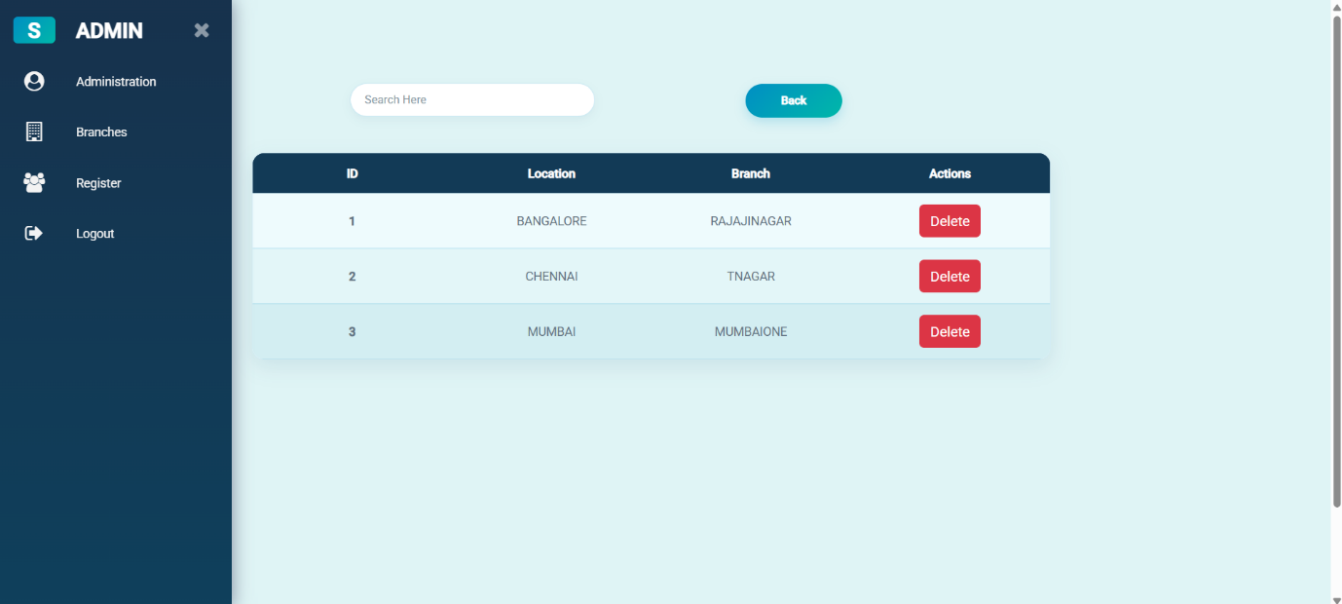
Figure 7. View Branches
Branch listing with available record actions.

4.3 Course Management
The course screens show the course list as well as forms for adding and updating course details.
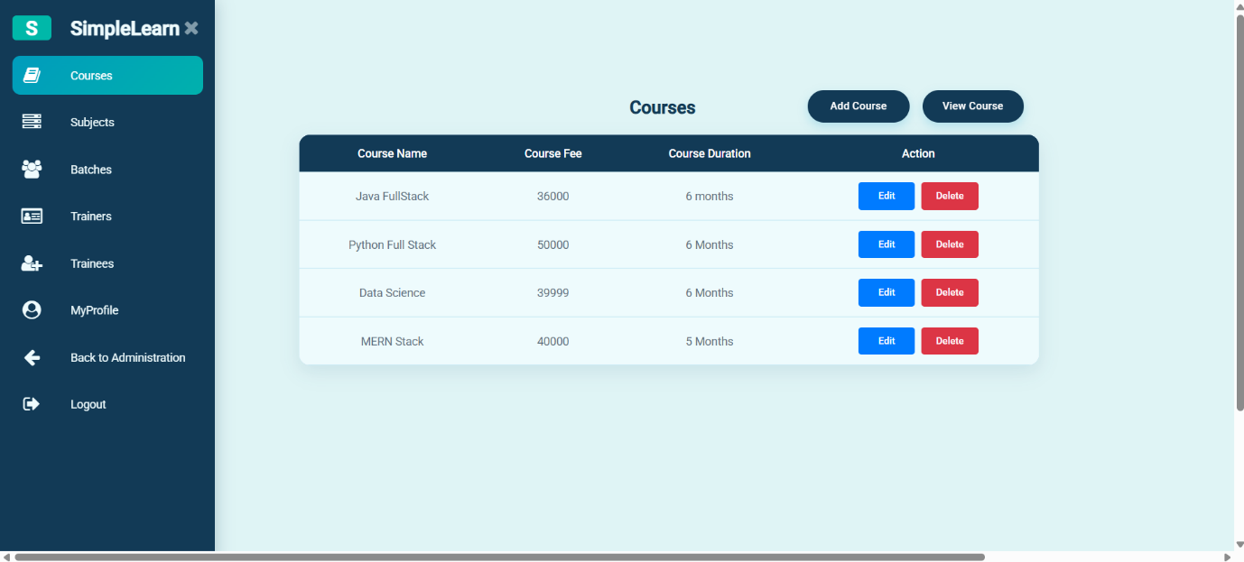
Figure 9. Courses List
Course listing and available management actions.
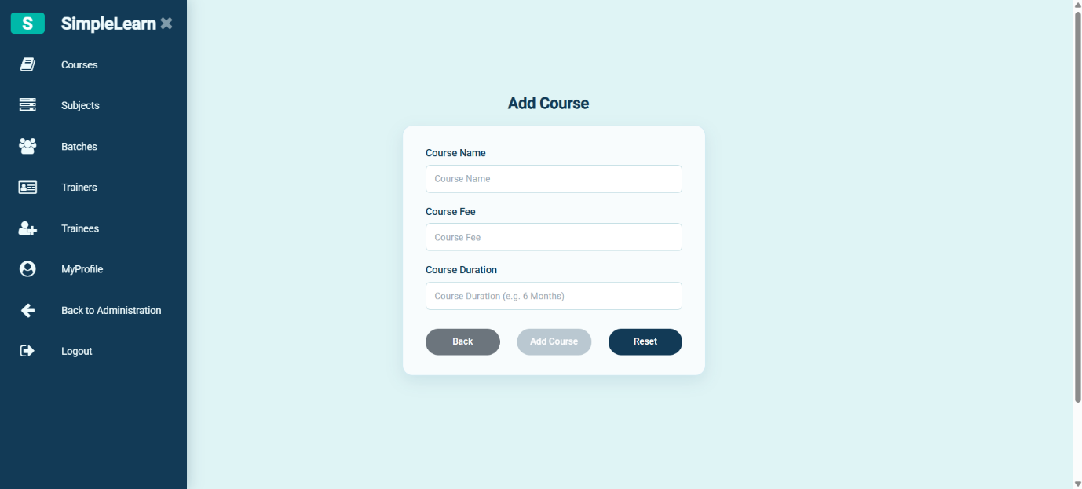
Figure 10. Add Course
Form for entering a new course.
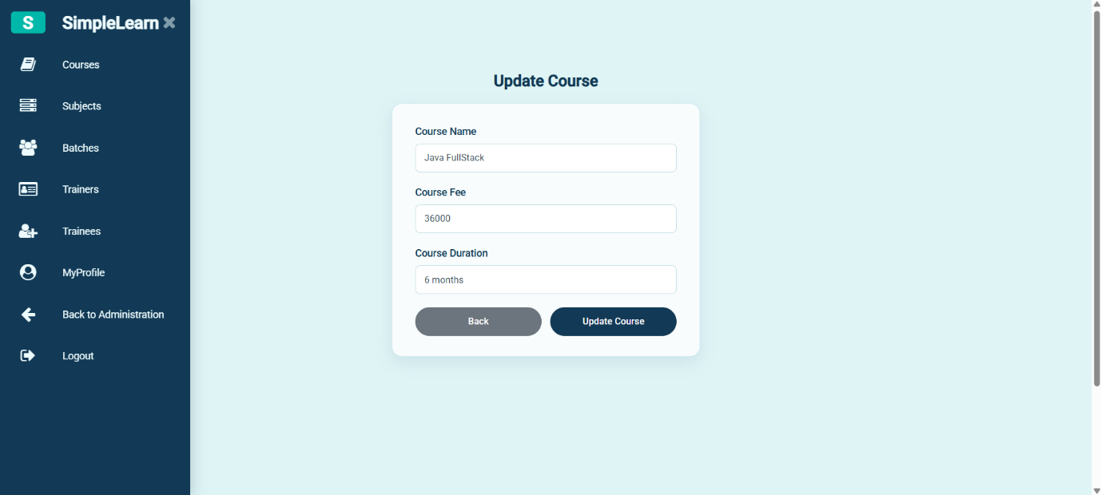
Figure 11. Update Course
Form for updating course information.
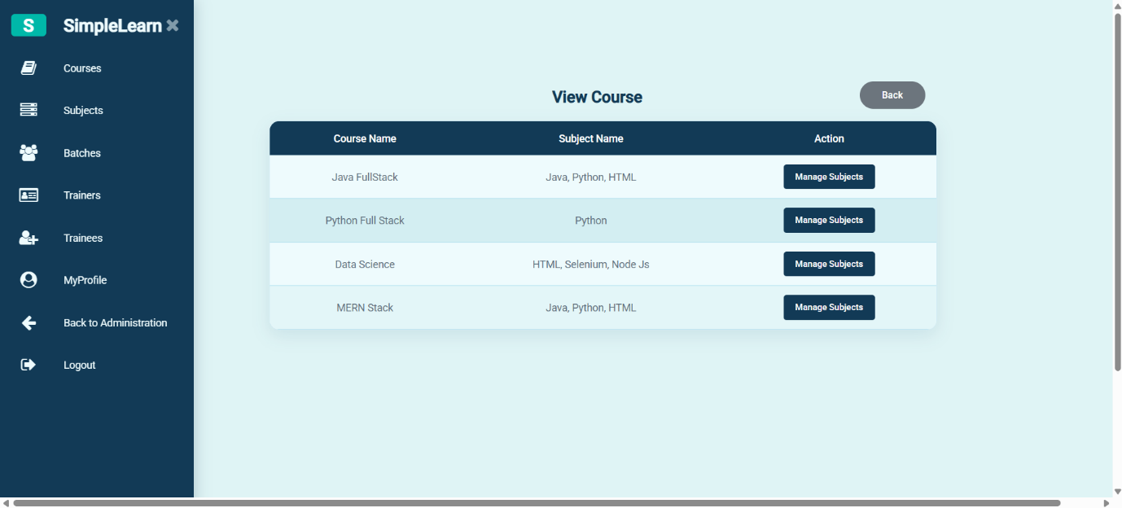
Figure 12. View Course
Course view with subject-management access.

4.4 Subject and Topic Management
The subject screens show the subject list and dialogs for managing subjects and topics.
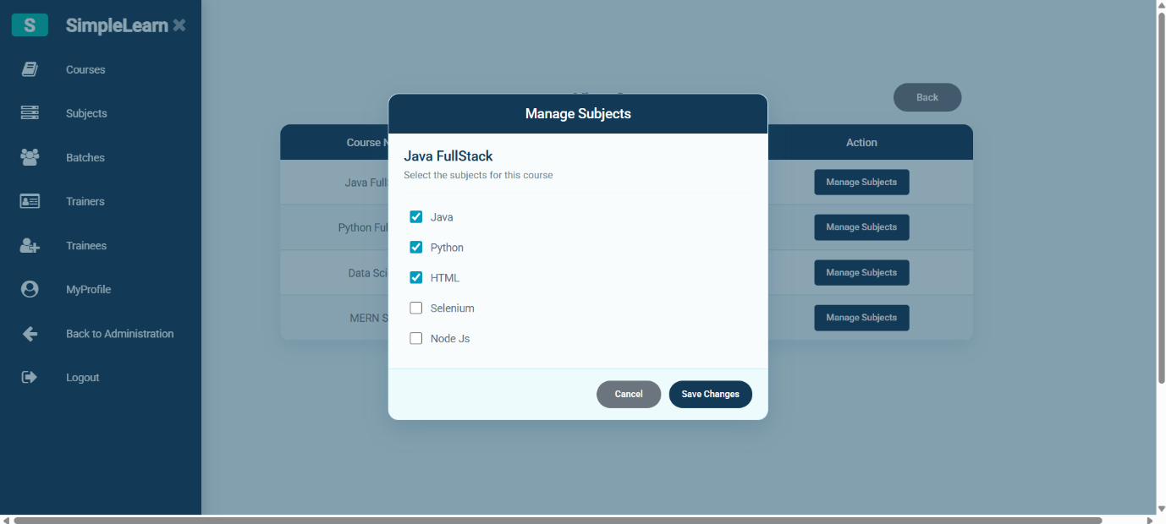
Figure 13. Manage Subjects Dialog
Dialog for selecting or managing subjects associated with a course.
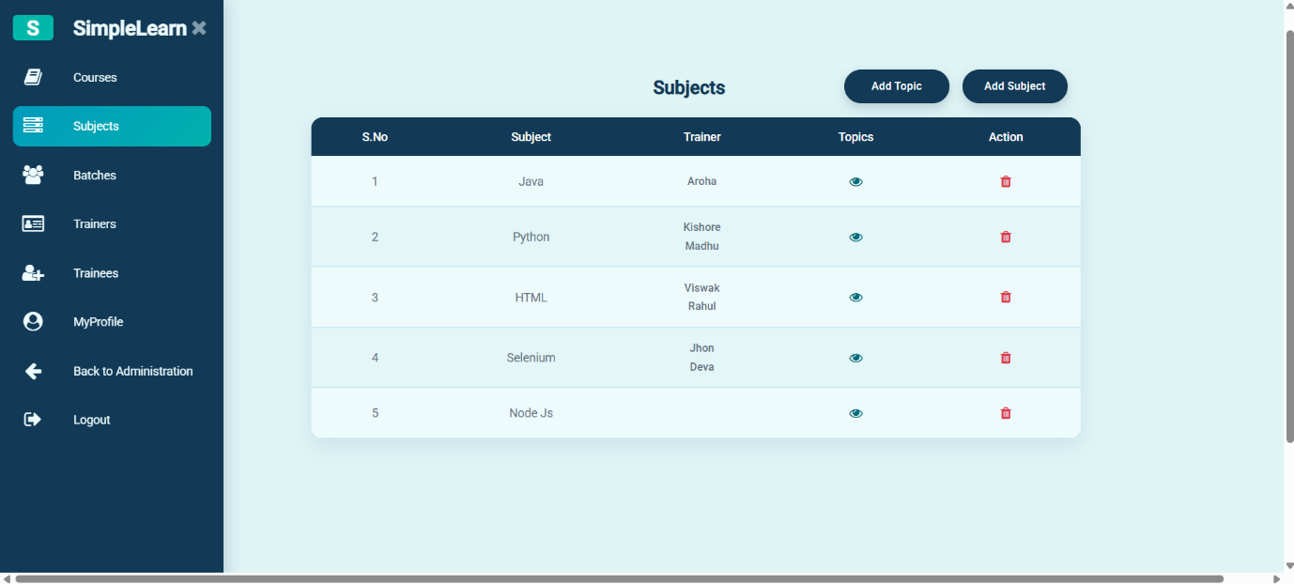
Figure 14. Subjects List
Subject listing with available subject actions.
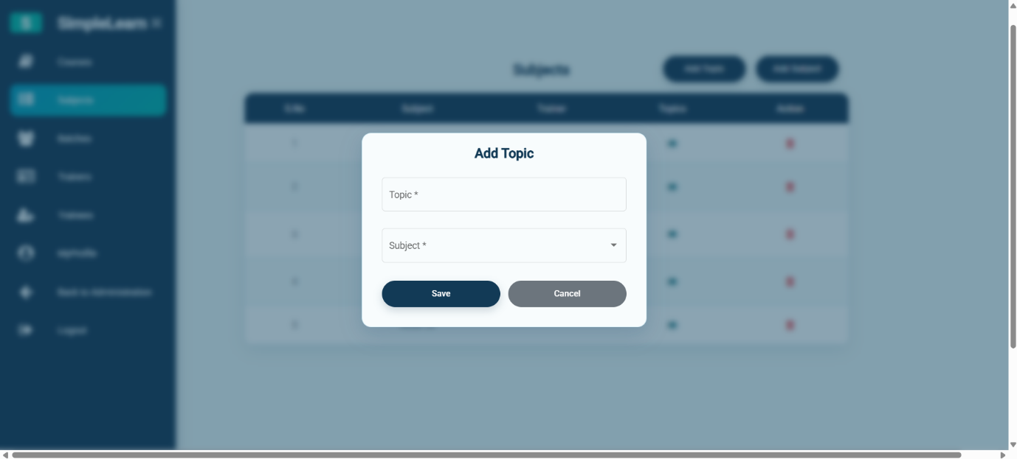
Figure 15. Add Topic Dialog
Dialog for adding a topic.
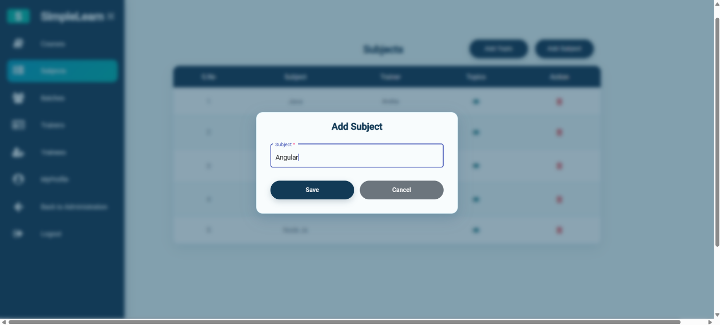
Figure 16. Add Subject Dialog
Dialog for adding a subject.

4.5 Batch Management
The batch screens show the batch listing and the forms used to add or update batch information.
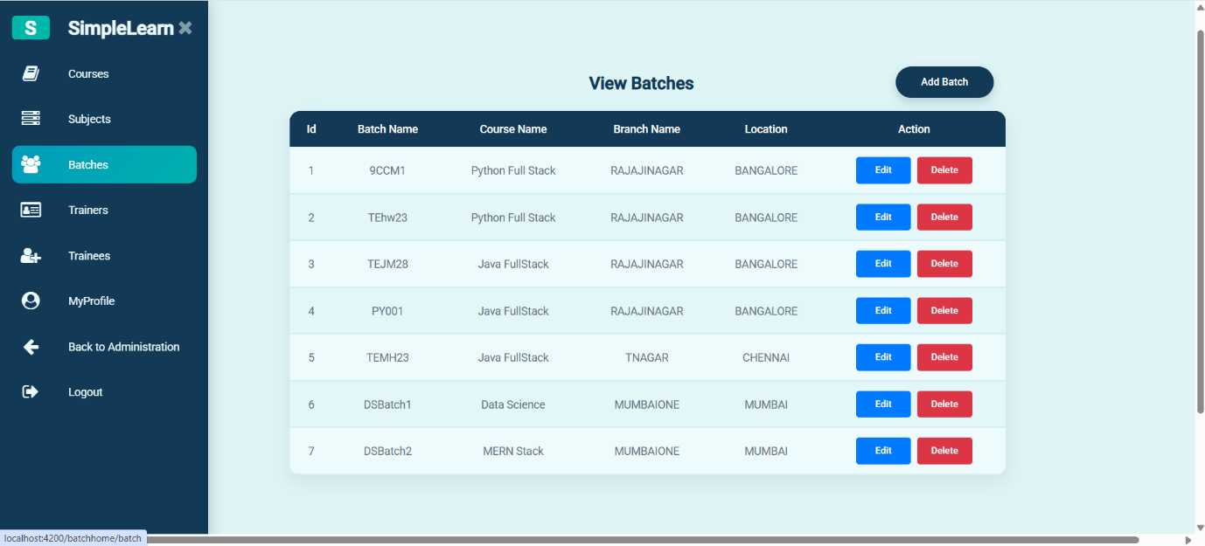
Figure 17. View Batches
Batch list with available record actions.
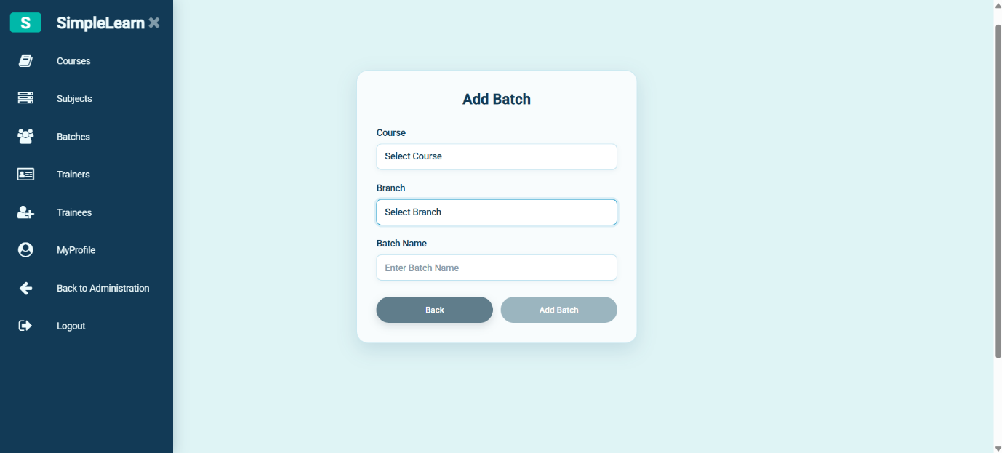
Figure 19. Add Batch
Form for entering a new batch.
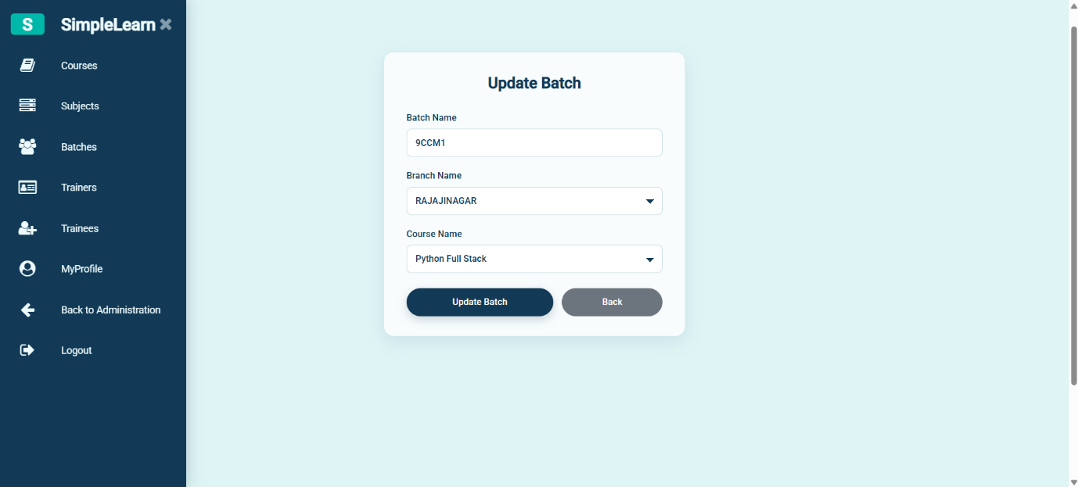
Figure 18. Update Batch
Form for updating an existing batch.

4.6 Trainer Management
The trainer area displays trainer records and includes detail/edit dialogs.
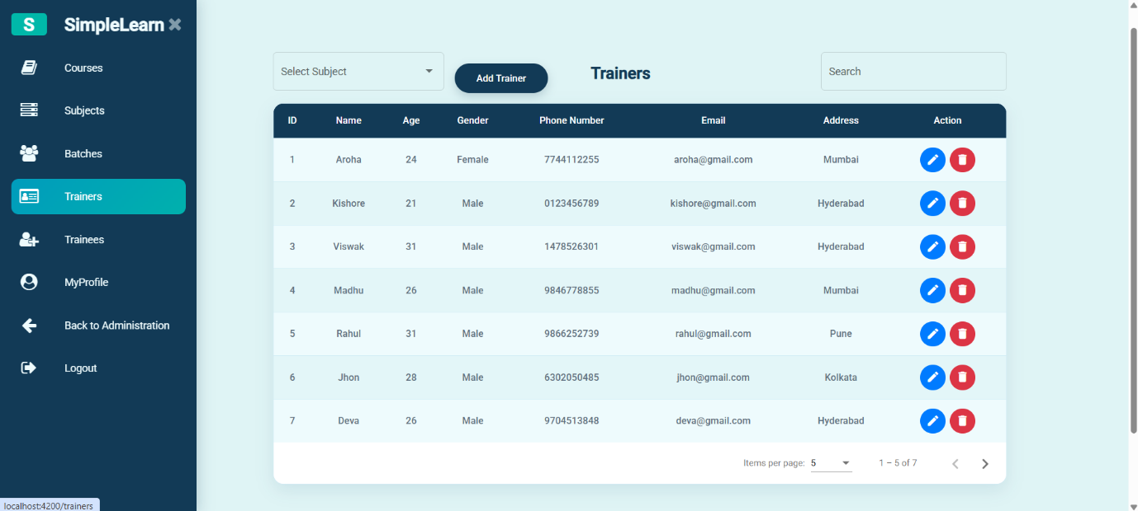
Figure 20. Trainers List
Trainer listing with available record controls.
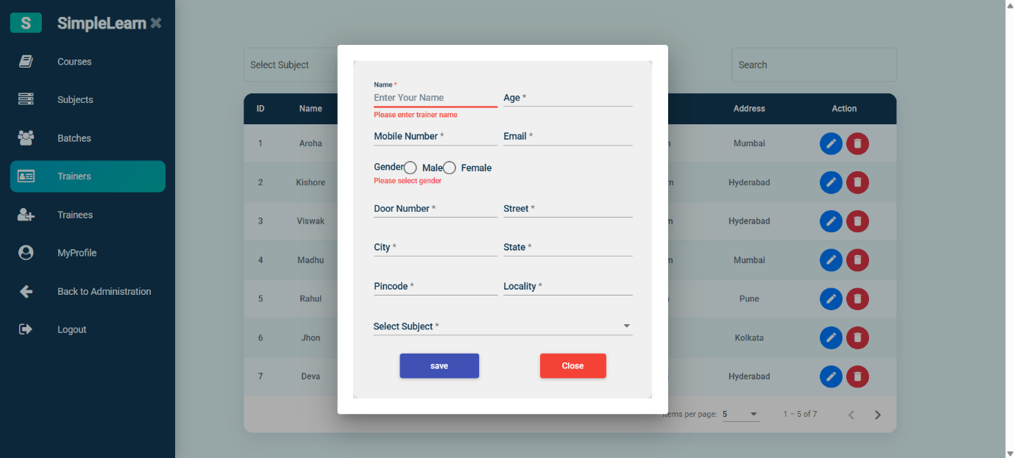
Figure 21. Trainer Details / Edit Dialog
Trainer information form displayed over the listing.
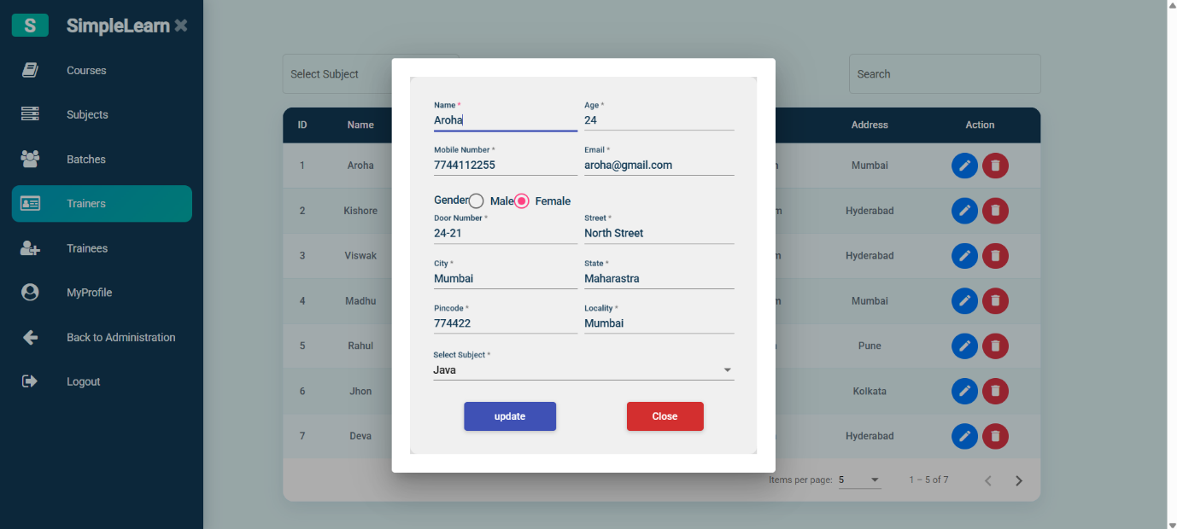
Figure 22. Trainer Details / Edit Dialog – Alternate State
Additional supplied view of the trainer form.

4.7 Trainee Management
The trainee area displays trainee records and provides a form for viewing or editing a trainee's information.
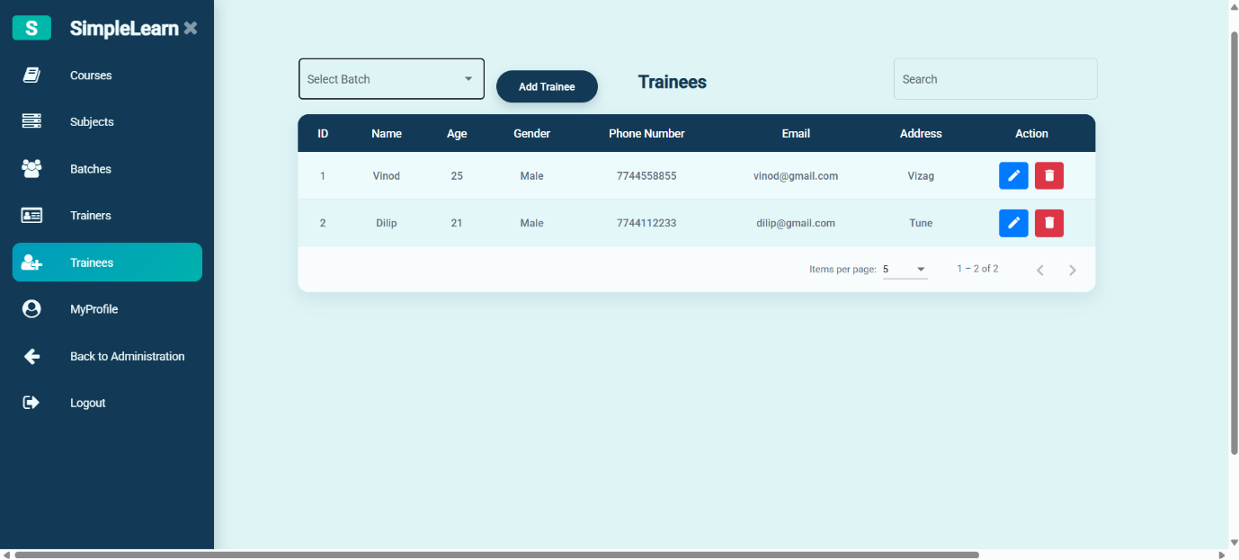
Figure 23. Trainees List
Trainee listing with available record controls.
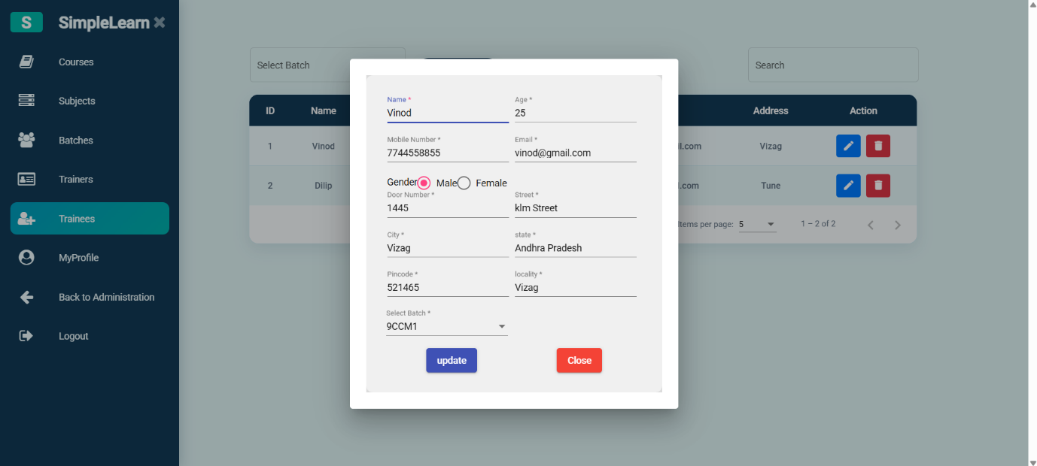
Figure 24. Trainee Details / Edit Dialog
Trainee information form displayed over the listing.

4.8 Profile and Exit Navigation
The final supplied images show the profile area and its account/navigation controls. The last two screenshots appear visually identical in the supplied file, so both are retained here for completeness.
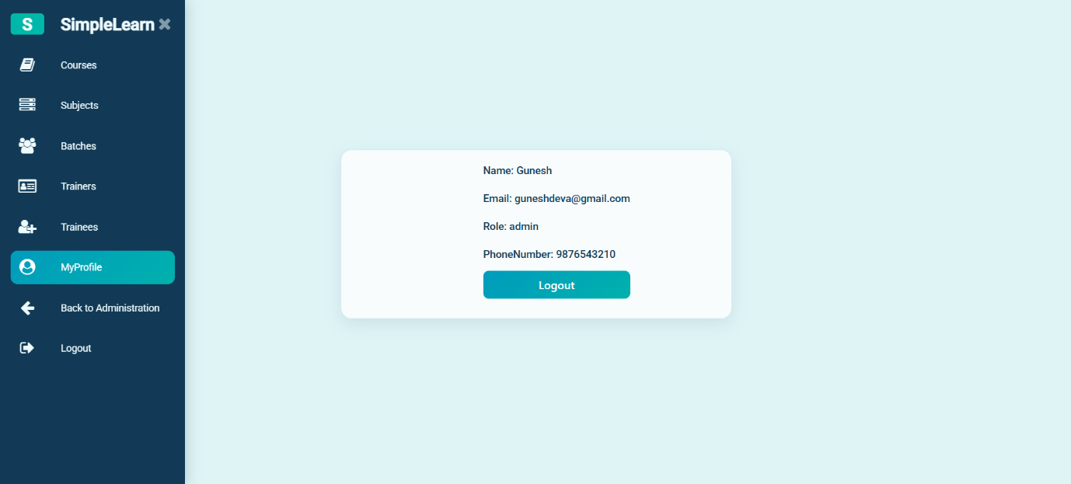
Figure 25. Profile Page
Profile details and a visible Logout control.
Figure 26. Profile Page – Second Supplied Capture
Second supplied capture; it appears visually identical to Figure 25.

5. High-Level System Architecture
Simple Learn follows a client–server structure. The Angular application renders the screens and sends HTTP requests to Django REST Framework. Django URL patterns route requests to views; serializers can validate and format API data; Django models and the ORM provide database access; MySQL stores persistent application records.
Angular Frontend | Django REST API | MySQL Database
Browser interface → REST API request → Django request handling / ORM → MySQL

6. Backend and API Layer
Django REST Framework provides the API layer used by the Angular frontend. In a typical request flow, the frontend service sends a request, the URL configuration selects the relevant view, the backend processes the request and interacts with the database, and the response is returned to the frontend. Postman can be used to test API endpoints independently from the UI.
- Angular components display lists, forms, dialogs, and navigation.
- Frontend services communicate with backend endpoints.
- Django URL patterns map API paths to views.
- Views implement request handling and application rules.
- Serializers validate or format data when used by the endpoint.
- Django ORM models connect application data to MySQL tables.

7. Security and Operational Considerations
- Enforce authentication and authorization on the backend for protected operations.
- Do not rely only on hiding frontend navigation to protect API endpoints.
- Validate required fields and referenced record IDs before saving.
- Keep database credentials and secret keys out of source control.
- Confirm database settings and migrations before running the application in a new environment.
- Test endpoints with Postman and then verify the same workflows through the Angular interface.

8. Development Run Overview
- Start MySQL and verify the configured database, port, user, and permissions.
- Activate the project's Python virtual environment.
- From the folder containing manage.py, install the required packages and run applicable Django migrations.
- Start the Django development server using the project settings.
- Open the Angular project folder, install dependencies if required, and start the Angular development server.
- Open the application in a browser and test each workflow; use Postman to isolate API issues.

9. Conclusion
Simple Learn brings key trainee-management and training-administration screens into one web application. The supplied screenshots document account access, organization setup, courses, subjects, batches, trainers, trainees, and profile navigation. The Angular, Django REST Framework, and MySQL stack separates the user interface, backend processing, and persistent data storage.
— End of Document —

