The Architecture of Distributed Systems
  - Dr. Ada Lovelace & Alan Turing
Department of Computing

Chapter 1: Foundations of Computing

1.1 The Theoretical Model
A distributed computational model operates across autonomous nodes communicating via message passing. Each node maintains local state and coordinates through deterministic consensus algorithms.
Typography check: bold statement, followed by an italicized caveat, an underlined clause, and large emphasis text.
Node ID | Throughput (ops/s) | Consensus State
node-01 | 12500 | Leader
node-02 | 11800 | Follower

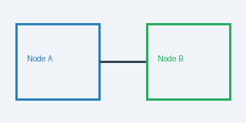
Figure 1.1: Distributed consensus state transition between Node A and Node B.
- Initialize all consensus registers to state zero.
- Broadcast vote request to all active peer nodes.
- Commit state transition upon receiving quorum threshold.
- High availability with zero single points of failure.
- Deterministic log replication with bounded latency.
- Cryptographic audit trails for state mutations.

References
1. Shannon, C. E. (1948). A Mathematical Theory of Communication. Bell System Technical Journal, 27(3), 379-423.
2. Turing, A. M. (1936). On Computable Numbers, with an Application to the Entscheidungsproblem. Proceedings of the London Mathematical Society, 42, 230-265.
3. Lamport, L. (1978). Time, Clocks, and the Ordering of Events in a Distributed System. Communications of the ACM, 21(7), 558-565.

