Flipkart AC Price & Rating Analysis Project Report

Project Overview
- This project is based on analyzing Air Conditioner (AC) products from Flipkart.
- Data was collected using Python web scraping.
- The main goal is to analyze AC prices and ratings under 50,000.
- The project follows an end-to-end data analytics process.

Dataset Summary
- Dataset contains AC product details scraped from Flipkart.
- Key columns include Product Name, Brand, Price, Rating, Ton, and AC Type.
- Data was stored in Excel in three stages: raw data, cleaned data, and final data with formulas.

Web Scraping Using Python
- Python libraries used: Requests and BeautifulSoup.
- Data was scraped from Flipkart product listing pages.
- Extracted details include product name, price, rating, and brand.
- The scraped data was saved into an Excel file for further analysis.

Exploratory Data Analysis (EDA) Using Excel
- Removed currency symbols and converted prices into numeric format.
- Handled missing values in rating and ton columns.
- Used Excel formulas to create calculated fields.
- Analyzed price distribution and brand-wise data.

Power BI Dashboard
- Created an interactive dashboard using Power BI.
- KPIs included Average Price, Average Rating, and Total Models.
- Visuals include brand-wise price, price vs rating, and ton-wise analysis.
- Slicers allow filtering by brand, ton, and AC type.
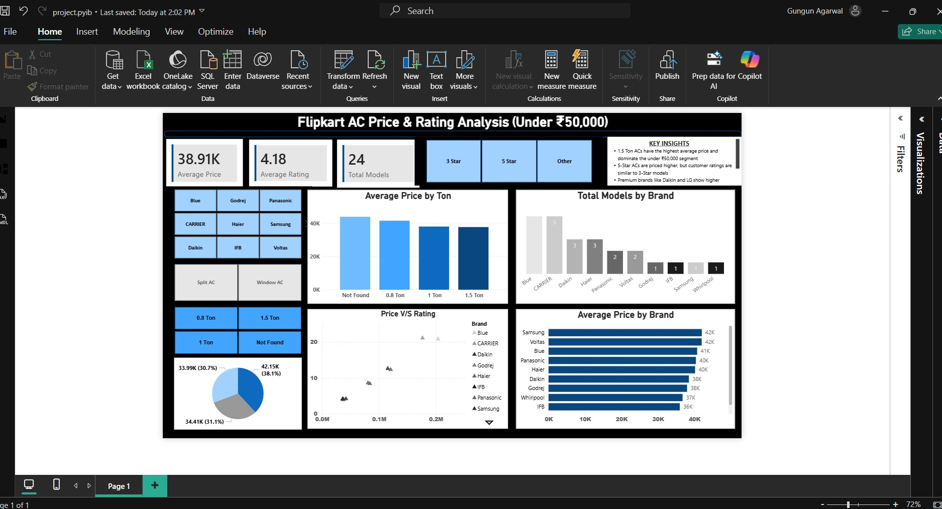

Key Insights
- 1.5 Ton ACs have the highest average price.
- Most ACs under 50,000 have ratings above 4.0.
- Premium brands are priced higher but ratings are similar across brands.
- Mid-range brands provide good value for money.

Challenges Faced
- Website structure changes caused missing data issues.
- Some products had missing ratings or ton information.
- Cleaning unstructured scraped data required extra effort.

Business Recommendations
- Focus more on mid-range AC models with high ratings.
- Maintain competitive pricing for 1 Ton and 1.5 Ton ACs.
- Highlight customer ratings to improve buyer trust.
- Promote value-for-money brands to attract budget customers.

Conclusion
- This project shows a complete data analytics workflow.
- Python, Excel, and Power BI were used effectively.
- The analysis provides useful insights for customers and businesses.
- This project demonstrates strong skills suitable for a Data Analyst fresher.

