Einstein HX Calculation – Developer Manual

The actual Version (18.10.2010) is merged with the Streambranch from the sourceforge git repository (14.10.2010).

New Modules for HX
The main Heat exchanger Calculation module is located in einstein/modules/energystreams.

Module | Purpose
CurveCalculation.py | Calculation of the HX Network Curves (CCC, HCC, GCC)
DistributionLineStreamSet.py | Functions for Calculation of Distribution Lines (Former Distribution Lines were saved here) main Distribution Line Functionaliy can be found in StreamGeneration.py class DistLineStreams
EquipmentStreamSet.py | Functions for Calculation of Equipments. Holds Helper Functions to calculate Streams (gets Line per Equipment etc.)
HXCalculation.py
ProcessStreamSet.py | Calculation Functions for Processes. This file contains the two calculation modes for processes (e.g. batch, continuous)
Stream.py | Collection of Classes with the purpose to store Heat Exchanger and Stream Data at runtime and into the database.
StreamConstants.py | Constants (python Lists) to assign a Stream-Type to a Stream
StreamGeneration.py | The StreamGeneration Classes create all Streams, get the data from the database and calculate them.
StreamSet.py | StreamSet contains calculation methods that are shared by all streams.
WasteHeatElectricalStreamSet.py | Only minimal functionality is used of this class. Soon to be moved.

All HX Calculation Files that are not listed in this table are outdated and/or not in use anymore.

Changes on other modules
The following modules needed to be changed in order for the new HX module to work accordingly:
Module | Changes
dataHR.py | New Function storeHXData to store the calculated Heat Exchanger in the Database
interfaces.py | Function calcQ_Tt to create the Matrix needed for Post-Processing. Variables to store new Schedules.
moduleHR.py | Function doHXPostProcessing created to simulate the original Post Processind and call storeResults
processes.py | Create custom Schedules (UPH_m_t,etc.) in createAggregateDemand
schedules.py | Stores intermediate Step in schedule.fav calculation
panelHR.py | Initialization of the new Heat Exchanger module
panelQ6.py | User Interface adapted to the new needs of the Heat Exchanger Modules

General Program flow

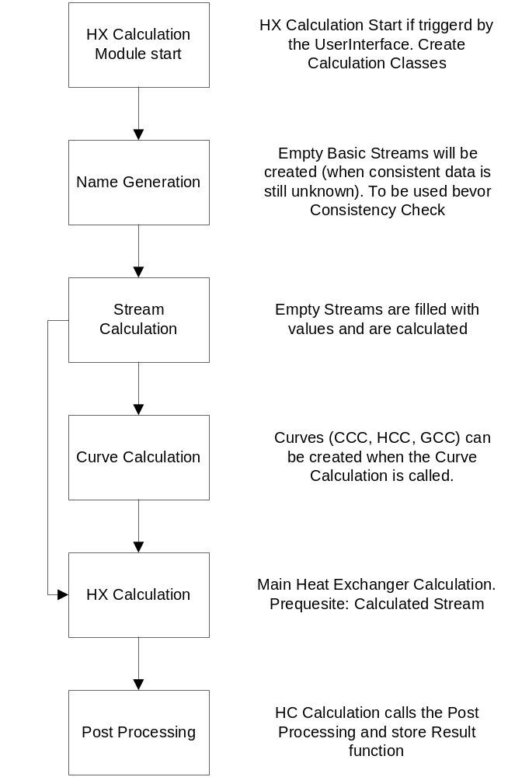

Detailed Module Description

Database Changes and Additions
According to the Filechanges a couple of Database Additions were needed.

New Tables:
pinchstream
Variable | Type | Description
id | int(11) | Primary Key
name | varchar(255) | Every Stream has a distinct name
Hot_Cold | varchar(6) | Stream is Hot or Cold
Type | varchar(8) | Startup, Circulation, Exhaust gas, etc.
source_id | int(11) | Database ID to link to the data origin
source_type | varchar(64) | Process, Equipment, WHEE, etc.
medium_id | int(11) | Database ID to link to the origin of the medium
StartTemp | double | Stream Start Temperature
EndTemp | double | Stream End Temperature
StreamType | varchar(64) | Sensible or latent
HeatCapacity | double | Heat Capacity
MassFlowNom | double | Nominal Mass Flow Rate
SpecHeatCapacity | double | Specific Heat Capacity
SpecEnthalpy | double | Specific Enthalpy
EnthalpyNom | double | Nominal Enthalpy
HeatTransferCoeff | double | Heat Transfer Coefficient

Heatexchanger_pinchstream
Variable | Type | Description
id | int(11) | Primary Key
qheatexchanger_ Id | int(11) | Foreign Key into qheatexchanger
pinchstream_id | int(11) | Foreign Key into pinchstream
inletTemp | double | Stream Inlet Temperature
outletTemp | double | Stream Outlet Temperature
outletOfHX_id | int(11) | Key to outlet of a Heat Exchanger
inletOfHX_id | int(11) | Key to inlet of a Heat Exchanger
HeatFlowPercent | int(11) | Used heat flow in Percent

Other Changes
Module | Changes
HelperClass.py | Path of configfile changed to os.path.join(sys.path[0], ConfigFile)
importHR.py | Bugfix Function getPoints
dialogDatabase.py | Path of Einstein.ini changed to inifile = os.path.join(sys.path[0], 'einstein.ini')

