3

View Fundamentals

In this chapter, we will cover

* View fundamentals
* Strongly-typed views
* View helper objects
* Templates

The view's responsibility can be deceptively simple. Its entire goal in life is to take the model given to it, and use it to render content. Because the controller and related services already executed all business logic and packaged the results into a model object, the view only needs to know how to take that model and turn it into HTML. While this separation of concerns removes much of the responsibilities that can plague traditional ASP.NET applications, views still need to be carefully and deliberately designed. Views require knowledge and understanding of the building blocks of the web, including HTML, CSS and JavaScript.

In this chapter, we'll take examine how ASP.NET MVC renders views, how the default WebFormsViewEngine functions, and how to structure and organizing views. Next, we'll look at a couple different approaches for using the model to render content in a view. Finally, we will cover the templating features new to ASP.NET MVC 2.

3.1 View Fundamentals

A view's responsibility is to render content. But how does the MVC framework decide which view to use? How do we control what gets rendered, and how do we organize our content? How do we even tell MVC to render a View? In the ASP.NET MVC framework, the controller decides, based on user input, that a view should be rendered by returning a ViewResult object from a controller action, shown in Listing 3.1 below.

Listing 3.1: Using the ViewResult object to render a view

[Authorize]

public ActionResult ChangePassword()

{

return View();

}

Although the method name seems to indicate that a view is rendered as the result of calling the View method, it is merely a helper method in the Controller base class to create a ViewResult object. The ViewResult object contains all the information needed to render the view at a later time. This information includes the view name, the model, and other pertinent information an IViewEngine can use to render a view.

Internally, the ViewResult object delegates to the IViewEngine to render the actual content for a view. The IViewEngine implementation, commonly just called the view engine, is the class responsible for examining the ViewResult information as well as other context information and locating the correct IView to render.

3.2 Examining the ViewDataDictionary

The main object used to pass model information to a view is the ViewDataDictionary class. Like other MVC frameworks, ASP.NET MVC exposes a dictionary to enable the controller action to pass any number of model objects and information to the view. With a dictionary object, we can pass as many items as need be for the view to render appropriately. For example, our application includes a profile page, shown in figure 3.1 where users can view other user's profiles. However, only the current logged in user can edit their profile. To display the profile information on the profile screen, we can pass in the Profile object directly to the view, shown in Listing 3.2 below.

Listing 3.2: The Profile class

public class Profile

{

public Profile(string username)

{

Username = username;

}

public string Username { get; set; }

public string FirstName { get; set; }

public string LastName { get; set; }

public string Email { get; set; }

}

While our Profile class has all the information needed to display our Profile, it does not include any information about the current logged in user, or whether the view should display the edit link. We need to give the view more information than solely the Profile object to make this decision. To do so, we can use the ViewData dictionary object for this extra piece of information, shown in Listing 3.3 below.

Listing 3.3: The Show controller action

public ViewResult Show(string username)

{

var profile = _profileRepository.Find(username);

bool hasPermission = User.Identity.Name == username;

ViewData["hasPermission"] = hasPermission;

return View(profile);

}

In the Controller base class, we have access to the ViewDataDictionary object used to pass to the view in the ViewData property. We check the current user's name, compare it to the profile to be shown in the username parameter, and place the result of the comparison into ViewData with a "hasPermission" key. Next, we use the helper View method to create a ViewResult object and set the ViewData's Model property to our Profile object. On the view side, we will pull the "hasPermission" information out of ViewData, and use it to hide the Edit link, shown in Listing 3.4 below.

Listing 3.4: Using ViewData information to hide a link

<p>

<%

bool hasPermission = (bool)ViewData["hasPermission"]; #1

if (hasPermission)

{ %>

<%=Html.ActionLink("Edit", "Edit", new { username = Model.Username }) %> #2

|

<%=Html.ActionLink("Back to List", "Index") %> #3

<% } %>

</p>

In our view, we extract the "hasPermission" information (1) from ViewData. Next, we conditionally show the edit link based on the "hasPermission" variable (2). Finally, we display a link (3) to take the user back to the profile list page. The final rendered page for showing the current user's profile is shown in Figure 3.1.

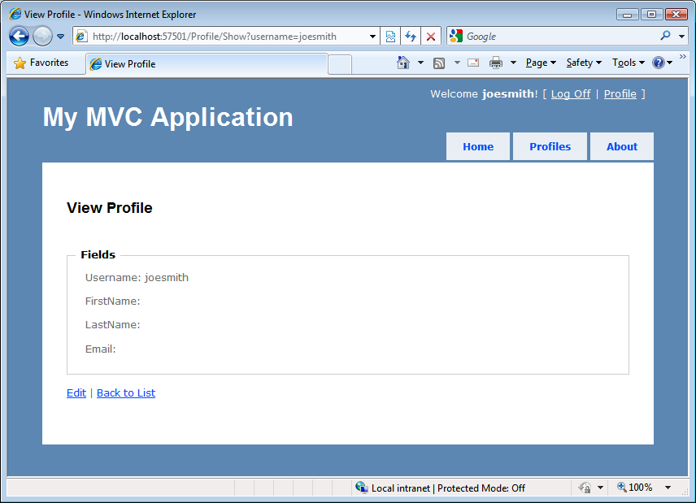

Figure 3.1: The current user's profile page

While using the technique of utilizing the dictionary aspects of the ViewDataDictionary gives us a lot of flexibility, it comes at a price. Because we create weak, compile-unsafe links in a dictionary, we open ourselves to problems in the future. For example, we might misspell hasPermission in the view, and only learn of our mistake at runtime. However, our use of the Profile object as our ViewModel gives us a strong link between controller action and view, compile-time safety, and IntelliSense in the view.

Using the loose-type semantics of a dictionary can also hinder us in more complex scenarios. Consider a login screen, where the username and password are required fields. With an actual object to represent the model for this view, we can then decorate our ViewModel object with validation attributes. In the next section, we'll look at taking advantage of ViewModel types with strongly-typed views.

3.2 Strongly-typed views with ViewModel

In the WebFormViewEngine, our views can inherit from two different types: System.Web.Mvc.ViewPage, or System.Web.Mvc.ViewPage<T>. The generic ViewPage<T> inherits from ViewPage, but offers some unique additions not available in the non-generic ViewPage class. The skeleton member definition of ViewPage<T> is shown in Listing 3.5 below.

Listing 3.5: Skeleton definition of ViewPage<T>

public class ViewPage<TModel> : ViewPage

{

public AjaxHelper<TModel> Ajax { get; set; } #2

public HtmlHelper<TModel> Html { get; set; } #3

public TModel Model { get; } #1

public ViewDataDictionary<TModel> ViewData { get; set; }

}

In addition to providing a strongly-typed wrapper over ViewData.Model through the Model property (1), we have access to strongly-typed versions of the associated view helper objects, AjaxHelper (2) and HtmlHelper(3). To use a strongly-typed view, we first have to ensure that our controller action sets the ViewData.Model properly. In Listing 3.6, we retrieve all of the profiles for display in a list page, and pass the entire collection of profiles to the View method, which encapsulates setting the ViewData.Model property.

Listing 3.6: Passing a collection of profiles to our view

public ViewResult Index()

{

var profiles = _profileRepository.GetAll();

return View(profiles);

}

In the Index view used with this action, even the loose-typed ViewPage class can use the ViewData.Model property. However, this property is only of type object, and we would need to cast the result to use it effectively. Instead, we can make our view page inherit from ViewPage<T>, shown in Listing 3.7 below.

Listing 3.7: Inheriting from ViewPage<T> for a strongly-typed view

<%@ Page Language="C#"

MasterPageFile="~/Views/Shared/Site.Master"

Inherits="System.Web.Mvc.ViewPage<AccountProfile.Models.Profile[]>" %>

By inheriting from ViewPage<T> instead of merely ViewPage, we now have a strongly-typed view. In the next section, we'll look at how we can use our ViewModel object to display information in a view.

3.3 Displaying ViewModel data in a View

Typically, to display information in a view, we will use the HtmlHelper object to help us use our ViewModel to generate HTML. In our profile list screen, we want to iterate over the profiles passed in our Model (1) and display select information from each (2), shown in Listing 3.8.

Listing 3.8: Displaying a list of profiles in our view

<h2>Profiles</h2>

<table>

<tr>

<th>Username</th>

<th>First name</th>

<th>Last name</th>

<th>Email</th>

</tr>

<% foreach (var profile in Model) { %> #1

<tr>

<td>

<%= Html.Encode(profile.Username) %> #2

</td>

<td>

<%= Html.Encode(profile.FirstName) %>

</td>

<td>

<%= Html.Encode(profile.LastName) %>

</td>

</tr>

<% } %>

</table>

Because we would rather not open ourselves to the myriad of scripting attacks possible when displaying un-encoded user input to the screen, we encode all user-entered information displayed on a screen. In the example above, this is accomplished through the HtmlHelper object, provided through the Html property on our base ViewPage<T> (and ViewPage) class.

In our login page, we use a ViewModel object to represent the entire form, shown in Listing 3.9 below.

Listing 3.9: Our LogOnModel class

public class LogOnModel

{

[Required]

[DisplayName("User name")]

public string UserName { get; set; }

[Required]

[DataType(DataType.Password)]

[DisplayName("Password")]

public string Password { get; set; }

public bool RememberMe { get; set; }

}

The logon screen shows input elements for each of these properties, shown in Figure 3.2.

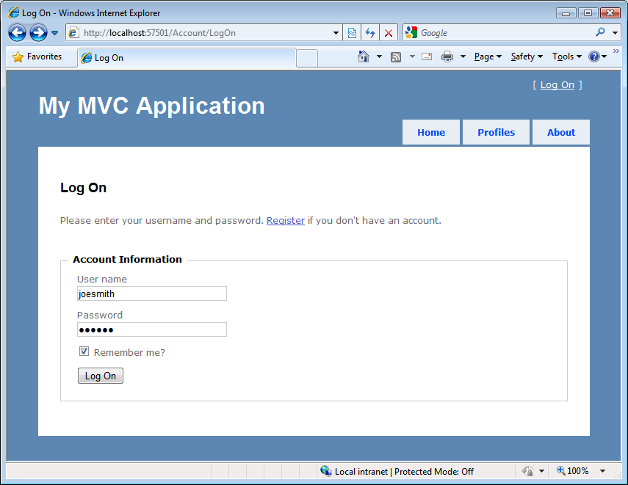

Figure 3.2: The log on screen

Because we opted for a strongly-typed view for our log on screen, we can use the built-in helpers to render the HTML for each input element. Instead of loosely-bound strings to represent the action parameters, we can take advantage of the expression-based HtmlHelper extensions for creating various types of input elements, shown in Listing 3.10.

Listing 3.10: Rendering the account information input form

<% using (Html.BeginForm()) { %>

<div>

<fieldset>

<legend>Account Information</legend>

<p>

<%= Html.LabelFor(m => m.UserName) %> #1

<%= Html.TextBoxFor(m => m.UserName) %> #2

<%= Html.ValidationMessageFor(m => m.UserName) %> #3

</p>

<p>

<%= Html.LabelFor(m => m.Password) %>

<%= Html.PasswordFor(m => m.Password) %>

<%= Html.ValidationMessageFor(m => m.Password) %>

</p>

<p>

<%= Html.CheckBoxFor(m => m.RememberMe) %> <label class="inline" for="rememberMe">Remember me?</label>

</p>

<p>

<input type="submit" value="Log On" />

</p>

</fieldset>

</div>

<% } %>

In the code above, we take advantage of several of the HtmlHelper extension methods designed for strongly-typed view pages, including methods for labels (1), input textboxes (2), and validation messages (3). Instead of a loose-typed string to represent properties, these helper methods utilize the C# 3.5 feature of expressions to generate HTML. Since these HTML elements need to be generated to match properties on objects, it is only fitting that the original types and objects are used with expression to generate the related HTML. The Html.LabelFor and Html.TextBoxFor methods used in the example above for the UserName property generate the HTML shown in Listing 3.11.

Listing 3.11: HTML generated from expression-based HtmlHelper methods

<label for="UserName">User name</label> #2

<input id="UserName" name="UserName" type="text" value="" /> #1

For our page to pass accessibility validation, every input element (1) needs to include a corresponding label element (2). Because our label and input elements are generated using expressions, we no longer need to worry about our hard-coding label and input names. Including the helper methods used above, the HtmlHelper extensions designed for strongly-typed views are in table 3.1.

Table 3.1 Html helpers added for ASP.NET MVC 2.

|  |  |
| --- | --- |
| Html helper | Description |
| DisplayFor | Returns HTML markup for each property in the object that is represented by the expression. |
| DisplayTextFor | Returns HTML markup for each property in the object that is represented by the specified expression. |
| EditorFor | Returns an HTML input element for each property in the object that is represented by the specified expression. |
| CheckBoxFor | Returns a check box input element for each property in the object that is represented by the specified expression. |
| DropDownListFor | Returns an HTML select element for each property in the object that is represented by the specified expression using the specified list items. |
| HiddenFor | Returns an HTML hidden input element for each property in the object that is represented by the specified expression. |
| LabelFor | Returns an HTML label element and the property name of the property that is represented by the specified expression. |
| ListBoxFor | Returns an HTML select element for each property in the object that is represented by the specified expression and using the specified list items. |
| PasswordFor | Returns a password input element for each property in the object that is represented by the specified expression. |
| RadioButtonFor | Returns a radio button input element for each property in the object that is represented by the specified expression. |
| TextAreaFor | Returns an HTML textarea element for each property in the object that is represented by the specified expression. |
| TextBoxFor | Returns a text input element for each property in the object that is represented by the specified expression. |
| ValidateFor | Retrieves the validation metadata and validates each data field that is represented by the specified expression. |
| ValidationMessageFor | Returns the HTML markup for a validation-error message for each data field that is represented by the specified expression. |

Since our form was generated using a strongly-typed view, we can take advantage of this in the design of our action that the form posts to. Instead of enumerating every input field as separate action method parameters, all of the parameters can be bound to the same ViewModel we used to render the view, shown in Listing 3.11.

Listing 3.11: The signature of the LogOn action using the ViewModel as a parameter

public ActionResult LogOn(LogOnModel model, string returnUrl) #1

{

// Action method body here

…

}

Our LogOn action method takes a single LogOnModel object, as well as the potential return URL, instead of a method parameter for each input element on our form (1). As powerful as the HtmlHelper extensions for strongly-typed views can be, we still introduce quite a bit of duplication in our views if we rely solely on these extensions for generating HTML. For example, if every input element requires a corresponding label, why not always include it? Every user interface is different, so the MVC team cannot predict the layout everyone wants to use for input and label elements. Instead, we can take advantage of a new feature in ASP.NET MVC2, templates, to enforce a standardized approach to generating HTML.

3.4 Using strongly-typed templates

As we move towards using strongly-typed views, views based on a presentation model, we will start to see more and more patterns emerge. If a ViewModel object has a boolean property on a form, we will almost certainly want to display a checkbox on a form. Email addresses should always render the same, as should password fields and so on. It is very rare that an input element won't also include the corresponding validation message.

HtmlHelper extension methods work well for individual snippets of HTML elements, but tend not to scale as the HTML generated starts to become more complex and include more varieties of elements. ASP.NET MVC 2 gives us a way to start basing our rendering decisions based on model metadata. An example of this is marking our view model with a RequiredAttribute so that is will be automatically validated. The framework also provides ways to generate snippets of HTML based on properties of our view model.

With ASP.NET MVC 2, the MVC team designed a view feature that tends to sit between HtmlHelper extension methods and full-blown partials in size and scope. This feature is templated helpers, and is designed to assist in generating HTML based on strongly-typed views. Templated helpers can be used to generate HTML for the entire model or one member at a time. Because HTML for viewing and editing are radically different, generating templates for each is accomplished through two different sets of methods, with two different sets of templates.

3.4.1 EditorFor and DisplayFor templates

These two different sets of templates are separated into a set of Editor and Display templates. The Editor and Display templates are generated from the following methods:

* Html.Display("Message")
* Html.DisplayFor(m => m.Message)
* Html.DisplayForModel()
* Html.Editor("UserName")
* Html.EditorFor(m => m.UserName)
* Html.EditorForModel()

Although string-based versions exist for using templates against loosely-typed views, we will prefer to use the expression-based methods to gain the benefits of using strongly-typed views. If our model is very simple, we can use the "ForModel" methods, which enumerate over every member in our model to generate the complete HTML. Since our "Change Password" page is very simple, we can use the EditorForModel method, shown in Listing 3.12.

Listing 3.12: Using EditorForModel for a simple model

<% using (Html.BeginForm()) { %>

<div>

<fieldset>

<legend>Account Information</legend>

<%= Html.EditorForModel() %> #1

<p>

<input type="submit" value="Change Password" />

</p>

</fieldset>

</div>

<% } %>

This EditorForModel method (1) loops through all of the members on our Model for this view, generating the editor templates for each member. Each template generated may be different, depending on the model metadata information on each member. This HTML might suit our needs, but there is only so much you can embed in your view model before you can no longer sanely emit HTML based solely on model metadata. The model for the Change Password screen, shown in Listing 3.13, already has validation and label information.

Listing 3.13: The Change Password model

[PropertiesMustMatch("NewPassword", "ConfirmPassword",

ErrorMessage = "The new password and confirmation password do not match.")]

public class ChangePasswordModel

{

[Required] #1

[DataType(DataType.Password)] #2

[DisplayName("Current password")] #3

public string OldPassword { get; set; }

[Required, ValidatePasswordLength

[DataType(DataType.Password)]

[DisplayName("New password")]

public string NewPassword { get; set; }

[Required

[DataType(DataType.Password)]

[DisplayName("Confirm new password")]

public string ConfirmPassword { get; set; }

}

We include validation information (the Required attribute (1)) as well as display information (the DisplayName (2) and DataType (3) attributes), both of which can be used to influence final HTML generated in our templates. However, we may need more control over our HTML than what is allowed or even desired in our model class through metadata information. For example, we might want to surround some of our elements with paragraph tags. For this level of individual control where we want to lay out individual elements, we can use the EditorFor method, shown in Listing 3.14.

Listing 3.14: Using EditorFor for extra layout control

<p>

<%= Html.EditorFor(m => m.OldPassword) %>

</p>

<p>

<%= Html.EditorFor(m => m.NewPassword) %>

</p>

<p>

<%= Html.EditorFor(m => m.ConfirmPassword) %>

</p>

Since templates are shared across our site, we may not want to force every editor to include a paragraph tag. But for complex forms, we're likely to include organizational elements such as horizontal rules, fieldsets and legends to organize our elements. But for very simple display and edit models, the EditorForModel and DisplayForModel will likely meet our needs.

3.4.2 Built-in templates

Out of the box, ASP.NET MVC includes a set of built-in templates for both editor and display templates. The included display templates are shown in the table below.

|  |  |
| --- | --- |
| Display Template | Description |
| EmailAddress | Renders a link with a mailto URL |
| HiddenInput | Conditionally hides the display value |
| Html | Renders the formatted model value |
| Text | Renders the raw content |
| Url | Combines the model and formatted model value to render a link |
| Collection | Loops through an IEnumerable and renders the template for each item |
| Boolean | Renders a checkbox for regular boolean values, and a drop-down list for nullable boolean values |
| Decimal | Formats the value with two decimals of precision |
| String | Renders the raw content |
| Object | Loops through all properties of the object and renders the display template for each property |

With the exception of the Collection and Object templates, each template renders a single value. The Object template iterates through every item in the ModelMetadata.Properties collection (which is in turn populated by inspecting the public properties on the item type), and displays the corresponding display template for each item. The Collection template iterates through every item in the model object, displaying the correct display template for each item in the list. The display templates, as you would expect, render display elements to the browser, such as raw text and anchor tags, while the editor templates render form elements. The default editor templates include:

|  |  |
| --- | --- |
| Editor Template | Description |
| HiddenInput | Uses the HtmlHelper Hidden extension method to render a <input type="hidden" /> element |
| MultilineText | Uses the HtmlHelper TextArea extension method to render a multi-line input element |
| Password | Uses the HtmlHelper.Password extension method to render a password input element |
| Text | Uses the HtmlHelper.TextBox extension method to render a text input element |
| Collection | Loops through an IEnumerable and renders the template for each item, with correct index values |
| Boolean | Renders a checkbox for regular boolean values, and a drop-down list for nullable boolean values |
| Decimal | Formats the decimal value with two decimals of precision inside a text box |
| String | Uses the HtmlHelper.TextBox extension method to render a text input element |
| Object | Loops through all properties of the object and renders the editor template for each property |

The Collection and Object templates behave identically to the display templates, with the exception that the editor templates are used instead of the display templates for each child item examined. In the next section, we will examine how MVC decides which template to use.

3.4.2 Selecting templates

Internally, the Editor and Display template helper methods choose a template to display by looking for a template by name. The template name value can come from a variety of sources, but the template helper methods use a very specific algorithm for choosing the template to render based on the name. Once a matching template is found by name, that template will be used to generate the appropriate content. The template helper methods search for a template in specific locations before trying the next template name. The template search locations are an "EditorTemplates" or "DisplayTemplates" folder. Similar to partial and view names, the template methods will first look in the controller-specific view folder (or area- and controller-specific view folder) first, before moving on to the Shared view folder. If the template helper method is used inside an area-specific view, these folders include:

* <Area>/<ControllerName>/EditorTemplates/<TemplateName>.ascx (or .aspx)
* <Area>/Shared/EditorTemplates/<TemplateName>.ascx (or .aspx)

If a template is not found in these folders or if the view is not in an area, then the default view search locations are used:

* <ControllerName>/EditorTemplates/<TemplateName>.ascx (or .aspx)
* Shared/EditorTemplates/<TemplateName>.ascx (or .aspx)

The template helper methods try each folder in sequence, and for each search folder, run through a list of template names to find a match. The template names also follow a particular algorithm:

|  |  |
| --- | --- |
| Step | Search Location |
| 1 | The template name passed in through the Display/Editor helper template methods (defaults to null) |
| 2 | The ModelMetadata.TemplateHint value (populated from the [UIHint] attribute by default) |
| 3 | The ModelMetadata.DataTypeName value (populated from the [DataType] attribute by default) |
| 4 | The model type (if a nullable type, then the underlying type) |
| 5 | |  |  | | --- | --- | | If the model type is… | The template used is | | Not a complex type (a type converter exists from the model type to String) | "String" | | An IEnumerable | "Collection" | | Any other interface | "Object" | |
| 6 | Recursively search the base types, one by one, and search the Type.Name. If the item is an IEnumerable, search the name "Collection", then "Object" |

For example, we want to display a custom "ChangePasswordModel" template for our model for the change password screen. We already have a complete model object, so we can define a template matching the name of the model type, "ChangePasswordModel". Since this template is specific to our Account controller, we place the template in an EditorTemplates folder underneath the Account-specific view folder, shown in figure 3.3.

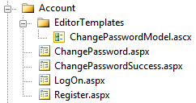

Figure 3.3: The ChangePasswordModel template in the EditorTemplates folder

If we want our template to be visible to all controllers, we would need to place our template in the EditorTemplates folder in the Shared folder, shown in Figure 3.4.

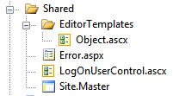

Figure 3.4: Creating a global Object editor template in the Shared folder

Although we created our templates as ViewUserControls (.ascx files), we can use ViewPages, which will allow us to use master pages for another level of templating. In the next section, we will examine the different ways we can create custom templates and override the existing templates.

3.4.3 Customizing templates

In general, we will have two reasons to create a custom template:

1. Create a new template
2. Override an existing template

The template resolution rules first look in the controller-specific view folder, so it is perfectly reasonable to first override one of the built-in templates in the Shared folder, and then override that template in the controller-specific view folder. For example, we might have an application-wide template for displaying the Email template, but then provide a specific template in an area or controller template folder. For the most part, templates are as equivalent to developing a partial for a type. The template markup for our ChangePasswordModel is shown in Listing 3.15 below.

Listing 3.15: The template markup for our ChangePasswordModel template

<%@ Control Language="C#"

Inherits="System.Web.Mvc.ViewUserControl<ChangePasswordModel>" %>

<%@ Import Namespace="AccountProfile.Models" %>

<p>

<%= Html.EditorFor(m => m.OldPassword) %> #1

</p>

<p> #2

<%= Html.EditorFor(m => m.NewPassword) %>

</p>

<p>

<%= Html.EditorFor(m => m.ConfirmPassword) %>

</p>

Our template simply uses the existing EditorFor templates for each member (1), but wraps each in a paragraph tag (2). But what is the advantage of this model over a partial template? For one, partials need to be selected by name in the view. Templates are selected from model metadata information, thereby bypassing the need for the view to explicitly specify which template to use. Additionally, templates are given extra information in the ViewDataDictionary that partials and other pages do not receive, and that information is in the ViewData.ModelMetadata property. Only templates have the ModelMetadata property populated by ASP.NET MVC, and for partials and views, this property is null.

With the ModelMetadata property, we are able to get access to all of the metadata information generated from the model metadata provider. This information includes model type information, properties, and metadata about the model. Model type information includes:

|  |  |
| --- | --- |
| ModelMetadata Property | Description |
| Model | The value of the model |
| ModelType | The type of the model |
| ContainerType | The type of the container for the model, if Model is the property of a parent type |
| PropertyName | The property name represented by the model value |
| Properties | Collection of model metadata objects that describe the properties of the model |
| IsComplexType | Value that indicates whether the model is a complex type |
| IsNullableValueType | Value that indicates whether the type is nullable |

In addition to general model type information, the ModelMetadata object contains other metadata information, which by default is populated from attributes:

|  |  |
| --- | --- |
| ModelMetadata Property | Source of value |
| ConvertEmptyStringToNull | System.ComponentModel.DataAnnotations.DisplayFormatAttribute |
| DataTypeName | System.ComponentModel.DataAnnotations.DataTypeAttribute |
| DisplayFormatString | System.ComponentModel.DataAnnotations.DisplayFormatAttribute |
| DisplayName | System.ComponentModel.DisplayNameAttribute |
| EditFormatString | System.ComponentModel.DataAnnotations.DisplayFormatAttribute |
| HideSurroundingHtml | System.Web.Mvc.HiddenInputAttribute |
| ReadOnly | System.ComponentModel.ReadOnlyAttribute |
| IsRequired | System.ComponentModel.DataAnnotations.RequiredAttribute |
| NullDisplayText | System.ComponentModel.DataAnnotations.DisplayFormatAttribute |

In our custom template, we can examine these model metadata properties to customize the HTML rendered. In addition to the above properties, the ModelMetadata object exposes an AdditionalValues property of type IDictionary<string, object> that can contain additional metadata information populated from custom model metadata providers. For example, if we want to display an asterisk for required fields, we only need to examine the IsRequired property in our custom template. Or, if we decorate our model with a DataType attribute with a value of DataType.DateTime, we can create a custom template that renders dates with a custom date picker widget.

In practice, we will likely override existing templates, as the existing Object template may or may not suit our needs. The model metadata does not include any styling information, so custom styling or other markup will be accomplished by overriding the built-in templates. But since many sites tend to standardize on general user interface layout, such as "labels always above inputs" or "required fields always have an asterisk", we only need to override the template once to affect potentially the entire site. For example, we might want to standardize on labels on the same line as fields, but right aligned in a column. To do so, we would need to override the existing Object template, shown in listing 3.16 below.

Listing 3.16: Custom Object template

<%@ Control Language="C#" Inherits="System.Web.Mvc.ViewUserControl" %>

<% foreach (var prop in ViewData.ModelMetadata.Properties

.Where(pm => pm.ShowForEdit && !ViewData.TemplateInfo.Visited(pm))) { %> #1

<div class="editor-field-container">

<% if (!String.IsNullOrEmpty(Html.Label(prop.PropertyName).ToHtmlString())) { %>

<div class="editor-label">

<%= Html.Label(prop.PropertyName) %>: #2

</div>

<% } %>

<div class="editor-field">

<%= Html.Editor(prop.PropertyName) %> #3

<%= Html.ValidationMessage(prop.PropertyName, "*") %> #4

</div>

<div class="cleaner"></div> #5

</div>

<% } %>

We create a for loop to loop all of the ModelMetadata.Properties that should be shown for editing and have not been shown before (1), displaying the label (2), editor template (3) and validation message (4) for each property in a set of DIV tags. Finally, we include a cleaner div (5) that resets the float styling applied to achieve a column layout. The final layout is shown in figure 3.5 below.

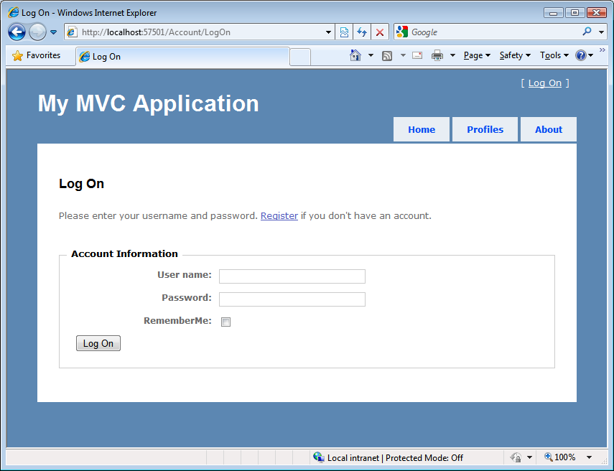

Figure 3.5: The float-based layout enforced by our custom Object template

By placing common rendering logic in our global templates, we can easily standardize the display and editor layout for our views across the entire site. For areas that need customization, we can selectively override or provide new templates. By standardizing and encapsulating our rendering logic in one place, it is both less code we have to write and one place we can use to affect our entire site. If we want to change our date time picker widget, we can simply go to the one date time template to easily change the look and feel of our site.

3.5 Summary

The MVC pattern reduces business logic clutter in a view. Unfortunately, views now bring their own complexities that must be handled. To manage that complexity and reduce the frequency of breakage, we examined how we can use strongly-typed views and separated view models to increase the cohesion of our views. With the popularity of separated view models increasing, the concept of using templates to drive content from the metadata on these view models became possible. With completely separated view models, we can keep the view concerns of our application now completely isolated from our domain model.