# **TUNA TOKSÖZ**

|  |  |
| --- | --- |
| Department of Computer Engineering  Bogazici University  **Email:** tuna.toksoz@boun.edu.tr **Blog:** http://tunatoksoz.devlicio.us http://tunatoksoz.com  **Linked In:** http://www.linkedin.com/in/tunatoksoz | **Birth date:** 28.07.1988  5.Kısım E-1 3/A D:7 Atakoy  Istanbul/Turkey  **Phone:** +90 212 560 8665  **GSM:** +90 555 562 3598 |

### PERSONAL INFORMATION

A software enthusiast trying to apply and develop new technologies, and simplify complex problems. Moreover, experienced in several database management systems. Loves agile software development methodologies and experienced in Test Driven Development. Has passion in Open Source Software and is a committer to some well-known projects such as Castle and NHibernate. Believes in the importance of information sharing and actively participates in several mailing groups including ALT.NET, NH-Users, Castle.

### EDUCATIONAL BACKGROUND

|  |  |  |
| --- | --- | --- |
| B.Sc | 2007 - Present[1] | Bogazici University - Department of Computer Engineering |
| High School | 2002 - 2005 | Kultur Science High School |

### AWARDS & HONORS

### db4o Most Valuable Professional, 2007, 2008, 2009 by db4objects

* **Ranked in the top 1000 among 1.6 million examinees** in nationwide University Entrance Examinations - Turkey, 2005
* **Ranked in the top 100 among 900 thousand examinees** in nationwide High School Entrance Examinations - Turkey, 2002

### TECHNICAL SKILLS & COMPETENCE

* **Certifications**
  + **dVP db4o** **Most Valuable Professional 2007, 2008, 2009**
  + **MCP Microsoft Certified Professional**
* **Technical Skills & Competencies**

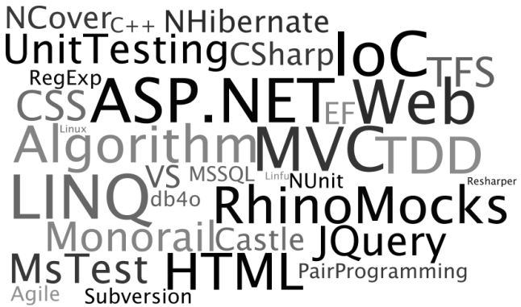

* **Languages**
  + English - TOEFL IBT 2009 (109/120)

### WORKING EXPERIENCE

|  |  |
| --- | --- |
| * **Internship at MIT** | **February 2009 – February 2009 September 2009 – October 2009** |
| Responsibilities: Development of a simulator as a testing platform for path finding algorithms in an environment with uncertainity. Development of a 3D visualizer to be used for algorithm testing. | |
| * **Internship at IBM Turkey** | **August 2008 –September 2008** |
| Responsibilities: Developing internal web applications, and data mining software for a private TV Channel | |
| * **Internship at Purdue University** | **June 2007- August 2007** |
| Responsibilities: Developing a GUI for a scientific simulator project and parallelization of the same simulator under the guidance of Professor Klimeck. | |

### PROJECTS

1. **Open Source Projects**

* **Nhibernate - Committer**
* **Castle – Commiter – Nhibernate Facility Lead**
* **BlogSharp - Co-Founder**

1. **Private Projects**

* **LiveLab 3D - Simulator (2009 - 2010)**

**@Massachusetts Institute of Technology - Software Developer – Intern**

**Implemented:** A windows based visualization environment for both ground and air vehicles. Also implemented simulator modelling behaviors of vehicles specified in a competition requirements.

* **LigTv (2008) – Data Mining Application**

**@IBM - Software Developer – Intern**

**Implemented:** A windows application in Java, various optimizations have been done to reduce database traffic.

* **Resonant Tunneling Diodes Simulator (2007) – A scientific simulator**

**@Purdue University Software Developer – Research Assistant**

A scientific simulator on Resonnant Tunneling Diodes.

**Implemented:** A GUI for the simulator, and some work on parallelization of matlab code.

### SOCIAL SKILLS & COMPETENCES

* **Memberships**

1. **ALT.NET Developer Community**
2. **IAESTE Student Community**
3. **TOG Student Community**

### PERSONAL INTERESTS

* Likes to contribute open source projects such as Nhibernate, and Castle as a committer.
* Plays basketball for more than 14 years, and was a player in an ameteur basketball team.
* Likes to watch the TV series such Lost, Fringe, The Big Bang Theory

### REFERENCES

|  |  |
| --- | --- |
| **INDUSTRY**  **Oren Eini(Ayende Rahien – MVP)**  Computer Software Consultant  ayende@ayende.com  http://www.ayende.com  **Tim Barcz (MVP)**  Senior E-Commerce Manager  JP Cycles/USA tbarcz@jpcycles.com | **ACADEMY**  **Prof. Jon How**  Department of Aeronautics and Astronautics  MIT / USA +1 (617) 253-7397 jhow@mit.edu  **Prof. Gerhard Klimeck**  Electrical and Computer Engineering  Purdue University / USA  +1 (765) 494-9212  gekco@purdue.edu |

1. Expected graduation: June 2010, Current GPA: 4.00/4.00