[1]

Household Energy Demand Predictions for IoT Systems

Leite, R.G., *P.G. Big Data Analytics, University of Liverpool, MSc. Computer Science student, University College Dublin, MSc. Electrical Engineering and Telecommunications student, Universidade Federal Fluminense*

***Abstract*—In modern societies, the ubiquity of computing devices highlights how data processing capabilities transitioned from revolutionary novelty to commodity. Lowering prices of smartphones, intelligent doorbells, or internet-enabled lightbulbs drive the creation of large software platforms responsible for the intensive computations requiring resources that would overwhelm more modest devices. Nonetheless, some use cases cannot cope with delays introduced by this type of distributed computation. For example, demand response proposals for smart electrical grids can expect millisecond-level thresholds. One possible way of mitigating this issue is by adding decision-making to the device itself. It is a case of edge computing that keeps a frequent communication channel with a large, distributed control plane always open. However, having a concise, deterministic algorithm that can handle cases like consumption forecasting seems beyond our current understanding of electrical engineering. This restriction points to the need for some form of pattern matching process constantly updated by a training feedback loop. The edge device would handle decisions by applying this model trained by the central platform. This document investigates the options available for proposals for time-series forecasting, including modern machine learning techniques. It investigated the feasibility and trade-offs expected to satisfy the technical challenges posed by this scenario.**

***Index Terms*—Machine Learning, Internet of Things, Edge Computing**

# I. INTRODUCTION

The importance of demand-side control of consumer-grade electrical systems has increased in popularity in the past decade. It is now discussed as an integral component of research areas such as Smart Electrical Grids and Distributed energy generation. The underlying motivation for bringing this topic to a more central position is the overdue modernization of electrical distribution systems worldwide. There is a departure from a centralized, unidirectional control system towards more fine-grained distributed models.

Some technological breakthroughs did not fit this legacy top-down communication model. For example, the introduction of Solar and Wind generation requires a much more agile response given the unpredictable nature of their availability. The operator started dealing with greater levels of variance that more slow-moving forecasting models could not reliably manage.

Figure - Demand Response, bidirectional communication

This landscape gave rise to energy aggregation services acting as independent coordinators. Industry players place bids on supply requirements advertised by system operators. It is the first step in decentralizing control. However, decentralizing the generation control might still require more fine-grained information dissemination.

This level of diffusion enables more radical proposals from the demand-side of the energy distribution equation. Research is often not tied to the same constraints imposed by routine business concerns. There are countless proposals for communication architectures inspired by many disciplines, from Neighbourhood-level microgrids to multi-layered energy distribution cells, similar to cellular telephone zoning.

This restructuring shares the traits of similar past modernization endeavours. One often overlooked is moving consumers from passive receivers of information to active participants of the platform. The main driver is the move from simple broadcasting to a much more immersive bidirectional channel. Other industries went through similar updates. The advertisement industry was the first to exploit bidirectionality to establish feedback loops thus driving revenue increase.

There is no reason why Smart electrical systems could not follow this example. Updates in the distribution network require moving to the same type of infrastructure used by digital advertisement players. Therefore, there is little reason to reinvent consumer data extraction tools. Most importantly, this strategy enables leveraging tried and tested methods for handling privacy and cybersecurity.

This document explores the beginning of this journey. It aims to investigate what is the best strategy for understanding consumer behaviour and its relationship with the energy distribution system. The focus is on developing a reliable tool for forecasting household demand as the first step toward fleshing out a fully modernised digital communication medium.

# II. Related Work

It starts by disambiguating the acronyms involved in developing such systems. It must interact with newer iterations of older concepts, like Fog Computing. Moreover, it must also provide some guidance on terminology that seems well defined but still suffer from conflicting details. J. Kampars, et al., 2021, provide a comprehensive survey of the technological landscape. It explores the multiple overlapping concepts between the Internet of Things (IoT), Edge Computing, and Cloud Platforms.

Another relevant survey is B. Sudharsan et al., 2021. The authors present several options for energy demand forecasting on embedded platforms. While this document cannot reach the same level of depth, it is essential to understand the practical implications of connecting and distributing forecasting models across distributed networks.

Finally, A. T. Eseye and M. Lehtonen, 2020, discuss the standard machine learning techniques employed for this project. The document performs a comprehensive analysis of Artificial Neural Networks in roughly the same terms stated by this research's objectives. It also provides parallels with competing implementations using Support Vector Machines.

# III. Methodology

Multiple academic disciplines are involved in proposing a solid implementation for an ambitious Smart Grid system. A fully fleshed-out plan requires much more than examining candidate machine learning implementations. However, this study cannot spare the resources necessary to perform due diligence in all required aspects. Therefore, the scope will remain on the study of the decision-making process.

This focus on software implementation implies a primarily quantitative exploration of resource consumption. Since there is no candidate hardware platform, there are no expected limits. The scenario comes with extra tasks such as defining credible baselines so the researcher can reach credible conclusions.

Nonetheless, some theoretical guidelines can form a comfortable guardrail. We are discussing a time-series forecasting problem that fits a well-established statistical mould. There are clear baselines for how effective a model can perform. Most importantly, this framework allows experiments to quantify each proposal's effectiveness level.

The intersection between computer science and statistical model evaluation defines the point where automated decision-making becomes a viable option. For example, inspecting the behaviour of a dataset will allow us to compute the error margins of doing nothing. Assuming that previous readings are close enough to the subsequent measurement, there is little reason to waste computing cycles.

With this baseline, we can look for algorithms to improve this score. This step lets us put computational costs in context and define a price-per-point accuracy boost. This evaluation can rely on well-established time and space complexity analysis. There is no point in discussing strategies for proper assignment of responsibilities of components in the distributed architecture of a Smart Grid system if we do not know the costs involved in each stage.

Space complexity will inform the memory capacity required to build adaptative models and evaluate decisions. The size of these artefacts also impacts the required network bandwidth to operationalise an appropriate response time. Finally, it will inform the storage requirements of the platform. Keeping a database of consumer profiles may allow more sophisticated inferences, but it can also be prohibitively expensive.

Time complexity will dictate the level of responsiveness of the system. We already discussed moving from a slow-moving, centralised forecasting plan to a distributed, fine-grained and responsive one. Generating and updating models can be a bottleneck that restricts response times. But also, forecasting times can hamper the agility of the solution.

Finally, the research will investigate the gains accrued by the automated decision model. It must look for relevant statistical criteria that will quantify the confidence in results. The stationary baseline model, while trivial, has its own structural capabilities that might not differ much from an estimator. An even worse case would be if the model could not even reach the same level of reliability as the one presented by the baseline.

# IV. Candidate Models

Figure - Household consumption, daily seasonality

Household consumption injects a fair amount of human unpredictability in the problem. There are some aspects that can be reasoned at a coarse-grained level. For example, daily seasonal patterns are undeniable (Figure 2). This type of information drives decision-processes in several disciplines having direct impact on the design of well-established supply chains. In the energy distribution space, these seasonal patterns are important drivers of supply-side planning.

This proposal explores a different pathway, more in line with the online connectivity patterns proposed by the modern Smart Electrical grid. The argument is that traditional seasonal windows do not capture single household demand behaviour with enough resolution to empower residents to drive energy conservation decisions. They are better suited to a centrally managed system, like the ones in place in the current Energy Distribution control planes. The main idea of this article is not scraping the current model but refine it to include a more decentralised component that consumers could interact directly through their daily routines.

Unfortunately, capturing consumption patterns in this resolution is not a trivial matter. Human behaviour has a notoriously chaotic component that challenges conventional modelling. For this reason, the research explores non-mainstream applications. It borrows from modern digital marketing platforms and their successful applications of non-linear models such as Artificial Neural Networks (ANN).

Before discussing possibilities, it is important to place some guidelines that constrain available options. ANNs are a popular academic field with a prolific community. The number of possible architectures increase every year. Nonetheless, the proposed solution cannot reasonably expend the same resources as state-of-the-art Transformer solutions employed in large language models. In fact, it goes in the opposite direction, favouring light-weight structures transmitted over the network.

However, the other side of the spectrum does not provide a straightforward option either. While Feed Forward Neural Networks (FFNN) can be easily embedded in simple devices, they might not provide adequate structural support. The problem lies in treating an extrapolation problem, that is, one that might not have a datapoint available to map its construction, as a data interpolation problem if the process is not modeled at the required levels of sophistication.

Energy consumption forecasting requires a structure closer to a time series analysis. Patterns of neigbouring measurements inform the behaviour of future ones. FFNNs treat all datapoints in the same fashion if no structural inference mechanism is modelled explicitly. This research must rely on a decision framework that can adaptatively map sequential structures according to temporal invariances. For that reason, we will explore a few candidates that exist between the simplest architectural choices and strong contenders with a track record of capturing time displacement patterns. They selected candidate must be simple enough to fit an embedded system but capture enough complexity to provide reliable forecasts.

## A. Convolutional Neural Networks

One of the simplest ways of looking for invariant behaviours across time is the application of adaptative filters. Instead of treating neurons as weight placeholders in a non-linear system, this architecture groups these structures into kernels and create a lower resolution matrix on to of this convolution layer. This configuration allows the translation of neighboring pattern (a slight signal increase followed by a sharp drop) into a meaningful information unit to be manipulated by an upper layer. Since the experiment deals with a single signal, the best representative is the Single Dimension Convolution Neural Network (CNN1D). In this case, the kernel is a subset of the sequential input widow.

## B. Gated Recurrent Units

GRUs provide an extra layer of refinement on top of the standard Recurrent Neural Networks (RNN). These ANNs specialize in mapping sequential patterns found in their inputs. Standard RNNs use the composition of sigmoid units to capture context information in the input by applying the same structure to each input sequentially. Their limitation is their tendency to “forget” sequence members in especially long input vectors. GRUs filter irrelevant members by adding a forget logical gate before proceeding with the signal propagation. Like the CNN1D it will take neighbouring sequence values into account thus creating a similar pattern grouping mechanic.

## C. Long-Term Short-Term Memory

LSTMs are the most sophisticated of the RNNs. The rationale behind this architecture is adaptatively constructing context masks that propagate along with the inputs. This structure allows the model to select arbitrary subsets of the input sequence during the prediction stage thus enabling a sophisticated composition of simple pattern classification filters that rely on neighbouring indexes.

# V. Implementation

Figure - Decision Support System, experiment summary

There is one interesting contrast when considering the departure from centralized control systems towards more collaborative frameworks: the importance of concept-drift. Large-scale planning dilutes individual shifts in consumer behaviour since it is concerned in putting together a macro view of the distribution system. In this case, significant perturbations on energy flow require events with wide-spread impact, like events that capture the attention of a whole region (popular televised sporting events, or season finales of shows on a schedule). Direct consumer engagement requires a much more individual approach. Residents will see little incentive to use a solution that is not responsive to their actions.

For this reason, it is vital that this proposal favours individualized decision-making models. At this point, there is some architectural considerations that can rationalize this problem statement into a workable solution. Hefty datasets required to train these models might not conform to the processing restrictions of a simpler meter. However, in a fully distributed system, this requirement does not need to be fulfilled on site. The system’s design can accommodate delays in model update if the existing solution perform at reasonable levels.

Following this premise, we can add three restrictions to the implementation:

1. The model must fit the embedded system after training.
2. The model must be responsive given the hardware restrictions of the embedded system.
3. Training times offsite must be fast enough, so concept-drift does not degrade model response.

Point 3 should not become an after though. Training millions of simple models on large datasets can become intractable even for powerful scalable platforms.

Our choice in working with ANN also introduces additional concerns that act as both benefits but sometimes as system constraints. Figure 3 provides a visual summary of this exercise:

1. The Global Active Power signal must be down sampled to a workable discrete measurement, represented by the white circles in Figure 3.
2. The output of the predicted model will also represent the same type of discrete measurement of the same interval size, white diamonds in Figure 3.
3. The model will leverage a set of hidden units of one of the candidate architectures discussed in the previous section, white squares in Figure 3.

Although there is only one hidden layer shown in Figure 3, the actual implementation might be more complex. For example, it is advantageous to add some noise in the system though the application of a Dropout layer (Srivastava, N. et al., 2014). Additionally, some architectures, like CNN1D, require some extra manipulation, such as model Flattening, to provide the expected type of output.

Modern ANNs are highly modular and support the level of interchangeability required by this experiment. The source code was written using Python and the Tensorflow library (M. Abadi et al., 2015). The main reason for this choice was the possibility of progressing this research with the use of Tensorflow Lite and embedding the trained model into a few candidate hardware platforms directly (B. Sudharsan et al., 2021).

Figure - Model Applicability, hypothesis test

Even though there is a significant amount of time spent on the analysis of the computational requirements involved in this proposal, model’s applicability is the paramount concern. A highly scalable, computationally efficient, inaccurate solution will not warrant the resources spent on deploying it, even though the cost was minimized. In this case, the proposal must provide the required level of observability. Figure 4 provides a visual summary of the data collected for validating applicability. Every prediction records the baseline (persistence model) used to compute the error accrued by the assumption that current readings will not change (Figure 4, left). Model’s output provides the de-facto estimation of the future reading and provides its own residual error (Figure 4, centre). Finally, we have the ground truth, or the labeled test data, used to define the target for both error margins (Figure 4, right).

As follows, our hypothesis for using a machine learning model hinges on the qualitative gains in terms of minimizing the residual errors in comparison with not using type of estimation, but also on the quantitative assessments of the structural differences between both cases (Figure 5).

Figure - Model Applicability, comparison

**W(1) P(1857):** MSE (baseline) 5.58394734

MSE (cnn1d) 1.44245937

p-value (student T) 0.00000003

Figure - Model Applicability, experiment's output

Figure 6 provides the output generated by the experiment. At window 1 prediction 1857 of this batch, 48 5-minute readings (blue line) were given as an input for prediction. The baseline (red line) used the last reading as the result of every position (the persistence model). There were 13 5-minute interval predictions (orange line) adding up to a little over 1 hour (ANN model output). Both cases were compared with the 13-ground truth points (cyan line) with significant differences in error margins favouring the estimator. According to the student-t statistic there are enough structural differences between the baseline and the estimator to accept that they are not the same model with a high degree of confidence (p-value).

# VI. Discussion

|  |  |  |  |
| --- | --- | --- | --- |
| **Structure** | **Train T. (s)** | **Pred. T. (s)** | **Size (KB)** |
| FFNN | 28.500 | 0.205 | 13.254 |
| GRU | 1174.000 | 1.760 | 663.670* |
| LSTM | 1731.000 | 1.580 | 768.541* |
| CNN1D | 17.500 | 0.166 | 11.573 |

Table - Time and Space analysis

The starting point for a technical discussion is the comparison between candidate models and their applicability to the problem statement. Table 1 showcases the results of the time and complexity analysis of all ANN architectures. Most of the research in machine learning models focus on the residual analysis of a model’s error when discussing regressions. Nonetheless the hardware constraints imposed by embedded systems demand a focus on processing power.

For example, trained Tensorflow models can be shrink-wrapped to fit this scenario through Tensorflow Lite. However, not all architectures are compatible with this transformation. GRUs and LSTMs rely on sophisticated data-structures that cannot be trivially ported to an embeddable counterpart (Table 1, Size Column). Even if the costs of sending a trained model over the network are disregarded, its size is directly correlated to its memory consumption. Using an ANN model to forecast energy demand on an embedded scenario is a CPU intensive process. There are bespoke hardware optimizations in the form of GPUs and TPUs that might not be readily available on simpler computing platforms. The choice between FFNNs and CNN1Ds is less obvious, however the later has a slight edge in terms of model size.

The analysis of candidate’s time complexity followed the same pattern. Given the CPU intensive nature of these computations, their level of sophistication reflected on both training and prediction times. The CNN1D was the clear winner in all criteria. Table 1 does not provide an accurate picture of the prediction times (Pred. T. column) since a candidate hardware platform was not used. However, training times (Train. T. column) provide a much more accurate simulation. In this case, we can speculate how long would it take to generate individual predictions for a large population. Table 2 presents these figures assuming a target audience of 100 thousand households and a parallelism of 4. The choice between roughly 500 days (LSTM) versus 5 roughly days (CNN1D) puts choices in more concrete terms.

|  |  |  |  |
| --- | --- | --- | --- |
| **Structure** | **Train T. (s)** | **Serial (h)** | **Par. x4 (h)** |
| FFNN | 28.500 | 791.666 | 197.916 |
| GRU | 1174.000 | 32611.111 | 8152.777 |
| LSTM | 1731.000 | 48083.333 | 12020.833 |
| CNN1D | 17.500 | 486.111 | 121.527 |

Table - Training times

Once discussions about resource requirements are finished, the analysis must focus on the standard concerns of machine learning systems. Figure 7 charts the CNN1D’s predictions across the whole data set. Since the chosen structure is a forecasting model that takes a sequence of 48 5-minute intervals and maps it into a sequence of 13 5-minute intervals, each point represents the averages of the expected sequence and the predicted sequence.

Figure - Consumption forecasting

Figure 8 presents a more fine-grained view of the whole experiment. In this case, we see the consolidation of the R2 metric of each training window (3 months). This visualization attempts to answer two questions. First, what are the gains of using a machine learning model (blue and orange aligns) instead of just using the last consumption measurement during the whole forecasted period (red dashed line). Afterwards, which training strategy is the most effective: creating a new model from scratch on each training window (batch learning, blue line), or updating the existing model with the new measurements (online learning, orange line).

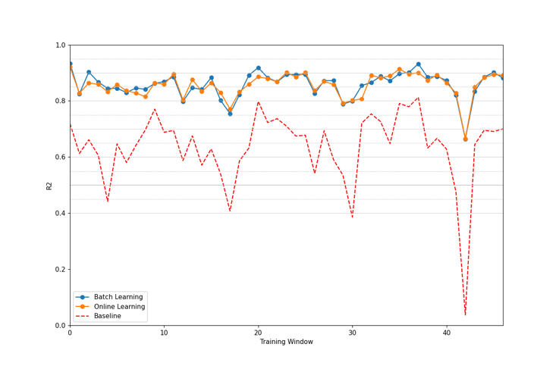

**Online:** mean(0.8560), gain(0.2208), var(0.0022)

**Batch:** mean(0.8583), gain(0.2232), var(0.0023)

Figure - Model gains over Baseline

The results showcase an average gain of 22% on the R2 metric. Moreover, the reported level of accuracy is aligned with current finding in the literature. The low mean variance across the residual error is another fortunate finding, since it signals that the models are not converging to these scores on average but make individual predictions that are significantly off the mark.

The next step is validating the hypothesis that the proposed model is structurally different from the baseline of just using the last measurement. The chosen process compared each prediction’s mean and variance using the z-score. At each training window, the test data was used to compute this work unit’s prediction. The repeated last measurement stood in for the predictions of the baseline. Both samples’ scores supplied the raw material for generating the p-value. The median value of this metric for all training windows could finally be compared to the gold standard of 0.05.

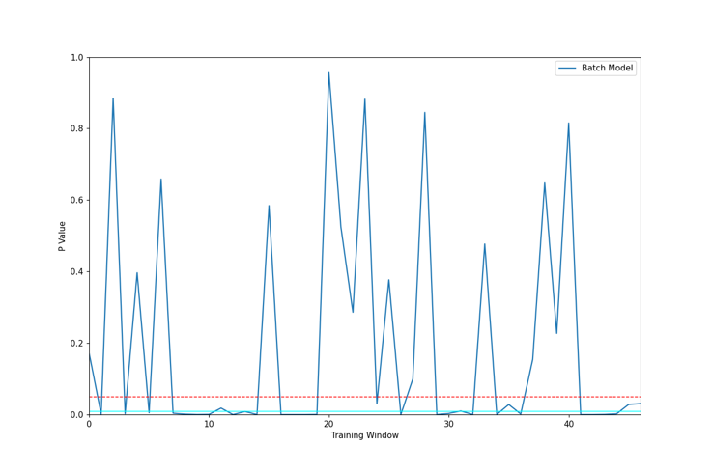

**Batch Model:** median p-value(0.0085)

Figure - Hypothesis testing: Batch x Baseline

Figure 9 provides the summary of the evolution of p-value across the training windows. On the positive side, the median score points to a high likelihood of rejecting the hypothesis that both the baseline model and a CNN1D trained in batches are structurally similar. The dashed red line marks the 0.05 threshold, the gold standard for this test. Still, on several training windows we encounter a diametrically opposed behaviour.

**W(1) P(930):** MSE (baseline) 0.00029548

MSE (cnn1d) 0.00025535

p-value (student T): 0.01607697

Figure - Model and Baseline similarities

One explanation for these discrepancies can be found on Figure 10. It showcases a period of low variation on consumption. In this case it is expected that the mean squared error reported by baseline and CNN1D approach the same neighborhoods. Consequently, both models will be structurally similar. It is a key finding about the behaviour of the forecasting model: its gains in terms of minimizing residual errors are linked to periods of high variance in metering. In scenarios where consumption remains stable, we can expect degradation in overall predictive power.

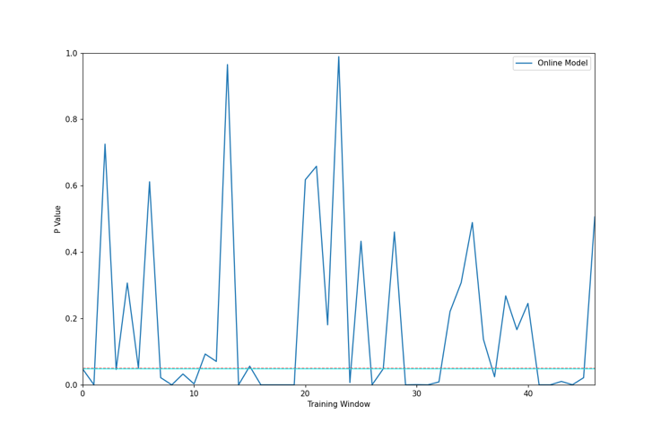

**Online Model:** median p-value(0.0475)

Figure - Hypothesis testing: Online x Baseline

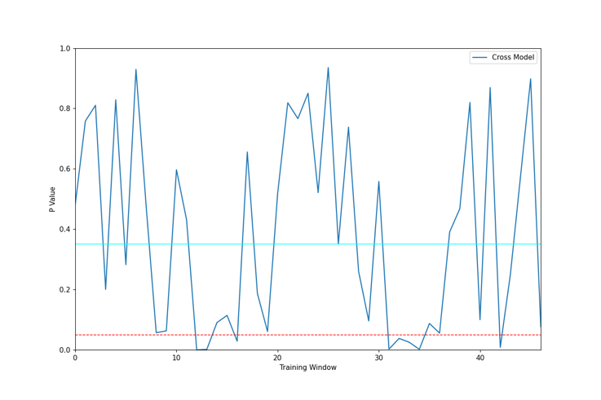

**Cross Model:** median p-value(0.3508)

Figure - Hypothesis testing: Batch x Online

Finally, we perform the structural comparison between the Batch and Online training strategies. Figure 12 supplies an inconclusive picture. The hypothesis of both models being significantly different has a much less consistent behaviour across training windows. For that reason, it seems the Batch training strategy has a slight edge since it does not require sophisticated state keeping on the control plane and can be generated ad-hoc.

# VII. Conclusion

This document outlined a possible strategy for enabling demand-side response in the context of smart electrical grids. It builds on two foundational aspects of a broader technological landscape. First, the move from a mostly central control system that relies mainly on information broadcast to manage consumption towards a distributed, fully connected platform. Second, the opportunities for engaging with residential consumers directly, borrowing successful applications of machine learning systems on state-of-the-art marketing solutions.

The discussion surveyed the applicability of this toolkit on current IoT applications and, most importantly, residential smart meters. To that effect, the research focused on finding the most cost-effective algorithm in terms of both size (to be lightweight and distributable over the network) and processing times (to reduce resource consumption on embedded side of the solution). ANNs provide a comfortable level of modularization to enable solution interchangeability without affecting data preprocessing or output formatting. Out of all candidate architectures, CNN1D was the best choice in both criteria.

Next, the document compared the residual errors of the estimator against the persistence model. This baseline stood in as metering systems that just report current consumption profile. The results pointed to an overall gain of 0.21 point in the R2 statistic, reaching a mean value of 0.85 on a test dataset that spans 4 years.

A more rigorous appraisal of the hypothesis presented some challenges. A stationary baseline provides meaningful insights on scenarios when constant consumption variation is the norm, but act as a confounding factor when consumption stabilizes. This is an intractable problem since we need an estimator that capture both signal shifts, but also stabilization. Nonetheless, the experiment detected enough difference using this imperfect approach to highlight that the model did not perform like the baseline in 50% of the dataset.

Another research question was possible operational gains enabled by different training strategies. Both batch and online training options performed at roughly the same level of accuracy. Moreover, the z-statistic test showed no clear structural differences between candidates.

This experiment was not an exhaustive exploration of the proposed scenario. One possible next step is to validate findings in candidate hardware platforms. Another serious issue that remains untouched is the *“cold-start problem”*. The reported scores used 3-month intervals for training and the model uses the last 4-hour metering data to generate a 1-hour prediction. Newly installed meters will not have any historical data to work with. They must rely on additional strategies, such as swarm-intelligence, to cover for these short-comings. As it stands now, little has been covered by the literature in this respect.

References

A. T. Eseye and M. Lehtonen, "Short-Term Forecasting of Heat Demand of Buildings for Efficient and Optimal Energy Management Based on Integrated Machine Learning Models," in IEEE Transactions on Industrial Informatics, vol. 16, no. 12, pp. 7743-7755, Dec. 2020, doi: 10.1109/TII.2020.2970165.

B. Sudharsan et al., "TinyML Benchmark: Executing Fully Connected Neural Networks on Commodity Microcontrollers," 2021 IEEE 7th World Forum on Internet of Things (WF-IoT), 2021, pp. 883-884, doi: 10.1109/WF-IoT51360.2021.9595024.

J. Kampars, D. Tropins and R. Matisons, "A Review of Application Layer Communication Protocols for the IoT Edge Cloud Continuum," 2021 62nd International Scientific Conference on Information Technology and Management Science of Riga Technical University (ITMS), 2021, pp. 1-6, doi: 10.1109/ITMS52826.2021.9615332.

Dua, D. and Graff, C. (2019). UCI Machine Learning Repository [http://archive.ics.uci.edu/ml]. Irvine, CA: University of California, School of Information and Computer Science.

Georges Hebrail (georges.hebrail '@' edf.fr), Senior Researcher, EDF R&D, Clamart, France

Alice Berard, TELECOM ParisTech Master of Engineering Internship at EDF R&D, Clamart, France

Martín Abadi, Ashish Agarwal, Paul Barham, Eugene Brevdo, Zhifeng Chen, Craig Citro, Greg S. Corrado, Andy Davis, Jeffrey Dean, Matthieu Devin, Sanjay Ghemawat, Ian Goodfellow, Andrew Harp, Geoffrey Irving, Michael Isard, Rafal Jozefowicz, Yangqing Jia, Lukasz Kaiser, Manjunath Kudlur, Josh Levenberg, Dan Mané, Mike Schuster, Rajat Monga, Sherry Moore, Derek Murray, Chris Olah, Jonathon Shlens, Benoit Steiner, Ilya Sutskever, Kunal Talwar, Paul Tucker, Vincent Vanhoucke, Vijay Vasudevan, Fernanda Viégas, Oriol Vinyals, Pete Warden, Martin Wattenberg, Martin Wicke, Yuan Yu, and Xiaoqiang Zheng. TensorFlow: Large-scale machine learning on heterogeneous systems, 2015. Software available from tensorflow.org.

Srivastava, N., Hinton, G., Krizhevsky, A., Sutskever, I. and Salakhutdinov, R., 2014. Dropout: a simple way to prevent neural networks from overfitting. The journal of machine learning research, 15(1), pp.1929-1958.

**Rodrigo Gonçalves Leite** (PG, University of Liverpool)

1. Submitted as part of the coursework required for the PPGET Pos-graduate course in Machine Learning, UFF-RJ. UFF