AI-ASSISTANT CODING
Assignment -5.3
Gunishetty Sukruti
2303A52152
Batch-38

Lab 5: Ethical Foundations – Responsible AI Coding Practices
Lab Objectives
• To explore ethical risks associated with AI-generated code
• To understand security, bias, transparency, inclusiveness, and
• To analyze AI-generated code critically instead of blindly accepting it
• To promote responsible and ethical use of AI tools in softwa-asre
development
Lab Outcomes (LOs)
After completing this lab, students will be able to:
• Identify insecure coding practices generated by AI tools
• Detect bias or unfair logic in AI-assisted programs
• Evaluate transparency and explainability of AI-generated code
• Modify AI-generated code to be inclusive and fair
• Understand human responsibility in ethical AI coding

Task 1: Privacy and Data Security in AI-Generated Code
Scenario
AI tools can sometimes generate insecure authentication logic.
Task Description
Use an AI tool to generate a simple login system in Python.
Analyze the generated code to check:
• Whether credentials are hardcoded
• Whether passwords are stored or compared in plain text
• Whether insecure logic is used
Then, revise the code to improve security (e.g., avoid hardcoding, use input
validation).
Expected Output
• AI-generated login code
• Identification of security risks
• Revised secure version of the code
• Brief explanation of improvements

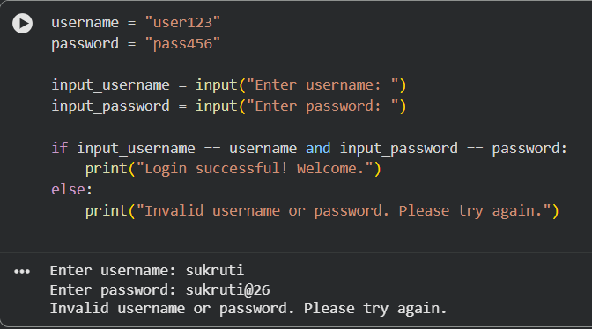

Explanation:
The generated login system uses hardcoded username and password values, which is a major security risk. Passwords are stored in plain text, making them visible to anyone who accesses the code. Users cannot set their own credentials, and sensitive data is not protected. This violates basic privacy and secure coding practices.

Prompt:
Rewrite the login system to avoid hardcoded credentials and use secure input validation

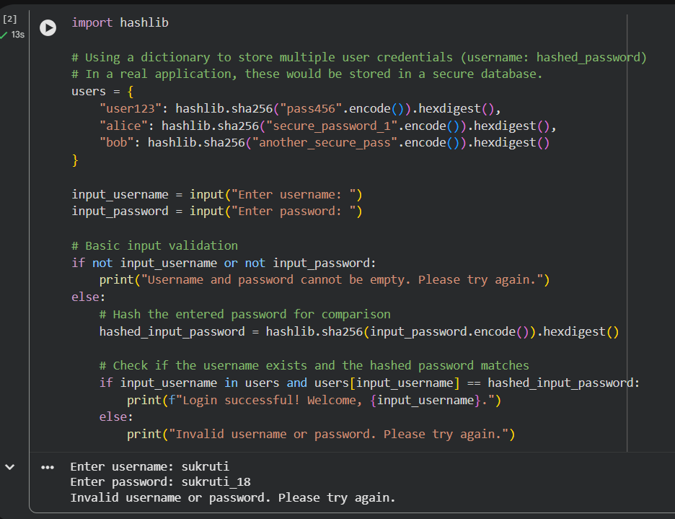

Task 2: Bias Detection in AI-Generated Decision Systems
Scenario
AI systems may unintentionally introduce bias.
Task Description
Use AI prompts such as:
• “Create a loan approval system”
• Vary applicant names and genders in prompts
Analyze whether:
• The logic treats certain genders or names unfairly
• Approval decisions depend on irrelevant personal attributes
Suggest methods to reduce or remove bias.
Expected Output
• Python code generated by AI
• Identification of biased logic (if any)
• Discussion on fairness issues
• Mitigation strategies
Prompt: Create a simple loan approval system in Python based on income and credit score.

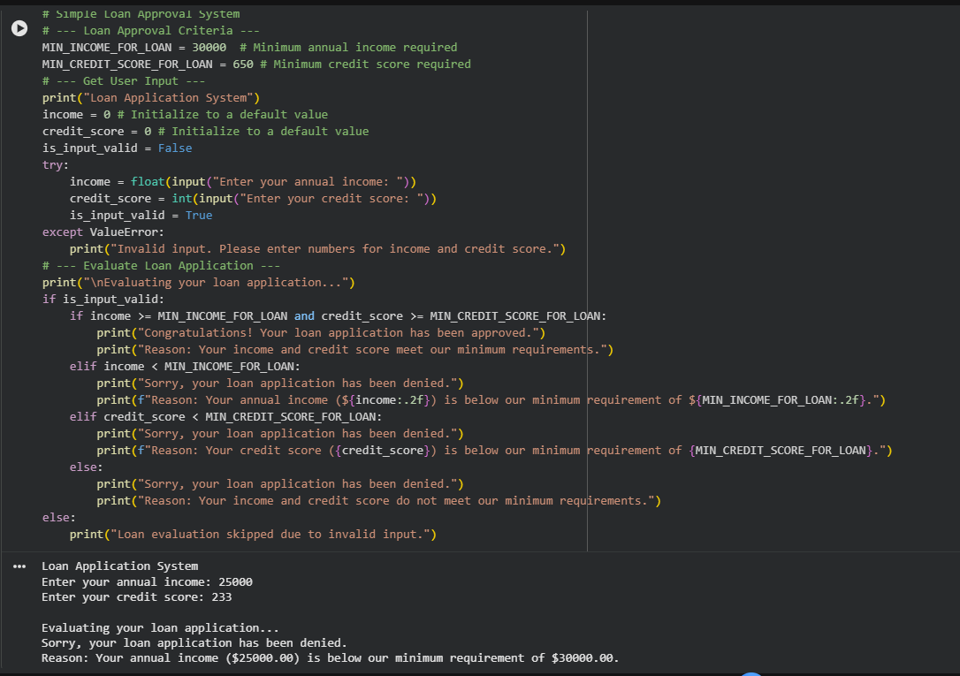
Explanation: The AI-generated loan approval system makes decisions based only on income and credit score. No personal or sensitive attributes such as gender, name, or age are used in the decision-making process. This ensures that the system does not show bias toward any individual or group. Using only financial factors helps maintain fairness and ethical behavior in AI systems.

Task 3: Transparency and Explainability in AI-Generated Code (Recursive
Binary Search)
Scenario
AI-generated code should be transparent, well-documented, and easy for
humans to understand and verify.
Task Description
Use an AI tool to generate a Python program that:
• Implements Binary Search using recursion
• Searches for a given element in a sorted list
• Includes:
o Clear inline comments
o A step-by-step explanation of the recursive logic
After generating the code, analyze:
• Whether the explanation clearly describes the base case and recursive
case
• Whether the comments correctly match the code logic
• Whether the code is understandable for beginner-level students
Expected Output
• Python program for recursive binary search
• AI-generated comments and explanation
• Student’s assessment on clarity, correctness, and transparency
Prompt : Generate a Python program for recursive binary search. Include clear comments explaining the base case and recursive case

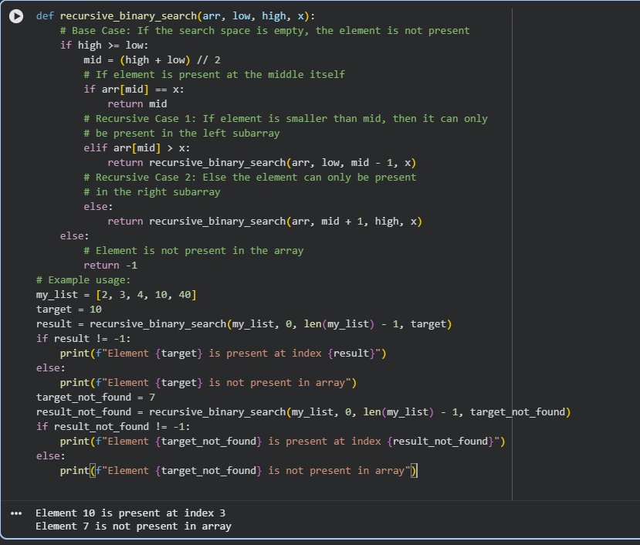
Explanation: In this task, the recursive binary search code is easy to understand because clear comments explain what each part does. The base case and recursive calls are clearly mentioned, so it is simple to follow how the algorithm works step by step. This makes the program transparent and helps users trust the logic and results.

Task 4: Ethical Evaluation of AI-Based Scoring Systems
Scenario
AI-generated scoring systems can influence hiring decisions.
Task Description
Ask an AI tool to generate a job applicant scoring system based on features
such as:
• Skills
• Experience
• Education
Analyze the generated code to check:
• Whether gender, name, or unrelated features influence scoring
• Whether the logic is fair and objective
Expected Output
• Python scoring system code
• Identification of potential bias (if any)
• Ethical analysis of the scoring logic
Task 5: Inclusiveness and Ethical Variable Design
Scenario
Inclusive coding practices avoid assumptions related to gender, identity, or
roles and promote fairness in software design.
Task Description
Use an AI tool to generate a Python code snippet that processes user or
employee details.
Analyze the code to identify:
• Gender-specific variables (e.g., male, female)
• Assumptions based on gender or identity
• Non-inclusive naming or logic
Modify or regenerate the code to:
• Use gender-neutral variable names
• Avoid gender-based conditions unless strictly required
• Ensure inclusive and respectful coding practices
Expected Output
• Original AI-generated code snippet
• Revised inclusive and gender-neutral code
• Brief explanation of:
o What was non-inclusive
o How inclusiveness was improved
Prompt Used: Create a Python program to score job applicants based on skills, experience, and education

