AI ASSISTANT CODING
ASSIGNMENT-3
Gunishetty Sukruti
2303A52152
Batch-38

Prompt Engineering – Improving Prompts and Context Management
Lab Objectives:
● To understand how prompt structure and wording influence AI-generated code.
● To explore how context (like comments and function names) helps AI generate
relevant output.
● To evaluate the quality and accuracy of code based on prompt clarity.
● To develop effective prompting strategies for AI-assisted programming.

Lab Outcomes (LOs):
After completing this lab, students will be able to:
● Generate Python code using Google Gemini in Google Colab.
● Analyze the effectiveness of code explanations and suggestions by Gemini.
● Set up and use Cursor AI for AI-powered coding assistance.
● Evaluate and refactor code using Cursor AI features.
● Compare AI tool behavior and code quality across different platforms.

Task Description-1
• Progressive Prompting for Calculator Design: Ask the AI to design a simple calculator
program by initially providing only the function name. Gradually enhance the prompt by
adding comments and usage examples.

Expected Output-1
• Comparison showing improvement in AI-generated calculator logic and structure.

Prompt:
design a simple calculator program by initially providing only the function name. Gadually enhance the prompt by adding comments and usage examples and the input values should be taken by the user side and when ever if i given string to the input value it should not give the error the output should be invaliid but it should not give error . Expected Output-1 • Comparison showing improvement in AI-generated calculator logic and structure.

CODE & OUTPUT:

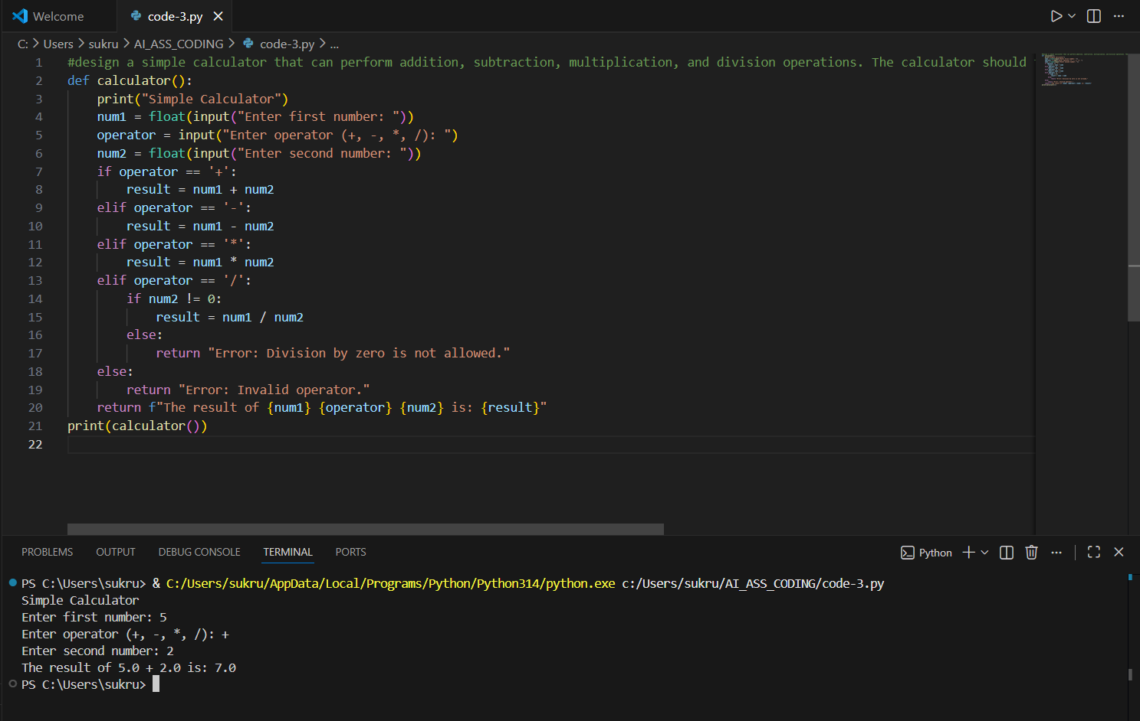
PROMPT:
design a simple calculator that can perform addition, subtraction, multiplication, and division operations. The calculator should take two numbers and an operator as input from the user and display the result and add comment lines and example usages
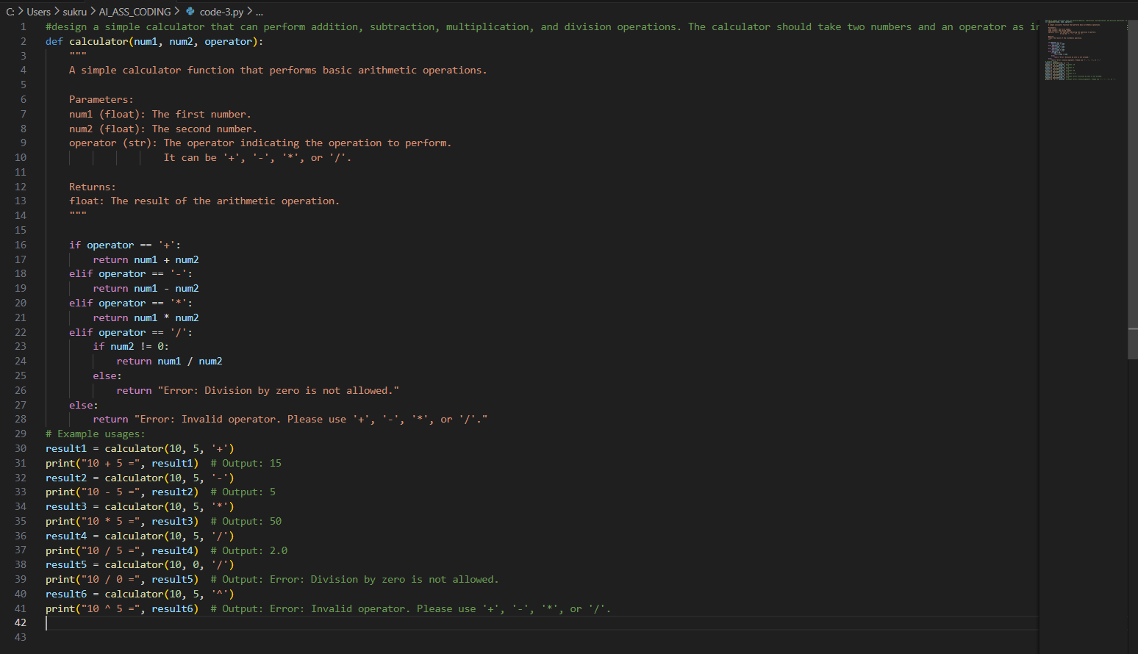
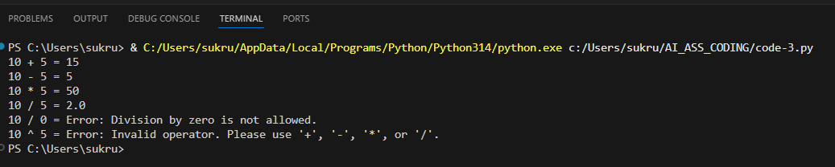

Explanation:
This task shows how a simple calculator program is built step by step. At first, the program only includes the function name and basic arithmetic logic. Gradually, comments and a clear description are added to explain how the function works and what inputs it expects. Error handling is then included to manage cases like division by zero and invalid operators. Finally, example calculations are provided to demonstrate how the function is used. This progression highlights how the calculator becomes more clear, readable, and well-structured over time.

Task Description-2
• Refining Prompts for Sorting Logic: Start with a vague prompt for sorting student marks,
then refine it to clearly specify sorting order and constraints.
Expected Output-2
• AI-generated sorting function evolves from ambiguous logic to an accurate and efficient
Implementation

Prompt:

Write a program to sort the student marks

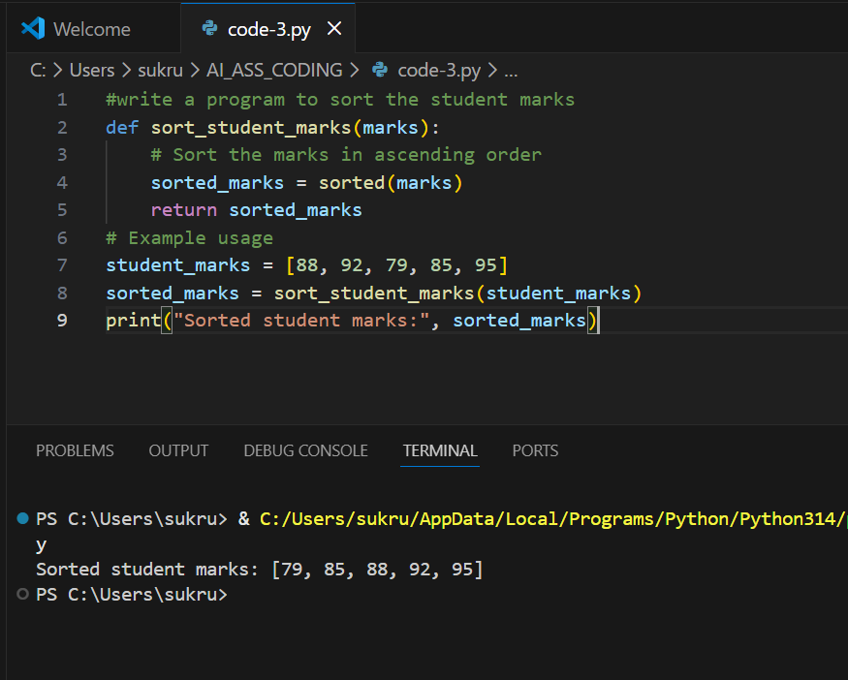
Prompt:
write a program to sort the student marks in ascending order and by using constraints by user input
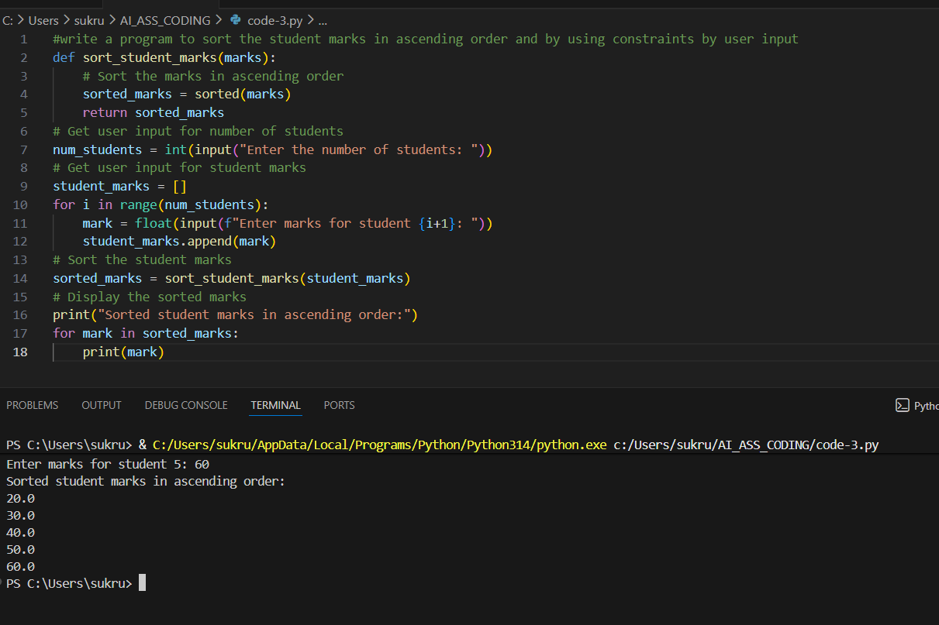
Explanation:
First, a general prompt was given to sort student marks. Since it did not mention the sorting order or any conditions, the output was basic and unclear.
Then, the prompt was refined by specifying ascending order and user input constraints. This helped the AI generate a more accurate and well-defined sorting program.

Task Description-3
• Few-Shot Prompting for Prime Number Validation: Provide multiple input-output
examples for a function that checks whether a number is prime. Observe how few-shot
prompting improves correctness.
Expected Output-3
• Improved prime-checking function with better edge-case handling.
PROMPT:
Write a program to check whether a number is prime or not
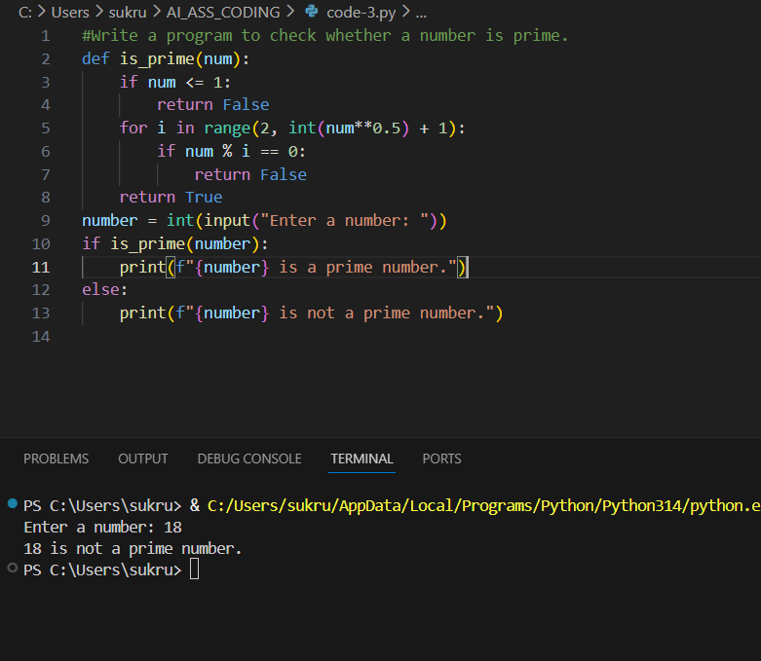

Prompt:
#Write a program to check whether a number is prime.
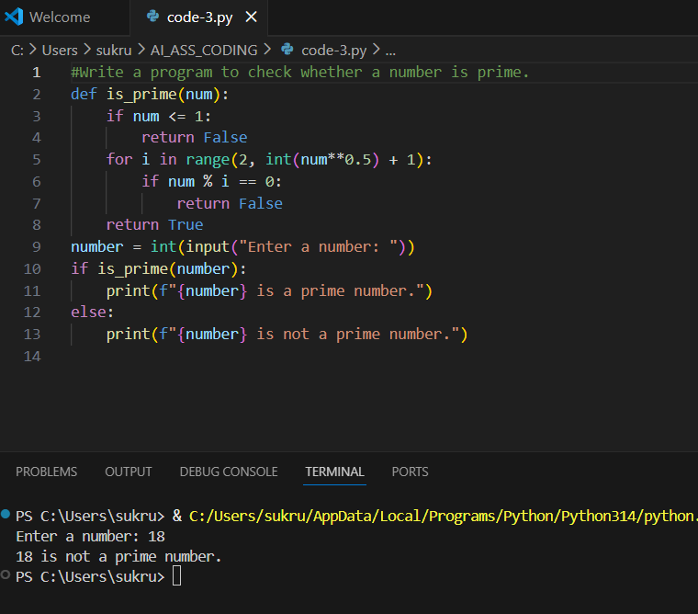

EXPLANATION:
The program checks whether a given number is a prime number.
It takes a number as input and tests if it can be divided by any number other than 1 and itself.
For the input 2, it has no other divisors, so the program prints Prime.

Task Description-4
• Prompt-Guided UI Design for Student Grading System: Create a user interface for a
student grading system that calculates total marks, percentage, and grade based on user
input.
Expected Output-4
• Well-structured UI code with accurate calculations and clear output display.
PROMPT:
Create a user interface for a student grading system that calculates total marks, percentage, and grade based on user input.
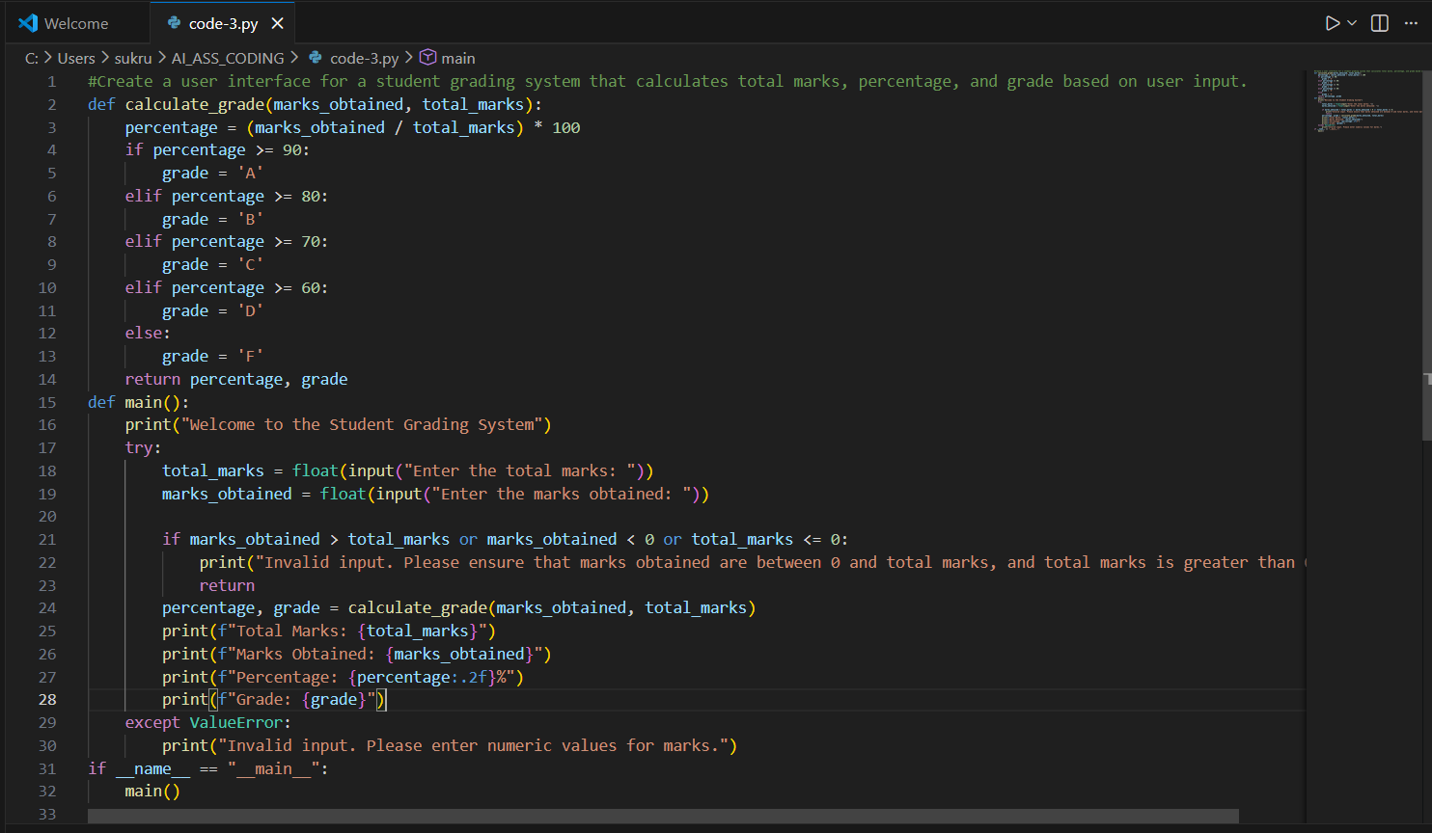

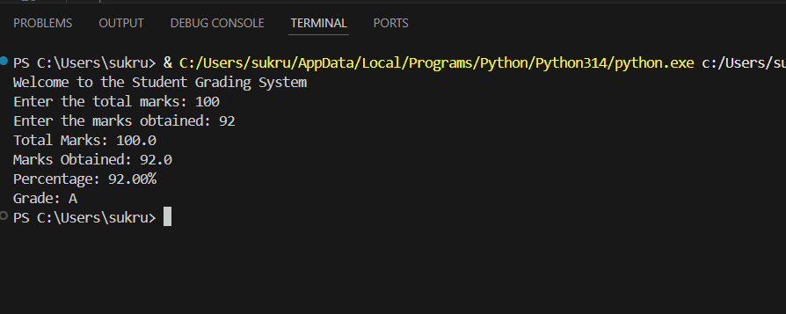
EXPLANATION:
The prompt generated a student grading system that takes user input, calculates percentage, assigns a grade, and displays the result clearly.

Task Description-5
• Analyzing Prompt Specificity in Unit Conversion Functions: Improving a Unit
Conversion Function (Kilometers to Miles and Miles to Kilometers) Using Clear
Instructions.
Expected Output-5
• Analysis of code quality and accuracy differences across multiple prompt variations.
PROMPT:
Write a program to convert kilometers to miles and miles to kilometers the user should be user input

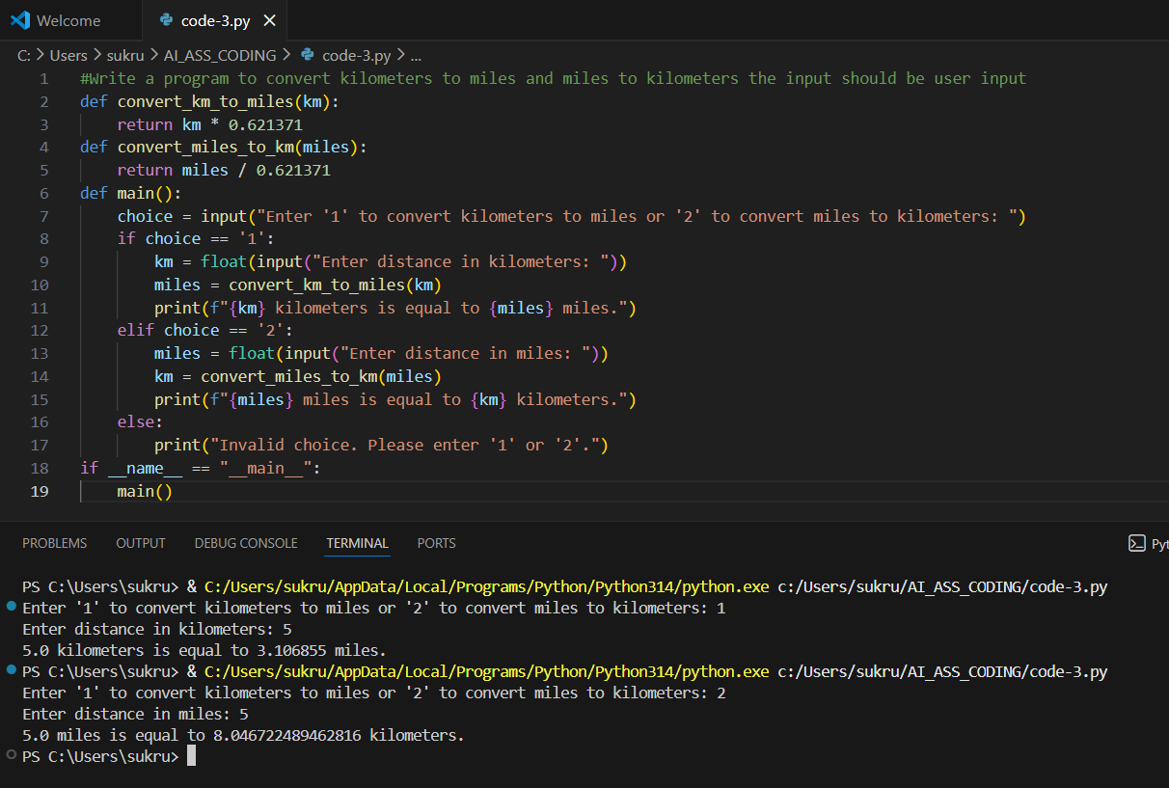
Explanation:
The program converts kilometers to miles and miles to kilometers using user input and displays accurate results through a menu-driven interface.

