Assignment -23.2
Gunishetty Sukruti
2303A52152
Batch-38
Task 1 – Project Proposal
• Students choose a real-world problem to solve with an AI-
assisted application (e.g., e-commerce billing system, health
monitoring dashboard, student attendance tracker).
• Prepare a project proposal including:
o Objective
o Features
o Tools/technologies to be used
o Expected output

prompt:
Generate a Project Proposal Students choose a real-world problem to solve with an AI-assisted application (e.g., e-commerce billing system, health monitoring dashboard, student attendance tracker). Include the following Objective, Features , Tools/technologies to be used, Expected output

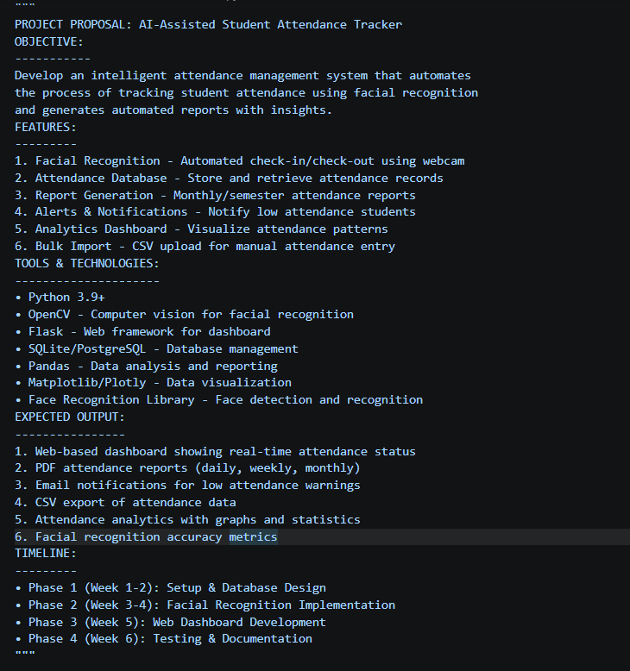

Task 2 – Application Design
• Use AI tools to assist in:
o Designing system architecture diagrams.
o Defining database schema (if needed).
o Creating wireframes/UI mockups for frontend design.
Prompt:
Generate a code in such a way that it can design system architecture diagrams and define database schema and lose creates wireframes/ui mockups for fronted design

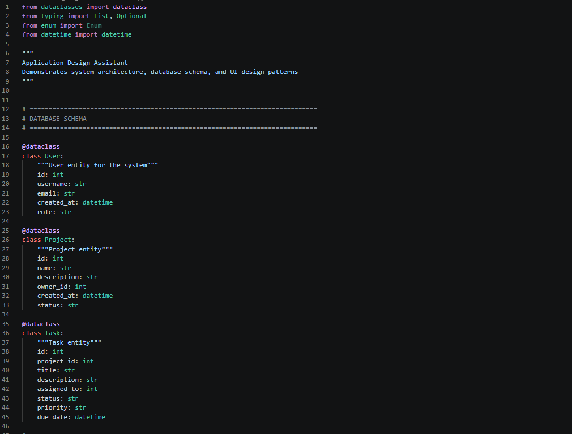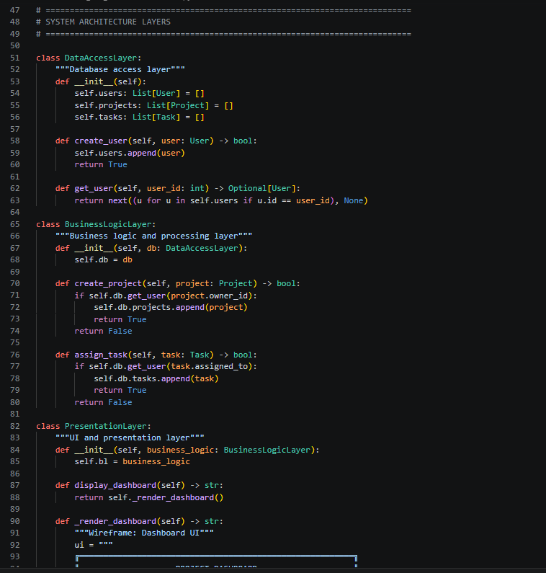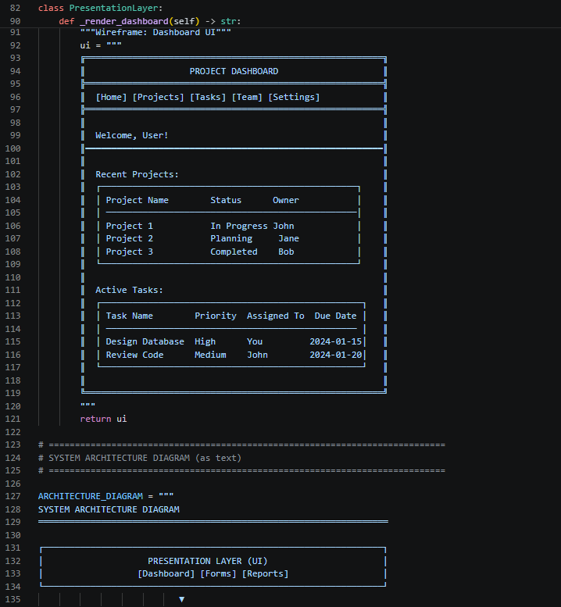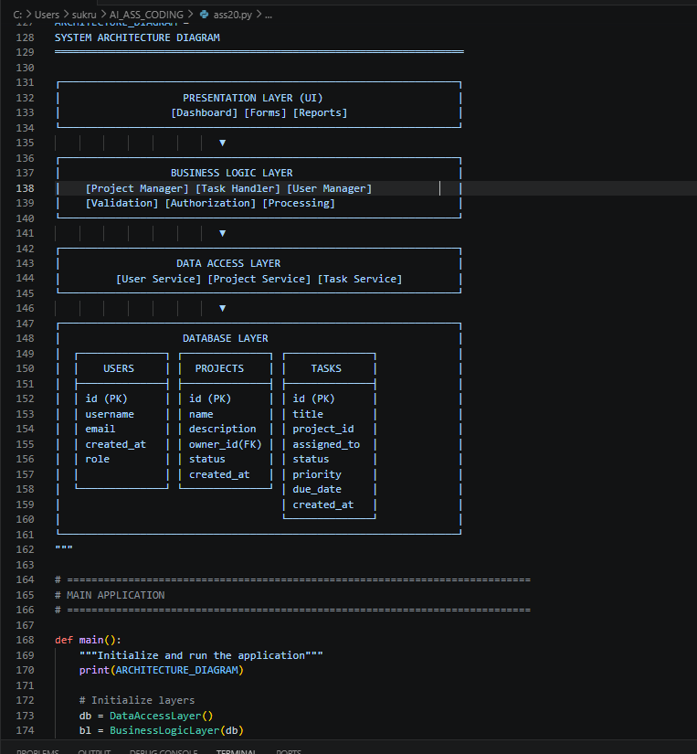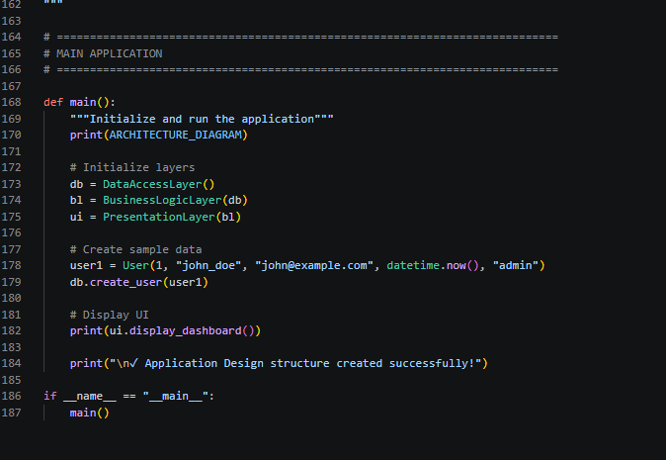
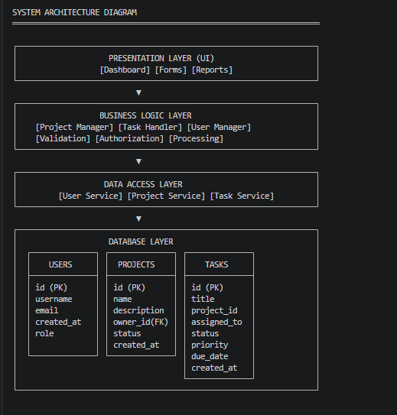
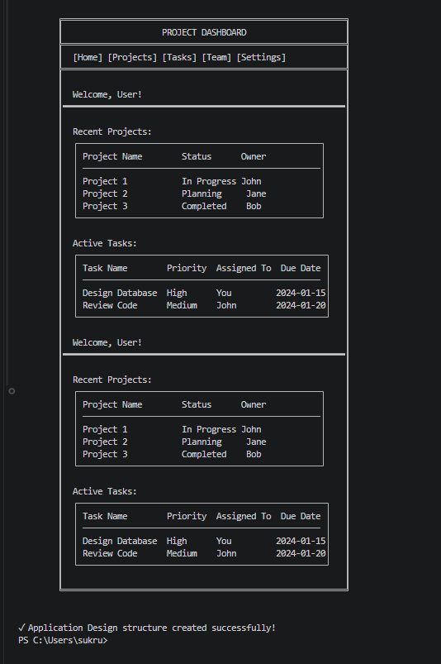

Explanation
This program demonstrates a layered application design with clear separation of concerns.
It defines database entities (User, Project, Task) using dataclasses to represent structured data.
The system is divided into Data Access, Business Logic, and Presentation layers for better organization.
The business layer handles validation and operations, while the UI layer displays a dashboard.
Overall, it shows how scalable and maintainable software architecture is designed.

Task 3 – AI-Assisted Code Development
• Implement the application in phases:
o Frontend: Web/mobile UI with HTML/CSS/JS (or
framework).
o Backend: RESTful APIs or server logic.
o Database: Schema design, SQL queries.
o Integration: API calls, authentication, error handling.
Prompt:
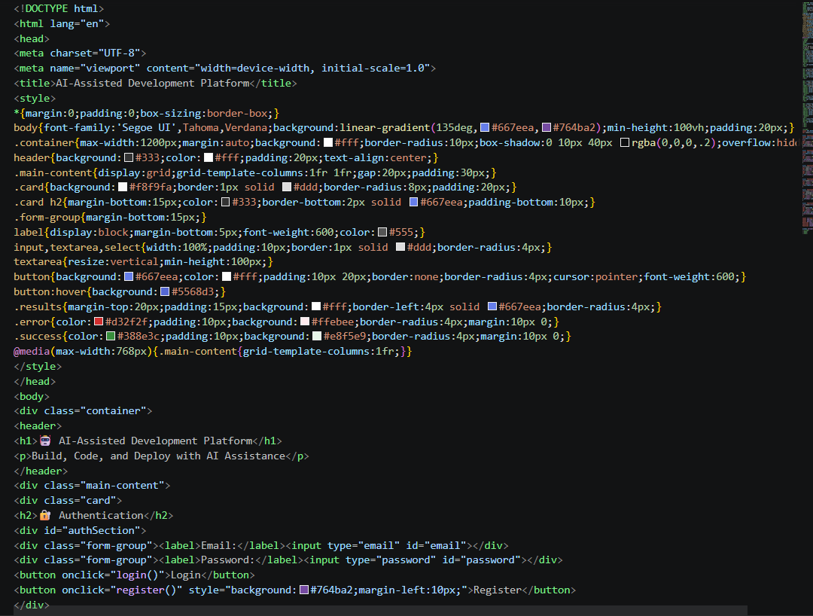
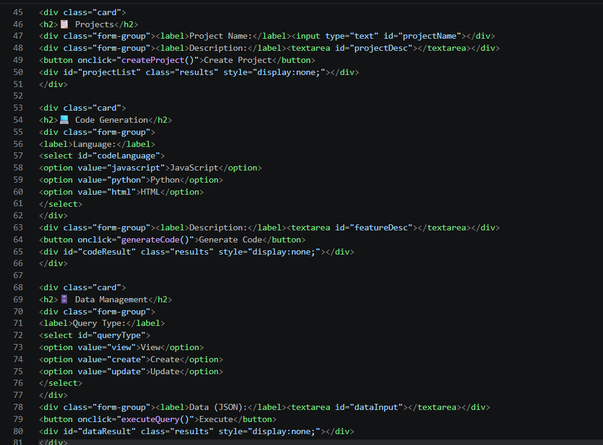
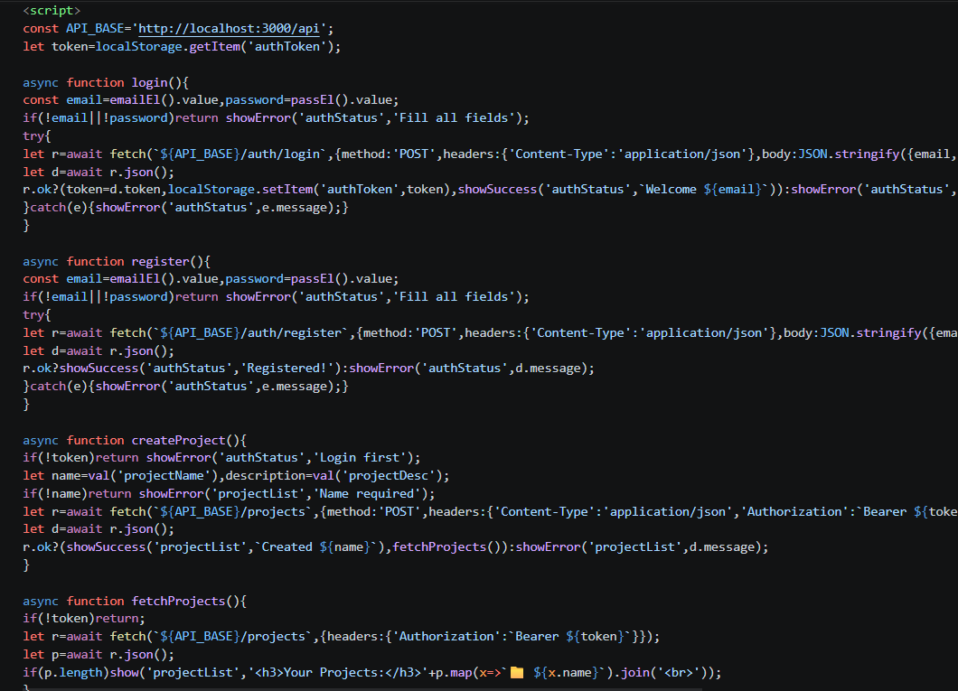
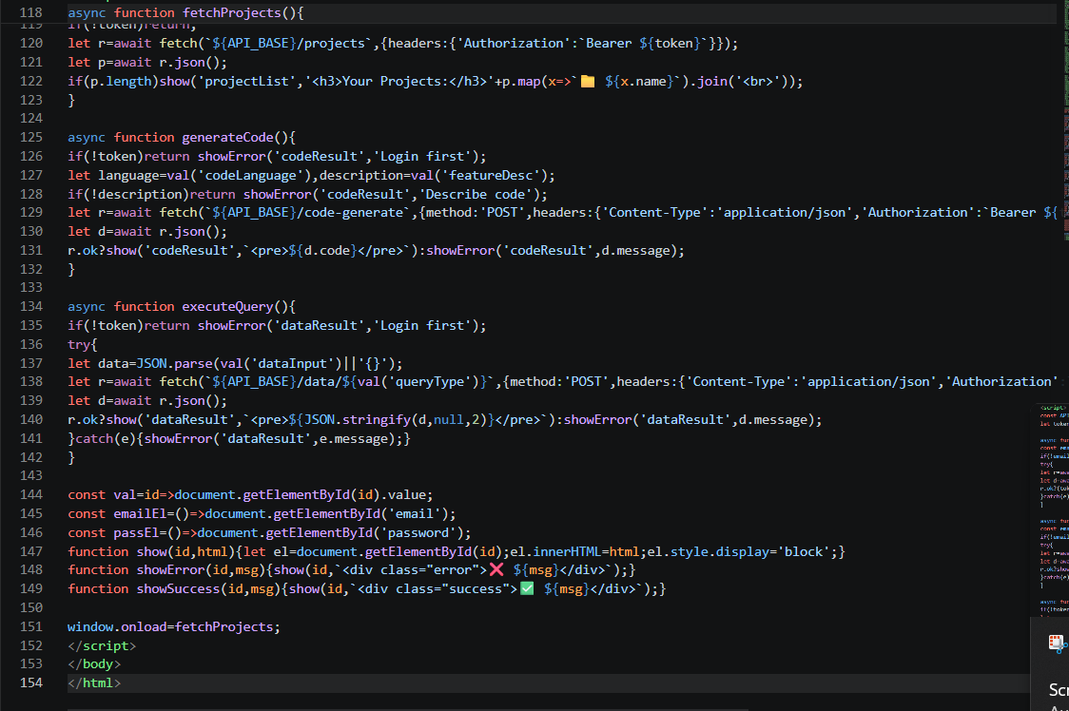
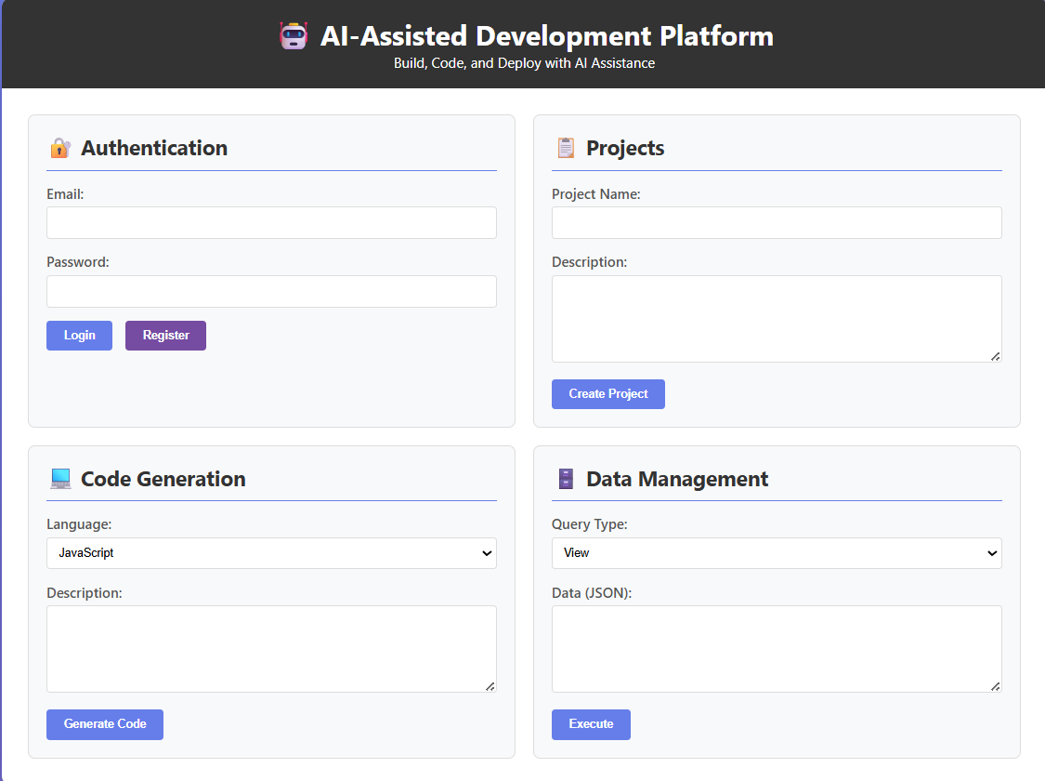

Explanation:
This code represents a simplified frontend for an AI-assisted development platform.
It includes sections for authentication, project management, code generation, and data handling.
The JavaScript interacts with backend APIs using fetch and handles user actions dynamically.
Utility functions are used to reduce repetition and make the code more efficient.
Overall, the optimized version maintains the same functionality with cleaner and shorter code.

Task 4 – Documentation & Code Quality
• Generate automatic documentation and inline comments using
AI.
• Ensure clear README.md for project setup and usage.
• Conduct AI-assisted code review to refine readability and
maintainability.
Prompt:
Help me with Task 4 – Documentation and Code Quality for my project “AI-Powered Personal Finance Assistant”.
Please provide:
1. Automatic project documentation
2. Inline comments for the code
3. A simple README.md file for project setup and usage
4. AI-assisted code review suggestions to improve readability and maintainability
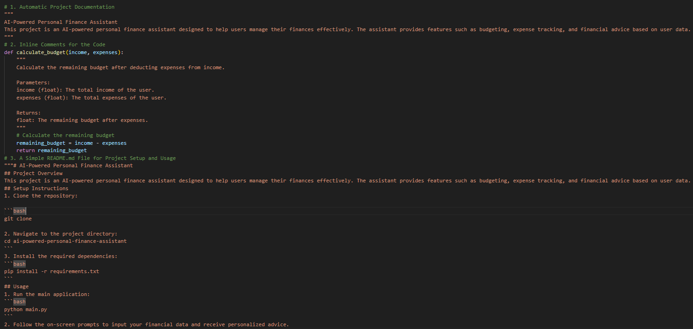
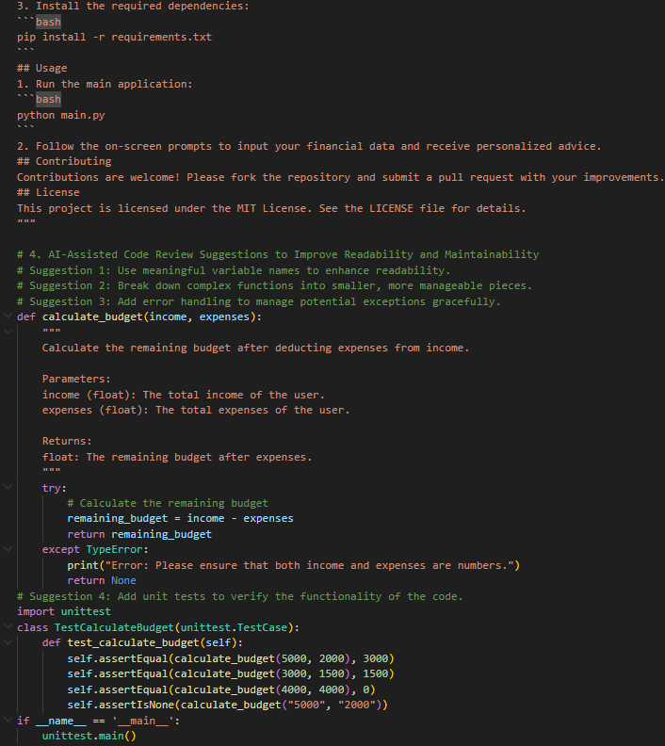
EXPLANATION:
This task focuses on improving the documentation and quality of the project code. Automatic documentation and inline comments help explain the purpose and working of the code clearly. The README.md file provides setup instructions and usage details so that anyone can run the project easily. AI-assisted code review helps improve readability, maintainability, and error handling, making the project more organized and reliable.

Task 5 – Testing & Debugging
• Use AI to:
o Generate unit tests.
o Identify vulnerabilities/security flaws.
o Suggest optimizations for performance.

Promt:
Write Python code that defines a sample function, then automatically generate unit tests for it using unittest. Next, analyze the function for possible vulnerabilities or security flaws, and finally suggest code optimizations to improve performance.

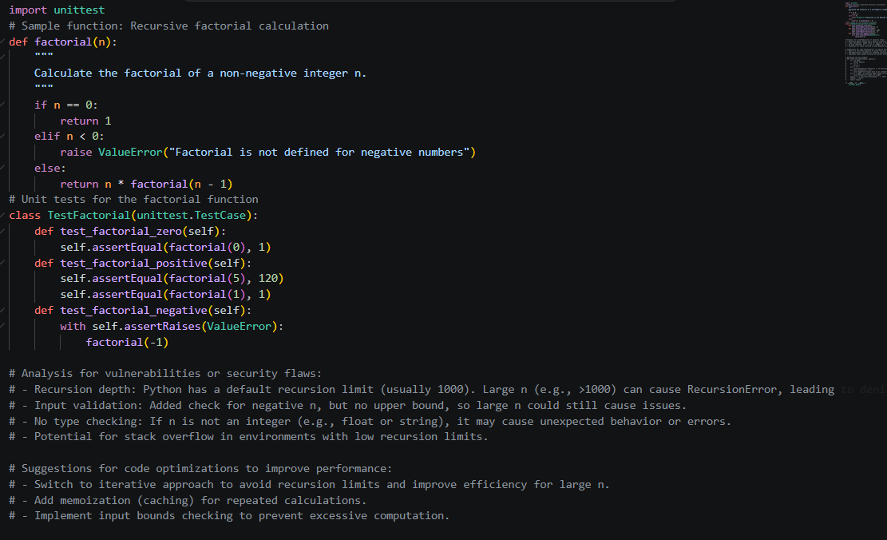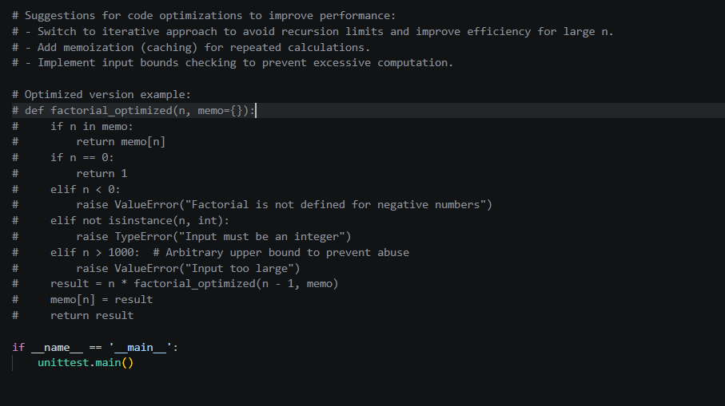

output:

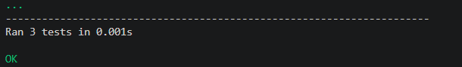
Explanation:
This assignment prompt asks you to use AI for three tasks: first, generate unit tests for a given function to ensure correctness; second, analyze the function for vulnerabilities or security flaws like unsafe inputs or poor validation; and third, suggest optimizations to improve performance. By structuring the request clearly, you’ll get code that includes a sample function, its tests, plus AI-driven insights on security and efficiency. This makes the exercise practical, combining testing, debugging, and optimization in one workflow.

Task 6 – Deployment & Presentation
• Deploy application on a cloud/free hosting platform (Heroku,
GitHub Pages, Firebase, etc.).
• Prepare a final presentation including:
o Problem statement
o Solution architecture
o Live demo
o Reflection on AI assistance and limitations
Expected Outcomes:
• A complete, deployable software application.
• Students gain experience in end-to-end development with AI
tools.
• Improved skills in teamwork, documentation, and ethical AI
usage.
Prompt:
Develop a simple web application using Python (Flask or Django), deploy it on a free cloud hosting platform such as Heroku or Firebase, and then create a final presentation that covers: the problem statement, the solution architecture, a live demo of the deployed app, and a reflection on how AI tools assisted in development and their limitations
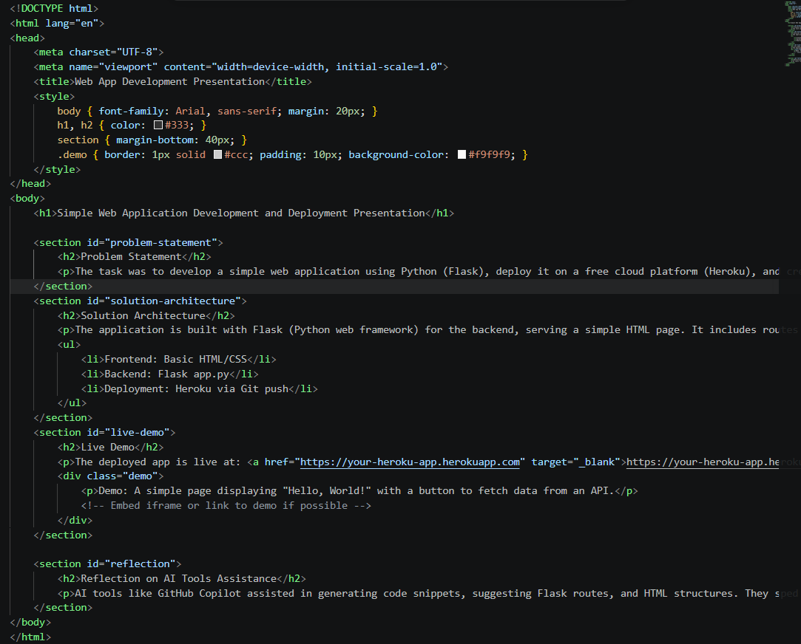
Output:
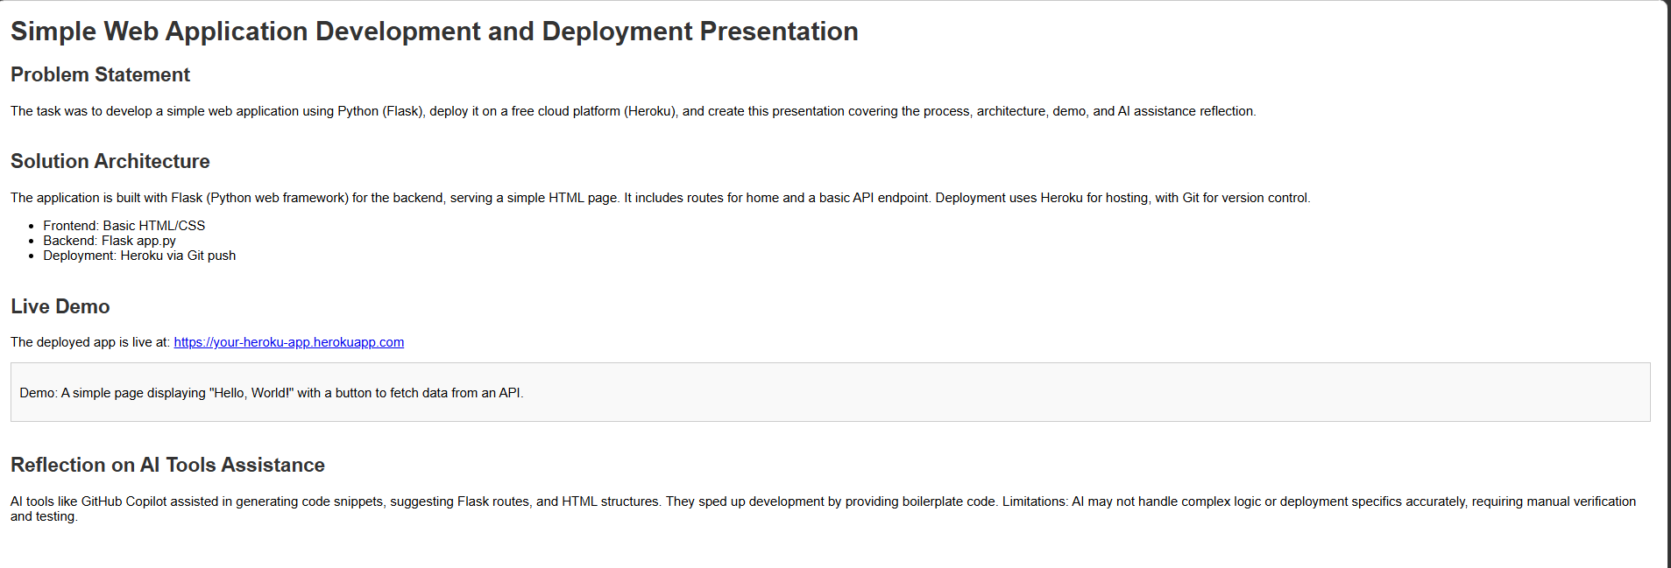
Explanation.
This assignment requires you to build and deploy a simple web application on a free cloud platform like Heroku or Firebase. You then prepare a presentation that explains the problem your app solves, the architecture behind it, and show a live demo of the deployed app. Finally, you reflect on how AI assisted in development and where its limitations appeared. The expected outcome is a complete, deployable project with practical experience in teamwork, documentation, and ethical AI usage.

