**AIM: - Design a system for doors at home, such that whenever a door is opened, a light turns on for 1000 ms if it is day & 2000 ms if it is night.**

**CIRCUIT DIAGRAM: -**

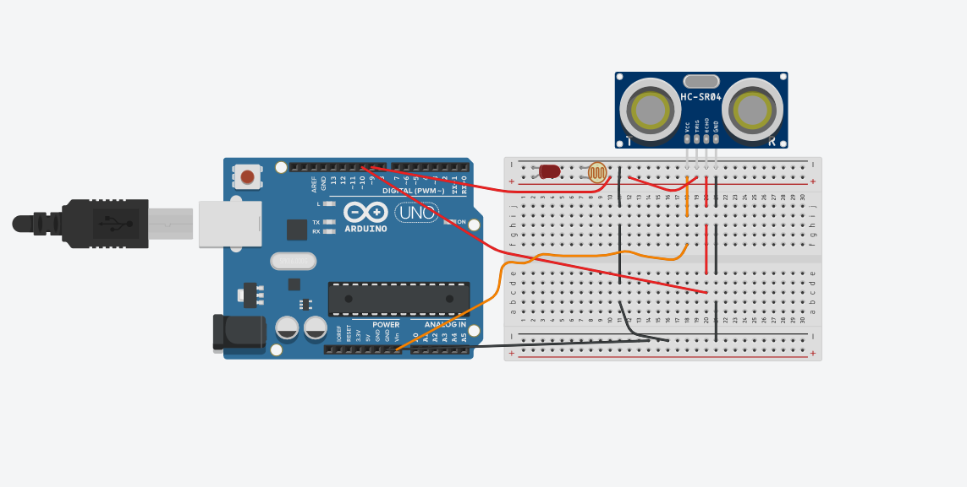

**THEORY: - LEDs** are a particular type of diode that convert electrical energy into light. In fact, LED stands for “Light Emitting Diode.” (It does what it says on the tin!) And this is reflected in the similarity between the diode and LED schematic symbols.

In short, LEDs are like tiny lightbulbs. However, LEDs require a lot less power to light up by comparison. They’re also more energy efficient, so they don’t tend to get hot like conventional light bulbs do (unless you’re really pumping power into them). This makes them ideal for mobile devices and other low-power applications. Don’t count them out of the high-power game, though. High-intensity LEDs have found their way into accent lighting, spotlights and even automotive headlights!

The brightness of an LED is directly dependent on how much current it draws. That means two things. The first being that super bright LEDs drain batteries more quickly, because the extra brightness comes from the extra power being used. The second is that you can control the brightness of an LED by controlling the amount of current through it. But, setting the mood isn’t the only reason to cut back your current.

The **Arduino Uno** is an open-source microcontroller board based on the Microchip ATmega328P microcontroller and developed by Arduino.cc. The board is equipped with sets of digital and analog input/output (I/O) pins that may be interfaced to various expansion boards (shields) and other circuits. The board has 14 Digital pins, 6 Analog pins, and programmable with the Arduino IDE (Integrated Development Environment) via a type B USB cable. It can be powered by the USB cable or by an external 9-volt battery, though it accepts voltages between 7 and 20 volts.

A Light Dependent Resistor (LDR) is also called a photoresistor. It is also called a photoconductor. It is basically a photocell that works on the principle of photoconductivity. The passive component is basically a resistor whose resistance value decreases when the intensity of light decreases. This [optoelectronic device](http://www.circuitstoday.com/optoelectronic-devices) is mostly used in light varying sensor circuit, and light and dark activated switching circuits. Some of its applications include camera light meters, street lights, clock radios.

Ultrasonic sensors emit short, high-frequency sound pulses at regular intervals. These propagate in the air at the velocity of sound. If they strike an object, then they are reflected back as echo signals to the sensor, which itself computes the distance to the target based on the time-span between emitting the signal and receiving the echo. They are used as the distance to an object is determined by measuring the time of flight and not by the intensity of the sound, ultrasonic sensors are excellent at suppressing background interference.

**CONCEPT USED: -**

When there is change in distance between doors, which is detected by ultrasonic sensor then it will give command to LDR to sense the light intensity if its below then 500 lux then it will glow LED for 2sec and if more then 500 lux then it will glow LED flor 1sec.

**LEARNING OUTCOMES: -**

1. Making circuits using Breadboard.2. Using multimeter to apply Resistance on a given LED.3. Working of Arduino UNO.4. Coding to be done on Arduino.exe for stimulation of the experiment.

**PROBLEMS & TROUBLESHOOTING: -**

No problems were occurred during the execution of the experiment.

**PRECAUTIONS: -**

1. The circuit made on breadboard can be wrong.
2. Any Element used can be defective.
3. The coding done for Arduino Board can be incorrect due to which stimulation can be failed.
4. Port Selection for Arduino can be incorrect due to which it won’t upload on Arduino Board and resulting in failure of experiment.

**Learning Outcomes: -**1.Setting up circuit on a Breadboard.2.Using Multimeter.3.Working and coding of Arduino and its IDE.4.Using LDR and learning its features . **Result: -** The system made is able to count the visitors in a hall entering through a door with the help of a LDR.