AI Diffusion DPG
Technical Specification

A configuration-driven framework for AI voice and chat assistants,
assembled from seven standardised Digital Public Good building blocks.

Version: post-PR #307 · 2026-05-05
Audience: engineering teams adopting or extending the framework

Contents
1. Executive Summary
2. System Context and Goals
3. Architecture Overview
4. Block Specifications
4.1 Agent Core
4.2 Knowledge Engine
4.3 Memory Layer
4.4 Trust Layer
4.5 Action Gateway
4.6 Reach Layer
4.7 Observability Layer
5. Domain Configuration Kit
6. Configuration Reference and KKB Walkthrough
7. Cross-cutting Concerns
8. Deployment and Operations
9. Implementation Status and Roadmap
Appendix A. HTTP API Reference
Appendix B. Internal Interfaces and Data Model
Appendix C. Error Codes and Failure Modes
Appendix D. Worked Examples
Appendix E. Glossary
Appendix F. Source Specs and Plans Index

1. Executive Summary
The AI Diffusion DPG framework assembles AI-powered voice and chat assistants from seven standardised Digital Public Good (DPG) building blocks. The runtime block boundaries are fixed; all domain-specific intelligence — persona, knowledge, connectors, guardrails, escalation policy — is externalised to per-domain YAML consumed at startup. The same code can therefore power a labour-market assistant, a banking assistant, or a citizen-services helpline by swapping configuration only.
The framework targets a per-turn latency of 800–1200 ms suitable for voice. It favours a single LLM call per turn, with a bounded tool-use loop when the model needs to consult an external system. Trust enforcement runs on every input and every output and is fail-closed; observability is async-only and never sits in the response path. State is held in three scopes — Redis for live session, Memgraph for the per-session context graph, and SQLite for audit and persistent profile — so the orchestrator itself is stateless and horizontally scalable.
The reference domain is KKB (Kaam Ki Baat), a labour-market assistant for informal workers in India. KKB is fully wired end-to-end and is the primary integration test bed for every block. Production-grade implementations exist for Agent Core, Knowledge Engine, Memory Layer, Action Gateway, and the Domain Configuration Kit; Trust Layer, Reach Layer, and Observability Layer have correct interfaces with documented gaps tracked in GitHub issues.

2. System Context and Goals
Building a domain-specific voice or chat assistant typically requires bespoke engineering: prompt construction, retrieval, integration with backend systems, guardrails, telemetry, and deployment. The DPG framework collapses these concerns into seven standard blocks with stable interfaces and lifts everything that varies between domains into configuration. A new domain is delivered by writing seven YAML files and supplying connectors, not by writing application code.
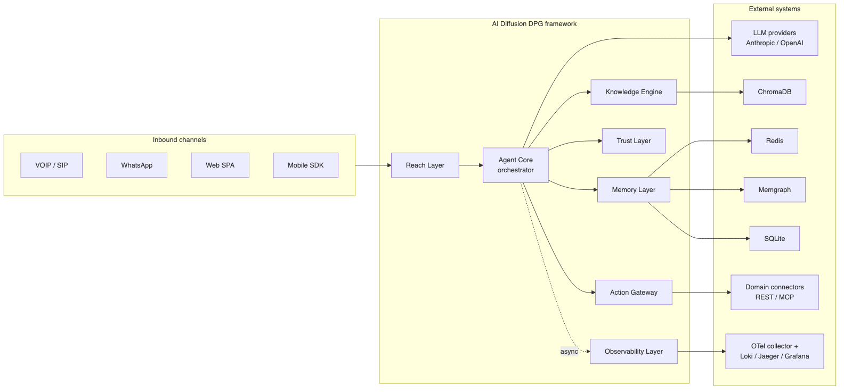
Figure 2.1 — System context: channels, framework, and external dependencies.

2.1 Goals
- Configuration-driven runtime. No model name, persona, prompt, tool definition, guardrail, or routing rule is hard-coded; all are read once at startup from YAML.
- Stateless orchestration. Agent Core holds no per-session memory; any instance can serve any session, enabling horizontal scaling behind a load balancer.
- Mandatory, fail-closed safety. Trust Layer runs on every input and every output and returns 'block' on internal error; safety is never skipped.
- Multi-channel reach. CLI, web, and voice channels share a common Reach Layer base and the same orchestration contract; new channels conform to the base ABC.
- Voice-grade latency. Target end-to-end latency of 800–1200 ms per turn, achieved by minimising LLM round-trips and running observability writes asynchronously.
- Auditability and DPDP compliance. Every turn produces an audit record; PII handling rules are explicit and config-driven; consent is captured before write/identity tools run.

2.2 Non-goals
- ASR and TTS pipelines. The framework consumes provider-supplied speech services (Raya STT/TTS) via Reach Layer; speech model training and infrastructure are out of scope.
- Model training. The framework consumes hosted LLM APIs only.
- Multi-tenant SaaS controls. The framework deploys per-domain; multi-tenant isolation, billing, and tenant management are not provided.
- Production load testing tools, versioning and rollback systems, and bespoke infrastructure provisioning are out of scope.

2.3 Reference Domain — KKB
Kaam Ki Baat (KKB) is the canonical reference domain. It is a labour-market assistant for informal workers, accessed via voice (dial 5226), web, and CLI. KKB exercises the full block matrix: a Conversational agent with a multi-subagent workflow, NLU-driven routing, ChromaDB-backed retrieval over five reference documents, REST connectors for ONEST job postings, DPDP-compliant consent gating, and the dignity-check guardrail. Section 6 walks through a single KKB turn end to end.

3. Architecture Overview

3.1 Block Topology
The seven blocks are grouped by concern: Channels and Reach (Reach Layer); Orchestration and Trust (Agent Core, Trust Layer); Intelligence and Integration (Knowledge Engine, Action Gateway); State and Memory (Memory Layer); Learning and Observability (Observability Layer). Each block runs as an independent FastAPI service in development, and the framework imposes strict rules about which block may call which.
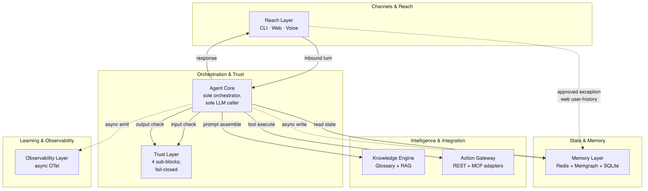
Figure 3.1 — Block topology with allowed call arrows.

3.2 Module Interaction Rules
Only Agent Core initiates calls to other blocks. No other block initiates a cross-block call. The framework enforces this invariant by code review and by service-level network policy in production deployments. Action Gateway is the sole route to external systems; Knowledge Engine is the sole route for prompt assembly; Memory Layer is the sole route for state. There is one approved, scoped exception: the Reach Layer web channel calls Memory Layer's GET /users/{user_id}/active-history directly to restore chat history before the first turn. This exception is documented and applies only to the dev/demo web adapter; future production channel adapters route state retrieval through Agent Core.
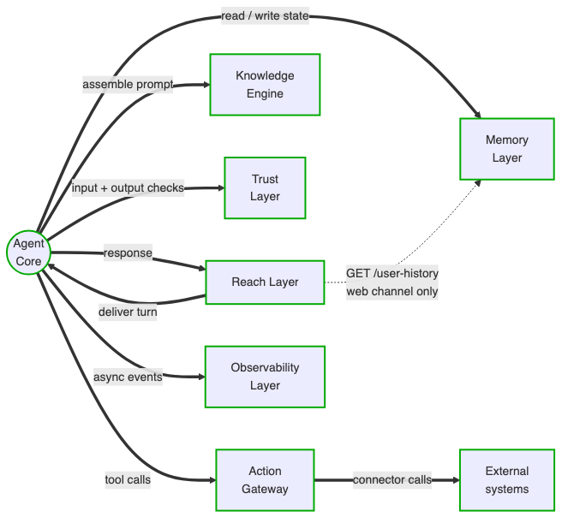
Figure 3.2 — Caller → callee matrix and the approved Reach-web exception.

3.3 Runtime Turn Sequence
Two execution paths exist: POST /process_turn returns a synchronous JSON TurnResult and is used by the web channel in direct mode; POST /stream_turn streams Server-Sent Events through the TurnAssembler and is used by CLI and voice in session mode. Both paths execute the same logical sequence: read state, consent gate, NLU, input check, language normalisation, constraint assembly, subagent routing, LLM call, optional tool loop, output check, response delivery, and asynchronous post-turn writes to Memory Layer and Observability Layer.
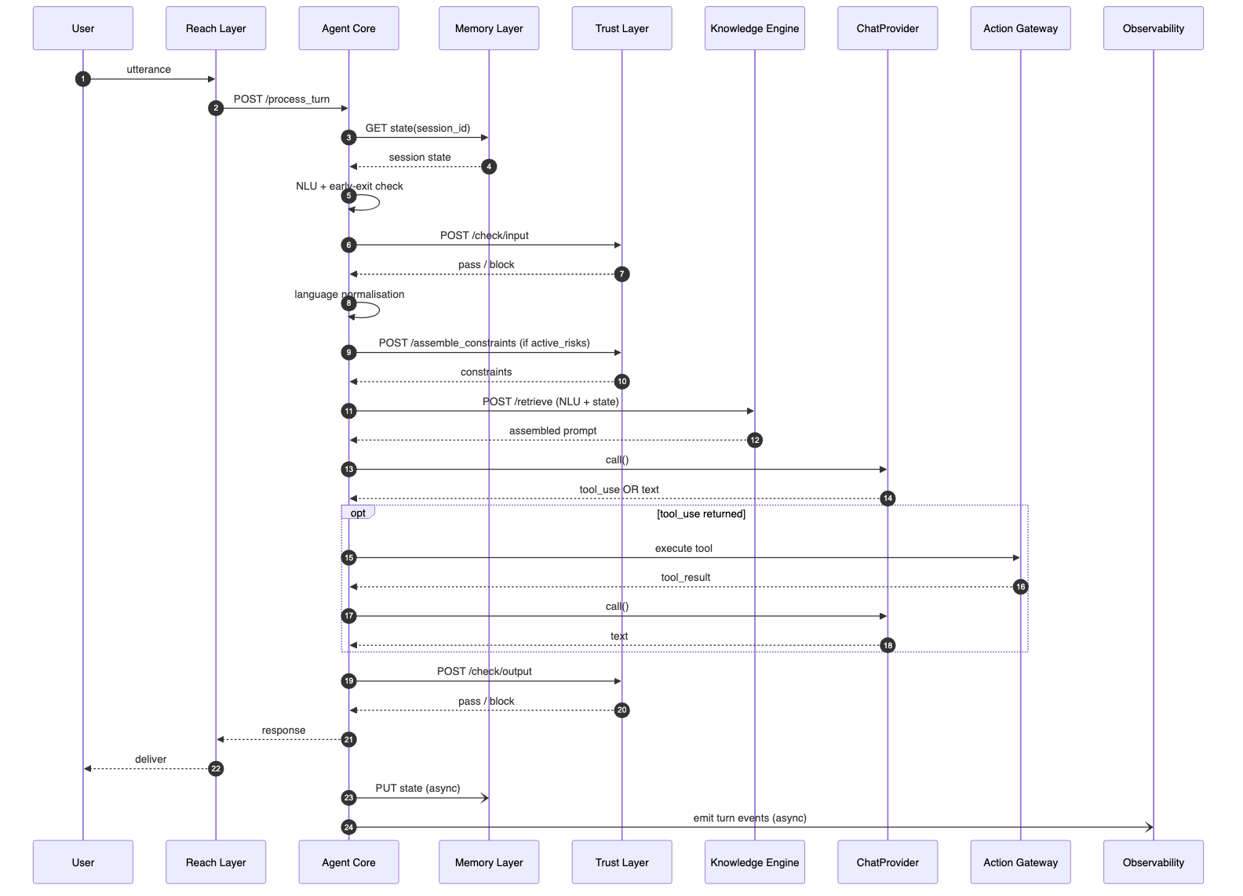
Figure 3.3 — Synchronous turn sequence (POST /process_turn).
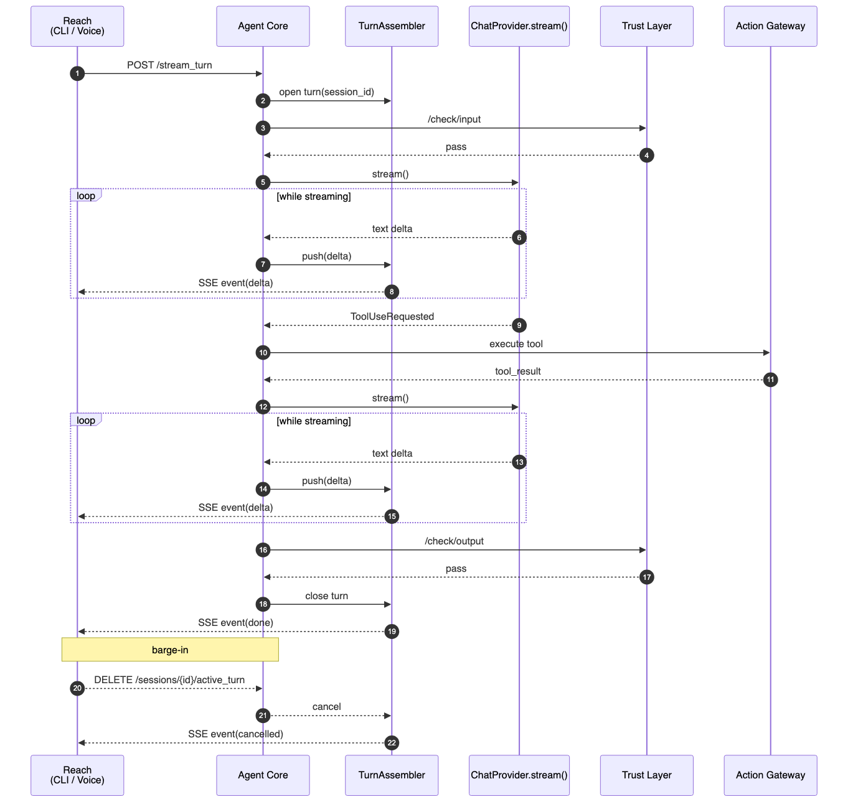
Figure 3.4 — Streaming turn sequence with TurnAssembler and barge-in.

3.4 Three-Tier Configuration Model
Configuration is structured in three tiers. Tier 1 is the Configuration Agent — a FastAPI server with a React SPA frontend that interviews a domain expert through eight phases and emits the seven YAML files for a new domain. Tier 2 is the YAML configuration itself, which is the canonical runtime source of truth: each block deep-merges its framework defaults from dev-kit/dpg/<module>.yaml with domain values from dev-kit/configs/<domain>/<module>.yaml at startup. Tier 3 is a Live Tuning Dashboard that reads Observability signals and patches YAML post-deployment; it is on the roadmap and not yet built. Tiers 1 and 3 are tools, not DPGs — they live outside the deployed runtime.

4. Block Specifications
Each subsection follows the same layout: responsibility, public interface, internal components, key data structures, external dependencies, failure modes, and known gaps. Test counts and source paths are current as of the latest release.

4.1 Agent Core
Agent Core is the sole orchestrator and the sole LLM caller. It runs language normalisation and NLU internally before calling any other block, builds the system prompt by combining the active subagent prompt with Trust-Layer-supplied constraints and disclosures, executes the bounded tool-use loop, performs the post-LLM safety check, and dispatches asynchronous writes to Memory Layer and Observability Layer after the response has been delivered. It is stateless between turns; any instance can handle any session.
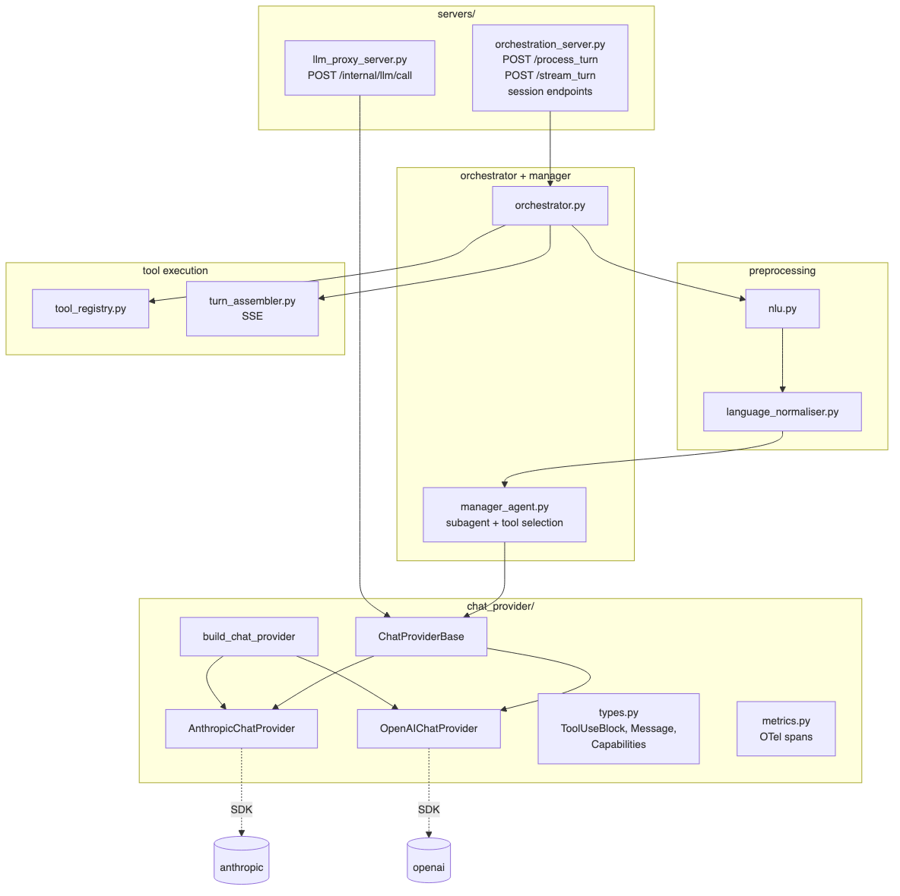
Figure 4.1 — Agent Core internal components.

Multi-provider LLM access
All LLM access is mediated by ChatProviderBase, an abstract class that defines a single neutral interface used by every Agent Core component. Concrete providers (AnthropicChatProvider, OpenAIChatProvider) are selected by the factory build_chat_provider(agent_config) based on the agent.provider field in YAML. Each provider owns the wire-format translation, retry and timeout policy, and OTel telemetry for its SDK; nothing else in agent_core imports the underlying provider library. Cheap classification calls (NLU, language normalisation) use dedicated provider instances configured with smaller models. AzureOpenAI and Ollama are planned follow-ups and slot into chat_provider/ without changing the orchestration layer. POST /internal/llm/call is implemented as a future LLM proxy endpoint and is not yet wired to downstream callers.
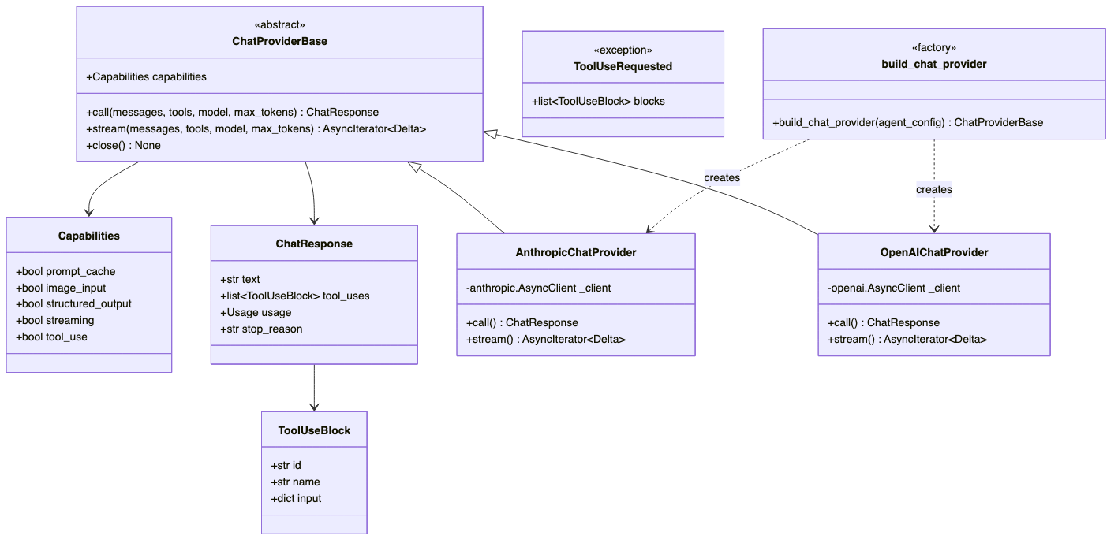
Figure 4.2 — chat_provider class hierarchy.

Streaming and TurnAssembler
POST /stream_turn is an async SSE endpoint backed by stream_turn() in orchestrator.py. It uses async HTTP clients for all external calls, yields SignalEvents at each pipeline stage, streams LLM tokens split into sentences, runs a per-sentence Trust output check, and emits a final DoneEvent. Memory and observability writes fire via asyncio.create_task after DoneEvent and never block delivery.
TurnAssembler sits between the server and stream_turn() for channels that deliver multi-segment input — voice VAD output, rapid corrections — and decides when a turn is complete. It holds Session objects keyed by session_id; each Session owns the current Turn (per-turn segments, event queue, abort signal, state). The pipeline invokes TurnAssembler via a three-policy stack: a semantic completeness gate driven by NLU confidence, a silence trigger that resets on every segment, and a max-wait ceiling. Cancellation is structural — a cancelled Turn is dead, its queue sealed, and a successor Turn gets a fresh queue. Public endpoints: POST /sessions/{id}/input, GET /sessions/{id}/events (SSE), and DELETE /sessions/{id}/active_turn (barge-in).

Subagent workflow and routing
Manager Agent selects the active subagent and tool list at the start of every turn based on current_subagent_id and the NLU intent, following routing rules declared in dev-kit/configs/<domain>/agent_core.yaml. Each subagent declares a system prompt, an allowed tool list, optional opening_phrase, and routing transitions. KKB ships with a 10-subagent workflow; collapsed reference designs exist for simpler domains. Tool lists are filtered further by Trust-Layer-returned action_gates so write/identity tools are unavailable until the relevant consent has been verified.

Public interface
Endpoint | Purpose
POST /process_turn | Sync turn execution; returns TurnResult JSON.
POST /stream_turn | SSE turn execution; emits SignalEvent, SentenceEvent, DoneEvent.
POST /sessions/{id}/input | TurnAssembler segment submit (202).
GET /sessions/{id}/events | TurnAssembler SSE stream.
DELETE /sessions/{id}/active_turn | Barge-in / structural cancel.
POST /internal/llm/call | Future LLM proxy (implemented; not yet wired).
GET /health | Liveness probe.

Tests: 818 across 32 files, ≥70% line coverage. See Appendix A for full request/response schemas and Appendix B for the SignalEvent / DoneEvent dataclasses.

4.2 Knowledge Engine
Knowledge Engine assembles the full LLM prompt from NLU results and session state passed in the request body. It is stateless and never calls Memory Layer directly. Internal components are: Glossary and Domain Vocabulary, Static Knowledge Base (semantic RAG over ChromaDB), and a Multimodal Input Handler (disabled in current configurations). Retrieval is invoked by the LLM as an internal tool named knowledge_retrieval; subagents whose tool list does not include this tool never trigger a KE call.
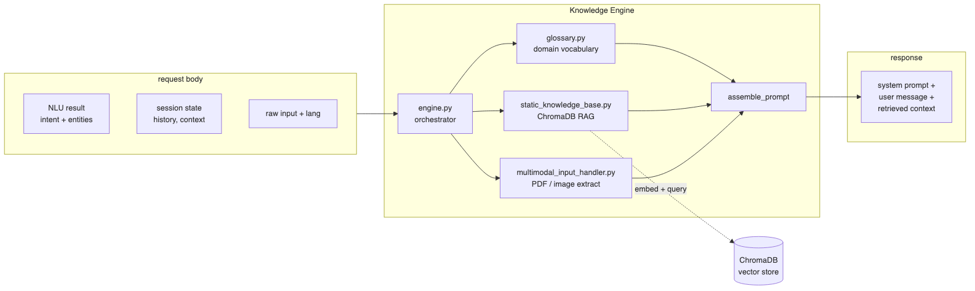
Figure 4.3 — Knowledge Engine prompt assembly.
Endpoints: POST /retrieve and GET /health on port 8001. KKB ships a pre-computed vector store under knowledge_engine/data/chroma_db/ built from five reference documents (labour schemes, trade descriptions, training institutes, bridge income options, ONEST market truth). The CLI ingestion script (scripts/ingest.py) rebuilds the store from sources defined in config/domain.yaml. Tests: 192 across 13 files, ≥70% coverage.

4.3 Memory Layer
Memory Layer manages state at three scopes. Turn/Session state lives in Redis (RedisJSON, TTL 24h for consented users / 4h for non-consented). The per-session context graph lives in Memgraph as typed attribute nodes — each Session node is connected to Attribute nodes via edge labels declared in config (profile_collection.profile_graph_relations); edge types are never hard-coded. One Cypher query returns the LLM's complete context, eliminating the need to replay raw conversation history. Audit records and the persistent cross-session profile live in SQLite.
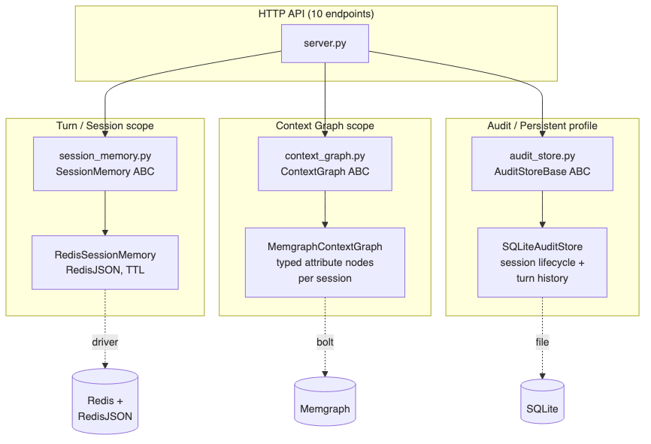
Figure 4.4 — Memory Layer stores by scope.
Public interface: context_bundle(), write(), flush_session(), get_active_sessions(), delete_user(), and audit write — exposed over HTTP at 10 endpoints on port 8002. Agent Core reads at turn start and writes asynchronously after response delivery. Tests: 226 across 7 files. The data model — Redis keys, Memgraph nodes and edge types — is documented in Appendix B.

4.4 Trust Layer
Trust Layer is the mandatory safety gate. It is stateless, runs on every turn, and is structured as four internal sub-blocks — ContentBlock (phrase-match input/output blocking and escalation routing), GuardrailsBlock (pre-LLM constraint assembly mapping active risks to a Policy Pack), ConsentBlock (evaluates user response against consent/decline phrases), and HiTLBlock (escalation queue). All endpoints are fail-closed: any internal error returns block or deny.
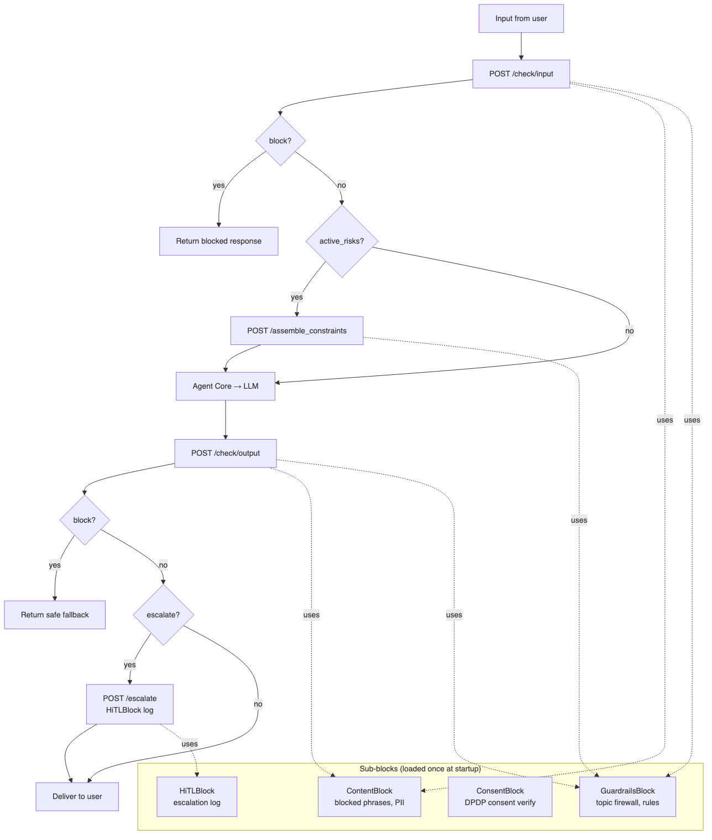
Figure 4.5 — Trust Layer flow with sub-block dispatch.
Endpoints: POST /check/input, POST /assemble_constraints, POST /check/output, POST /consent/verify, POST /check/consent, POST /escalate, GET /health on port 8003. The dignity-check feature, when enabled, auto-populates five canonical pre-response questions that GuardrailsBlock appends to the prompt_constraints payload — the LLM self-checks before emitting its response, with no extra LLM call. Tests: 138 across 9 files. Known gaps: ContentBlock uses phrase-match only (no ML semantic matching); HiTL queue currently has only the log backend wired; consent store is in-process SQLite (multi-instance deployments need a shared store).

4.5 Action Gateway
Action Gateway is the sole interface with external systems. The LLM never calls APIs directly; it expresses intent via tool definitions, and Action Gateway executes the tool call and returns a normalised result. Write and identity connectors are gated by Trust Layer consent verification before execution. The gateway is a generic adapter framework: each external tool is described in action_gateway.yaml under tools:[]; the gateway instantiates the correct adapter at startup based on type. Currently shipped adapters are RestApiAdapter (api_key, bearer, none auth; agent or static parameter sourcing) and McpAdapter (Model Context Protocol over JSON-RPC). database, file_upload, gRPC, and GraphQL adapter types are reserved.
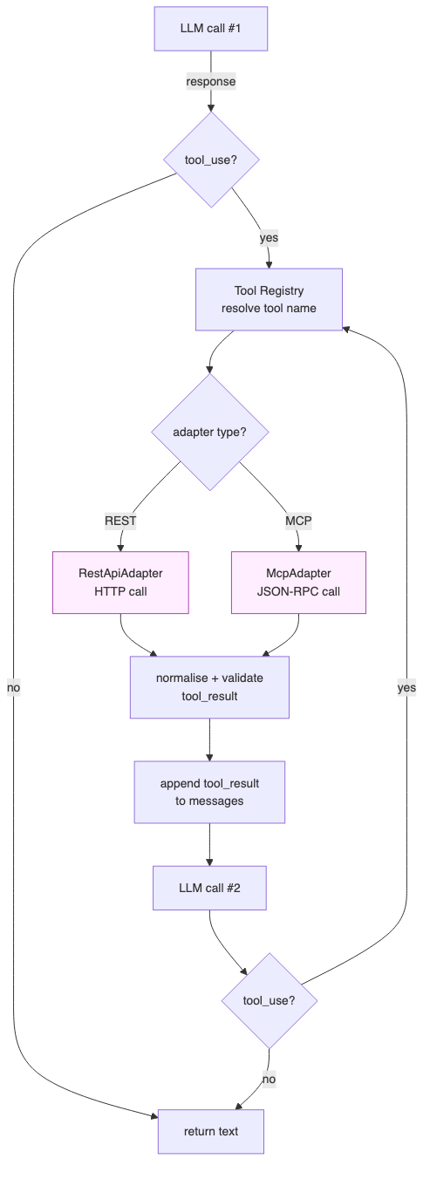
Figure 4.6 — Tool execution loop.
Endpoints: GET /tools (returns Anthropic-format tool definitions; Agent Core fetches at startup), POST /execute (executes a single tool call; never raises — returns success: false with structured error on failure), GET /health on port 9999. Adding a new tool is a YAML edit and a restart; adding a new adapter type means implementing the ToolAdapter ABC and registering the class in ADAPTER_TYPES. Tests: 173 across 8 files.

4.6 Reach Layer
Reach Layer normalises inbound channels and delivers responses. It ships as three independently-deployable services that share a common reach_layer/base/ library: ReachLayerBase (async ABC), TextChannelBase, VoiceChannelBase, and the SignalEvent / SentenceEvent / DoneEvent dataclasses. Each channel imports reach-layer-base and overrides only its input/output surface. The HTTP wire protocol to Agent Core (submit, subscribe, cancel) is concrete on the base class and identical for all channels.
Two assembly modes are supported. session mode (CLI, Voice) submits via POST /sessions/{id}/input and streams via GET /sessions/{id}/events. direct mode (Web) submits via POST /process_turn and receives the synchronous TurnResult. The Web channel additionally supports a routing_only configuration for voice-only deployments, where the SPA presents a click-to-call surface and hands off to the voice channel without running its own chat session.
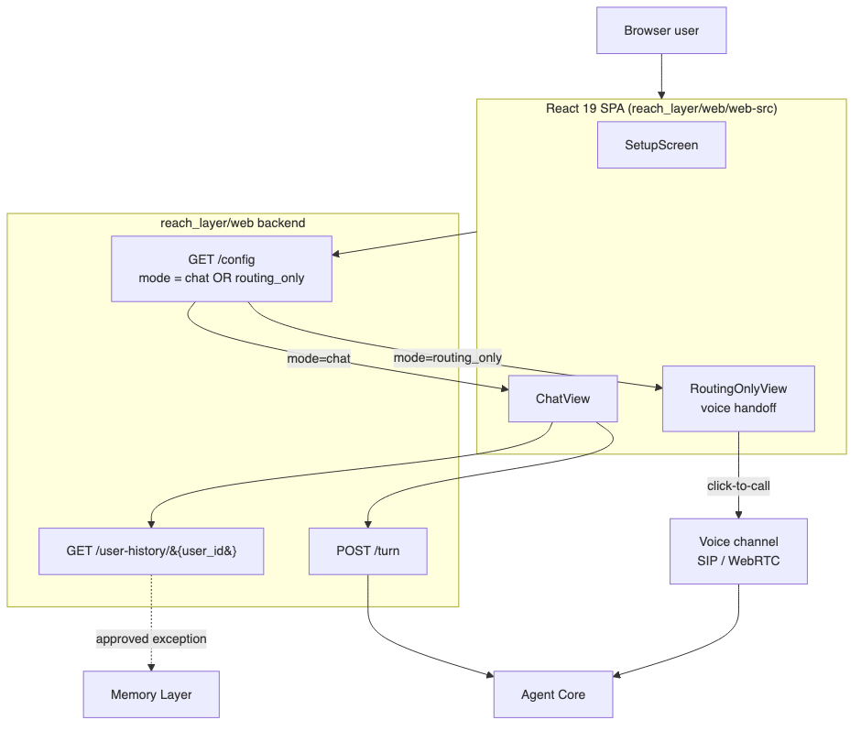
Figure 4.7 — Web channel modes (chat vs routing_only).
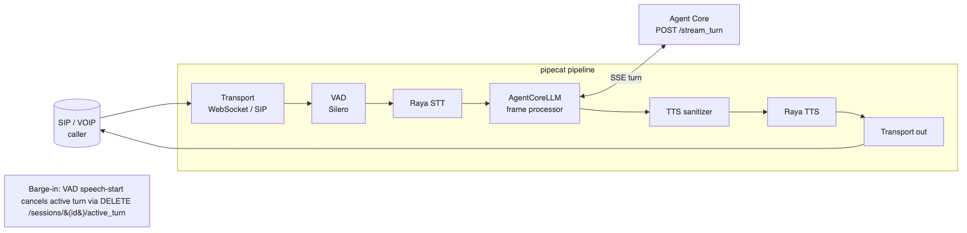
Figure 4.8 — Voice pipeline (pipecat).
Voice runs on a pipecat pipeline (VAD → Raya STT → AgentCoreLLM frame processor → TTS sanitizer → Raya TTS → SIP) with barge-in driven by VAD speech-start events that issue DELETE /sessions/{id}/active_turn. The TTS sanitizer is a pre-TTS pass that strips markdown, normalises numerals into spoken form, and applies domain-specific pronunciation overrides. Tests: 308 Python tests across 20 files (cli 47 + web 95 + voice 166) plus 143 React UI tests across 14 files. Production SIP/PSTN, WhatsApp, mobile SDK, and outbound campaigns are tracked but pending.

4.7 Observability Layer
Observability Layer is async-only and never sits in the response path. All seven blocks self-instrument via the shared dpg_telemetry package (init_otel(service_name, config), get_tracer(), get_meter()) installed from observability_layer/. Telemetry flows over OTLP/gRPC to an OTel Collector sidecar; from there logs land in Loki, traces in Jaeger, and dashboards are built in Grafana. Audit trail is the same Loki/Jaeger pair — no separate audit DB is needed.
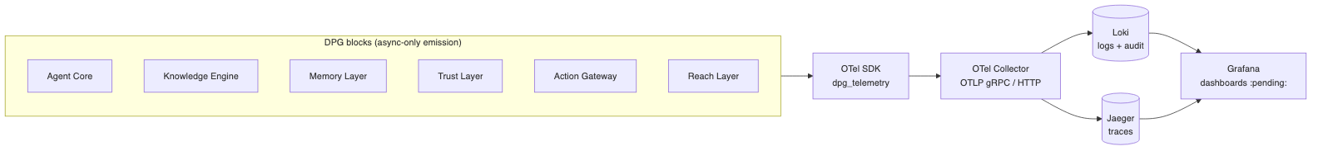
Figure 4.9 — Observability data flow.
DPDP Act compliance is enforced at the instrumentation layer via two distinct PII exclusion lists: observability.audit.pii_fields_excluded for the audit log and observability.telemetry.pii_fields_excluded for spans (user_id is allowed in spans for dashboard joins, excluded from audit). HTTP service on port 8004 exposes /emit/turn (legacy; routes to OutcomeTracker), /emit/signal, /validate-config, and /health. Primary implementation is OtelObservabilityLayer with OutcomeTracker. Tests: 101 across 7 files. Grafana dashboard provisioning and persistent outcome store are planned production additions.

5. Domain Configuration Kit
The Domain Configuration Kit (dev-kit/) is the toolchain that produces and maintains the YAML configuration consumed by the runtime. It is not part of the deployed runtime. Three tiers cover the full configuration lifecycle.
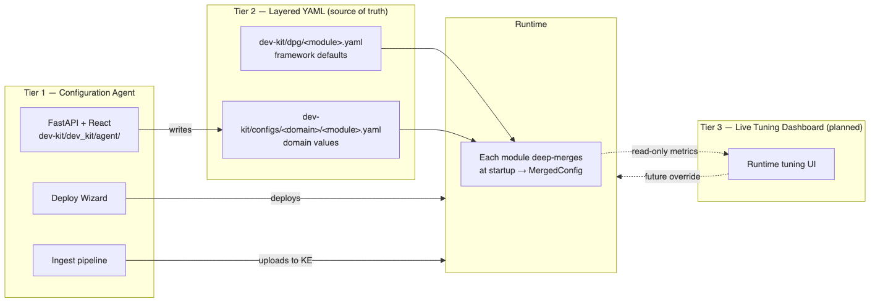
Figure 5.1 — Three-Tier configuration model.

5.1 Tier 1 — Configuration Agent
The Configuration Agent (dev-kit/dev_kit/agent/) is a FastAPI server with a React SPA frontend. A domain expert is interviewed through eight structured phases — domain framing, persona, knowledge sources, connector taxonomy, trust rules, channels, observability, deployment — and the agent emits the seven YAML files for the new domain. The Deploy Wizard runs Docker Compose against the generated configuration and surfaces service health, log tails, and a Destroy Stack action for clean teardown. The ingest pipeline feeds Knowledge Engine through a host-gateway proxy so document upload from the wizard reaches the running KE container.

5.2 Tier 2 — Layered YAML
Each module loads two YAML files at startup and deep-merges them: the framework default at dev-kit/dpg/<module>.yaml and the domain override at dev-kit/configs/<domain>/<module>.yaml. The merge is performed by config/loader.py and is followed by a full schema validation; mismatches between declared provider capabilities and YAML cause startup to fail loudly with ProviderConfigError. There are no runtime config reads — values are read once and bound to MergedConfig objects that are read-only thereafter.
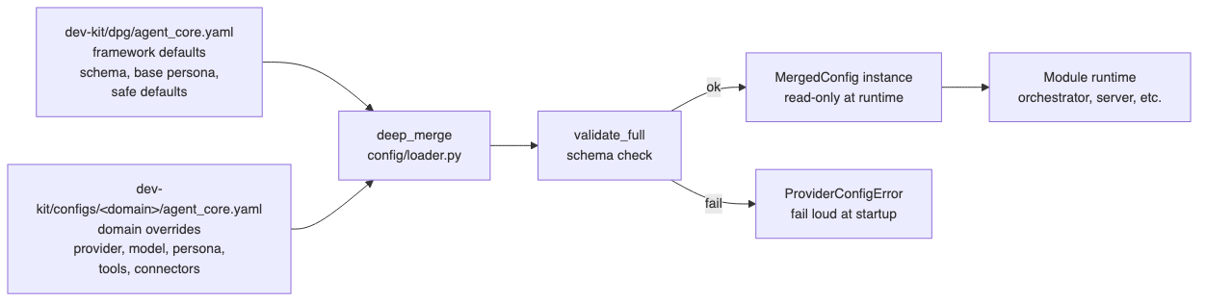
Figure 5.2 — Layered config deep-merge.

5.3 Tier 3 — Live Tuning Dashboard (planned)
Tier 3 is a management UI that reads Observability Layer signals and patches Tier 2 YAML post-deployment. Use cases include adjusting a guardrail threshold in response to a spike in blocked outputs, tweaking subagent routing on the back of intent confusion telemetry, or swapping an LLM model when latency regresses. Tier 3 is on the roadmap and not yet built; the data sources it needs (OTel signals, schema validators) are already in place.

5.4 Connector Taxonomy and Consent Gating
Connectors declared in action_gateway.yaml fall into three categories: read (no consent required), write (creates or modifies external state; requires Trust Layer consent verification before execution), and identity (resolves a user against an external system; requires consent). Consent verification is performed at the consent gate in Agent Core's tool loop via POST /check/consent; on deny the tool is removed from the available tool list and the LLM proceeds without it. Connector category is the authoritative signal — it is not derived from tool name or HTTP method.

6. Configuration Reference and KKB Walkthrough
Each block consumes a single YAML file with a stable top-level shape. The fields below are the load-bearing keys; full schemas live in dev-kit/dpg/ and Appendix B reproduces representative examples.

6.1 Per-block YAML schemas (key fields)
Module | Key fields
agent_core.yaml | agent.{provider,primary_model,fallback_model}, conversation.{persona,session_end_eval,user_state_model}, channels.*, subagents[].{id,system_prompt,tool_list,opening_phrase}, routing_rules[]
knowledge_engine.yaml | glossary.{terms[]}, static_kb.{enabled,collection_name,embedding_model}, multimodal.{enabled}
memory_layer.yaml | redis.{url,ttl_consented,ttl_anonymous}, memgraph.{url}, profile_collection.{profile_graph_relations[]}, audit.{sqlite_path}
trust_layer.yaml | content.{blocked_phrases,escalation_phrases}, guardrails.{policy_packs[]}, consent.{phrases,timeout}, hitl.{queue_backend}, dignity_check.{enabled,questions[]}
action_gateway.yaml | tools[].{name,type,category,auth,endpoints,params}, adapters.{rest_api,mcp}
reach_layer.yaml | channels.{cli,web,voice}.*, web.mode (chat|routing_only), voice.{tts,stt,sip}, campaign_manager.*
observability_layer.yaml | telemetry.{exporter,endpoint,pii_fields_excluded}, audit.{pii_fields_excluded}, outcomes.{lifecycle}, metrics[]

6.2 KKB Walkthrough — A Single Turn End-to-End
The example below traces a single KKB voice turn through every block. The user calls the KKB number and asks 'What is my balance?' The assistant must look up the user's account in the core-banking connector and respond in spoken form.
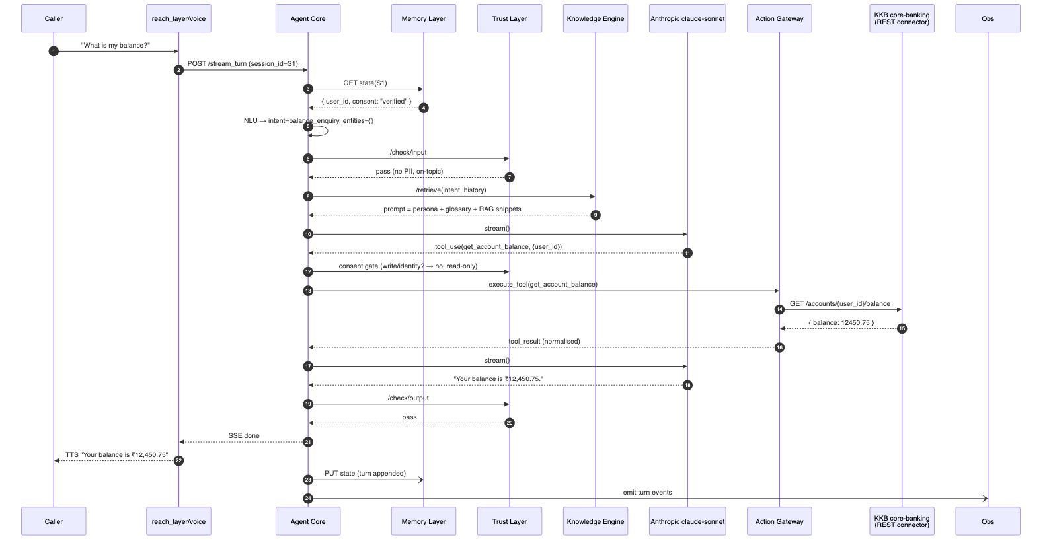
Figure 6.1 — KKB single-turn walkthrough.
Voice transport receives audio frames, the pipecat VAD detects an utterance boundary, Raya STT transcribes it, and the AgentCoreLLM frame processor opens an SSE turn against Agent Core. Memory Layer returns the cached session state (user_id, consent: verified). Agent Core runs NLU — intent: balance_enquiry, no entities — and Trust Layer's input check passes (no PII, on-topic). Knowledge Engine assembles the prompt: persona + glossary + RAG snippets covering account explanations. The first LLM call returns a tool_use block invoking get_account_balance; Agent Core's consent gate confirms the read connector needs no further verification, the Action Gateway dispatches the REST call, and the normalised result feeds a second LLM call. The reply is checked by Trust Layer's output gate, the TTS sanitizer rewrites the rupee figure into spoken form, Raya TTS synthesises audio, and the user hears the result. After the response is delivered, Agent Core fires the asynchronous Memory write and Observability emit; neither blocks the user-facing path.

7. Cross-cutting Concerns

7.1 Security and Trust
Trust Layer is mandatory and fail-closed. Input and output checks run on every turn, never skipped. Consent is captured before any write or identity tool runs and is enforced at the consent gate; consent decline removes the relevant tool from the LLM's tool list rather than being treated as a soft warning. The topic firewall (escalation_phrases) routes hard out-of-scope topics to the HiTL queue without ever reaching the LLM. All credentials and connector secrets are supplied via environment variables and never logged.

7.2 Observability
Every significant operation emits a structured log entry with operation, status, error (on failure), and latency_ms (for external calls). Bare print() is forbidden in module code. Logging is performed via the shared dpg_telemetry package, which configures TracerProvider, MeterProvider, OTLP exporter, W3C propagator, and resource attributes from config. PII handling uses the two exclusion lists described in Section 4.7. Spans cover the full turn lifecycle; metrics expose tokens, blocks, retrievals, tool calls, and outcomes.

7.3 Latency Budget
The 800–1200 ms voice target is met by the following stage budget: 80 ms for Memory read, 30 ms for Trust input check, 100 ms for NLU on a small model, 60 ms for prompt assembly (Knowledge Engine), 500–800 ms for the main LLM call, 30 ms for Trust output check, and the remainder absorbed by transport and TTS. Tool turns add one more LLM round-trip and an Action Gateway call (target 200 ms), pushing the worst case toward 1500 ms; voice surfaces this with a filler phrase from the active subagent's opening_phrase or a configured wait phrase. Memory and Observability writes are async and outside the budget.

7.4 Coding Standards
Five rules govern code review and CI:
- Base class pattern. Every core component defines an ABC before any concrete implementation; signatures and return types are preserved across implementations; internals are prefixed with _.
- Error handling. Every external call has an explicit timeout, a retry on transient failure, and returns a structured error; bare except: pass is forbidden.
- Configuration discipline. No domain-specific or environment-specific value is hard-coded; configuration is read once at startup; loaders are not re-read on the request path.
- Testing requirements. Every module covers normal execution, edge cases, and failure scenarios; external dependencies are mocked; ≥70% line coverage is enforced on agent_core and knowledge_engine.
- Logging and observability. Structured logs only; no PII outside the audit path; Google-style docstrings on all public classes, methods, and functions.

8. Deployment and Operations

8.1 Docker Compose (development)
automation/docker/docker-compose.dev.yml runs every service in development. Service ports: agent_core 8000, knowledge_engine 8001, memory_layer 8002, trust_layer 8003, observability_layer 8004, reach_layer_web 8005, reach_layer_voice 8006, action_gateway 9999. Data services: redis 6379, memgraph 7687, chromadb 8100. Telemetry: OTel collector on 4317/4318, Loki on 3100, Jaeger on 16686, Grafana on 3000. ANTHROPIC_API_KEY (or OPENAI_API_KEY) is sourced from the environment; channel credentials and connector secrets are passed through env files written by the Deploy Wizard.
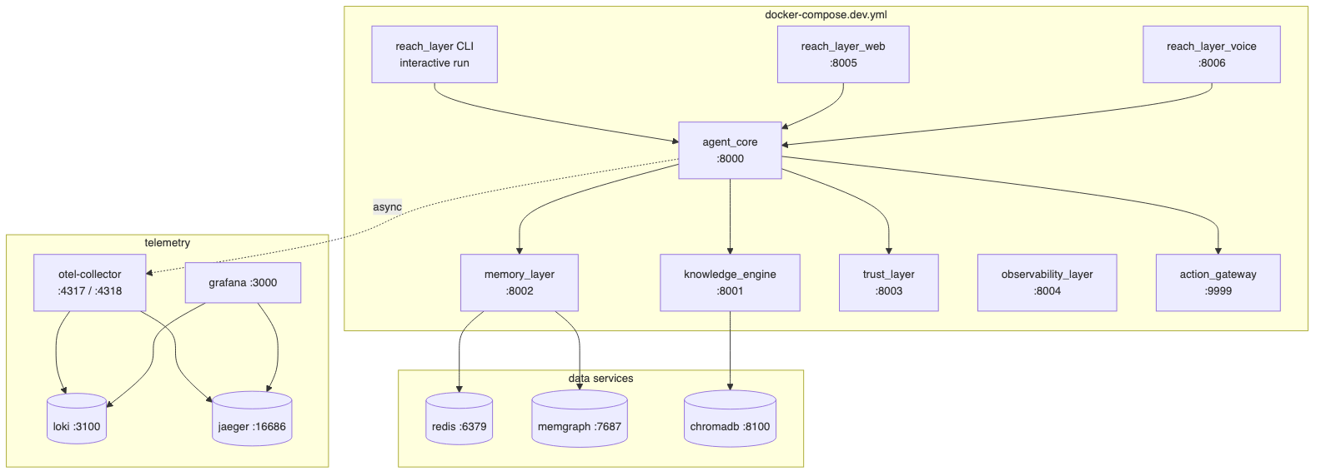
Figure 8.1 — Docker Compose development topology.
export ANTHROPIC_API_KEY=sk-ant-...
cd automation/docker
docker compose -f docker-compose.dev.yml up -d
docker compose -f docker-compose.dev.yml run --rm reach_layer

8.2 Helm (production)
automation/helm/ contains the Helm chart for Kubernetes deployment. Each block is a Deployment + Service pair; data services (Redis, Memgraph, ChromaDB) are expected to be managed externally and referenced via configurable URLs. OTel collector, Loki, Jaeger, and Grafana are deployed as sidecars or as a shared observability stack depending on the cluster's existing footprint. Service names use hyphens in Helm (memory-layer); Compose uses underscores (memory_layer). Network policy is expected to enforce the module-interaction rules described in Section 3.2 — only Agent Core may reach the other blocks.

8.3 Health and Diagnostics
Every block exposes GET /health for liveness; readiness probes additionally check downstream connectivity (Redis ping, Memgraph bolt handshake, ChromaDB collection list). The Deploy Wizard surfaces health and a tailing log view. Production deployments rely on Grafana dashboards (planned) and Loki log queries on operation, status, and latency_ms fields.

9. Implementation Status and Roadmap

9.1 Per-block Status
Block | Status | Notes | Tests
Agent Core | ✅ | Sync + async streaming, multi-provider chat_provider, TurnAssembler, 10-subagent workflow. | 818 / 32 files
Knowledge Engine | ✅ | Glossary + ChromaDB RAG; multimodal handler disabled. | 192 / 13 files
Memory Layer | ✅ | Redis + Memgraph + SQLite; 10 HTTP endpoints. | 226 / 7 files
Trust Layer | 🟡 | All 4 sub-blocks; HiTL log backend only; in-process consent store. | 138 / 9 files
Action Gateway | ✅ | RestApiAdapter + McpAdapter; database/file_upload/gRPC/GraphQL reserved. | 173 / 8 files
Reach Layer | 🟡 | CLI ✅, Web ✅ (with routing_only mode), Voice 🟡; SIP/PSTN, WhatsApp, mobile pending. | 308 Py + 143 UI
Observability Layer | 🟡 | OTel functional; Grafana dashboards + persistent outcome store pending. | 101 / 7 files
Domain Configuration Kit | ✅ | Tier 1 + Tier 2; Tier 3 (live tuning) on roadmap. | 365 / 26 files

9.2 Roadmap
- AzureOpenAI and Ollama chat_provider implementations (slot into existing chat_provider/).
- HiTL escalation queue: redis and webhook backends; output-path escalation wiring.
- Trust Layer consent store: shared backend for multi-instance deployments.
- Channel-aware prompt assembly (GH-97) — per-channel system prompt suffixes already in place; full per-channel persona variations pending.
- Reach Layer: production SIP/PSTN, WhatsApp, mobile SDK; outbound campaigns full implementation.
- Observability Layer: Grafana dashboard provisioning, persistent outcome store.
- Domain Configuration Kit Tier 3 — Live Tuning Dashboard.

Appendix A. HTTP API Reference
All endpoints accept and return application/json unless otherwise stated. Errors follow the structure { error: { code, message, details? } }.

A.1 Agent Core (port 8000)
Method | Path | Request | Response | Notes
POST | /process_turn | TurnRequest { session_id, user_id, message, channel, attachments? } | TurnResult { text, blocked?, holding_message?, session_ended?, metadata } | Sync. Used by Web direct mode.
POST | /stream_turn | TurnRequest | SSE stream of SignalEvent | SentenceEvent | DoneEvent | Async. Used by CLI and Voice.
POST | /sessions/{id}/input | SegmentInput { text, lang?, meta? } | 202 Accepted | TurnAssembler segment submit.
GET | /sessions/{id}/events | — | SSE stream | TurnAssembler subscriber.
DELETE | /sessions/{id}/active_turn | — | 204 No Content | Barge-in / structural cancel.
POST | /internal/llm/call | LLMCallRequest { messages, tools?, model?, max_tokens? } | LLMCallResponse | LLM proxy; not yet wired.
GET | /health | — | { status: 'ok', version, uptime_s } | Liveness probe.

A.2 Knowledge Engine (port 8001)
Method | Path | Request | Response
POST | /retrieve | RetrieveRequest { intent, entities, history, raw_input, lang } | RetrieveResponse { system_prompt, user_message, context_blocks[] }
GET | /health | — | { status, collections: int }

A.3 Memory Layer (port 8002)
Method | Path | Purpose
POST | /context_bundle | Read full context (Redis + Memgraph) for a session.
POST | /write | Persist a turn (Redis + graph deltas + audit).
POST | /flush_session | Force-flush Redis state to disk and rotate keys.
GET | /users/{user_id}/active-history | List active sessions for a user with last-accessed timestamp.
GET | /profile/{session_id} | Read user profile attached to a session.
GET | /session/{session_id} | Read raw session state.
DELETE | /users/{user_id} | Delete a user (DPDP right-to-erasure).
POST | /audit | Append an audit record.
POST | /get_active_sessions | Query active sessions across users.
GET | /health | Liveness probe.

A.4 Trust Layer (port 8003)
Method | Path | Purpose
POST | /check/input | Phrase-match + risk-signal input check. Returns allow | block | escalate.
POST | /assemble_constraints | Returns prompt_constraints, required_disclosures, action_gates, refusal_templates.
POST | /check/output | Output phrase-match and guardrail contract check.
POST | /consent/verify | Evaluates user response against consent phrases. Returns granted: bool.
POST | /check/consent | Verifies connector-level consent before write/identity tool execution. Fail-closed.
POST | /escalate | Queues HiTL escalation. Returns holding_message, ticket_id.
GET | /health | Liveness probe.

A.5 Action Gateway (port 9999)
Method | Path | Purpose
GET | /tools | Returns all registered tool definitions in Anthropic tool-use format. Agent Core fetches at startup.
POST | /execute | Executes a single tool call. Never raises; returns success: false with structured error on failure.
GET | /health | Liveness probe.

A.6 Observability Layer (port 8004)
Method | Path | Purpose
POST | /emit/turn | Emit a turn-completion event (legacy; routes to OutcomeTracker).
POST | /emit/signal | Emit a structured signal (e.g. user_state_transition).
POST | /validate-config | Validate an ObservabilityConfig payload.
GET | /health | Liveness probe.

A.7 Reach Layer Web (port 8005)
Method | Path | Purpose
POST | /chat | Proxy a single user turn to Agent Core /process_turn (direct mode).
GET | /user-history/{user_id} | Restore chat history before first turn (approved Memory Layer call).
GET | /app-config | Returns app config (mode = chat | routing_only, branding, etc).
GET | /health | Liveness probe.

A.8 Reach Layer Voice (port 8006)
Method | Path | Purpose
WS | /ws | Vobiz-format WebSocket transport for inbound audio.
POST | /campaigns/{id}/dial | Outbound campaign dial trigger (skeleton).
GET | /health | Liveness probe.

Appendix B. Internal Interfaces and Data Model

B.1 Key ABCs (sync interfaces)
class ChatProviderBase(ABC):
capabilities: Capabilities
@abstractmethod
def call(self, messages, tools, model, max_tokens) -> ChatResponse: ...
@abstractmethod
async def stream(self, messages, tools, model, max_tokens) -> AsyncIterator[Delta]: ...
@abstractmethod
def close(self) -> None: ...
class MemoryLayerBase(ABC):
@abstractmethod
def context_bundle(self, session_id: str) -> dict: ...
@abstractmethod
def write(self, session_id: str, state: dict, deltas: list[GraphDelta]) -> None: ...
@abstractmethod
def flush_session(self, session_id: str) -> None: ...
@abstractmethod
def get_active_sessions(self, user_id: str) -> list[ActiveSession]: ...
@abstractmethod
def delete_user(self, user_id: str) -> None: ...
class ToolAdapter(ABC):
@abstractmethod
async def execute(self, name: str, args: dict, ctx: ExecCtx) -> ToolResult: ...

B.2 Event Dataclasses (Reach Layer / streaming)
@dataclass
class SignalEvent:
stage: Literal['nlu','trust_input','assemble','llm_start','tool_start','llm_end','trust_output']
payload: dict
@dataclass
class SentenceEvent:
text: str
index: int
final: bool
@dataclass
class DoneEvent:
turn_id: str
blocked: bool
session_ended: bool
metadata: dict

B.3 Memgraph Schema (Memory Layer)
Node label | Purpose
User | Top-level user node keyed by user_id.
UserProfile | Persistent attributes (e.g. preferred_lang, consent_state).
UserAttribute | Ad-hoc fields not in the profile schema.
JourneyHistory | Aggregator linking a user to their Journeys.
Journey | One Journey = one Session.
ContextGraph | Per-session context aggregator.
ContextAttribute | Typed attribute node attached via domain edge type.
Signal | Lightweight event marker (e.g. consent_granted).

Edge labels: HAS_PROFILE, HAS_JOURNEY_HISTORY, HAS_CONTEXT, JOURNEY, HAS_ATTRIBUTE, SIGNAL, plus domain edges declared in memory_layer.profile_collection.profile_graph_relations (e.g. OFFERED, DROPPED_AT). Domain edge labels are never hard-coded.

B.4 Redis Keys (Memory Layer)
Key pattern | Type | TTL | Purpose
session:{session_id} | Hash (RedisJSON) | 24h consented / 4h anonymous | Live session state. TTL reset on every write and context_bundle call.
user:{user_id} | Hash | 24h / 4h | Map of session_id → ISO-8601 last_accessed. Lazy cleanup on get_active_sessions.

B.5 SQLite Audit Schema (Memory Layer)
CREATE TABLE session_lifecycle (
session_id TEXT PRIMARY KEY,
user_id TEXT,
started_at TEXT,
ended_at TEXT,
consent_given BOOLEAN,
consent_granted_at TEXT
);
CREATE TABLE turn_history (
id INTEGER PRIMARY KEY,
session_id TEXT,
turn_no INTEGER,
subagent_id TEXT,
intent TEXT,
user_message TEXT,
system_message TEXT,
model TEXT,
latency_ms INTEGER,
created_at TEXT
);

Appendix C. Error Codes and Failure Modes
All inter-block calls return structured errors. The orchestrator translates downstream errors into a small, stable set of codes that surface in TurnResult.metadata.

C.1 Stable Error Codes
Code | Origin | Meaning | Behaviour
E_TRUST_BLOCKED | Trust Layer | Input or output failed safety check. | Return blocked_input_message or safe_fallback.
E_TRUST_ESCALATE | Trust Layer | Topic firewall hit; escalate to HiTL. | Return holding_message + ticket_id.
E_TRUST_INTERNAL | Trust Layer | Internal error in Trust Layer. | Treated as block (fail-closed).
E_LLM_TIMEOUT | ChatProvider | LLM call timed out after retry budget. | Return generic apology; emit error span.
E_LLM_PROVIDER | ChatProvider | Provider returned non-retryable error. | Same as above; alert via metric.
E_TOOL_FAILED | Action Gateway | Tool execution returned success: false. | Append normalised error as tool_result; LLM may retry or apologise.
E_TOOL_TIMEOUT | Action Gateway | Tool call exceeded timeout. | Same as above.
E_KE_RETRIEVAL | Knowledge Engine | RAG retrieval failed after retries. | Continue with no retrieval context; emit warning span.
E_MEMORY_READ | Memory Layer | context_bundle failed. | Continue with empty state; emit warning span; do not block turn.
E_MEMORY_WRITE | Memory Layer | Async write failed. | Logged; user response already delivered.
E_REACH_CANCELLED | Reach Layer | Turn was cancelled (barge-in or client disconnect). | Cancel pending stream and seal queue.
E_CONFIG_INVALID | Loader | Schema validation failed at startup. | Fail loud — service refuses to start.
E_PROVIDER_CAPS | ChatProvider factory | Declared capability mismatched YAML. | Fail loud at startup (ProviderConfigError).

C.2 Fail-Closed Semantics
Trust Layer is fail-closed by contract: any internal exception in /check/input, /check/output, /assemble_constraints, /check/consent, or /consent/verify results in block or deny. The Agent Core HTTP client to Trust Layer enforces this — there is no fallback path that bypasses the gate. Action Gateway is fail-soft: tool execution failures return structured errors so the LLM can decide how to recover.

C.3 Retry and Timeout Policy
Call site | Timeout | Retry
LLM call (chat_provider) | 30s | 1 retry on rate limit / transient with exponential back-off
Knowledge Engine /retrieve | 5s | 1 retry
Memory Layer read | 2s | 1 retry; degrade to empty state on second failure
Trust Layer endpoints | 1s | 0 retries (fail-closed)
Action Gateway /execute | tool-defined (default 10s) | 0 retries; LLM-driven recovery

Appendix D. Worked Examples

D.1 TurnRequest / TurnResult
POST /process_turn
{
"session_id": "S-1234",
"user_id": "U-5678",
"message": "What is my balance?",
"channel": "voice",
"lang": "en"
}
200 OK
{
"text": "Your balance is ₹12,450.75.",
"blocked": false,
"session_ended": false,
"metadata": {
"intent": "balance_enquiry",
"subagent_id": "banking_main",
"model": "claude-sonnet-4-5",
"latency_ms": 920,
"tools_used": ["get_account_balance"]
}
}

D.2 Streaming SSE Frame Sequence
event: signal
data: {"stage":"nlu","payload":{"intent":"balance_enquiry","confidence":0.94}}
event: signal
data: {"stage":"trust_input","payload":{"action":"allow"}}
event: sentence
data: {"text":"Your balance is","index":0,"final":false}
event: sentence
data: {"text":" ₹12,450.75.","index":1,"final":true}
event: done
data: {"turn_id":"T-99","blocked":false,"session_ended":false}

D.3 Tool Definition (Action Gateway YAML)
tools:
- name: get_account_balance
type: rest_api
category: read
auth:
kind: bearer
env: CORE_BANKING_TOKEN
description: |
Returns the current account balance for the user.
endpoints:
execute:
method: GET
url: https://core-banking.example.com/accounts/{user_id}/balance
params:
user_id:
source: agent
type: string
required: true

D.4 Subagent Declaration (Agent Core YAML)
subagents:
- id: banking_main
system_prompt: |
You are the KKB banking assistant. Be concise and confirm before any
action that changes account state. Use the available tools rather than
guessing.
tool_list:
- get_account_balance
- list_recent_transactions
- end_session
opening_phrase: "Hi! I can check your balance or recent activity. What would you like?"

D.5 Trust Layer /assemble_constraints Response
{
"prompt_constraints": [
"Do not disclose account numbers in spoken responses.",
"Round all rupee figures to two decimal places."
],
"required_disclosures": [
"If the user reports fraud, instruct them to call 1800-XXXX immediately."
],
"action_gates": {
"transfer_funds": "consent_required"
},
"refusal_templates": {
"out_of_scope": "I can only help with KKB banking queries."
}
}

Appendix E. Glossary
DPG. Digital Public Good. A standard, reusable software component.
Block. One of the seven DPG building blocks the framework composes.
Subagent. A configured persona / scope inside Agent Core with its own system prompt and tool list.
ChatProviderBase. The neutral LLM interface; concrete providers are AnthropicChatProvider and OpenAIChatProvider.
TurnAssembler. Component that decides when a multi-segment input (e.g. voice) constitutes a complete turn.
Signal mode / direct mode. Reach Layer assembly modes; session mode for streaming, direct for sync.
Active risks. NLU-derived risk signals (e.g. distress, financial pressure) that drive Trust Layer constraint assembly.
Policy Pack. Set of guardrail rules selected by GuardrailsBlock based on active_risks.
Consent gate. The pre-tool-execution check that ensures the user has consented to write/identity actions.
HiTL. Human-in-the-Loop. Trust Layer's escalation path.
DPDP Act. Digital Personal Data Protection Act (India). Drives the consent flow and PII exclusion lists.
RAG. Retrieval-Augmented Generation; KE's retrieval over ChromaDB.
KKB. Kaam Ki Baat; the reference labour-market domain.
Routing-only mode. Web SPA configuration that surfaces a click-to-call experience and hands off to voice.
Dignity check. Pre-response self-check questions appended to the system prompt by GuardrailsBlock.
Outcome. OutcomeTracker lifecycle marker emitted by Observability Layer; drives quality scoring.
PII. Personally Identifiable Information; excluded from telemetry / audit per the two config-driven lists.
Session mode. Reach assembly mode using POST /sessions/{id}/input + SSE; opposite of direct.
MergedConfig. The post-deep-merge, post-validation, read-only configuration object held in memory.

Appendix F. Source Specs and Plans Index
The following specs and plans under docs/superpowers/ informed this document. Some are partially superseded by subsequent commits — refer to ARCHITECTURE.md for the current state where they conflict.

F.1 Specs (docs/superpowers/specs/)
- 2026-04-30-llm-provider-redesign-design.md — multi-provider chat_provider redesign (PR #287, #300).
- 2026-04-25-turn-lifecycle-redesign-design.md — TurnAssembler structural cancel and lifecycle (#224).
- 2026-04-21-gh137-framework-uplift-design.md — channels block, session_end_eval, dignity_check, opening_phrase (#GH-137).
- 2026-04-20-gh139-user-state-model-design.md — optional user_state_model for conversational agents.
- 2026-04-22-kkb-config-remap-and-layered-prompt-design.md — KKB config remap and layered system prompt.
- 2026-04-23-kkb-subagent-collapse-design.md — subagent collapse for simpler workflows.
- 2026-04-18-kb-upload-ingestion-design.md — KE document upload + ingestion pipeline.
- 2026-04-17-channel-aware-prompting-design.md — per-channel prompt suffixes.
- 2026-04-15-action-gateway-production-connector-design.md — generic adapter framework.
- 2026-04-14-agent-core-async-streaming-spec.md, 2026-04-14-agent-core-turn-assembler-spec.md — async SSE and TurnAssembler internals.
- 2026-04-14-reach-layer-restructure-spec.md — three-service Reach Layer split.
- 2026-04-13-tts-sanitizer-design.md — pre-TTS rewriting pass.
- 2026-04-13-voip-reach-layer-design.md, 2026-04-09-telephony-pipecat-pipeline-design.md, 2026-04-08-telephony-integration-design.md — voice pipeline and SIP integration.
- 2026-04-13-reach-layer-google-sso-design.md — Google Sign-In on web channel.
- 2026-04-08-deploy-wizard-design.md — Tier 1 Deploy Wizard.
- 2026-04-06-observability-layer-design.md — async OTel and OutcomeTracker.
- 2026-04-03-trust-layer-design.md — four-sub-block structure and fail-closed semantics.
- 2026-04-02-memgraph-migration-design.md — context graph migration.
- 2026-04-02-config-template-design.md, 2026-04-02-dev-kit-agent-design.md — Tier 2 schema and Tier 1 agent.
- 2026-04-30-reach-layer-web-routing-only-mode.md — voice-only deployment surface (PR #293).

F.2 Plans (docs/superpowers/plans/)
Plans typically pair with a spec under the same date. The most load-bearing active plans are the LLM provider redesign series (2026-04-30-llm-provider-redesign-pr1..pr5.md), the turn lifecycle redesign (2026-04-25), the framework uplift (2026-04-21-gh137), the user-state model (2026-04-20-gh139), and the dev-kit ingest backend / frontend / OpenAPI plans (2026-04-20).

