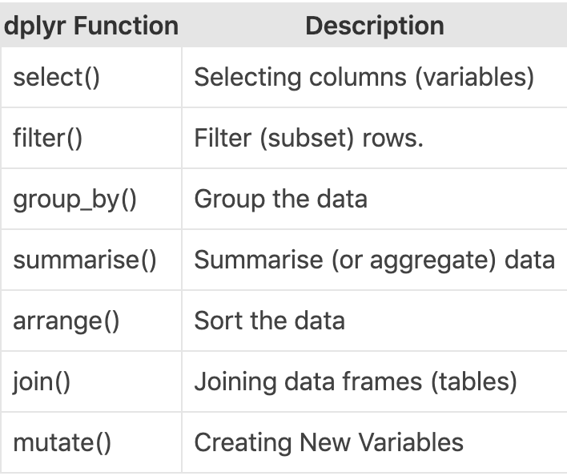

Use this as reference to implement Dplyr package and use any inbuilt dataset built in R