

GROUP 13

**COUNSELR**

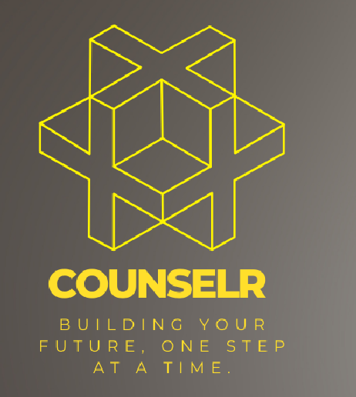

**DONE BY:**

Gunjan Chakraborty, 22MSRDS007, MSc Data science and Analytics

V Dheeraj Shenoy, 22MSRPH022, MSc Physics

Dishank Kanhaiyalal Gour, 22MSRDF013, MSc Digital forensics and information security

**Under the Guidance Of**

Dr. Pooja Varma [Department of Psychology]

Mebin Wilson Thomas [Department of Forensic Science]

Date of Submission

18/05/2023

**COUNSELR**

Building your future, one step at a time

***Abstract***

**Counselr** is a career counselling website for students that analyses their aptitude for betterment of their future. Our website is a comprehensive platform designed to help students make informed decisions about their future careers.

***Introduction***

Our student career counselling website provides a platform designed to help students make informed decisions about their future careers. We understand that choosing a career path can be a daunting task, and that's why we're here to help.

Our website offers a range of resources and services to help students identify their strengths and interests, explore different career paths, and make informed decisions about their future. Whether you're a high school student trying to choose a college major, a college student preparing for a job search, or a working professional looking to transition to a new career, our website has something for everyone.

We offer a range of tools and resources to help students explore different career paths, including career assessments, job search tools, and educational resources. Our team of experienced career counselors will also be available to provide personalized guidance and support to students who need it.

Our goal is to empower students to make informed decisions about their future careers. We believe that everyone deserves to find a career that is fulfilling and rewarding, and we're here to help you achieve that goal. So, whether you're just starting to explore different career paths or you're ready to take the next step in your career, we invite you to explore our website and discover all that we have to offer.

***Methodology***

**Needs Assessment**: We will conduct a needs assessment using specialised aptitude test to understand the requirements and expectations of our target audience. This will involve gathering feedback from students, parents, teachers, and career counselors to determine the types of resources and services that would be most helpful to them.

**Content Development**: Based on the need’s assessment, we will develop a range of content to help students explore different career paths and make informed decisions about their future. This may include career assessments, job search tools, educational resources, and other relevant information.

**User Experience Design**: We will design a user-friendly interface that makes it easy for students to navigate and find the information they need. This will involve conducting user testing to ensure that the website is intuitive and user-friendly.

**Personalization**: We will provide personalized guidance and support to students who need it. This may involve offering one-on-one counselling sessions with experienced career counselors or providing tailored recommendations based on a student's interests and strengths.

**Continuous Improvement**: We will regularly review and update the website to ensure that the content remains relevant and up-to-date. This may involve conducting surveys and gathering feedback from users to identify areas for improvement.

**Partnership and Collaboration**: We will establish partnerships and collaborations with educational institutions, employers, and other relevant organizations to provide students with a broader range of resources and opportunities.

**Data Privacy and Security**: We will prioritize data privacy and security to ensure that users' personal information is protected. This may involve implementing measures such as encryption, secure data storage, and regular security audits.

***Stage of the work***

* We have started building the UI for the website.
* We have planned to team up with psychology students to create optimal aptitude design.

***Expected outcomes***

**Greater Clarity and Confidence**: By providing students with a range of resources and services, including career assessments, job search tools, and personalized guidance, our website can help students gain greater clarity and confidence in their career choices.

**Improved Decision-Making**: By helping students identify their strengths and interests and providing them with information about different career paths, our website can help students make more informed decisions about their future careers.

**Enhanced Employability**: By providing students with job search tools and educational resources, our website can help students develop the skills and knowledge they need to be competitive in the job market.

**Increased Satisfaction and Fulfilment**: By helping students find careers that align with their interests and values, our website can help students achieve greater satisfaction and fulfilment in their professional lives.

***Learning Outcome***

* Increased self-awareness of skills, interests, and values.
* Expanded knowledge of career options and industries.
* Improved career planning and goal-setting skills.
* Strengthened job search and application abilities.
* Enhanced networking and professional development skills.
* Increased confidence and motivation to pursue career goals.
* Improved decision-making skills for career choices.
* Knowledge of educational and training opportunities.
* Understanding of industry trends and advancements.
* Overall empowerment in managing one's career effectively.

***Future Plan***

* Expand content and resources.
* Develop interactive aptitude tests.
* Offer career coaching and mentoring.
* Create a community platform.
* Incorporate AI chatbots for immediate assistance.
* Partner with employers and recruiters.
* Provide online courses and workshops.
* Utilize data analytics for insights and improvements.
* Develop a mobile app for wider accessibility.
* Continuously improve and adapt to user needs.

***References***

1. "Designing the User Interface: Strategies for Effective Human-Computer Interaction" by Shneiderman and Plaisant.
2. National Career Development Association (NCDA) website ([www.ncda.org](http://www.ncda.org/)).
3. "Career Development and Counseling: Theory and Practice in a Multicultural World" by Tang and Heppner.
4. The National Career Development Association's Career Resource Store ([www.careerresourcestore.org](http://www.careerresourcestore.org/)).
5. "Building Websites All-in-One For Dummies" by Karlins.

