Task 3 – Group task
(5): Spatial Distribution of Deprivation

R Code
library(sf)
library(tidyverse)
library(ggplot2)

# Unzip and load shapefile
unzip("Local_Authority_Districts_December_2024_Boundaries_UK_BFC.zip",
exdir = "shapefile_extracted")
shapefile <- st_read("shapefile_extracted/LAD_DEC_24_UK_BFC.shp")

# Load IMD data and create PC scores
imd_group <- read_csv("imd2025_group.csv")

domains <- c("Income", "Employment", "Education", "Health",
"Crime", "Barriers", "Living")

pca_result <- prcomp(imd_group[, domains], scale = TRUE, center = TRUE)

imd_group <- imd_group %>%
mutate(
PC1 = pca_result$x[, 1],
PC2 = pca_result$x[, 2]
)

# Join shapefile with IMD data
map_data <- shapefile %>%
left_join(imd_group, by = c("LAD24CD" = "LAD24CD"))

# Create three choropleth maps
## Map 1: Overall IMD Deprivation
map_overall <- ggplot(map_data) +
geom_sf(aes(fill = Overall), color = NA) +
scale_fill_viridis_c(
name = "Overall\nDeprivation",
direction = -1,
option = "viridis"
) +
labs(
title = "Overall IMD 2025: Geographic Distribution of Deprivation",
subtitle = "Higher scores = greater deprivation",
caption = "Source: Index of Multiple Deprivation 2025"
) +
theme_minimal() +
theme(plot.title = element_text(size = 14, face = "bold"),
axis.text = element_blank(), axis.title = element_blank())

print(map_overall)

## Map 2: PC1 (General Economic Deprivation)
map_pc1 <- ggplot(map_data) +
geom_sf(aes(fill = PC1), color = NA) +
scale_fill_gradient2(
name = "PC1 Score",
low = "blue", mid = "white", high = "red", midpoint = 0
) +
labs(
title = "PC1: General Deprivation Gradient",
subtitle = "North-south economic divide (Employment, Health, Income, Education, Crime)",
caption = "PC1 explains 60% of variance"
) +
theme_minimal() +
theme(plot.title = element_text(size = 14, face = "bold"),
axis.text = element_blank(), axis.title = element_blank())

print(map_pc1)

## Map 3: PC2 (Housing & Environmental Barriers)
map_pc2 <- ggplot(map_data) +
geom_sf(aes(fill = PC2), color = NA) +
scale_fill_gradient2(
name = "PC2 Score",
low = "darkblue", mid = "white", high = "darkred", midpoint = 0
) +
labs(
title = "PC2: Housing & Environmental Barriers",
subtitle = "Service access and living environment deprivation",
caption = "PC2 explains 19.3% of variance"
) +
theme_minimal() +
theme(plot.title = element_text(size = 14, face = "bold"),
axis.text = element_blank(), axis.title = element_blank())

print(map_pc2)

R Output:
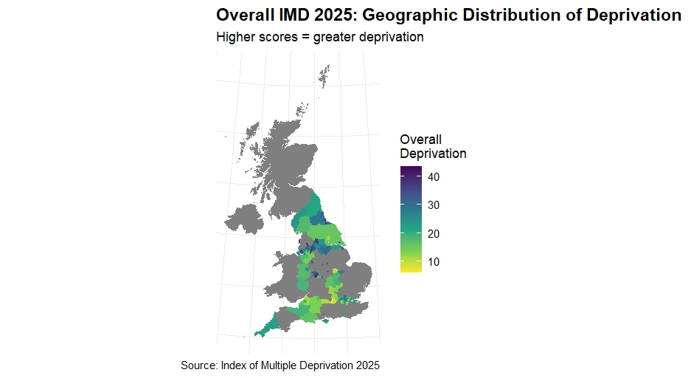
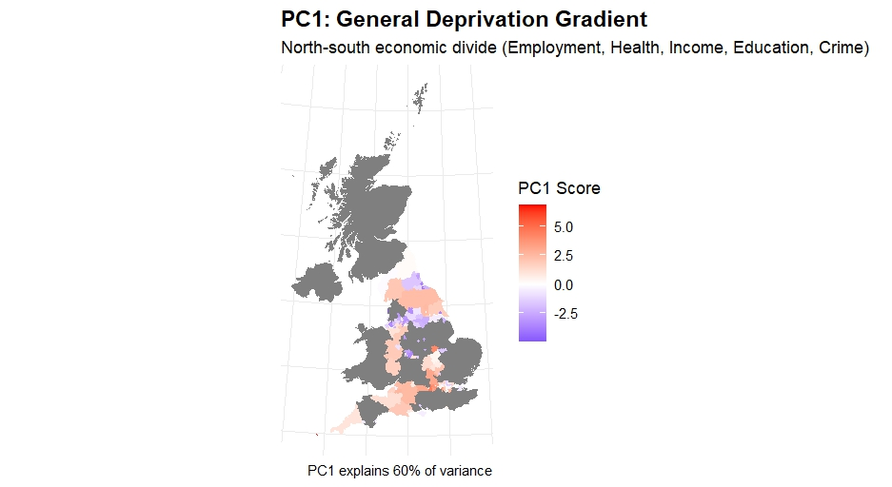

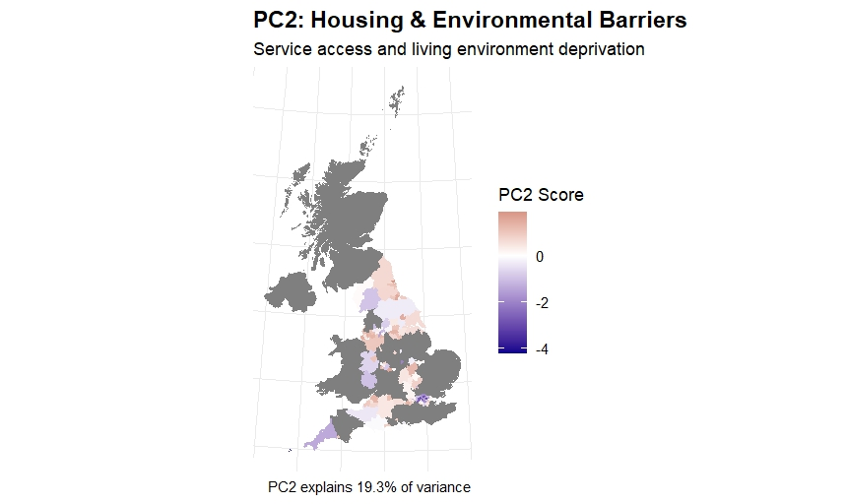
Interpretation and Analysis
Overall IMD Deprivation Map: Geographic Concentration
The overall deprivation map illustrates that there are large geographically polarized areas across England. The North of England (North East and North West) and the Midlands have the highest concentrations of deprivation - these are illustrated by the darkest purple-grey colour on the map which represents deprivation scores approaching 40. Conversely, the South East, South West and large sections of the East of England show low levels of deprivation; represented by yellow-green colours and deprivation scores between 10-20. The deprivation map of London shows a mixed picture, with pockets of high deprivation located in East London Boroughs (such as Newham and Tower Hamlets) which appear as patches of dark on the map and are interposed with affluent districts in the west of London (for example Kensington and Chelsea); illustrating London's documented spatial inequalities.

PC1 Map: Strong North-South Economic Gradient
The PC1 choropleth map has an impressive north-south geographical trend with red (indicating high PC1 scores, or deprivation) concentrated in the North of England and blue (indicating low PC1, or affluence) concentrated in the South of England. It is also visually pleasing, due to the smooth progression from one colour to another from North to South, which is consistent with how the researchers interpret PC1 as a deprivation factor, representing economically poor/underprivileged areas.
The gradient suggests that economically poor areas have similar problems simultaneously, for example employment, health, income, education and crime are all clustered together spatially, thus they have similar issues across the same area. For example, the North East appears to be very red (high PC1) indicating that it has many issues across many different areas including unemployment opportunities, health and educational standards. On the other hand, the South East appears to be very blue (low PC1) indicating prosperity across all of the above-mentioned areas.
PC1 accounts for 60% of variance, and the geographical trend of PC1 appears to be almost identical to the Overall Map, suggesting that the predominant deprivation structure in England is unidimensional and geographical; one north/south axis, i.e., the economy, explains most of the variation in deprivation throughout the country.

PC2 Map: Complex, Non-Geographic Distribution of Housing Barriers
As opposed to PC1, the PC2 choropleth map of housing and environmental barrier deprivation is a random pattern of where these deprivations are found geographically. The pattern does not show the expected north/south gradient as seen with the overall deprivation/PC1 choropleth maps; rather it has red (high PC2) patches in isolated rural areas throughout the North and Midlands, whereas, some of the most economically challenged regions in the South exhibit a negative value for PC2 (blue), which indicates less housing-related deprivation even though they suffer from economic disadvantage.
This lack of geographic correlation between economic disadvantage and housing accessibility/environmental quality deprivation indicate that these two types of disadvantage are being determined by different spatial mechanisms. For example, rural areas in Scotland, Northern England, and Wales suffer from housing related disadvantage because of their remote location and sparse population density, although their total income disadvantage is somewhat limited. Additionally, many economically disadvantaged urban areas possess sufficient housing infrastructure (social housing, etc.) and services, therefore their PC2 values are lower than those of similarly deprived rural areas, but higher than their PC1 or overall disadvantage score.
Comparison and Policy Implications
A difference exists between overall/PC1 and PC2 maps that represent two different policy problems:
- Economic Disadvantage (Overall /PC1) is concentrated, geographically consistent, and systemic and thus requires an integrated and/or multi-faceted approach to coordinate an economic development strategy for Northern Regions (job creation, business investment, job readiness/skills training etc.) as they face multiple concurrent disadvantages; a single policy area or focus (i.e. only education) will not be sufficient.
- Housing/Environmental Barriers (PC2) are spread across the region in isolated pockets and are not tied to economic disadvantage. Therefore, housing/service deprivations need to be addressed through targeted and place-based interventions, particularly in those rural areas with service access being limited by the physical distance from services and in select urban areas experiencing severe housing crises.
The large degree of correlation between overall and PC1 and therefore similarities on the map suggest that there are limitations to how well a national deprivation index captures the complexity of the issue. A regional approach illustrates the qualitative difference in the form of deprivation experienced in London (where it can vary widely in each borough from one of the most deprived to affluent), compared to the North which has been predominantly economically disadvantaged as evidenced by its high levels of scores for PC1. On the other hand, South East regions demonstrate very little disadvantage in terms of deprivation across all dimensions, suggesting an area that enjoys significant advantage.

Conclusion
The geographic, economic, and complexity of deprivation in England are illustrated in these three choropleth maps as a collective whole. The north-south divide appears to be the primary (PC1) factor; however, the presence of dispersed housing barrier deprivation (PC2) illustrates that there is an urgent need for policy makers to develop spatially targeted multi-dimensional interventions that address both the economic, housing, and environmental aspects of deprivation, particularly in Northern and Midlands districts where the high levels of PC1 and overall deprivation are most evident.

