SOFTWARE REQUIREMENTS SPECIFICATION (SRS)
SparshCare — a field-screening, teleconsultation and referral system for the early detection of leprosy
HIT701 — Software Development & Lifecycle Management · PGDM HHM 2025–27
Analyst: Dr. Gunjan Singhal · Version 1.0 · 18 August 2026 · Kondagaon PHC, Bastar, Chhattisgarh, under the National Leprosy Eradication Programme
Contents
Section | Content
1 | Introduction — purpose, scope, definitions, references, overview
2 | Overall description — product perspective, functions, user characteristics, constraints, assumptions, apportioning
3.1 | External interface requirements — user interfaces (wireframes), hardware, software and communications interfaces
3.2 | Functional requirements by user class — 47 requirements across six stakeholders
3.3 | Non-functional requirements — 26 quality requirements in PLanguage form
3.4 / 3.5 | Design constraints and software system attributes
4 | Safety, regulatory classification and risk management — SaMD determination, IEC 62304 class, the rule set, ISO 14971
5 | Prioritisation and release plan
Appendix A | Requirements traceability matrix — stakeholder requirement → system requirement → interface
Appendix B | Change record
1 Introduction
1.1 Purpose
This document specifies what SparshCare must do and how well it must do it, in enough detail for a development team to build it and for a test team to decide whether it has been built. It follows the structure of IEEE Std 830-1998. Its inputs are the Detailed Requirements Document (DRD v3.0) — six stakeholder interviews, sixteen stakeholder requirements and nineteen user stories — and the HIT701 case brief. Every requirement here traces back to one of those sources; nothing has been invented at this stage.
The intended readers are the development team, the test team, the district health society that will operate the system, and the programme and legal reviewers who must sign off the clinical-decision boundary before the risk module is built.
1.2 Scope
SparshCare is one system with four interfaces: an offline-first Android application for the ASHA, a web portal for the PHC Medical Officer, a web portal for the district specialist, and a district dashboard for the leprosy officer, with an administration console behind them. The beneficiary is reached only by SMS or IVR and never operates the software.
In scope: beneficiary registration and identity; offline screening capture; risk stratification; consent; referral to the PHC with tracked closure; appointment booking against confirmed clinician availability; specialist teleconsultation by store-and-forward or video; the district worklist and monthly indicators; role-based access, audit and synchronisation integrity.
Out of scope: the multi-drug therapy supply chain; laboratory and slit-skin smear systems; hospital billing; disability care after treatment (physiotherapy, footwear, reconstructive surgery); and full ABDM certification. ABHA identity is integrated where available, never built.
The objective is not to treat leprosy but to shorten the interval between a patch appearing in a village and a clinician examining it, without exposing the person walking that path.
1.3 Definitions, acronyms and abbreviations
Term | Definition
ASHA | Accredited Social Health Activist — the community frontline worker who screens in the village.
ANM | Auxiliary Nurse Midwife at the sub-centre; supervises ASHAs and performs first-line credential recovery.
MO | Medical Officer — the doctor at the Primary Health Centre who confirms diagnosis.
NLEP | National Leprosy Eradication Programme.
MDT | Multi-drug therapy — the curative treatment, 6 or 12 months.
Grade-2 disability | Visible, irreversible deformity present at diagnosis; the outcome early detection prevents.
Risk category | The computed value routine / suspected / high-risk. A prioritisation, never a diagnosis.
Case packet | The structured findings, images and referral question sent to a specialist before a consultation.
Store-and-forward | Asynchronous consultation: the packet is read and an opinion recorded without a live session.
Open item | A referral, teleconsultation or alert that exists until a human records an outcome against it.
Nil return | A positive statement that a round was screened and nothing found, with a reason code if it was not.
ABHA / ABDM | Ayushman Bharat Health Account and Digital Mission — national health identity, optional here.
SaMD | Software as a Medical Device — the regulatory frame that applies once software computes risk.
PLanguage | Notation for quantified quality requirements: TAG, GIST, SCALE, METER, MUST, PLAN.
DPDP Act 2023 | Digital Personal Data Protection Act — India’s data-protection statute, including breach notification.
1.4 References
[1] IEEE Software Engineering Standards Committee, “IEEE Std 830-1998, Recommended Practice for Software Requirements Specifications”, 1998.
[2] ISO/IEC/IEEE 29148:2018, “Systems and software engineering — Life cycle processes — Requirements engineering”.
[3] IEC 62304:2006/AMD1:2015, “Medical device software — Software life cycle processes”.
[4] ISO 14971:2019, “Medical devices — Application of risk management to medical devices”.
[5] IMDRF/SaMD WG/N12, “Software as a Medical Device: Possible Framework for Risk Categorization”.
[6] AAMI TIR45:2012, “Guidance on the use of AGILE practices in the development of medical device software”.
[7] The Digital Personal Data Protection Act, 2023 (India).
[8] National Leprosy Eradication Programme, operational guidelines for active case detection and referral.

1.5 Overview
Section 2 describes the system in its context — what it connects to, who uses it, and the constraints and assumptions it is built under. Section 3 is the specification proper: external interfaces including the wireframes, functional requirements grouped by user class, and non-functional requirements stated in PLanguage so that each carries a scale and a measured target. Section 4 states the regulatory classification, the risk rule set and a worked ISO 14971 analysis. Section 5 prioritises and apportions the requirements to three releases. Appendix A traces every stakeholder requirement forward to the system requirements and the interface that realises it; Appendix B is the change record.
2 Overall description
2.1 Product perspective
SparshCare is a new, self-contained system that must interoperate with five things it does not control: the ABDM/ABHA identity service, an SMS and IVR gateway, the mandated video platform, and the national reporting portals (Nikusth, HMIS). The architecture is offline-first: the field application is authoritative for capture, the server is authoritative for reconciliation, and every external dependency has a defined degraded mode in which clinical work continues.
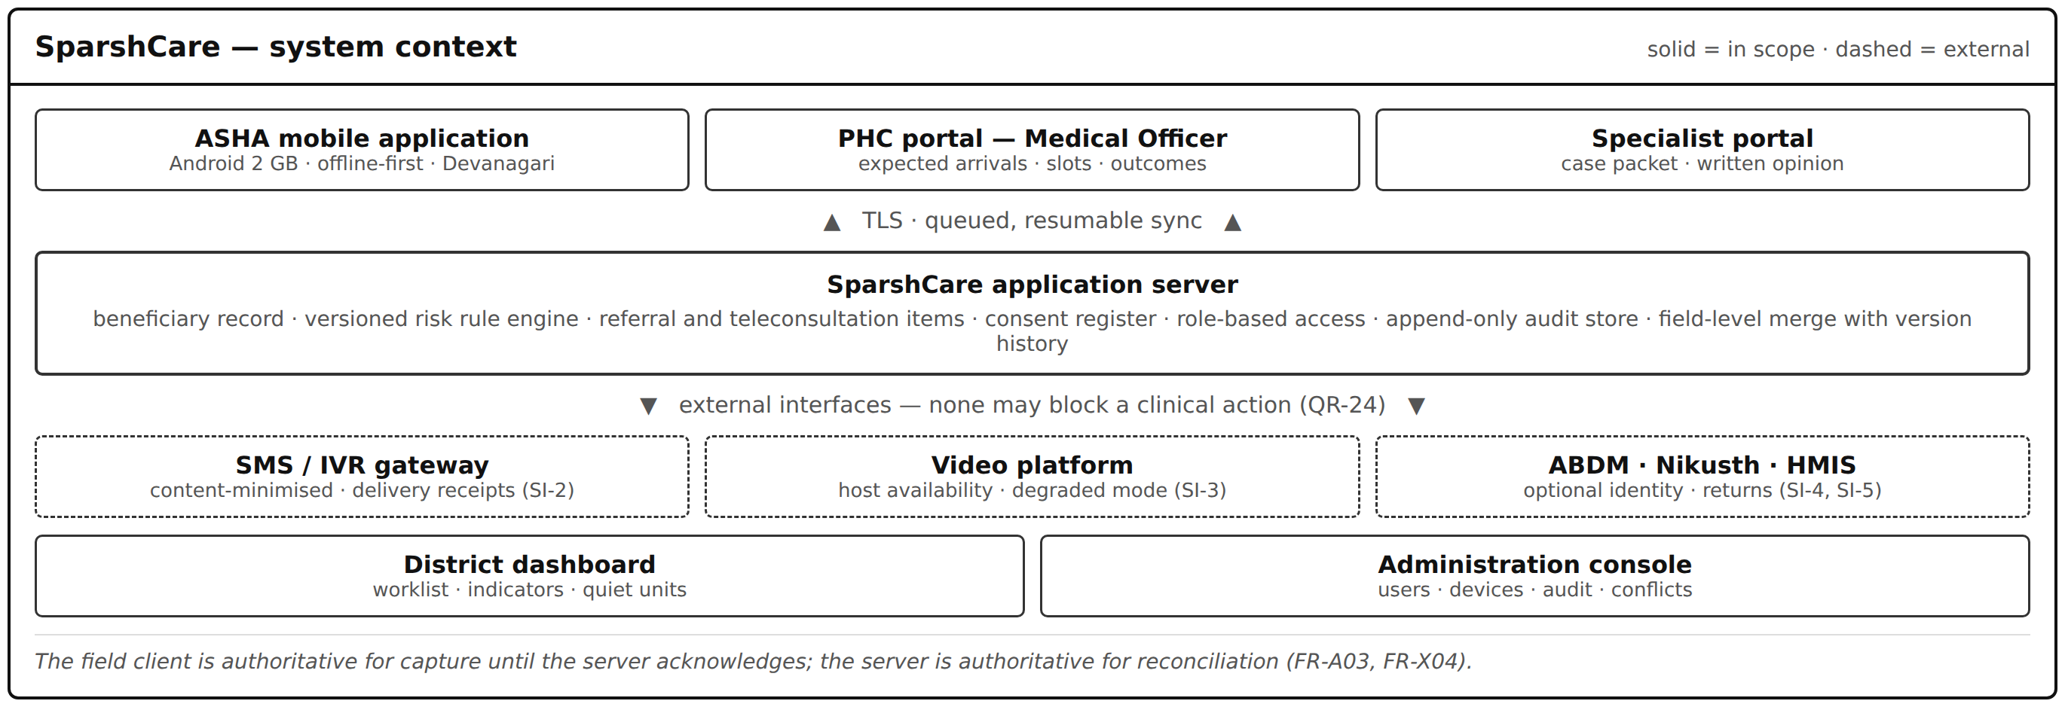
Figure 1 — System context. Solid boxes are parts of SparshCare; dashed boxes are external systems it does not control.
2.2 Product functions
At the level of a summary: register and identify a person; capture a screening offline and stratify its risk; record consent; raise a referral that stays open until a human closes it with a stated outcome; book only into clinician time that has been confirmed; notify the beneficiary without naming the condition; assemble a case packet and record a specialist opinion with a review date; return the outcome to the worker who found the person; and give the district a worklist of what is open and an indicator set of what has happened — while logging every read, merging every concurrent edit, and losing nothing.
2.3 User characteristics
User class | Interface | Population | Characteristics that constrain design | What they need most
Sunita Devi — ASHA | Android app | ~1,100 in district; ~700 active monthly | Low digital literacy; basic Hindi reading; no English; shared 2 GB handset | Offline, ≤ 12 taps, Devanagari, nothing on screen
Dr. A. Rao — Medical Officer | Web portal | 40 across the district | Clinically expert; 80–120 patients per OPD session; under 4 min per patient | Findings before the patient; his own calendar; no second register
Dr. Meera Iyer — Specialist | Web portal | 1 in the district | Dermatology and leprosy trained; two protected windows a week | Packet 12 h ahead; store-and-forward; a recorded, dated opinion
Mr. S. Verma — District Leprosy Officer | Dashboard | 1, plus ~12 block managers | MPH; reports to the state within the first fortnight of each month | Worklist separate from report; honest zeros; coarse geography
Ramesh — beneficiary | None — SMS / IVR only | ~2.4 m population; ~1,100 referred per year | Reads slowly; keypad handset shared with the household; wage labourer | Nothing that names the condition; a confirmed appointment
Priya — System Administrator | Admin console | 1 (with one non-technical data operator) | Sole technical staff; no on-call rota; peak support load 21:00–23:00 | Audit answers, no lost writes, self-service recovery
2.4 Constraints
Device baseline. Entry-level Android, 2 GB RAM, Android 11, frequently shared with the household and subject to multi-hour power cuts. The application shall be usable one-handed and shall not be battery-hungry.
Connectivity. Zero coverage in interior hamlets and 2G at best elsewhere; the correlation is adverse, since coverage is worst exactly where screening need is highest. Offline-first is mandatory, not a feature.
Regulatory. Once software computes who is high-risk it influences a clinical decision: IEC 62304, ISO 14971 and the IMDRF SaMD framework apply, as do the DPDP Act 2023 and ABDM privacy expectations.
Clinical authority. The software may flag, prioritise and warn. It shall never conclude, and shall never render a case closed on its own reasoning. This constrains the product beyond the interface.
Mandated platforms. The video platform is mandated and shall be integrated, not rebuilt. ABHA is integrated where available with a graceful fallback. Notification is by SMS and IVR because most beneficiaries have keypad handsets.
Operating ratio. Approximately 1,100 field users to 1.5 administrators, with no on-call rota. Any control that generates support calls must be justified against that ratio.
2.5 Assumptions and dependencies
• Screening findings are recorded by a worker who has been trained in the cotton-wisp sensation test; the specification assumes that training exists and is refreshed. A structured form does not create a skill, and this is the largest hidden dependency in the project.
• The district will accept a generated digital return in place of at least one paper format. If it does not, the system is a net addition regardless of design quality (QR-26 becomes unmet).
• A clinician’s availability can be recorded ahead of time. Emergencies will still break slots, which is why FR-M06 exists.
• Figures quoted in the DRD are stakeholders’ own estimates and are not used as design baselines; where a requirement depends on one, it is stated as a target to be validated in the pilot.
• The programme and its legal advisers will settle ownership of a recorded screening determination before the risk module is built. Until then FR-A05 and FR-A07 are specified but not releasable.
2.6 System components
Five deployable components. The risk engine is separated deliberately: it carries a medical-device lifecycle (section 4) and that obligation should fall on a small, well-bounded component rather than on the whole system.
Component | Responsibility | Safety class | Requirements
Field client (Android) | Registration, screening capture, local store and sync queue, worklist, module credential, guided image capture | Class A (host of the engine) | FR-A01 to FR-A04, FR-A09 to FR-A13
Risk engine | Evaluates the versioned rule set and returns exactly one category; runs on-device and offline; stores the rule version with the record | Class C — segregated | FR-A05, FR-A06, FR-A07
Application server | Beneficiary record, referral and teleconsultation items, consent register, scheduling, reconciliation and version history | Class B | FR-A08, FR-M01 to FR-M09, FR-S01 to FR-S06
Reporting and dashboard | District worklist, indicators, nil returns, accumulation detection, generated returns | Class A | FR-D01 to FR-D07
Administration and audit | Users, roles, devices, append-only read/write audit, conflict queue, telemetry | Class A | FR-X01 to FR-X07
2.7 Apportioning of requirements
Requirements are apportioned to three releases in section 5. Release 1 delivers screening, referral and appointment — the two workflows that decide whether a person is seen at all. Release 2 adds the specialist path. Release 3 adds the district view. The ordering is the stakeholders’ own: “if you can build just one thing, build the one that lets a person not be lost.”

3 Specific requirements
3.1 External interface requirements
3.1.1 User interfaces
Eight wireframes follow, one screen each, covering all four interfaces. They are deliberately low-fidelity: they fix information architecture, control types, wording and what must never appear on a screen, and leave visual design — colour, typography, spacing, iconography — entirely open. The italic line inside each frame states the requirement the screen exists to satisfy. Labels are in English for legibility; the production field interface is Devanagari (QR-07).
Two interface rules apply across every screen. First, no field screen may display a disease name, diagnostic term, risk label or colour-coded alert (QR-13), and the screening flow must be visually and behaviourally identical for a flagged and an unflagged person (QR-14). Second, every clinical value is displayed in three states — recorded, recorded-normal, and not checked — with no coercion of a blank into a normal (FR-A06, FR-M03).
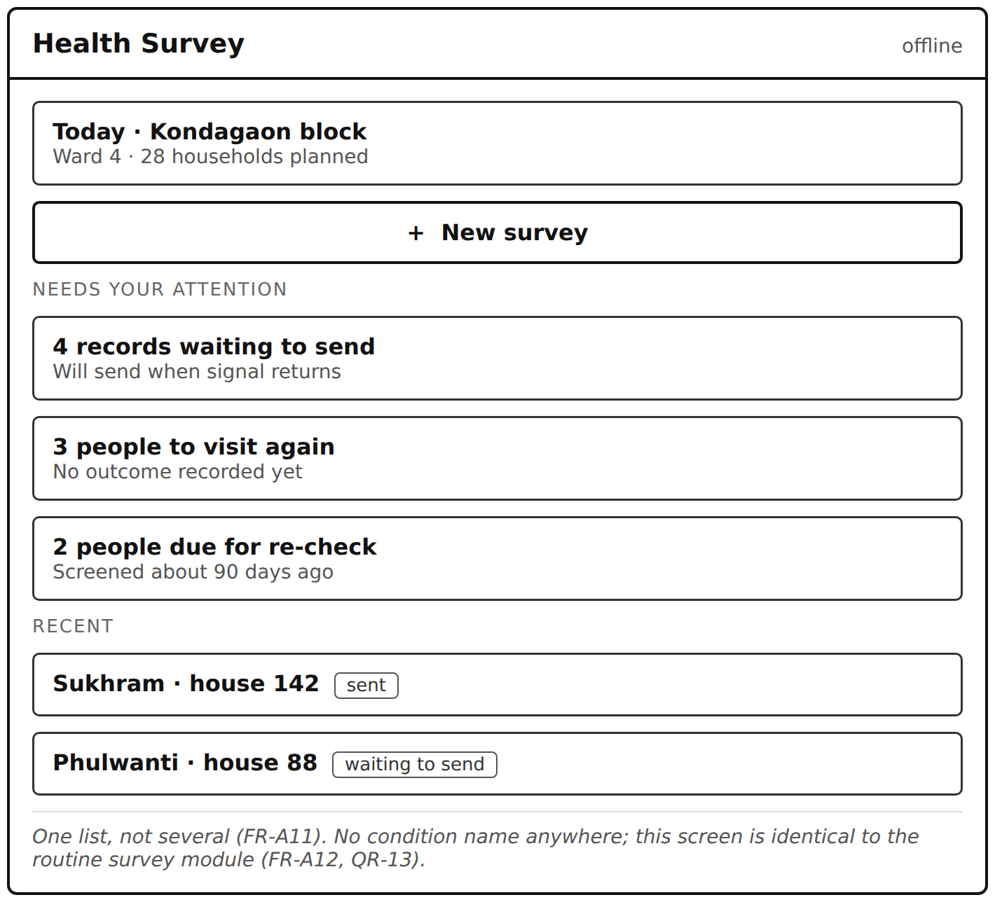
Figure 2 — ASHA application · daily worklist and pending records
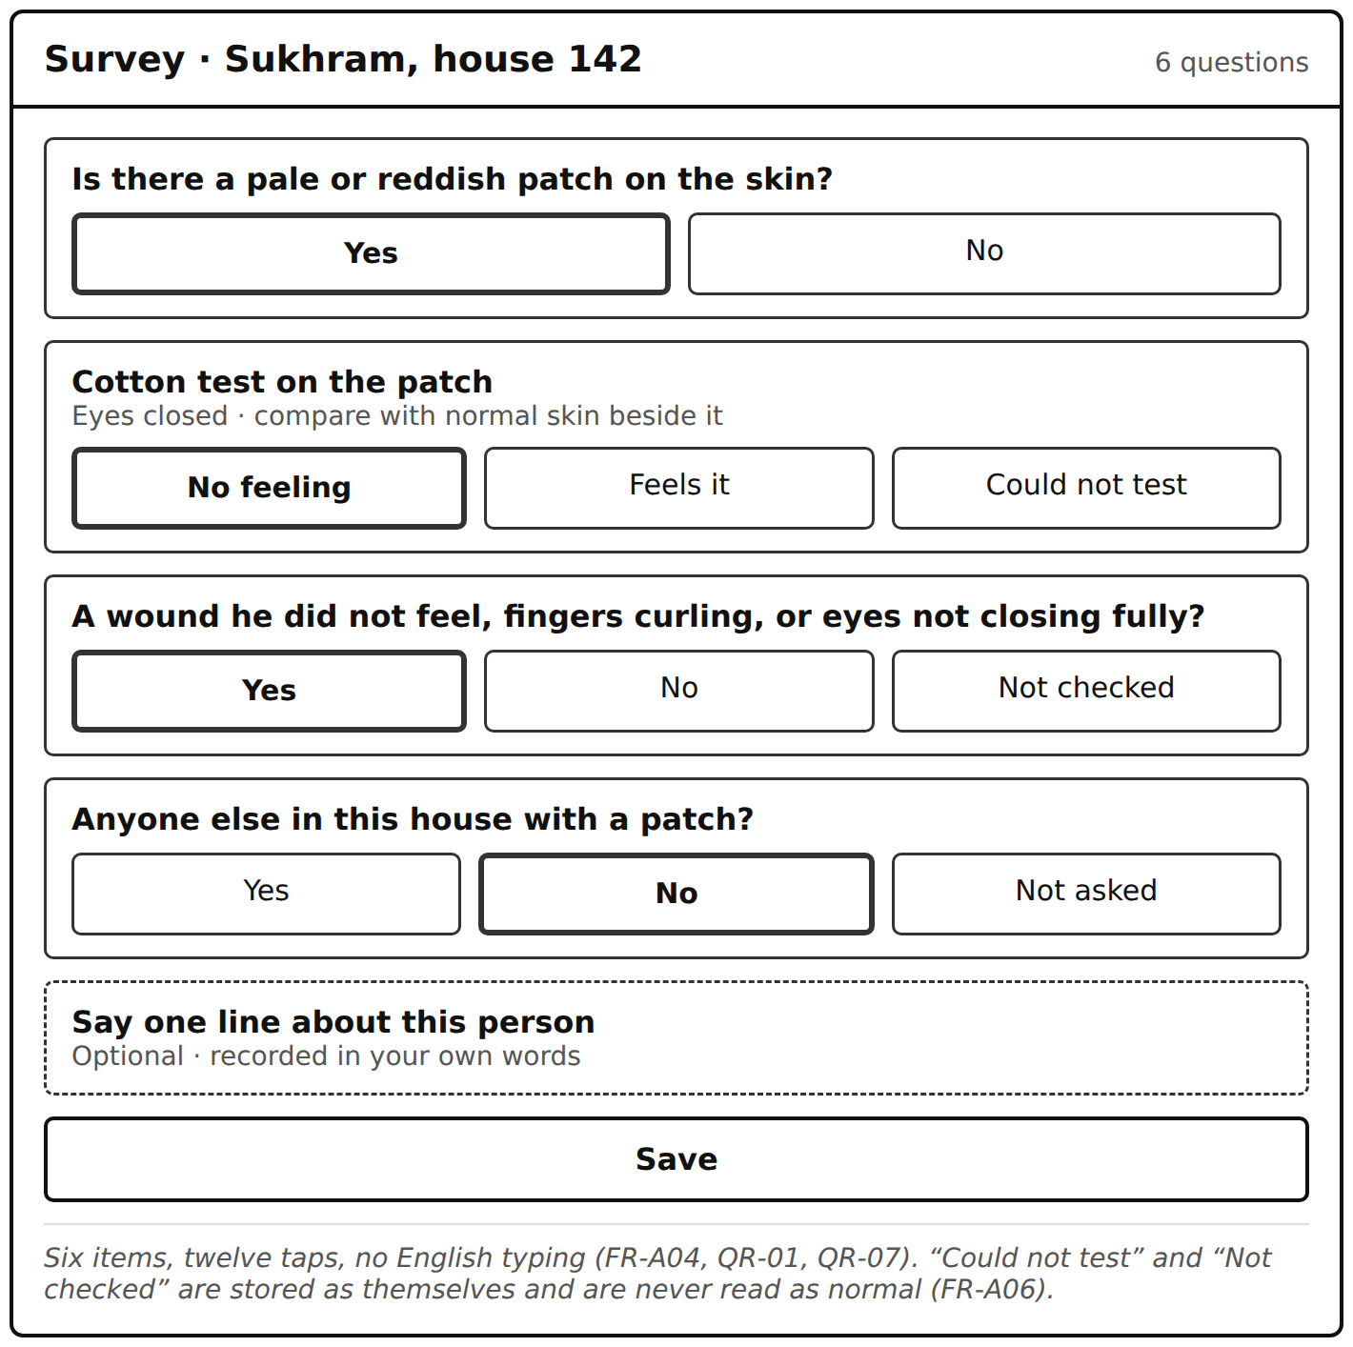
Figure 3 — ASHA application · the screening form (the six field-captured items)
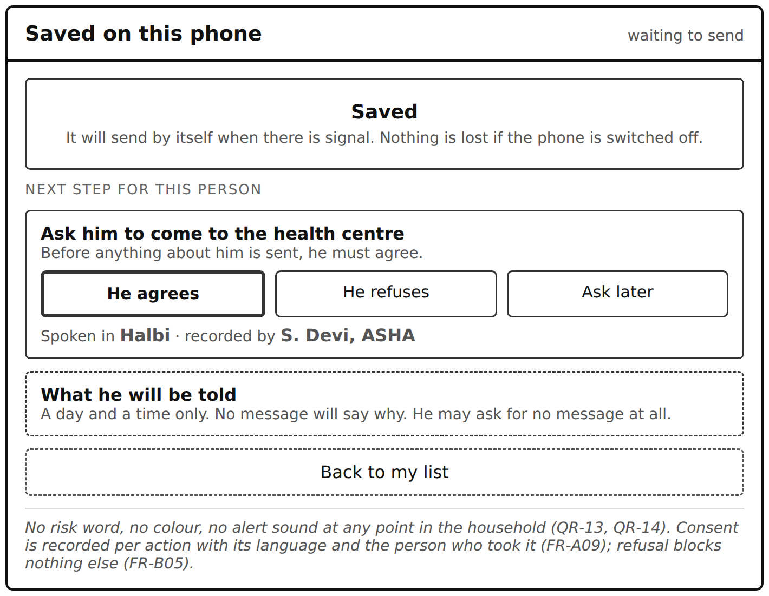
Figure 4 — ASHA application · save, consent and what the beneficiary will be told
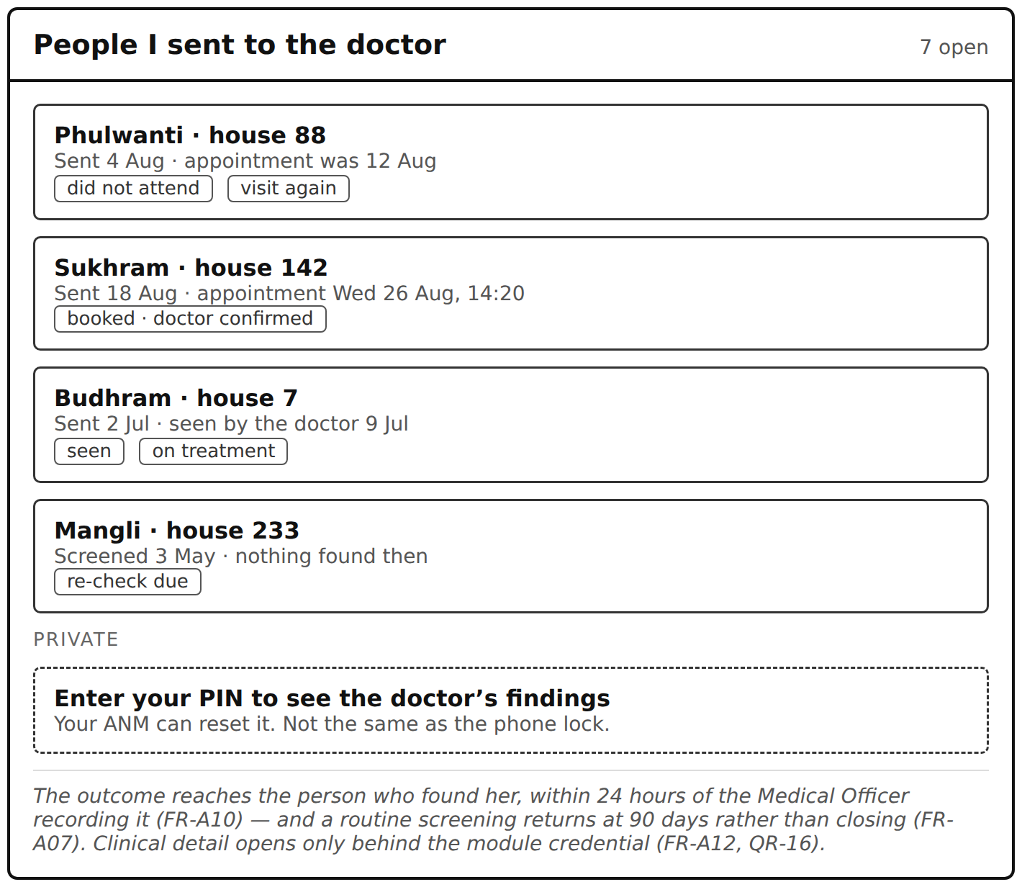
Figure 5 — ASHA application · referral outcomes returned to the worker who found the person
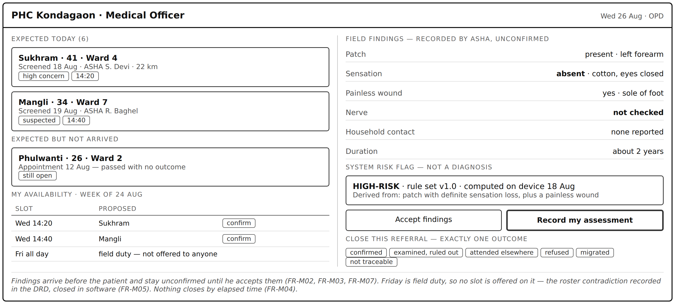
Figure 6 — PHC portal · expected arrivals, field findings, risk flag, availability and closure
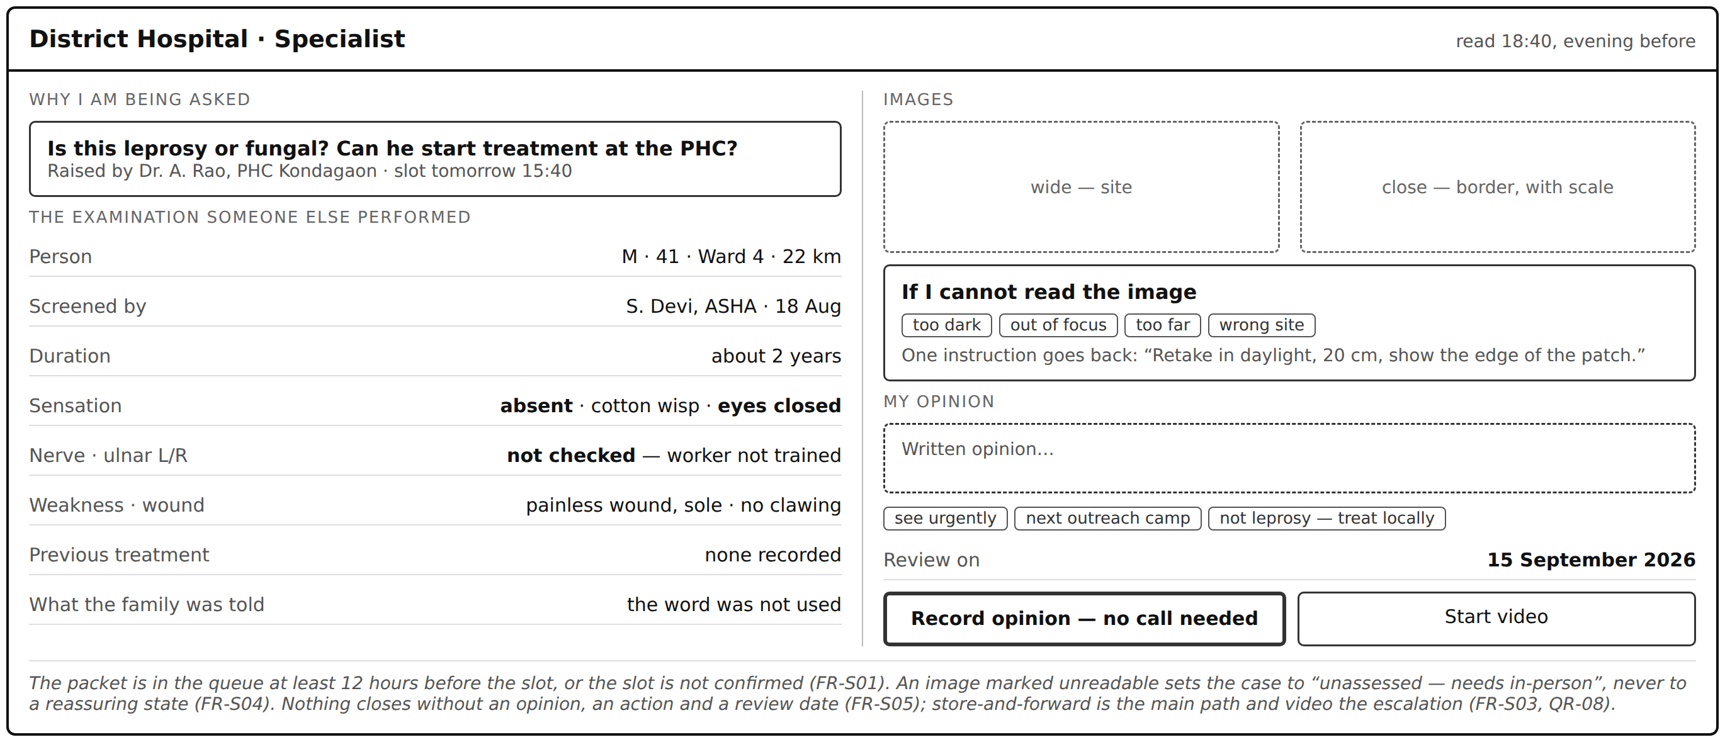
Figure 7 — Specialist portal · the pre-call packet, image adequacy and the recorded opinion
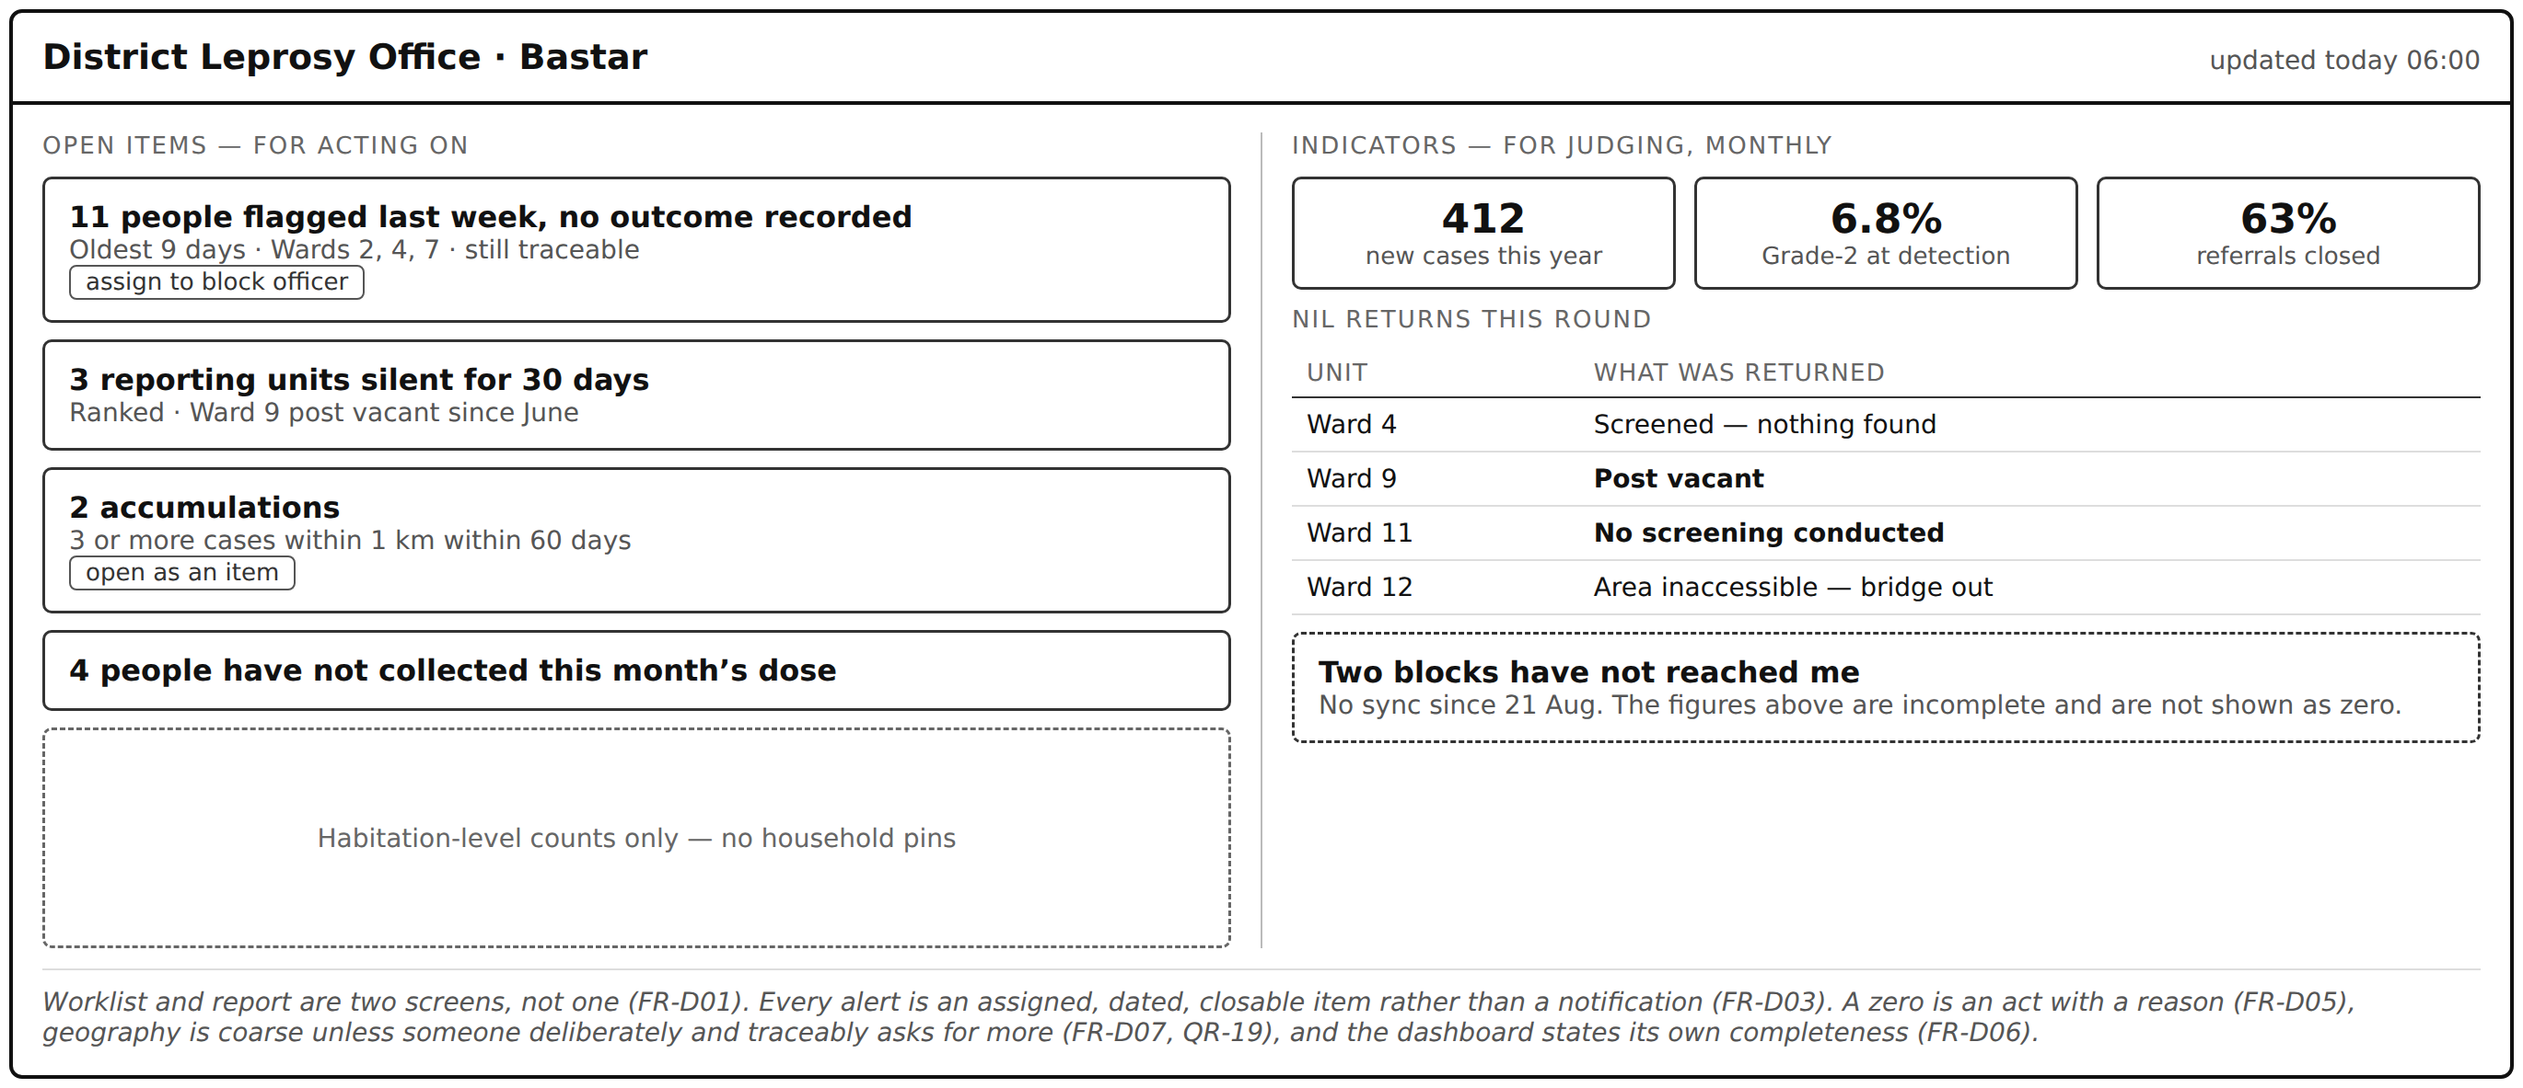
Figure 8 — District dashboard · open items for acting on, indicators for judging
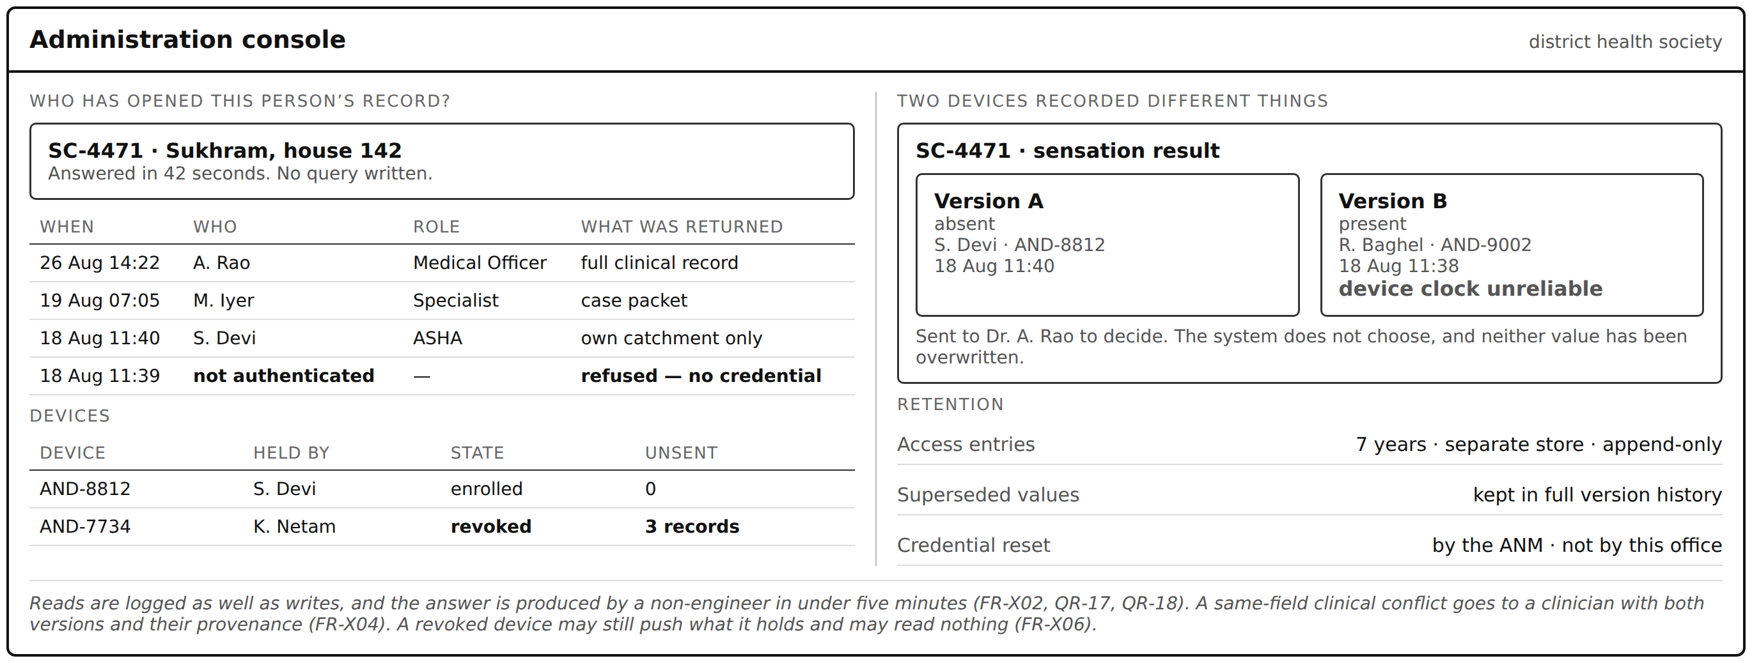
Figure 9 — Administration console · access answer, device registry and the conflict queue
3.1.2 Hardware interfaces
HI-1 Handset. Android 11 or later, 2 GB RAM, ARMv8; the application shall run within 200 MB of storage for the active caseload and shall not exceed 6% battery consumption per hour of active screening.
HI-2 Camera. The device camera is used for lesion images. The application shall verify focus on the handset before accepting an image and shall store a cropped derivative rather than the full frame.
HI-3 Clinician workstations. Standard desktop browsers at the PHC and district hospital; no installed client. The portals shall function at 1366 × 768 and above.
HI-4 Beneficiary handset. Assumed to be a keypad feature phone shared within the household. No application, no smartphone capability and no data connection may be assumed.
3.1.3 Software interfaces
SI-1 ABDM / ABHA. Identity linkage over the ABDM APIs. Verification failure or timeout shall be non-blocking: the beneficiary is created against a local identifier and marked identity-unverified, with linkage possible later (FR-A01, QR-24).
SI-2 SMS / IVR gateway. Outbound messages via the state-empanelled aggregator. Delivery receipts shall be consumed and the delivery state — not the submission state — displayed to users; undelivered messages become work items (QR-25).
SI-3 Video platform. Scheduling shall check real host availability before offering a slot. On failure at the point of use the system shall present a defined in-app fallback — reschedule, voice, or store-and-forward — and record the failure as a clinical event, not merely a technical one (FR-S03).
SI-4 Nikusth and HMIS. Aggregate returns shall be generated from recorded data and exported in the formats those portals accept, so that no figure is keyed twice (FR-M09, QR-26).
SI-5 Welfare and certification extracts. Any request for disability-certificate or pension extracts shall be served only through a formal, consented and logged interface, or refused. Ad-hoc spreadsheet export is prohibited (FR-X01).
3.1.4 Communications interfaces
CI-1 Transport. All traffic over TLS 1.2 or later with certificate pinning on the mobile client. No clinical payload shall traverse an unencrypted channel.
CI-2 Synchronisation. A resumable, idempotent, queue-and-retry protocol tolerant of 2G interruption; the client shall never clear a local record before an explicit server acknowledgement (FR-A03).
CI-3 Conflict semantics. Field-level change sets carrying author, device and capture time. Server-side reconciliation shall not use device clocks as an arbiter of recency (FR-X04).
CI-4 Bandwidth floor. A screening record shall be transmissible in under 8 kB of payload so that a day’s work drains over a 2G link (QR-04). Images are queued separately and never block the record.

3.2 Functional requirements by user class
Forty-seven functional requirements, grouped by the stakeholder who needs them. Each carries a rationale drawn from the interviews, its dependencies, the stakeholder requirement and user story it satisfies, and a MoSCoW priority (M = Must, S = Should). Statements use shall for obligation and contain no implementation choice.
3.2.1 User class 1 — ASHA / frontline worker (Sunita Devi) · Android application
Primary field user. Works offline on a shared 2 GB-RAM handset, in a courtyard, with neighbours watching. Thirteen requirements; the interface is Figures 2 and 3.
ID | Title | Description — the system shall… | Rationale | Dep. | Traces to | Pri.
FR-A01 | Register a beneficiary offline | Create a beneficiary record with no network, against a locally generated identifier, capturing name, household reference and father’s or husband’s name; ABHA linkage shall be offered but shall never be a precondition for registration or for any clinical action. | Registration must never fail because an OTP did not arrive at a husband’s phone. | — | STR-13 · US-16 | M
FR-A02 | Duplicate candidate matching | Search existing records on name, household reference and village before a new record is created, present any candidate matches for the user to confirm or reject, and never merge two beneficiary records automatically. | “In one hamlet there are four Sukhram”; 1,400 duplicate pairs were found in the district immunisation register. | A01 | STR-13 · US-16 | M
FR-A03 | Offline capture and guaranteed retention | Write every completed screening record to encrypted local storage, mark it pending, retain it through application termination, device restart and storage exhaustion until the server acknowledges receipt, and synchronise automatically without a user action and without a failure message interrupting fieldwork. | One data-loss event returns this user to paper permanently — she has said so explicitly. | A01 | STR-01 · US-01 | M
FR-A04 | Minimum screening record | Capture the six field-recorded items — patch present, sensation result, painless wound / finger curling / eye closure, household contact with a patch, plus identity and household reference — using three-state answers where a finding may be unchecked. | The set a non-clinician can record reliably at 100-plus people a campaign day. | A01 | STR-02 · US-02 | M
FR-A05 | Offline risk stratification | Derive exactly one risk category from the set {routine, suspected, high-risk} from the findings recorded in that record, with no network connection, store the identifier and version of the rule set used, and display that rule on request. | “The model said so” is not an answer a Medical Officer can give anyone. | A04 | STR-03 · US-07 | M
FR-A06 | Three-state findings | Store, display and export “not checked” as a value distinct from “checked — normal”, and reject a sensation result submitted without its method and the patient’s eyes-closed status. | A blank field is workable; a wrongly-confident field is dangerous. | A04 | STR-09 · US-05 | M
FR-A07 | No screening is ever concluded | Keep every screening record open until a Medical Officer or specialist records an examination outcome against it, and place every record categorised routine on the screening worker’s re-screen worklist 90 days after the screening date. | A recorded negative must carry a review path, never a closure — the liability boundary. | A05 | STR-04 · US-07 | M
FR-A08 | High-risk opens two items | Create both a specialist teleconsultation request and a PHC referral for every high-risk record, and refuse to close either while the other remains open. | “No high-risk case is lost” — the case study’s first success criterion. | A05 | STR-05 · STR-14 | M
FR-A09 | Consent capture | Record consent — the action consented to, the language it was given in and the name of the person who obtained it — before a referral is raised, a teleconsultation scheduled, a photograph captured or household contacts approached; refusal of any one shall leave screening and all other care available. | Consent is a safety control here, not a compliance formality. | A04 | STR-15 · US-18 | M
FR-A10 | Referral outcome returned to the finder | Display the outcome of a referral she raised on her own worklist within 24 hours of a Medical Officer recording it, and show a person as “not yet attended” once the appointment date has passed with no outcome. | Twenty referrals, about six attended, nine years, no outcome ever reported back — the pain she raised unprompted three times. | A08 | STR-05 · US-04 | M
FR-A11 | One prioritised worklist | Present all outstanding work — re-screens due, open referrals, requested image retakes and unsynced records — as a single prioritised list, and carry forward previously recorded findings when a beneficiary is re-screened. | She carries hundreds of names in her head and forgets; the app should carry them instead. | A03 | STR-16 · US-19 | S
FR-A12 | Module credential | Require a module credential (PIN or biometric), distinct from the device screen lock and recoverable through the ANM, before any clinical field or risk category is displayed, and require it no more than once per working session. | The handset is a family phone whose pattern lock the husband and son both know. | A01 | STR-08 · US-03 | M
FR-A13 | Guided image capture | Coach image capture at the point of capture (daylight, distance, scale object, one wide and one close frame), check focus on the handset before accepting, and transmit a crop that excludes the face. | Every image-quality problem is a problem of feedback arriving three days late. | A04 | STR-10 · US-09 | S
3.2.2 User class 2 — Medical Officer, PHC (Dr. A. Rao) · web portal
Receives referrals, confirms diagnosis, owns his own calendar. Nine requirements; the interface is Figure 4.
ID | Title | Description — the system shall… | Rationale | Dep. | Traces to | Pri.
FR-M01 | Expected-arrivals list | Present every person screened in his catchment on an expected-arrivals list within 5 minutes of the screening device synchronising, whether or not that person has been booked. | “You cannot notice that they did not come” for a person with no record. Ranked first by this stakeholder. | — | STR-05 · US-05 | M
FR-M02 | Structured findings with provenance | Deliver the recorded findings, the screening date and the name of the worker who screened, before or with the beneficiary’s arrival, as structured data rather than free text. | He identifies the referring worker today by recognising handwriting. | M01 | STR-05 · US-05 | M
FR-M03 | Blanks shown as blanks | Display any finding that was not recorded as “not checked”, never as empty and never as normal. | Merging “not checked” with “normal” is actively unsafe. | M02 | STR-09 · US-05 | M
FR-M04 | Referral closure vocabulary | Permit a referral to be closed only by recording exactly one outcome from: confirmed · examined and ruled out · attended elsewhere · refused · migrated · not traceable. | “I would rather have four hundred honest not-traceable entries than seven hundred people I cannot account for.” | M01 | STR-05 · US-12 | M
FR-M05 | Propose-and-confirm scheduling | Offer and hold appointment slots only within periods he has marked available within the preceding 7 days, refuse any booking in a period marked leave, field duty or closed, and commit no slot without his explicit confirmation; no slot shall be double-booked. | “The first time it double-books me I will abandon it. You get exactly one chance at that.” | — | STR-06 · US-06 | M
FR-M06 | Broken-slot notification | Notify the beneficiary and the referring ASHA within 15 minutes of a confirmed slot being cancelled, and offer an alternative slot. | A wasted journey costs the ASHA her credibility, which is the scarcer resource. | M05 | STR-06 · US-10 | M
FR-M07 | Clinician override | Allow him to change a computed risk category in either direction, require a recorded reason, and never present the override as an error or a data-quality exception. | The software flags; the clinician decides. This is the boundary, not a preference. | M02 | STR-04 · US-07 | M
FR-M08 | Two escalation channels | Escalate a non-attending high-concern case to him actively within 24 hours, and present routine and suspected non-attenders only in an aggregate view he opens himself; routine chasing shall never be routed to him as a task. | “If you blur that line and send me everything, the alerts that matter get ignored with the rest.” | M01 | STR-05 · US-05 | M
FR-M09 | Monthly return generated, not re-keyed | Generate the monthly NLEP progress return from data already recorded — disaggregated by new cases, child cases, Grade-2 disability, female cases, on treatment, released and defaulted — for him to check and sign. | The previous tablet system died because it added a fourth transcription and removed no register. | M04 | STR-05 · QR-26 | S
3.2.3 User class 3 — Dermatologist / Leprologist (Dr. Meera Iyer) · web portal
Sole specialist for ~1.8 million people. Consults remotely in two protected windows a week. Six requirements; the interface is Figure 5.
ID | Title | Description — the system shall… | Rationale | Dep. | Traces to | Pri.
FR-S01 | Pre-consultation case packet | Make the case packet — identity, symptom duration, per-patch sensation result with method, per-nerve palpation status, weakness and painless-wound findings, prior treatment, disclosure state, images and the referral question — available not less than 12 hours before the scheduled slot, and refuse to confirm a slot while any mandatory item other than an image is absent. | Nine minutes of a 22-minute call spent discovering why she had been called. | — | STR-10 · US-08 | S
FR-S02 | Mandatory sensation method | Reject any sensation result recorded without both the test method and the patient’s eyes-closed status, at the interface and at the API. | “It will look like a fussy detail on a form. It is the diagnosis.” | S01 | STR-09 · US-08 | M
FR-S03 | Store-and-forward as the main path | Allow a written opinion to be recorded against a packet without a live video session, and select that path automatically where measured uplink at the field end is below 256 kbit/s. | A third of the district cannot carry a video call; slow photographs beat a failed call. | S01 | STR-14 · US-17 | M
FR-S04 | Inadequate image is not reassurance | Record “image inadequate” with a reason from a fixed list (too dark · out of focus · too far · wrong site), return one specific retake instruction to the capturing worker, and set the case state to “unassessed — needs in-person examination”, never to a negative or deferred state. | “A photograph I could not read must cost the system something. At the moment it costs nothing.” | S01 | STR-09 · US-09 | S
FR-S05 | Opinion, action and review date | Refuse to mark a consultation complete until a written opinion, a recommended action and a review date are recorded against the beneficiary, and return the case to her exception list if no outcome is recorded by that date. | “Nobody chases what nobody wrote down. Eleven weeks.” | S03 | STR-14 · US-17 | M
FR-S06 | Slot backfill | Offer the next reviewed store-and-forward case when the beneficiary is not present within 3 minutes of a slot starting, and re-queue the absent case. | “Turn fifteen wasted minutes into two disposed cases, and I never learn to resent the window.” | S03 | STR-14 · US-17 | S
3.2.4 User class 4 — District Leprosy Officer (Mr. S. Verma) · district dashboard
Programme sponsor. Needs perishable operational triggers daily and trustworthy indicators monthly. Seven requirements; the interface is Figure 6.
ID | Title | Description — the system shall… | Rationale | Dep. | Traces to | Pri.
FR-D01 | Worklist separated from report | Present a daily-updating worklist of open items — unclosed referrals, quiet units, geographic accumulations, stockouts and treatment defaulters — on a screen structurally separate from the monthly indicator set. | “Indicators are for judging. Triggers are for acting. If the two are mixed I will use neither properly.” | — | STR-05 · US-13 | M
FR-D02 | Referral closure figure | Compute referral closure from recorded closure codes and report the count of each outcome, including not traceable, for any period and any reporting unit. | In four years he has never had a referral closure figure at all — not a poor one, none. | D01 | STR-05 · US-12 | M
FR-D03 | Alerts are assigned items | Raise every alert as an item with an owner, a date raised and a required closing action, and record the response action taken. | “An alert that arrives among forty other things is not a system, it is a notification.” | D01 | STR-05 · US-13 | S
FR-D04 | Rolling accumulation detection | Detect and raise an accumulation where three or more suspected or confirmed cases occur within one kilometre within a rolling 60 days, evaluated continuously and across reporting-period boundaries. | Ghatpara: 14 cases along 2 km over nine months, invisible inside monthly block totals. | D01 | STR-05 · US-13 | S
FR-D05 | Reasoned nil reporting | Require one nil return per screening round per reporting unit, selected from: screened and none found · no screening conducted · post vacant · area inaccessible · other with reason. | “A zero must be an act, not an absence.” A silent zero sent his one survey team to the wrong block. | D01 | STR-05 · US-13 | S
FR-D06 | Declared completeness | State on every figure which reporting units have not yet synchronised for the period displayed, and never render an unsynchronised unit as a zero. | So that a gap in the data is never read as a finding about the disease. | D01 | STR-05 · US-13 | M
FR-D07 | Coarse geography by default | Display geographic distribution at habitation level or coarser by default, and require a deliberate, separately logged action to view any finer resolution. | “A village-level dot map is, in a village of two hundred households, very nearly a list of names.” | D04 | STR-08 · QR-19 | M
3.2.5 User class 5 — Beneficiary / community member (Ramesh) · no user interface
Never operates the software. Reached only by SMS, IVR and the people who carry it. Five requirements; his safety depends on what the system does not say.
ID | Title | Description — the system shall… | Rationale | Dep. | Traces to | Pri.
FR-B01 | Appointment confirmation | Send an appointment confirmation by SMS, or by IVR voice call where no SMS-capable handset is registered, in the language recorded for that person, stating the facility, date and time. | He reads slowly and hands messages to whoever can read them. | — | STR-07 · US-11 | M
FR-B02 | Content minimisation | Exclude from every outbound message and from the sender identifier any disease name, diagnostic term, symptom, risk category or departmental name that could disclose the reason for the appointment. | “My son will read that about his own father, out loud, before he understands what he is reading.” | B01 | STR-07 · US-11 | M
FR-B03 | Right to receive nothing | Allow a beneficiary to elect to receive no messages, record that election, and notify the referring ASHA to deliver the information in person instead. | For a household where any unfamiliar sender invites questions. | B01 | STR-07 · US-11 | M
FR-B04 | Confirmed presence stated | State in the confirmation that the clinician’s presence has been confirmed for that slot, and issue no confirmation for a slot that has not been confirmed by the clinician. | “If somebody tells me the doctor is sitting, I will come on Thursday.” One failed trip ends this pathway. | B01 | STR-06 · US-10 | M
FR-B05 | Consent and withdrawal | Record consent or refusal separately for referral, teleconsultation, photograph and contact visit, and stop the corresponding activity within one working day of a recorded withdrawal. | What happens to his name must be his decision. | — | STR-15 · US-18 | M
3.2.6 User class 6 — IT / System Administrator (Priya) · administration console
One administrator, about 1,100 field users, no on-call rota. Seven requirements; the interface is Figure 7.
ID | Title | Description — the system shall… | Rationale | Dep. | Traces to | Pri.
FR-X01 | Least-privilege access, enforced server-side | Enforce role-scoped access on the server for every request: an ASHA reaches only beneficiaries in her own catchment, an ANM and pharmacist only the fields their work requires, and no role receives a browsable district-wide case list. | Access control must live in the software, not in a circular the DLO signs. | — | STR-08 · STR-11 | M
FR-X02 | Append-only read and write audit | Write an append-only entry for every read and every write of a beneficiary record — user, role, device, record identifier, fields returned and timestamp — to a store separate from the application database, retain it for not less than 7 years, and answer “who has accessed this record” for a named beneficiary within 5 minutes without a query being written. | Reads are what matter in a disclosure; nothing she runs today logs them. | X01 | STR-11 · US-14 | M
FR-X03 | Device registry | Enrol, list and revoke devices as first-class objects bound to a user account, and show the pending queue held on each. | 15–20% of field handsets change each year and nothing can be invalidated today. | — | STR-12 · US-15 | M
FR-X04 | Field-level merge, no silent loss | Merge concurrent offline edits at field level, retain every superseded value in a recoverable version history, disregard device clocks as an arbiter of recency, and present two conflicting clinical values to a Medical Officer with both versions, author, device and capture time rather than selecting one. | Record-level last-write-wins destroyed several thousand growth measurements and taught the field that the app eats your work. | X03 | STR-12 · US-15 | M
FR-X05 | Supervisor-mediated recovery | Allow an ANM to reset the module credential of an ASHA in her sub-centre, without the district administrator and without an SMS one-time password. | Median 1.5 days to recover an account today; the peak support hour is 21:00 and there is nobody on duty. | X01 | STR-16 · QR-21 | S
FR-X06 | Revoked device may push, not read | Permit a revoked device to transmit its undrained queue and permit it to read nothing. | Security requires the wipe; integrity forbids losing the only copy of a record. | X03 | STR-12 | S
FR-X07 | Client-side telemetry | Report crashes, failed synchronisations and stuck queues from the client to the administrator without depending on a user raising a complaint. | “I cannot distinguish a block that is busy from a block where something broke in June.” | X03 | QR-22 | S
3.3 Non-functional (quality) requirements
Twenty-six quality requirements in PLanguage form. Each names the quality (TAG), what it means (GIST), the scale it is measured on (SCALE), how it will be measured (METER), the level below which the system fails (MUST) and the level at which it can be called a success (PLAN). A quality requirement without a scale and a meter is an opinion, not a requirement.
ID | Category | TAG | GIST and SCALE — the quality, and the scale it is measured on | METER · MUST · PLAN | Stakeholder | Traces
QR-01 | Performance | ScreeningEffort | Effort to record one screening. SCALE: elapsed seconds and screen taps to complete and save the minimum record, offline, in a household. | METER: 10 ASHAs × 20 screenings, stopwatch and tap counter. MUST: median ≤ 90 s, 90th pct ≤ 180 s, ≤ 12 taps in 45/50. PLAN: median ≤ 60 s. | Sunita Devi | STR-02
QR-02 | Performance | SaveLatency | Time from pressing Save to a stored-and-confirmed record. SCALE: seconds on the reference handset (2 GB RAM, Android 11, all radios off). | METER: 40 consecutive saves. MUST: 95th pct ≤ 1.000 s. PLAN: ≤ 0.6 s. | Sunita Devi | STR-01
QR-03 | Performance | RiskComputation | Time to derive and display the risk category. SCALE: seconds from submission, offline. | METER: 200 submissions across the rule table. MUST: ≤ 2 s in 100%. PLAN: ≤ 1 s. | Dr. A. Rao | STR-03
QR-04 | Performance | SyncThroughput | Time to upload a full campaign day. SCALE: minutes to drain 120 queued records over a 2G (≈ 40 kbit/s) uplink. | METER: network-shaped test at 40 and 128 kbit/s. MUST: ≤ 15 min at 40 kbit/s, resumable. PLAN: ≤ 8 min. | Priya | STR-01
QR-05 | Performance | PortalResponse | Responsiveness of the clinician portals. SCALE: seconds to render the expected-arrivals list of 50 items. | METER: 100 loads at the PHC broadband baseline. MUST: ≤ 3 s at the 95th pct. PLAN: ≤ 1.5 s. | Dr. A. Rao | STR-05
QR-06 | Usability | CognitiveLoad | Mental demand the application places on the field worker. SCALE: NASA-TLX mental-demand score after a full campaign day, and instances of a datum being requested twice. | METER: 10 ASHAs, TLX at close of day plus observation. MUST: median ≤ 40/100 and zero re-asked data. PLAN: ≤ 30/100. | Sunita Devi | STR-16
QR-07 | Usability | LanguageAndScript | Language of the field interface. SCALE: proportion of labels, values and required entry available in Devanagari with no Latin-script typing. | METER: screen inventory plus field trial. MUST: 100% of labels and values; keyboard required for the name field only. PLAN: voice capture for non-identifying fields. | Sunita Devi | STR-02
QR-08 | Usability | AsynchronousFirst | Reliance on live video. SCALE: proportion of specialist opinions that can be completed without a live session. | METER: 50 consecutive teleconsultations. MUST: 100% completable store-and-forward. PLAN: ≥ 70% actually completed that way. | Dr. Meera Iyer | STR-14
QR-09 | Usability | PacketReadability | Effort to absorb a case before a consultation. SCALE: minutes for the specialist to read a packet and state a disposition. | METER: 20 packets, timed. MUST: ≤ 4 min in 18 of 20. PLAN: ≤ 3 min. | Dr. Meera Iyer | STR-10
QR-10 | Usability | AdministratorSelfService | Dependence on one administrator. SCALE: proportion of account recoveries completed without the district administrator. | METER: 60 recoveries over one quarter. MUST: ≥ 90% by ANM. PLAN: ≥ 98%. | Priya | STR-16
QR-11 | Confidentiality | MessageDisclosure | Information leaked by an outbound message. SCALE: count of prohibited terms in templates, generated messages and sender identifiers. | METER: template review plus 100 generated samples in both languages. MUST: zero, in 100% of samples. PLAN: zero, with an annual re-review. | Ramesh | STR-07
QR-12 | Confidentiality | LeastPrivilege | Data reachable by a role beyond its work. SCALE: records reachable outside a user’s scope by manipulating an identifier in a request. | METER: adversarial permissions test, 200 attempts across 6 roles. MUST: zero reachable. PLAN: zero, plus alerting on attempts. | Priya | STR-08
QR-13 | Confidentiality | ScreenDiscretion | Disclosure by the screen itself. SCALE: prohibited terms or alert markers on field screens, and the proportion of lay observers who can identify the screening module. | METER: screen inspection plus a blind test, 20 observers, 10 s per module. MUST: zero terms; identification < 55% (chance at the 5% level). PLAN: identification ≈ 50%. | Sunita Devi · Ramesh | STR-08
QR-14 | Confidentiality | BehaviouralParity | Disclosure by how the worker behaves. SCALE: difference in taps and elapsed time between a flagged and an unflagged household visit. | METER: 40 paired observations. MUST: no additional taps and ≤ 10 s difference in the household. PLAN: indistinguishable to an observer. | Sunita Devi | STR-08
QR-15 | Confidentiality | DeviceDataMinimisation | Sensitive data resident on a shared handset. SCALE: records held locally, and their readability without the module credential. | METER: forensic inspection of a handset after 30 days of use. MUST: active caseload only, encrypted under a key derived from the credential; zero clinical fields readable without it. PLAN: no historical caseload cached at all. | Priya | STR-08 · STR-12
QR-16 | Confidentiality | SessionFriction | Authentication burden against exposure. SCALE: routine credential entries per working session and idle time before re-lock. | METER: session logs over 200 working sessions. MUST: exactly one routine entry per session, ≤ 5 s, idle lock ≤ 2 min. PLAN: biometric where the handset supports it. | Sunita Devi · Priya | STR-08
QR-17 | Accountability | AuditAnswerTime | Ability to answer a disclosure allegation. SCALE: minutes for a non-engineer to list every access to a named record. | METER: cold dry run on a randomly chosen beneficiary. MUST: ≤ 5 min, no query written, 500/500 accesses present. PLAN: ≤ 2 min. | Priya | STR-11
QR-18 | Accountability | AuditDurability | Survival and integrity of the audit trail. SCALE: retention period, and successful alterations using application credentials. | METER: retrieval of a 6-year-old entry; 50 tamper attempts. MUST: ≥ 7 years retained; zero successful alterations. PLAN: write-once storage with quarterly integrity checks. | Priya | STR-11
QR-19 | Accountability | GeographicResolution | Re-identification risk in the programme view. SCALE: default map resolution, and whether finer views are logged. | METER: inspection of every district view. MUST: habitation-level or coarser by default; 100% of drill-downs logged with user and reason. PLAN: suppression below a threshold agreed with the district. | Mr. S. Verma | STR-08
QR-20 | Reliability | ZeroDataLoss | Survival of captured work. SCALE: records lost across termination, restart, storage exhaustion and interrupted sync. | METER: 40 offline screenings with the app force-killed mid-sync and storage filled. MUST: zero lost, 40/40 reconciled. PLAN: zero across 500 records. | Sunita Devi | STR-01
QR-21 | Reliability | NoSilentOverwrite | Integrity of concurrent edits. SCALE: fields overwritten without a recoverable prior value. | METER: conflict test, both reconnection orders, one device with an incorrect clock. MUST: zero silent overwrites; 100% of prior values recoverable. PLAN: conflicts surfaced within 5 min of sync. | Priya · Dr. A. Rao | STR-12
QR-22 | Availability | ServiceAvailability | Availability of the server-side service. SCALE: proportion of time the API accepts a sync, excluding field network failure. | METER: external monitoring over 1,000 hours. MUST: ≥ 99.0%. PLAN: ≥ 99.5%. | Priya | STR-01
QR-23 | Availability | OfflineEndurance | Working time without any connectivity. SCALE: consecutive hours of field use with full function and no data loss. | METER: airplane-mode endurance run across 40 households. MUST: ≥ 72 h. PLAN: ≥ 7 days. | Sunita Devi | STR-01
QR-24 | Interoperability | DependencyIsolation | Effect of an external system failing. SCALE: clinical actions blocked when ABHA, the SMS gateway and the video platform are all unavailable. | METER: each integration tested in its failure state, not only its success state. MUST: zero clinical actions blocked; a defined user-visible degraded mode for each. PLAN: automatic recovery without user action. | Priya · Ramesh | STR-13
QR-25 | Interoperability | DeliveryTruth | Honesty about notification delivery. SCALE: proportion of messages whose displayed state reflects the delivery receipt rather than submission. | METER: 200 messages including one carrier failing silently. MUST: 100% show delivery state; undelivered surface as a work item. PLAN: administrator alerted when any carrier drops below baseline. | Ramesh · Priya | STR-07
QR-26 | Interoperability | NetZeroPaperwork | Whether the system replaces work or adds it. SCALE: registers and formats that must still be maintained by hand after go-live. | METER: count before and after, agreed with the district. MUST: no net addition — the monthly return is generated, not re-keyed. PLAN: at least one paper register retired. | Dr. A. Rao · Mr. S. Verma | STR-05

3.4 Design constraints
DC-1 Offline-first architecture. Local capture is authoritative until acknowledged. This is a constraint on the architecture, not a feature to be scheduled: data captured only where there is network is data about network coverage, not about disease.
DC-2 Sensitivity as a property of the data. Leprosy status shall be classified at field level in the schema and protected independently of the screen that displays it. Presentation-layer confidentiality is not confidentiality, and this cannot be retrofitted.
DC-3 Least data on the most exposed surface. The handset holds the active caseload only — never block or district history — encrypted under a key derived from the user credential.
DC-4 No second register. Any output the system produces shall replace an existing paper format rather than add to it. A system that does not remove paperwork is a net addition regardless of its quality.
DC-5 Explainable rules only. Risk stratification shall be a published, versioned decision table. Opaque or learned models are excluded at this release: the rule must be statable to a patient and defensible in review.
DC-6 No clinical action behind an external dependency. ABHA, the SMS gateway and the video platform may each be unavailable simultaneously without preventing registration, screening or dose recording.
3.5 Software system attributes
Reliability. Zero loss of captured work under termination, restart, storage exhaustion and interrupted synchronisation (QR-20); no silent overwrite of any field (QR-21). Failure of these attributes is not a defect but an adoption event — the field learns that the application eats work.
Availability. ≥ 99.0% server-side, and 72 hours of full field function with no connectivity at all (QR-22, QR-23).
Security. Server-side least privilege (QR-12), encryption at rest keyed to the user credential (QR-15), one session credential with a two-minute idle lock (QR-16), and an append-only read-and-write audit retained seven years and queryable in five minutes by a non-engineer (QR-17, QR-18).
Maintainability. The risk rule set shall be a versioned, externally editable artefact so that a clinical change does not require an application release; every record stores the rule version that produced its category (FR-A05).
Portability. The field client targets Android 11 and above on 2 GB devices; the portals require no installed client.
Supportability. Credential recovery devolved to the ANM (FR-X05) and client-side telemetry (FR-X07), because the operating ratio is roughly 1,100 users to 1.5 administrators with no on-call rota.
4 Safety, regulatory classification and risk management
The case brief observes that the moment software computes who is high-risk it is influencing a clinical decision. This section states the consequence: whether SparshCare is a medical device, what software safety class the risk engine carries, what the rules actually are, and one worked risk analysis in the form ISO 14971 requires. Without 4.3 in particular, FR-A05 is not verifiable — a decision-table test needs a decision table.
4.1 Is SparshCare Software as a Medical Device?
Determination: yes, in part. The risk-stratification function (FR-A05) is Software as a Medical Device. The rest of the system is not, and the distinction matters because it decides how much of the build carries a regulated lifecycle.
SparshCare is software intended for a medical purpose — the early detection of a disease — performing that purpose without being part of a hardware device, which is the IMDRF definition of SaMD. On the significance of the information it provides, it drives clinical management in one direction and informs it in the other, and that asymmetry is the crux of the classification:
• Where the engine returns suspected or high-risk, it informs clinical management: a clinician then examines the person and reaches an independent diagnosis, so the output is one input among several.
• Where the engine returns routine, it effectively drives clinical management, because no clinician is involved at all. There is no referral, no appointment and no second opinion. That output is the final decision for that person until someone screens them again.
Untreated leprosy leads to irreversible Grade-2 disability, which is a serious healthcare situation. Serious situation plus information that drives clinical management places the engine at IMDRF Category III on the routine path and Category II on the referral path. This specification takes the higher of the two, because a classification is made against the worst credible outcome and not the typical one.
Not SaMD: appointment booking, notification, the district dashboard, reporting export, access administration and audit. They carry serious privacy and programme consequences and are specified to the same standard here, but they do not provide information for a diagnostic or therapeutic purpose.
4.2 IEC 62304 software safety classification
The risk engine is Class C. The referral and teleconsultation path is Class B. The remainder is Class A. IEC 62304 permits a classification to be reduced where an external risk control reduces the resulting harm, and the obvious argument for Class B here is that a Medical Officer independently confirms every diagnosis, so a software error is caught by a clinician. That argument fails on the path that matters. The hazardous failure is a false routine, and on that path the person never reaches the Medical Officer at all: an external control cannot mitigate a failure whose effect is to prevent the person from ever meeting the control. The harm is irreversible disability — serious injury — and the classification is therefore Class C.
Two consequences are recorded here so that they are not discovered late. First, the engine requires a documented architecture, detailed design, unit-level verification and a maintained anomaly list, and its rule set must be version-controlled with a recall route — which is why FR-A05 stores the rule-set version with every record. Second, the engine shall be segregated from the rest of the application (section 2.6) so that the Class C obligations fall on a small component rather than on the whole system; the segregation must itself be documented and justified. The lifecycle is hybrid, as AAMI TIR45 permits: iterative increments for the application, with design controls, traceability and verification records maintained continuously rather than assembled at the end.
4.3 The risk rule set, version 1.0
Stated here rather than left to design, because it is the safety-critical content of the system. Rules are evaluated top to bottom and the first match wins; every record stores the version identifier of the rule set that produced its category (FR-A05).
If any of these is true | Category | Action
Visible deformity (claw hand, foot drop, incomplete eye closure) or an ulcer on a hand or foot the person did not feel; OR weakness of grip, foot or eyelid closure; OR five or more patches; OR a thickened nerve together with loss of sensation or numbness | HIGH-RISK | Specialist teleconsultation and a PHC referral, both raised, neither closable alone (FR-A08)
One or more patches with definite loss of sensation; OR numbness or tingling in hands or feet with no patch; OR a thickened nerve alone; OR one or more patches in a household contact of a known case; OR one or more patches in a person under 15; OR one or more patches where the sensation test could not be completed | SUSPECTED | PHC referral raised, with an appointment offered in confirmed clinician time (FR-A08, FR-M05)
None of the above — including patches with intact sensation and no other sign | ROUTINE | Health education; the record stays open and returns on the re-screen worklist at 90 days (FR-A07)
Two safety properties are deliberate and must not be optimised away. Uncertainty escalates: where a finding could not be established, the rule treats it as present rather than absent, because a false suspected costs a journey and a false routine can cost a hand. And a worker may escalate but never de-escalate — her judgement can raise the safety floor, never lower it (FR-M07). The rule uses WHO cardinal signs 1 and 2 only; sign 3, the slit-skin smear, is a laboratory test and out of scope, so the engine operates on partial diagnostic evidence by design. It can raise or lower suspicion; it cannot exclude leprosy, and the release record shall say so.
4.4 ISO 14971 risk analysis — worked row
One hazard analysed in full, chosen because it is the hazard that determined the safety class. The full analysis covers every hazard identified in the interviews; this row is the specimen.
Element | Analysis
Hazard | Incorrect risk classification — specifically a false routine (under-classification).
Foreseeable sequence of events | The cotton-wisp test is performed with the patient watching, or on a patch in poor light → loss of sensation is recorded as sensation present → the rule set returns routine → no referral, no appointment and no specialist request is raised → the person meets no clinician.
Hazardous situation | A person with early, treatable leprosy leaves the encounter with no clinical follow-up, and with a record stating that nothing further was required.
Harm | Continued nerve involvement leading to irreversible Grade-2 disability — claw hand, foot drop, corneal exposure — with lifelong social and economic consequence.
Severity | Serious: irreversible impairment of body function.
Probability before control | Occasional. Two of four confirmed cases recalled by one worker over nine years already had irreversible damage at detection; the district reports 6.8% Grade-2 at detection against a state average near 4%.
Risk before control | Unacceptable.
Risk control measures | (1) FR-A06 — a sensation result cannot be recorded without its method and eyes-closed status, and “could not test” is a distinct value that escalates rather than de-escalates. (2) FR-A07 — no screening is ever closed by the software; every routine record returns on the re-screen worklist at 90 days. (3) FR-A05 — the rule set is versioned and stored with each record, so a defective rule can be recalled and every affected record re-evaluated. (4) FR-M07 — a clinician may re-classify in either direction; the field worker may escalate but never de-escalate. (5) Information for safety: training in the cotton-wisp test, recorded as an external control on which the classification depends.
Residual risk | Reduced but not eliminated. A patch the worker never sees — on the back, the thigh, or on a person who conceals it — is outside the system’s reach entirely. Accepted, disclosed in the release record, and monitored through the Grade-2-at-detection indicator and through specialist calibration feedback.
Benefit–risk | Acceptable. The alternative in place today — a paper form with no recall, no closure and no record of a negative screening — carries the same hazard with no control at all.
Verification | Decision-table test of every rule combination (FR-A05); 90-day recall test (FR-A07); field audit showing sensation method recorded in ≥ 95% of screenings; and the escalation-only property proved by attempted de-escalation at the API.
Boundary. The software may flag, prioritise and warn. It shall never conclude, and shall never render a case closed on its own reasoning. FR-A05, FR-A07, FR-A08 and FR-M07 implement that boundary and are specified but not releasable until the programme and its legal advisers settle ownership of a recorded screening determination — an open item carried from the DRD.
5 Prioritisation and release plan
Priorities are MoSCoW, assigned from the stakeholders’ own rankings rather than the analyst’s judgement: confidentiality and data retention from the ASHA’s forced prioritisation, “make the screened person exist” from the Medical Officer’s, the pre-call packet from the specialist’s, and the referral closure loop from the District Leprosy Officer’s. Where a stakeholder ranked an item below another of their own, that ordering is preserved here.
Release | Requirements | What it delivers | Why in this order
Release 1 “Make the person exist” | FR-A01 to FR-A10, FR-A12 · FR-M01 to FR-M08 · FR-B01 to FR-B05 · FR-X01 to FR-X04 · QR-01 to QR-07, QR-11 to QR-23 | Workflows A and C end to end: screening, risk stratification, referral with a closing outcome, appointments in confirmed time, contentless notification, audit and merge integrity. | All Must-priority. Nothing here can be deferred without defeating the case study’s success criteria.
Release 2 “Close the specialist loop” | FR-A13 · FR-S01 to FR-S06 · FR-M09 · QR-08, QR-09, QR-24, QR-25 | Workflow B: the pre-call packet, store-and-forward opinion, image adequacy handling, slot backfill, and the generated monthly return. | Depends on Release 1 — a packet cannot be assembled for a person who has no record.
Release 3 “See the programme” | FR-D01 to FR-D07 · FR-X05 to FR-X07 · QR-10, QR-26 | District worklist and indicators, nil returns, accumulation detection, coarse mapping, supervisor-mediated recovery and telemetry. | Mr. Verma’s own ranking: the referral loop before the cluster alert.
Release gates. Release 1 shall not go live until four tests pass: an airplane-mode endurance run across a full campaign day; a conflict test with two devices and one wrong clock; every integration exercised in its failure state; and an audit dry run in which the administrator answers “who has accessed this record” cold, in under five minutes. A demonstration proves nothing — everything works with two records and full signal in a conference room.
Appendix A · Requirements traceability matrix
Every stakeholder requirement from the DRD is realised by named system requirements and by an interface the reader can look at. Nothing in section 3 exists without a line here, and no line here is empty.
Stakeholder req. | Realised by | Shown in | Subject
STR-01 | FR-A03 · QR-02, QR-20, QR-23 | Figure 2c | Offline capture and retention
STR-02 | FR-A04 · QR-01, QR-07 | Figure 2b | The minimum screening record
STR-03 | FR-A05 · QR-03 | Figure 3c | Risk stratification, offline and explainable
STR-04 | FR-A07 · FR-M07 | Figure 3c | Flag and prioritise, never conclude
STR-05 | FR-A08, FR-A10 · FR-M01 to FR-M04, FR-M08 · FR-D01 to FR-D06 | Figures 3a, 4, 6 | Referral as an open item with explicit closure
STR-06 | FR-M05, FR-M06 · FR-B04 | Figure 4 | Slot integrity and break notification
STR-07 | FR-B01 to FR-B03 · QR-11, QR-25 | — (no UI) | Notification content minimisation
STR-08 | FR-A12 · FR-D07 · FR-X01 · QR-12 to QR-16, QR-19 | Figures 2a, 3b, 6 | Discretion on screen and in behaviour
STR-09 | FR-A06 · FR-M03 · FR-S02, FR-S04 | Figures 2b, 5 | Method recorded; three-state findings
STR-10 | FR-A13 · FR-S01 · QR-09 | Figure 5 | The pre-consultation case packet
STR-11 | FR-X02 · QR-17, QR-18 | Figure 7 | Read and write audit trail
STR-12 | FR-X03, FR-X04, FR-X06 · QR-15, QR-21 | Figure 7 | Field-level merge; no silent data loss
STR-13 | FR-A01, FR-A02 · QR-24 | Figure 2a | Registration and identity without ABHA
STR-14 | FR-S03, FR-S05, FR-S06 · QR-08 | Figure 5 | Teleconsultation scheduling and closure
STR-15 | FR-A09 · FR-B05 | Figure 2c | Consent before anything leaves the village
STR-16 | FR-A11 · FR-X05 · QR-06, QR-10 | Figures 2a, 3a | Cognitive and memory load on the ASHA
Coverage. All 16 stakeholder requirements are realised; all 47 functional and 26 quality requirements trace to at least one; all six user classes and all three case workflows are covered. Four requirements — FR-A05, FR-A07, FR-A08 and FR-M07 — implement the clinical-decision boundary and are held pending the programme and legal sign-off recorded as an open item in the DRD.
Appendix B · Change record
Version | Date | Change | Origin
0.1 | 20 Aug 2026 | First draft of sections 1 and 2 from the DRD; user classes and constraints fixed. | DRD v2.0
0.2 | 21 Aug 2026 | Functional requirements written per user class; quality requirements expressed in PLanguage with scales and meters. | Analyst
1.0 | 23 Aug 2026 | Wireframes redrawn as single-screen low-fidelity frames; section 4 added (SaMD determination, IEC 62304 classification, risk rule set v1.0, worked ISO 14971 row); system components and segregation of the risk engine added at 2.6; non-functional requirements renumbered QR-01 to QR-26. | Review against the reference SRS

AS -IS WORKFLOW

TO-BE PROCESS MODEL
SparshCare — how leprosy screening, referral and specialist opinion will work once the system exists
HIT701 — Software Development & Lifecycle Management · PGDM HHM 2025–27 · Day 3, process view of the Software Design Sheet
Analyst: Dr. Gunjan Singhal · Version 1.0 · 23 August 2026 · Built from the As-Is process model v1.0 and the SRS v1.0 (47 functional and 26 quality requirements)
1 Purpose and how to read this
This is the same process as the As-Is model, redrawn with SparshCare in it. It is a single flow read top to bottom: fifty steps, seven lanes, and one decision. Nothing here is a feature for its own sake — every step removes a pain recorded in the As-Is model, and every step carries the SRS requirement that specifies it.
Two rules govern the drawing. First, the shaded column is the system itself: where a box sits in that lane, the software is acting on its own, and the blue edge marks it. Second, there is exactly one gateway — the risk stratification at step 9 — because that is the only decision the software makes. Everything else is a sequence of steps; the process does not branch.
Notation
Symbol | Meaning
Rounded box, black edge | A step a person performs, in that person’s lane.
Rounded box, blue edge | A step the system performs on its own, in the SparshCare lane.
Diamond | The risk-stratification gateway — the only decision the software makes, and the one the SaMD classification rests on.
Circle | Start or end event; the heavy circle is the end state.
Grey italic line | The As-Is pain that this step removes.
Blue tag | The SRS requirement the step satisfies. FR = functional, QR = quality. Every identifier used here exists in SRS v1.0.
The safety design
The guide asks that the risk decision be explicit and that every high-risk or borderline case still reach a human. Both are visible in the flow. The software computes a category and stamps the rule-set version on the record (step 9, FR-A05); it never diagnoses and it never closes a case. A routine result is not terminal — the record stays open and returns on the re-screen worklist at 90 days (step 10, FR-A07). Suspected and high-risk raise a tracked referral, and a high-risk case raises a teleconsultation as well, with neither closable while the other is open (step 11, FR-A08). The clinician may confirm or override the category in either direction, with a reason recorded and the override never treated as an error (step 24, FR-M07). The risk engine is IEC 62304 Class C and IMDRF SaMD Category III, for the reasons set out in SRS section 4.
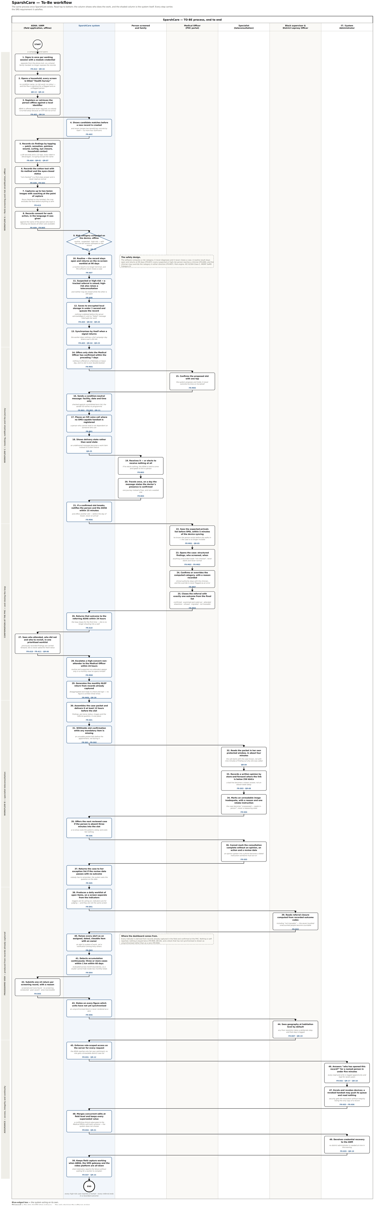
Figure T1 — the To-Be flow at a glance. The full-size diagram is delivered separately as a draw.io file, a PDF and three readable image sections; the step register in section 2 carries the same content as text.

