WEEK 3
Trend Analysis and Insights Generation
Marketing Campaign Performance Analysis
Complete analytical report using the real cleaned marketing campaign dataset from Week 1.
Report item | Details
Dataset | Real cleaned marketing campaign dataset • 916 ad-level records
Main tools | Python, Pandas, NumPy, Matplotlib, SciPy
Supporting file | Excel workbook with analysis and calculation sheets
Visualizations | 12 analytical charts
Statistical analysis | Pearson, Spearman, Kruskal-Wallis, Mann-Whitney U
Outlier method | IQR screening
Currency | ₹85 = US$1 for consistent presentation
Critical limitation | No reliable date/reporting-period field

1. Executive Summary
This Week 3 report analyses 916 real cleaned marketing records to identify performance patterns, relationships and unusual observations. The dataset contains 173,170,166 impressions, 30,642 clicks, 2,685 total conversions and 884 approved conversions. Overall CTR is 0.018% and the approved conversion rate from clicks is 2.885%. The presentation CPA is ₹4,337 per approved conversion.
The analysis finds meaningful differences between campaign groups and audience segments. It also demonstrates that high conversion volume, high CTR and low CPA are not interchangeable measures. The recommendations therefore focus on balancing scale, engagement and acquisition efficiency.

2. Introduction and Task Alignment
The Week 3 task asks for in-depth trend analysis, seasonal patterns, correlations, statistical methods, visualizations and actionable recommendations. The analysis follows these requirements wherever the dataset supports them.
Task requirement | How this report addresses it | Why this approach was chosen
In-depth EDA | Campaign, age, gender, interest, KPI and outlier analysis. | Multiple dimensions reduce the risk of relying on one metric.
Trends over time | Data limitation documented; no artificial time series created. | A trend requires a real date/time field.
Seasonal patterns | Not calculated because no reliable time field exists. | Fabricating months or seasons would create unsupported findings.
Correlations | Pearson and Spearman tests included. | Two association measures provide complementary evidence.
Statistical methods | Kruskal-Wallis and Mann-Whitney U tests. | These are suitable non-parametric methods for skewed/discrete marketing data.
Visualizations | 12 charts with individual rationale and examples. | Each chart answers a specific marketing question.
Recommendations | Seven practical recommendations tied to findings. | Recommendations should follow evidence rather than generic marketing advice.
Reproducibility | CSV, Excel workbook, Python code and requirements file included. | An evaluator can inspect or rerun the analysis.

3. Dataset Used
The analysis uses the same real cleaned dataset produced for Week 1. This keeps the work consistent across the internship tasks and avoids introducing a different or simulated dataset.
Dataset characteristic | Value
Records | 916
Campaign groups | 916, 936, 1178
Main dimensions | Campaign, age, gender, interest
Core measures | Impressions, clicks, spend, total conversions, approved conversions
Derived measures | CTR, CPC, CPM, conversion rate, CPA
Date field | Not available as a reliable reporting-period field
Revenue/profit | Not available

3.1 Why this dataset was retained
Using the Week 1 cleaned dataset makes the analysis reproducible and demonstrates progression: Week 1 prepared reliable data, Week 2 visualized it, and Week 3 applies deeper analysis to the same data.

4. Data Preparation and Metric Logic
Before calculating insights, the dataset was checked for usable numeric fields and the derived metrics required for the analysis. The objective was not to perform another full cleaning exercise, but to build analysis-ready measures from the validated Week 1 output.
Step | What was done | Why it was necessary
Load | Read the cleaned CSV with Pandas. | Creates a reproducible starting point.
Currency conversion | Spent × 85 = Spend in INR. | Makes financial figures easier to interpret in the report.
CPA | Spend ÷ Approved conversions where approved conversions > 0. | Measures acquisition efficiency.
CTR | Clicks ÷ Impressions × 100. | Measures the proportion of impressions producing clicks.
Approved CVR | Approved conversions ÷ Clicks × 100. | Measures downstream conversion from clicks.
Aggregation | Grouped records by campaign and audience. | Makes segment-level comparison possible.
Outlier screening | IQR rule. | Provides a consistent way to flag unusual observations.

Important: the ₹85/USD rate is a fixed presentation conversion only. It is not used to claim historical currency conditions.

5. Exploratory Data Analysis

5.1 Overall KPI snapshot
KPI | Result | Why it matters
Impressions | 173,170,166 | Shows the scale of advertising exposure.
Clicks | 30,642 | Shows direct engagement with advertisements.
Spend | ₹3,834,067 | Shows total advertising investment in the report currency.
Total conversions | 2,685 | Shows all recorded conversion events.
Approved conversions | 884 | Focuses on the conversion outcome used for CPA.
CTR | 0.018% | Measures click engagement relative to impressions.
Approved CVR from clicks | 2.885% | Shows how clicks translate into approved conversions.
CPA | ₹4,337 | Connects spend directly to approved conversions.

5.2 Campaign volume
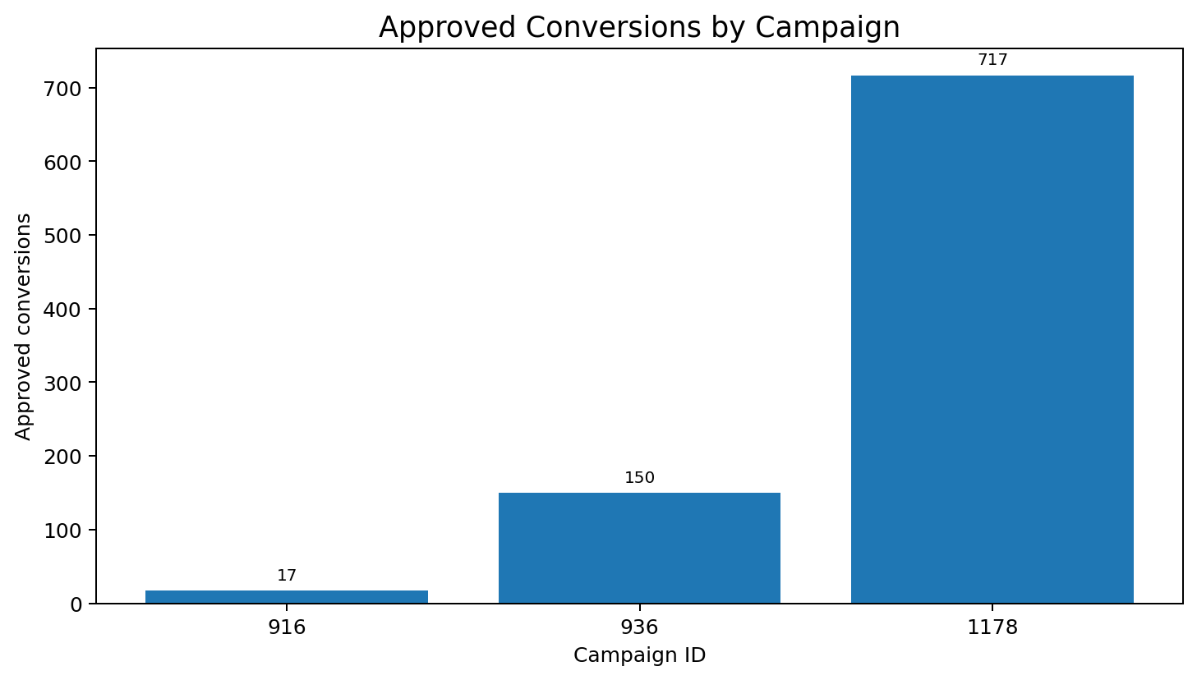
Figure 1. Why this chart was selected: a bar chart is appropriate for comparing discrete campaign categories. It answers: “Where is approved-conversion volume concentrated?” Example: a campaign manager can immediately see which campaign contributes the largest conversion volume.
What the graph shows: This graph compares the number of approved conversions generated by each campaign. The horizontal axis represents the campaign ID, while the vertical axis represents approved conversions.
What we can understand: The graph makes the difference in conversion volume easy to see. Campaign 1178 has the largest approved-conversion volume, while the other campaign groups operate at a smaller scale.
Why this matters: Conversion volume tells us how much output a campaign generated, but it does not tell us whether that output was inexpensive. A larger campaign can naturally generate more conversions simply because it receives more exposure and spending.
Example of use: For example, if a marketing manager is deciding which campaign needs a deeper review, this graph identifies the campaigns contributing most to the final conversion count. The manager should then compare those campaigns with CPA and conversion rate before making a budget decision.
Observed finding: Campaign 1178 has the highest approved-conversion volume. This indicates scale, but it should not be interpreted as proof of superior efficiency because campaign size and spend also affect volume.

5.3 Campaign efficiency
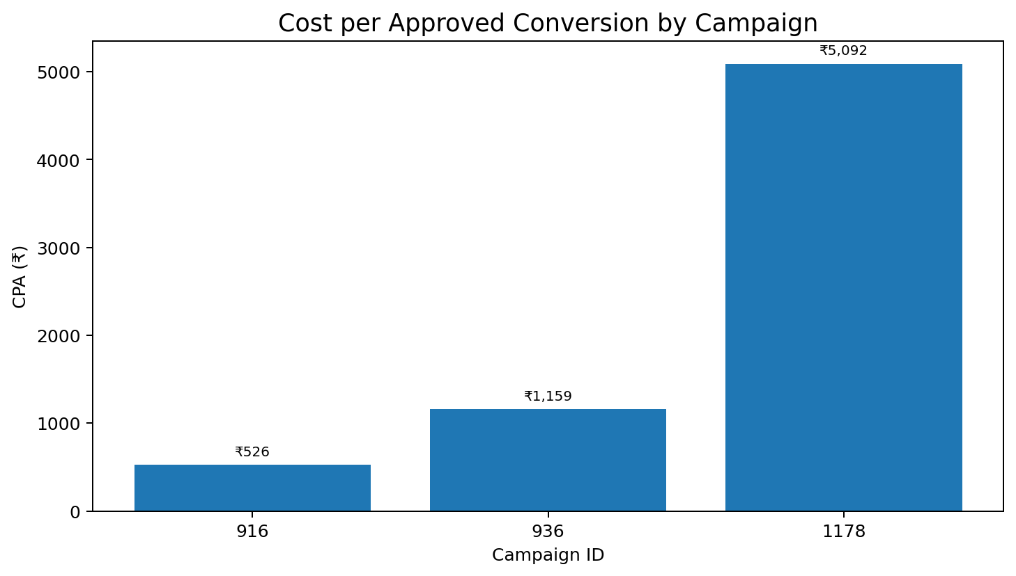
Figure 2. Why this chart was selected: CPA is a direct efficiency measure and a bar chart makes campaign-to-campaign cost differences easy to compare. Example: a budget review can use this view alongside conversion volume.
What the graph shows: This graph compares the cost required to generate one approved conversion in each campaign. A lower bar represents a lower observed cost per approved conversion.
What we can understand: Campaign 916 has the lowest aggregate CPA in the dataset, while Campaign 1178 has the highest aggregate CPA among the three campaign groups.
Why this matters: This graph adds the efficiency dimension that the previous conversion-volume graph cannot provide. A campaign can generate many conversions but still require considerably more advertising spend for each approved conversion.
Example of use: For example, before increasing the budget of a high-volume campaign, a marketing team could use this graph to check whether its acquisition cost is also reasonable. It can also compare the lower-CPA campaign to understand what audience, creative or placement characteristics may be worth investigating.
Observed finding: Campaign 916 has the lowest aggregate CPA at approximately ₹526; Campaign 1178 has the highest at approximately ₹5,092. This is why the report does not rank campaigns using conversion count alone.

5.4 Campaign engagement
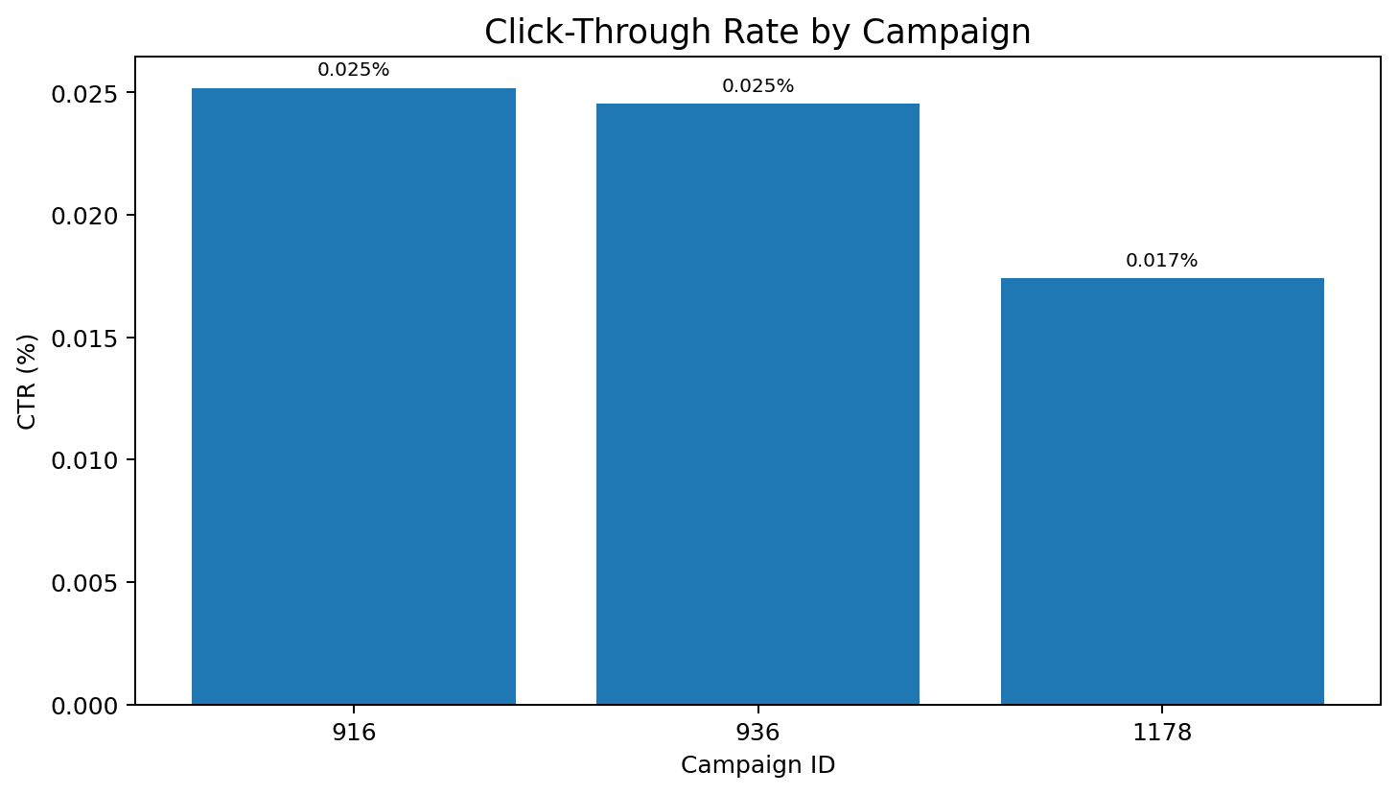
Figure 3. Why this chart was selected: CTR is an intermediate engagement measure, and the campaign categories can be compared directly. Example: a creative team can use it to identify campaigns that attract relatively more clicks.
What the graph shows: This graph compares Click-Through Rate (CTR) across the campaign groups. CTR represents the percentage of impressions that resulted in clicks.
What we can understand: The chart shows that campaigns do not generate exactly the same level of click engagement. This helps identify differences in how effectively advertisements attract initial user attention.
Why this matters: CTR is an important early-stage marketing metric, but it is not the final conversion outcome. A campaign can receive many clicks without generating an equally strong number of approved conversions.
Example of use: For example, if one campaign has a noticeably stronger CTR, the creative team could examine its advertisement wording, visual design or targeting. However, the team should then check approved conversion rate and CPA before concluding that the campaign is actually more successful.
CTR answers a different question from CPA: it measures whether people click, not whether those clicks become approved conversions.

5.5 Post-click conversion efficiency
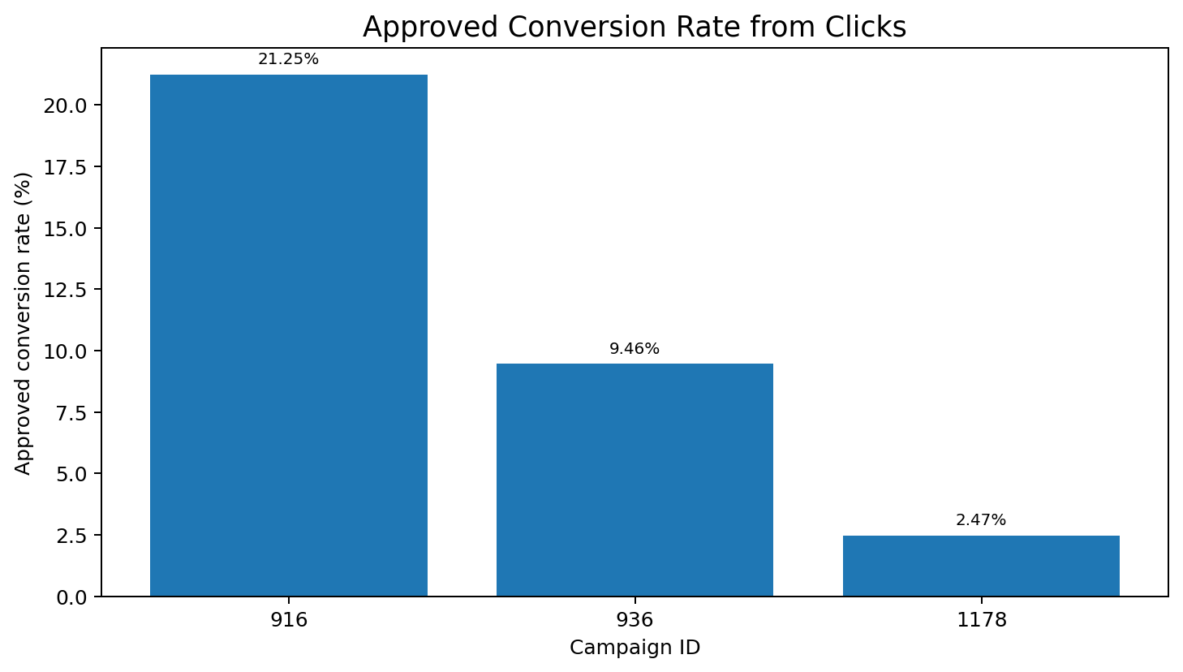
Figure 4. Why this chart was selected: approved conversion rate from clicks connects engagement with the downstream outcome. Example: a campaign with good CTR but weak approved CVR may need a post-click or audience-intent investigation.
What the graph shows: This graph measures the percentage of clicks that resulted in approved conversions for each campaign. It therefore examines what happens after the user has already clicked the advertisement.
What we can understand: The graph helps distinguish campaigns that are good at generating clicks from campaigns whose clicks are more likely to become approved conversions.
Why this matters: Looking only at CTR can hide problems after the click. A campaign may attract attention successfully but have weaker audience intent, landing-page relevance or conversion performance.
Example of use: For example, if a campaign has a high CTR but a relatively weak approved conversion rate, the marketing team could investigate the landing page, offer, audience quality or conversion journey instead of simply trying to increase CTR further.
This metric prevents the analysis from stopping at the click stage. It is especially useful when two campaigns have similar CTR but different conversion outcomes.

5.6 Spend versus conversion scale
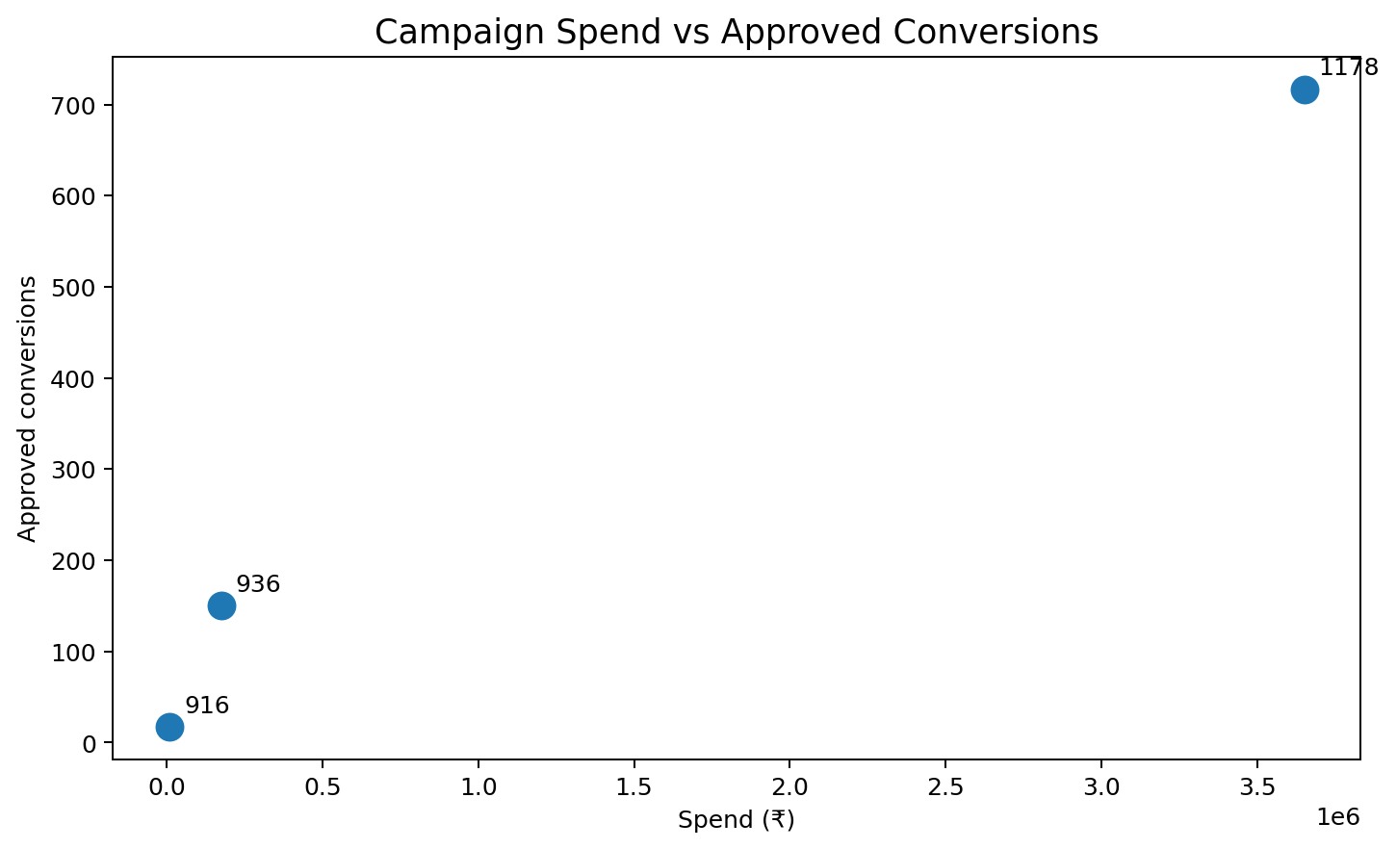
Figure 5. Why this chart was selected: a scatter plot is suitable for examining the relationship between two numeric campaign-level measures. Example: it helps distinguish increased conversion volume caused by scale from efficiency measured by CPA.
What the graph shows: This scatter plot places campaign spending on one axis and approved conversions on the other. Each point represents a campaign.
What we can understand: The campaigns with greater spending also tend to have greater conversion volume in this dataset. This is consistent with the fact that more investment generally creates more opportunities for impressions, clicks and conversions.
Why this matters: The graph helps separate scale from efficiency. Higher conversion volume does not automatically mean better performance because the campaign may also have required substantially more spending.
Example of use: For example, two campaigns can be compared by asking both questions: 'How many approved conversions did it produce?' and 'How much did each approved conversion cost?' The first question is answered by conversion volume, while the second is answered by CPA.
The campaign-level relationship shows that larger investment is associated with larger conversion volume in these records. That does not mean every additional rupee will generate the same number of conversions, so CPA remains necessary.

6. Audience Analysis

6.1 Age and approved conversions
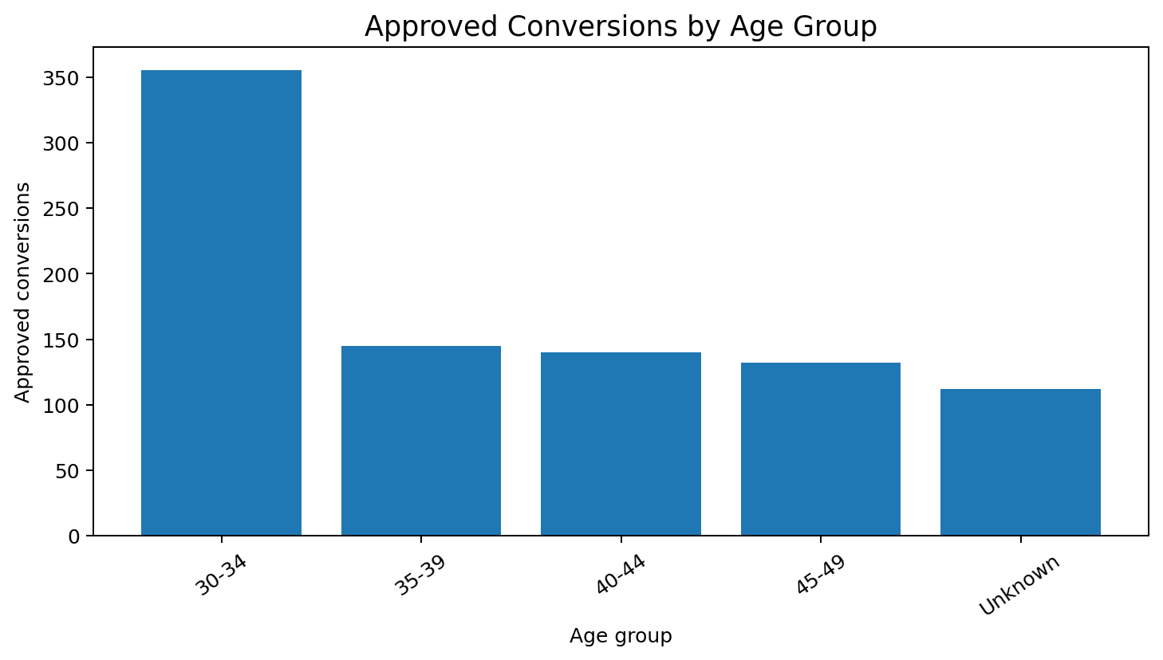
Figure 6. Why this chart was selected: age is a categorical audience segment, so a bar chart provides a simple comparison. Example: marketers can use the result to decide which age groups deserve controlled creative or offer tests.
The 30–34 segment is an important high-volume group in the dataset. This is descriptive evidence only; it does not show that age itself causes conversion performance because spend, campaign mix and exposure also matter.

6.2 Age and CTR
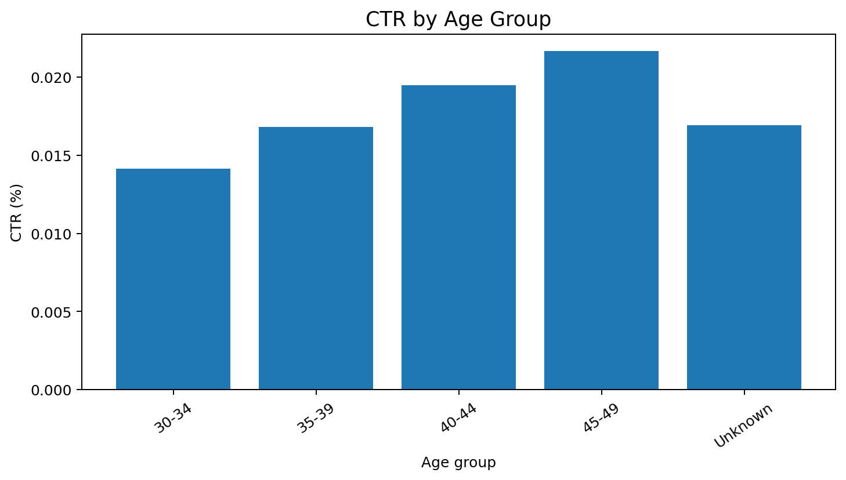
Figure 7. Why this chart was selected: it checks whether engagement varies across age segments. Example: different creative messages can be tested where CTR differs meaningfully.
Comparing age-level conversion volume and CTR together is more informative than using either metric alone: a segment can receive many conversions because of high exposure, while another can show stronger engagement relative to impressions.

6.3 Gender and CPA
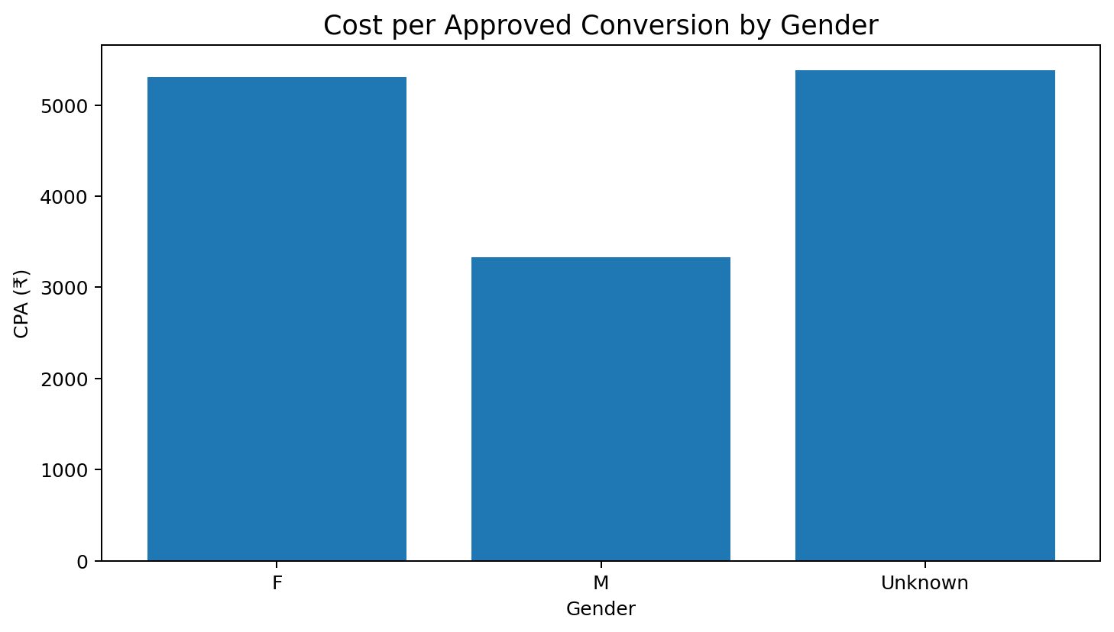
Figure 8. Why this chart was selected: CPA provides an efficiency comparison across demographic categories. Example: the marketing team can investigate whether creative, targeting or campaign mix differs between groups.
Male records have a lower observed aggregate CPA than female records. The Unknown group is kept separate because missing/unknown demographic information should not be treated as a meaningful demographic segment. The result is observational, not causal.

6.4 Interest targeting
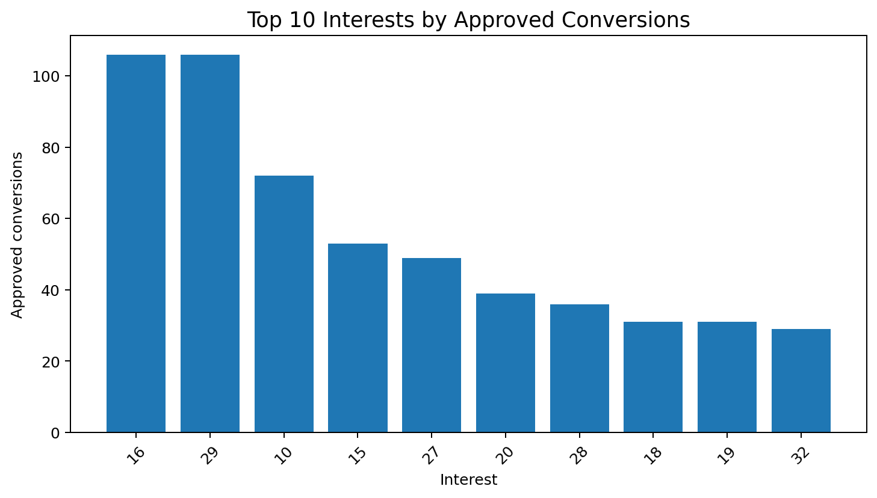
Figure 9. Why this chart was selected: interests are targeting categories, and a top-10 chart keeps the view readable. Example: high-volume interests can be selected for deeper ad-level and CPA investigation.
Interest-level results should be used as a screening tool rather than an automatic budget-allocation rule because conversion volume depends on both audience size and spend.

7. Statistical Analysis
Statistical testing was added because the Week 3 instructions specifically ask for statistical methods where applicable. The tests support the descriptive analysis but do not turn observational marketing data into causal evidence.
Test | Result | Why this test was used | Interpretation
Kruskal-Wallis | H=83.741, p=6.546e-19 | Compares three campaign distributions without assuming normality. | The campaign groups show statistically detectable differences in ad-level approved-conversion distributions.
Mann-Whitney U | U=19545, p=0.005282 | Compares two independent CPA distributions without assuming normality. | The observed male and female CPA distributions differ statistically in this dataset.

7.1 Correlation analysis
Metric pair | Pearson r | Pearson p | Spearman ρ | Why examined
Impressions ↔ Clicks | 0.951 | 0 | 0.973 | To determine whether the metrics move together and whether the relationship deserves further investigation.
Clicks ↔ Approved_Conversion | 0.604 | 4.32e-92 | 0.403 | To determine whether the metrics move together and whether the relationship deserves further investigation.
Spent ↔ Approved_Conversion | 0.631 | 8.2e-103 | 0.406 | To determine whether the metrics move together and whether the relationship deserves further investigation.
Spent ↔ Clicks | 0.965 | 0 | 0.970 | To determine whether the metrics move together and whether the relationship deserves further investigation.
CTR (%) ↔ Approved_Conversion | -0.006 | 0.866 | 0.001 | To determine whether the metrics move together and whether the relationship deserves further investigation.
Conversion Rate (%) ↔ Approved_Conversion | -0.133 | 0.000251 | -0.072 | To determine whether the metrics move together and whether the relationship deserves further investigation.

Why both Pearson and Spearman? Pearson is useful for linear association, while Spearman uses ranks and is less dependent on normality. Agreement between the two provides a useful consistency check, but neither establishes causation.

8. Correlation Visualization
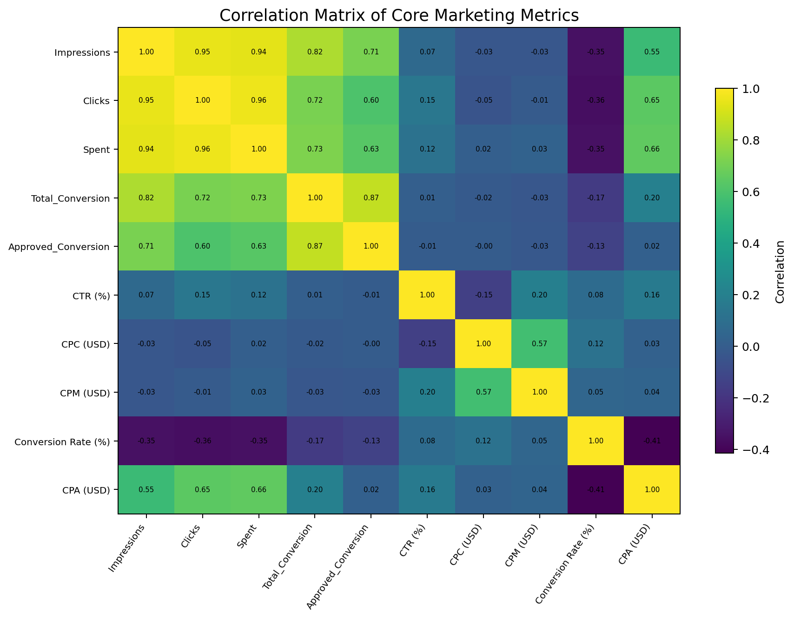
Figure 10. Why this chart was selected: a correlation matrix compresses many numeric relationships into one visual summary. Example: an analyst can use it to identify metric pairs that deserve a focused investigation.
Strong relationships between scale metrics such as impressions, clicks and spend should be interpreted carefully because larger campaigns naturally generate more opportunities for activity. Correlation is therefore a screening tool, not a direct optimization rule.

9. Outlier and Anomaly Analysis
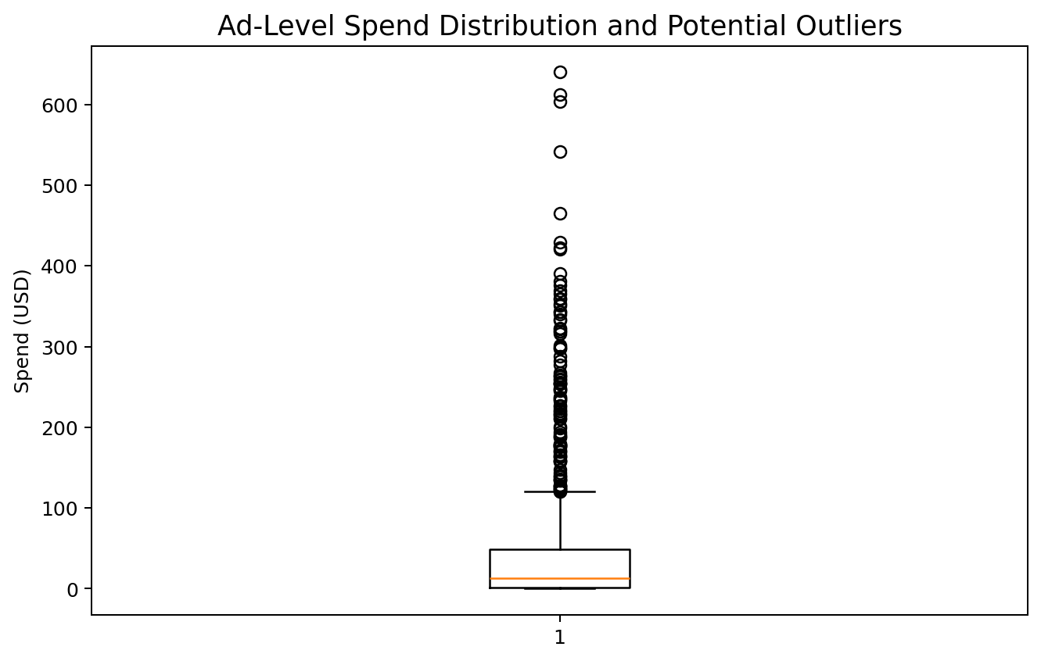
Figure 11. Why this chart was selected: a boxplot summarizes the distribution and highlights unusually high observations without letting a few extreme values dominate the entire chart.
The IQR rule produces an upper spend threshold of approximately $120.48, with 110 records above that threshold. The approved-conversion threshold is 2.50, with 81 records above it.
Why investigate instead of delete? An unusual record may be a real high-budget/high-performing ad, a tracking issue or an unusual audience response. Removing it automatically could hide important business information.
Example: if an ad has unusually high spend and unusually high approved conversions, the observation may represent deliberate scaling. If it has high spend but weak approved conversions, it should be reviewed for targeting, creative relevance and conversion-path problems.

10. CTR versus CPA
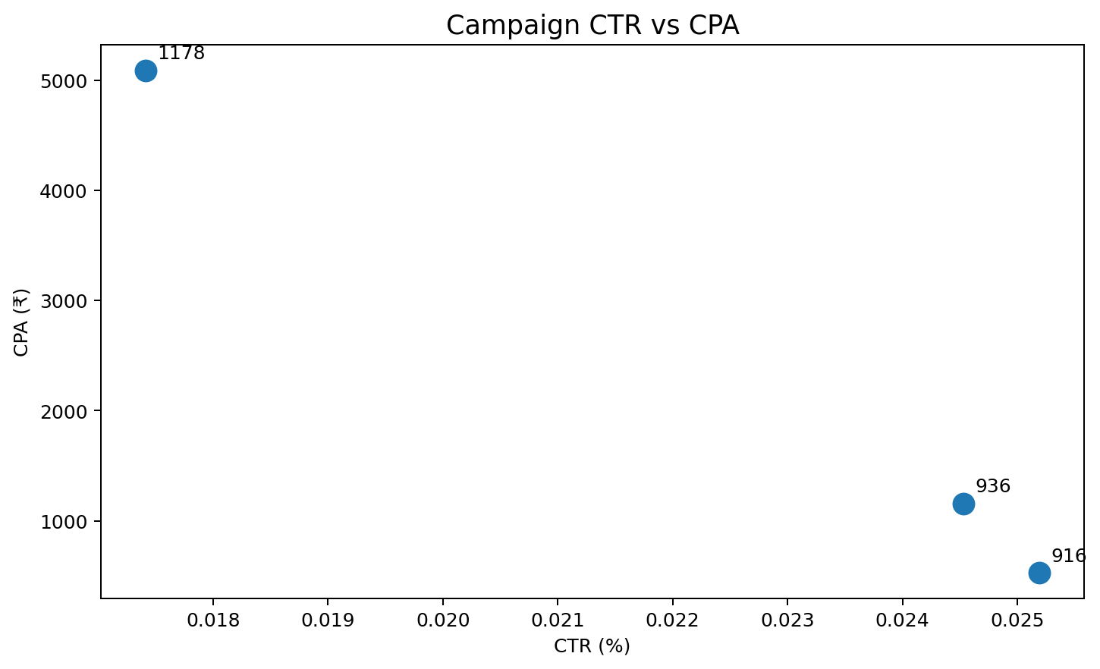
Figure 12. Why this chart was selected: the scatter plot compares an engagement metric with an efficiency metric. Example: it helps identify campaigns where strong click engagement does not necessarily produce low acquisition cost.
This comparison is important because CTR is not the final marketing outcome. A campaign can attract clicks successfully but still produce expensive approved conversions. The correct response is to inspect the full funnel rather than optimize CTR in isolation.

11. Key Insights
- Campaign 1178 is the largest scale campaign by ad count and approved-conversion volume, but its higher CPA shows that scale and efficiency are different dimensions.
- Campaign 916 has the lowest aggregate CPA in the dataset, making it useful as a case for deeper investigation into audience, creative and conversion-path characteristics.
- The 30–34 age group is a major approved-conversion segment, but exposure and campaign mix must be considered before making targeting decisions.
- Observed gender-level CPA differs, and the statistical test supports a distributional difference; however, this should not be interpreted as a causal gender effect.
- CTR and approved conversion rate answer different questions. High engagement does not automatically mean efficient acquisition.
- Spend and conversion volume are associated at campaign level, but higher spend partly reflects campaign scale; CPA is required to judge efficiency.
- Outliers should be investigated rather than automatically removed because extreme records may represent genuine business events.
- A reliable date field is the most important missing element for future true trend and seasonality analysis.

12. Actionable Marketing Recommendations
1. Review campaign scale and efficiency separately.
Why: conversion volume alone rewards large campaigns. Use approved conversions to assess scale and CPA to assess acquisition efficiency.
2. Investigate Campaign 916 for transferable practices.
Why: its lower observed CPA makes it useful for a structured comparison of audience, creative, placement and conversion-path characteristics.
3. Audit expensive parts of Campaign 1178.
Why: the campaign produces substantial conversion volume but has a higher CPA. Ad-level analysis can identify whether a small group of expensive ads is driving the difference.
4. Run controlled age-based creative tests.
Why: the 30–34 segment contributes substantial conversion volume. Testing tailored messaging can determine whether the pattern is repeatable rather than assuming it is causal.
5. Optimize for downstream conversion, not clicks alone.
Why: CTR is only an intermediate stage. Review CTR together with approved conversion rate and CPA.
6. Investigate high-value outliers before excluding them.
Why: an outlier can be a real successful campaign event or a data-quality problem. Both cases require investigation rather than automatic deletion.
7. Add campaign date and reporting-period fields.
Why: this is required to measure weekly/monthly trends, seasonality, launch effects and performance changes over time.
8. Add revenue/profit fields in future datasets.
Why: ROI and ROAS cannot be calculated from spend and conversions alone. Revenue or profit is required for financial return analysis.

13. Limitations and Responsible Interpretation
- No reliable date/reporting-period field is available, so genuine time-series and seasonal analysis cannot be performed.
- Revenue and profit are unavailable, so ROI/ROAS are intentionally not calculated.
- The dataset is public and may not represent a current company-specific advertising environment.
- Correlation measures association and does not prove causation.
- Unknown demographic values reduce precision in audience comparisons.
- CPA is calculated only where approved conversions are greater than zero.
- The fixed ₹85/USD conversion is for presentation consistency and is not historical FX data.
- Statistical significance does not automatically mean a difference is large or commercially important.

14. Reproducibility and Submission Files
Every major result in this report is supported by a file in the submission package. The spreadsheet provides the calculation tables, the Python script provides the reproducible workflow, the CSV is the actual source dataset and the visualization folder contains the figures used in the report.
File | What it contains | Why it is included
Week_3_Trend_Analysis_and_Insights_Report.docx | Complete written analysis | Primary report submission.
Week_3_Trend_Analysis_Supporting_Analysis.xlsx | Data, calculations, tests, methodology and chart register | Allows the evaluator to inspect supporting calculations.
week3_trend_analysis.py | Reproducible Python workflow | Demonstrates the analytical process.
cleaned_marketing_campaign_data.csv | Real Week 1 cleaned dataset | Provides the source data used for the analysis.
visualizations/*.png | 12 charts | Provides the visual evidence used in the report.
requirements.txt | Python dependencies | Makes the code environment easier to reproduce.
README.md | Package guide and interpretation rules | Explains how the files connect.

15. Final Conclusion
The Week 3 analysis demonstrates that meaningful marketing insight requires more than plotting numbers. Campaign scale, engagement, conversion efficiency, audience segmentation and statistical evidence provide different pieces of the performance story. The analysis identifies clear areas for investigation while avoiding unsupported causal claims.
The most important next improvement is to capture reliable dates and reporting periods in future campaign exports. With that field, the same analytical workflow can be extended to genuine weekly and monthly trend analysis, seasonal patterns, campaign launch effects and performance changes over time.

Appendix A. Statistical Methods – Simple Explanation
Method | Simple explanation | Why used here
Pearson correlation | Measures the strength/direction of a linear relationship. | To examine numeric marketing metric relationships.
Spearman correlation | Measures a ranked/monotonic relationship. | Useful when distributions may be skewed.
Kruskal-Wallis | Tests whether 3+ groups differ in their distributions. | Campaigns contain discrete/skewed conversion counts.
Mann-Whitney U | Tests whether two independent groups differ in their distributions. | Used for male vs female CPA.
IQR | Uses the middle 50% of values to flag unusually high/low observations. | Robust screening for ad-level anomalies.

Appendix B. Example Business Questions Answered
Business question | Analysis used | Why it helps
Which campaign produces the most approved conversions? | Campaign conversion bar chart | Shows scale.
Which campaign has the lowest CPA? | Campaign CPA chart | Shows efficiency.
Does more spend correspond to more conversions? | Spend vs conversion scatter | Shows scale relationship.
Do clicks become approved conversions? | Approved CVR analysis | Examines downstream funnel efficiency.
Which age groups generate more conversions? | Age conversion chart | Supports audience investigation.
Does engagement differ by age? | Age CTR chart | Supports creative testing.
Does observed CPA differ by gender? | Gender CPA + Mann-Whitney | Combines descriptive and statistical evidence.
Are some ads unusually expensive? | IQR + boxplot | Highlights records requiring review.
Is high CTR always efficient? | CTR vs CPA scatter | Prevents optimizing a single intermediate KPI.

