Fashion Retail Analytics
Reporting, Evaluation and Presentation of Data Insights

Week 6 Final Report | Junior Data Science Analyst, Apparel and Fashion
Author: [Your Name]
Date: October 2026
Repository: github.com/[your-username]/fashion-retail-analytics
Data note: the figures in this report come from a simulated weekly sales dataset of 4,992 cleaned records (6 product categories, 4 regions, 2 channels, 104 weeks), generated by the accompanying code so every number is reproducible.
Report contents
1. Executive Summary
2. Business Context and Objectives
3. Integrated Analytics Workflow (Weeks 1 to 5)
4. Key Findings and Data Storytelling
5. Predictive Modelling Approach
6. Evaluation of Models and Techniques
7. Strategy for Presenting the Insights
8. Strategic Recommendations
9. Recommendations for Further Improvement
10. Roadmap for Future Analytics Initiatives
11. Conclusion
Appendix: Reproducibility

1. Executive Summary
This report brings together the full analytics workflow completed over the previous weeks (data understanding, cleaning, exploratory analysis, predictive modelling and optimisation) into one evaluated, decision-oriented story for an apparel retailer. The business questions were: what drives sales, how reliably can demand be forecast, and where is margin being lost?
Headline findings:
- Revenue is concentrated. Outerwear, Denim and Dresses generate 27.6%, 21.3% and 20.1% of $13.03M total revenue, about two thirds of the business combined.
- Demand is strongly seasonal and promotion-sensitive. Moving from no discount to a 30% discount lifts average units sold by roughly 59%, but return rates climb from 12.7% to 15.29%.
- Returns are a material leak. 14.0% of units are returned, cutting $13.03M gross revenue to $11.19M net. Online returns run at 17.2% versus 10.3% in stores, and Dresses are the worst category at 18.1%.
- Forecasting works, with caveats. A Random Forest model explains 80.7% of the variance in unseen weeks (baseline: negative R-squared) and forecasts total weekly units within 8.4% error.
Recommended actions: use the forecast to plan seasonal inventory, replace blanket deep discounts with targeted promotions, and run a returns-reduction programme focused on online Dresses. Section 8 details each action.

2. Business Context and Objectives
Fashion retail combines short product life cycles, strong seasonality, trend-driven demand and high return rates, especially online. Over-ordering leads to markdowns and waste; under-ordering loses sales at the point of peak demand. A junior data science analyst supports these decisions by turning raw transactional data into clear, trustworthy and actionable evidence.
The objectives of this final task are to:
- integrate the earlier weekly analyses into one coherent narrative;
- evaluate the accuracy and reliability of the models and techniques used;
- propose how to present the insights to different audiences; and
- recommend strategic steps for future analytics work in fashion.

3. Integrated Analytics Workflow (Weeks 1 to 5)
Each earlier stage feeds the next, so conclusions at the end of the workflow rest on a documented chain of decisions.
Stage | What was done | How it fed the next stage
Data understanding | Defined the grain (week x category x region x channel) and variables: price, discount, marketing spend, holiday flag, units sold, returns. | Fixed the unit of analysis and the target variables.
Data cleaning | Removed 60 duplicate rows, standardised region labels, imputed 90 missing marketing values with the category-channel median. | Produced a trustworthy table of 4,992 rows for analysis.
Exploratory analysis and visualisation | Profiled revenue mix, seasonality, discount and channel effects. | Revealed which features matter, shaping model inputs.
Predictive modelling | Forecast units sold with regression models against a baseline. | Quantified demand drivers and forecast accuracy.
Returns and optimisation | Classified high return-risk rows and costed returns. | Linked demand to profitability and drove the recommendations.

Pipeline: raw data, cleaning, feature engineering, models, evaluation, recommendations. All steps are in src/analysis.py.

4. Key Findings and Data Storytelling

4.1 Revenue is concentrated in three categories
Outerwear (27.6%), Denim (21.3%) and Dresses (20.1%) dominate revenue, while Accessories contribute only 5.3%. Because of their weight, forecast errors in these categories matter most to cash flow and inventory risk.
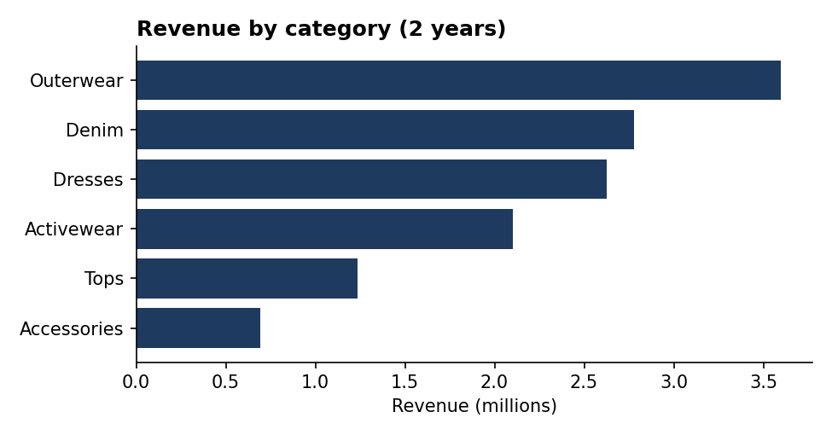
Figure 1. Revenue by category over two years

4.2 Seasonality is the backbone of demand
Outerwear, Denim and Tops peak in month 11 (November, driven by cold weather and holiday promotions), Dresses peak in month 7 (July) and Activewear in month 1 (January, the new-year fitness effect). Buying and marketing calendars should follow these category-specific curves rather than a single company-wide season.
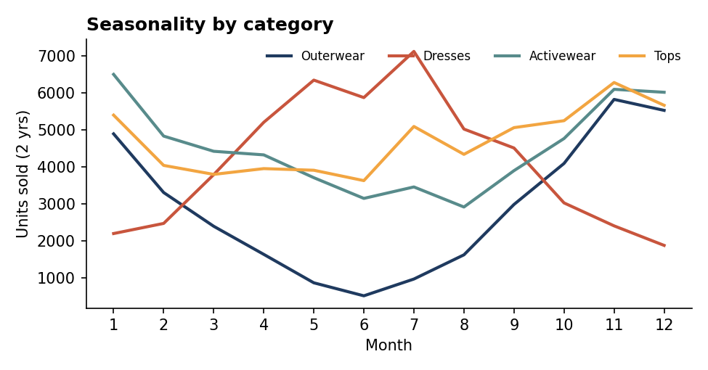
Figure 2. Monthly units sold by category

4.3 Discounts lift volume but erode quality of sales
Discount | Avg units per record | Return rate
0% | 45.9 | 12.7%
10% | 53.2 | 12.86%
20% | 68.9 | 14.16%
30% | 72.8 | 15.29%

Deeper discounts sell more units, but returns rise at the same time (12.7% to 15.29%). Because the dataset has no cost data, true margin impact cannot be confirmed; this is flagged as a data gap in Section 9.
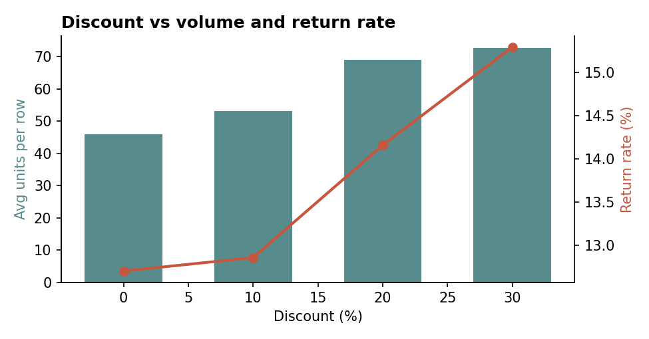
Figure 3. Average units sold and return rate by discount level

4.4 Online is bigger, but returns more
Online generates $7.13M (55% of revenue) against $5.90M in stores, but its return rate is 17.2% compared with 10.3%. Dresses are the most-returned category at 18.1%, consistent with fit and sizing uncertainty when buying online.

5. Predictive Modelling Approach
The target was weekly units sold per category, region and channel. Features were list price, discount, marketing spend, holiday-week flag, month, week of year and one-hot encoded category, region and channel. To mimic real forecasting, the data was split by time: the first 80 weeks (3,840 rows) trained the models and the final 24 weeks (1,152 rows) were held out for testing. Random shuffling was deliberately avoided because it leaks future information into training.
Four models were compared: a mean-prediction baseline, Linear Regression, Random Forest and Gradient Boosting.
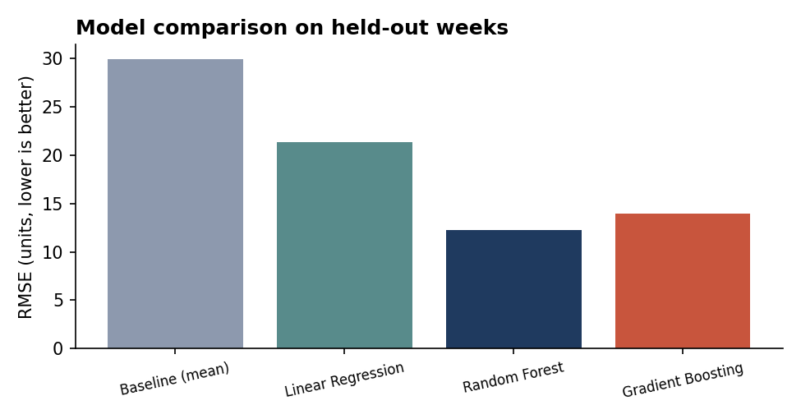
Figure 4. Test RMSE by model (lower is better)
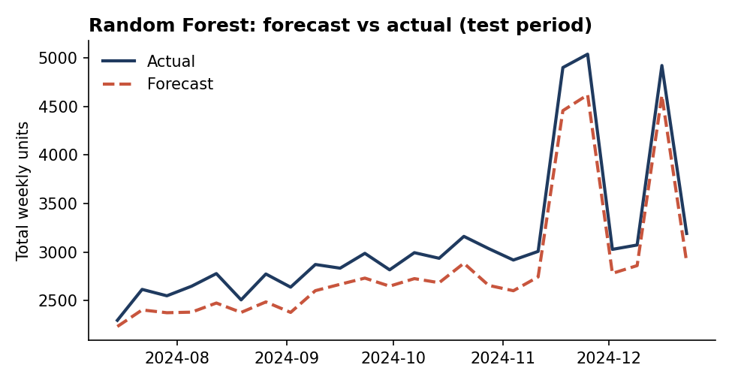
Figure 5. Random Forest forecast against actual weekly units in the test period
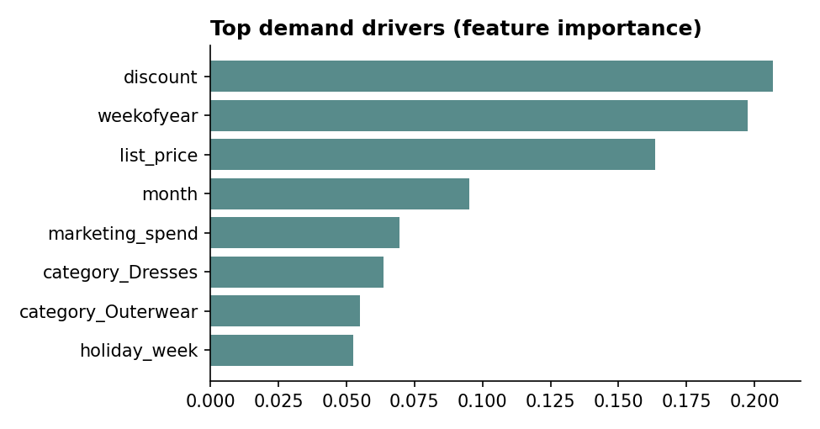
Figure 6. Top demand drivers by feature importance
The most influential drivers were discount, weekofyear, list price, confirming that promotions, timing in the season and price point shape demand. Feature importance describes association in the model, not causation.

6. Evaluation of Models and Techniques

6.1 Evaluation methodology
- Hold-out test by time. Models are scored only on weeks they never saw during training.
- Baseline comparison. Every model must beat a naive mean predictor; otherwise the added complexity has no value.
- Regression metrics. MAE (average error in units), RMSE (penalises large misses), R-squared (share of variance explained) and WAPE (error as a percentage of total units, easy for business readers).
- Time-series cross-validation. Five expanding-window folds test stability as more history becomes available.
- Classification metrics. Accuracy, precision, recall, F1, ROC-AUC and a confusion matrix for the return-risk model.

6.2 Demand forecasting results
Model | MAE | RMSE | R-squared | WAPE
Baseline (mean) | 22.19 | 29.98 | -0.16 | 34.3%
Linear Regression | 16.70 | 21.36 | 0.41 | 25.8%
Random Forest | 9.33 | 12.24 | 0.81 | 14.4%
Gradient Boosting | 10.90 | 13.92 | 0.75 | 16.8%

Random Forest was the best performer with MAE 9.3 units, RMSE 12.2 and R-squared 0.81, against a baseline R-squared of -0.16. Linear Regression only reaches 0.41 because demand depends non-linearly on season, price and promotion. At the record level the error is 14.4%; once aggregated to total weekly units it drops to 8.4%, because individual errors partly cancel out. Planners should therefore trust the forecast most at aggregate level. Figure 5 also shows the forecast sitting slightly below actual sales during peak weeks, so the model tends to under-predict spikes and safety stock should be added for peak periods.

6.3 Cross-validation and reliability
Expanding-window cross-validation gave R-squared values of 0.47, -0.49, 0.68, 0.84, 0.80 (mean 0.46, standard deviation 0.49). Performance is weak on early folds, which have not yet seen a full seasonal cycle (the second fold is negative), and strong once at least a year of history is available. This is an important honest finding: the model needs about 12 or more months of history to be reliable, and new categories or launches should not be forecast with it until that history exists.

6.4 Return-risk classification
Model | Accuracy | Precision | Recall | F1 | ROC-AUC
Baseline (majority) | 49.0% | 0.0% | 0.0% | 0.0% | 0.50
Logistic Regression | 73.4% | 71.9% | 78.7% | 75.1% | 0.81
Random Forest | 74.7% | 74.0% | 77.7% | 75.8% | 0.79

The Random Forest classifier reached F1 0.76 and ROC-AUC 0.79 versus a majority-class baseline that never flags a high-return record (F1 0). Of the held-out records, 456 high-return records were correctly caught, 131 were missed, and 160 were flagged unnecessarily. Because the cost of a missed high-return product is usually higher than a needless review, recall deserves priority over precision when setting the alert threshold.
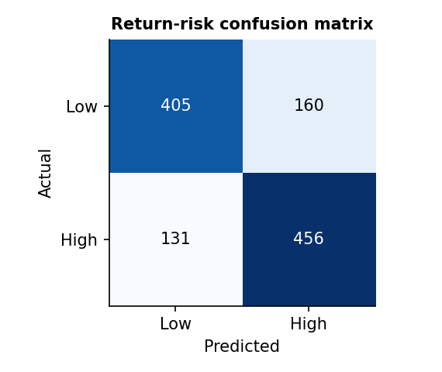
Figure 7. Confusion matrix for the return-risk classifier

6.5 Limitations
- The data is simulated, so real-world noise (stock-outs, competitor moves, weather, social trends) is absent and real accuracy will likely be lower.
- No cost or margin data, so profitability conclusions about discounting are indirect.
- Feature importance and discount effects show association, not proven causation; a controlled promotion test would be needed.
- The model under-predicts peak weeks, and only one train/test split and limited hyperparameter tuning were used.

7. Strategy for Presenting the Insights
Good analysis only creates value if decision makers understand and act on it. The presentation approach below is built around the audience, a clear story and disciplined visuals.

7.1 Know the audience
Audience | What they need | Format
Executives and merchandising heads | The decision, the size of the prize and the risk, in under five minutes. | 3 to 5 slide summary with one headline chart per slide.
Planners and category managers | Forecasts by category and season, and how reliable they are. | Dashboard with filters plus a short methodology note.
Marketing and e-commerce teams | Which promotions and channels to change. | Visual comparison charts and a simple action list.
Technical reviewers | Method, metrics and limitations. | This report and the GitHub repository.

7.2 Storytelling structure
- Situation: what the business is trying to achieve (growth with healthy margin).
- Insight: one clear finding per slide, stated as the slide title (for example: online returns are 7 points higher than store returns).
- Evidence: a single chart that proves the title, with the key number annotated.
- Implication and action: what to do, who owns it and the expected impact.
- Caveat: one honest line on certainty so trust is not lost later.

7.3 Visual design principles
- Use the simplest chart for the question: bars for comparison, lines for trends over time, a table when exact values matter.
- Title each chart with the conclusion, not the topic; remove gridline clutter and unneeded colours.
- Use one accent colour to highlight the point and neutral tones for context; check legibility for colour-blind viewers.
- Show forecasts as actual versus predicted with a visible error range so uncertainty is not hidden.
- Keep wording short and free of jargon; define any metric (such as WAPE) in plain language on first use.

7.4 Suggested slide outline
- Slide 1: Business question and headline answer.
- Slide 2: Where revenue comes from (Figure 1).
- Slide 3: Seasonality calendar for buying and marketing (Figure 2).
- Slide 4: Discounts and returns trade-off (Figure 3).
- Slide 5: Forecast accuracy and reliability (Figures 4 and 5).
- Slide 6: Recommendations, owners and next steps.

8. Strategic Recommendations
# | Recommendation | Evidence | Expected benefit
1 | Plan inventory and marketing on category-specific seasonal curves, using the forecast at aggregate level. | Seasonality (Fig. 2); weekly WAPE 8.4% | Less overstock and fewer lost sales at peak.
2 | Replace blanket deep discounts with targeted, tested promotions (for example 10 to 20% on slow lines). | Units +59% at 30% off but returns up to 15.29% | Better margin quality per promotion.
3 | Launch a returns-reduction programme for online Dresses: size guides, fit reviews, better imagery. | Online 17.2% vs store 10.3%; Dresses 18.1% | Recover part of the $1.84M lost to returns.
4 | Use the return-risk model as an early-warning flag for new styles and promotions. | F1 0.76, ROC-AUC 0.79 | Earlier action on high-risk products.
5 | Protect the three core categories with the most accurate forecasting and safety stock. | 27.6%, 21.3%, 20.1% of revenue | Reduced revenue volatility.

9. Recommendations for Further Improvement

9.1 Data
- Add cost and margin data so promotions can be judged on profit, not just volume.
- Add customer-level data (purchase history, loyalty, size and fit) for segmentation and personalised returns prevention.
- Add external signals: weather, social media and search trends, competitor prices, events and economic indicators.
- Add stock-level data to separate low demand from stock-outs, which currently look identical.

9.2 Modelling
- Test dedicated time-series methods (SARIMA, Prophet) and gradient boosting libraries such as LightGBM, with lag and rolling-average features.
- Tune hyperparameters with time-aware cross-validation and report prediction intervals, not only point forecasts.
- Model new-product demand using attributes of similar past products (cold-start approach).
- Run controlled promotion experiments (A/B tests) to measure true discount effects.

9.3 Process
- Monitor model drift monthly and retrain when error rises above an agreed threshold.
- Document data definitions and keep the pipeline in version control for reproducibility.

10. Roadmap for Future Analytics Initiatives in Fashion
Horizon | Initiative | Success measure
0 to 3 months | Operationalise the weekly forecast and a returns dashboard; fix data gaps (cost, stock). | Forecast WAPE under 10% at aggregate level; dashboard adopted by planners.
3 to 6 months | Run promotion A/B tests; launch size and fit improvements for online Dresses. | Return rate reduction; margin per promotion.
6 to 12 months | Customer segmentation and personalised recommendations; trend detection from social data. | Conversion and repeat-purchase uplift.
12 months and beyond | Dynamic pricing, markdown optimisation and sustainability analytics (overproduction and returns waste). | Lower markdown spend and waste.

11. Conclusion
This project shows how a complete analytics workflow, from cleaning through modelling to evaluation, can be turned into clear business guidance. Revenue is concentrated in a few seasonal categories, promotions boost volume at the cost of higher returns, and online returns are the largest controllable leak. The Random Forest forecast is a strong planning tool at aggregate level but needs at least a year of history, and the findings should be validated on real data and through controlled experiments before major commitments. By pairing rigorous evaluation with honest communication of limits, a junior analyst can earn the trust that makes data-driven decisions stick.

Appendix: Reproducibility
All code, data and figures are in the GitHub repository. To reproduce the results:
- Install dependencies: pip install -r requirements.txt
- Generate the simulated data (optional): python src/generate_data.py
- Run the full pipeline: python src/analysis.py (writes figures and reports/metrics.json)
- Every number in this report is stored in reports/metrics.json.

