Scope of Work regarding Bird Feeder User Hybrid Android and iOS Application Design and Development:

To do list:

1. Hybrid Application Design & Development (1st phase work)
2. Seek/iNnaturalist API/Database integration - Client need to provide (1st phase work)–
   1. We have have integrate ebirdapi to get bird common name, scientific name, family scientific name, family common name,
3. Image Recognition (1st phase work) – dependent on image processing library
4. (At the mobile App – 1st Phase) User should be able to upload an image taken by the mobile phone and the app should be able to recognize the bird and tell all the details.
   1. We have created static api and given “thagul” species to all observation and completing the process
   2. on image processing library
5. (At the Feeder – 2nd Phase) Feeder camera will take high quality image of the bird up close as they eat their food which will be activated through motion sensors; once the picture is taken, feeder board will do run its own AI model and recognize the bird. Later the feeder will push the details to the mobile app for further classification and to add more details.
6. Bird Feeder device integration with the mobile application. (2nd phase work)

User Android and iOS Application:

Key Features:

1. User has to register/login (1st phase work) - Done

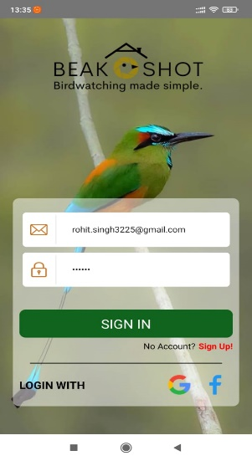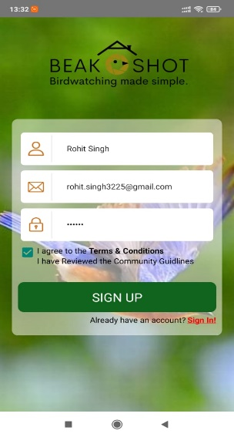

1. Also, user can do Social Media Login (1st phase work) [Primarily we will use google and Facebook]
   1. Please provide gmail and fb login details or app credentials
2. Profile Setting (1st phase work) – mainly to gather user preferences.done

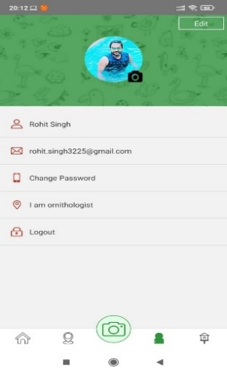

1. User can see nearby birds and their information via maps (1st phase work); [Ref: Seek App by iNaturalist focusing on birds] -- Done

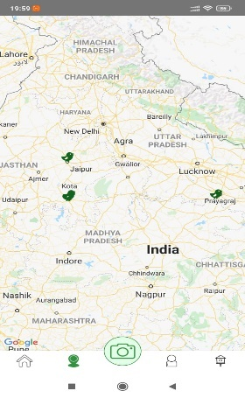

1. 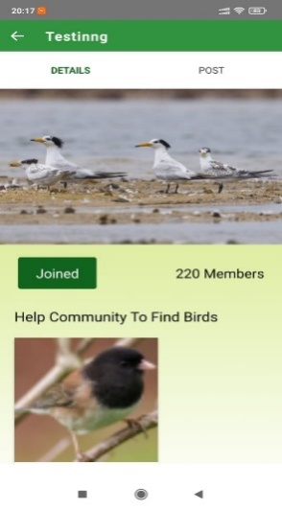User can join the local community of the bird watchers (1st phase work)–Done
2. Use can take picture via application (using phone camera i.e. camera button can activate phone camera) and can get details of the bird (1st phase work)
   1. We have integrated ebird api to get bird common name, scientific name, family scientific name, family common name but it is returning me a static data set for “thagul” species. If species name will return from bird recognition API it will return dynamic data.

1. Also user can see nearby birds which is being uploaded by the community people.(1st phase work) – Done

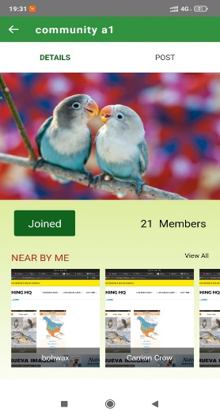

BELOW POINTS ARE COMPLETED BY US

1. 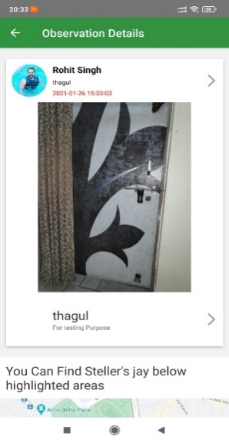User can create new observation and can see in recently uploaded by– Done
2. 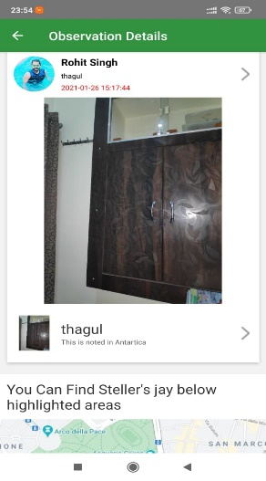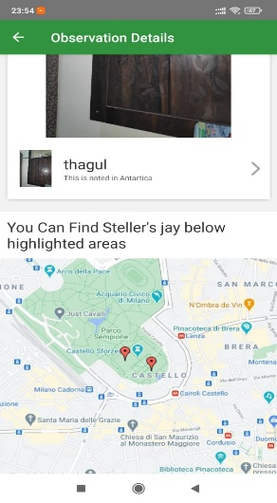User can see anyone observation details in recently uploaded by with highlighted areas on map– Done
3. 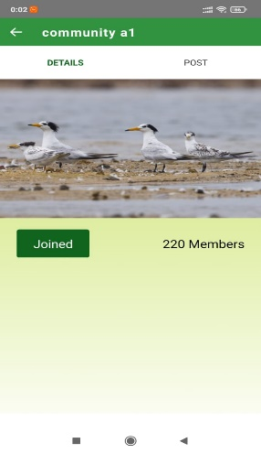User can create new community and can see in My Community– Done

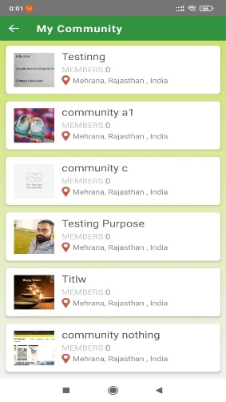

1. 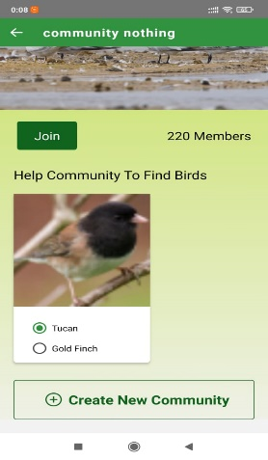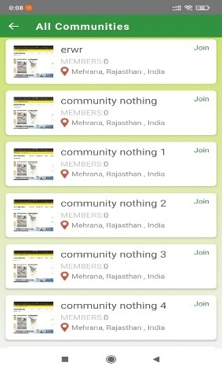User can see all communities and can join it, which will come in My Community– Done
2. 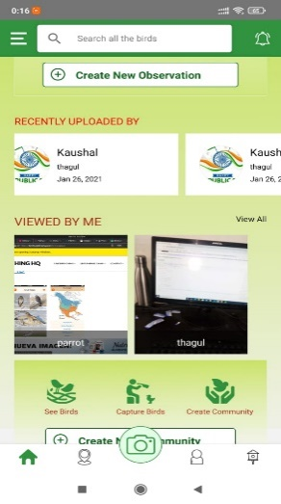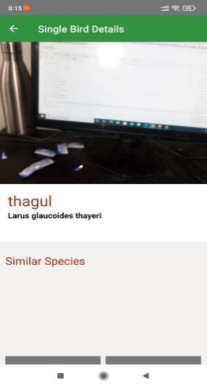Recently seen single bird list can be seen in ‘Viewed by me’ on home page– Done
3. 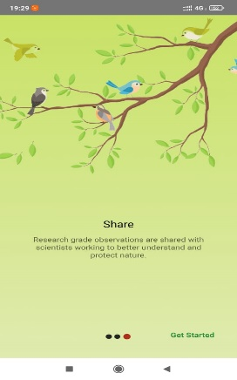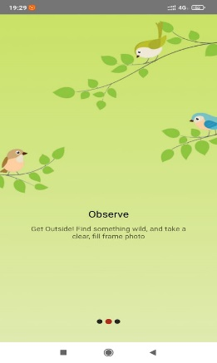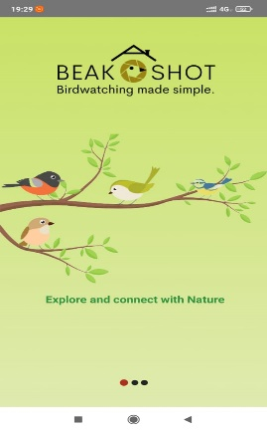Boarding Screen - Done
4. User will receive 3 updates on daily basis through bird feeder device.(2nd phase work)
5. Through this device user will receive notifications:(2nd phase work)  
   •Battery working condition  
   •SD card storage status  
   •Food availability   
   •How many birds visited in a single day and their photo with details  
   ⎫If user click on the birds' image, it will show(1st phase work) [Ref: Seek app & Audubon app]  
   •Bird name  
   •Scientific name of the bird  
   •Family  
   •Weight/Length  
   •Life span  
   •Food habit  
   •Nearby places where the birds has been spotted  
   •Wiki summary of the bird  
   ⎫Push Notification

Admin Panel

1. Sub-admins Management (Add/View/Update/Delete)

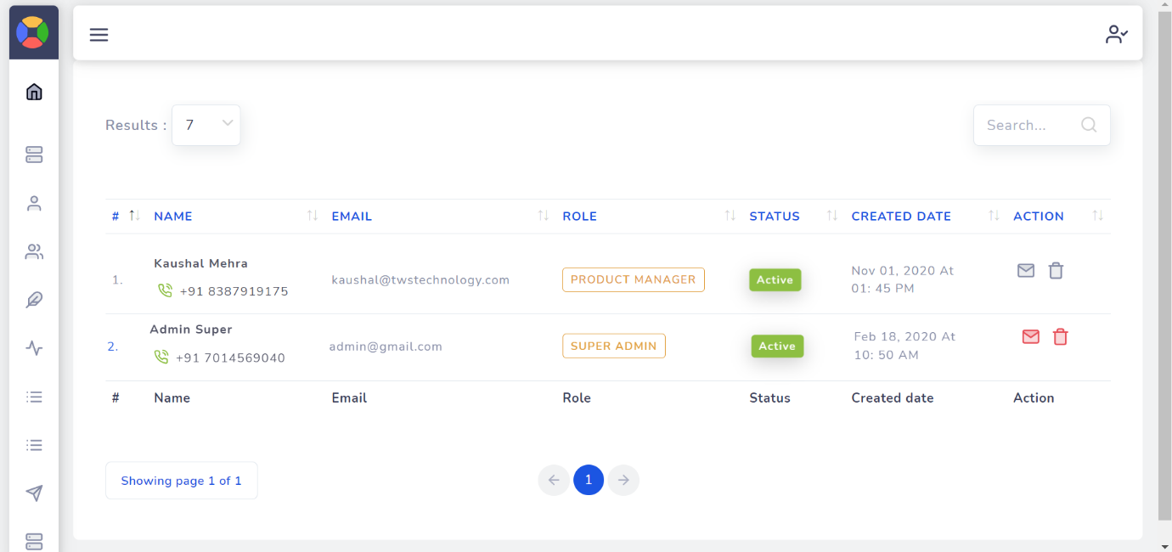

1. User management (View/Add/Delete)

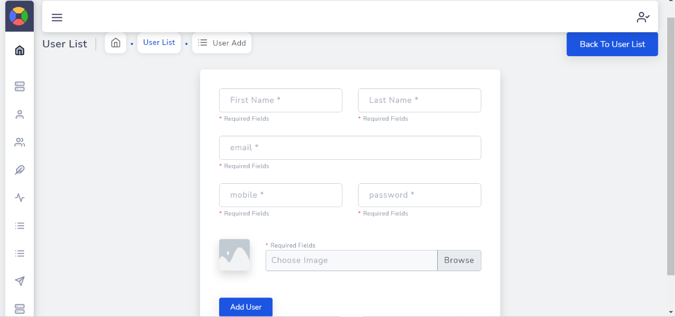

1. Community (View/Add/Update/Delete)

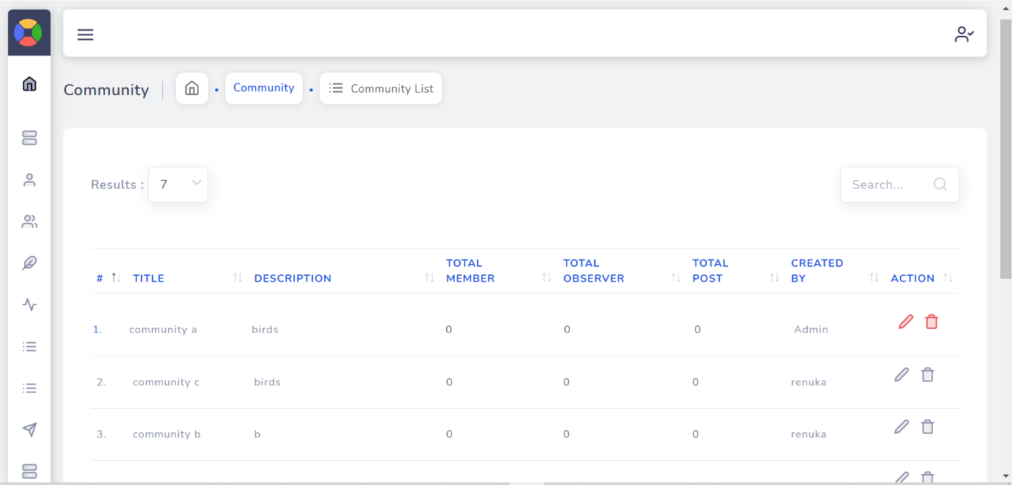

1. Species (View/add/delete)

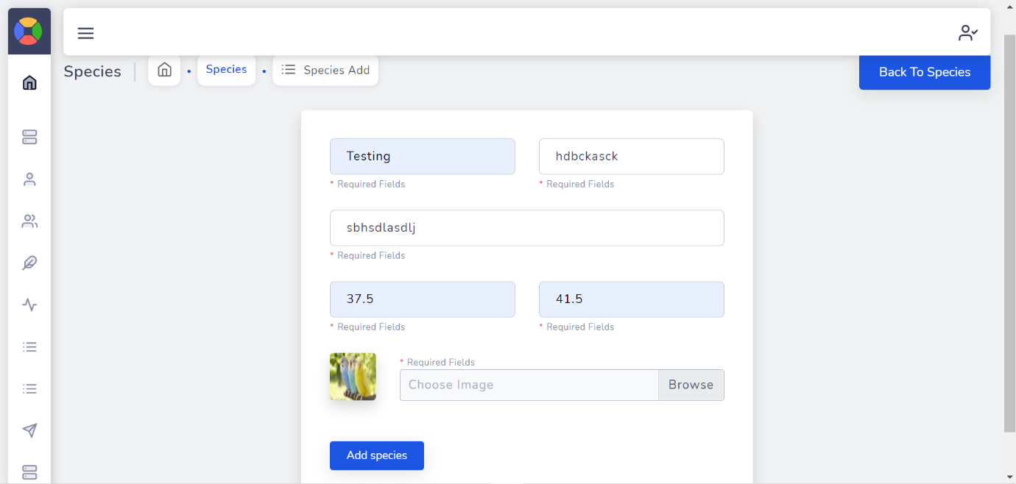

1. Slider (View/Add/Edit/Delete)

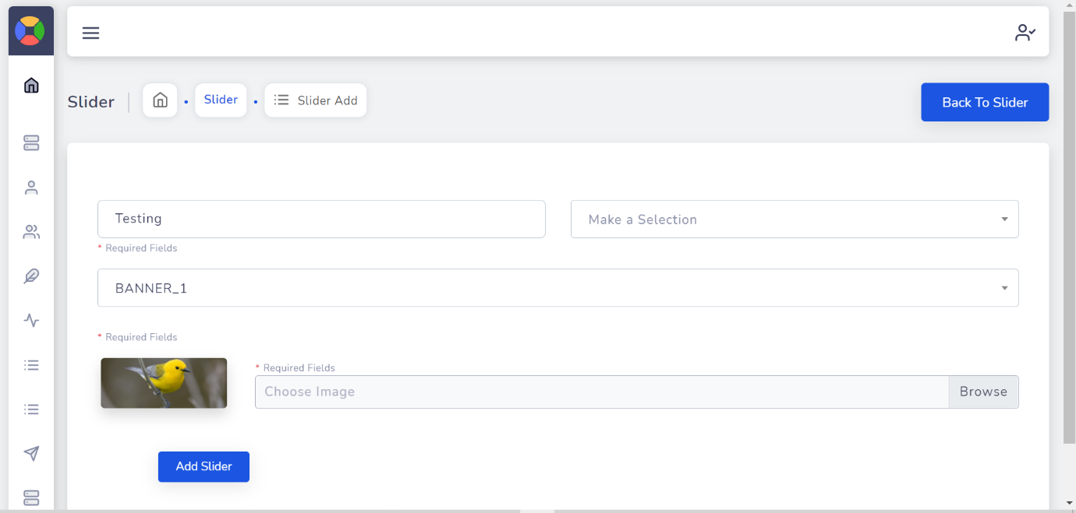

1. Notification (View/send/delete)

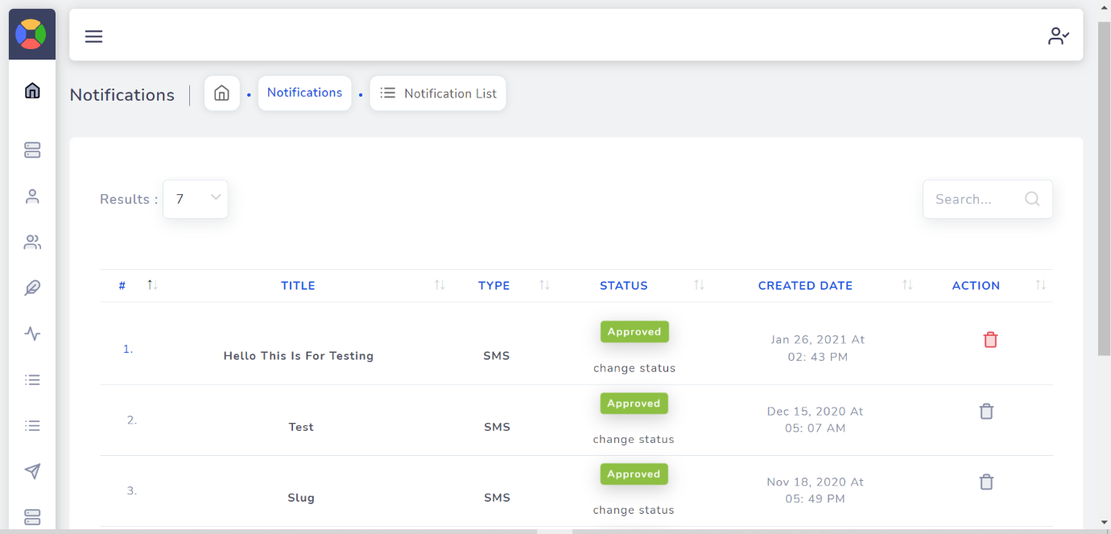

1. User Group & Modules (View/Add/Edit/Delete)

