Easy2ship Feedback 4 feb

1. Homepage 4 icons should be small and according to small mobile screen and font also small
2. Homepage < In from < auto user location should come
3. In International Flight
   1. Export < “Origin (From)” field Only India and “Destination (To)” field **will not** choose Indian address
   2. Import < “Destination (To)” field always Only India address can choose and Origin (from)” field always Only India address **cannot** choose
4. In domestic flight
   1. From and To field < Only India address(location)
5. bike, local truck, National truck< only Indian address(location) should come
6. In Local truck < One way option should come first as selected
7. Homepage < when choosing domestic < Sequence will be: Flight, Road, Train
8. Homepage < after choosing document and parcel < position is misplaced in some other screens
9. 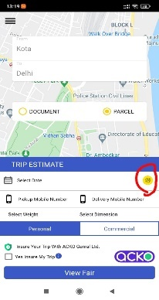Homepage < On 2nd Screen < Vehicle icon should be bigger
10. Homepage < Create shipment
    1. Pickup mobile number should come automatic from user profile
    2. Contact list icon to be paste in pickup mobile pop-up box < From which user can select anyone contact
    3. In delivery mobile number <Contact list icon to be paste in pickup mobile pop-up box < From which user can select anyone contact
    4. User can also type his mobile number

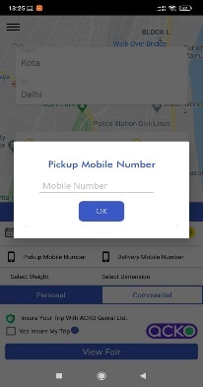

1. Create shipment < when scheduling courier < booking with past selected time
   1. Pickup Timings will be
      1. Bike: 8 AM to 10 PM
      2. Trucks: 6 AM to 11 PM
      3. Courier: 9 AM to 8 PM
2. Weight Pickup slabs
   1. In Bike
      1. In documents- 1 to 10 kg and can increase and decrease with + and –
      2. In Parcel – 1 to 15 kg and can increase and decrease with + and –
   2. In local Truck (Weight factor should be in check box)
      1. Below and up to700
      2. In between 700 to 1500
   3. In National Truck (can increase and decrease with + and -)
      1. Up to 25 kg
      2. Additional weight should increase by 1 kg
   4. In national and international flight (can increase and decrease with + and -)
      1. Document – 1 to 5 kg
      2. Parcel – 1 to 1000 kg

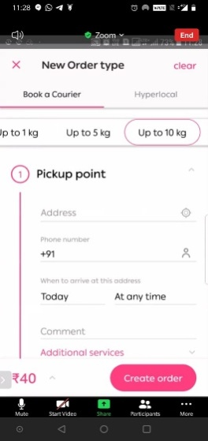

1. Increase and decrease porter count with + and – ( min 1 to max 5)
2. 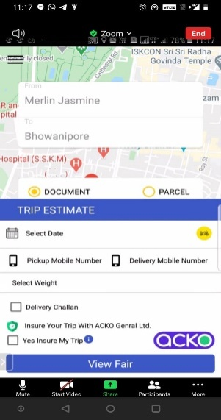After Creating shipment < 2nd screen should be dynamic means price should change when changing weight, dimension and checking or unchecking porter, DC, Insurance box
3. After creating shipment < when view price < also show distance (km)- approx.
4. Volumetric calculation weight to be shown near dimension box
   1. If n no. of pieces of same dimension are present then pieces field box to be present in which weight will be calculated by multiplying with pieces
5. When choosing commercial address < Upload button to be present in which user can capture or upload ‘invoice’
6. After successful booking < On booking Page
   1. Done button **(indicator)** to be present in footer
   2. Booking Id should come and other details are missing on page.
   3. Share button to be present in top right corner
   4. Estimated distance (km) should come
   5. Can also add Pick up address < “+”button will come
   6. Download Invoice button will come
   7. 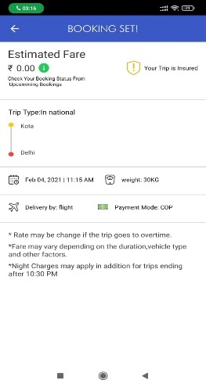Estimated Fare i info showing 0 prices
7. When selecting and doing payment < coupon field should come
8. In shipment history < Cancel and refund order should come
9. Can see live tracking
   1. Bike and Truck
10. Homepage icons renaming
    1. Domestic 🡪 Domestic courier
    2. International 🡪 International courier
    3. Truck 🡪 Intercity Truck
11. 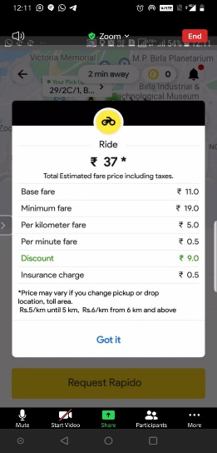Fare sheet of each service should be different
12. UPI payment link to be added
13. In My Profile < Verified should come in mobile and email id
14. Contact us page design