Step-1 : Launch EC2 instance

1. Connect VM

2.install docker = yum install docker –y

3.docker service start = service doocker start

Step-2 : create two bridge networks

1. docker network create networkname-1 --driver=bridge
2. docker network create networkname-2 --driver=bridge

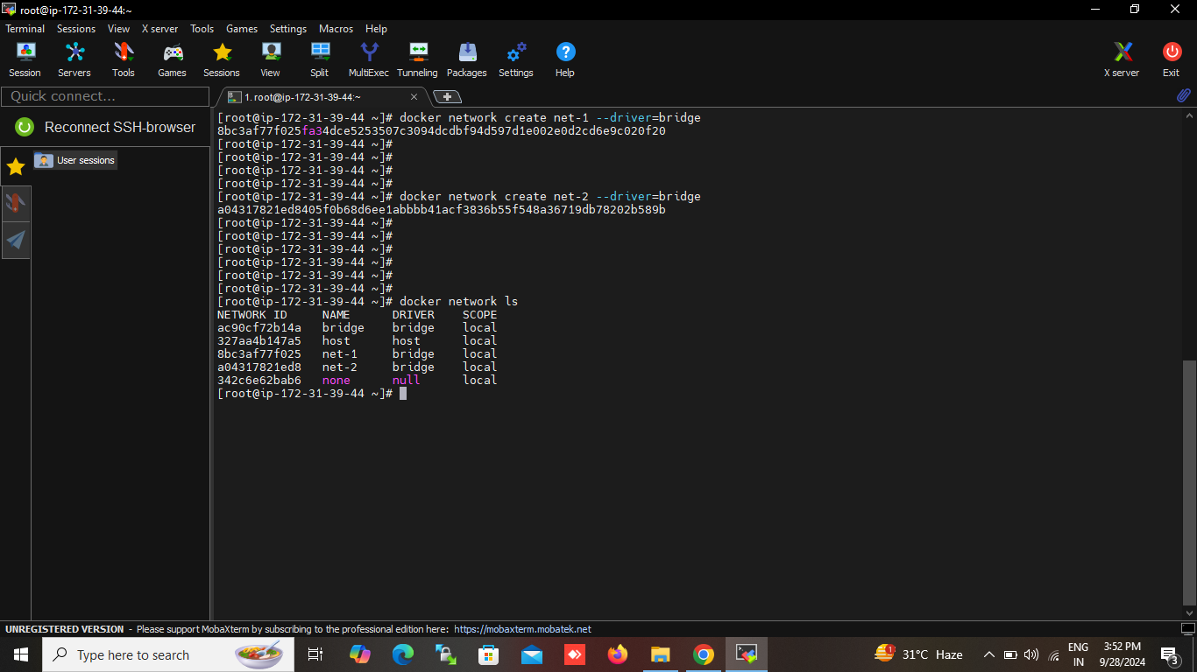

Step-3 : create two container on each of the network

1. docker run -itd --name container-name-1 --network networkname-1 imagename bash
2. docker run -itd --name container-name-2 --network networkname-2 imagename bash

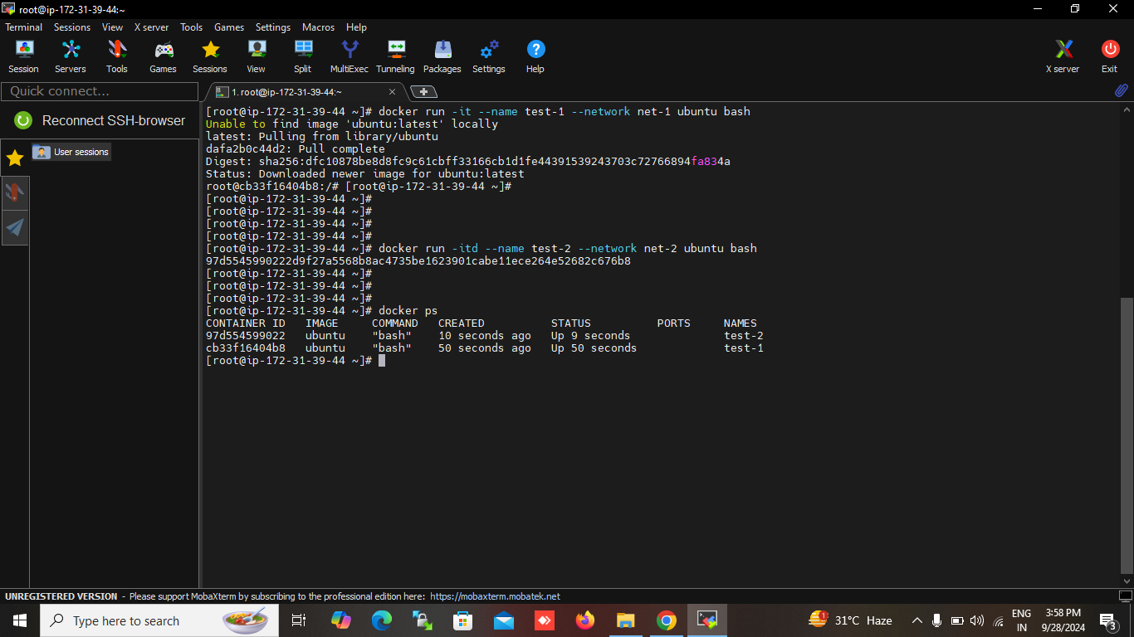

Step-4 : connect the container using the docker network connect command

1. docker network connect networkname-2 container-name-1
2. docker network connect networkname-1 container-name-2

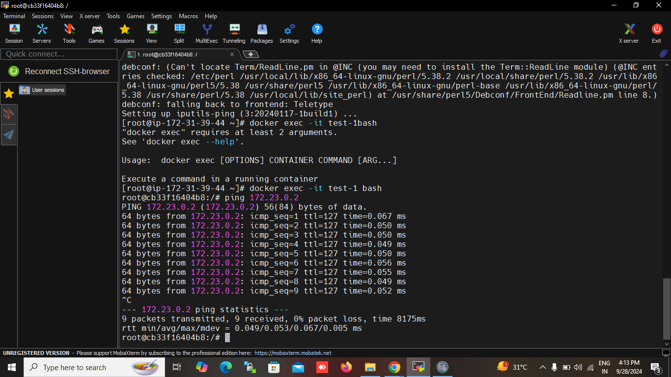

Step-5 : verify the connection

1. enter the container-name-1 and ping container-name-2 IP

# docker exec -it container-name-1 bash

# docker inspect container-name-2 |grep IPA = to check the ip address of the container

1. enter the container-name-2 and ping the container-name-1 IP

# docker exec -it container-name-2 bash

# docker inspect container-name-1 |grep IPA = to check the ip address of the container

# IF the ping command is not installed in container .to install the ping command by using command

1. docker exec -it container-id apt-get update
2. docker exec -it container-id apt-get install iputils-ping == (for Ubuntu container)