Bashchallenge.sh

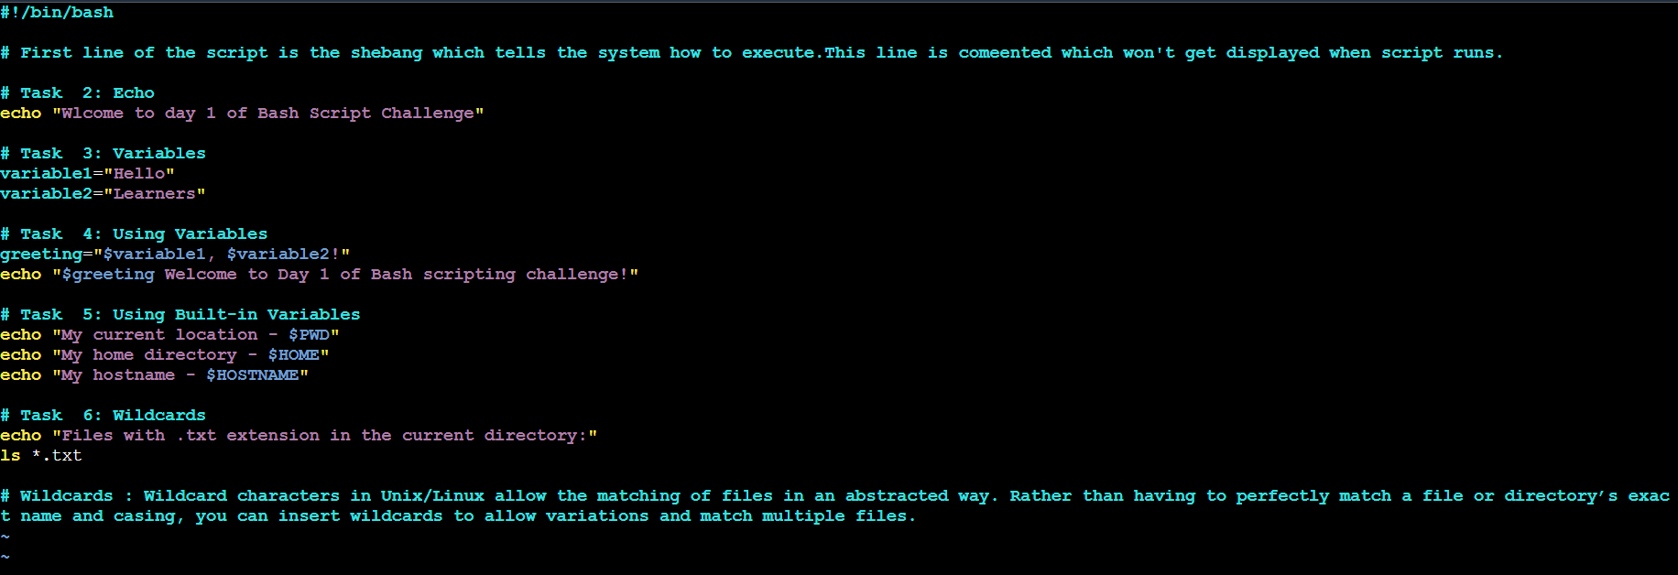

Output :

