Phone Book Directory Management System
B.E. Vth Sem Mini Project

By
Kalash Hatwar (26)
Arjun Wankhede (08)
Deepanshu Rathore (13)
Divyanshu Bhoyar (17)
Gunjan Kayarkar (21)
Maulik Pandya (31)
Rohan Mahakalkar (45)

Guide
Priti Dhanke
Assistant Professor

DEPARTMENT OF COMPUTER SCIENCE AND ENGINEERING
GOVERNMENT COLLEGE OF ENGINEERING NAGPUR 441 108
2021

1. Introduction
We are presenting mini-project based on Object Oriented Programming. We thought to work on real life based problem to get an exposure of how complex projects are handled in easier way. So to start with we picked up Phone Book Directory Management System.
Phone Book application is one of the most popular application and is being used in most of the devices these days like mobiles, smartphones and business organizations. Whether you are at office or at home, you will always have access to your contacts.
Phone Book Management System is simple system software implemented using Java. Using this system, one can add new contact details, edit/update details, delete records and save all contact’s in a text file. A Phone Book Directory Management System In Java is a command line application. File handling and data structure concepts has been extensively used for almost all functions in this mini project.

2. Features of Phone Book Management System:
a) Add new contact
This feature adds a new phone record to the file. It asks for the id, name, phone number, city and country whose record is to be created. Upon successful creation of a new phone record, the phonebook management system program asks the user in which group to store phone record, that is either in family, friend, work, others or no group. If the new phone record with new id already exists in the file, it displays the message – “Id already exists...”
b) Search contact
This function is very simple, and with-it users can search for a phone record by providing the name of a particular person whose record has already been added in the file. If the name provided is not present in the file, then it displays the message – “Record Not Found…!”
c) View the list of all contacts
In phonebook management system, this feature allows user to list all the phone records stored in file. The information displayed here are user-id, phone number person’s name, city and country.

d) Edit/Update contacts
This simple feature allows user to edit the phone number, person name, city and country corresponding to a particular phone record. Upon successful modification, the program displays the message – “Record Updated Successfully…!”
e) Delete specific contact
This feature deletes added phone record from the file. The user needs to provide the user-id to be deleted from phonebook management system. Upon successful deletion, it displays the message – “Record Deleted Successfully...!”. If the phone number provided is not found in file, the program displays the message – “Record Not Found...!”.
f) View contacts in Sorting manner
In phonebook management system, this feature allows user to list all the phone records according to user-id, person’s name or phone number based on user input of which type of sorting order he wants.
g) View all contacts of specific group
In this feature, user can list all phone records of a particular group by providing the name of that group.

2. Objective
The main objective of phonebook application is to get contact details of a person or an organization in very less amount of time. For example, we can get information of a particular person such as name, city, country, phone or a location.
This system is user friendly and is developed to reduce the errors that creep up in manual systems. It was very difficult to store all these details manually so such a system was developed.
Phone Book Management Software manages contact details of users in one central location. Rather than maintaining customer records in papers or files, the information is stored in the contact management software application.

3. Language used - Java
This Phone Book Directory Management system is implemented using Java programming language. Most of our group members were new to Java and hence we thought it would be a great opportunity to learn it and develop a project simultaneously. Besides this, we all know how versatile a language java is, while also being used widely in the industry. It is the most popular object-oriented programming language and all these features of java led to us selecting this as the language for our mini-project.

4. Code

Main
package phonebook;
import java.io.*;
import java.util.*;

/*
* al = ContactList
* ois = FileReader
* oos = FileWriter
* li = ListIterator*/
class User implements Serializable {
int Id;
String name;
String phNo;
String city;
String country;
String group;
public int id;

User(int Id, String name, String phNo, String city, String country,String group){
this.Id = Id;
this.name = name;
this.phNo = phNo;
this.city = city;
this.country = country;
this.group=group;
}
public String toString(){
return (" " +(Id) + "," + (name) + "," + (phNo) + "," + (city) + "," + (country)+ "," + (group));
}
}

public class Main extends DisplayUser{
public static ArrayList<User> al = new ArrayList<>();
public static File file = new File("Data.txt");
public static ObjectOutputStream oos;
public static ObjectInputStream ois;
public static ListIterator<User> li;
public static void main(String[] args) throws Exception{
int choice;
Scanner s = new Scanner(System.in);
Scanner s1 = new Scanner(System.in);
// ois will read the data of file and store all characters one by one.
// al will store the all records in arraylist by reading ois
if(file.isFile()){
ois = new ObjectInputStream(new FileInputStream(file));
al = (ArrayList<User>)ois.readObject();
ois.close();
}
do{
DisplayMainScreen();
System.out.print("Enter Your Choice : ");
choice = s.nextInt();
System.out.println(" ");

switch(choice){
case 1:
AddUser au = new AddUser();
au.Add(al);
oos = new ObjectOutputStream(new FileOutputStream(file));
oos.writeObject(al);
oos.close();
break;
case 2:
Display(file);
break;
case 3:
SearchUser.Search(file);
break;
case 4:
DeleteUser del_u = new DeleteUser();
del_u.Delete(file);
break;
case 5:
UpdateUser uu = new UpdateUser();
uu.Update(file);
break;
case 7:
AddGroup a_group = new AddGroup();
a_group.add(file);
break;
case 6:
do {
DisplaySortMenu();
System.out.print("Enter Your Choice : ");
choice = s.nextInt();

switch(choice) {
case 1:
SortUser si = new SortUser();
si.sortid();
choice=0;
break;
case 2:
SortUser s_pno = new SortUser();
s_pno.sort_pno();
choice=0;
break;
case 3:
SortUser s_name = new SortUser();
s_name.sort_name();
choice=0;
break;
}
}while(choice!=0);
choice=1;
}
}while(choice!=0);
s.close();
s1.close();
}
}

Display User
package phonebook;
import java.util.*;
import java.io.*;

public class DisplayUser extends AddUser{
public static void Display(File file) throws IOException, ClassNotFoundException {
ObjectInputStream ois1;
if(file.isFile()){
ois1 = new ObjectInputStream(new FileInputStream(file));
ArrayList<User> al = (ArrayList<User>) ois1.readObject();
ois1.close();
System.out.println("|================= MY CONTACTS ==================|");
System.out.println("|--------------------------------------------------|");
for (User user : al){
System.out.println(user.toString());
}
System.out.println("L__________________________________________________⅃");
System.out.println(" ");
System.out.println(" ");

}else{
System.out.println("File not Exists....!");
}
}

public static void DisplayMainScreen(){
System.out.println("\t\t\t\t\t+----------------------------------------------------------------------+");
System.out.println("\t\t\t\t\t| PHONE BOOK MANAGEMENT SYSTEM |");
System.out.println("\t\t\t\t\t+----------------------------------------------------------------------+");
System.out.println("\t\t\t\t\t\t\t _______________________________");
System.out.println("\t\t\t\t\t\t\t| |");
System.out.println("\t\t\t\t\t\t\t| 1.Create a contact \uD83D\uDD25 |");
System.out.println("\t\t\t\t\t\t\t| |");
System.out.println("\t\t\t\t\t\t\t| 2.Display all contacts |");
System.out.println("\t\t\t\t\t\t\t| |");
System.out.println("\t\t\t\t\t\t\t| 3.Search \uD83D\uDD0D |");
System.out.println("\t\t\t\t\t\t\t| |");
System.out.println("\t\t\t\t\t\t\t| 4.Delete contacts |");
System.out.println("\t\t\t\t\t\t\t| |");
System.out.println("\t\t\t\t\t\t\t| 5.Edit contacts |");
System.out.println("\t\t\t\t\t\t\t| |");
System.out.println("\t\t\t\t\t\t\t| 6.Sort contacts |");
System.out.println("\t\t\t\t\t\t\t| |");
System.out.println("\t\t\t\t\t\t\t| 7.Contact groups |");
System.out.println("\t\t\t\t\t\t\t| |");
System.out.println("\t\t\t\t\t\t\t| 0.Exit application |");
System.out.println("\t\t\t\t\t\t\t|_______________________________|");
System.out.println(" ");
System.out.println(" ");
}

public static void DisplaySortMenu(){
System.out.println("\t\t\t\t\t\t ___________________________________________________");
System.out.println("\t\t\t\t\t\t| |");
System.out.println("\t\t\t\t\t\t| 1.SORT By Id - On Screen |");
System.out.println("\t\t\t\t\t\t| 2.SORT By PhoneNo - On Screen |");
System.out.println("\t\t\t\t\t\t| 3.SORT By Name - On Screen |");
System.out.println("\t\t\t\t\t\t|__________________________________________________|");
}

public static void DisplayGroups(){
System.out.println("Select a group :");
System.out.println("+__________+ +__________+ +_________+ +__________+ +___________+");
System.out.print("| 1.family | ");
System.out.print("| 2.friend | ");
System.out.print("| 3.work | ");
System.out.print("| 4.others | ");
System.out.println("| 0.nogroup | ");
System.out.println("+¯¯¯¯¯¯¯¯¯¯+ +¯¯¯¯¯¯¯¯¯¯+ +¯¯¯¯¯¯¯¯¯+ +¯¯¯¯¯¯¯¯¯¯+ +¯¯¯¯¯¯¯¯¯¯¯+");
}

public static void Groups(){
System.out.println(" _____________");
System.out.println("| |");
System.out.println("| GROUPS: |");
System.out.println("| family ("+AddGroup.g_family+") |");
System.out.println("| friend ("+AddGroup.g_friend+") |");
System.out.println("| work ("+AddGroup.g_work+") |");
System.out.println("| others ("+AddGroup.g_other+") |");
System.out.println("| nogroup ("+AddGroup.g_nogroup+") |");
System.out.println("|_____________|");
}
}

Add User
package phonebook;
import java.io.IOException;
import java.util.ArrayList;
import java.util.Scanner;

public class AddUser {
public void Add(ArrayList<User> al) throws Exception{
Scanner s = new Scanner(System.in);
System.out.println("___________________________________________________");
System.out.print("Enter User Id: ");
int id = s.nextInt();
SearchUser.check(id);
s.nextLine();
System.out.print("Enter User Name: ");
String name = s.nextLine();
System.out.print("Enter User Phone Number : ");
String phNo = s.nextLine();
System.out.print("Enter User City : ");
String city = s.nextLine();
System.out.print("Enter User Country : ");
String country = s.nextLine();
DisplayUser.DisplayGroups();
System.out.print("Enter group name: ");
String group = s.nextLine();
int l=SearchUser.check(group);
if(l==1)
{
al.add(new User(id,name,phNo,city,country,group));
}
else
{
System.out.println("enter valid group");
}
}
}

Search User
package phonebook;

import java.util.*;
import java.io.*;

public class SearchUser extends Main{
static Scanner s = new Scanner(System.in);
public static void Search(File file) throws IOException, ClassNotFoundException {
if (file.isFile()) {
ObjectInputStream ois = new ObjectInputStream(new FileInputStream(file));
ArrayList<User> al = (ArrayList<User>) ois.readObject();
ois.close();
boolean found = false;
System.out.println("Enter contact name to Search : ");
String name = s.nextLine();
name = name.toLowerCase();
System.out.println("-------------------------------------");
for (User u : al) {
if (u.name.toLowerCase().contains((name))){
System.out.println(u);
found = true;
}
}
if (!found)
System.out.println("Record Not Found...!");
System.out.println("-------------------------------------");
} else {
System.out.println("File not Exists....!");
}
}

public static int SearchForUpdate(ArrayList<User> al, String name){
ArrayList<Integer> availableIds = new ArrayList<>();
for (User u : al) {
if (u.name.toLowerCase().contains(name.toLowerCase())) {
availableIds.add(u.Id);
}
}

if (availableIds.size() == 1) {
return availableIds.get(0);
} else {
System.out.println(availableIds);
System.out.println("Which " + name.toUpperCase() + " you want to update ?");
return s.nextInt();
}
}
public static int check(String group) throws Exception{
List<String> list=new ArrayList<String>();
list.add("family");
list.add("friend");
list.add("work");
list.add("others");
list.add("nogroup");
if(list.contains(group))
{
return 1;
}
else
{
return 0;
}

}

public static void check(int id) throws Exception{
if (file.isFile()) {
ObjectInputStream ois = new ObjectInputStream(new FileInputStream(file));
ArrayList<User> al = (ArrayList<User>) ois.readObject();
ois.close();

if (file.isFile()) {

Collections.sort(al, new Comparator<User>() {
public int compare(User u1, User u2) {
return u1.group.compareTo(u2.group);
}
});
for(User u : al)
//while (li.hasNext())
if(u.Id==id)
{
//System.out.println("bss");
System.out.println("Id already Exists...");
DisplayUser.Display(file);
Main.main(null);
}
} else {
System.out.println("File not Exists....!");

} } } }

Sort User

package phonebook;

import java.io.*;
import java.util.*;

public class SortUser extends Main {
public void sortid() throws IOException, ClassNotFoundException {
ois = new ObjectInputStream(new FileInputStream(file));
al = (ArrayList<User>) ois.readObject();
ois.close();

if (file.isFile()) {

al.sort(new Comparator<User>() {
public int compare(User u1, User u2) {
return u1.Id - u2.Id;
}
});

System.out.println("-------------------------------------");
li = al.listIterator();
while (li.hasNext())
System.out.println((li.next()).toString());
System.out.println("-------------------------------------");
} else {
System.out.println("File not Exists....!");
}
}

public void sort_pno() {
if (file.isFile()) {

al.sort(new Comparator<User>() {
public int compare(User u1, User u2) {
return u1.phNo.compareTo(u2.phNo);
}
});

System.out.println("-------------------------------------");
li = al.listIterator();
while (li.hasNext())
System.out.println((li.next()).toString());
System.out.println("-------------------------------------");
} else {
System.out.println("File not Exists....!");
}
}

public void sort_name() {
if (file.isFile()) {

al.sort(new Comparator<User>() {
public int compare(User u1, User u2) {
return u1.name.compareTo(u2.name);
}
});

System.out.println("-------------------------------------");
li = al.listIterator();
while (li.hasNext())
System.out.println((li.next()).toString());
System.out.println("-------------------------------------");
} else {
System.out.println("File not Exists....!");
}
}
}

Add Group
package phonebook;
import java.io.*;
import java.util.*;

public class AddGroup extends Main{
Scanner s = new Scanner(System.in);
static int g_family=0;
static int g_friend=0;
static int g_work=0;
static int g_other=0;
static int g_nogroup=0;
public void add(File file) throws ClassNotFoundException, IOException{
if (file.isFile()) {
ObjectInputStream ois = new ObjectInputStream(new FileInputStream(file));
ArrayList<User> al = (ArrayList<User>) ois.readObject();
ois.close();
int n_family=0;
int n_friend=0;
int n_work=0;
int n_other=0;
int n_nogroup=0;
for (User u : al) {
if (u.group.equals("family") ) {
n_family++;
}
if (u.group.equals("friend") ) {
n_friend++;
}
if (u.group.equals("work") ) {
n_work++;
}
if (u.group.equals("others") ) {
n_other++;
}
if (u.group.equals("nogroup") ) {
n_nogroup++;
}
}
g_family = n_family;
g_friend = n_friend;
g_nogroup = n_nogroup;
g_other = n_other;
g_work = n_work;
DisplayUser.Groups();
System.out.println("select the group");
String find = s.nextLine();

if (file.isFile()) {

Collections.sort(al, new Comparator<User>() {
public int compare(User u1, User u2) {
return u1.group.compareTo(u2.group);
}
});
System.out.println("-------------------------------------");
for(User u : al)
//while (li.hasNext())
if(u.group.equals(find))
{
//System.out.println("bss");
System.out.println((u.name).toString());
}
System.out.println("-------------------------------------");
} else {
System.out.println("File not Exists....!");
}
}

}
}

7. Update User
package phonebook;

import java.io.*;
import java.util.*;

public class UpdateUser extends Main {
public void Update(File file) throws ClassNotFoundException, IOException {

Scanner s1 = new Scanner(System.in);
// Scanner s = new Scanner(System.in);
if (file.isFile()) {
ois = new ObjectInputStream(new FileInputStream(file));
al = (ArrayList<User>) ois.readObject();
ois.close();
boolean found = false;
System.out.print("Enter contact name to Update : ");
String ContactName = s1.nextLine();
System.out.println("-------------------------------------");
DisplayUser.Display(file);
int id = SearchUser.SearchForUpdate(al,ContactName);
li = al.listIterator();
while (li.hasNext()) {
User u = li.next();
if (u.Id == id) {
System.out.print("Enter New User Name : ");
String name = s1.nextLine();

System.out.print("Enter new Phone Number : ");
String phNo = s1.nextLine();

System.out.print("Enter City : ");
String city = s1.nextLine();

System.out.print("Enter Country : ");
String country = s1.nextLine();

DisplayUser.DisplayGroups();
System.out.println("select the group : ");
String group = s1.nextLine();
li.set(new User(id,name,phNo,city,country,group));
found = true;
}
}
if (found) {
oos = new ObjectOutputStream(new FileOutputStream(file));
oos.writeObject(al);
oos.close();
System.out.println("Record Updated Successfully....!");
} else {
System.out.println("Record Not Found...!");
}
System.out.println("-------------------------------------");
} else {
System.out.println("File not Exists....!");
}
}
}

8. Delete User
package phonebook;

import java.util.*;
import java.io.*;

public class DeleteUser extends Main {
public void Delete(File file) throws ClassNotFoundException, IOException{
Scanner s = new Scanner(System.in);
if(file.isFile()){
ois = new ObjectInputStream(new FileInputStream(file));
al = (ArrayList<User>)ois.readObject();
ois.close();

DisplayUser.Display(file);

boolean found = false;
System.out.print("Enter user-id to Delete : ");
int id = s.nextInt();
System.out.println("-------------------------------------");
li = al.listIterator();
while(li.hasNext()){
User u = li.next();
if(u.Id == id){
li.remove();
found = true;
}
}
if(found){
try{
oos = new ObjectOutputStream(new FileOutputStream(file));
oos.writeObject(al);
oos.close();
}catch(Exception e){
e.printStackTrace();
}
System.out.println("Record Deleted Successfully....!");
}
else{
System.out.println("Record Not Found...!");
}
System.out.println("-------------------------------------");
}else{
System.out.println("File not Exists....!");
}
}
}

5. Output(Screenshots )
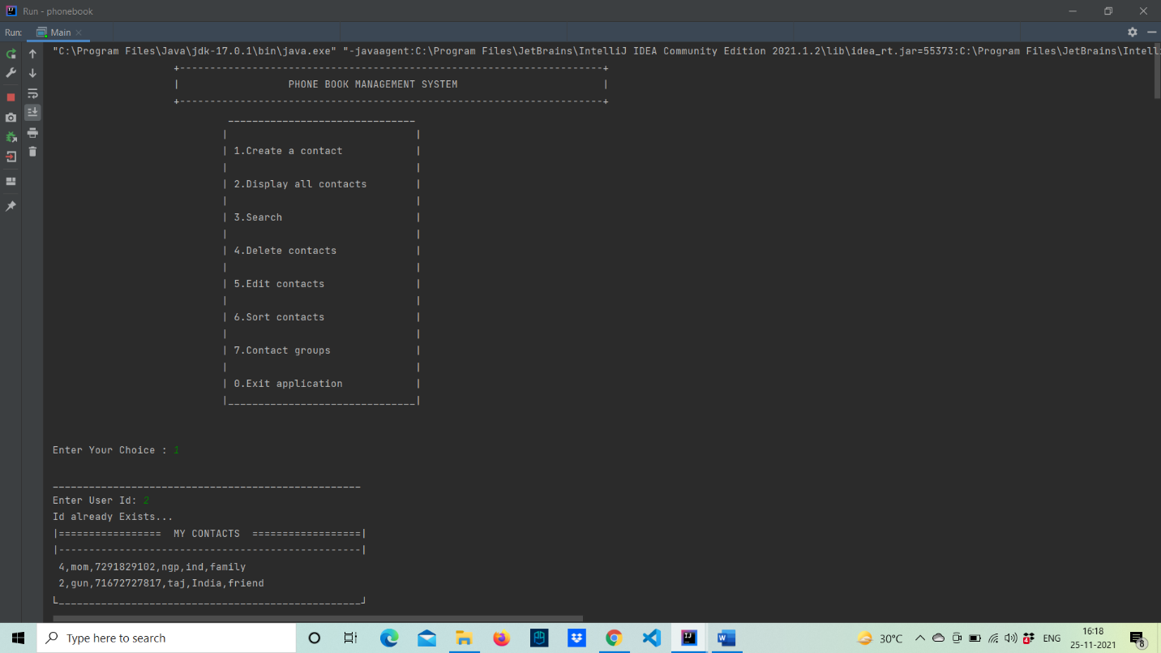

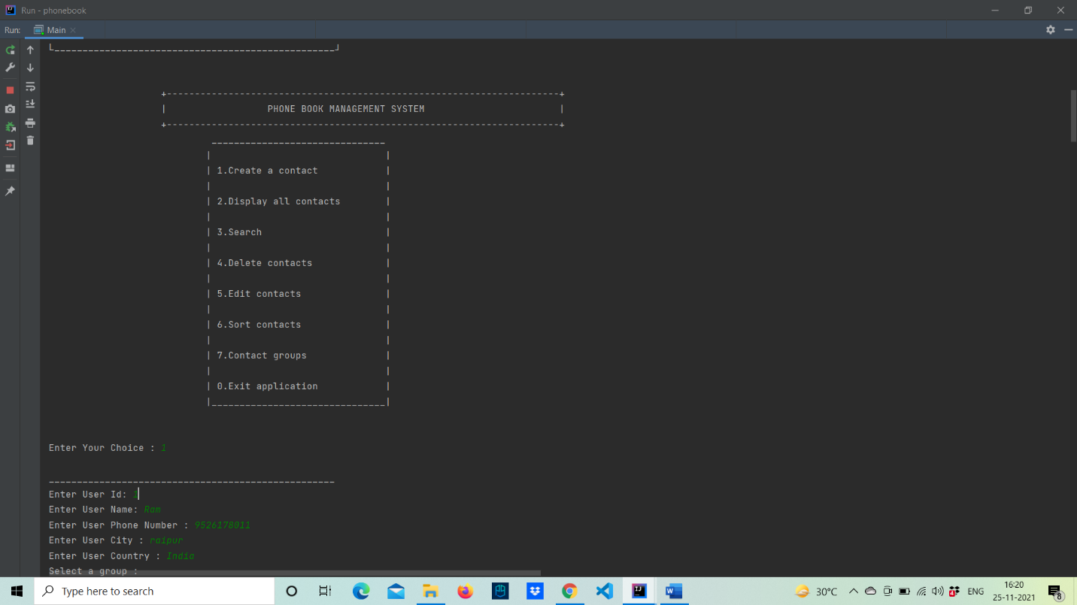
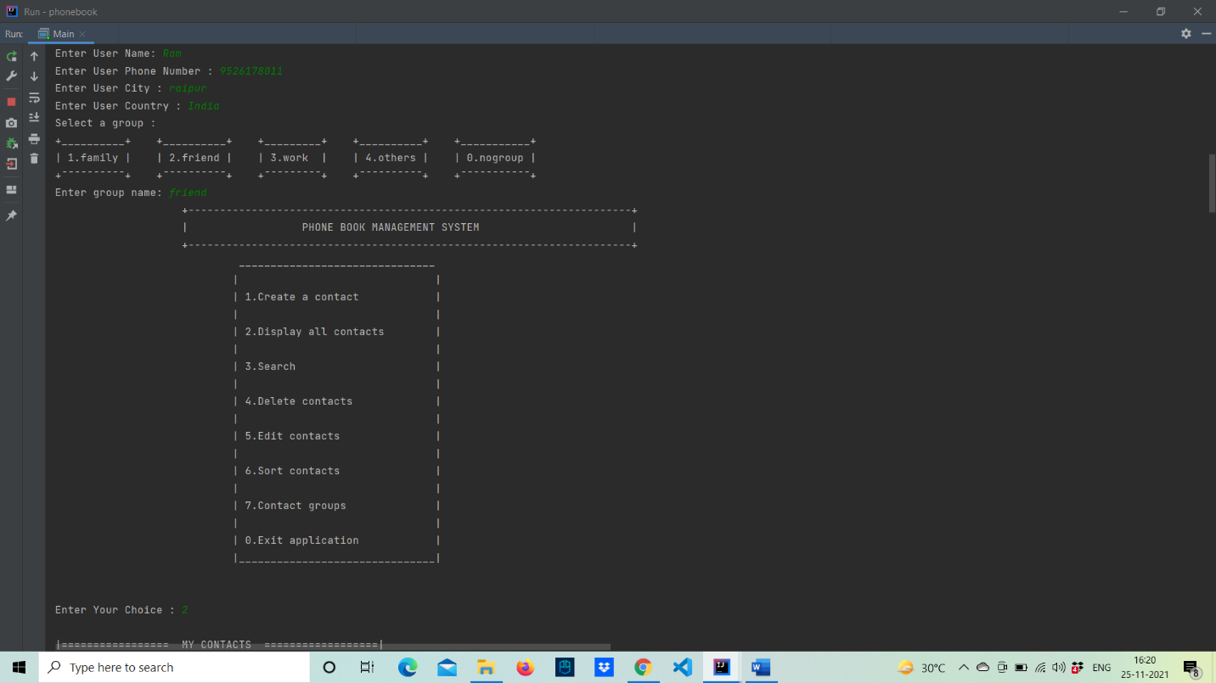

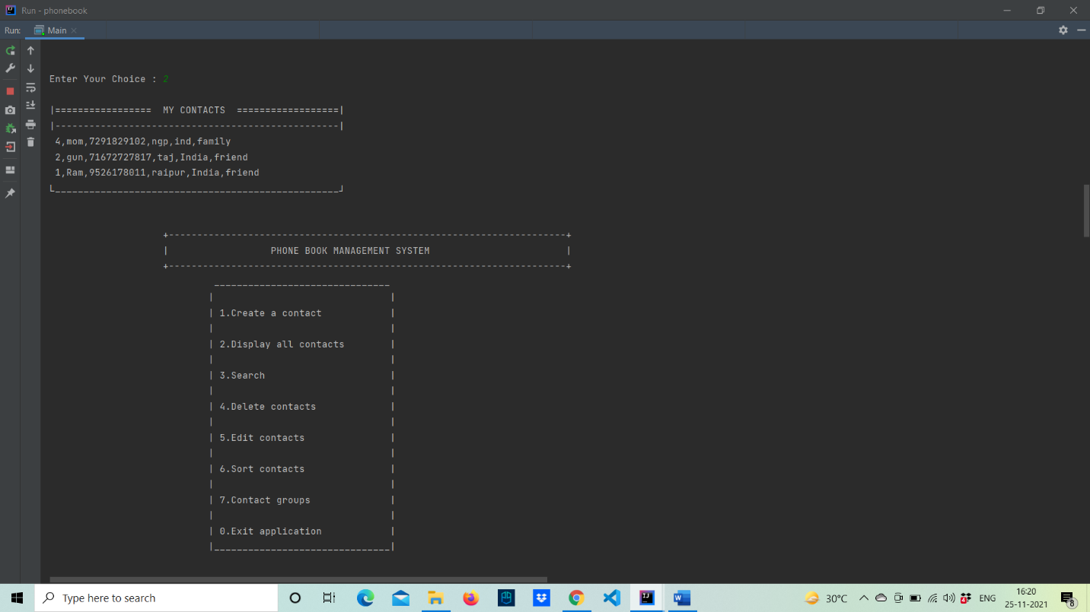
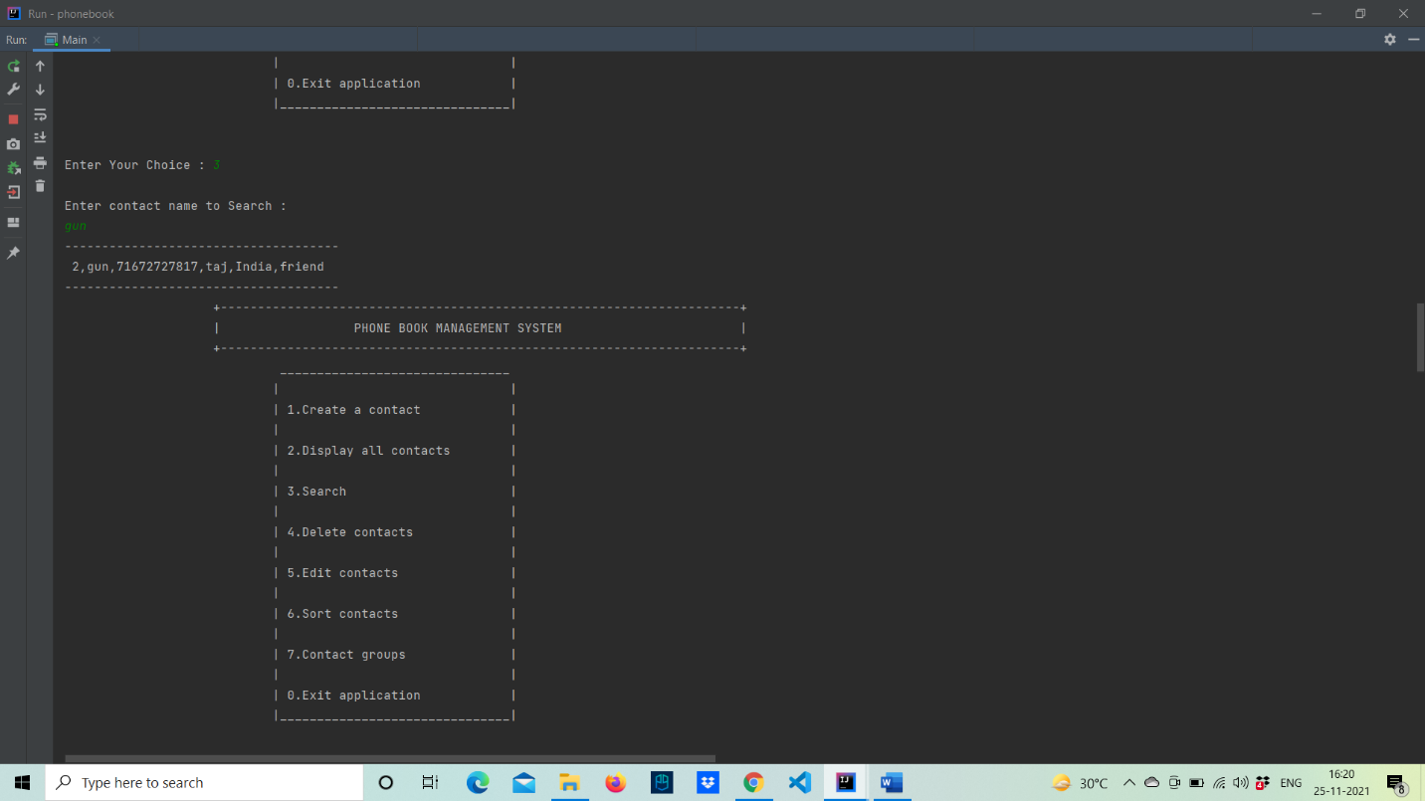

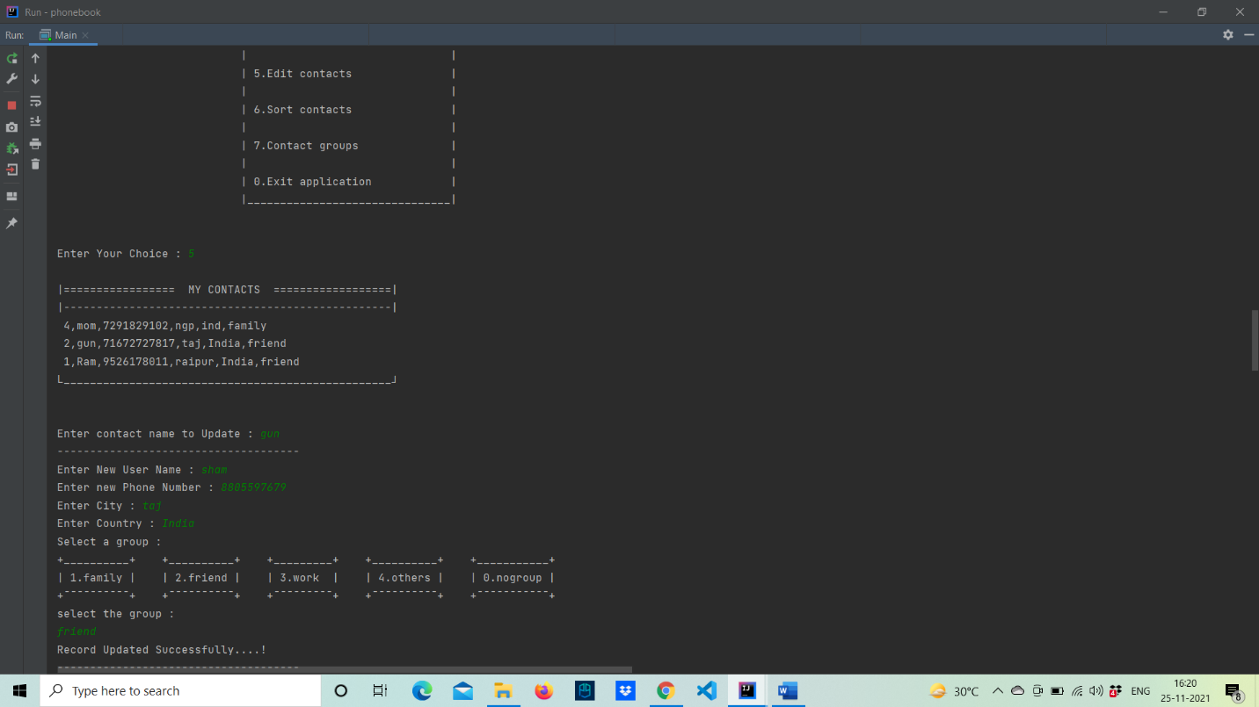
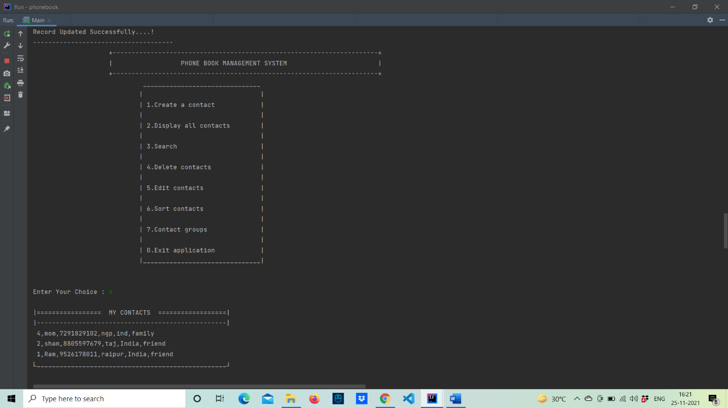

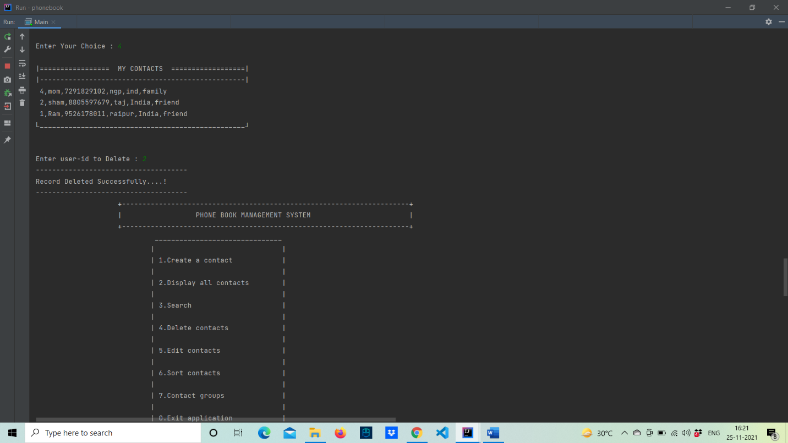

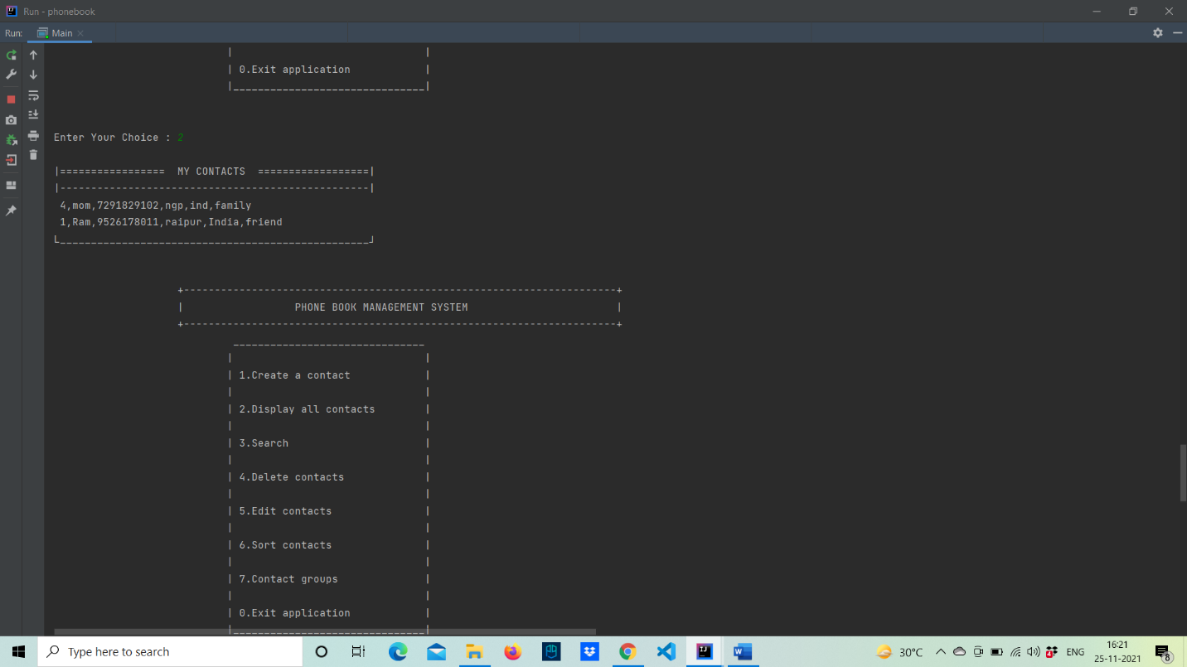

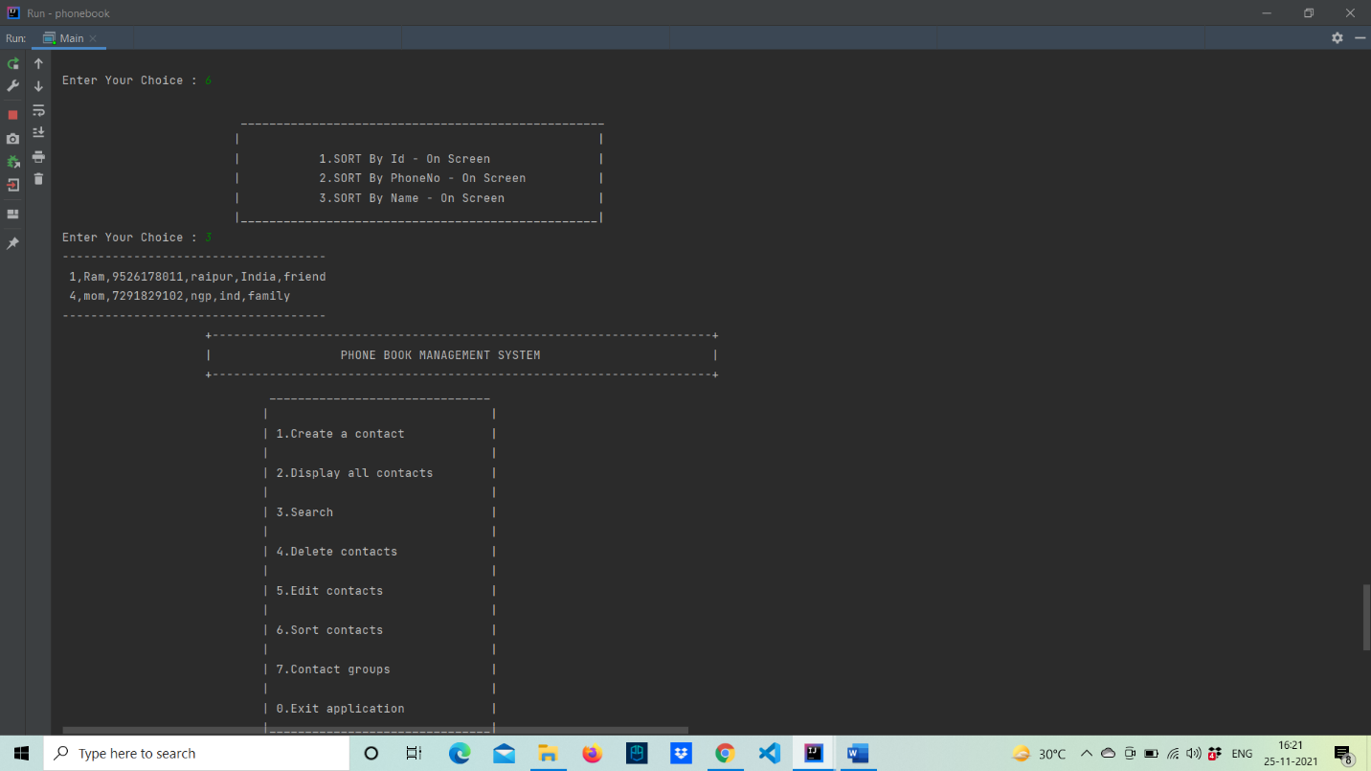

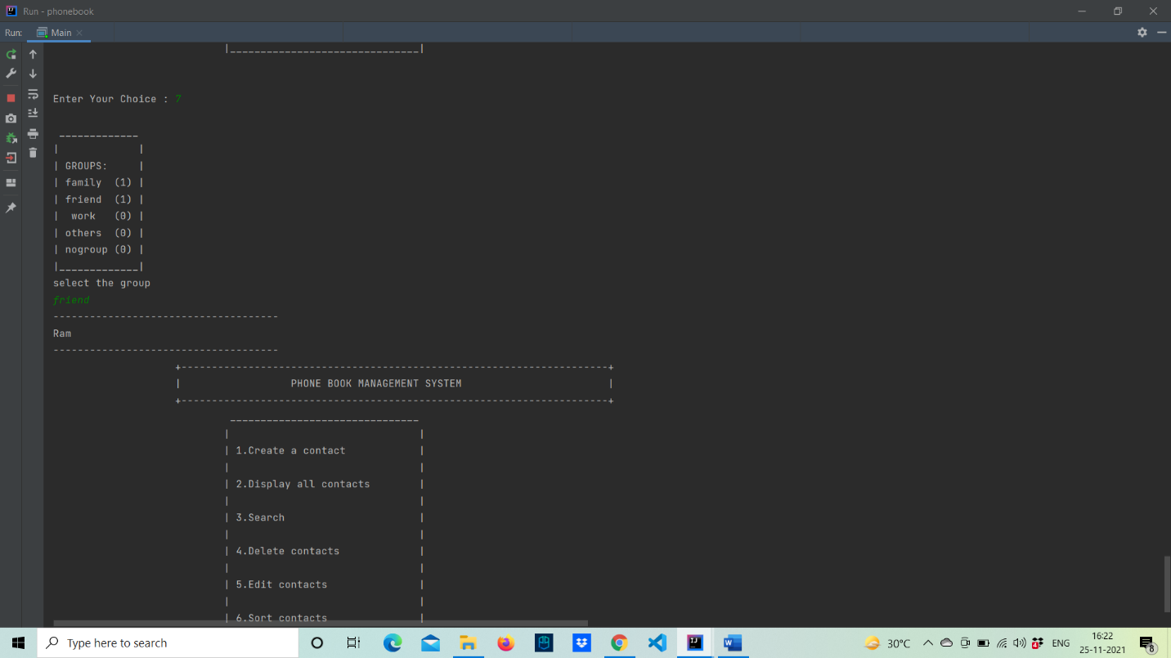

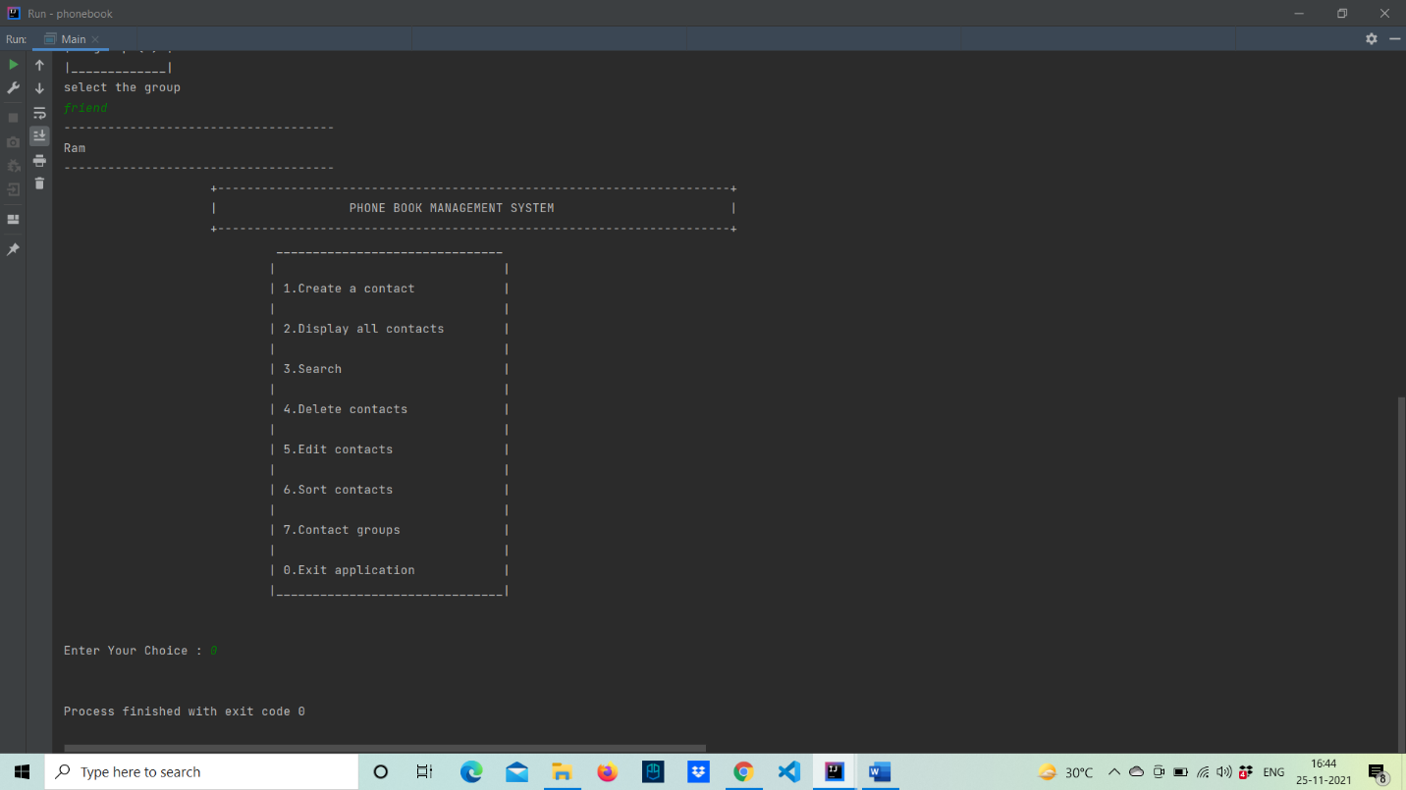

6. Conclusions
Using various concepts of Object Oriented Programming and practices of developing interactive command line interfaces, we achieved all the required functionality of this application. It helped us learn how modular and organized the codebase becomes on leveraging OOPS practices rather than just functional programming.

7. Future Scope
- Currently all of our data is being stored in a basic text file. We would like to further improve upon this by using a database to store all of our data.
- Our interaction with the project is limited to the command line, this can however prove difficult to use for the average user. So, a graphical user interface for this project is something we would like to work on in the future.
- There might be a ton of edge cases that we might have missed out on, which might lead to data duplication and a lot of redundancy. So this is something we would have worked upon if given more time.

8. References
- www.tutorialspoint.com
- www.javatpoint.com
- https://www.youtube.com/c/Freecodecamp
- https://www.youtube.com/channel/UC2KfmYEM4KCuA1ZurravgYw
- https://docs.oracle.com/en/java/
- https://javahungry.blogspot.com/

