**PROJECT-II REPORT**

**On**

**AUTOMATIC FACE DETECTION ATTENDENCE SYSTEM**

Submitted to Rajasthan Technical University

in partial fulfillment of the requirement for the award of the degree of

**B.TECH.**

**in**

**COMPUTER ENGINEERING**

**Submitted By**

**Harshit Chaurasiya (PIET15CE039)**

**Gunjan Kundalia (PIET15CE037)**

**Ruchi Kumari (PIET15CE095)**

**Under the Guidance of**

**Mr. Deepak Moud & Mr. Puneet Mathur**

at



**POORNIMA INSTITUTE OF ENGINEERING & TECHNOLOGY, JAIPUR**

**Rajasthan Technical University, KOTA**

**APRIL, 2018**

**CERTIFICATE**

This is to be certified that the project entitled “Automatic Attendance Marking System” has been submitted for the Bachelor of Computer Science and Engineering, Poornima Institute Of Engineering & Technology, Jaipur during the academic year 2018-2019 is a bonafide piece of project work carried out by “ **Harshit Chaurasiya, Gunjan Kundalia & Ruchi Kumari**” towards the partial fulfillment for the award of the Degree (B.Tech.) under the guidance of “**Mr. Deepak Moud**” and supervision and no part of thereof has been submitted by them for any degree or diploma.

Project Guide Project Coordinator Mr. Deepak Moud

Mr. Deepak Moud Prof. (Dr.) Praveen Gupta (H.O.D CSE)

(Assistant Professor) (Professor)

**CANDIDATE’S DECLARATION**

We, Harshit Chourasia **(PIET15CE039), Gunjan Kundalia (PIET15CE037) & Ruchi Kumari (PIET15CE094)** B.Tech (Semester- VIII) of “**Poornima Institute Of Engineering & Technology, Jaipur”**

hereby declare that the Project Report entitled **“Automatic Attendance Marking System”** is an original work and data provided in the study is authentic to the best of our knowledge.This report has not been submitted to any other Institute for the award of any other degree.

|  |  |  |
| --- | --- | --- |
| **PIET15CE039** | **PIET15CE037** | **PIET15CE094** |
| **(Registration No)** | **(Registration No)** | **(Registration No)** |

|  |  |
| --- | --- |
| **Place: Jaipur** |  |
| **Date: 22/10/18** |  |

**ACKNOWLEDGEMENT**

It is our pleasure to be indebted to various people, who directly or indirectly contributed in the development of this work and who influenced our thinking, behavior and acts during the course of study.

We express our sincere gratitude to ***Dr. O. P. Sharma,*** Director, PIET for providing us an opportunity to undergo this Major Project as the part of the curriculum.

We are thankful to ***Mr. Deepak Moud, HOD, CS*** for his support, cooperation, and motivation provided to us during the training for constant inspiration, presence and blessings.

We are thankful to ***Mr. Deepak Moud*** for his support, cooperation, and motivation provided to us during the training for constant inspiration, presence and blessings.

We also extend our sincere appreciation to***Prof. (Dr.) Praveen Gupta*** who provided his valuable suggestions and precious time in accomplishing our Project report.

Lastly, we would like to thank the almighty and our parents for their moral support and friends with whom we shared our day-to-day experience and received lots of suggestions that improved our quality of work.

|  |  |  |
| --- | --- | --- |
| **PIET15CE039** | **PIET15CE037** | **PIET15CE094** |
| **(Registration No)** | **(Registration No)** | **(Registration No)** |

**TABLE OF CONTENTS**

|  |  |  |  |
| --- | --- | --- | --- |
| **CHAPTER NO.** | | **TOPICS** | **PAGE NO.** |
|  | | TITLE PAGE | I |
|  | | CERTIFICATE | II |
|  | | CANDIDATE’S DECLARATION | III |
|  | | ACKNOWLEDGEMENT | IV |
|  | | TABLE OF CONTENTS | V |
|  | | TABLE OF FIGURE | VI |
|  | | ABSTRACT | VII |
| 1 | | **INTRODUCTION TO PROJECT** | 1 |
|  | |  |  |
|  | | Project Aim and Objective  Problem Statement  Background of the Project (Literature Survey)  Software Requirements  Hardware Requirements |  |
| 2 | | **PRODUCT BACKLOG** |  |
|  | | 1. PRODUCT Backlog 2. Sprint Backlog-1 3. Sprint Backlog-2 4. Sprint Backlog-3 5. Sprint Backlog-4 |  |
|  | |  |  |
| 3 | | **TECHNOLOGY APPLIED AND PROJECT MANAGEMENT** |  |
|  | | Brief Description of All technology Apply in the Project.  Project management  Agile  Relevance to Society  Ethics  Life Long Learning  Project Finance  Environment and Sustainability |  |
|  | |  |  |
|  | |  |  |
| 4 | | **PROJECT IMPLEMENTATION** |  |
|  | | Sprint Backlog-1  Sprint Backlog-2  Sprint Backlog-3  Sprint Backlog-4 |  |
|  | |  |  |
| 5 | | **CONCLUSION** |  |
|  | | Results  Conclusion  Future Scope |  |
| 6 | | ANNEXURES |  |
|  | | References |  |
|  |
|  |
|  |
|  | |  |  |

**LIST OF FIGURES**

|  |  |  |
| --- | --- | --- |
| **S. NO.** | **FIGURE** | **PAGE NO.** |
| 1. | Figure 2.1 |  |
| 2. | Figure 2.2 |  |
| 3. | Figure 2.3 |  |
| 4. | Figure 2.4 |  |
| 5. | Figure 3.1 |  |
| 6. | Figure 3.2 |  |
| 7. | Figure 3.3 |  |
| 8.  9.  10.  11. | Figure 4.1  Figure 4.2  Figure 4.3  Figure 4.4 |  |

**LIST OF TABLES**

|  |  |  |
| --- | --- | --- |
| **S. NO.**  1.  2.  3.  4.  5. | **FIGURE**  Table 3.1  Table 3.2  Table 3.3  Table 3.4  Table 3.5 | **PAGE NO.** |

**ABSTRACT**

**KEYWORDS:** Automated, attendance, face recognition, automatic.

**CHAPTER 1**

**INTRODUCTION TO PROJECT**

**Project Aim and Objective**

AutomaticAttendance Marking System is a system developed for marking daily student attendance in schools, colleges and institutes. The main objective of this project is to provide attendance through the face detection and recognition techniques. The face can detect by using camera which will be built in the classrooms. The system accepts the attendance record from snaps taking by the built cameras as an input and perform processing on it then in database. Then mark present and absent and then display the record over a sheet. The processing of taking snaps, detection of face and the recognition of face take only few seconds and it provide an accurate result. This system is less time consuming and very secure. This system reducing the need for manual labor which is prone to human errors and time consuming

* Detection of unique face image amidst the other natural components such as walls, background etc.
* Extraction of unique characteristics features of a face useful for face recognition.
* Detection of Faces amongst other face characters such a beard, spectacles etc.
* Effective recognition of unique faces in a crowd (individual recognition in crowd).

Our primary goal is to help the lecturers, improve and organize the process of track and manage student attendance and absenteeism. Additionally, we seek to:

* Provides a valuable attendance service for both teachers and students.
* Reduce manual process errors by provide automated and a reliable attendance system uses face recognition technology.
* Increase privacy and security which student cannot presenting himself or his friend while they are not.
* Produce monthly reports for lecturers.
* Flexibility, Lectures capability of editing attendance records.
* Calculate absenteeism percentage and send reminder messages to students.

**Problem Statement**

For marking the attendance for every classes every faculty members needs to mark present and absent on sheet manually, and this process is time consuming by which faculties losses their time in marking attendance. Automatic Attendance Marking System is developed to solve this problem. And it is for marking daily student attendance in schools, colleges and institutes. It facilitates to marking the attendance of every particular student in a particular class. This system will also help in evaluating attendance of a student. By just a click on the mouse, the system will be able to produce the student’s attendance report. This system reducing the need for manual labor which is prone to human errors and time consuming.  
This system is built for automating the processing of attendance. It also enhances the speed of performing attendance task easily. The Student Attendance will be based on the department and section. According to the department wise and section wise the attendance will be marked for the students.

Taking and tracking students’ attendance manually, losing attendance sheets, dishonesty, wasted time and high error scales are problems facing the lecturers use the existing attendance system. It is a hard process, take time and cause a lot of paper-based work. As a result, in order to solve these problems and avoid errors we suggest to computerize this process by providing a system that record and manage students’ attendance automatically without needing to lecturers’ interference.

Our project targets the students of different academic levels and faculty members. The main constraint we faced is distinguishing between identical twins. This situation is still a challenge to biometric systems especially facial recognition technology. According to Phillips and his co-researcher paper to get the best results of the algorithms your system employed, they should run under certain conditions for taken pictures (i.e… age, gender, expressions, studio environment ¦etc.) otherwise, the problem is still ongoing.

They provide application (method) to solve this problem, but in order to use this solution you have to sign a contract with the (NIST) organization and to be a researcher or developer. For us, to solve this issue we suggest to record twins’ attendance manually.

**Background of the Project (Literature Survey)**

Most lecturers have a significant number of students and it is hard to keep taking or tracking all their absence. Facial recognition is commonly used in many institutions to take attendance of a significant number of students. There are many errors that could occur during this process, including misidentification and self-recognition [3]. Lecturer can control the errors and correct it.

In the next subsection, brief overview of the usage,techniques, and methods in facial recognition.

**Face Recognition Usage**

“Face recognition rises from the moment that machine started to become more and more intelligent and had the advance of fill in, correct or help the lack of human abilities and senses.” Common uses of Facial recognition clarify in following points;

* Security; can be crime-fighting it will recognize people based on their eyes, nose and face.
* Searching for lost people.
* Games
* Taking student or employee attendance

**Face Recognition Techniques and Methods**

Many factors influence the process of face recognition such as shape, size, pose, occlusion, and illumination. Facial recognition, have two different applications: basic and advanced. Major face recognition recognizes faces or no faces such as balls and animals. If it is a face, then the system searches for eyes, a nose, and a mouth. Advanced facial recognition manages the question on a specific face. This contains unique landmarks: the width of nose, wideness of the eyes, the depth and angle of the jaw, the height of cheekbones, and the separation between the eyes, and makes a unique numerical code. Utilizing these numerical codes, the system then matches that image with another image and distinguishes how comparable the pictures are to each other. The image provenance for face recognition includes pre-existing pictures from various datasets.

**Software Requirements**

* Windows/Linus OS
* Raspian OS

**Hardware Requirements**

* High resolution camera
* Secondary Memory

**CHAPTER 2**

**PRODUCT BACKLOG**

**PRODUCT Backlog**In product backlog we are trying to detect the present human face using best of the algorithms and Haar Cascading to detect the presence of human face, and to check if it is more proficient for face detection we will use the Local Binary Patterns (LBP). And then we will capture the face and we will use the feature extraction by which feature will be extracted for comparison. Then we will use PCA using Eigen Values and Fisher values for the Data Reduction. And many more process for the same like KNN, K-means, Haar Cascading, Wavelet Transformation, LBP (Local Binary Patterns), Attribute Selection using Eigen Values and Fisher Values. After that we will proceed further to the Recognition of the face from dataset, and for this capturing of all the faces will happen, and the recognition of multiple faces at the same time will happen. And then we will extract the data through PCA using Eigen Values and Fisher Values. And there are many more process for the same operation and those are K-means, Haar Cascading, Wavelet Transformation, LBP (Local Binary Patterns), Attribute selection using Eigen values and attribute selection using Fisher values. And then we will calculate the time by making it robust by time. Then we will capture the video which will be done in few seconds, then we will use the video Meta data extraction for capturing images/snaps from video within the time frame. Then we will use the fast and robust extraction key methods for capturing frames with the good exposure and light. Then we will use the method of matching extracted images from the dataset for match those images which has been taken from camera. Then we will give unique id to all the members of dataset it will get displayed who is present in the class. Then we will display the Ids when face from video is matched with dataset, by which the Ids and its corresponding information like name, roll-number get display. After that we will make the attendance sheet with database where record of present student will be displayed. And then we will create the work space to store face/videos for matching. And then we will design GUI of the sheet. And after we will make class wise databases for marking the attendance of each section separately. Then we will connect that GUI with database through which connectivity of database with camera will happen. Then the connecting video extraction method will get applied through which output- attendance sheet will be ready. And after that list of all subjects will get prepared to see attendance of individual subjects. Then login for individual subject attendance will get build to see result of attendance individually. Then the operation get performed and showing output on database and all attendance get counted in total. After all these operations the implementation process will get performed on the hardware and connecting with the camera for practical implementation. Then we will implement the system in the college and track the accuracy and working for testing on implemented application and system. And then if some issues are there that will get find out and get resolved and then implement the system again.

|  |  |  |  |
| --- | --- | --- | --- |
| **US ID** | **­­** | | |
| **AS A/AN** | **I WANT TO** | **SO THAT** |
| SB1/US1 | Developer | Detecting human face | It will detect if the human face is present or not |
| SB1/US2 | Developer | Use best of algorithms | To detect human face accurately |
| SB1/US3 | Developer | Feature extraction for matching | Feature will be extracted for comparision |
| SB1/US4 | Developer | Capturing all the faces | Capturing of face |
| SB1/US5 | Developer | Recognition of the faces | Recognizing multiple faces |
| SB1/US6 | Developer | Making it robust by time | Calculating time for making time efficient |
| SB2/US1 | Developer | Detecting multiple human faces | Multiple faces needed to be reconized in one frame |
| SB2/US2 | Developer | Identifying and matching captured images from database | It will compare faces |
| SB2/US3 | Developer | Capturing videos | Video is capture for few minutes |
| SB2/US4 | Developer | Video meta data extraction | Capturing images from video with time frame |
| SB2/US5 | Developer | Extracting clear image/face from the video | It will extract clear faces from the video to match with data sets |
| SB2/US6 | Developer | Matching extracted images from the dataset(using same algos mentioned above) | Match those images |
| SB2/US7 | Developer | Giving unique id to all the members of dataset | It will be displayed who is present in the class |
| SB2/US8 | Developer | Displaying of Ids when face from video is matched with dataset | Display of Id and its corresponding informations like name, roll no. |
| SB3/US1 | Developer | Making of attendence sheet with data base | Where record of present student will be displayed |
| SB3/US2 | Developer | Work Space | To store face/videos for matching |
| SB3/US3 | Developer | Desing GUI of the sheet | Designing of sheet |
| SB3/US4 | Developer | Making class wise databases | For attendence of each section |
| SB3/US5 | Developer | Connecting GUI with database | conectivity of database with camera |
| SB3/US6 | Developer | Connecting Video extraction | Output- attendence sheet is ready |
| SB3/US7 | Developer | List of all subjects | to see attendence of indivisual subjects |
| SB3/US8 | Developer | Login for indivisual subject attendance | to see result of attendence indivisually |
| SB3/US9 | Developer | Showing output on database | All attendence is counted in total |
| SB3/US10 | Developer | Marking of attendance | All attendence is counted in total |
| SB4/US1 | Developer | Implementation on the hardware | Practical Implimentation |
| SB4/US2 | Developer | conecting with the camera | Practical Implimentation |
| SB4/US3 | Developer | Implementing in the college | Real time applicaton implimentation |
| SB4/US4 | Developer | Track the accuracy and working | Testing on implimented application |
| SB4/US5 | Developer | Finding issues | Finding problem after implimentation |
| SB4/US6 | Developer | Resolving issues | Resolving the issue of the found problem |
| SB4/US7 | Developer | Impleting again | Finally impliment the system |

Table 2.1

1. **Sprint Backlog-1**

Under Sprint Backlog 1- User Story 1 our first task is to find out the methods to detect the human face which will be done by all the team members (Harshit Chourasia (HC), Gunjan Kundalia (GK), Ruchi Kumari (RK)). The second task is to find and use best of algorithms for the same and it will be done by all the team members. Third task is to learn and apply Haar Cascading, LBP methods. The next task is to capturing face and using the methods for feature extraction technique for matching and this all will be done by all the team members.

Now under User Story 2 our first and second task is to learn and apply the PCA using Eigen Values and PCA using Fisher Values. Third task is to learn and apply the KNN algorithm, and the fourth task is to learn and apply the K-means. Then the fifth task is to learn and apply the Haar Cascading method and these all tasks will be done by all the team members (HC, GK, RK).

And under User Story 3 our first task is to learn and apply the Wavelet Transformation method. And the second task is to learn and apply the LBP method. And third and fourth task is learn and apply about the Attribute selection using Eigen values and Attribute selection using Fisher values. These all tasks will be done by all the team members (HC, GK, RK).

After this in User Story 4 our first task is to learn and apply the methods for recognition of detecting face. Second task is about learn and apply the methods of capturing all the faces, and learn about the methods for recognition of faces will be our third task. And our fourth and fifth task is to learn and apply the PCA using Eigen values and PCA using Fisher values, and this all will done by the all the team members (HC, GK, RK).

In the User Story 5 our tasks are to learn and apply for K-means, Haar Cascading, Wavelet Transformation and LBP methods and these all tasks will be done by all the team members (HC, GK, RK).

After these in the User Story 6 our first and second tasks are to learn and apply the Attribute selection using Eigen values and Attribute selection using Fisher values. After that our third task is try to make it robust by time. And then our fourth task is to learn and apply the methods of detecting multiple human faces at the same time. And all these tasks will be done by (HC, GK, RK).

|  |  |  |  |
| --- | --- | --- | --- |
| **US ID** | **USER STORY** | **TASK ID** | **TASKS** |
| SB1/US1 | I want to detect human face and it will only recognize human face only | SB1/US1/T1 | Write code for Dectection of human face |
| SB1/US1/T2 | Testing of code |
| SB1/US1/T3 | Solving the error if any |
| SB1/US2 | I will implement multiple algorithms, and algorithm with best results will be used | SB1/US2/T1 | By applying Haar Cascading algorithm |
| SB1/US2/T2 | Get the accuracy for haar cascading algorithm |
| SB1/US2/T3 | Solving the error if any |
| SB1/US2/T4 | By applying LBP (Local binary patterns) algorithm |
| SB1/US2/T5 | Get the accuracy for LBP algorithm |
| SB1/US2/T6 | Solving the error if any |
| SB1/US2/T7 | Compare and seclet the best acuurate algorithm. |
| SB1/US3 | Feature extraction algorithms for matching with from dataset | SB1/US3/T1 | Applying algorithm for extracting the features of faces |
| SB1/US3/T2 | Solving the error if any |
| SB1/US3/T3 | Testing of written algorithm code for extraction |
| SB1/US4 | Feature Extraction | SB1/US4/T1 | Applying PCA using Eigen values |
| SB1/US4/T2 | Applying PCA using Fisher values |
| SB1/US4/T3 | Applying KNN Algorithm |
| SB1/US4/T4 | Applying K-means Algorithm |
| SB1/US4/T5 | Applying Haar-cascading Alogorithm |
| SB1/US4/T6 | Applying Wavelet Transformation |
| SB1/US4/T7 | Applying LBP (Local binary patterns) Algorithm |
| SB1/US4/T8 | Applying Attribute Selection using Eigen values |
| SB1/US4/T9 | Applying Attribute Selection using Fisher values |
| SB1/US4/T10 | Obtain accuracy result for all the above algoritms. |
| SB1/US4/T11 | Compare accuracy and seclet the best acuurate algorithm. |
| SB1/US5 | Faces will be captured and saved temporily to use it for matching with dataset | SB1/US5/T1 | Take the screenshot of the as image |
| SB1/US5/T2 | Store that screenshot in database |
| SB1/US5/T3 | Provide the unique id to the picture |
| SB1/US5/T4 | Similarly capture all the faces detected |
| SB1/US6 | Comparision of the faces using multiple algorithms | SB1/US6/T1 | Applying PCA using Eigen values |
| SB1/US6/T2 | Applying PCA using Fisher values |
| SB1/US6/T3 | Applying K-means Algorithm |
| SB1/US6/T4 | Applying Haar-cascading Alogorithm |
| SB1/US6/T5 | Applying Wavelet Transformation |
| SB1/US6/T6 | Applying LBP (Local binary patterns) Algorithm |
| SB1/US6/T7 | Applying Attribute Selection using Eigen values |
| SB1/US6/T8 | Applying Attribute Selection using Fisher values |
| SB1/US6/T9 | obtain accuracy result for all the above algoritms. |
| SB1/US6/T10 | Compare accuracy and seclet the best acuurate algorithm. |
| SB1/US7 | Making it robust by time, so that it will become more time efficient and accurate | SB1/US7/T1 | Obtain the accuracy for all algorithm written on the basis of time |
| SB1/US7/T2 | Compare the result obtain for all algorithm |
| SB1/US7/T3 | Select the best algorithm. |
| SB1/US8 | Now algoarithms will be implemented such that it will detect multiple faces altogether | SB1/US8/T1 | Repeat this process upto the last face detection. |
| SB1/US8/T2 | Provide the unique id to the detected face. |

Table 2.2

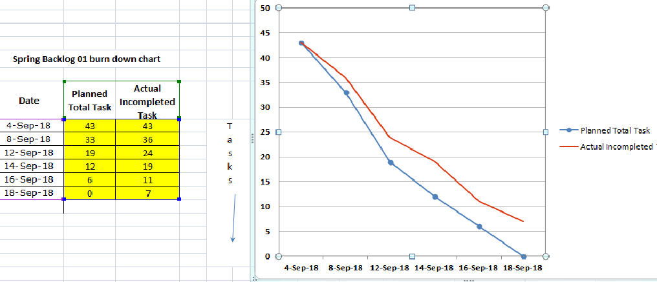

Figure 2.1

**Sprint Backlog-2**

Under Sprint Backlog 2- User Story 1 our first task is to creating dataset of faces for attendance, and this task will be done by (GK and RK). Then second task is to identifying and matching captured images from database and this task will be done by (HC, GK, RK). Our third task is to learn about the methods of capturing videos and extracting snaps from it and then apply and this task will be done by (HC, GK, RK). In User Story 2 our first task is to learn and apply the video meta data extraction and this will be done by (HC, GK, RK). And then our second task is to learn and apply the Fast and robust extraction key methods. And then our third task is to learn and apply the methods of extraction for images from videos. Fourth task under this is to learn about the methods of matching extracted images from dataset using some algorithms. And then our fifth task is giving unique id to all the members of the dataset. And these all will be done by (HC, GK, RK). In User story 3 our first task is to displaying of Ids when face from video is matched with dataset and this will done by (HC, GK, RK).

|  |  |  |  |
| --- | --- | --- | --- |
| SB2/US1 | I will create dataset of faces beforehand for attendence(database), where attendence will be marked | SB2/US1/T1 | Data set consisting of all the students in a class |
| SB2/US1/T2 | Dataset of time table |
| SB2/US2 | Identifying and matching captured images from database | SB2/US2/T1 | Assigning Ids to the faces in dataset |
| SB2/US2/T2 | Check faces with Ids |
| SB2/US2/T3 | If matched than mark attendence |
| SB2/US3 | Videos will be captured | SB2/US3/T1 | Making video for span of time |
| SB2/US4 | Frames with clearer images will be extracted from the video | SB2/US4/T1 | Fast and robust extraction key method algorithms |
| SB2/US4/T2 | Implementing and extracting images |
| SB2/US4/T3 | Matching images with dataset |
| SB2/US4 | Matching extracted images from the dataset (using same algos mentioned above) | SB2/US5/T1 | Using algorithms |
| SB2/US6/T2 | Fast and robust extraction key method |
| SB2/US5 | Giving unique id to all the members of dataset and this unique id will be used to mark attendence against them | SB2/US7/T1 | Assigning unique ids to datasets |
| SB2/US7/T2 | It will be used to match faces and mark attendence |
| SB2/US6 | Displaying of Ids when face from video is matched with dataset | SB2/US8/T1 | Mark if face is matched with ids |
| SB2/US8/T2 | Display attendence |

Table 2.3

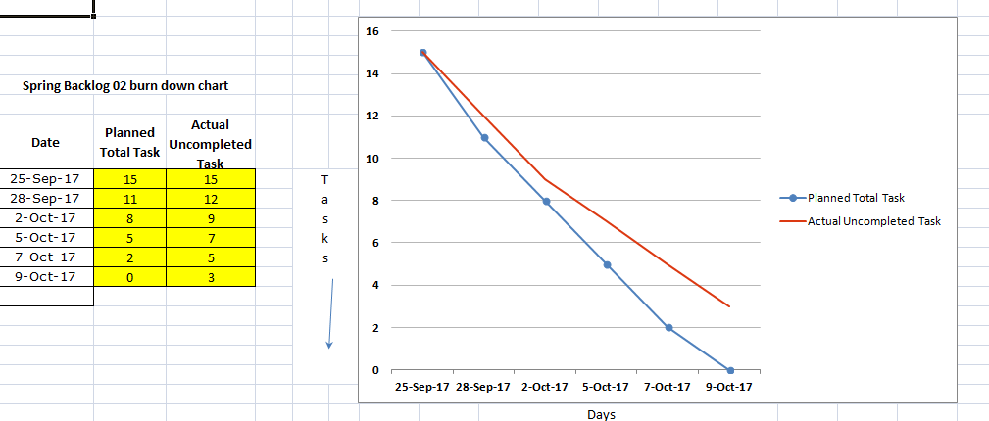

Figure 2.2

**Sprint Backlog-3**

Under Sprint Backlog 3- User Story 1 our first task is making of attendance sheet with the database which will be done by (GK). The second task is to creating the work space and this will be done by (GK). And then our third task is to design GUI for the sheet and this will be done by (RK and GK).

In User Story 2 our first task is to making the class wise dataset that will be done by (HC and GK). Second task under it to connecting GUI with database and that will be done by GK. Our third task under it is to connecting video extraction with database and this will be done by (HC and RK). The fourth task is to prepare the list of all subjects and that will be done by HC. Fifth task under this is to apply methods of login for individual subject attendance and that will be done by (HC and GK).

In User Story 3 our first task is to showing output from database and second task is to mark the attendance for particular class and that will be done by (HC and GK).

|  |  |  |  |
| --- | --- | --- | --- |
| SB3\US1 | I will prepare an attendence sheet where attendence will be marked | SB3\US1\T1 | I will prepate a sheet containg datas of students so that I can use it while marking attendence |
| SB3\US1\T3 | If the face is recognized and matched attence will be marked in data sheet |
| SB3\US2 | I will require work space where images of students will be stored as dataset | SB2\US2\T1 | Workspace will be required to store dataset as images |
| SB3\US2\T2 | Database will be connected to datasets |
| SB3\US2\T3 | Also I will store temporary images while marking attendence and matching faces |
| SB3\US3 | Design GUI of the system | SB3\US3\T1 | User interface will be required so that faculty can login and get attendence |
| SB3\US3\T2 | That login page will be secured with user name and password |
| SB3\US4 | Making class wise database, which will used for attendence of that particular class | SB3\US4\T1 | There will be a separate sheet for each class so that markings can be seperated |
| SB3\US4\T2 | There will also a separate database table for each of the class. |
| SB3\US4\T3 | That sheet of the particular class will connect with its database table. |
| SB3\US5 | Connecting GUI with the database | SB3\US5\T1 | The designed GUI will connected in database |
| SB3\US6 | Connecting vedio extraction | SB3\US6\T1 | System will select the vedio |
| SB3\US6\T2 | The perfect snapshot of that vedio will taken by the system |
| SB3\US6\T3 | That snapshot/small vedio will connected through the database. |
| SB3\US7 | List of all the subjects | SB3\US7\T1 | Create the list of all the subjects along with the faculty name. |
| SB3\US7\T2 | Connect that list with database |
| SB3\US7\T3 | List will be displayed in database table. |
| SB3\US8 | Login for individual subject attendence | SB3\US8\T1 | Login will required for each of the subject |
| SB3\US8\T2 | Admin will has right to login every time |
| SB3\US9 | Marking of attendence as per lectures | SB3\US9\T1 | Attendence will mark according to matched face in databse |
| SB3\US9\T2 | Marking attendence will display in database table |
| SB3\US9\T3 | A sheet of that attendence will be updated |
| SB3\US10 | Showing output in database | SB3\US10\T1 | A sheet with marked attendence will display in the database. |
|  |  |  |  |

Table 2.4

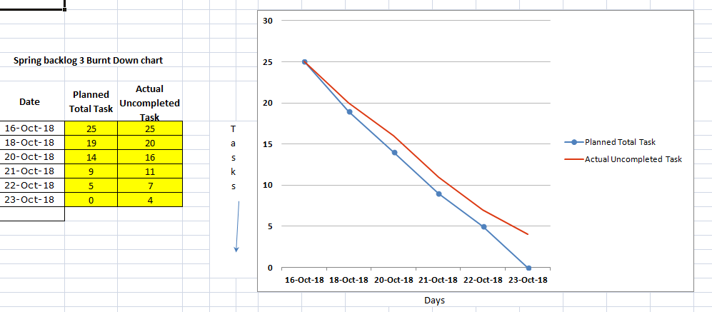

Figure 2.3

**Sprint Backlog-4**

Under Sprint Backlog 4 – User Story 1 our first task is to implement the software over hardware that will be done by (GK and RK). The second task is to connect all setups and camera with the system and that will be done by (GK and RK). And then our third task under this is to implement the system in the department and this will be done by (GK, RK, HC). First task under User Story 2 this is to track the accuracy of the working of the system and that will be done by (HC, RK, GK). And the second task under it is to find issues if any appear and resolve it as soon as possible and that will be done by (HC, RK, GK). And the third task is implement the system again after resolving the problem and that will be done by (HC, RK, GK).

|  |  |  |  |
| --- | --- | --- | --- |
| SB4/US1 | I want to implementation the software on the hardware | SB4\US1\T1 | Select a proper hardware apparatuses. |
| SB4\US1\T2 | Combine them together as a proper system. |
| SB4\US1\T3 | Implement the software on hardware system. |
| SB4/US2 | I want to connect the camera | SB4\US2\T1 | Selection of camera according to their quality and features. |
| SB4\US2\T2 | Connect the camera with rerspective devices. |
| SB4\US2\T3 | Implement program using camera (testing). |
| SB4/US3 | I want to implement this project in the college | SB4\US3\T1 | There will be a proper and final connection between camera and other  devices. |
| SB4\US3\T2 | The camera get mounted in every classrooms. |
| SB4\US3\T3 | Setup of system will be done properly. |
| SB4\US3\T4 | Test the whole project as hardware and software system both. |
| SB4/US4 | I want to track the accuracy and working | SB4\US4\T1 | Find out whether the system is accurate with their working or not. |
| SB4\US4\T2 | Find out whether the system works on time or not. |
| SB4\US4\T3 | Find out the time consumed by system. |
| SB4/US5 | I will find issues if any one is present there | SB4\US5\T1 | Find out any issue if occurs in the hardware system. |
| SB4\US5\T2 | Find out any issue if occurs in the software system. |
| SB4\US5\T3 | We will try to catch the errors if any present in their in program. |
| SB4\US5\T4 | We will find if any updates are required or not. |
| SB4/US6 | I will resolve the issues as per their requirements. | SB4\US6\T1 | Solve the issues related with the hardware system accordingly. |
| SB4\US6\T2 | Solve the issues related with the software system accordingly. |
| SB4\US6\T3 | Resolve all the errors present in the program. |
| SB4\US6\T4 | We will make update according to the requirements of the user. |
| SB4/US7 | I will implement system again after modification and testing | SB4\US7\T1 | After making all the modification the system get test again. |
| SB4\US7\T2 | After testing the system get set up according to the requirements. |
| SB4\US7\T3 | Implementation of the system occurs again. |
|  |  |  |  |

Table 2.5

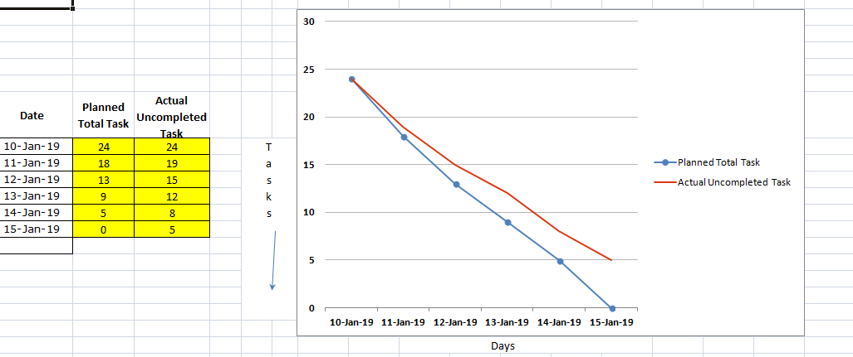

Figure 2.4

**CHAPTER 3**

**TECHNOLOGY APPLIED AND PROJECT MANAGEMENT**

**Automatic Face Detection:**

In the 21st century, everything around us has become depends upon technology to make our life much easier. Daily tasks are continuously becoming computerized. Nowadays more people prefer to do their work electronically. To the best of our knowledge, the process of recording students’ attendance at the university is still manual. Lecturers go through manual attendance sheets and signed papers to record attendance. This is slow, inefficient and time consuming. The main objective of this project is to offer system that simplify and automate the process of recording and tracking students’ attendance through face recognition technology. It is biometric technology to identify or verify a person from a digital image or surveillance video. Face recognition is widely used nowadays in different areas such as universities, banks, airports, and offices. We will use preprocessing techniques to detect, recognize and verify the captured faces like Eigenfaces method. We aim to provide a system that will make the attendance process faster and more precisely. The core problem is identified along with solutions and project path. Furthermore, detailed system analysis and design, user interface, methods and the estimated results are presented through our documentation.

**LITERATURE SURVEY**

Image processing is consists of the input image, a photograph; the output of may be an image or a set of characteristics or parameters respect to the image. Image processing is classified into two types. They are,

1. Analog image processing
2. Digital image processing

Two dimensional analog signals is processed by analog image processing. Digital image processing is the use of computer algorithms or image processing on digital images. Digital image processing is performed on a two dimensional image by a digital computer.

Facial recognition technology is a new way of identify people. It works by picking faces out of a crowd, obtaining the measurements and comparing it to the images already present in the database. The manual method will be replaced by automatic attendance system , which is takes a lot of time and is hard to maintain. In general, there are two known approaches to HFR, i.e. feature-based and brightness-based approach. The feature-based approach uses key point features of the face, such as edges, eyes, nose, mouth, or other special characteristics. Therefore, the calculation process only covers some parts of the given image that have been extracted previously. On the other hand, the brightness-based approach calculates all parts of the given image. It is also known as holistic-based or image-based approach.

**Eigenface Approach**

Eigenface approach is used ,it transforms faces into a set of characteristics, eigenfaces which is considered as training data. Recognition is done by projecting a new image in the eigenface subspace, in which person is classified by comparing its position in eigenface space with the position of known individuals.

**Hard ware**

Camera Specifications

Pan Angle: 360 degree

Connectivity: Ethernet, Fireware

Focus Range: 100-150 cm

It has Night Vision and

Devices: Laptop, PC

Video Sensor Resolution : 1280*720 pixel

Still Image Sensor Resolution: 720 MPHD

**ALGORITHMS**

* **Haar Cascading Algorithm**

It is a machine learning based approach where a cascade function is trained from a lot of positive and negative images. It is then used to detect objects in other images.

Here we will work with face detection. Initially, the algorithm needs a lot of positive images (images of faces) and negative images (images without faces) to train the classifier. Then we need to extract features from it. For this, haar features shown in below image are used. They are just like our convolution kernel. Each feature is a single value obtained by subtracting sum of pixels under white rectangle from sum of pixels under black rectangle.

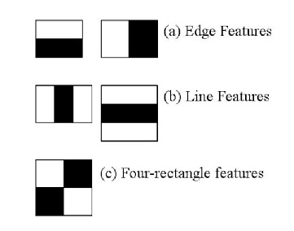

Figure 3.1

OpenCV comes with a trainer as well as detector. If you want to train your own classifier for any object like car, planes etc. you can use OpenCV to create one

Here we will deal with detection. OpenCV already contains many pre-trained classifiers for face, eyes, smile etc. Those XML files are stored in opencv/data/haarcascades/ folder. Let's create face and eye detector with OpenCV.

First we need to load the required XML classifiers. Then load our input image (or video) in grayscale mode.

 import numpy as np

 import cv2

face_cascade = cv2.CascadeClassifier('haarcascade_frontalface_default.xml')

 eye cascade = cv2.CascadeClassifier('haarcascade_eye.xml')

 img = cv2.imread('sachin.jpg')

 gray = cv2.cvtColor(img, cv2.COLOR_BGR2GRAY)

Now we find the faces in the image. If faces are found, it returns the positions of detected faces as Rect(x,y,w,h). Once we get these locations, we can create a ROI for the face and apply eye detection on this ROI (since eyes are always on the face !!! ).

faces = face_cascade.detectMultiScale(gray, 1.3, 5)

for (x,y,w,h) in faces:

cv2.rectangle(img,(x,y),(x+w,y+h),(255,0,0),2)

roi_gray = gray[y:y+h, x:x+w]

roi_color = img[y:y+h, x:x+w]

eyes = eye_cascade.detectMultiScale(roi_gray)

for (ex,ey,ew,eh) in eyes:

cv2.rectangle(roi_color,(ex,ey),(ex+ew,ey+eh),(0,255,0),2)

cv2.imshow('img',img)

cv2.waitKey(0)

cv2.destroyAllWindows()

* **LBPH Algorithm**

**Local Binary Pattern** (LBP) is a simple yet very efficient texture operator which labels the pixels of an image by thresholding the neighborhood of each pixel and considers the result as a binary number.

It was first described in 1994 (LBP) and has since been found to be a powerful feature for texture classification. It has further been determined that when LBP is combined with histograms of oriented gradients (HOG) descriptor, it improves the detection performance considerably on some datasets.

Using the LBP combined with histograms we can represent the face images with a simple data vector. As LBP is a visual descriptor it can also be used for face recognition tasks

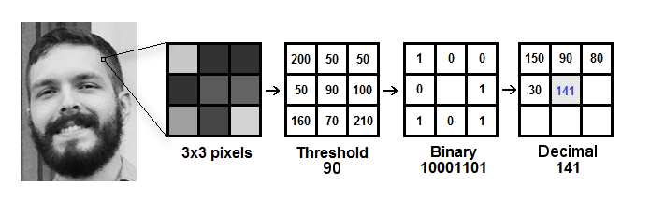

Figure 3.2

* **PCA using Eigen Values**

Principal Component Analysis does just what it advertises; it finds the principal components of the dataset. PCA transforms the data into a new, lower-dimensional subspace—into a new coordinate system—. In the new coordinate system, the first axis corresponds to the first principal component, which is the component that explains the greatest amount of the variance in the data.

Each eigenvector has a corresponding eigenvalue. An eigenvalue is a scalar. Recall that an eigenvector corresponds to a direction. The corresponding eigenvalue is a number that indicates how much variance there is in the data along that eigenvector (or principal component).

In other words, a larger eigen value means that that principal component explains a large amount of the variance in the data.

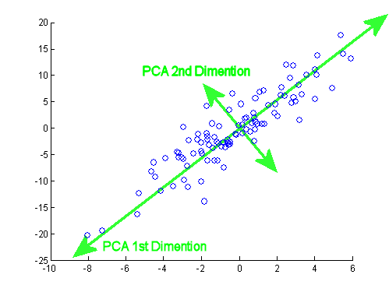

Figure 3.3

* **K-means Algorithm**

k-means is  one of  the simplest unsupervised  learning  algorithms  that  solve  the well  known clustering problem. The procedure follows a simple and  easy  way  to classify a given data set  through a certain number of  clusters (assume k clusters) fixed apriori. The  main  idea  is to define k centers, one for each cluster. These centers  should  be placed in a cunning  way  because of  different  location  causes different  result. So, the better  choice  is  to place them  as  much as possible  far away from each other. The  next  step is to take each point belonging  to a  given data set and associate it to the nearest center. When no point  is  pending,  the first step is completed and an early group age  is done. At this point we need to re-calculate k new centroids as barycenter of  the clusters resulting from the previous step. After we have these k new centroids, a new binding has to be done  between  the same data set points  and  the nearest new center. A loop has been generated. As a result of  this loop we  may  notice that the k centers change their location step by step until no more changes  are done or  in  other words centers do not move any more. Finally, this  algorithm  aims at  minimizing  an objective function know as squared error function given by:

[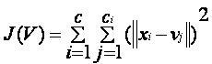](https://sites.google.com/site/dataclusteringalgorithms/k-means-clustering-algorithm/kmeans.JPG?attredirects=0)

* **Wavelet Transformation**

The wavelet transform is similar to the Fourier transform (or much more to the windowed Fourier transform) with a completely different merit function. The main difference is this: Fourier transform decomposes the signal into sines and cosines, i.e. the functions localized in Fourier space; in contrary the wavelet transform uses functions that are localized in both the real and Fourier space. Generally, the wavelet transform can be expressed by the following equation:

http://gwyddion.net/documentation/user-guide-en/eq-wavelet-transform-continuous.png

where the * is the complex conjugate symbol and function ψ is some function. This function can be chosen arbitrarily provided that it obeys certain rules.

As it is seen, the Wavelet transform is in fact an infinite set of various transforms, depending on the merit function used for its computation. This is the main reason, why we can hear the term “wavelet transform” in very different situations and applications. There are also many ways how to sort the types of the wavelet transforms. Here we show only the division based on the wavelet orthogonality. We can use orthogonal wavelets for discrete wavelet transform development and non-orthogonal wavelets for continuous wavelet transform development. These two transforms have the following properties:

1. The discrete wavelet transform returns a data vector of the same length as the input is. Usually, even in this vector many data are almost zero. This corresponds to the fact that it decomposes into a set of wavelets (functions) that are orthogonal to its translations and scaling. Therefore we decompose such a signal to a same or lower number of the wavelet coefficient spectrum as is the number of signal data points. Such a wavelet spectrum is very good for signal processing and compression, for example, as we get no redundant information here.
2. The continuous wavelet transform in contrary returns an array one dimension larger than the input data. For a 1D data we obtain an image of the time-frequency plane. We can easily see the signal frequencies evolution during the duration of the signal and compare the spectrum with other signals spectra. As here is used the non-orthogonal set of wavelets, data are highly correlated, so big redundancy is seen here. This helps to see the results in a more humane form.

* Image Procurement

Image Procurement is also called as image acquisition. The picture is settled that of the pixels that are collected.

* Scatter image normalisation

The spitting image that is taken rarely consume brilliance else dimness that is used for decent results. The key is the RGB one. The picture then renovated grey picture the progress.

* Noise clarifying method:

There may exist a lot of causes of sound in the participation image when we take picture with the camera. Many methods available there is one method that is low permit clarifying in the frequency area it might be a virtuous choice but this also leads to the elimination of some significant information in image. Medium cleaning is used in our system for the reason for sound dismissal in form of normalized spitting image.

* Attendance and face recognition

Next stage that used after the image recognition method is face identification method. It can be accomplished by collecting the image that is first identified face from image then is matched with images that are in the database. In this manner the images the learners are verified one after another with record

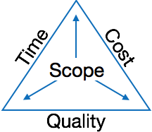

The image above shows triple constraints for automatic face recognition attendance system. It is an essential part of software organization to deliver quality product, keeping the cost within client’s budget constrain and deliver the project as per scheduled. There are several factors, both internal and external, which may impact this triple constrain triangle. Any of three factor can severely impact the other two.

Therefore, software project management is essential to incorporate user requirements along with budget and time constraints.

**Managing People**

* Act as project leader
* Liaison with stakeholders
* Managing human resources
* Setting up reporting hierarchy etc.

**Managing Project**

* Defining and setting up project scope
* Managing project management activities
* Monitoring progress and performance
* Risk analysis at every phase
* Take necessary step to avoid or come out of problems
* Act as project spokesperson

**Software Management Activities**

Software project management comprises of a number of activities, which contains planning of project, deciding scope of software product, estimation of cost in various terms, scheduling of tasks and events, and resource management. Project management activities may include:

* **Project Planning**
* **Scope Management**
* **Project Estimation**

**Project Planning**

Software project planning is task, which is performed before the production of software actually starts. It is there for the software production but involves no concrete activity that has any direction connection with software production; rather it is a set of multiple processes, which facilitates software production. Project planning may include the following:

**Scope Management**

It defines the scope of project; this includes all the activities, process need to be done in order to make a deliverable software product. Scope management is essential because it creates boundaries of the project by clearly defining what would be done in the project and what would not be done. This makes project to contain limited and quantifiable tasks, which can easily be documented and in turn avoids cost and time overrun.

During Project Scope management, it is necessary to -

* Define the scope
* Decide its verification and control
* Divide the project into various smaller parts for ease of management.
* Verify the scope
* Control the scope by incorporating changes to the scope

**Project Estimation**

For an effective management accurate estimation of various measures is a must. With correct estimation managers can manage and control the project more efficiently and effectively.

Project estimation may involve the following:

* **Software size estimation**

Software size may be estimated either in terms of KLOC (Kilo Line of Code) or by calculating number of function points in the software. Lines of code depend upon coding practices and Function points vary according to the user or software requirement.

* **Effort estimation**

The managers estimate efforts in terms of personnel requirement and man-hour required to produce the software. For effort estimation software size should be known. This can either be derived by managers’ experience, organization’s historical data or software size can be converted into efforts by using some standard formulae.

* **Time estimation**

Once size and efforts are estimated, the time required to produce the software can be estimated. An effort required is segregated into sub categories as per the requirement specifications and interdependency of various components of software. Software tasks are divided into smaller tasks, activities or events by Work Breakthrough Structure (WBS). The tasks are scheduled on day-to-day basis or in calendar months.

The sum of time required to complete all tasks in hours or days is the total time invested to complete the project.

* **Cost estimation**

This might be considered as the most difficult of all because it depends on more elements than any of the previous ones. For estimating project cost, it is required to consider -

* + Size of software
  + Software quality
  + Hardware
  + Additional software or tools, licenses etc.
  + Skilled personnel with task-specific skills
  + Travel involved
  + Communication
  + Training and support

**Project Estimation Techniques**

We discussed various parameters involving project estimation such as size, effort, time and cost.Project manager can estimate the listed factors using two broadly recognized techniques

**Decomposition Technique**

This technique assumes the software as a product of various compositions.

There are two main models -

* **Line of Code** Estimation is done on behalf of number of line of codes in the software product.
* **Function Points** Estimation is done on behalf of number of function points in the software product.

**Empirical Estimation Technique**

This technique uses empirically derived formulae to make estimation.These formulae are based on LOC or FPs.

* **Putnam Model**

This model is made by Lawrence H. Putnam, which is based on Norden’s frequency distribution (Rayleigh curve). Putnam model maps time and efforts required with software size.

* **COCOMO**

COCOMO stands for COnstructiveCOstMOdel, developed by Barry W. Boehm. It divides the software product into three categories of software: organic, semi-detached and embedded.

**Project Scheduling**

Project Scheduling in a project refers to roadmap of all activities to be done with specified order and within time slot allotted to each activity. Project managers tend to define various tasks, and project milestones and they arrange them keeping various factors in mind. They look for tasks lie in critical path in the schedule, which are necessary to complete in specific manner and strictly within the time allocated. Arrangement of tasks which lies out of critical path are less likely to impact over all schedule of the project.

For scheduling a project, it is necessary to -

* Break down the project tasks into smaller, manageable form
* Find out various tasks and correlate them
* Estimate time frame required for each task
* Divide time into work-units
* Assign adequate number of work-units for each task
* Calculate total time required for the project from start to finish

**Resource management**

All elements used to develop a software product may be assumed as resource for that project. This may include human resource, productive tools and software libraries.

The resources are available in limited quantity and stay in the organization as a pool of assets. The shortage of resources hampers the development of project and it can lag behind the schedule. Allocating extra resources increases development cost in the end. It is therefore necessary to estimate and allocate adequate resources for the project.

Resource management includes -

* Defining proper organization project by creating a project team and allocating responsibilities to each team member
* Determining resources required at a particular stage and their availability
* Manage Resources by generating resource request when they are required and de-allocating them when they are no more needed.

**Project Risk Management**

Risk management involves all activities pertaining to identification, analysing and making provision for predictable and non-predictable risks in the project. Risk may include the following:

* Experienced staff leaving the project and new staff coming in.
* Change in organizational management.
* Requirement change or misinterpreting requirement.
* Under-estimation of required time and resources.
* Technological changes, environmental changes, business competition.

**Risk Management Process**

There are following activities involved in risk management process:

* **Identification -** Make note of all possible risks, which may occur in the project.
* **Categorize -** Categorize known risks into high, medium and low risk intensity as per their possible impact on the project.
* **Manage -** Analyze the probability of occurrence of risks at various phases. Make plan to avoid or face risks. Attempt to minimize their side-effects.
* **Monitor -** Closely monitor the potential risks and their early symptoms. Also monitor the effects of steps taken to mitigate or avoid them.

**Project Execution & Monitoring**

In this phase, the tasks described in project plans are executed according to their schedules.

Execution needs monitoring in order to check whether everything is going according to the plan. Monitoring is observing to check the probability of risk and taking measures to address the risk or report the status of various tasks.

These measures include -

* **Activity Monitoring -** All activities scheduled within some task can be monitored on day-to-day basis. When all activities in a task are completed, it is considered as complete.
* **Status Reports -** The reports contain status of activities and tasks completed within a given time frame, generally a week. Status can be marked as finished, pending or work-in-progress etc.
* **Milestones Checklist -** Every project is divided into multiple phases where major tasks are performed (milestones) based on the phases of SDLC. This milestone checklist is prepared once every few weeks and reports the status of milestones.

**Project Communication Management**

Effective communication plays vital role in the success of a project. It bridges gaps between client and the organization, among the team members as well as other stake holders in the project such as hardware suppliers.

Communication can be oral or written. Communication management process may have the following steps:

* **Planning** - This step includes the identifications of all the stakeholders in the project and the mode of communication among them. It also considers if any additional communication facilities are required.
* **Sharing** - After determining various aspects of planning, manager focuses on sharing correct information with the correct person on correct time. This keeps every one involved the project up to date with project progress and its status.
* **Feedback** - Project managers use various measures and feedback mechanism and create status and performance reports. This mechanism ensures that input from various stakeholders is coming to the project manager as their feedback.
* **Closure** - At the end of each major event, end of a phase of SDLC or end of the project itself, administrative closure is formally announced to update every stakeholder by sending email, by distributing a hardcopy of document or by other mean of effective communication.

After closure, the team moves to next phase or project.

**Configuration Management**

Configuration management is a process of tracking and controlling the changes in software in terms of the requirements, design, functions and development of the product.

IEEE defines it as “the process of identifying and defining the items in the system, controlling the change of these items throughout their life cycle, recording and reporting the status of items and change requests, and verifying the completeness and correctness of items”.

Generally, once the SRS is finalized there is less chance of requirement of changes from user. If they occur, the changes are addressed only with prior approval of higher management, as there is a possibility of cost and time overrun.

**Project management Tools:**

Project management required tools to manage the work , time and resources. At present many of the software are available for project management. Some of the popular software tools are as follows.

### 01. [Trello](http://send.getapp.com/aff_c?offer_id=677&aff_id=1371)

Trello is an project management tool, instead this app is a free visual way to to glance at the entire project with a single view. With Trello you can organise cards, these cards can be your thoughts, conversations and to-do lists and be placed on a board for everyone to collaborate on.

### 02. [Basecamp](http://send.getapp.com/aff_c?offer_id=637&aff_id=1371)

Basecamp is the granddaddy of project management apps. Basecamp is considered the leading project management tool around. It boost a simple and easy to use interface to collaborate with your team and client. It allows you to create multiple projects and setup discussions, write to-do lists, manage files, create and share documents, and organise dates for scheduling.

### 03. [Teamwork Projects](http://send.getapp.com/aff_c?offer_id=947&aff_id=1371)

Teamwork Projects is the ultimate productivity tool to manage projects with your team. Teamwork allows you to keep all your projects, tasks and files all in one place and easily collaborate with a team. Teamwork helps you to visualise the entire project through a marked calendar and gantt chart and setup reporting. Teamwork supports file management with Google Drive, Box.com and Dropbox. As well as integration with leading apps such as third party accounting software and customer support apps.

### 04. [Resource Guru](https://resourceguruapp.com/)

Billed as the "simple way to schedule people, equipment and other resources", Resource Guru is a streamlined resource scheduling and leave management tool that’s designed to keep your projects on track. You can plan your team's workloads, receive daily booking reminders, report on KPIs, and more. Apple, Saatchi & Saatchi and Deloitte are among some of the cloud-based team calendar’s heavyweight customers.

### 05. [ActiveCollab](http://send.getapp.com/aff_c?offer_id=949&aff_id=1371)

ActiveCollab recently released its new version 5.0. The new revamped app is now more powerful and focused project management tool. It offers team collaborating features, task management, time tracking and importing expenses. One of the biggest asset of ActiveCollab is it offers invoicing features. You are able to track payments and expenses and have invoices paid directly within ActiveCollab with PayPal, and other credit card payments.

### 06. [Zoho Projects](http://send.appdoubler.com/aff_c?offer_id=101&aff_id=1371)

Zoho offers a wide range of business software including Projects. Zoho Projects is an proficient tool to project plan and project coordinator from start to finish. It boost all the features you need for project management with some advance features including reporting, integration with Google Apps and Dropbox, bug tracking, setup Wiki Pages to build a repository of information, forums and more.

### 07. [Jira](http://send.getapp.com/aff_c?offer_id=281&aff_id=1371)

Jira is specifically targeted for software development teams. Jira offers abilities to raise issues and bugs. Jira makes it real easy to track bugs and see which issues are still outstanding and how much time was spent on each task. Jira offer other products including Confluence a document collaboration tool, and HipChat a team chat and video and file sharing platform and other products.

### 08. [Asana](http://send.getapp.com/aff_c?offer_id=587&aff_id=1371)

Asana is the easiest way for teams to track their work so everyone knows who's doing what, by when. With tasks, projects, conversations and dashboards, Asana keeps your work organized, and teammates accountable so you can move work forward faster. Asana also lets you keep track of your work wherever you are with mobile apps for both iOS and Android.

### 09. [Podio](http://send.getapp.com/aff_c?offer_id=951&aff_id=1371)

Podio is a ever growing tool to organise and communication tool for any business. Podio allows you to personalise this platform to fit your business needs. Besides being able to communicate with a team, setup task management, use as a file storage system, like a traditional project management app, Podio can be an internal intranet for all your colleagues and departments to interact.

### 10. [Freedcamp](https://freedcamp.com/)

Whatever your project may be, either setting up an event, a web project or organising a wedding, Freedcamp helps you organise and plan effectively. Freedcamp has an organised dashboard to view the entire project at a glance. You can easily setup tasks, use sticky notes to visually setup tasks and organise them into the calendar. Freedcamp provides advance add-ons for high level business use including CRM, invoicing, issue tracking and setting up wiki pages.

### 11. [Wrike](http://send.getapp.com/aff_c?offer_id=239&aff_id=1371)

Wrike is advance application to help you work smarter. By making sure you are always staying on track and ensure you have the adequate resources to finish on time and on budget.Setting up tasks, engage your team and integrate with your business tools including Google Apps, Microsoft Excel, Dropbox and many more is so easy with Wrike.

**PO and Their Relevance to project**

**PO1: Engineering knowledge:**Apply the knowledge of mathematics, science, engineering fundamentals and an engineering specialization to the solution of complex engineering problems.

In this project creation process engineering knowledge of the software engineering and Electronics engineering have been applied. we have used software engineering , HTML,xml, java , android , java script , php , j2ee, data base , oracle , my sql , mango and other programming language and database to the project. We have applied all above engineering subjects in our projects.

**PO2: Problem analysis:**Identify, formulate, review research literature, and analyze complex engineering problems reaching substantiated conclusions using first principles of mathematics, natural sciences, and engineering sciences.

In our projects we have identified an problem , once verified by the client we have worked to identify the solution using all of our theoretical and practical knowledge.

**PO3: Design/development of solutions:** Design solutions for complex engineering problems and design system components or processes that meet the specified needs with appropriate consideration for the public health and safety, and the cultural, societal, and environmental considerations.

**PO4: Conduct investigations of complex problems:** Use research-based knowledge and research methods including design of experiments, analysis and interpretation of data, and synthesis of the information to provide valid conclusions.

**PO5: Modern tool usage:**Create, select, and apply appropriate techniques, resources, and modern engineering and IT tools including prediction and modeling to complex engineering activities with an understanding of the limitations.

In the project development we have applied Integrated Development Environment IDE for the rapid development of the code, used web server for the software development.

**PO6: The engineer and society**: Apply reasoning informed by the contextual knowledge to assess societal, health, safety, legal and cultural issues and the consequent responsibilities relevant to the professional engineering practice.

In 1961 , the Conference of Engineering Societies of Western Europe and the United States of America defined "professional engineer" as follows.

A professional engineer is competent by virtue of his/her fundamental education and training to apply the scientific method and outlook to the analysis and solution of engineering problems. He/she is able to assume personal responsibility for the development and application of engineering science and knowledge, notably in research, design, construction, manufacturing, superintending, managing and in the education of the engineer. His/her work is predominantly intellectual and varied and not of a routine mental or physical character. It requires the exercise of original thought and judgement and the ability to supervise the technical and administrative work of others. His/her education will have been such as to make him/her capable of closely and continuously following progress in his/her branch of engineering science by consulting newly published works on a worldwide basis, assimilating such information and applying it independently. He/she is thus placed in a position to make contributions to the development of engineering science or its applications. His/her education and training will have been such that he/she will have acquired a broad and general appreciation of the engineering sciences as well as thorough insight into the special features of his/her own branch. In due time he/she will be able to give authoritative technical advice and to assume responsibility for the direction of important tasks in his/her branch.

**PO7: Environment and sustainability:** Understand the impact of the professional engineering solutions in and environmental contexts, and demonstrate the knowledge of, and need for sustainable development.

Sustainability is the ability to continue a defined behavior indefinitely. Sometimes environmental, social and economic are termed to be the three pillars of sustainability.

**PO8: Ethics**: Apply ethical principles and commit to professional ethics and responsibilities and norms of the engineering practice

The ethics of engineers and the fundamental principles for Engineers are as follows.

Engineers uphold and advance the integrity, honor and dignity of the engineering profession by:

I. using their knowledge and skill for the enhancement of human welfare;

II.being honest and impartial, and servicing with fidelity the public, their employers and clients;

III. Striving to increase the competence and prestige of the engineering profession; and

IV. Supporting the professional and technical societies of their disciplines.   
  
  
**PO9. Individual and team work**: Function effectively as an individual and as a member or leader in diverse teams, and in multidisciplinary settings.  
  
  
To work successful in team a team member must have following capabilities.

**1. The Ability to Listen**

it is important to listen to one another's ideas. Too often in a business setting, you have a group of people simply waiting for their turn to speak, not paying one iota of attention to the persons on their left or right. So it is a good teamwork skill to have the ability to listen

**2. Check Your Ego**

This isn't saying abandon your ego all together, because that isn't healthy. But leaving your ego at the door temporarily is a very important team work skill. The reason this is so essential is because there is always someone better than you at something, no matter how brilliant you are.

**3. Critique**

By critique, I mean constructive criticism. Be able to give others constructive criticism and be able to listen to others critique your ideas and work. There shouldn't be any offense taken to constructive criticism. You all want to succeed, and this is a vital step in doing so.

**4. Delegation**

The mentality must be applied to teamwork. Delegate roles to those who do them best.

**5. Show Respect**

If you and another person happen to be paired up and can't stand each other, you can still put that aside for a couple of hours, treat each other civilly, and complete the tasks at hand. You may even overcome the dislike toward one another.

**6. Be Helpful**

This is simple.If one of your teammates does not understand an idea, discussion, or task that is being completed, take the necessary time to explain it to them and work with them. There are no weak links when everyone helps one another. Some take longer to learn than others, but that doesn't mean that they are of less intelligence. If in a meeting someone asks a question because they don't understand, don't frown at them. Just answer the questions patiently and concisely.

**7. Question One Another**

If someone brings up a topic of discussion and a solution to this topic, question them. Respectfully question, don't badger. Rather, ask them how it will work, why it will work over the long-run, and how everyone else can implement the idea.

**8. Participation**

Have the entire team encourage shy people to engage in the topics of discussion. Don't demand it, but make them realize that you really want to hear their ideas.

**9. Rational Debate**

Bad ideas are bad for teams. Spirited, friendly, rational debate is where facts come forward, ideas are born, and quality rises to the top.

**10. Set The Right Environment**

Try to make the space in which your team is assembled as comfortable, relaxing, and inviting as possible. You do not want your team to be tense and with frayed nerves.

**PO 10: Communication:**Communicate effectively on complex engineering activities with the engineering community and with society at large, such as, being able to comprehend and write effective reports and design documentation, make effective presentations, and give and receive clear instructions.

**PO11: Project management and finance:**Demonstrate knowledge and understanding of the engineering management principles and apply these to one’s own work, as a member and leader in a team, to manage projects and in multidisciplinary environments.

Project management is the application of processes, methods, knowledge, skills and experience to achieve the project objectives. In general project is a unique, transient endeavour, undertaken to achieve planned objectives, which could be defined in terms of outputs, outcomes or benefits.

**PO12: Life-long learning**: Recognize the need for and have the preparation and ability to engage in independent and lifelong learning in the broadest context of technological change.

Life Long Learning means is the provision or use of both formal and informal learning opportunities throughout people's lives in order to foster the continuous development and improvement of the knowledge and skills needed for employment and personal fulfillment.

**CHAPTER 4**

**PROJECT IMPLEMENTATION**

1. **Sprint Backlog-1**  
   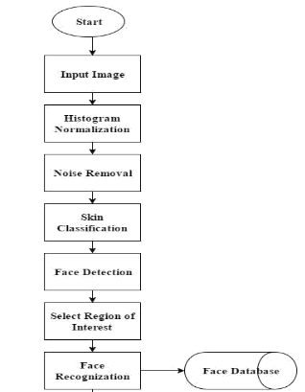

Figure 4.1

import cv2

import numpy as np

faceDetect=cv2.CascadeClassifier('haarcascade_frontalface_default.xml');

#faceDetect=cv2.CascadeClassifier('haarcascade_eye.xml');

cam=cv2.VideoCapture(0);

sampleNo=0;

#identifier

id=input('Enter user id')

while(True):

ret,img=cam.read()

gray=cv2.cvtColor(img,cv2.COLOR_BGR2GRAY)

faces=faceDetect.detectMultiScale(gray,1.3,5);

for(x,y,w,h) in faces:

sampleNo=sampleNo+1

cv2.imwrite("dataset/User."+str(id)+"."+str(sampleNo)+".jpg",gray[y:y+h,x:x+w])

cv2.rectangle(img,(x,y),(x+w,y+h),(0,255,0),2)

cv2.waitKey(100);

cv2.imshow("face",img)

cv2.waitKey(1);

if(sampleNo>100):

break;

cam.release()

cv2.destroyAllWindows()

1. **Sprint Backlog-2**

#to find path of images

import os

import cv2

import numpy as np

from PIL import Image

#create a recognizer

recognizer=cv2.face.LBPHFaceRecognizer_create();

path='dataset'

#create a method to get images

def getImagesWithId(path):

imagePath=[os.path.join(path,f) for f in os.listdir(path)]

# print (imagePath)

faces=[]

IDs=[]

for imgPath in imagePath:

#convert image in numpy array

faceImg=Image.open(imgPath).convert('L');

faceNp=np.array(faceImg,'uint8')

#for having ID we split the path

ID=int(os.path.split(imgPath)[-1].split('.')[1])

faces.append(faceNp)

# print(ID)

IDs.append(ID)

cv2.imshow("training",faceNp)

cv2.waitKey(20)

return np.array(IDs),faces

Ids,faces=getImagesWithId(path)

recognizer.train(faces,Ids)

recognizer.save('recognizer/trainingData.yml')

cv2.destroyAllWindows()

import cv2

import numpy as np

faceDetect=cv2.CascadeClassifier('haarcascade_frontalface_default.xml');

cam=cv2.VideoCapture(0);

recognizer=cv2.face.LBPHFaceRecognizer_create();

recognizer.read("recognizer/trainingData.yml")

id=0

#font=cv2.cv.InitFont(cv2.cv.CV_FONT_HERSHEY_COMPLEX_SMALL,1,1,0,1)

font=cv2.FONT_HERSHEY_SIMPLEX

while(True):

ret,img=cam.read()

gray=cv2.cvtColor(img,cv2.COLOR_BGR2GRAY)

faces=faceDetect.detectMultiScale(gray,1.3,5);

for(x,y,w,h) in faces:

cv2.rectangle(img,(x,y),(x+w,y+h),(0,255,0),2)

id,conf=recognizer.predict(gray[y:y+h,x:x+w])

if id==1:

id="Harshit"

elif id==2:

id="Gunjan"

elif id==3:

id="kanishk"

cv2.putText(img,str(id),(x,y+h),font,2,255,2)

cv2.imshow("face",img)

if cv2.waitKey(1) & 0xFF == ord('q'):

break;

cam.release()

cv2.destroyAllWindows()

1. **Sprint Backlog-3**

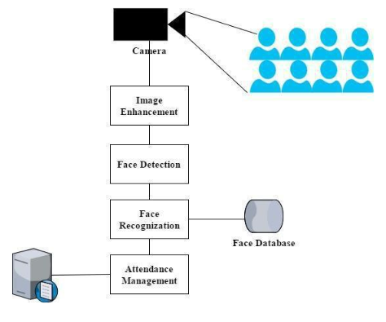

Figure 4.2

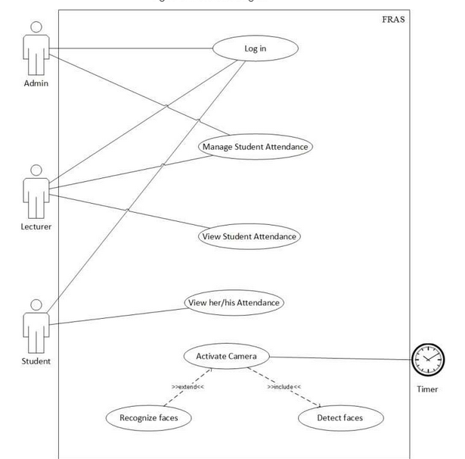

Figure 4.3

1. **Sprint Backlog-4**  
   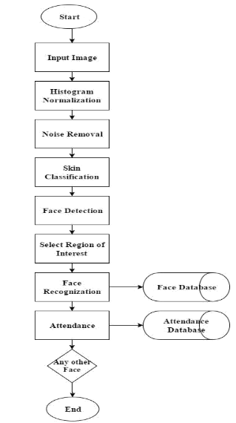

Figure 4.4

**CHAPTER 5**

**CONCLUSION**

**Results**

* Take picture to make dataset

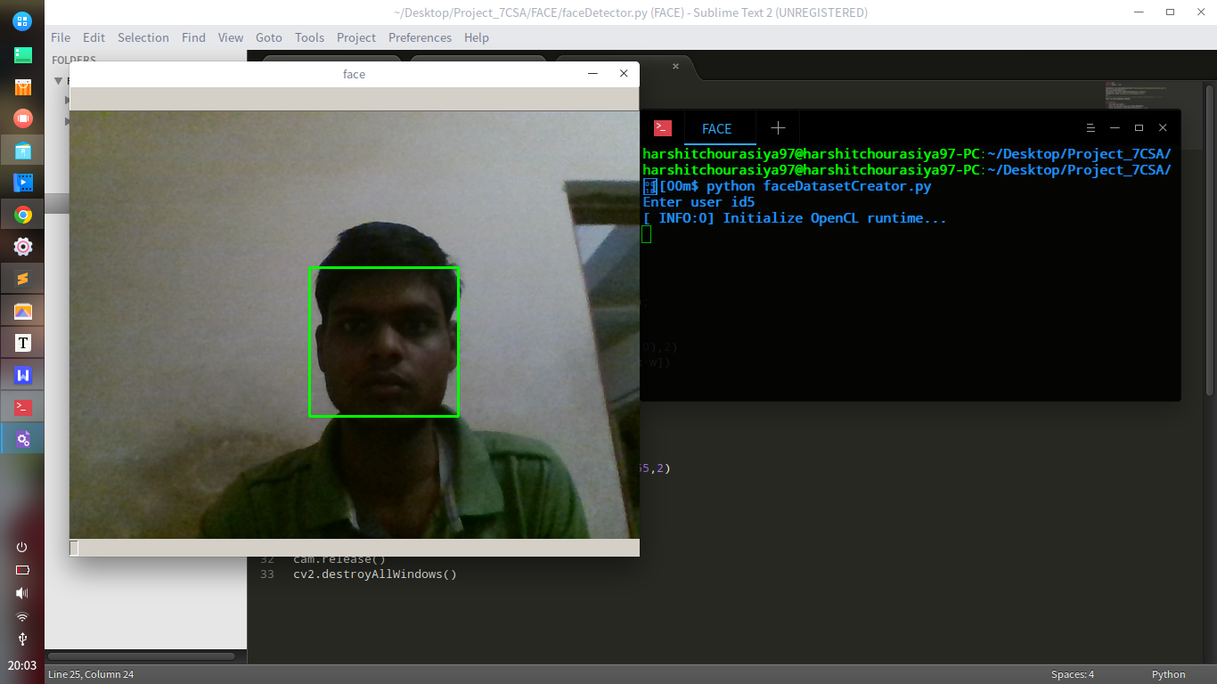

* Train that newly image into dataset

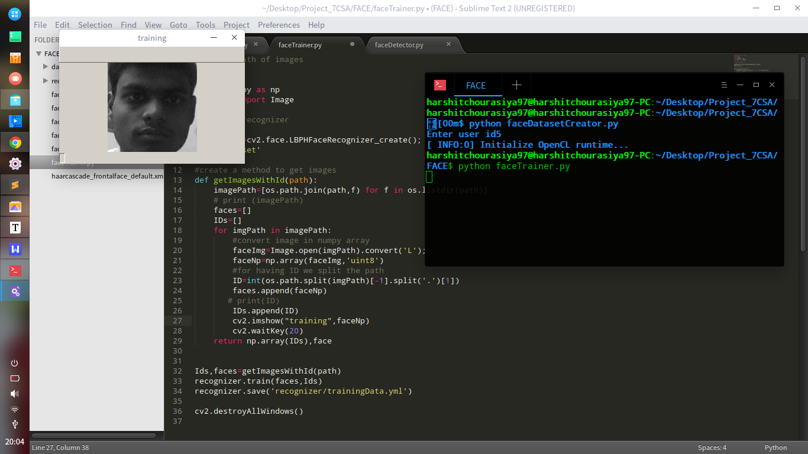

* Detect image from camera

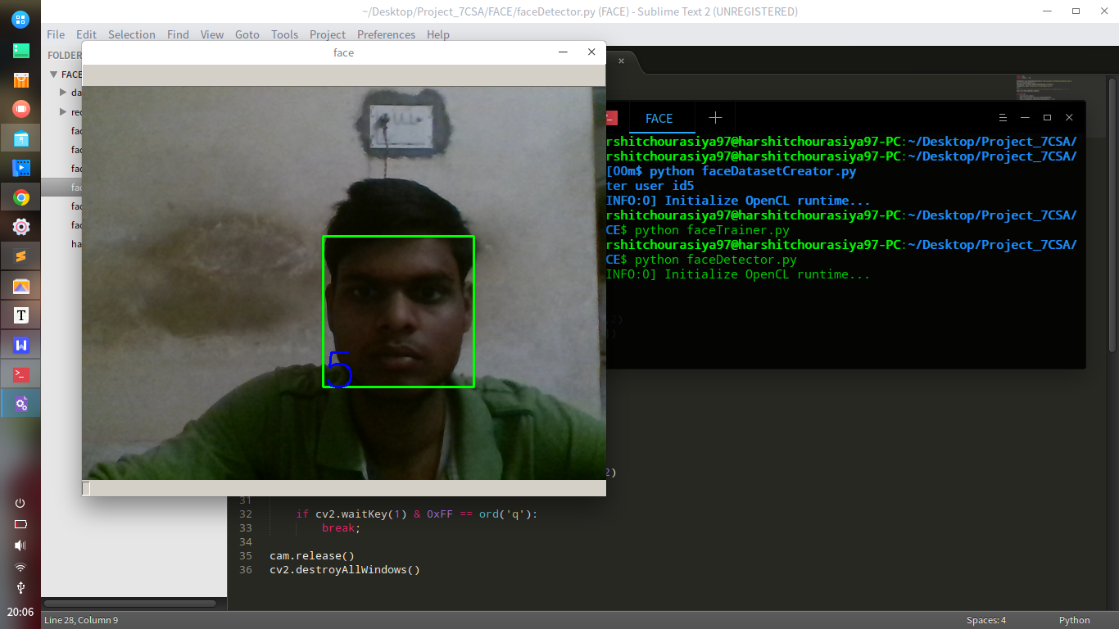

* Compare image from dataset

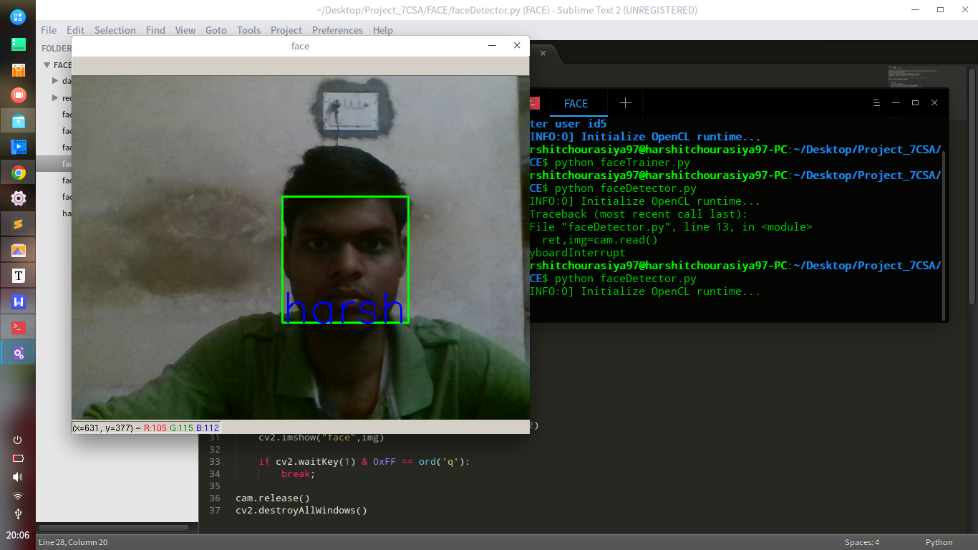

**Conclusion**

It can be concluded that a reliable, secure, fast and an efficient class attendance management system has been developed replacing a manual and unreliable system. This face detection and recognition system will save time, reduce the amount of work done by the administration and replace the stationery material currently in use with already existent electronic equipment. There is no need for specialized hardware for installing the system as it only uses a computer and a camera. The camera plays a crucial role in the working of the system hence the image quality and performance of the camera in real time scenario must be tested especially if the system is operated from a live camera feed. The system can also be used in permission based systems and secure access authentication (restricted facilities)for access management, home video surveillance systems for personal security or law enforcement. The major threat to the system is Spoofing. For future enhancements, anti-spoofing techniques like eye blink detection could be utilized to differentiate live from static images in the case where face detection is made from captured images from the classroom. From the overall efficiency of the system i.e. 83.1% human intervention could be called upon to make the system foolproof. A module could thus be included which lists all the unidentified faces and the lecturer is able to manually correct them. Future work could also include adding several well-structured attendance registers for each class and the capability to generate monthly attendance reports and automatically email them to the appropriate staff for review.

**Future Scope**

The current recognition system has been designed for frontal views of face images. A neural network architecture (may be together with a feature based approach) can be implemented in which the orientation of the face is first determined, and then the most suitable recognition method is selected, Also the current recognition system acquires face images only from face files located on magnetic mediums. Camera and scanner support should be implemented for greater flexibility.

**ANNEXURES**

**Refrences-**

[**http://vis-www.cs.umass.edu/lfw/results.html**](http://vis-www.cs.umass.edu/lfw/results.html)

[**http://www.robots.ox.ac.uk/~vgg/research/nface/**](http://www.robots.ox.ac.uk/~vgg/research/nface/)

[**http://face.com/**](http://face.com/)

[**https://facedetection.com/algorithms**](https://facedetection.com/algorithms)