**PROJECT REPORT**

On

**Estate Edge**

**Submitted in partial fulfilment of the requirement for the**

**Course**

**FULL STACK ENGINEERING (22CS037)**

**of**

COMPUTER SCIENCE AND ENGINEERING

**B. E. Batch-2022**



Under the Guidance of DR.HARPREET KAUR

SUBMITTED BY:

ARPITA RANA 2210991359

ARSHIKA GUNJAN

2210991369 2210991588

DEPARTMENT OF COMPUTER SCIENCE AND ENGINEERING

**CHITKARA UNIVERSITY**

### ****Abstract****

Estate Edge is an innovative, user-centric, web-based platform designed to address and streamline the process of renting flats by directly connecting property owners with prospective tenants. Built using the MERN stack (MongoDB, Express.js, React.js, Node.js), the platform offers a modern solution to the traditional rental market, which is often burdened by inefficiencies such as limited accessibility, lack of transparency, and high intermediary costs.

Traditional rental processes often involve multiple intermediaries such as real estate agents, offline advertisements, and fragmented online platforms. These systems result in a slow, opaque, and costly experience for both property owners and tenants. Estate Edge aims to eliminate these inefficiencies by offering a centralized platform where both parties can interact directly, ensuring quicker transactions, reduced costs, and greater transparency throughout the rental process.

The platform offers a comprehensive solution that caters to both property owners and tenants. Property owners can easily create and manage property listings, track inquiries, and communicate with prospective tenants through an intuitive dashboard. Tenants benefit from an advanced search engine with customizable filters, allowing them to effortlessly find properties based on their location, budget, amenities, and other preferences. Personalized recommendations and real-time updates further enhance the search experience, ensuring that tenants can find the most suitable properties without unnecessary delays.

Security and transparency are key priorities for Estate Edge. The platform features user authentication to verify the identities of both property owners and tenants, providing a layer of trust and ensuring that all interactions are secure. Additionally, property listings are verified, and transactions are encrypted, reducing the risks of fraud and building confidence in the system. Users can also access reviews and ratings from previous tenants, promoting transparency and fostering a trustworthy environment for all stakeholders.

Estate Edge also integrates features that streamline property management for owners and create a seamless rental experience for tenants. With an intuitive dashboard, property owners can efficiently manage their listings, respond to inquiries in real time, and handle all communications directly through the platform. This reduces reliance on third-party intermediaries and significantly enhances the overall experience.

Looking toward the future, Estate Edge plans to incorporate advanced technologies to further enhance the platform. AI-driven property recommendations will be used to match tenants with properties that best suit their preferences, while augmented and virtual reality (AR/VR) capabilities will allow tenants to explore properties virtually, providing a more immersive search experience. Additionally, mobile app development is in the works to ensure that users can access the platform on-the-go, further increasing accessibility.

**1.Introduction to the project**

**1.1 Background**

The rental property market has evolved significantly over the last few decades. As urbanization continues to accelerate, more people are relocating to cities, and the demand for rental properties has seen a steady increase. This shift in demographics, combined with rising housing costs, has made renting a more viable option for many individuals and families. As a result, the rental property market has grown substantially and shows no signs of slowing down.

However, despite this growth, traditional methods of renting flats remain outdated, fragmented, and inefficient. For property owners, methods such as offline advertisements, printed listings, or relying on real estate agents for property leasing often come with limitations. They struggle with reaching a wide audience, and the costs associated with hiring agents or using multiple platforms add unnecessary overheads.

Tenants, on the other hand, face challenges such as finding suitable properties in one place, verifying property details, and navigating through multiple sites. With the absence of integrated platforms, the search for rental properties often involves navigating different websites, contacting agents, and waiting for replies, resulting in a cumbersome and time-consuming experience.

Furthermore, traditional systems often lack transparency. Property listings may not be up-to-date, and tenants can struggle to find genuine reviews or authentic feedback about properties. This lack of transparency often results in distrust between tenants and property owners, causing friction in the rental process.

Additionally, intermediary costs—whether they are agent commissions, advertising fees, or platform charges—only add to the complexity and expense of the rental process. This inefficiency can create barriers to entry for both property owners and tenants, particularly in competitive markets.

**Estate Edge** is designed to address these challenges by offering an innovative, user-friendly digital solution. The platform connects property owners directly with tenants, bypassing intermediaries and streamlining the entire rental process. By leveraging modern web technologies such as the MERN stack (MongoDB, Express.js, React.js, Node.js), Estate Edge offers a seamless, efficient, and secure platform where users can easily list, search, and communicate regarding properties.

The platform's features include advanced search filters, real-time property updates, verified listings, secure communication channels, and tools for managing inquiries and listings. The goal of Estate Edge is to simplify the property rental process, offering both property owners and tenants a reliable, accessible, and efficient solution.

Estate Edge aims to foster trust and transparency by offering verified listings, authentic reviews, and secure user authentication. It also aims to ensure that property owners can easily manage their listings and communicate with potential tenants through a user-friendly dashboard. Moreover, with scalability in mind, Estate Edge leverages cutting-edge technologies to accommodate growing demand and future developments such as mobile applications, AI-driven recommendations, and blockchain-based transactions.

**1.2 Objective:**

The primary objective of Estate Edge is to create a platform that enhances the efficiency, transparency, and accessibility of the rental property market. By removing intermediaries, simplifying property management, and improving communication between property owners and tenants, the platform addresses the challenges of traditional rental methods. The specific goals of Estate Edge are as follows:

1. **Simplify the Property Rental Process:** The platform is designed to be intuitive, making it easy for property owners to list their flats and for tenants to find properties that meet their needs. By providing a single interface for both owners and tenants, Estate Edge eliminates the need for multiple platforms, reducing complexity and improving the user experience.
2. **Enhance Transparency:** Estate Edge will feature verified property listings, allowing tenants to trust that the information they view is accurate and current. Additionally, user authentication and reviews provide transparency and build credibility. The platform will offer a seamless process for both parties to verify each other’s credentials, ensuring peace of mind throughout the transaction.
3. **Streamline Communication:** Estate Edge integrates messaging features that allow property owners and tenants to communicate directly with one another. With this feature, there is no need for third-party intermediaries, making the communication process faster, more efficient, and secure.
4. **Ensure Security:** Security is a cornerstone of Estate Edge. By incorporating user verification and encrypted transactions, the platform ensures that both property owners and tenants can trust that their data is safe. Verified listings and secure user authentication prevent fraud and ensure the integrity of the rental process.
5. **Offer Advanced Search and Filters:** One of the key features of Estate Edge is its powerful search capabilities. Tenants will be able to filter properties based on location, price, size, and amenities, making the process of finding the perfect rental much more efficient. Personalized recommendations based on tenant preferences will further streamline the search process.
6. **Improve Property Management:** For property owners, Estate Edge provides an intuitive dashboard to manage listings, inquiries, and communications. The platform's tools allow owners to update property details, respond to tenant inquiries, and keep track of their property rental activities—all in real time.

Through these objectives, Estate Edge aims to simplify the rental experience, increase accessibility, foster trust, and ultimately enhance the rental property market.

### ****1.3 Significance:****

Estate Edge is poised to make a significant impact on the rental property market by addressing the inefficiencies of traditional systems. Key aspects of its significance include:

1. **Increased Accessibility:** Estate Edge allows property owners to reach a much larger audience than traditional offline methods. With its online presence, property owners can list their flats and have them seen by potential tenants across the globe, increasing their chances of renting their property faster and at the best price.
2. **Enhanced Transparency:** One of the major challenges in the rental property market is trust. Tenants often face difficulties in verifying the authenticity of property listings, and property owners have limited insight into the credibility of prospective tenants. Estate Edge addresses these issues by offering verified property listings, reviews from previous tenants, and user authentication, fostering trust between both parties.
3. **Cost Efficiency:** Traditional rental methods often involve high intermediary costs, such as commissions for real estate agents or listing fees for advertising platforms. By eliminating these intermediaries, Estate Edge reduces costs for both property owners and tenants, creating a more affordable rental market.
4. **Improved User Experience:** Estate Edge offers an intuitive, user-friendly platform for both property owners and tenants. The streamlined process, from listing properties to conducting inquiries and managing bookings, ensures an enhanced experience for all users, whether they are renting out a property or looking for a new home.
5. **Scalability and Growth Potential:** Built on the MERN stack, Estate Edge is a scalable platform that can handle increasing traffic and data demands. The architecture of the platform is designed to grow with the needs of the users, whether it is through adding more features, such as AI-driven property recommendations, or expanding to mobile applications and additional markets.
6. **Global Impact:** Estate Edge's potential is not limited to a specific geographical area. With the integration of AI, AR/VR technologies, and the potential for multi-language support, the platform has the opportunity to expand globally, offering personalized experiences for users around the world. Estate Edge could redefine the way people search for and rent properties in markets all over the globe.

Through its focus on efficiency, transparency, security, and scalability, Estate Edge stands to revolutionize the rental property market. Its innovative approach will not only benefit property owners and tenants but could also set the standard for the future of rental property platforms worldwide.

**2. Problem Definition and Requirements**

**2.1 Problem Statement**

In the rapidly evolving real estate market, the process of finding and renting flats has become increasingly cumbersome, especially for property owners and potential tenants. The traditional methods of advertising properties, such as offline listings (newspapers, posters, etc.) or fragmented online platforms, often present significant inefficiencies, lack transparency, and involve high intermediary costs. These problems persist, making it difficult for both property owners and tenants to navigate the real estate landscape effectively

Several key challenges exacerbate the inefficiency of the current rental system:

1. **Limited Accessibility**: Property owners often struggle to reach a broad audience of potential renters. Offline methods, like word-of-mouth or local ads, limit the number of people who can see the listing, and even online platforms fail to maximize reach due to their fragmented nature. As a result, owners miss out on potential tenants, and tenants waste time browsing through multiple, disconnected platforms.
2. **Inefficient Communication**: Tenants frequently encounter difficulties when trying to contact property owners directly. They may have to deal with third-party agents or unclear channels of communication. Furthermore, verifying property details can be time-consuming, as listings may be outdated, inaccurate, or lack detailed descriptions, making it harder for tenants to make informed decisions.
3. **Fragmented Processes**: The absence of a unified platform creates an inefficient experience for both parties. Information about available properties is scattered across various platforms, such as real estate websites, classifieds, and social media. This fragmentation forces users to juggle multiple sources of information, which is often disorganized and incomplete. For property owners, managing listings across several platforms is also time-consuming and prone to error.
4. **Trust Issues**: Both renters and property owners face challenges with trust and authenticity. There is a risk of fraud, with fake listings and dishonest reviews being prevalent. Furthermore, property owners often cannot be sure whether the tenants they are dealing with are reliable, and tenants may worry about the legitimacy of the properties they are considering. Without a transparent review system and verified property details, trust becomes a significant barrier in the rental process.

The **Estate Edge** platform is designed to address these critical challenges by offering a centralized, secure, and user-friendly space where property owners and tenants can connect directly. By eliminating intermediaries, ensuring secure communication, and providing transparent listings with verified information, the platform promises to revolutionize the rental process.

**2.2 Software and Hardware Requirements**

#### ****Frontend Technologies****

The frontend of Estate Edge is built using modern web development technologies to ensure an interactive, responsive, and seamless user experience. These technologies are chosen for their ability to create dynamic web applications that are easy to use across a wide range of devices.

1. **React.js-**React.js, a popular JavaScript library, is used to build dynamic and reusable user interfaces. It allows for efficient rendering of UI components through a virtual DOM, making the application responsive and fast. React’s component-based architecture promotes reusability, which is essential for a scalable application like Estate Edge. React Router is utilized to handle seamless navigation between pages, enabling a single-page application experience.
2. **HTML5-**HTML5 is used to structure the content of the web application, providing the backbone for the platform's layout and design. HTML5’s semantic tags help organize the content in a meaningful way, improving accessibility and SEO.
3. **CSS3-**CSS3 is used to style the application and ensure it provides a responsive and appealing experience across a wide range of devices. With a focus on user experience (UX), CSS3 enables smooth animations, media queries for mobile compatibility, and modern visual effects. Frameworks like **Bootstrap** or **Tailwind CSS** may be employed to speed up design implementation, providing pre-designed components and grid systems that make responsive design more accessible.
4. **JavaScript (ES6)-**ES6 JavaScript syntax is used to add interactivity and handle the client-side logic of the platform. It allows for the implementation of advanced features like asynchronous requests, better variable scoping, and more readable code. Features like **Promises** and **async/await** enhance user experience by enabling smooth, non-blocking data loading.

#### ****Backend Technologies****

The backend of Estate Edge is designed to handle complex business logic, secure data storage, and ensure the platform’s scalability. The choice of technologies enables robust, scalable, and efficient server-side operations.

1. **Node.js-**Node.js is the runtime environment used to execute JavaScript on the server-side. It allows for asynchronous event-driven programming, making the application highly scalable and efficient. Node.js is especially useful for handling concurrent requests and managing real-time data, essential for platforms that need to perform well under heavy traffic, such as Estate Edge.
2. **Express.js-**Express.js is the web application framework for Node.js. It simplifies the creation of routing and handling HTTP requests, providing middleware for handling various tasks such as user authentication, data validation, and logging. Express’s flexibility and minimalism make it ideal for building APIs and server-side logic for Estate Edge.
3. **MongoDB-**MongoDB, a NoSQL database, is used to store various types of unstructured data, such as user details, property listings, reviews, and more. Its flexible schema design allows for easy scaling and efficient querying, which is particularly useful as the platform grows. MongoDB’s document-based model also makes it a great choice for handling diverse types of data, such as property descriptions, images, and user reviews.
4. **Mongoose-**Mongoose is an ODM (Object Data Modeling) library for MongoDB, providing a higher-level abstraction for working with data. It simplifies database operations, such as creating, querying, and updating documents. Mongoose also enforces schema validation, ensuring that data remains consistent and secure.
5. **JSON Web Tokens (JWT)-**JWT is used for securing the platform by providing a token-based authentication system. JWT enables secure communication between the frontend and backend by transmitting user credentials securely. It ensures that only authenticated users can access certain features of the platform, such as listing properties or messaging potential tenants. JWT tokens are issued after a successful login and are used for validating subsequent requests.

**3. Proposed Design/Methodology**

#### ****1.IDEs/Editors****

* + **Visual Studio Code:** A lightweight, powerful IDE widely used for JavaScript, React.js, and Node.js development. It offers a wide range of extensions for front-end and back-end development, such as Prettier, ESLint, and GitLens for version control integration.
  + **IntelliJ IDEA (Optional):** A robust IDE that can be used for both front-end and back-end development. It provides extensive support for React.js, Node.js, and database management with integrated debugging and testing tools.

#### ****2. Version Control****

* + **Git:** Git is used for version control to track changes in the codebase, manage different versions of the platform, and allow collaborative development. Developers use Git commands to manage branches, commits, and merges efficiently.
  + **GitHub/GitLab:** These platforms host the repository and provide collaborative tools like issue tracking, pull requests, and continuous integration. GitHub and GitLab also offer additional features like automatic deployment pipelines (CI/CD), which simplify the deployment process.

#### ****3. Package Managers****

* + **npm (Node Package Manager):** npm is used to manage JavaScript dependencies. It allows developers to install libraries and packages needed for both frontend (e.g., React.js) and backend (e.g., Express.js).

#### ****4. Frameworks****

* + **React.js (Frontend)**: React.js is a JavaScript library used to build the front-end user interface. It is based on components, enabling developers to create reusable UI components that update efficiently as the data changes.
  + **Express.js (Backend)**: Express.js is a minimal web application framework for Node.js. It handles HTTP requests and routes, providing an efficient way to build scalable backend APIs for the platform.

### ****3.3 Requirements****

#### ****Server Requirements****

**1.Operating System**

* + **Linux (Ubuntu)**: Preferred for its stability, security, and performance. It is open-source, highly customizable, and ideal for web server hosting.
  + **Windows Server**: An alternative for users who prefer Windows-based environments. Windows Server is capable of handling complex backend operations and can support Node.js.

**2.Web Server**

* + **Nginx**: A powerful, high-performance web server used to serve the platform in production environments. Nginx acts as a reverse proxy, handling static files, load balancing, and SSL termination. It ensures that the platform is highly available and optimized for handling large amounts of traffic.

**3.Application Server**

* + **Node.js**: Node.js powers the backend services of Estate Edge. It’s a non-blocking, event-driven runtime environment that’s ideal for building fast and scalable web applications. Node.js handles the logic for processing requests, interacting with the database, and serving dynamic content to users.

**4.Database**

* + **MongoDB**: MongoDB is used to store all the platform’s data, such as property listings, user information, and transaction details. Its flexibility in schema design allows Estate Edge to scale as it accommodates more users and properties over time.

**5. Cloud Infrastructure**

* + **Firebase**: Firebase is used to handle real-time features such as notifications, chat systems, and user authentication. Firebase offers a managed backend for real-time updates, ensuring fast communication between property owners and tenants.

#### ****Client Requirements****

**1.Internet Connection**

* + A stable and high-speed internet connection (e.g., broadband, 4G, or 5G) is required for accessing the platform smoothly. A reliable connection ensures that the platform’s interactive features, such as property searches and messaging, work efficiently.

**2. Screen Resolution**

* + The platform is designed to be **responsive** and works seamlessly across various devices with different screen resolutions. Whether on **desktop**, **tablet**, or **mobile**, the design will automatically adapt to provide an optimal user experience.

**4.Result**

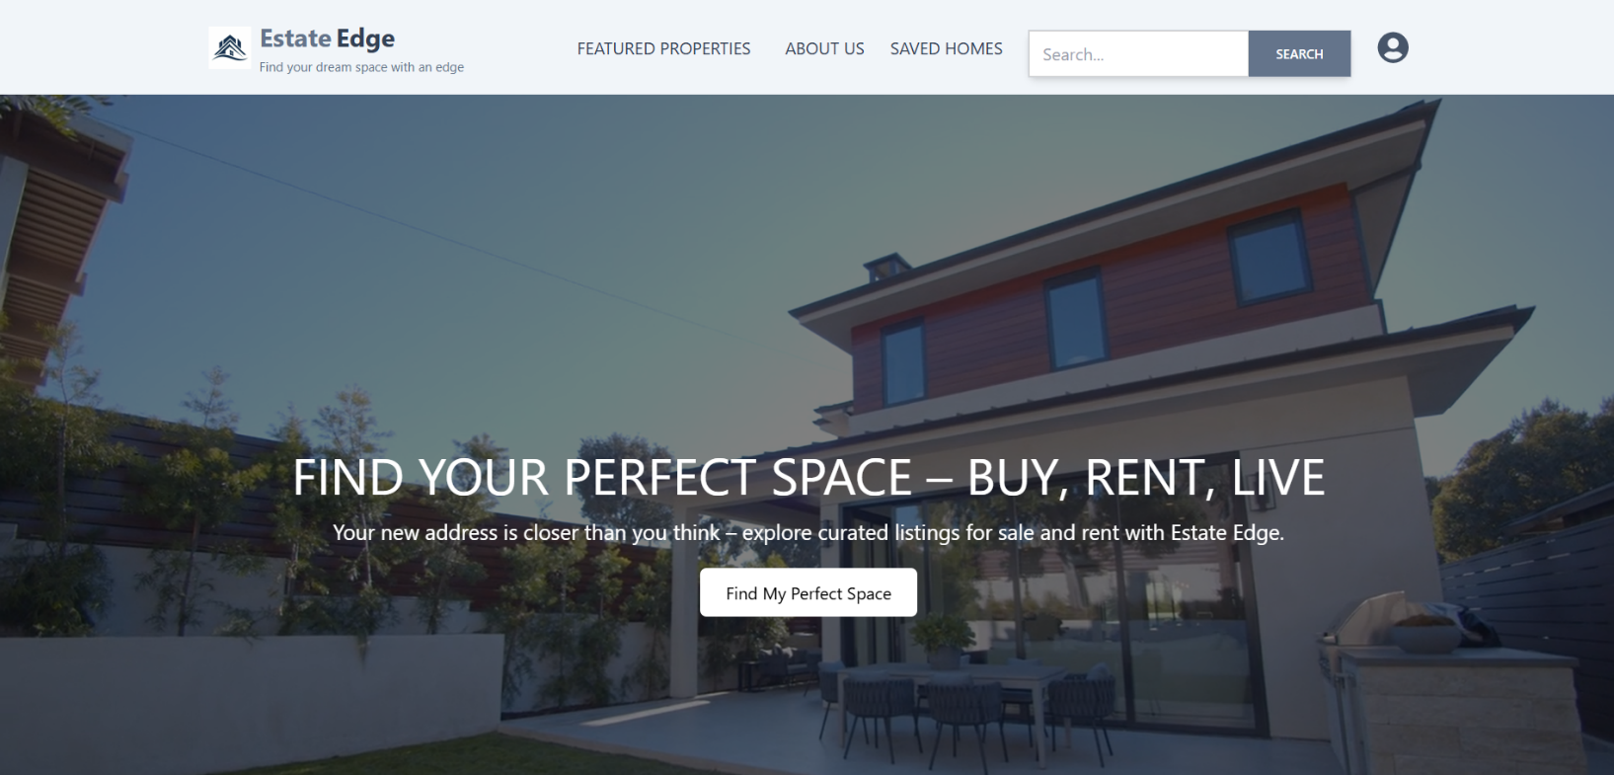

Landing page

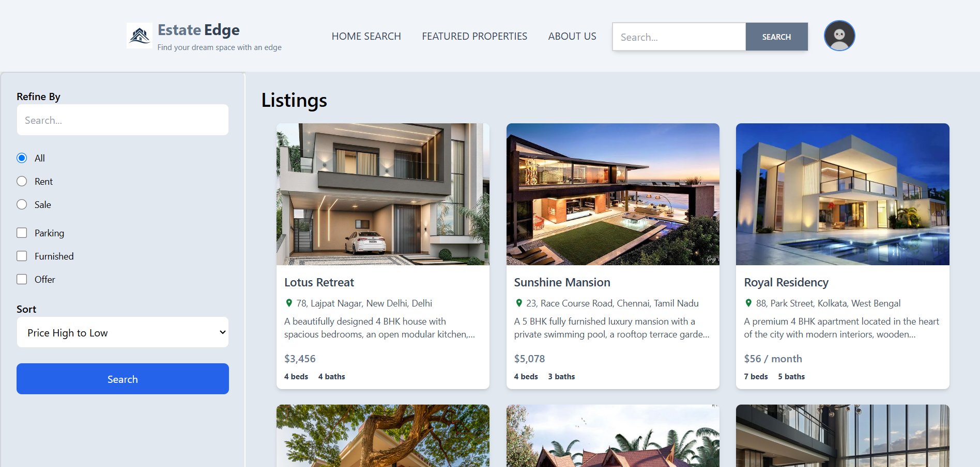

All Listings

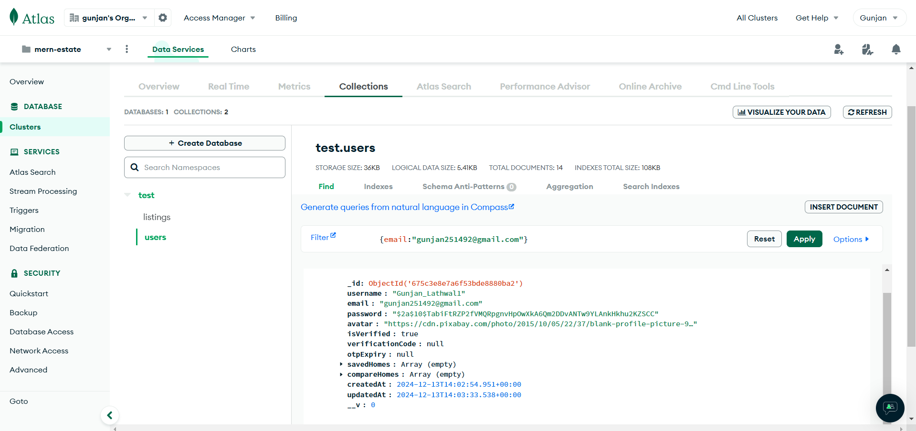

MongoDB database

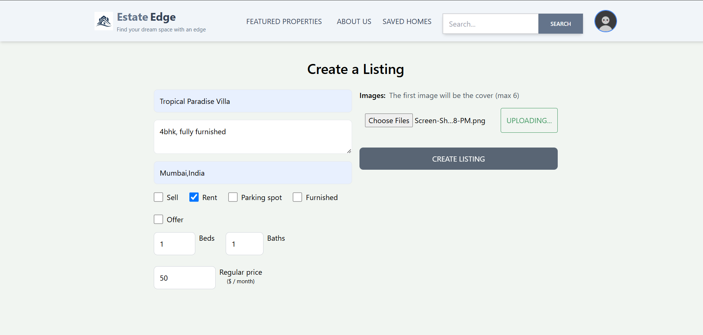

Create listings

**5.References**

**Books:**

"Eloquent.JavaScript: A Modern Introduction to Programming"

Author: Marijn Haverbeke

Eloquent JavaScript

A comprehensive guide to modern JavaScript, covering essential concepts and advanced techniques.

"JavaScript: The Good Parts"

Author: Douglas Crockford

JavaScript: The Good Parts

A focused book on the best features of JavaScript and how to use them effectively.

**Online Resources and Tutorials:**

1.MDN Web Docs-

Comprehensive documentation and tutorials for HTML, CSS, JavaScript, and web development best practices.

2.W3Schools-

Tutorials and references on web technologies like HTML, CSS, JavaScript, and SQL.

3.freeCodeCamp-

Interactive coding lessons and projects on web development, including HTML, CSS, JavaScript, React, and more.

**Tools and Frameworks Documentation:**

1.React.js Documentation-

Official documentation for React, including guides, API references, and best practices.