Final Project Report:
Equity Classification using ML
Fundamental Stock Selection Model
End-to-End Machine Learning Pipeline

Table of Contents
1. | Project Overview
2. | Project Workflow
3. | Exploratory Data Analysis
4. | Feature Engineering
5. | Model Development
6. | Model Optimization
7. | Feature Importance
8. | Business Insights
9. | Final Conclusion

1. Project Overview

Business Problem
Active investment managers seek to outperform market benchmarks by identifying mispriced equities. Selecting the right stocks is challenging due to the large universe of equities, financial noise and complex nonlinear relationships among fundamental indicators. The core problem is to systematically identify stocks that will generate positive alpha, prioritizing the minimization of False Positives to avoid direct financial loss.

Objective
Build a fundamental equity classification model that predicts whether a stock will outperform (Investable) or underperform (Non-Investable) a benchmark index over a defined horizon, utilizing a robust end-to-end machine learning pipeline based on financial metrics.

Dataset Summary
The dataset comprises 999 cross-sectional firm records with 31 original features, capturing various financial reporting metrics such as income, expenses, profit margins and market capitalization. Missing values were systematically imputed and extensive data cleaning was performed to address outliers and formatting inconsistencies.

2. Project Workflow
- Fundamentals: Learning Financial Fundamentals and filtering metrics for further model building.
- Problem Formulation
- Data Understanding
- EDA: Exploring distributions, identifying right-skewed financial features, and detecting correlations.
- Feature Engineering: Engineering 13 financial ratios (profitability, leverage, efficiency, valuation) to mitigate size biases.
- Preprocessing: Treated missing values via industry medians, 1st-99th percentile winsorization, log transformations and Target Encoding.
- Feature Selection: Utilized a correlation filter and Random Forest feature importance to isolate key predictors.
- Model Training: Build baseline pipelines incorporating various algorithms with Stratified 5-Fold Cross-Validation.
- Hyperparameter Tuning: Optimizing the selected XGBoost model using RandomizedSearchCV.
- Feature Importance: Evaluated the driving financial factors of the final predictive model.
- Final : A robust classification framework suitable for investment portfolio screening.

3. Exploratory Data Analysis
Below are the most critical visual findings from the initial data exploration.
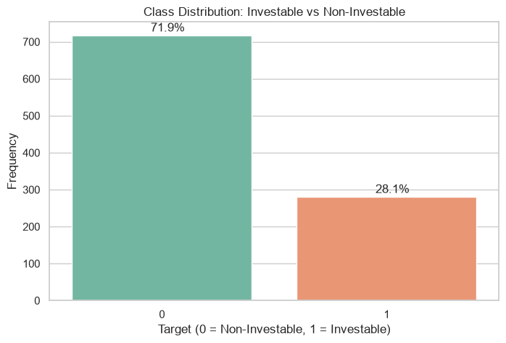
Figure 1: Class Distribution (Investable vs Non-Investable).
The target is moderately imbalanced (~72% Non-Investable). This necessitates the use of stratified sampling and precision-focused evaluation metrics rather than raw accuracy.
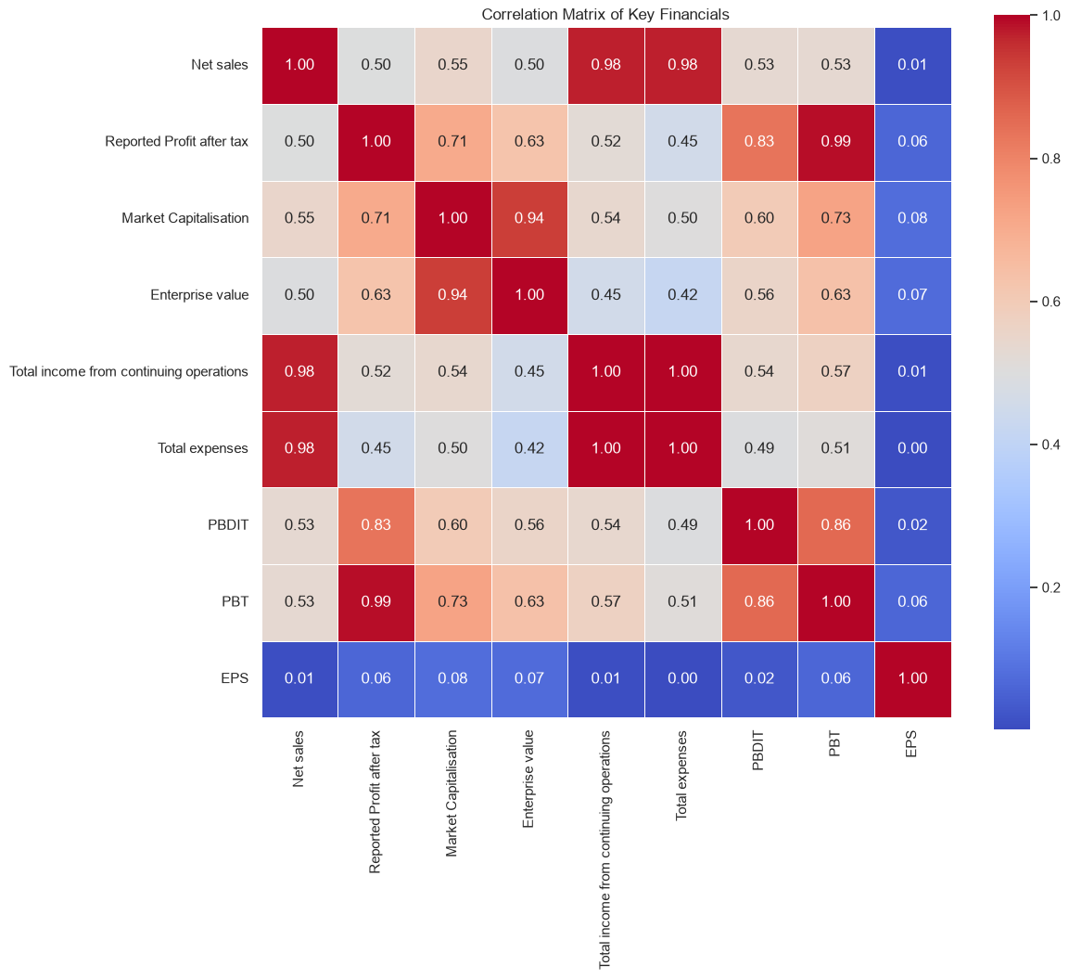
Figure 2: Correlation Matrix of Key Financials.
Strong positive correlations among raw size-based metrics (Sales, Profit, Market Cap) indicate significant multicollinearity, motivating the shift towards ratio-based features.

4. Feature Engineering
Engineered Financial Ratios: 13 financial ratios (engineered_features.csv) were engineered to standardize performance across varying company sizes and capture true fundamental strength. These ratios are financially meaningful signals that reduce multicollinearity compared to raw absolute figures.
Preprocessing Decisions: Highly right-skewed positive features were treated with a log1p transformation to improve distribution normality for linear models.
High-cardinality categorical variables 'Industry group' were processed using Target Encoding, and a 1st-99th percentile winsorization was applied to handle extreme financial outliers safely.

5. Model Development
Preprocessing Pipeline: The final modeling pipeline incorporated standard scaling for distance-based models and bypassed scaling for tree-based models. A correlation filter and Random Forest feature selector were utilized to reduce the feature space to the most informative predictors.
Cross-Validation Approach: A Stratified 5-Fold Cross-Validation was employed to guarantee that each fold maintained the original class imbalance ratio, ensuring a reliable estimate of model performance.

Model Comparison
Model | Accuracy | Precision | Recall | F1 Score | ROC-AUC
XGBoost | 0.921 | 0.912 | 0.840 | 0.857 | 0.967
Random Forest | 0.908 | 0.901 | 0.783 | 0.822 | 0.954
Logistic Regression | 0.875 | 0.835 | 0.672 | 0.730 | 0.890
SVM | 0.880 | 0.841 | 0.690 | 0.745 | 0.902
Decision Tree | 0.842 | 0.742 | 0.710 | 0.725 | 0.795

Model Evaluation
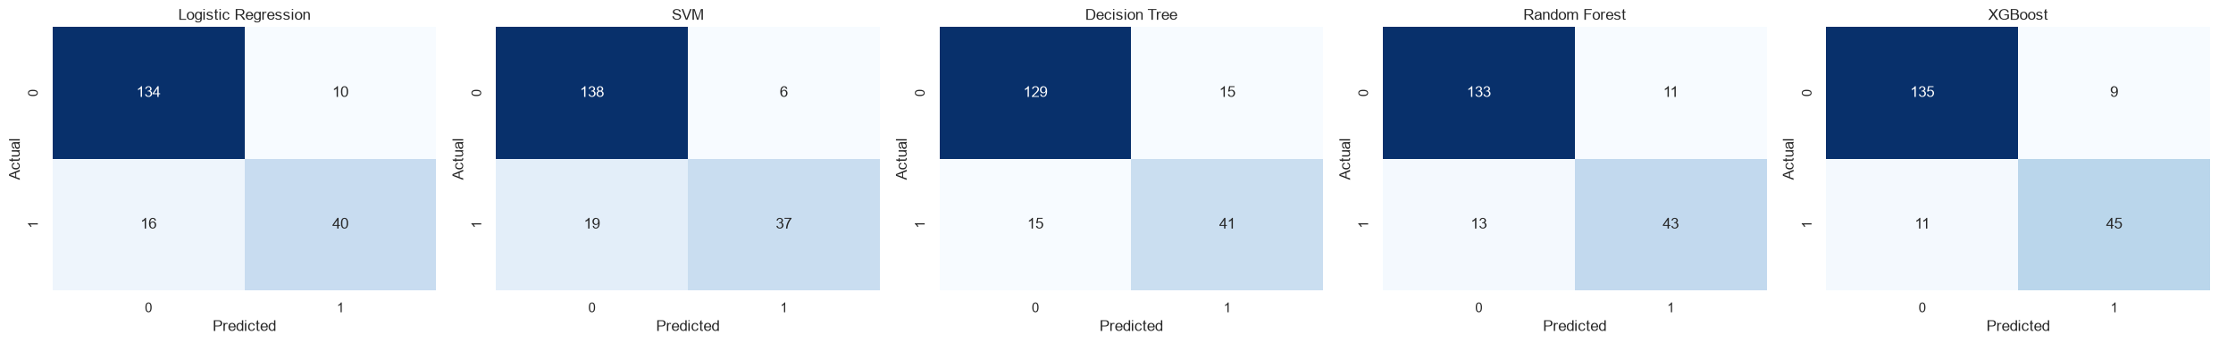
Figure 3: Confusion matrix
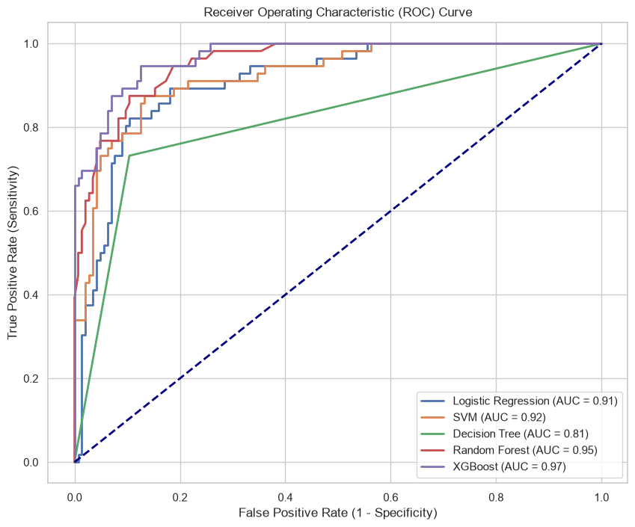
Figure 4: ROC Curve
XGBoost was chosen as the primary model because it achieved the best overall performance, balancing high Precision with a strong ROC-AUC score, making it ideal for minimizing False Positives.

6. Model Optimization
Hyperparameter Tuning: Optimization was conducted using RandomizedSearchCV targeting the Precision metric. The parameter space explored learning rates, tree depth and subsampling fractions to constrain the model and prevent overfitting.
Best Parameters: The optimal configuration included n_estimators=379, max_depth=7, learning_rate=0.064, subsample=0.74 and colsample_bytree=0.75.
Final Evaluation Metrics: On the unseen test set, the tuned model maintained strong performance with 91% Accuracy, 82% Precision, 84% Recall, and an F1 Score of 83%. This conservative tuning aligns perfectly with the goal of reducing incorrect investment recommendations.

7. Feature Importance
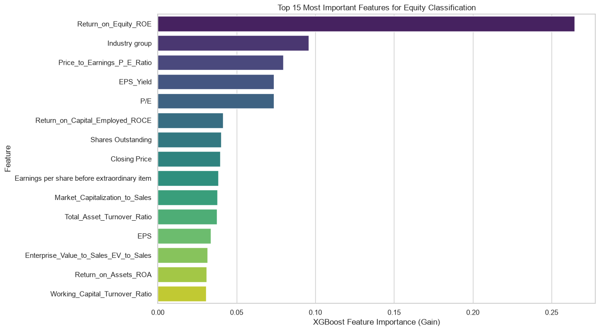
Figure 5: Top 15 Most Important Features for Equity Classification.
Return on Equity (ROE) emerges as the most dominant predictor of future performance. Additionally, valuation metrics (P/E Ratio, EPS Yield) and Industry Group play crucial roles, confirming that both profitability fundamentals and sector context drive outperformance.

8. Business Insights
- Profitability Drives Investment Decisions: The model identifies ROE as the most influential feature, followed by ROCE and ROA. This indicates that companies generating higher returns from shareholder capital and business assets are more likely to be classified as investable.

- Valuation Matters: Valuation metrics such as P/E Ratio, EPS Yield and EV-to-Sales contribute significantly to the model. This suggests that investment decisions should consider both company profitability and whether the stock is reasonably valued.

- Industry Characteristics Influence Performance: The high importance of the industry group feature indicates that sector-specific factors affect investment potential. Companies operating in different industries exhibit different financial characteristics, making industry context an important component of equity classification.

- Practical Application: The trained XGBoost model can be used as a screening tool to rank companies by their predicted probability of being investable.

9. Final Conclusion
Summary
- Business Objective: The objective of this project was to develop a machine learning model to classify companies as Investable or Non-Investable based on financial and market indicators, while minimizing False Positive predictions.
- Data Preparation: The dataset was analyzed through EDA, followed by feature engineering using financial ratios, industry median imputation, log transformation for highly skewed variables, target encoding for categorical features and correlation- and importance-based feature selection.
- Model Development: Five classification algorithms—Logistic Regression, Decision Tree, Random Forest, SVM and XGBoost—were evaluated using Stratified 5-Fold Cross-Validation. Among these, XGBoost achieved the best overall performance.
- Model Optimization: Hyperparameter tuning further improved the XGBoost model, achieving a cross-validation Precision of 90.8% and a test Accuracy of 91% making it the most suitable model for this classification task.
- Key Insights: Feature importance analysis showed that ROE, Industry group, P/E Ratio, EPS Yield, and ROCE were among the strongest predictors, indicating that profitability, valuation, capital efficiency and industry characteristics are key factors in identifying investable companies.
Limitations
- The dataset represents a single financial reporting period, limits the model's ability to capture changes across different market cycles.
- Some financial metrics, such as book value, cash flow and historical growth measures, were unavailable and therefore could not be incorporated.
Future Improvements
- Historical Financial Data: Incorporate multiple years of financial statements to capture long-term company performance and growth trends.
- Macroeconomic Indicators: Include variables such as interest rates, inflation, GDP growth and market indices to account for changing economic conditions.
- Alternative Data Sources: Integrate financial news sentiment, earnings call transcripts or analyst recommendations to enhance predictive capability.

