- INTRODUCTION

In today’s competitive business environment, effective inventory management is crucial for ensuring smooth operations, minimizing losses, and supporting informed decision-making. Small and medium-sized businesses often struggle with manual inventory tracking methods that are time-consuming, error-prone, and difficult to scale as the business grows. To address these challenges, a digital inventory management solution becomes essential.
This project focuses on the desi
gn and development of a web-based Inventory Management System that enables business owners to manage products, track sales, and monitor inventory levels through a centralized platform. The system provides an organized and structured way to store inventory data, record transactions, and view business performance through dashboards and reports.
The application is developed using React for the frontend, Node.js for backend services, and MongoDB for data storage, ensuring a modern, scalable, and responsive solution. The system emphasizes usability, data accuracy, and secure access, making it suitable for real-world business use.

- PROBLEM STATEMENT

In many small and medium-scale businesses, inventory management is still handled manually using paper records or basic spreadsheets. These traditional methods are time-consuming, prone to human error, and make it difficult to track stock levels, product details, and sales transactions in real time. As the business grows, maintaining accurate inventory data becomes challenging, leading to issues such as stock shortages, overstocking, delayed decision-making, and lack of clear insights into business performance.
Additionally, business owners often lack a centralized system that provides a clear overview of products, sales, and overall inventory status through a simple and user-friendly interface. Switching between multiple tools for tracking products, recording sales, and viewing reports reduces efficiency and increases the risk of data inconsistency. There is also a need for controlled access, where only authorized users can log in and manage inventory data securely.
To address these challenges, there is a need for a modern, web-based Inventory Management System that allows users to securely log in, manage products, record sales, and view inventory insights from a single platform. The system should be simple to use, scalable, and capable of performing essential CRUD operations while providing meaningful dashboards and summaries. This project aims to design and develop such a full-stack application using modern web technologies to improve accuracy, efficiency, and decision-making in inventory management.

- OBJECTIVES

1. Simplify Inventory Management
The primary objective of this project is to create a system that simplifies the process of managing inventory. Users should be able to easily add, view, update, and delete product details such as name, category, price, and stock quantity. This reduces manual effort and minimizes errors associated with traditional tracking methods.
2. Enable Efficient Sales Tracking
The system aims to record and manage sales transactions efficiently. Each sale updates the inventory automatically, ensuring accurate stock levels at all times. This helps users track product movement and understand which items are selling faster.
3. Provide Clear Business Insights
Another objective is to offer basic analytical insights through dashboards and overview pages. By displaying key metrics such as total products, stock availability, and recent sales, the system supports better decision-making without complex analytics.
4. Improve Data Organization and Accessibility
The project focuses on organizing business data in a structured database using MongoDB. This ensures that product and sales.

- TECHNOLOGIES USED

Frontend
- React.js
- Tailwind CSS
- JavaScript (ES6)
Backend
- Node.js
- Express.js (lightweight API routing)
Database
- MongoDB (NoSQL database)
Tools
- VS Code
- Git & GitHub
- MongoDB Compass Atlas

- SYSTEM ARCHITECTURE

The Inventory Management System follows a three-tier architecture, consisting of the Frontend, Backend, and Database layers.
Frontend Layer
The frontend is developed using React.js, which provides a dynamic and responsive user interface. The application is structured into reusable components such as Login, Sidebar, Dashboard, Products, Sales, and Settings pages. React handles user interactions, navigation between pages, and data display based on responses received from the backend. The frontend communicates with the backend through HTTP requests and displays real-time updates without page reloads.
Backend Layer
The backend is built using Node.js, which handles server-side logic, request processing, and communication between the frontend and the database. It is responsible for authenticating users, validating requests, managing business logic such as product updates and sales recording, and sending appropriate responses back to the frontend. The backend ensures that all operations follow defined rules and that data integrity is maintained.
Database Layer
The database used is MongoDB, a NoSQL document-based database. It stores collections such as users, products, and sales records. MongoDB allows flexible data storage and quick retrieval, making it suitable for handling dynamic inventory data. Each operation performed through the application reflects directly in the database, ensuring persistent and reliable data storage.
- The user logs in through the frontend
- Requests are sent to the backend for authentication and data access
- The backend processes the request and interacts with MongoDB
- The response is sent back to the frontend
- The frontend updates the UI based on the received data

- USER ROLES & ACCESS CONTROL

The Inventory Management System is designed for single-user operation, intended primarily for a business owner or administrator. There are no staff, public users, or customer-facing roles in the current scope of the application.
Admin / Business Owner
The Admin is the only authorized user of the system and has full access to all features after successful authentication.
Access Rights include:
- Secure login and logout using authenticated credentials
- Viewing the main dashboard with product, sales, and activity summaries
- Adding new products and updating or deleting existing product details
- Recording sale
- s transactions and automatically updating inventory stock
- Viewing complete sales history for tracking business performance
- Managing application settings such as preferences and configurations
Since all functionalities are restricted to authenticated access, the system ensures data privacy, controlled access, and operational security. This simplified role structure keeps the system easy to use while still maintaining professional-level access control.

- APPLICATION MODULES

7.1 Login Module
- Secure authentication using Firebase
- Validates user credentials
- Redirects authenticated users to the dashboard
7.2 Dashboard Module
- Displays total products
- Displays total sales
- Shows recent activity
- Provides quick navigation
7.3 Products Module
- View all products
- Add new products
- Edit existing products
- Delete products
- Automatically update stock
7.4 Sales Module
- Record product sales
- Automatically reduce stock
- Display sales history
- Track revenue
7.5 Settings Module
- User account information
- Logout functionality

- DATABASE DESIGN

Users Collection
- User ID
- Email
- Role
- Authentication Credentials
Products Collection
- Product ID
- Name
- Category
- Stock Quantity
- Price
- Unit
Sales Collection
- Sale ID
- Product Reference
- Quantity Sold
- Total Amount
- Timestamp
- Recorded By (User ID)

- SYSTEM REQUIREMENTS

1. Functional Requirements
- The system shall allow authenticated users to log in and securely access the application.
- The system shall provide a dashboard displaying product stock levels, sales summary, and recent activity.
- The system shall allow users to add new products with details such as name, category, price, and stock quantity.
- The system shall allow users to edit and delete existing product records.
- The system shall allow users to record sales and automatically update product stock.
- The system shall maintain a sales history that users can view and analyze.
- The system shall allow users to update basic application settings.
- The system shall restrict access to all features unless the user is logged in.
2. Non-Functional Requirements
- The system shall be user-friendly with a simple and responsive interface.
- The system shall provide fast performance for common operations like loading products and recording sales.
- The system shall ensure data consistency between products and sales records.
- The system shall handle moderate data volumes suitable for small businesses.
- The system shall be scalable to allow future feature expansion.
- The system shall maintain security by preventing unauthorized access.
- The system shall be reliable and stable during continuous usage.
- The system shall support modern web browsers.

10. IMPLEMENTATION
Code Snippet
App.jsx
import React, { useState } from 'react';
import { authAPI } from '../utils/api';
const LoginPage = ({ setAppUser, setCurrentPage, showMessage, closeModal, setUserId, setIsMockMode }) => {
const [email, setEmail] = useState('');
const [password, setPassword] = useState('');
const [loading, setLoading] = useState(false);
const handleManualLogin = async (e) => {
e.preventDefault();
const emailPattern = /^[^\s@]+@[^\s@]+\.[^\s@]+$/;
if (!email || !password) {
showMessage('Please enter both email and password.', 'error');
return;
}
if (!emailPattern.test(email)) {
showMessage('Please enter a valid email like example@domain.com.', 'error');
return;
}
if (password.length < 8) {
showMessage('Password must be at least 8 characters long.', 'error');
return;
}
setLoading(true);
try {
// Try to login via API first
const response = await authAPI.login(email, password);
setAppUser({
uid: response.user.uid,
email: response.user.email,
displayName: response.user.displayName || email.split('@')[0],
businessName: response.user.businessName || ''
});
setUserId(response.user.uid); setIsMockMode(false); setCurrentPage('Dashboard');
showMessage('Login successful! Connected to server.', 'success'); setLoading(false);
} catch (error) {
// If API fails, check if backend is available
const API_URL = import.meta.env.VITE_API_URL || 'http://localhost:5000/api';
fetch(`${API_URL}/health`)
.then(() => {
// Backend is up but login failed - show error
showMessage(`Login failed: ${error.message}. Please check your credentials or create an account.`, 'error');
setLoading(false);
})
.catch(() => {
// Backend is down - use mock mode
console.warn('Backend not available, using mock mode');
setAppUser({ uid: 'user-123', email, displayName: email.split('@')[0] });
setUserId('local-user');
if (setIsMockMode) setIsMockMode(true);
setCurrentPage('Dashboard');
showMessage('Login successful (offline mode). Backend server is not running.', 'info');
setLoading(false); }); }};
return (
<div className="min-h-screen w-full bg-[#f9f6f0] flex flex-col items-center justify-center px-4">
<div className="space-y-2 text-center mb-6">
<h1 className="text-3xl font-bold text-slate-900">Login</h1>
<p className="text-sm text-slate-500">Please enter your login and your password.</p>
</div>
<form onSubmit={handleManualLogin} className="space-y-4 w-full max-w-sm">
<div className="relative w-full max-w-sm mx-auto">
<div className="absolute inset-y-0 left-0 pl-4 flex items-center pointer-events-none">
<span className="text-slate-400 text-base">👤</span> </div>
<input type="email" id="email" value={email} onChange={(e) => setEmail(e.target.value)} placeholder="Username or E-mail"
className="w-full h-11 rounded-md border border-slate-300 bg-white pl-14 pr-4 text-sm text-slate-900 placeholder-slate-400 focus:outline-none focus:ring-2 focus:ring-indigo-200 focus:border-indigo-400" required /> </div>
<div className="relative w-full max-w-sm mx-auto">
<div className="absolute inset-y-0 left-0 pl-4 flex items-center pointer-events-none">
<span className="text-slate-400 text-base">🔑</span> </div>
<input type="password" id="password" value={password} onChange={(e) => setPassword(e.target.value)} placeholder="Password"
className="w-full h-11 rounded-md border border-slate-300 bg-white pl-14 pr-4 text-sm text-slate-900 placeholder-slate-400 focus:outline-none focus:ring-2 focus:ring-indigo-200 focus:border-indigo-400" required /> </div>
<div className="w-full max-w-sm mx-auto"> <button type="submit" disabled={loading}
className="mt-2 inline-flex items-center justify-center w-full h-11 rounded-md border border-lime-400 bg-lime-400 text-slate-900 font-semibold text-sm hover:bg-lime-300 transition disabled:opacity-50 disabled:cursor-not-allowed">
{loading ? 'Logging in...' : 'Login'} </button> </div>
</form> </div> ); };
export default LoginPage;
Screenshots
Login Page
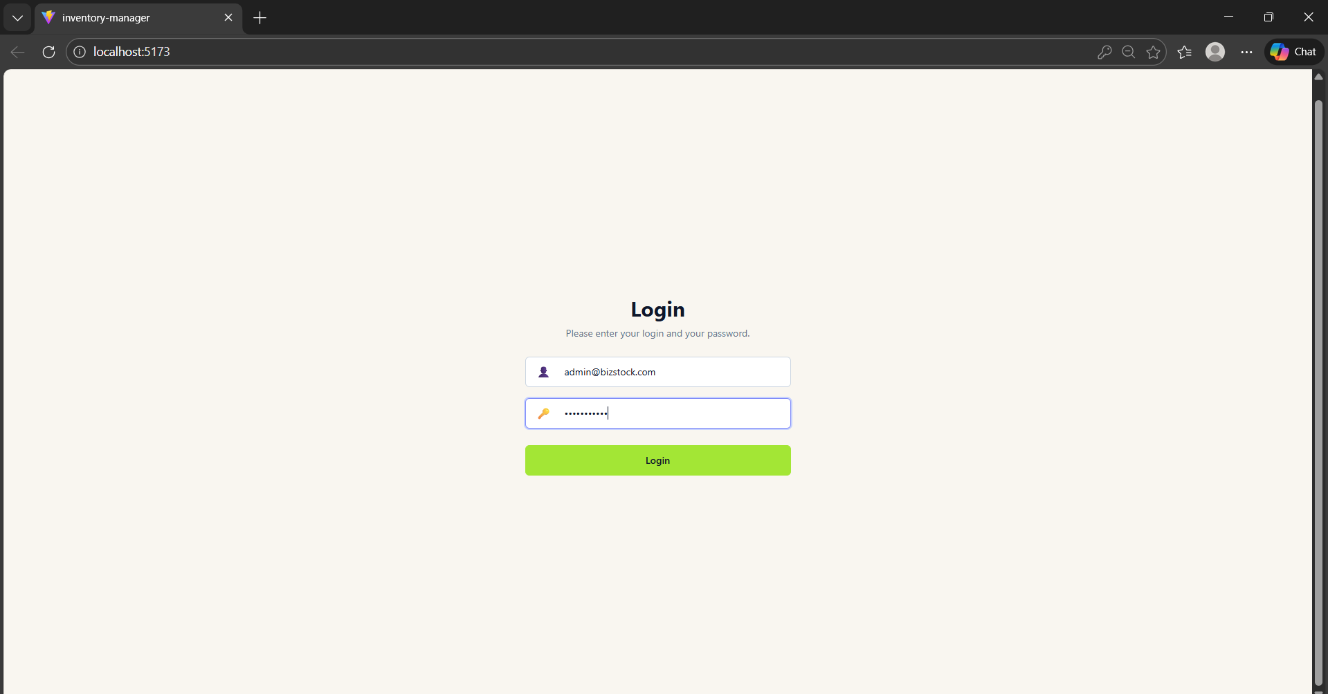

Overview Page
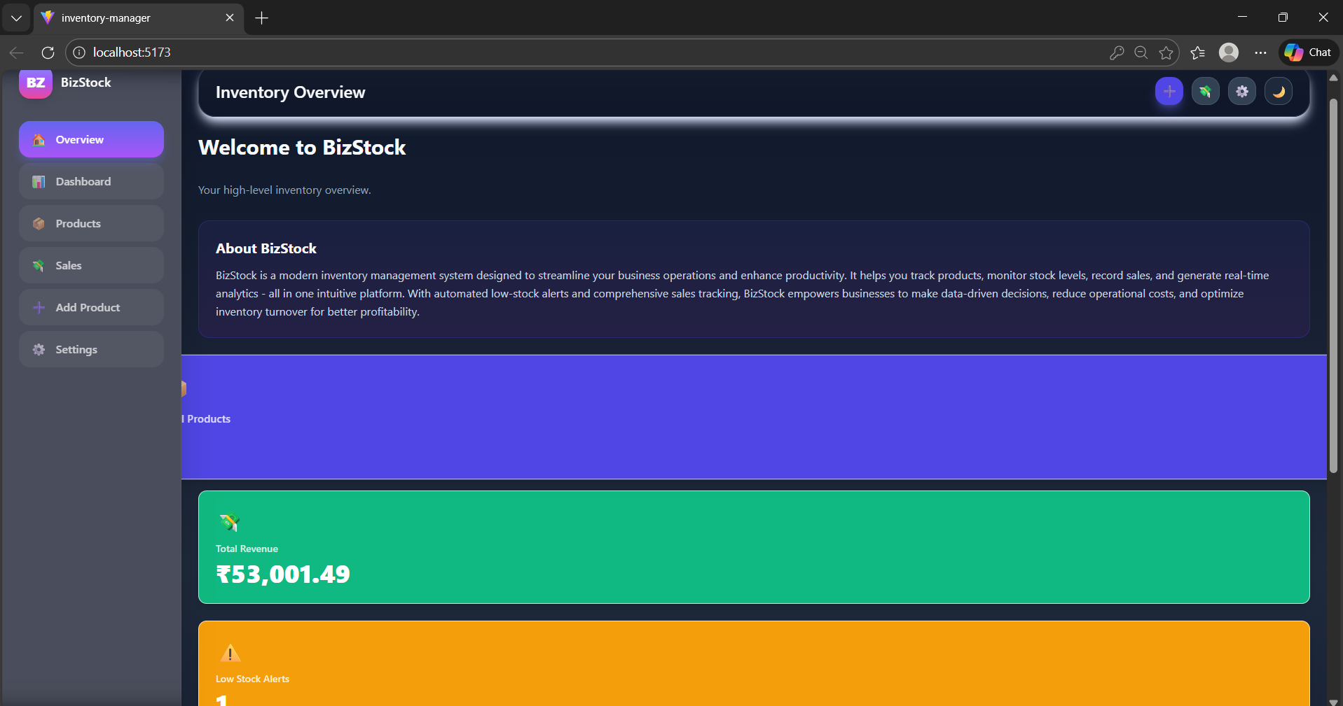

Dashboard Page
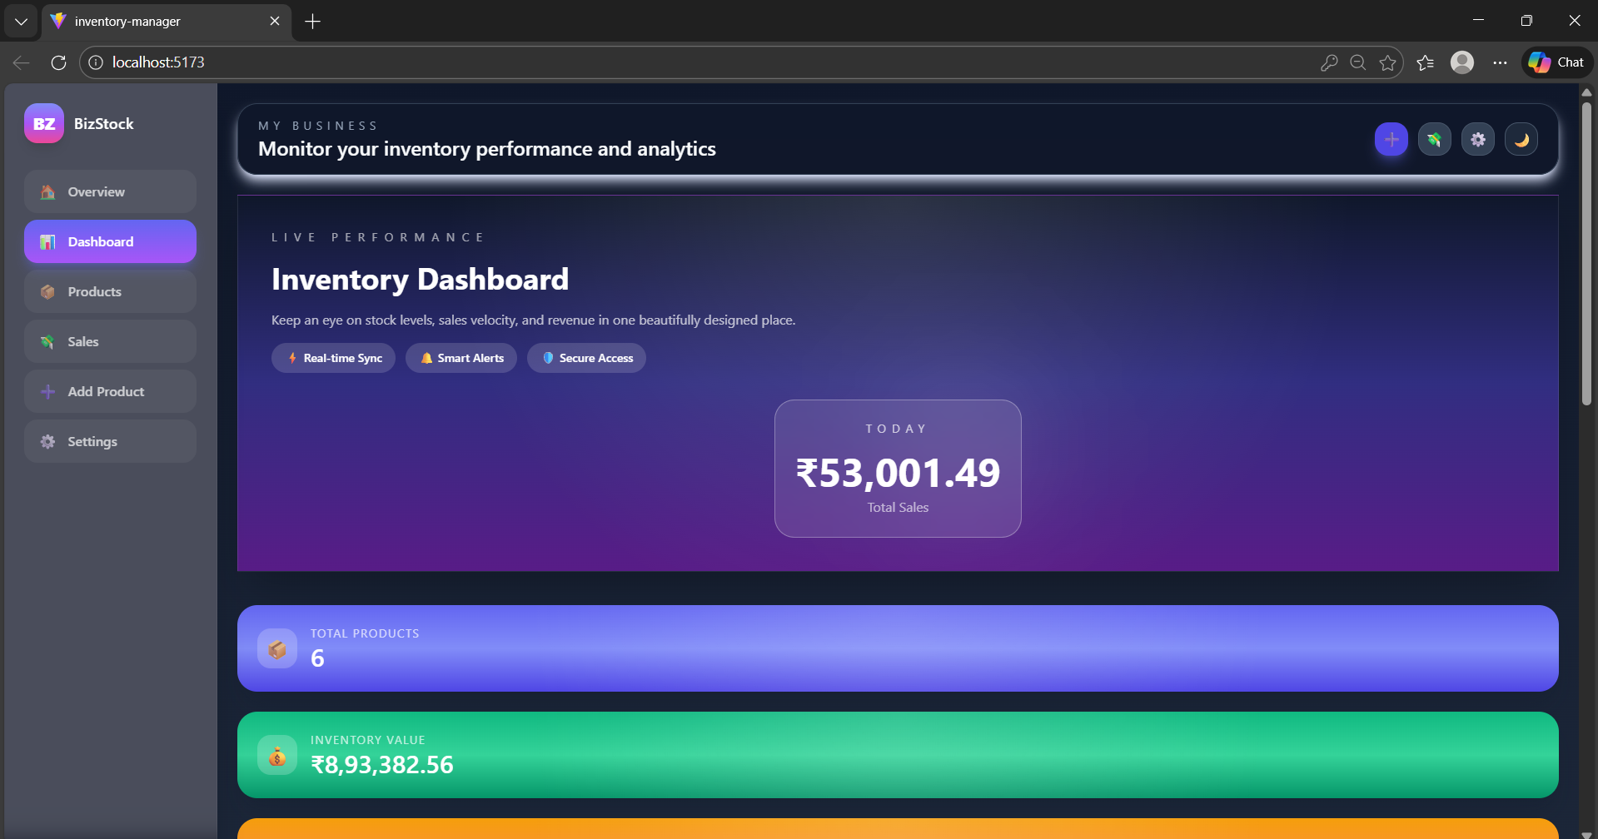

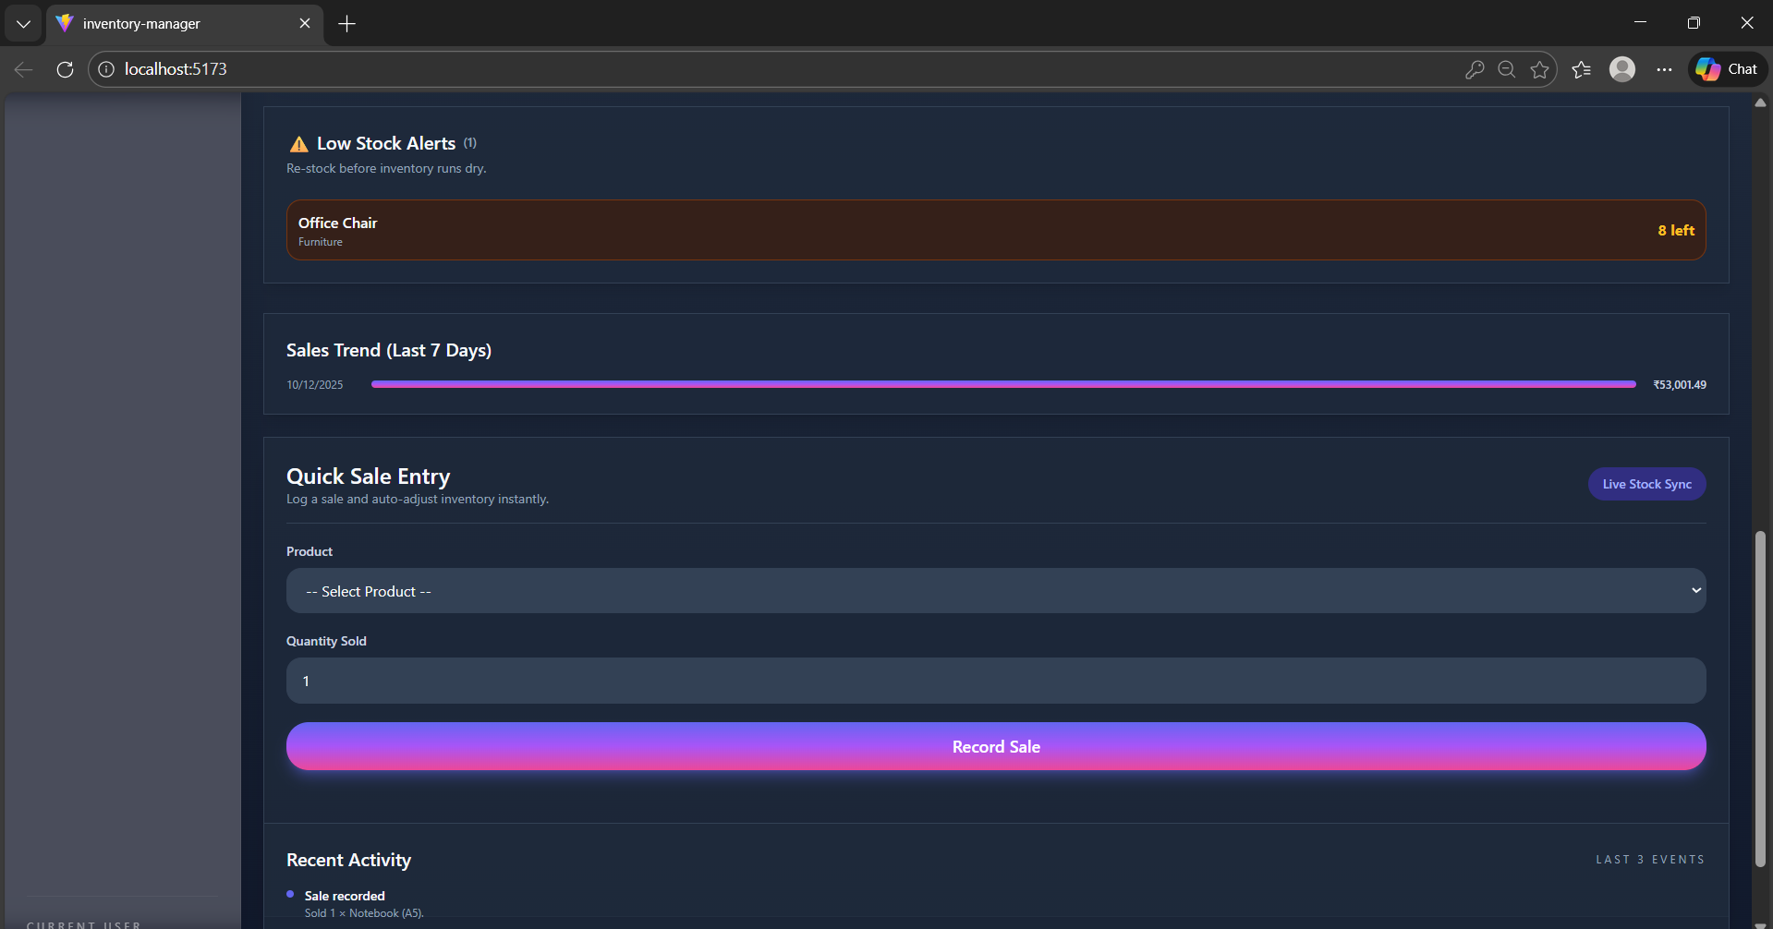

Products Page
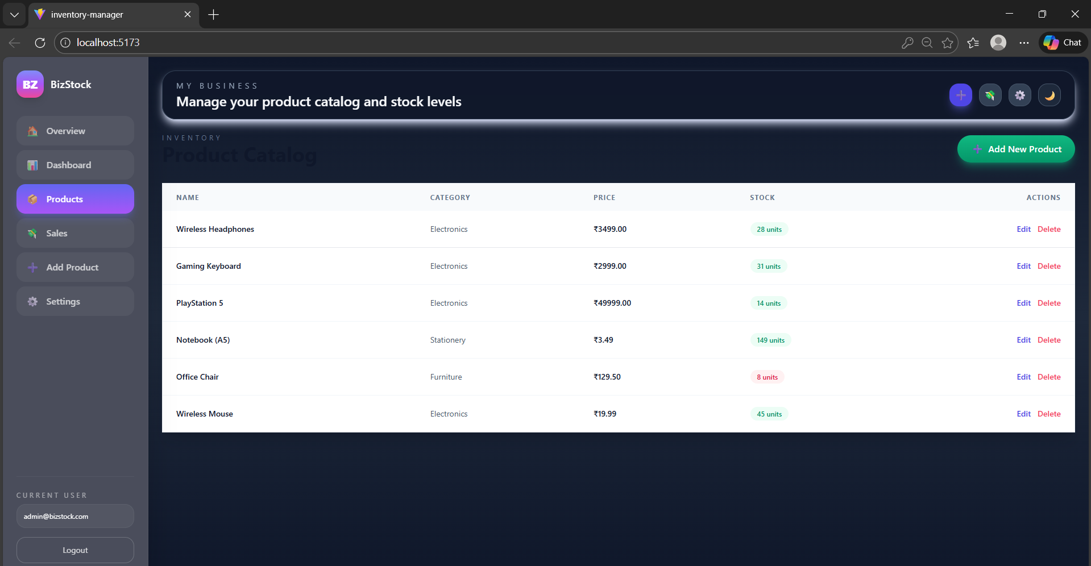

Sales Page
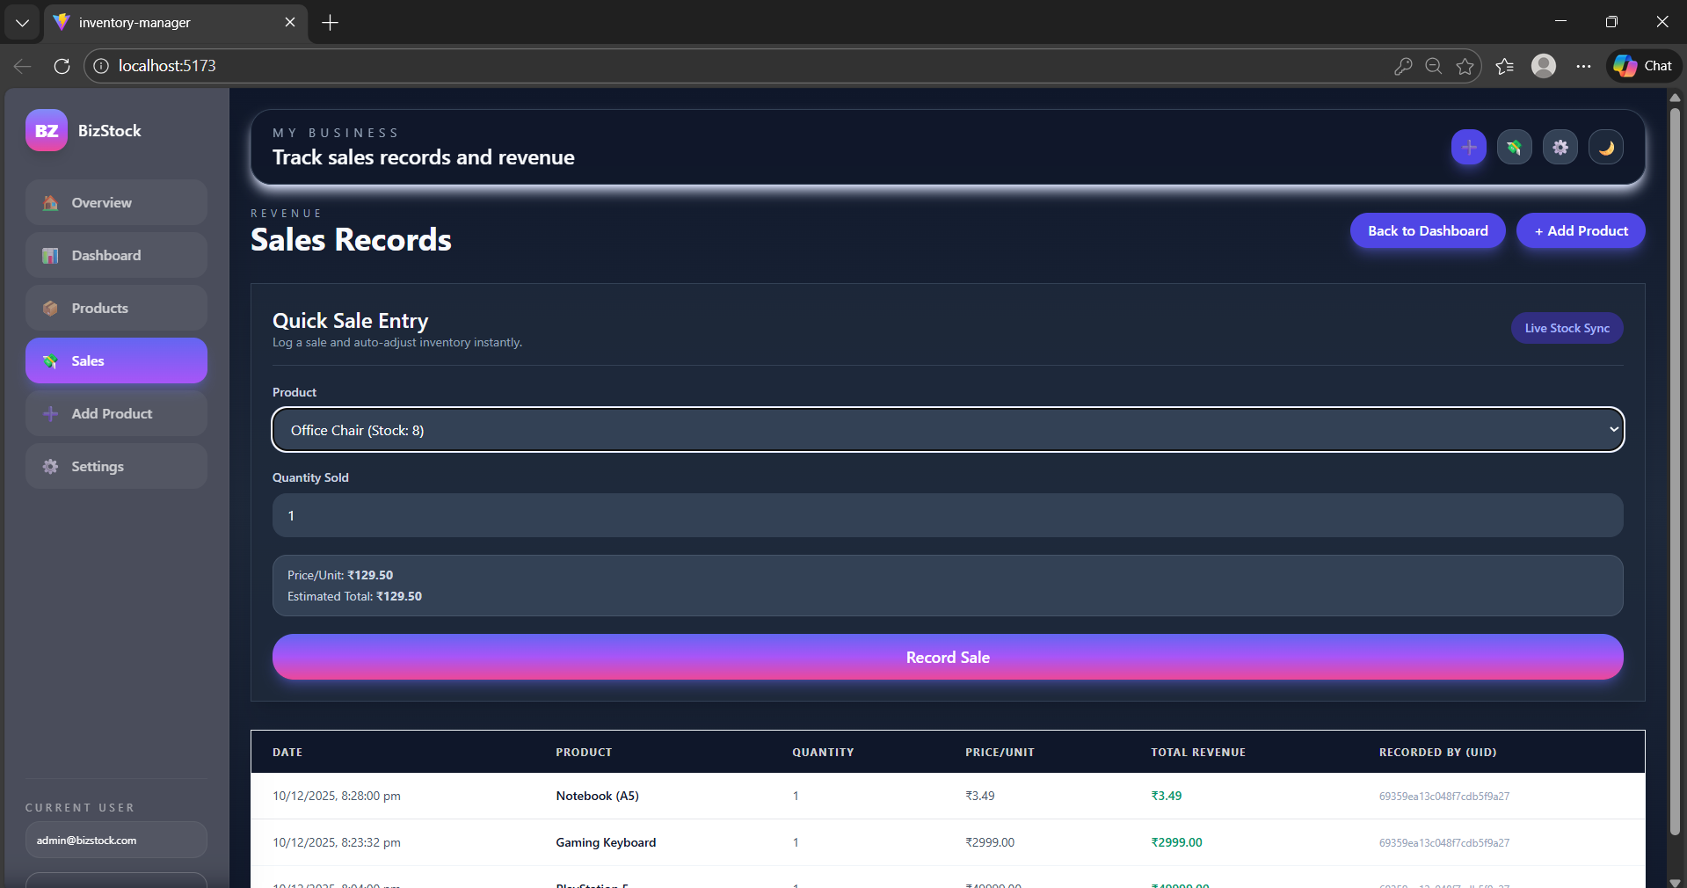

Add New Products Page
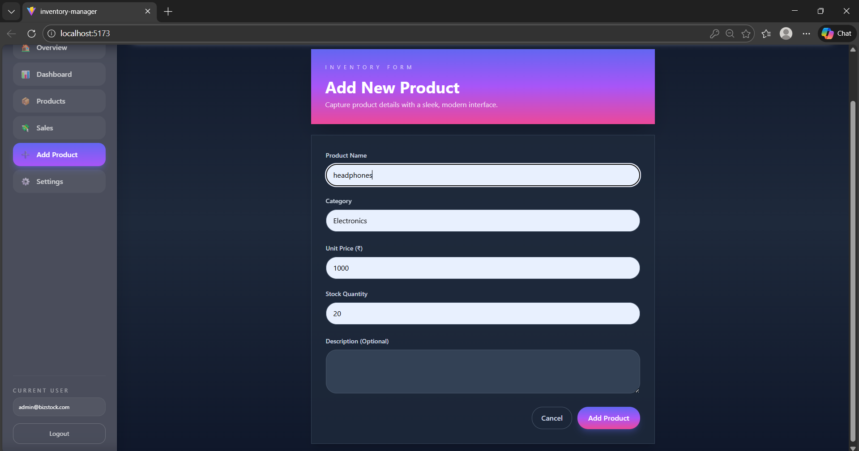
New Product Added
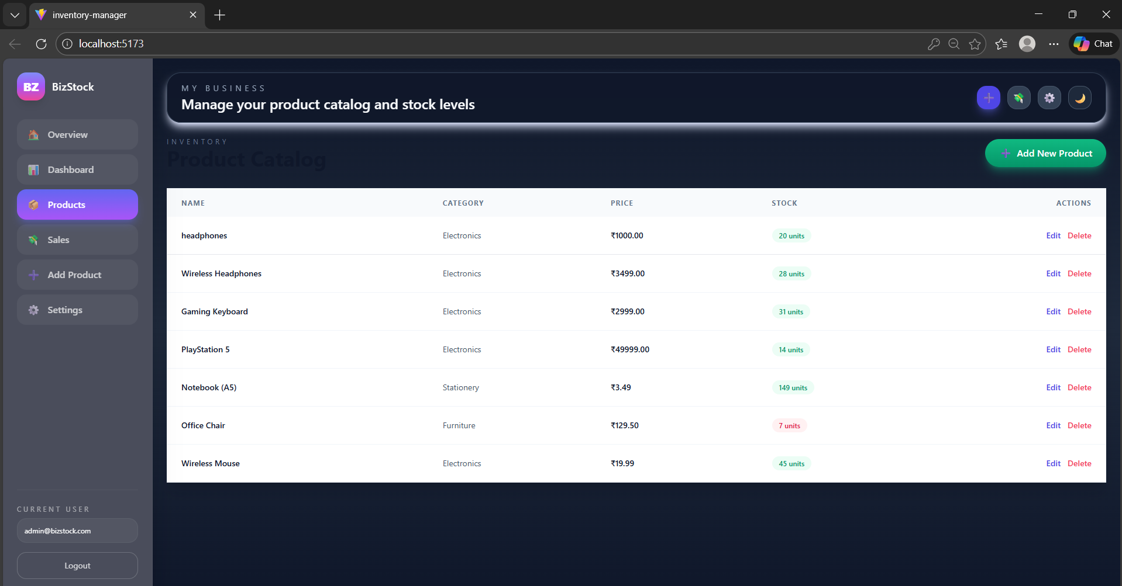

11. TESTING
Unit Testing
Unit testing focuses on verifying the functionality of individual components in isolation. Key modules such as product forms, sales input logic, stock calculations, and validation rules were tested independently. This ensures that each component behaves correctly when provided with valid and invalid data. Unit testing helps in identifying logic errors early in development and improves code stability.
Integration Testing
Integration testing ensures that different parts of the system work together as expected.
The interaction between the React frontend, Node.js backend, and MongoDB database was tested to confirm proper data flow. Scenarios such as adding a product, recording a sale, and updating stock levels were verified to ensure that data is correctly stored, retrieved, and displayed across the application without conflicts.
User Acceptance Testing (UAT)
User Acceptance Testing was performed from the perspective of the business owner or admin user. Common user workflows such as logging in, navigating the dashboard, managing products, recording sales, and viewing sales history were tested to ensure the system is intuitive and meets functional expectations. This testing confirms that the application fulfils its intended purpose in a real usage environment.
Error Handling and Edge Case Testing

Error handling testing was conducted to verify system stability under abnormal conditions. This includes testing invalid input values, empty form submissions, authentication failures, duplicate entries, and incorrect data types. The system was checked for proper error messages, safe handling of failures, and prevention of unexpected crashes, ensuring a robust and user-friendly experience.

12. CONCLUSION
The Inventory Management System developed in this project successfully addresses the core needs of small businesses by providing a simple, secure, and efficient platform to manage products and sales. The application allows authenticated users to maintain product records, track stock levels, record sales transactions, and monitor overall business performance through a centralized dashboard. By combining a React-based frontend with a Node.js backend and MongoDB database, the system achieves a balanced architecture that is both scalable and easy to maintain.
From a technical perspective, the project demonstrates effective implementation of full stack development concepts such as component-based UI design, state management, secure authentication, CRUD operations, and structured data storage. From a practical perspective, it reflects real-world business workflows, ensuring that the system remains intuitive for non-technical users while still being robust enough to handle essential operational tasks.
Overall, the project serves as a strong foundation for a production-level inventory system. It meets its functional objectives, adheres to non-functional requirements like usability and security, and validates the effectiveness of modern web technologies in building business-oriented applications.

  - FUTURE ENHANCEMENTS

- Role-Based Access Control: Introduce additional roles such as staff or manager with limited permissions, enabling controlled access to specific features.
- Advanced Reporting: Add downloadable reports, graphical analytics, and trend analysis for sales and inventory movement.
- Supplier & Purchase Management: Extend the system to manage suppliers, purchase orders, and stock replenishment.
- Cloud Deployment & Security Enhancements: Deploy the application on a cloud platform with advanced security features like token-based authentication and data backups.
- Mobile Responsiveness or App Version: Optimize for mobile devices or develop a dedicated mobile application for on-the-go access.

