PROJECT SELECTION FORM

PG-DAC February 2025

Date: 29/04/2025

Project No.: Group 27
1. Names of the Project Team Members:
Sr. No | Name | PRN | Signature
01. | PALASH SAHU | 250250120087 | 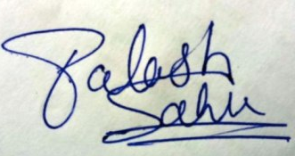
02. | GUNJAN KUMAR | 250250120043 | 
03. | VIPUL SAINI | 250250120136 |   
04. | IRAM MANSOORI | 250250120047
05. | KULDEEP SINGH | 250250120065 | 

2. Title of the Project:
University Alumni Student Connect

- Brief Description of the Project (Add Annexure if needed):
Purpose: The app aims to create a platform for students to connect with alumni for guidance, mentorship, and professional advice.
Functionality: Users can post questions and receive responses from alumni based on their expertise and experience.
User Interaction: The app enables seamless communication by allowing users to follow, like, comment, and directly interact with alumni on their posts or student can post their queries and alumni’s can reply.
Benefits: Facilitates networking, knowledge-sharing, and career development for students while alumni can contribute to the growth of future professionals.

- Software Requirements for the Project (Tentative):
a. Frontend: React.JS for building a cross-platform application interface.
b. Backend: Node.js with Express for handling API requests and MongoDB for database management.
c.
- Hardware Requirements for the Project (Tentative):
a. Intel Core i5 for smooth development and multitasking.
b. Windows 10/11, macOS for compatibility with development tools.
c.
Assigned Project Guide: Ashwin Kumar

Approved by

Project Coordinator :

