.
SpringBoot and ReactJS Integration
4-2-2022 @Ramkumar

Axios is a Javascript library used to make HTTP requests from node. js or XMLHttpRequests from the browser and it supports the Promise API
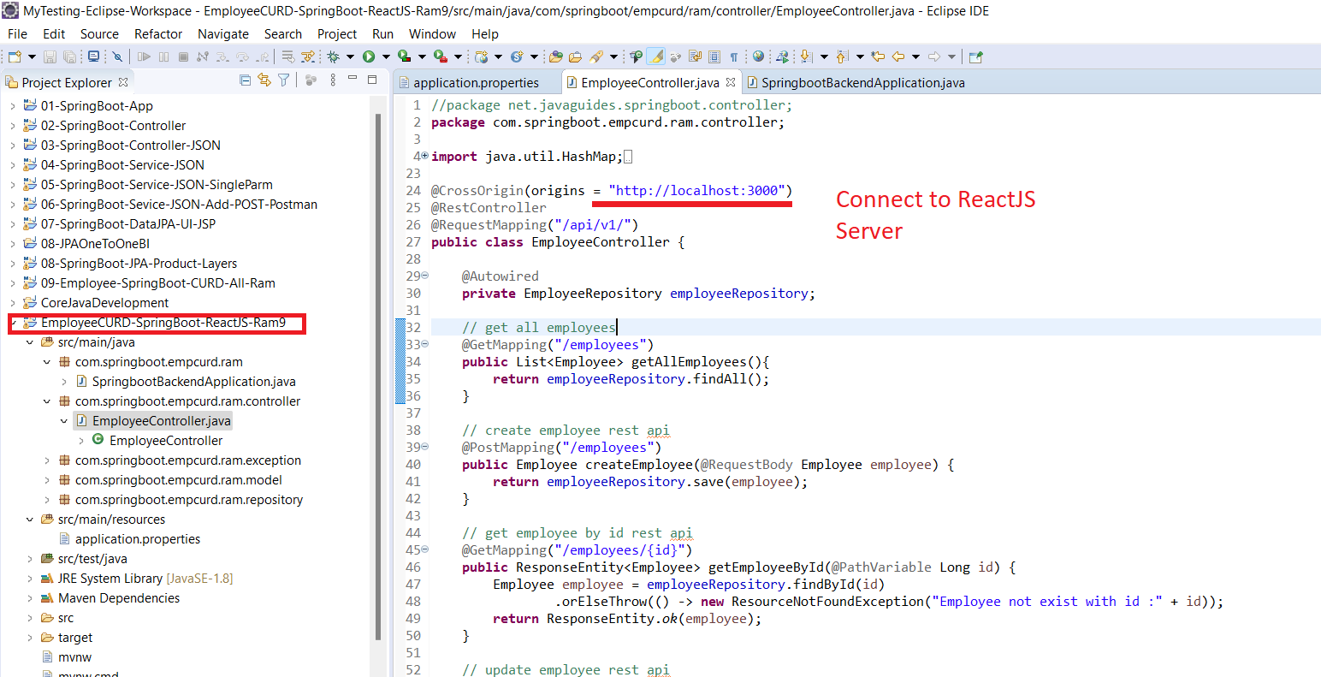
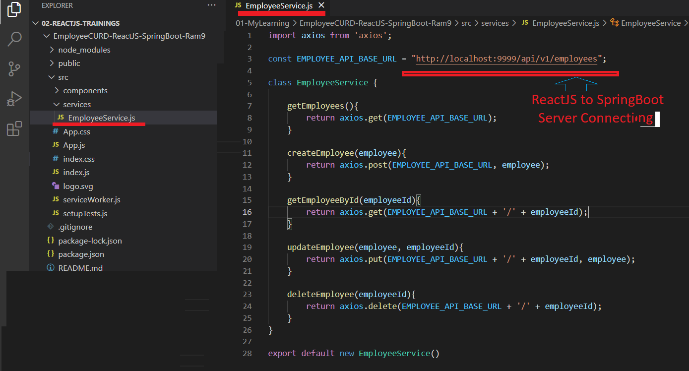
axios
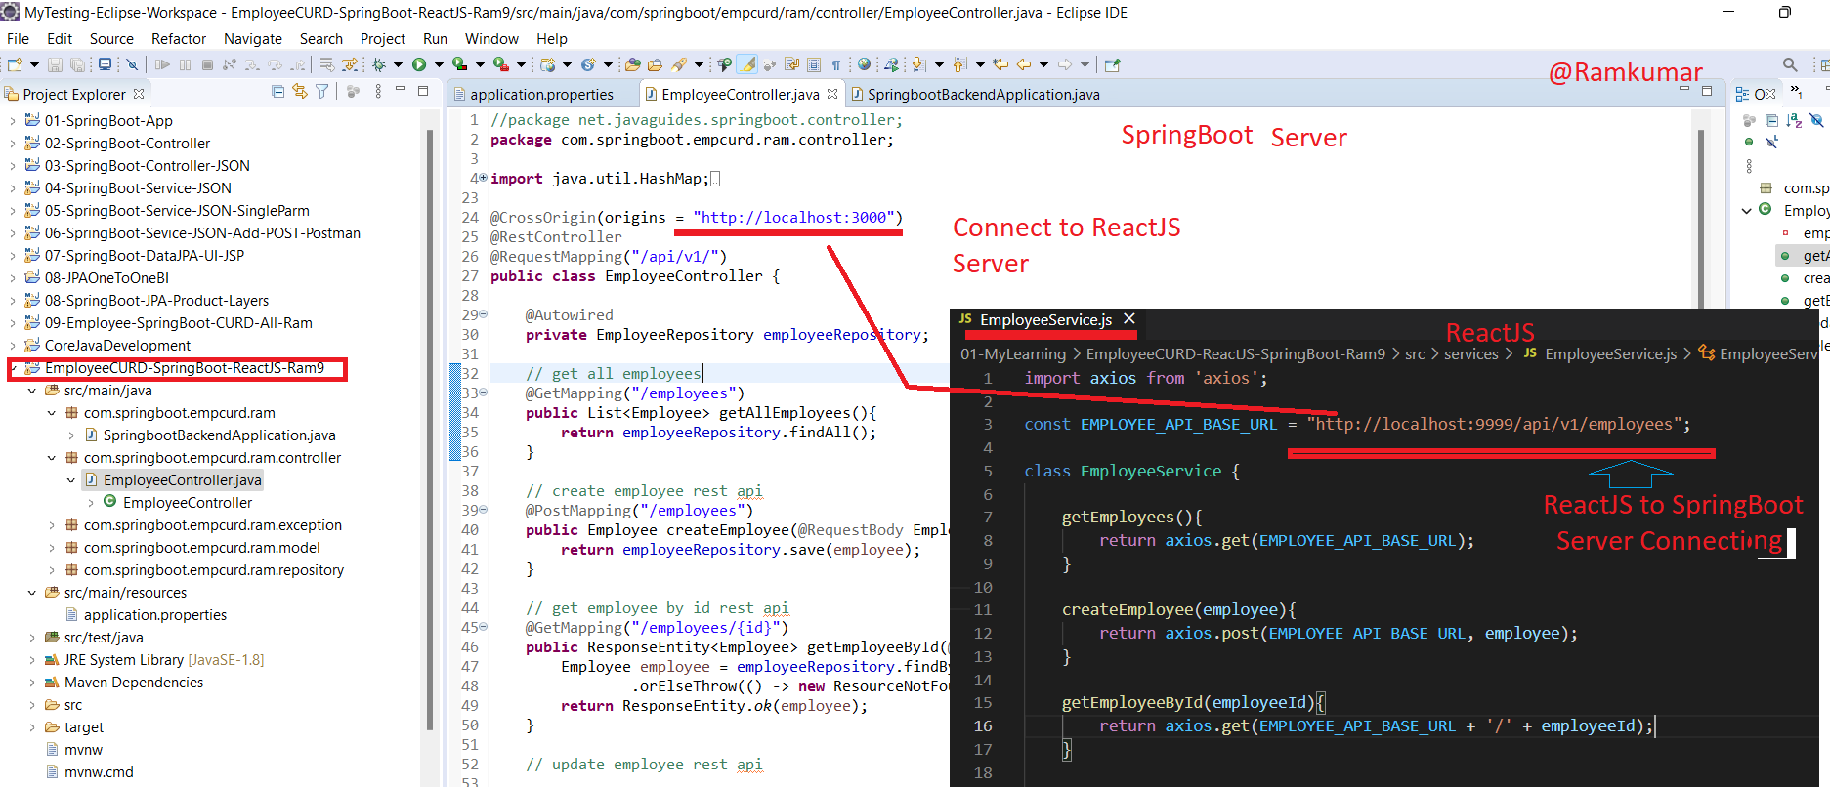

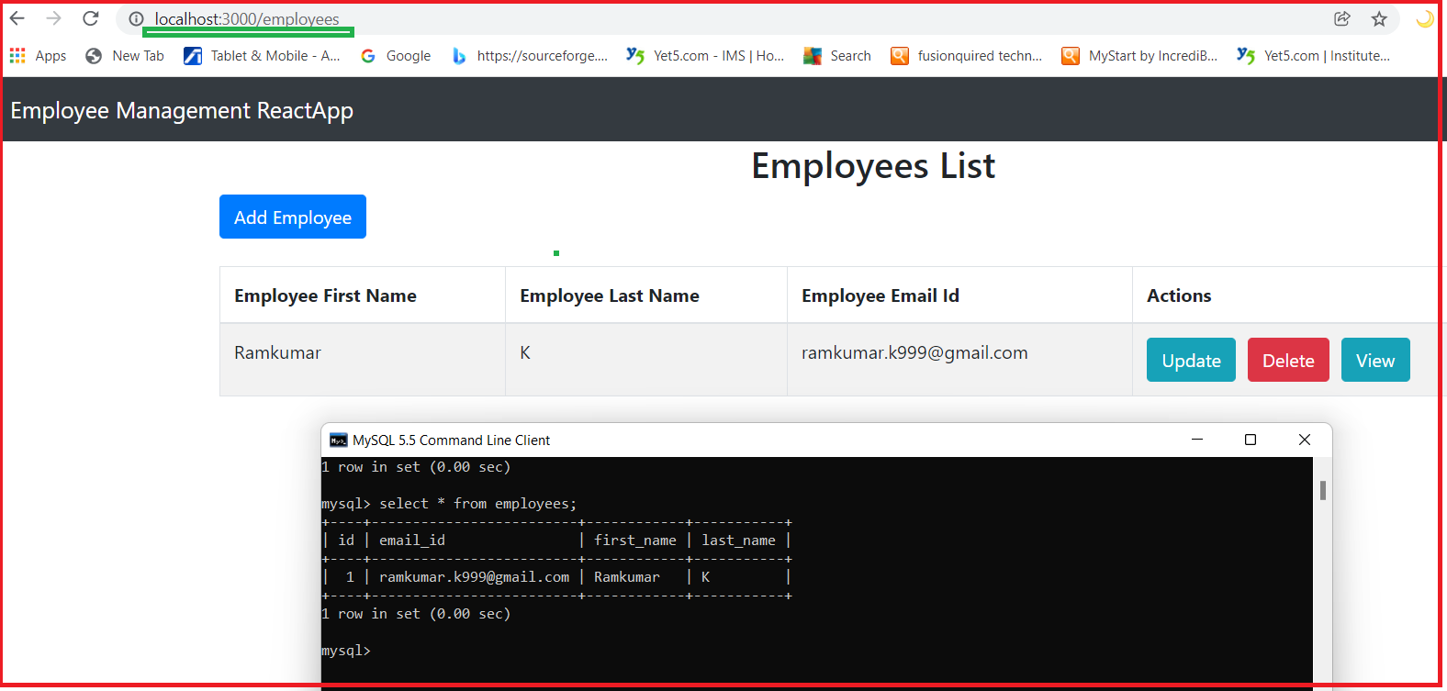

What is Axios?
- Axios is used to communicate with the backend and it also supports the Promise API that is native to JS ES6.
- It is a library which is used to make requests to an API, return data from the API, and then do things with that data in our React application.
- Axios is a Javascript library used to make HTTP requests from node. js or XMLHttpRequests from the browser and it supports the Promise API
- Axios allows you to communicate with the APIs in your React project.
- Axios has function names that match any HTTP methods. To perform a GET request, you use the .get() method.
C:\EmployeeCURD-ReactJS-SpringBoot-Ram9> npm install axios/>npm install axios

Example :
