**Pratical of c#.net**

**Assigment No:-1**

#Program to show how to accept runtime string in c#.net

using System;

using System.Collections.Generic;

using System.Linq;

using System.Text;

using System.Threading.Tasks;

namespace HelloWrold

{

internal class Program

{

static void Main(string[] args)

{

Console.WriteLine("Enter the world");

string n1 = Console.ReadLine();

Console.WriteLine("How Many Times");

int no1 = Convert.ToInt32(Console.ReadLine());

for (int i = 1; i <= no1; i++)

{

Console.WriteLine("\n" + n1);

}

}

}

}

Output:-

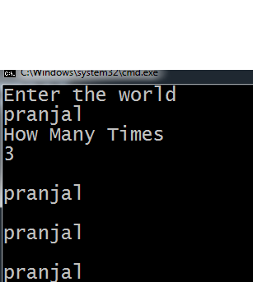

**Assigment No:-2**

**#Program to print “Teach One ,Each One,Tree One”for given number of times.**

using System;

using System.Collections.Generic;

using System.Linq;

using System.Text;

using System.Threading.Tasks;

namespace print_message

{

internal class Program

{

static void Main(string[] args)

{

int i;

int n;

Console.WriteLine("Enter A Number:-");

n = Convert.ToInt32(Console.ReadLine());

for (i = 1; i <= n; i++)

{

Console.WriteLine("Teach One,Each One,Tree One");

}

Console.ReadLine();

}

}

}

Output:-

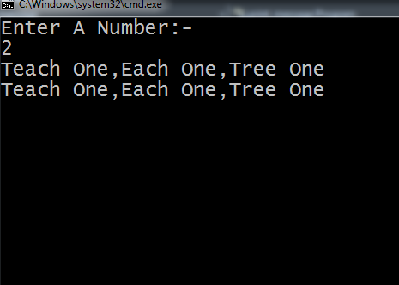

**Assigment No:-3**

#Program to demonstrate Arithmatic oprators in c#.net.

using System;

using System.Collections.Generic;

using System.Linq;

using System.Text;

using System.Threading.Tasks;

namespace Arthmatic_operator

{

internal class Program

{

static void Main(string[] args)

{

int a, b, c;

Console.WriteLine("Enter Values of a=");

a = Convert.ToInt32(Console.ReadLine());

Console.WriteLine("Enter Values of b=");

b= Convert.ToInt32(Console.ReadLine());

c = a + b;

Console.WriteLine("Addition of a and b=" + c);

Console.ReadLine();

c = a - b;

Console.WriteLine("Substraction of a and b=" + c);

Console.ReadLine();

c = a * b;

Console.WriteLine("Multiplication of a and b=" + c);

Console.ReadLine();

c = a / b;

Console.WriteLine("Division of a and b=" + c);

Console.ReadLine();

c = a %b;

Console.WriteLine("Modulation of a and b=" + c);

Console.ReadLine();

}

}

}

Output:-

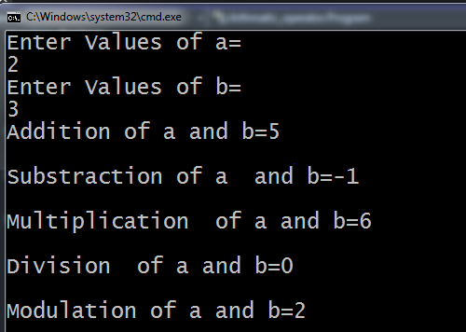

**Assigment No:-4**

#program to demonstrate inheritance in c#.net.

using System;

using System.Collections.Generic;

using System.Linq;

using System.Text;

using System.Threading.Tasks;

namespace Inheritance

{

public class stud

{

public string Class = "sybca";

public string name = "pranjal";

}

public class exam : stud

{

public string s1 = "c#";

public string s2 = "audit";

public string s3 = "rdbms";

}

public class result : exam

{

public int sc = 20;

public int sa = 30;

public int sr = 40;

static void Main(string[] args)

{

result r = new result();

Console.WriteLine(r.Class);

Console.WriteLine(r.name);

Console.WriteLine(r.s1);

Console.WriteLine(r.s2);

Console.WriteLine(r.s3);

Console.WriteLine(r.sc);

Console.WriteLine(r.sa);

Console.WriteLine(r.sr);

Console.ReadLine();

}

}

}

Output:-

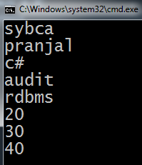

Assignment no:-5

#Program To demonstrate simple inheritance in c#.net.

using System;

using System.Collections.Generic;

using System.Linq;

using System.Text;

using System.Threading.Tasks;

namespace simple_inheritance

{

public class Program

{

public int rollno = 85;

public string name = "Pranjal";

}

class exam : Program

{

public static void Main(string[] args)

{

exam n = new exam();

Console.WriteLine(n.rollno);

Console.WriteLine(n.name);

Console.ReadLine();

}

}

}

Output:-

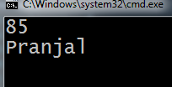

Assignment no:-6

#Program To demonstrate multiple inheritance in c#.net.

using System;

using System.Collections.Generic;

using System.Linq;

using System.Text;

using System.Threading.Tasks;

namespace multiple_inheritance

{

class student

{

public void info()

{

String name = "Pranjal";

String Class = "SYBCA";

Console.WriteLine("Student name :-" + name);

Console.WriteLine("Class:-" + Class);

}

}

interface exam

{

void mark();

}

class result:student, exam

{

public void mark()

{

String Subject = "c#.net";

int marks = 28;

Console.WriteLine("Subject:-" + Subject);

Console.WriteLine("Marks:-" + marks);

}

static void Main(string[] args)

{

result obj = new result();

obj.info();

obj.mark();

Console.ReadLine();

}

}

}

Output:-

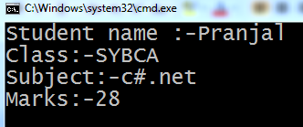

Assignment no:-7

#Program To demonstrate use of polymorphism in c#.net.

using System;

using System.Collections.Generic;

using System.Linq;

using System.Text;

using System.Threading.Tasks;

namespace polymorphism

{

public class Program

{

void add(int a, int b)

{

int c = a + b;

Console.WriteLine("addition of a and b=" + c);

}

void add(int a, int b,int c)

{

int c1 = a + b+c;

Console.WriteLine("addition of a and b=" + c1);

}

static void Main(string[] args)

{

Program p = new Program();

p.add(10,20);

p.add(10,20,30);

Console.ReadLine();

}

}

}

Output:-

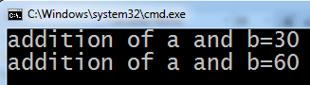

Assignment no:-8

#Program To demonstrate function definition and function call in c#.net.

using System;

using System.Collections.Generic;

using System.Linq;

using System.Text;

using System.Threading.Tasks;

namespace fun_defn_and_fun_call

{

public class Program

{

void print()

{

Console.WriteLine("Pranjal");

}

static void Main(string[] args)

{

Program p=new Program();

p.print();

}

}

}

Output:-

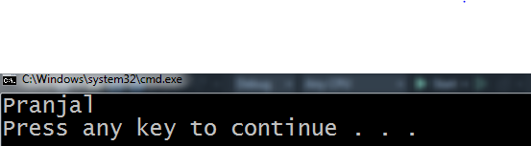

Assignment no:-9

#Program To demonstrate use of parameterize function in c#.net.

using System;

using System.Collections.Generic;

using System.Linq;

using System.Text;

using System.Threading.Tasks;

namespace parameterize_function

{

public class Program

{

int x = 0;

void print(int x,int y)

{

x = x + y;

Console.WriteLine(x);

}

static void Main(string[] args)

{

Program p = new Program();

p.print(5,5);

}

}

}

Output:-

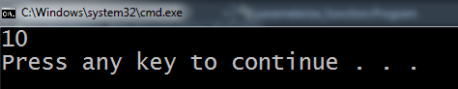

Assignment no:-10

#Program To show table of given number using while loop in c#.net.

using System;

using System.Collections.Generic;

using System.Linq;

using System.Text;

using System.Threading.Tasks;

namespace while_loop_table

{

internal class Program

{

static void Main(string[] args)

{

int i = 1;

int n;

Console.WriteLine("Enter A Number:-");

n = Convert.ToInt32(Console.ReadLine());

Console.WriteLine("Table of given number:-");

while(i<=10)

{

Console.WriteLine(n * i);

i++;

}

}

}

}

Output:-

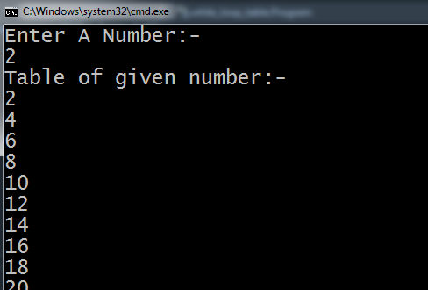

Assignment no:-11

#Program To demonstrate while loop in c#.net show Series of given number.

using System;

using System.Collections.Generic;

using System.Linq;

using System.Text;

using System.Threading.Tasks;

namespace show_series_while_loop

{

public class Program

{

public static void Main(string[] args)

{

int i = 1, n;

Console.WriteLine("Enter a number:-");

n = Convert.ToInt32(Console.ReadLine());

Console.WriteLine("Series of 1 to 10 in while loop:-");

while(i<=n)

{

Console.WriteLine(i);

i++;

}

Console.ReadLine();

}

}

}

Output:-

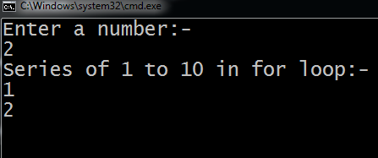

Assignment no:-12

#Program To demonstrate for loop in c#.net show Series of given number.

using System;

using System.Collections.Generic;

using System.Linq;

using System.Text;

using System.Threading.Tasks;

namespace show_series_for_loop

{

public class Program

{

public static void Main(string[] args)

{

int i, n;

Console.WriteLine("Enter a number:-");

n = Convert.ToInt32(Console.ReadLine());

Console.WriteLine("Series 1 to 10 for loop:-");

for(i=1;i<=n;i++)

{

Console.WriteLine(i);

}

Console.ReadLine();

}

}

}

Output:-

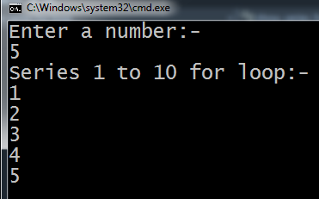

Assignment no:-13

#Program To demonstrate of continue statement in for loop.

using System;

using System.Collections.Generic;

using System.Linq;

using System.Text;

using System.Threading.Tasks;

namespace continue_state_for_loop

{

public class Program

{

public static void Main(string[] args)

{

for(int x=1;x<=12;x++)

{

if(x==3)

{

continue;

}

Console.WriteLine(x);

}

}

}

}

Output:-

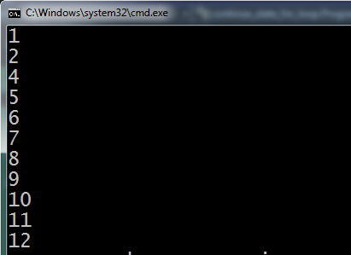

Assignment no:-14

#Program To demonstrate of continue statement in while loop.

using System;

using System.Collections.Generic;

using System.Linq;

using System.Text;

using System.Threading.Tasks;

namespace continue_statement_while_loop

{

public class Program

{

public static void Main(string[] args)

{

int i = 1;

while(i<=12)

{

i++;

if(i==5)

{

continue;

}

Console.WriteLine(i);

}

}

}

}

Output:-

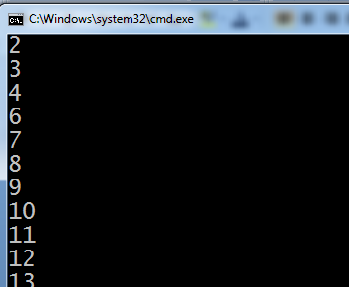

Assignment no:-15

#Program To demonstrate to show first 3 number in for loop.

using System;

using System.Collections.Generic;

using System.Linq;

using System.Text;

using System.Threading.Tasks;

namespace first_3_even_for_loop

{

public class Program

{

public static void Main(string[] args)

{

int i;

int n;

Console.WriteLine("Enter a number:-");

n = Convert.ToInt32(Console.ReadLine());

Console.WriteLine("first 3 even number of given number in for loop:-");

for(i=1;i<=6;i++)

{

{

if (i % 2 == 0)

{

Console.WriteLine(i);

}

}

}

Console.ReadLine();

}

}

}

Output:-

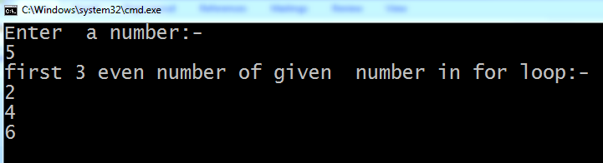

Assignment no:-16

#Program To demonstrate if else statement in c#.net.

using System;

using System.Collections.Generic;

using System.Linq;

using System.Text;

using System.Threading.Tasks;

namespace if_else

{

internal class Program

{

static void Main(string[] args)

{

int age;

Console.WriteLine("Enter age of candidate:-");

age = Convert.ToInt32(Console.ReadLine());

if(age>=18)

{

Console.WriteLine("Eligible for vote:-");

}

else

{

Console.WriteLine("Not eligible for vote:-");

}

}

}

}

Output:-

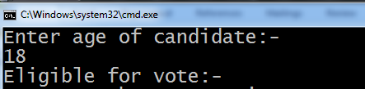

Assignment no:-17

#Program To demonstate default constructor and paramerterize constructor in c#.net.

using System;

using System.Collections.Generic;

using System.Linq;

using System.Text;

using System.Threading.Tasks;

namespace default_and_prameterize_constructor

{

public class Program

{

int r;

string n;

Program(int rollno, string name)

{

r = rollno;

n = name;

Console.WriteLine(r + "\t" + n);

}

Program()

{

Console.WriteLine("Constructor called");

}

public static void Main(string[] args)

{

Program p = new Program();

Program p1 = new Program(85, "pranjal");

}

}

}

Output:-

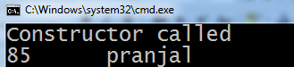

Assignment no:-18

#Program To demonstrate destructor in c#.net.

using System;

using System.Collections.Generic;

using System.Linq;

using System.Text;

using System.Threading.Tasks;

namespace Destructor

{

public class Program

{

public Program()

{

Console.WriteLine("Constructor called:-");

}

~Program()

{

Console.WriteLine("Destructor called:-");

}

public static void Main(string[] args)

{

Program p = new Program();

}

}

}

Output:-

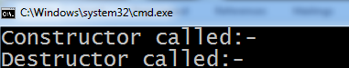

Assignment no:-19

#Program To demonstrate Function Overriding in c#.net.

using System;

using System.Collections.Generic;

using System.Linq;

using System.Text;

using System.Threading.Tasks;

namespace function_overriding

{

public class Program

{

public virtual void showinfo()

{

Console.WriteLine("Base class method");

}

}

class b:Program

{

public override void showinfo()

{

Console.WriteLine("Derived class method:-");

}

static void Main(string[] args)

{

b b1 = new b();

b1.showinfo();

b1.showinfo();

}

}

}

Output:-

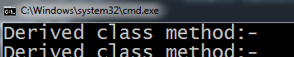

Assignment no:-20

#Program To demonstrate Array in c#.net.

using System;

using System.Collections.Generic;

using System.Linq;

using System.Text;

using System.Threading.Tasks;

namespace Array

{

public class Program

{

static void Main(string[] args)

{

int num;

int[] a = { 1, 2, 3, 4, 5, 6 };

Console.WriteLine("Enter any number:-");

num = Convert.ToInt32(Console.ReadLine());

if(num == a[0])

{

Console.WriteLine("true");

}

else if (num == a[1])

{

}

else if (num == a[2])

{

Console.WriteLine("true");

}

else if (num == a[3])

{

Console.WriteLine("true");

}

else if (num == a[4])

{

Console.WriteLine("true");

}

else if (num == a[5])

{

Console.WriteLine("true");

}

else

{

Console.WriteLine("false");

}

}

}

}

Output:-

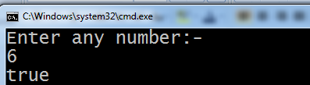

Assignment no:-21

#Program to show maximum and minimum number in an array.

using System;

using System.Collections.Generic;

using System.Linq;

using System.Text;

using System.Threading.Tasks;

namespace mim_and_max_number

{

internal class Program

{

static void Main(string[] args)

{

int[] a = { 12, 34, 56, 78, 89 };

int i,max,min;

max = a[0];

min = a[0];

for(i = 1; i < 5; i++)

{

if(a[i] > max)

{

max = a[i];

}

if(a[i] < min)

{

min = a[i];

}

}

Console.WriteLine("Maximum number:-" + max);

Console.WriteLine("Minium number:-"+min);

}

}

}

Output:-

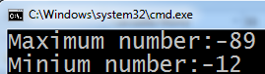

Assignment no:-22

#Program to demonstrate call by value in c#.net.

using System;

using System.Collections.Generic;

using System.Linq;

using System.Text;

using System.Threading.Tasks;

namespace call_by_value

{

public class Program

{

void show(int x)

{

x = 10;

Console.WriteLine(x);

}

static void Main(string[] args)

{

int x = 20;

Program p1 = new Program();

Console.WriteLine("Before function call:-"+x);

p1.show(x);

Console.WriteLine("After function call:-"+x);

}

}

}

Output:-

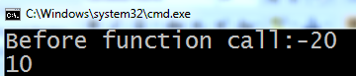

Assignment no:-23

#Program to demonstrate call by reference in c#.net.

using System;

using System.Collections.Generic;

using System.Linq;

using System.Text;

using System.Threading.Tasks;

namespace call_by_refrence

{

public class Program

{

void show(ref int x)

{

x = 10;

Console.WriteLine(x);

}

public static void Main(string[] args)

{

int x = 20;

Program p1 = new Program();

Console.WriteLine("Before the function call"+x);

p1.show(ref x);

Console.WriteLine("After the calling function"+x);

}

}

}

Output:-

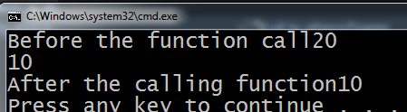

Assignment no:-24

#Program To Demonstrate exception handling in c#.net.

using System;

using System.Collections.Generic;

using System.Linq;

using System.Text;

using System.Threading.Tasks;

namespace Exception_handling

{

public class Program

{

public static void Main(string[] args)

{

try

{

int a = 2;

int b = 0;

int c = a / b;

Console.WriteLine(c);

}

catch(Exception e)

{

Console.WriteLine("Exception Occured:-"+e);

}

finally

{

Console.WriteLine("Exception Handle:-");

}

}

}

}

Output:-

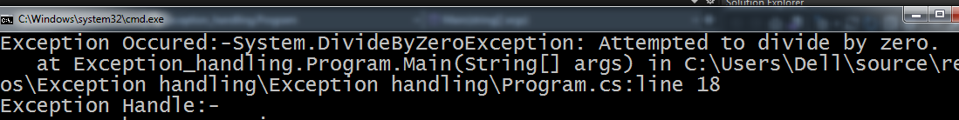

Assignment no:-25

#Program To Demonstrate of

TextBox,RadioButton,Button,Label,GroupBox.

using System;

using System.Collections.Generic;

using System.ComponentModel;

using System.Data;

using System.Drawing;

using System.Linq;

using System.Text;

using System.Windows.Forms;

namespace WindowsFormsApplication6

{

public partial class Form1 : Form

{

public Form1()

{

InitializeComponent();

}

private void btn1_Click(object sender, EventArgs e)

{

label1.Text = pranjl.Text;

if (chk1.Checked == true)

{

label2.Text = chk1.Text;

}

if (chk2.Checked == true)

{

label2.Text = chk2.Text;

}

if (rdb1.Checked = true)

{

label3.Text = rdb1.Text;

}

if (rdb2.Checked == true)

{

label3.Text = rdb2.Text;

}

}

}

}

Output:-

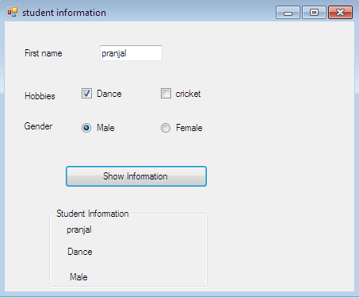

Assignment no:-26

#create a c# application using listBox,ComboBox control in c#.net.

using System;

using System.Collections.Generic;

using System.ComponentModel;

using System.Data;

using System.Drawing;

using System.Linq;

using System.Text;

using System.Threading.Tasks;

using System.Windows.Forms;

namespace listbox1_comobox1

{

public partial class Form1 : Form

{

public Form1()

{

InitializeComponent();

}

private void cmbselect_SelectedIndexChanged(object sender, EventArgs e)

{

lb1.Items.Clear();

if (cmbselect.SelectedItem == "India")

{

lb1.Items.Add("maharastra");

lb1.Items.Add("gujrat");

lb1.Items.Add("up");

}

if (cmbselect.SelectedItem == "USA")

{

lb1.Items.Add("A");

lb1.Items.Add("B");

lb1.Items.Add("C");

}

}

}

}

Output:-

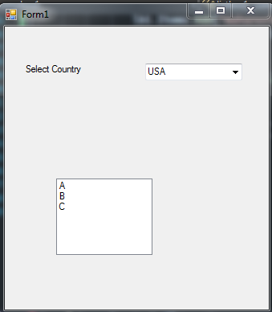

Assignment no:-27

#Program To demonstrate use of DateTimePicker in c#.net.

using System;

using System.Collections.Generic;

using System.ComponentModel;

using System.Data;

using System.Drawing;

using System.Linq;

using System.Text;

using System.Threading.Tasks;

using System.Windows.Forms;

namespace form

{

public partial class Form1 : Form

{

public Form1()

{

InitializeComponent();

}

private void dateTimePicker2_ValueChanged(object sender, EventArgs e)

{

int d;

DateTime firstdate = Convert.ToDateTime(dateTimePicker1.Text);

DateTime seconddate = Convert.ToDateTime(dateTimePicker2.Text);

d = firstdate.Subtract(seconddate).Days;

textBox1.Text = Math.Abs(d).ToString();

}

}

}

Output:-

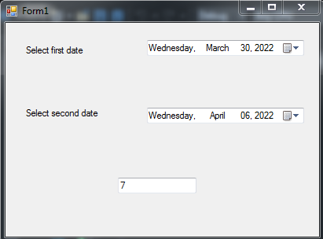

Assignment no:-28

#Program To demonstrate use of time control in c#.net.

using System;

using System.Collections.Generic;

using System.ComponentModel;

using System.Data;

using System.Drawing;

using System.Linq;

using System.Text;

using System.Threading.Tasks;

using System.Windows.Forms;

namespace Assignment_28

{

public partial class Form1 : Form

{

int t;

public Form1()

{

InitializeComponent();

timer1.Start();

timer2.Start();

}

private void timer1_Tick(object sender, EventArgs e)

{

t++;

label1.Text = t.ToString();

if(t==10)

{

timer1.Stop();

label1.Text = "Time out";

}

}

private void timer2_Tick(object sender, EventArgs e)

{

label2.Text = DateTime.Now.ToString();

}

}

}

Output:-

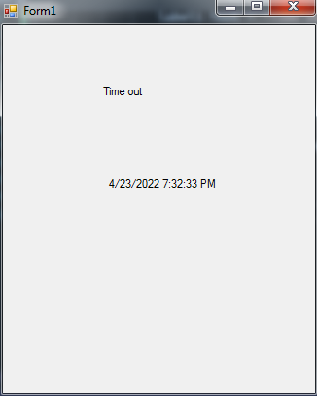

Assignment no:-29

#Program To demonstrate 0f menustrip control to change background color and open different c#.net.

using System;

using System.Collections.Generic;

using System.ComponentModel;

using System.Data;

using System.Drawing;

using System.Linq;

using System.Text;

using System.Threading.Tasks;

using System.Windows.Forms;

namespace assignment_29

{

public partial class Form1 : Form

{

public Form1()

{

InitializeComponent();

}

private void formsToolStripMenuItem_Click(object sender, EventArgs e)

{

Form1 f1 = new Form1();

f1.Show();

}

private void colorsToolStripMenuItem_Click(object sender, EventArgs e)

{

}

private void redToolStripMenuItem_Click(object sender, EventArgs e)

{

this.BackColor = Color.Red;

}

private void greenToolStripMenuItem_Click(object sender, EventArgs e)

{

this.BackColor = Color.Green;

}

private void blueToolStripMenuItem_Click(object sender, EventArgs e)

{

this.BackColor = Color.Blue;

}

}

}

Output:-

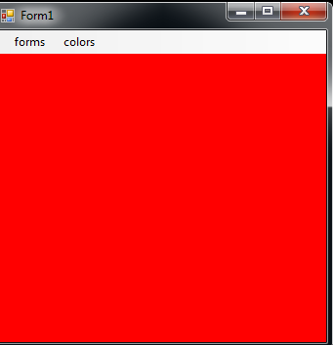

Assignment no:-30

#Program To demonstrate of PictureBox in c#.net.

using System;

using System.Collections.Generic;

using System.ComponentModel;

using System.Data;

using System.Drawing;

using System.Linq;

using System.Text;

using System.Threading.Tasks;

using System.Windows.Forms;

namespace PictureBox1

{

public partial class Form1 : Form

{

int count = -1;

public Form1()

{

InitializeComponent();

}

private void bt2_Click(object sender, EventArgs e)

{

if(count<=8)

{

count = count + 1;

}

pictureBox1.SizeMode = PictureBoxSizeMode.StretchImage;

pictureBox1.Image = imageList1.Images[count];

}

private void bt1_Click(object sender, EventArgs e)

{

if (count >=0)

{

count = count - 1;

}

pictureBox1.Image = imageList1.Images[count];

}

}

}

Output:-

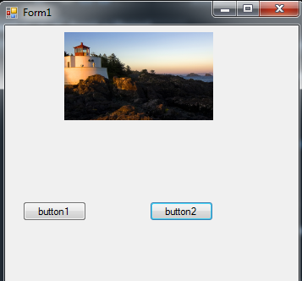

Assignment no:-31

#Program To demonstrate Simple Database Connectivity using wizard.

using System;

using System.Collections.Generic;

using System.ComponentModel;

using System.Data;

using System.Drawing;

using System.Linq;

using System.Text;

using System.Windows.Forms;

using System.Data.SqlClient;

namespace custtable

{

publicpartialclassForm1 : Form

{

SqlConnection con = newSqlConnection();

public Form1()

{

con.ConnectionString = "Data Source=.;Initial Catalog=emp;Integrated Security=True;Pooling=False";

InitializeComponent();

display();

}

privatevoid btinsert_Click(object sender, EventArgs e)

{

con.Open();

SqlCommand cmd = newSqlCommand("insert into emp85 values(@Empid,@Ename,@phone)",con);

cmd.Parameters.AddWithValue("@Empid", Convert.ToInt32(textBox1.Text));

cmd.Parameters.AddWithValue("@Ename", (textBox2.Text));

cmd.Parameters.AddWithValue("@phone", (textBox3.Text));

cmd.ExecuteNonQuery();

MessageBox.Show("Value insert succesfully");

con.Close();

display();

}

privatevoid display()

{

DataTable dt = newDataTable();

SqlDataAdapter da = newSqlDataAdapter("Select * from emp85",con);

da.Fill(dt);

dataGridView1.DataSource = dt;

}

privatevoid btupdate_Click(object sender, EventArgs e)

{

con.Open();

SqlCommand cmd = newSqlCommand("update emp85 set Ename=@Ename where Empid=@Empid", con);

cmd.Parameters.AddWithValue("@Empid", Convert.ToInt32(textBox1.Text));

cmd.Parameters.AddWithValue("@Ename", (textBox2.Text));

cmd.Parameters.AddWithValue("@phone", (textBox3.Text));

cmd.ExecuteNonQuery();

MessageBox.Show("Record update succesfully");

con.Close();

display();

}

privatevoid btdelete_Click(object sender, EventArgs e)

{

con.Open();

SqlCommand cmd = newSqlCommand("delete from emp85 where Empid=@Empid", con);

cmd.Parameters.AddWithValue("@Empid", Convert.ToInt32(textBox1.Text));

cmd.ExecuteNonQuery();

MessageBox.Show("Record delete succesfully");

con.Close();

display();

}

}

}

Output:-

