## <Ansible> Runbook

### Short Description

*This should be a short description of the service and what it is used for.*

* Ansible is used to manage and configure computers combining software deployment, ad hoc task execution and configuration management.

### Required Software

*Create a list of the software required to run this service. For example, web servers, databases, web frameworks, etc.*

* Windows / MAC OSx
* Oracle VM VirtualBox
* Centos 7
* Git
* Ansible

### 

### 

### 

### 

### 

### 

### Architecture Diagram

*An architecture diagram is a basic diagram that shows how your users might interact with the service, how different services are placed on systems, etc.*

*This diagram doesn’t need to be fancy, named boxes and circles with lines are fine. Please make sure that you proper denote services, hosts and connections. For example,* [*http://creately.com/images/landing-new/aws/aws-1-large.jpg*](http://creately.com/images/landing-new/aws/aws-1-large.jpg)*.*

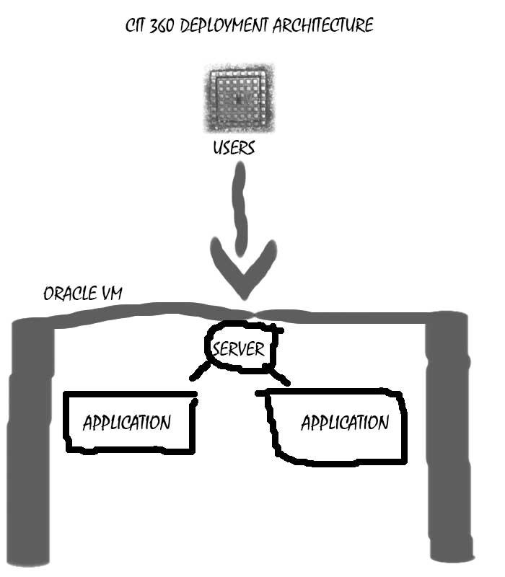

### Deployment

*Describe how to deploy the software. Note any required dependencies for the deploy (for example, the tool used for deployment). Describe the steps, including commands, to run in the proper order and the expected output of the commands.*

In order to deploy the software, if you are using a windows machine you must install ORACLE VM Box. From the Windows OS you must install Vagrant. From there you can open CMD. From the CMD you must install GIT:

Git clone <https://github.com/f16-cit360/cit-360.git>

From there you must install Pip:

$ sudo easy_install pip

Then install Ansible:

Sudo pip install ansible.

And there you have it.

### Issues

*Please specify any issues that might occur that would cause the service to not work properly. For example, what should you do if the service process dies or what should be done if the logs fill up the disk?*

*Use the following format for each issue:*

**Title:** *A quick description of the issue*

**Description:** *A longer description of the issue and how to detect it.*

**Remediation Steps:** *What are the steps to fix this issue*.

*Issue 1:*

**Title:** *GCC Error*

**Description:** *During the installation GCC error. There wasn’t a work around so I was left with one choice.*

**Remediation Steps:** *The only choice I found to fix this error was to completely remake the VM.*